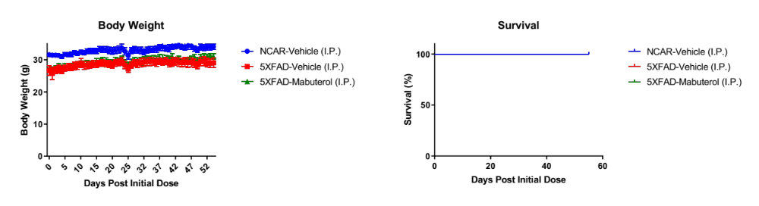
Supplementary Figure 1. Mouse body weight and survival during in vivo study. Mice maintained body weight, and all mice survived through the study. Vehicle-treated non-carriers (NCAR-Veh), vehicle-treated 5XFAD (Hemi-Veh), and mabuterol-treated 5XFAD (Hemi-Mabuterol) are represented by blue, red, and green data curves.

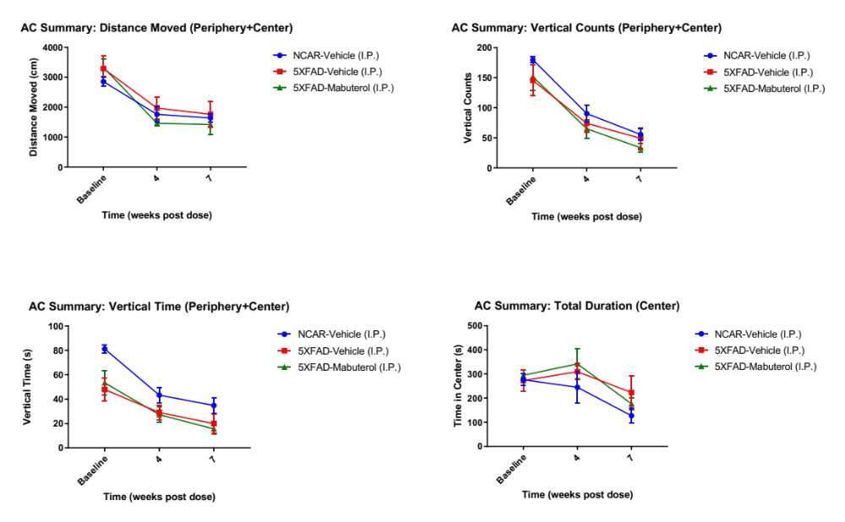
Supplementary Figure 2. Activity Chamber showed no significant changes in spontaneous activity over the course of the study. We measured the distance moved (upper left), vertical counts (upper right), vertical time (lower left), and total duration spent in the center of the arena (lower right) over the course of the study and observed no statistically significant differences. Vehicle-treated non-carriers (NCAR-Veh), vehicle-treated 5XFAD (Hemi-Veh), and mabuterol-treated 5XFAD (Hemi-Mabuterol) are represented by blue, red, and green data curves.

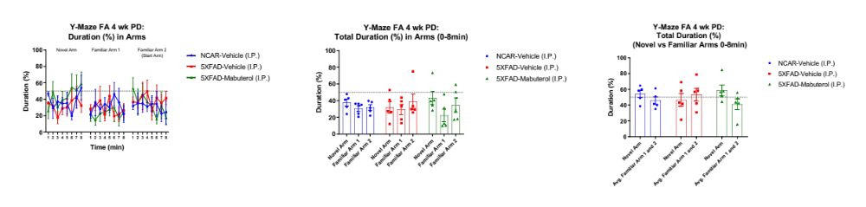
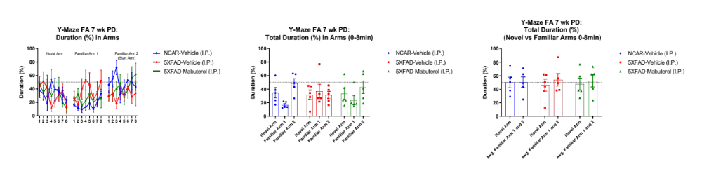
Supplementary Figure 3. Y-maze: Forced Alternation showed no changes in spatial reference memory across treatment groups. We examined the total duration spent in the novel and familiar arms at 4 weeks (top) and 7 weeks (bottom) post-dosing. We analyzed this information based on the duration in each arm (left) and based on the duration in the novel arm compared to the average of the duration in the familiar arms (right). Vehicle-treated non-carriers (NCAR-Veh), vehicle-treated 5XFAD (Hemi-Veh), and mabuterol-treated 5XFAD (Hemi-Mabuterol) are represented by blue, red, and green data curves.

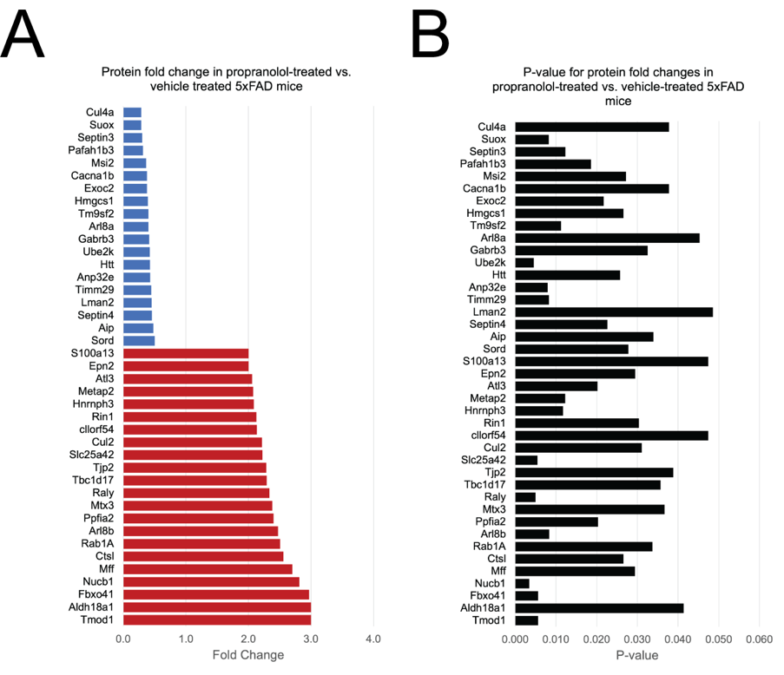
Supplementary Figure 4. Protein expression level changes detected by proteomics in 5XFAD mice compared to controls. Protein expression changes and their significance were assess for vehicle-treated 5XFAD (Hemi-Veh) compared to vehicle-treated non-carriers (NCAR-Veh) (A,B). Blue and red bars indicate down- and up- regulated proteins respectively.
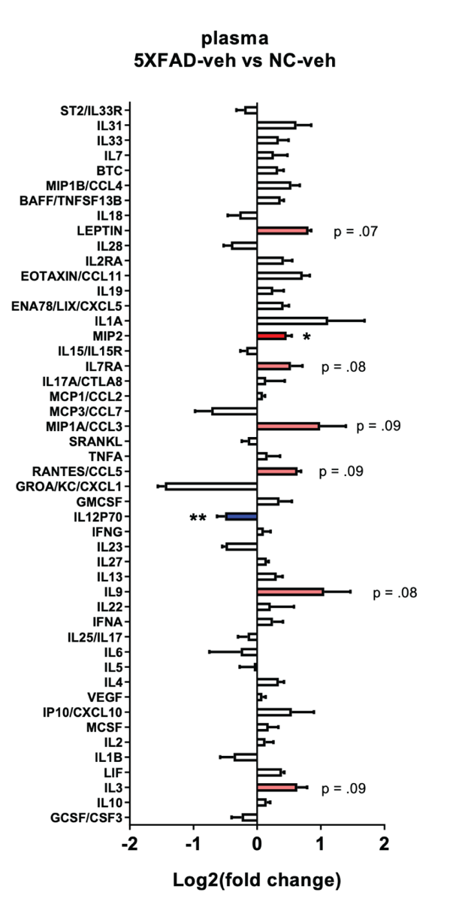
Supplementary Figure 5. Inflammatory cytokine changes in plasma detected by Luminex 48-plex (Affymetrix) mouse cytokine assay in 5XFAD mice compared to controls. We measured changes in cytokine levels comparing vehicle-treated 5XFAD (Hemi-Veh) to vehicle-treated non-carriers (NCAR-Veh).
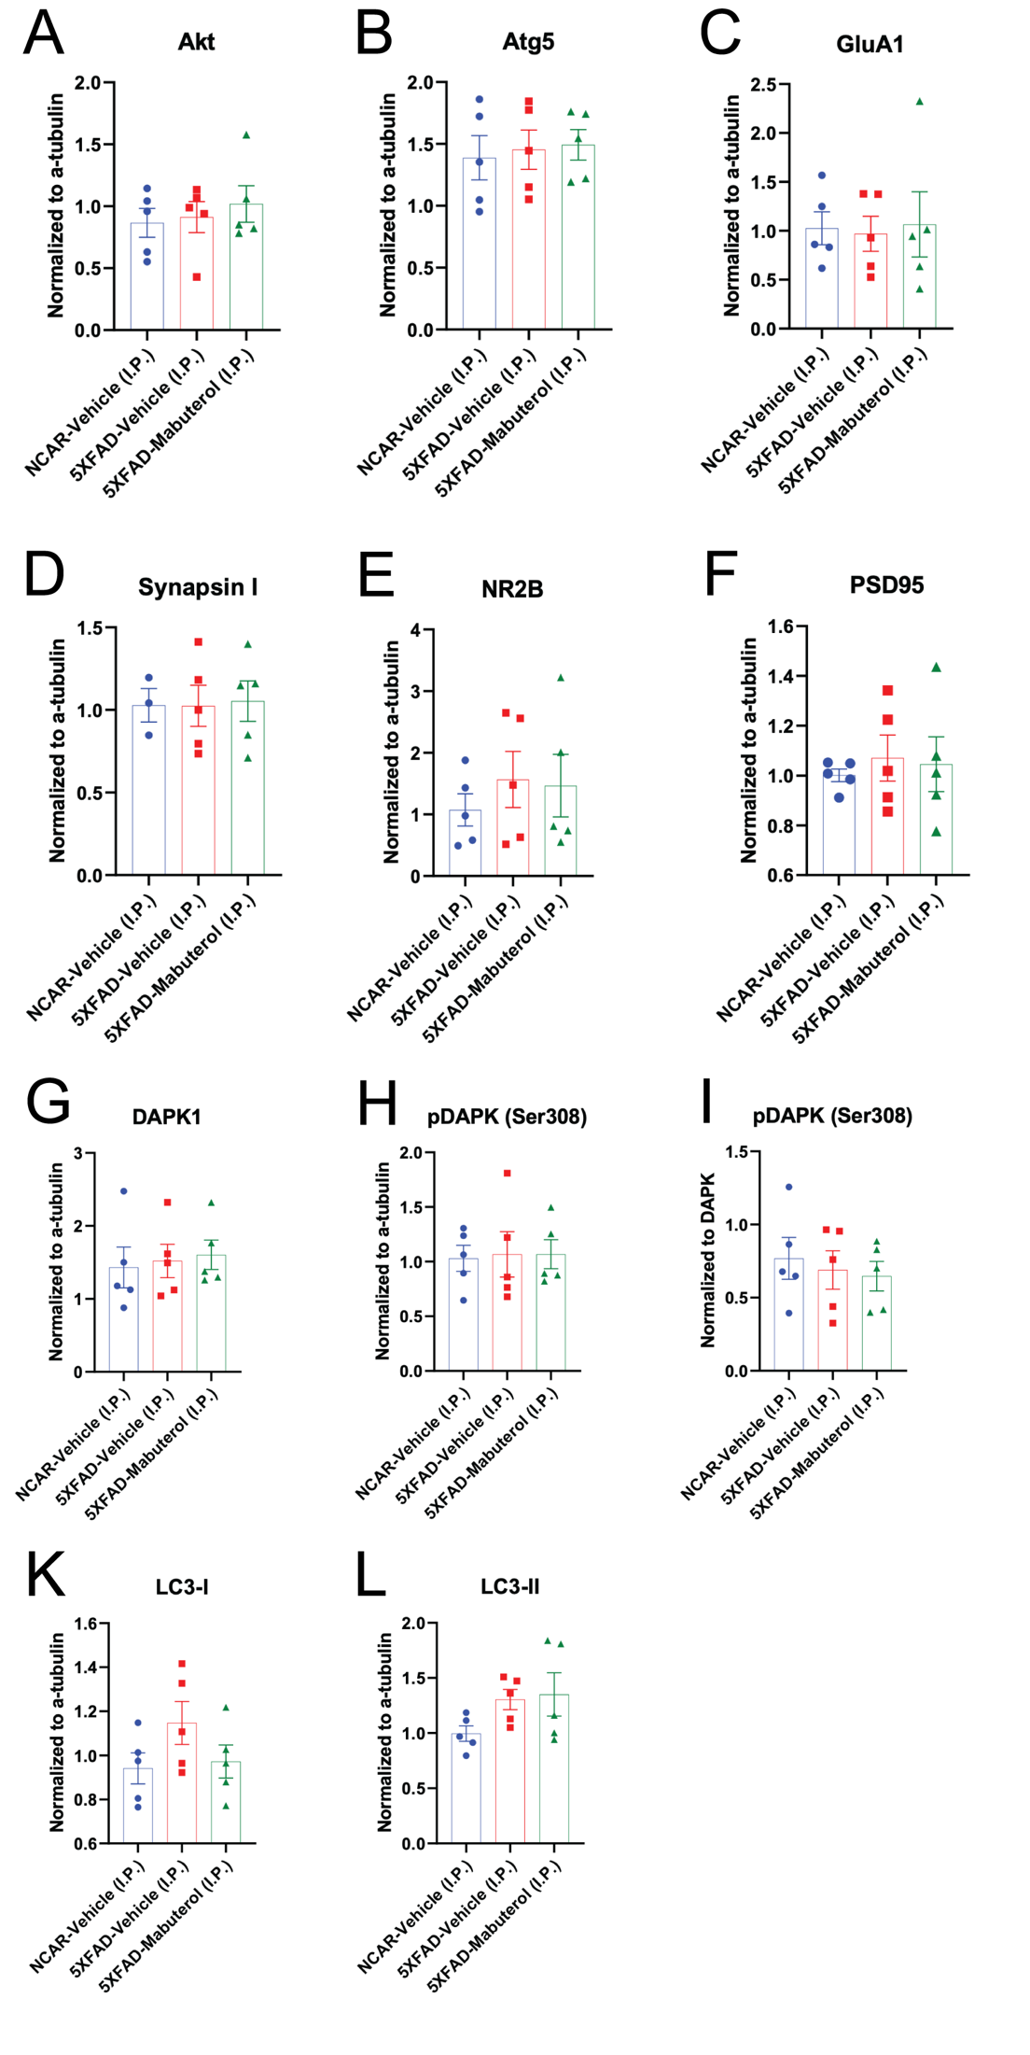
Supplementary Figure 6. Targeted Western blot analysis did not uncover any protein level changes in a handful of selected proteins. We analyzed protein level changes for Akt (A), Atg5 (B), GluA1 (C), synapsin I (D), NR2B (E), PSD95 (combined bands: F), DAPK1 (G), phospho-DAPK Ser308 (“pDAPK”) (normalized to alpha-tubulin: H, normalized to DAPK1: I), LC3-I (K), and LC3-II (L). Vehicle-treated non-carriers (NCAR-Veh), vehicle-treated 5XFAD (Hemi-Veh), and mabuterol-treated 5XFAD (Hemi-Mabuterol) are shown in blue, red, and green respectively.
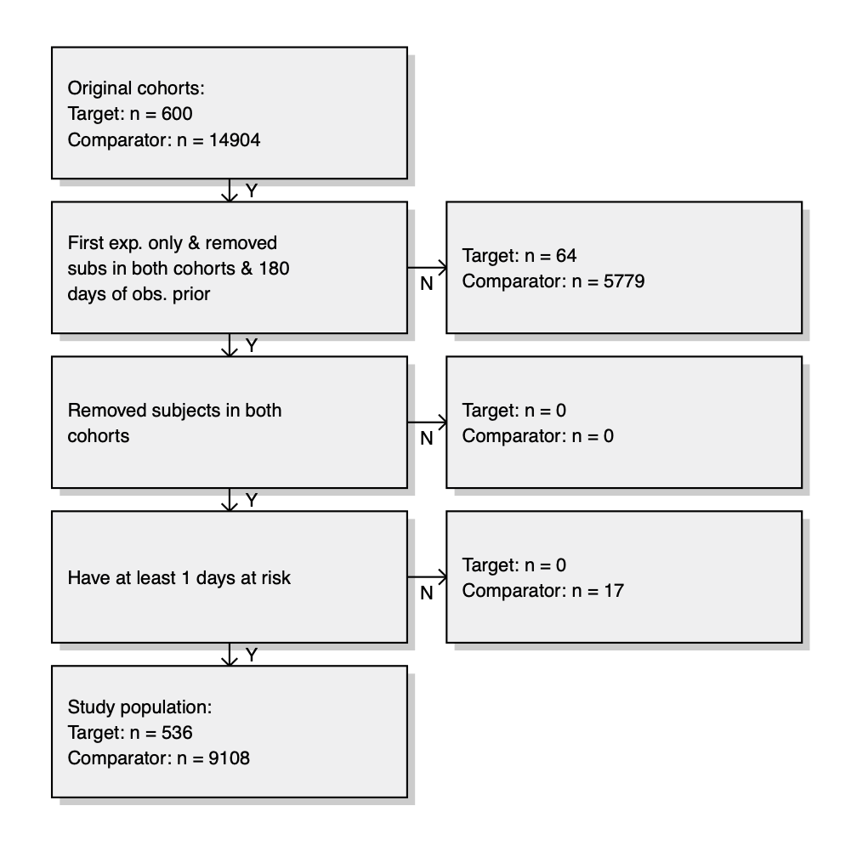
Supplementary Figure 7. Observational study attrition diagram.

 |  | Effect |  | Phagocytosis of synaptosomes  (% of control)
Adrenoceptor Agonists |  |  | 1.39  μM |  | 2.78  μM | 5.56  μM | 11.11  μM | 22.22  μM
Moxonidine hydrochloride | Alpha 2a Adrenoceptor Agonist | ↑ | 118 |  | 127.8 | 128.5 | 130.6 | 167.2
Salmeterol xinafoate | Beta2 Adrenoceptor Agonist | ↓ | 92 |  | 82.7 | 61.5 | 72.5 | 43.1
Sulfonylureas
Tolazamide |  | ↑ | 93.7 |  | 111.1 | 104.8 | 136.3 | 158.8
Glibenclamide |  | ↑ | 92.6 |  | 134.1 | 120.2 | 104 | 138.7
Androgen/Estrogen
Triptophenolide | Anti Androgen | ↓ | 69.8 |  | 54.5 | 57.1 | 32.1 | 21.9
Estradiol benzoate |  | ↓ | 4.2 |  | 4.2 | 33.6 | 5.5 | 69.9
Inflammatory
Prednisolone sodium phosphate |  | ↓ | 76.3 |  | 59.1 | 36.5 | 14.9 | 8.5
Gitoxigenin diacetate |  | ↓ | 71.9 |  | 52.7 | 18.2 | 12.2 | 47.2
Glutamate receptor agonists
Kynurenic acid |  | ↓ | 107.2 |  | 90.3 | 67.5 | 76 | 54.6
(±)-2-Amino-4-phosphonobutyric acid |  | ↑ | 98.6 |  | 101.3 | 120.2 | 132.4 | 131.5
Acamprosate calcium |  | ↓ | 86.5 |  | 35.5 | 28 | 6.6 | 5.9
Other
Fluphenazine dihydrochloride |  | ↓ | 103.6 |  | 93.6 | 84.5 | 49 | 47.3
Montelukast Sodium |  | ↓ | 46.4 |  | 2.7 | 24.9 | 28.5 | 0
Supplementary Table 1. Selected hit compounds and percent phagocytosis of synaptosomes by human astrocytes relative to control.

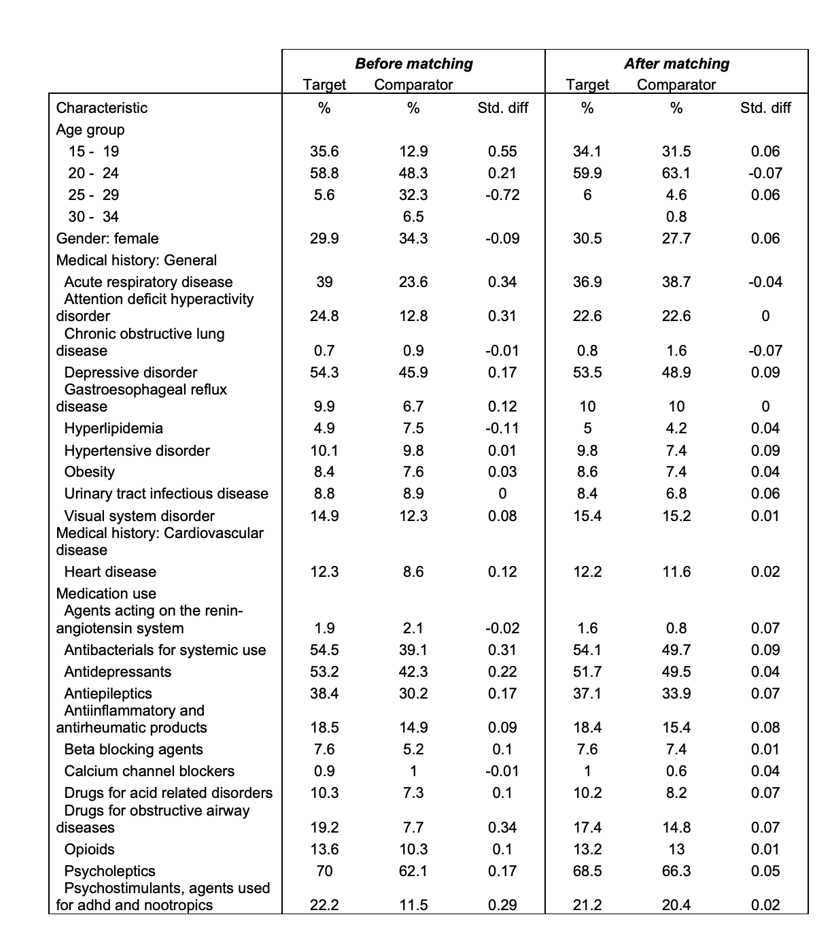
Supplementary Table 2. Abbreviated covariate balance between treatment and comparator groups after matching containing features with > 5% representation and a few selected cardiovascular features. Full covariate table provided in Supplementary File 9.

Cohort Descriptor | Cohort Count
beta2 agonist exposure while age <=18 and age > 6 | 1,295,938
schizophrenia young adult (SYA) diagnosis while age >= 18 | 15,504
patients with pediatric exposure and SYA diagnosis | 600
SYA diagnosis minus those with pediatric exposure | 14,904
In patient visits associated with a schizophrenia diagnosis (SZD) | 31,292
SYA patients with pediatric exposure and subsequent SZD inpatient visits | 15
SYA patients without pediatric exposure and subsequent SZDinpatient visits | 1,075
Supplementary Table 3. Patient counts for analysis of effect of exposure to beta-2 agonists on schizophrenia-associated (SZD) in-patient visits in young adult patients.

