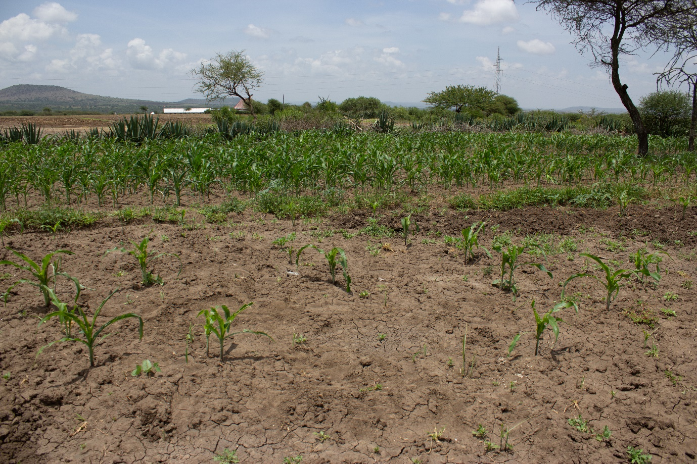
Figure S1. Site of field observations smallholder maize farm in Meleya village, Kisongo ward, Arumeru District, Arusha, Tanzania (3.40915° S, 36.52585° E).

