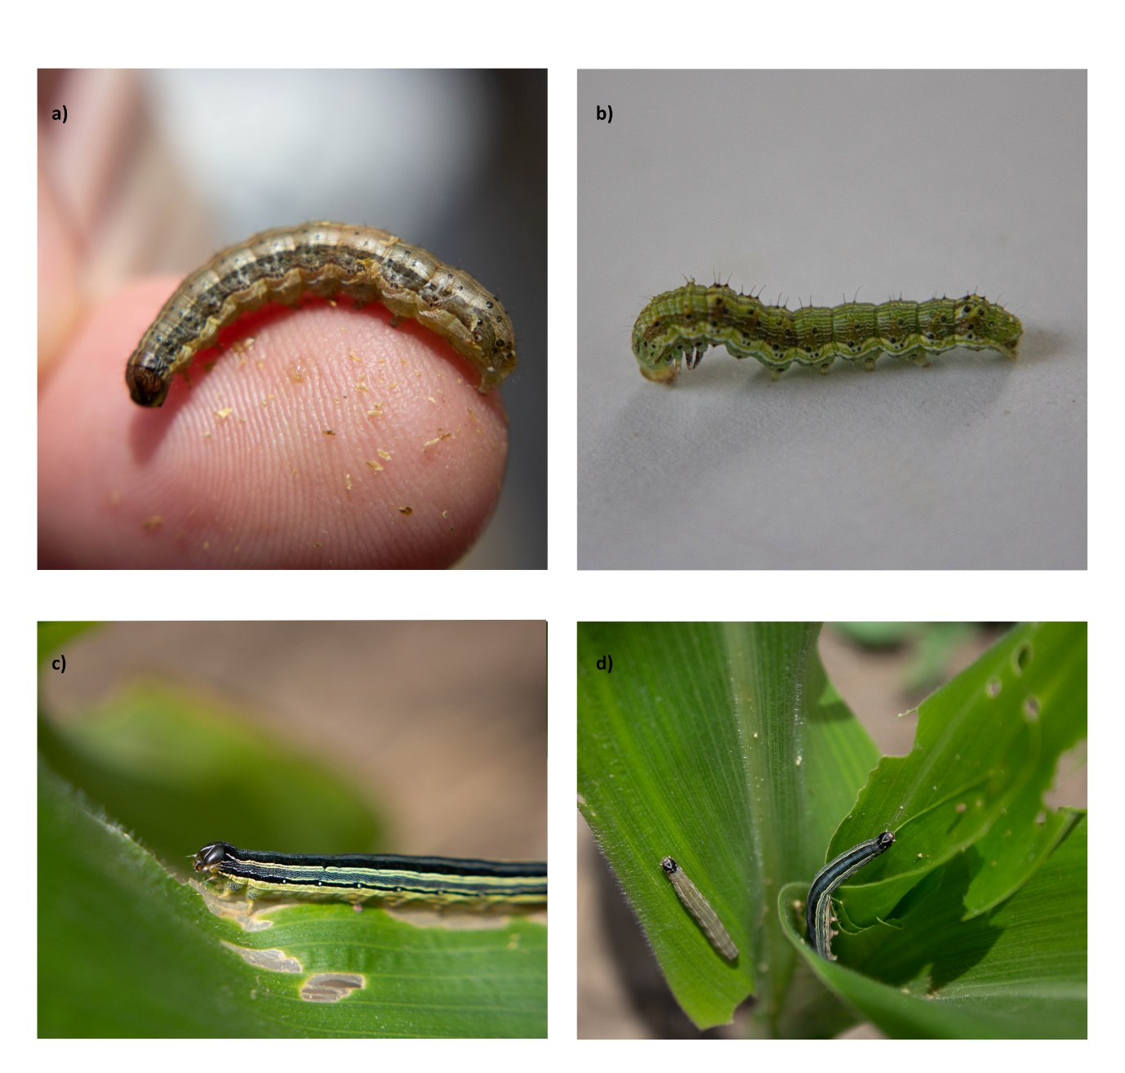
Figure S2. Photographs of a) FAW, b) variation in colour of FAW, c) AAW, d) variation in colour of AAW

