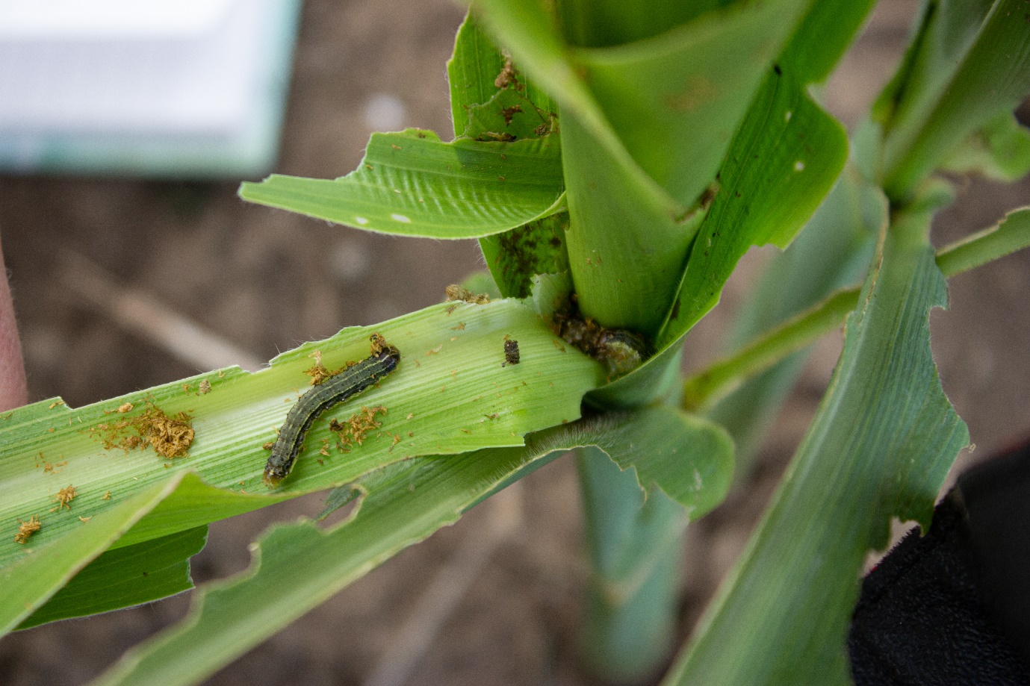
Figure S3 Two FAW larvae sharing a maize plant

