Supplementary Figure
Supplementary Figure 1
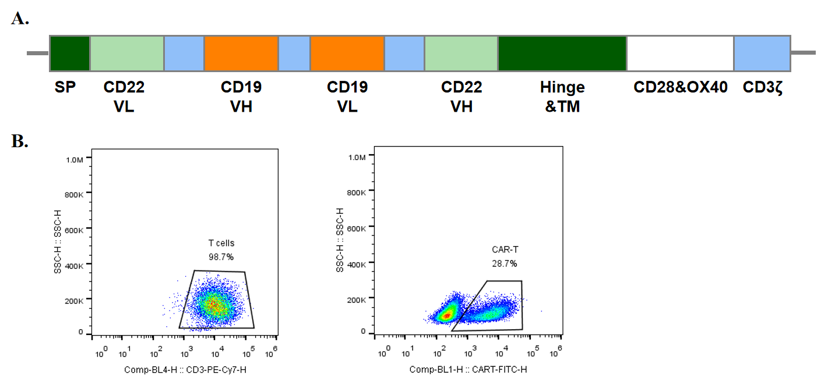
Supplementary Figure 2
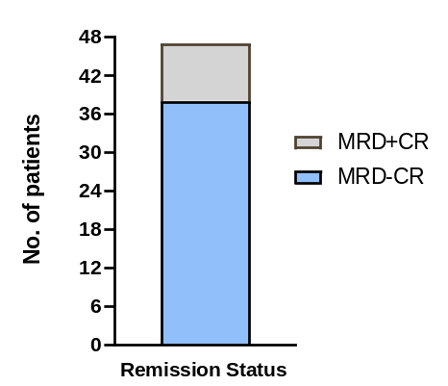
Supplementary Figure 3
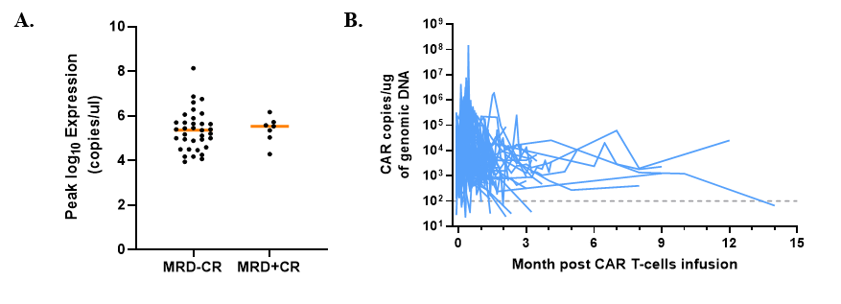
Figure 1. Characterization of tandem CD19/CD22 chimeric antigen receptor T (CAR-T) cells and the diagram of the clinical study.
A. The construction of tandem CD19/CD22 CAR molecule. The CAR molecule consists of two scFv of CD22 and CD19 derived from a mouse mAb and joined in tandem orientation with mouse hinge and TM, a transmembrane domain with CD28 and OX40 co-stimulators, as well as CD3ζ signaling chains. B. The transfection efficacy of tandem CAR-T cells. Flow cytometry (FCM) was used to determine the transduction efficiency by FITC-labeled goat anti-mouse IgG, Fab fragment-specific, and PE streptavidin antibodies (BD Biosciences, NJ, USA). C. The schedule of the clinical trial. Patients received tumor reduction therapy and conditioning regimen bridging CAR-T infusion. We monitored the level of complete blood count, liver function, renal function, creatinine, ferritin, myocardial enzyme profile every day post infusion. BM examination was performed at day 7, 14 and 28.

Supplementary Table 1. Patients characteristics and responses
ID | Age | BM blasts | CK | EMD | Unfavorable genetic charactersitics | Conditioning regimen | Dose Level | CRS Gd | Initial response
1 | 56 | 89.00% | N | N | BCR/ABL & T315Imut | chemo+FC | 1*107/kg | 3 | CR
2 | 53 | 1.00% | Y | N | BCR/ABL & T315Imut | FC | 5*106/kg | 0 | MRD-CR
3 | 48 | 32.50% | Y | N | BCR/ABL & T315Imut | chemo+FC | 2.5*107/kg | 1 | MRD-CR
4 | 15 | 87.00% | Y | N | TP53 | chemo+DAC+FC | 5*106/kg | 3 | MRD-CR
5 | 23 | 0.50% | N | Y | BCR/ABL & T315Imut | chemo+FC | 1*107/kg | 1 | MRD-CR
6 | 8 | 81.50% | Y | N | TP53 | chemo+FC | 1*107/kg | 2 | MRD-CR
7 | 44 | 3.50% | N | N | 0 | FC | 5*106/kg | 2 | MRD-CR
8 | 41 | 2.20% | N | Y | 0 | FC | 1*107/kg | 1 | MRD-CR
9 | 21 | 46.50% | N | N | Ph like | chemo+FC | 2*107/kg | 3 | CR
10 | 23 | 2.00% | N | N | 0 | FC | 1.5*107/kg | 1 | MRD-CR
11 | 47 | 1.00% | N | N | BCR/ABL | FC | 1.5*107/kg | 1 | MRD-CR
12 | 24 | 6.00% | N | N | Ph like | FC | 1.5*107/kg | 1 | MRD-CR
13 | 41 | 65.50% | Y | N | BCR/ABL & T315Imut | chemo+FC | 1.5*107/kg | 1 | MRD-CR
14 | 6 | 71.50% | N | N | Ph like | chemo+FC | 1*107/kg | 1 | CR
15 | 25 | 46.00% | N | N | BCR/ABL | chemo+FC | 1*107/kg | 1 | MRD-CR
16 | 21 | 42.50% | Y | N | 0 | chemo+FC | 1*107/kg | 2 | MRD-CR
17 | 14 | 66.50% | N | N | BCR/ABL & T315Imut & TP53 | chemo+DAC+FC | 1*107/kg | 2 | MRD-CR
18 | 47 | 45.00% | N | N | 0 | chemo+FC | 1*107/kg | 1 | MRD-CR
19 | 11 | 0.00% | Y | N | TP53 | FC | 1*107/kg | 1 | MRD-CR
20 | 19 | 0.50% | N | N | Ph like | FC | 1*107/kg | 0 | MRD-CR
21 | 8 | 32.00% | N | N | 0 | chemo+FC | 1*107/kg | 0 | MRD-CR
22 | 28 | 39.00% | N | N | 0 | chemo+FC | 1*107/kg | 2 | MRD-CR
23 | 16 | 85.50% | N | N | 0 | chemo+FC | 1*107/kg | 3 | MRD-CR
24 | 33 | 1.00% | Y | N | BCR/ABL & T315Imut | FC | 1*107/kg | 0 | MRD-CR
25 | 10 | 85.50% | 1 | N | BCR/ABL | chemo+FC | 1*107/kg | 0 | MRD-CR
26 | 56 | 7.00% | N | N | BCR/ABL & T315Imut | chemo+FC | 1*107/kg | 3 | MRD-CR
27 | 39 | 54.00% | N | Y | TP53 | chemo+FC | 1*107/kg | 2 | MRD-CR
28 | 16 | 68.00% | N | N | 0 | chemo+FC | 1*107/kg | 2 | CR
29 | 38 | 94.50% | N | N | BCR/ABL | chemo+FC | 2*107/kg | 3 | CR
30 | 37 | 8.50% | N | N | 0 | FC | 1*107/kg | 3 | CR
31 | 22 | 67.50% | N | N | 0 | chemo+FC | 2*107/kg | 1 | MRD-CR
32 | 43 | 88.00% | N | N | BCR/ABL & T315Imut | FC | 5*106/kg | 2 | MRD-CR
33 | 30 | 0.00% | N | Y | 0 | DAC+FC | 2*107/kg | 0 | MRD-CR
34 | 40 | 37.00% | N | N | Ph like | DAC+FC | 2*107/kg | 2 | MRD-CR
35 | 32 | 45.00% | N | Y | 0 | chemo+FC | 1*107/kg | 2 | MRD-CR
36 | 20 | 2.80% | N | Y | 0 | chemo+DAC+FC | 2*107/kg | 2 | MRD-CR
37 | 29 | 82.00% | N | N | 0 | chemo+DAC+FC | 2*107/kg | 3 | MRD-CR
38 | 16 | 33.00% | N | N | 0 | chemo+FC | 1*107/kg | 2 | MRD-CR
39 | 24 | 12.00% | N | N | 0 | FC | 2*107/kg | 2 | MRD-CR
40 | 21 | 0.00% | N | N | BCR/ABL | FC | 2*107/kg | 2 | MRD-CR
41 | 28 | 0.00% | N | N | BCR/ABL | DAC+FC | 2*107/kg | 2 | MRD-CR
42 | 50 | 28.00% | N | N | TP53 | DAC+FC | 2*107/kg | 2 | MRD-CR
43 | 14 | 8.50% | Y | N | Ph like | DAC+FC | 2*107/kg | 2 | CR
44 | 38 | 8.50% | Y | N | 0 | DAC+FC | 2*107/kg | 1 | MRD-CR
45 | 51 | 31.00% | N | N | BCR/ABL | DAC+FC | 2*107/kg | 2 | MRD-CR
46 | 30 | 0.00% | N | Y | BCR/ABL | DAC+FC | 2*107/kg | 1 | MRD-CR
47 | 52 | 64.00% | N | N | BCR/ABL & T315Imut | DAC+FC | 2*107/kg | 1 | MRD-CR
DAC: decitabine; CRS: cytokine release syndrome; MRD-CR: minimal residual disease negative complete remission.N: No; Y: Yes; M: Male; F: Female.

Supplementary Table 2. CD19 negative relapse in large CD19 CAR-T clinical trials
References | Center | Pts | CR | CR rate | CD19-rel | CD19- rel % | CD19+rel | Unknow status
Gardener 2017¹ | Seattle Children’s Research Institute | 43 | 40 | 93.02% | 7 | 17.50% | 11 | 0
Pan 2017² | Hebei Yanda Lu Daopei Hospital | 40 | 36 | 90.00% | 6 | 16.67% | 3 | 0
Park 2018³ | Memorial Sloan Kettering Cancer Center | 53 | 44 | 83.02% | 4 | 9.09% | 9 | 28
Maude 2018⁴ | Global, phase 2 of tisagenlecleucel in children and young adults | 75 | 61 | 81.33% | 15 | 24.59% | 1 | 6
Hay 2019⁵ | Fred Hutchinson Cancer Research Center | 53 | 45 | 84.91% | 6 | 13.33% | 14 | 2
Curran 2019⁶ | Memorial Sloan Kettering Cancer Center | 24 | 18 | 75.00% | 0 | 0.00% | 2 | 2
Jiang 2019⁷ | Tongji Medical College | 60 | 51 | 85.00% | 10 | 19.61% | 12 | 0
Zhang 2019⁸ | Beijing Boren Hospital | / | 52 | / | 5 | 9.62% | 3 | 1
Zhang 2020⁹ | Lu Daopei Hospital | 110 | 102 | 92.73% | 7 | 6.86% | 16 | 0
Wang 2020¹⁰ | Tianjin First Central Hospital | 23 | 19 | 82.61% | 2 | 10.53% | 5 | 0
Gu 2020¹¹ | Institute of Tianjin Hematology & Blood Diseases Hospital | 20 | 18 | 90.00% | 3 | 16.67% | 5 | 0
Chen 2020¹² | Peking University Institute of Hematology | 34 | 30 | 88.24% | 5 | 16.67% | 11 | 1
Wang 2020¹³ | The Affiliated Hospital of Xuzhou Medical University | 24 | 19 | 79.17% | 1 | 5.26% | 9 | 0
Dourthe 2021¹⁴ | tisagenlecleucel in pediatric Robert Debré and adult Saint Louis University Hospitals (AP-HP) | 49 | 47 | 95.92% | 12 | 25.53% | 8 | 2
Ortíz-Maldonado 2021¹⁵ | ARI-0001 cells in European multiple centers | 38 | 32 | 84.21% | 2 | 6.25% | 13 | 0
Shah 2021¹⁶ | KTE-X19 adults (ZUMA-3) | 55 | 39 | 70.91% | 3 | 7.69% | 6 | 3
Shah 2021¹⁷ | KTE-X19 adolescents | 50 | 31 | 62.00% | 3 | 9.68% | 3 | 1
Lamble 2022¹⁸ | Seattle Children's Hospital | 420 | 376 | 89.52% | 68 | 18.09% | 83 | 0
Pts: Evaluable patients in clinical trials; CR Rate: Percentage of complete remission patients in evaluable patients;CD19-rel: CD19 negative relapse;CD19-rel%: Percentage of CD19 negative patients in CR patietns

Supplementary Table 3. Recent updates on clinical trials of CD19/CD22 dual targets CAR T-cells therapy for B-ALL
References | Center | Pts | Dual Targets Strategy | Efficacy | Safety | Bridging HSCT | Long-term Outcome
Yang 2018¹⁹ | Hebei Yanda Lu Daopei Hospital | 15 | Cocktail | CR:100%  MRD-CR:93.3% | sCRS:1/15  ICANS:1/15 | 10/15 had HSCT | 2 relapsed
Gardner 2018²⁰ | Seattle Children's Hospital | 7 | uk | CR:5/7  MRD-CR:4/7 | CRS:5/7  ICANS:1/7 | uk | uk
Wang 2020²¹ | Tongji Medical College, Huazhong University of Science and Technology | 49 | Cocktail | CR:96%  MRD-CR:96% | sCRS:22.4%,1 dead for sCRS  sCRES:1.12% | 12 had HSCT | Median OS:31m  Median PFS:13.6m
Pan 2020²² | Beijing Boren Hospital | 20 | Sequential | CR:100%,  MRD-CR:100% | No sCRS  CRES:3/20 | No | 1y OS:92.3%  1y LFS:79.5%  3 relapsed
Yang 2020²³ | Hebei Yanda Lu Daopei Hospital | 10 | Dual/FasCAR | CR:9/10  MRD-CR:7/10 | No sCRS  ICANS:1/10 | uk | 5 kept MRD-CR;  2 relapsed; 1 dead for GVHD; 1 withdrew; 1 second infusion NR
Dai 2020²⁴ | Chinese PLA General Hospital | 6 | Tandem | CR:100%,  MRD-CR:100% | No sCRS  No CRES | 1 had HSCT | 1 relapsed in early month
Hu 2021²⁵ | The first affiliated of Zhejiang University | 6 | Tandem/universal | CR:83.3%,  MRD-CR:83.3% | No CRS and CRES  1 died of cardiac arrest | 1 had HSCT | 2 relapsed  2 kept MRD-CR  1 death  1 underwent HSCT
Liu 2021²⁶ | Beijing Boren Hospital | 27 | Sequential | CD19 CAR: 23/27 CR  CD22 CAR: 14/21 CR | CAR associated GVHD:23% | No | 21 pts follow-up:  1y OS:88.5%, Median OS:19.7 m
Cordoba 2021²⁷ | AUTO3/University of London | 15 | bicistronic | CR:13/15  MRD-CR:12/15 | No sCRS  ICANS:1/10 | 1 had HSCT | 9 Relapse  1 kept MRD-CR
Spiegel 2021²⁸ | Stanford University | 17 | bicistronic | CR:14/17 | sCRS:1/17  ICANS:5/17 | 2 had HSCT | Median OS:11.8m  Median PFS:5.8m

uk:Unknown; MRD-CR: minimal residual disease negative complete remission.N: No; Y: Yes; CRS: cytokine release syndrome; ICANS/CRES: Immune Effector Cell-Associated Neurotoxicity Syndrome; OS: Overall Survival; LFS: Leukemia Free Survival; HSCT: hematopoietic stem-cell transplantation.

Supplementary Reference
1. Gardner RA, Finney O, Annesley C, et al: Intent-to-treat leukemia remission by CD19 CAR T cells of defined formulation and dose in children and young adults. Blood 129:3322-3331, 2017
2. Pan J, Yang JF, Deng BP, et al: High efficacy and safety of low-dose CD19-directed CAR-T cell therapy in 51 refractory or relapsed B acute lymphoblastic leukemia patients. Leukemia 31:2587-2593, 2017
3. Park JH, Rivière I, Gonen M, et al: Long-Term Follow-up of CD19 CAR Therapy in Acute Lymphoblastic Leukemia. N Engl J Med 378:449-459, 2018
4. Maude SL, Laetsch TW, Buechner J, et al: Tisagenlecleucel in Children and Young Adults with B-Cell Lymphoblastic Leukemia. N Engl J Med 378:439-448, 2018
5. Hay KA, Gauthier J, Hirayama AV, et al: Factors associated with durable EFS in adult B-cell ALL patients achieving MRD-negative CR after CD19 CAR T-cell therapy. Blood 133:1652-1663, 2019
6. Curran KJ, Margossian SP, Kernan NA, et al: Toxicity and response after CD19-specific CAR T-cell therapy in pediatric/young adult relapsed/refractory B-ALL. Blood 134:2361-2368, 2019
7. Jiang H, Li C, Yin P, et al: Anti-CD19 chimeric antigen receptor-modified T-cell therapy bridging to allogeneic hematopoietic stem cell transplantation for relapsed/refractory B-cell acute lymphoblastic leukemia: An open-label pragmatic clinical trial. Am J Hematol 94:1113-1122, 2019
8. Zhang Y, Chen H, Song Y, et al: Chimeric antigen receptor T-cell therapy as a bridge to haematopoietic stem cell transplantation for refractory/relapsed B-cell acute lymphoblastic leukemia. British Journal of Haematology 189:146-152, 2020
9. Zhang X, Li JJ, Lu PH: Advances in the development of chimeric antigen receptor-T-cell therapy in B-cell acute lymphoblastic leukemia. Chin Med J (Engl) 133:474-482, 2020
10. Wang J, Mou N, Yang Z, et al: Efficacy and safety of humanized anti-CD19-CAR-T therapy following intensive lymphodepleting chemotherapy for refractory/relapsed B acute lymphoblastic leukaemia. Br J Haematol 191:212-222, 2020
11. Gu R, Liu F, Zou D, et al: Efficacy and safety of CD19 CAR T constructed with a new anti-CD19 chimeric antigen receptor in relapsed or refractory acute lymphoblastic leukemia. J Hematol Oncol 13:122, 2020
12. Chen YH, Zhang X, Cheng YF, et al: Long-term follow-up of CD19 chimeric antigen receptor T-cell therapy for relapsed/refractory acute lymphoblastic leukemia after allogeneic hematopoietic stem cell transplantation. Cytotherapy 22:755-761, 2020
13. Wang S, Wang X, Ye C, et al: Humanized CD19-targeted chimeric antigen receptor T (CAR-T) cells for relapsed/refractory pediatric acute lymphoblastic leukemia. Am J Hematol 96:E162-e165, 2021
14. Dourthe ME, Rabian F, Yakouben K, et al: Determinants of CD19-positive vs CD19-negative relapse after tisagenlecleucel for B-cell acute lymphoblastic leukemia. Leukemia 35:3383-3393, 2021
15. Ortíz-Maldonado V, Rives S, Castellà M, et al: CART19-BE-01: A Multicenter Trial of ARI-0001 Cell Therapy in Patients with CD19(+) Relapsed/Refractory Malignancies. Mol Ther 29:636-644, 2021
16. Shah BD, Ghobadi A, Oluwole OO, et al: KTE-X19 for relapsed or refractory adult B-cell acute lymphoblastic leukaemia: phase 2 results of the single-arm, open-label, multicentre ZUMA-3 study. Lancet 398:491-502, 2021
17. Shah NN, Lee DW, Yates B, et al: Long-Term Follow-Up of CD19-CAR T-Cell Therapy in Children and Young Adults With B-ALL. J Clin Oncol 39:1650-1659, 2021
18. Lamble A, Myers RM, Taraseviciute A, et al: Preinfusion factors impacting relapse immunophenotype following CD19 CAR T cells. Blood Adv, 2022
19. Yang J, Li J, Zhang X, et al: A Feasibility and Safety Study of CD19 and CD22 Chimeric Antigen Receptors-Modified T Cell Cocktail for Therapy of B Cell Acute Lymphoblastic Leukemia. Blood 132:277-277, 2018
20. Gardner R, Annesley C, Finney O, et al: Early Clinical Experience of CD19 x CD22 Dual Specific CAR T Cells for Enhanced Anti-Leukemic Targeting of Acute Lymphoblastic Leukemia. Blood 132:278, 2018
21. Wang N, Hu X, Cao W, et al: Efficacy and safety of CAR19/22 T-cell cocktail therapy in patients with refractory/relapsed B-cell malignancies. Blood 135:17-27, 2020
22. Pan J, Zuo S, Deng B, et al: Sequential CD19-22 CAR T therapy induces sustained remission in children with r/r B-ALL. Blood 135:387-391, 2020
23. Yang J, Jiang P, Zhang X, et al: Successful 24-Hours Manufacture of Anti-CD19/CD22 Dual Chimeric Antigen Receptor (CAR) T Cell Therapy for B-Cell Acute Lymphoblastic Leukemia (B-ALL). Blood 136:2-3, 2020
24. Dai H, Wu Z, Jia H, et al: Bispecific CAR-T cells targeting both CD19 and CD22 for therapy of adults with relapsed or refractory B cell acute lymphoblastic leukemia. J Hematol Oncol 13:30, 2020
25. Hu Y, Zhou Y, Zhang M, et al: CRISPR/Cas9-Engineered Universal CD19/CD22 Dual-Targeted CAR-T Cell Therapy for Relapsed/Refractory B-cell Acute Lymphoblastic Leukemia. Clin Cancer Res 27:2764-2772, 2021
26. Liu S, Deng B, Yin Z, et al: Combination of CD19 and CD22 CAR-T cell therapy in relapsed B-cell acute lymphoblastic leukemia after allogeneic transplantation. Am J Hematol 96:671-679, 2021
27. Cordoba S, Onuoha S, Thomas S, et al: CAR T cells with dual targeting of CD19 and CD22 in pediatric and young adult patients with relapsed or refractory B cell acute lymphoblastic leukemia: a phase 1 trial. Nat Med 27:1797-1805, 2021
28. Spiegel JY, Patel S, Muffly L, et al: CAR T cells with dual targeting of CD19 and CD22 in adult patients with recurrent or refractory B cell malignancies: a phase 1 trial. Nat Med 27:1419-1431, 2021

