Appendix A

Figure A1. Study design distribution of the included studies
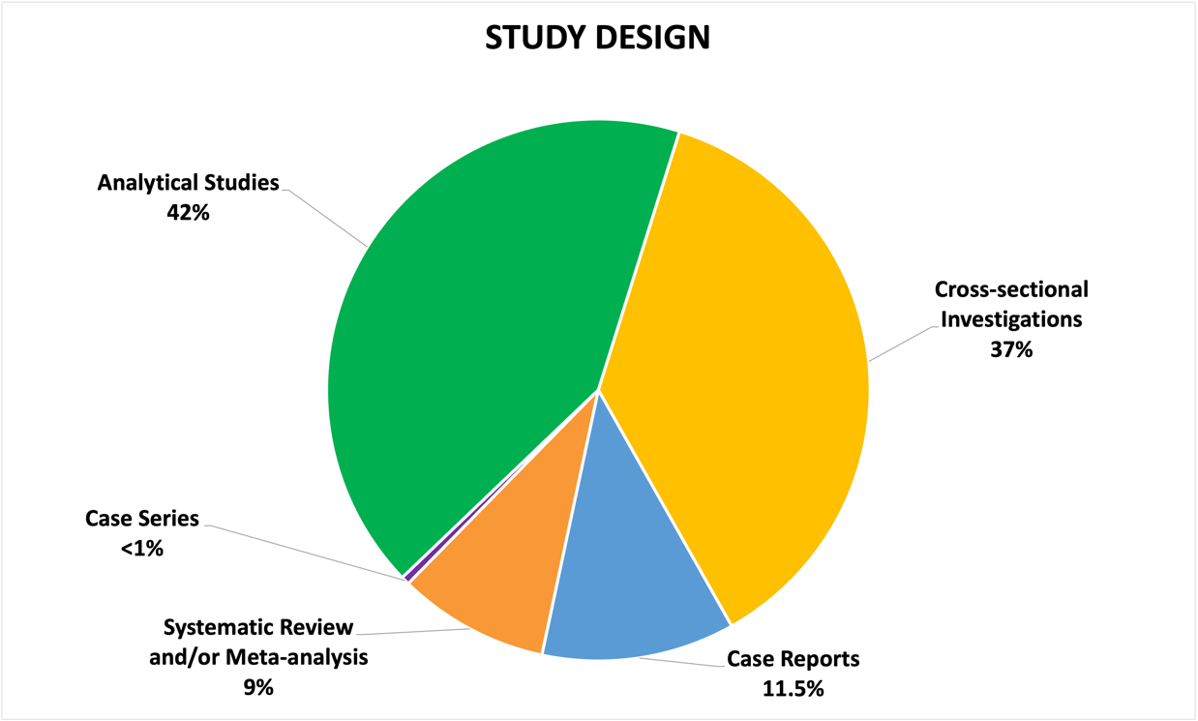

Figure A2. Graphic distribution of the personnel involved in the research

