Supporting Information for:
Transmission of COVID-19 was slower but more sustained in warm climate
Xinru Wan ¹, Chaoyuan Cheng ^{1,2} and Zhibin Zhang ^{1,3 *}
¹ State Key Laboratory of Integrated Management on Pest Insects and Rodents in Agriculture, Institute of Zoology, Chinese Academy of Sciences, Beijing 100101, China
² University of Chinese Academy of Sciences, Beijing 100049, China
³ CAS Center for Excellence in Biotic Interactions, University of Chinese Academy of Sciences, Beijing 100049, China.

TABLE OF CONTENTS
Correlation between the transmission severity and human/climate factors
Figure S1 - S7
Table S1

Correlation between the transmission severity and human/climate factors
Using Pearson’s correlation analysis on data from 1 January to 11 March, 2020 in China, we found the average daily increase rate was negative correlated with temperature (r = -0.16, p < 0.01), the maximum daily increase rate was negative correlated with human population (r = -0.15, p < 0.05) and temperature (r = -0.16, p < 0.05), the control efficiency was positive correlated with human population (r = 0.17, p < 0.01) and precipitation (r = 0.14, p < 0.05) (Figure S2).
Using Pearson’s correlation analysis on data from 20 January to 31 December, 2020 in the USA, we found the average daily increase rate was positive correlated with human population (r = 0.28, p < 0.05), but negative correlated with temperature (r = -0.38, p < 0.01), the maximum daily increase rate was negative correlated with human population (r = -0.40, p < 0.01), temperature (r = -0.30 p < 0.05), and precipitation (r = -0.27 p < 0.05), the control efficiency was positive correlated with human population (r = 0.47, p < 0.001) and precipitation (r = 0.38, p < 0.01) (Figure S3).
Using Pearson’s correlation analysis on data from 20 January to 31 December, 2020 in Europe, we found the average daily increase rate was negative correlated with founding population size during the initial 7 days after the first patient (r = -0.38, p < 0.05) and temperature (r = -0.33, p < 0.05), the maximum daily increase rate was negative correlated with human population (r = -0.39, p < 0.01) and temperature (r = -0.40 p < 0.01), the control efficiency was positive correlated with human population (r = 0.67, p < 0.001) (Figure S4).
Using Pearson’s correlation analysis on data from 1 January to 31 December, 2020 for the world data, we found the average daily increase rate was positive correlated with human population (r = 0.10, p < 0.05), but negative with temperature (r = -0.10, p < 0.01), maximum daily increase rate was negative correlated with human population (r = -0.27, p < 0.001), temperature (r = -0.37, p < 0.001), and precipitation (r = -0.21, p < 0. 001), the control efficiency was positive correlated with human population (r = 0.21, p < 0.001), temperature (r = 0.21, p < 0.001), and precipitation (r = 0.17, p < 0.001) (Figure S5).

Supplementary Figures
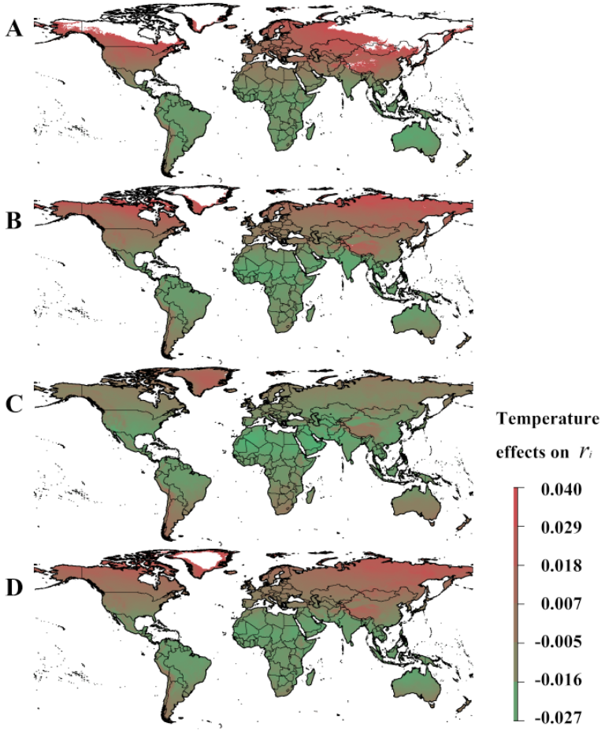
Supplementary Figure S1. Seasonal projected partial effects of air temperature on the average daily increase rate ($r_{i}$) under human intervention in January, April, July, and October (A-D). Colors (green to red: negative to positive) indicate the temperature effects on average daily increase rate ($r_{i}$).

Supplementary Figure S2. The correlation of the average daily increase rate ($r_{i}$) of cumulative cases, maximum daily increase rate ($a_{i}$), and control efficiency ($b_{i}$) of COVID-19 with founding population size during the initial 7 days after the first patient, human population, and climate factors (temperature and precipitation) in China.
Supplementary Figure S3. The correlation of the average daily increase rate ($r_{i}$) of cumulative cases, maximum daily increase rate ($a_{i}$), and control efficiency ($b_{i}$) of COVID-19 with founding population size during the initial 7 days after the first patient, human population, and climate factors (temperature and precipitation) in the USA.
Supplementary Figure S4. The correlation the average daily increase rate ($r_{i}$) of cumulative cases, maximum daily increase rate ($a_{i}$), control efficiency ($b_{i}$) of COVID-19 with founding population size during the initial 7 days after the first patient, human population, and climate factors (temperature and precipitation) in Europe.
Supplementary Figure S5. The correlation of the average daily increase rate ($r_{i}$) of cumulative cases, maximum daily increase rate ($a_{i}$), control efficiency ($b_{i}$) of COVID-19 with the founding population size during the initial 7 days after the first patient, human population, and climate factors (temperature and precipitation) in the world.
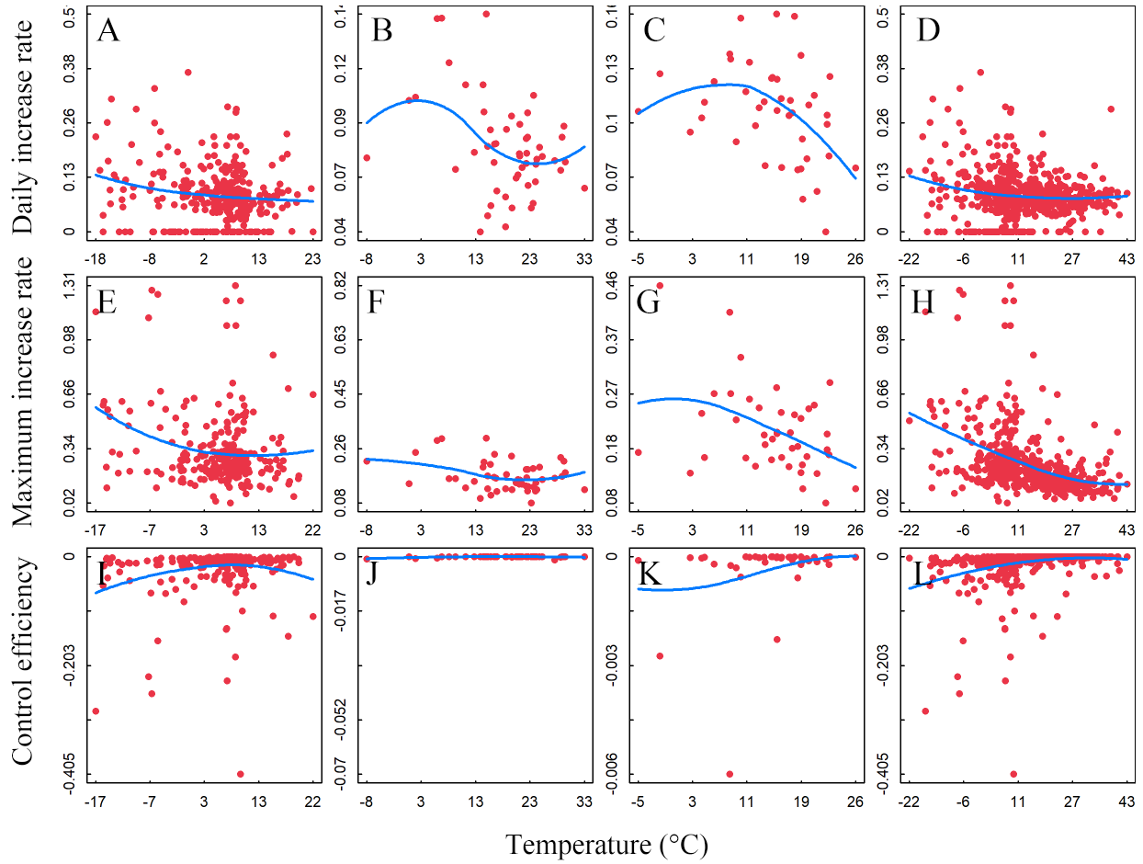
Supplementary Figure S6. Relationship of temperature with the average daily increase rate ($r_{i}$), maximum daily increase rate ($a_{i}$), control efficiency ($b_{i}$) of COVID-19 in China (A, E, I), USA (B, F, J), Europe (C, G, K), and the world (D, H, L). The blue lines indicate the loess regression with span = 1.

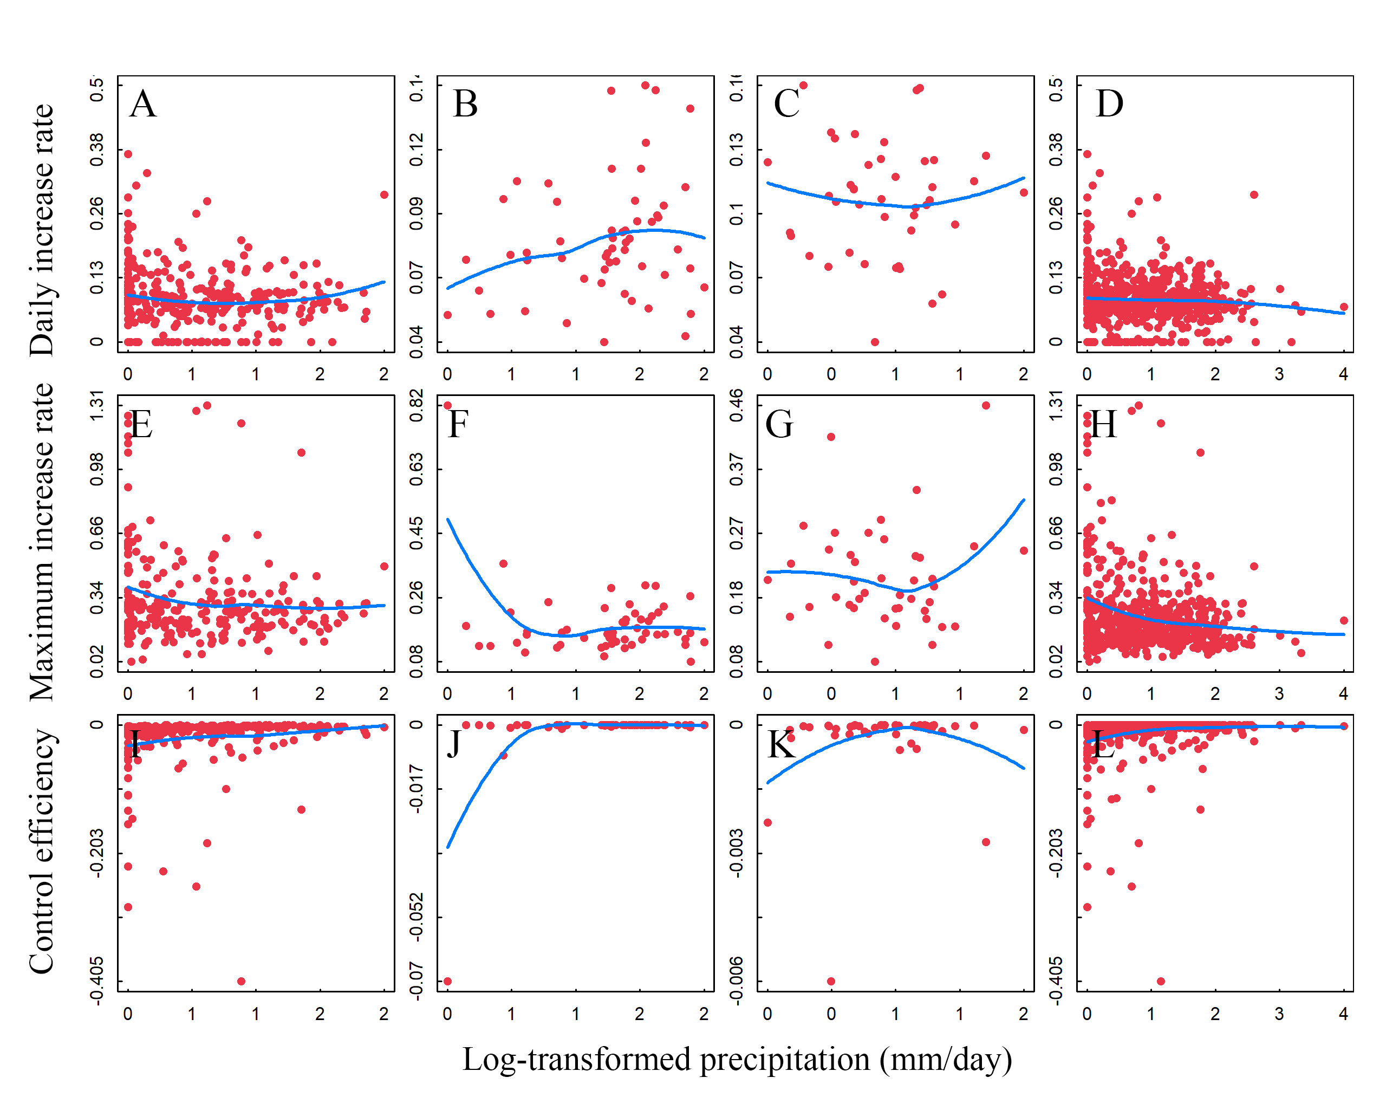
Supplementary Figure S7. Relationship of log-transformed precipitation with the average daily increase rate ($r_{i}$), maximum daily increase rate ($a_{i}$), control efficiency ($b_{i}$) of COVID-19 in China (A, E, I), USA (B, F, J), Europe (C, G, K), and the world (D, H, L). The blue lines indicate loess regression with span = 1.

Supplementary Table
Table S1 Associations of average daily increase rate ($r_{i}$) of cumulative cases, maximum daily increase rate ($a_{i}$), control efficiency ($b_{i}$) of COVID-19 with founding population size during the initial 7 days after the first patient ($F_{i}$), human population, climate factors (temperature and precipitation), and spatial autocorrelation based on analyses using Equation 3 (non-linear model). NS denotes non-significant effects. * p < 0.05, ** p < 0.01, *** p < 0.001.
Region | Transmission parameters | Founding population | Human population | Temperature | Precipitation | Spatial auto correlation | Variance explained | Sample size
China | Increase rate ($r_{i}$) | -0.00000098 | 0.01 * | ** | NS | * | 7.49% | 324
US | Increase rate ($r_{i}$) | -0.00014 * | 0.011 *** | *** | NS | ** | 56.07% | 52
Europe | Increase rate ($r_{i}$) | -0.00079 *** | 0.0071 ** | *** | * | *** | 60.18% | 42
Global | Increase rate ($r_{i}$) | -1.4e-06 * | 0.0061 *** | ** | NS | NS | 5.73% | 575
China | Maximum increase rate ($a_{i}$) | 6.1e-06 . | -0.042 * | *** | * | ** | 9.40% | 259
US | Maximum increase rate ($a_{i}$) | 0.00015 | 0.0099 | ** | NS | NS | 31.43% | 52
Europe | Maximum increase rate ($a_{i}$) | -0.00085 | -0.0063 | NS | NS | NS | 42.66% | 42
Global | Maximum increase rate ($a_{i}$) | -0.00000096 | -0.016 ** | *** | NS | * | 16.82% | 502
China | Control efficiency ($b_{i}$) | -1.6e-06 * | 0.01 ** | ** | * | ** | 11.08% | 259
US | Control efficiency ($b_{i}$) | 0.00000018 | 4e-05 ** | *** | * | *** | 89.67% | 52
Europe | Control efficiency ($b_{i}$) | 0.000012 | 3e-04 *** | NS | NS | NS | 51.25% | 42
Global | Control efficiency ($b_{i}$) | -0.000000074 | 0.0026 * | NS | NS | NS | 8.28% | 502

