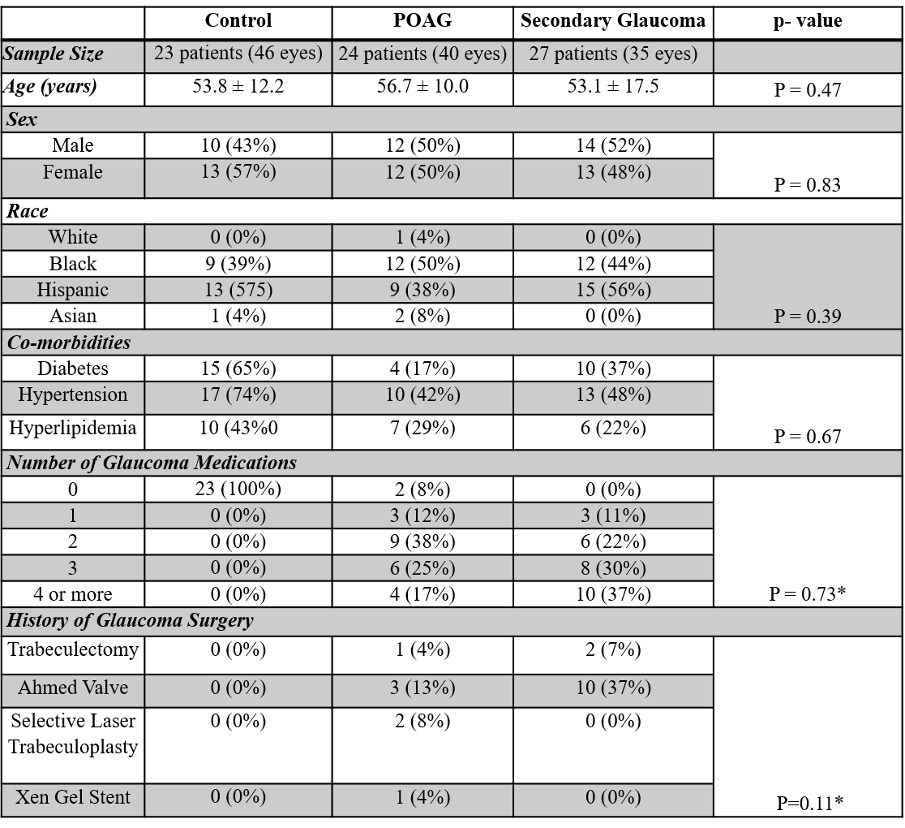
*Comparison was only done between POAG and secondary glaucoma groups
Table 1: Demographic Analysis of Study Population

