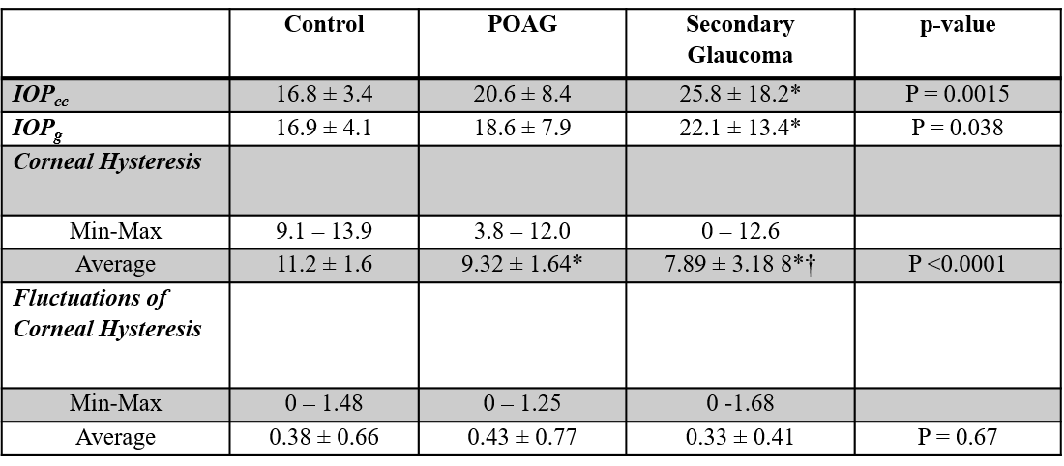
Data is presented as Mean ± SD
*P<0.05 vs. control group
†P<0.05 vs. POAG group
Table 2: Corneal Hysteresis in Patients with POAG & Secondary Glaucoma

