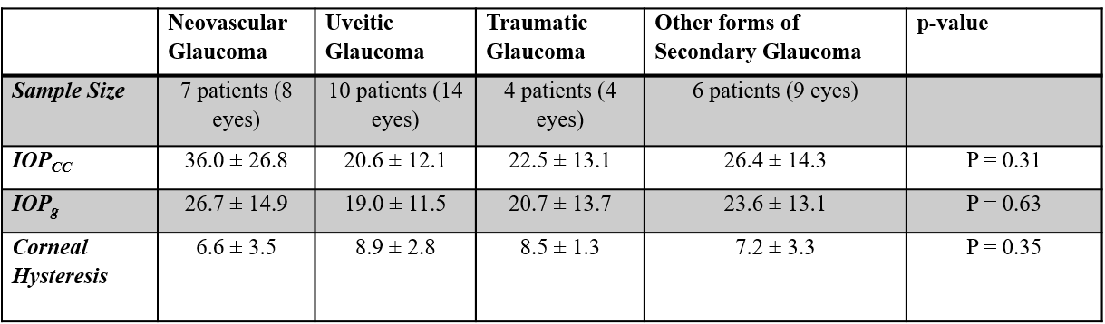
Data is presented as Mean ± SD
Table 3: Subset Analysis of Corneal Hysteresis in Secondary Glaucoma Types

