Supplementary material (A): methods

Contents
I. Literature search 2
Review of reviews 2
Second review: studies after 2015 4
Inclusion/exclusion criteria 6
Search details 7
II. Data extraction 9
Information about Interventions 9
Outcomes 11
Study details 12
III. Critical analysis 14
Information availability 14
Critical analysis: 15
1) Growth results 18
2) Shift results 23
3) Results by information assessment 24
4) Results by Study design 27
5) Evidence for publication bias 30

Literature search
Our data collection strategy involved three components: (1) string-based search query of relevant existing literature reviews and studies referenced by them (2) string-based search query of publication databases and (3) search for grey literature on Google and reference tracking.
Following the highest standards of systematic review, we searched a broad set of publication databases (Web of Science Core Collections, Scopus, and Google Scholar) based on a comprehensive search string that followed the PICOS (population, intervention, comparator, outcome and study design) logic recommended by Campbell Collaboration.⁴¹ We searched for articles that deal with urban transport behaviour along with one or more interventions of interest.
The review process was carried out in two steps. First, we search for literature reviews related to the adoption of low-carbon (urban) transport modes. Secondly, we conduct our string-based search of relevant primary studies conducted after 2015. Below, we first describe the methodology for the search for literature reviews. The review was conducted in accordance with the Roses guideline (for more information about the roses guideline see (Haddaway and Macura 2018).

Review of reviews
The systematic search was conducted in April-May, 2019. We restrict our search to articles on meta-databases (Web of Knowledge & Scopus). Our search and screening strategy is explained in figure A.5. We conduct the search in two waves. In the first and primary wave, we design our search query for the WoS database. Afterwards, we do a step-by-step screening process with multiple checks along the way to ensure consistency and agreement of exclusion/inclusion criteria among authors. In the secondary step, we complement the WoS search, with a query designed for Scopus. Author 1 did all the screening (before the last step). Lastly, we check the reference list of already identified articles to make sure no relevant review mentioned in them is left behind. For the primary WoS search, we use terms with variations in three sets of keywords. This includes; travel mode choice context (e.g. “urban” “modal choice”) including transport modes (e.g. “bicycles”), literature review (e.g. “meta-analysis”) and exclusion terms (such as oceanography). An example of the search query is given below. Search terms and Boolean combinations are customized to accommodate differences across databases.
Table A.1: Inclusion/Exclusion criteria used for classifying studies
 | Population | Intervention | Comparator | Outcome | Study Type
Inclusion | Households or individuals | Behavioural interventions to change transport behaviour |  | Transport behaviour* | Empirical studies
Exclusion | Tourists | Infrastructure or policy interventions such as fuel tax |  | Demand shifting, alternate route choice | Not simulation, modelling or predictive studies

Search query: a meta-analysis

Query structure
The query consists of three main parts (transport mode related + literature review related + exclusions). Full search query in the section below.
Title = (transport related keywords) AND Title+Abstract+keywords = (Literature review related keywords) NOT Title = (keywords associated with other topics) NOT Title+Abstract+keywords = (combination of words associated with other topics) NOT WoS categories (fields to be excluded)

Main query
TI = ("vehicle" OR “vehicles" OR "transit" OR "bus" OR "buses" OR "cycling" OR "biking" OR "bicycle" OR "train" OR "subway" OR "walk" OR "walking" OR "rail" OR "car-sharing" OR "car-pooling" OR "e-bike" OR "Modal" OR "modal split" OR "mobility" OR "travel" OR "trip" OR "trips" OR "transport" OR "drive" OR "driving" OR "car-use" OR "non-car") AND TS = ("review" OR "scooping" OR "meta-analysis " OR "synthesis" OR " Critical appraisal" OR " meta-regression") NOT TI = ("film" OR “thermal" OR "nanoparticle" OR "magnet" OR "film" OR "crystal" OR "chemical" OR "quantum" OR "metal" OR " oxid " OR "semiconductor" OR "nanostructure" OR "tourism" OR "freight" OR "mathematical" OR " fuzzy" OR "hinfin" OR "feedback" OR "closedloop" OR "lyapunov" OR "outputfeedback" OR "magnetorheolog" OR "bandwidth" OR "systemonchip" OR "onchip" OR "metalinsul " OR "soil " OR "plant" OR "plants" OR "biogeochemistry" OR "grassland" OR "sediment" OR "membrane" OR "magnet" OR "ocean") NOT TS = ("film " OR “thermal" OR "nanoparticle" OR "crystal" OR "chemical" OR "quantum" OR "metal" OR " oxid " OR " semiconductor " OR " nanostructure " OR " fuzzy " OR "closedloop" OR " lyapunov " OR " magnetorheolog soil " OR "plant" OR "biogeochemistry" OR "grassland" OR "sediment" OR "membrane" OR "magnet" OR " ocean" OR "semiconductor" OR "nanostructure" OR "nanoparticle" OR "protein" OR "neuron") NOT WC = (MEDICAL INFORMATICS OR MATERIALS SCIENCE MULTIDISCIPLINARY OR AGRICULTURAL ENGINEERING OR THERMODYNAMICS OR BIOPHYSICS OR ENGINEERING BIOMEDICAL OR NUCLEAR SCIENCE TECHNOLOGY OR PHYSICS FLUIDS PLASMAS OR METEOROLOGY ATMOSPHERIC SCIENCES OR SOIL SCIENCE OR OCEANOGRAPHY OR WATER RESOURCES OR CHEMISTRY PHYSICAL OR ENGINEERING GEOLOGICAL OR GERIATRICS GERONTOLOGY OR NANOSCIENCE NANOTECHNOLOGY OR CHEMISTRY MULTIDISCIPLINARY OR FORESTRY OR MEDICINE GENERAL INTERNAL OR PHYSIOLOGY OR ACOUSTICS OR MATHEMATICAL COMPUTATIONAL BIOLOGY OR AGRICULTURE MULTIDISCIPLINARY OR CHEMISTRY ANALYTICAL OR ROBOTICS OR AGRONOMY OR ELECTROCHEMISTRY OR PHARMACOLOGY PHARMACY OR BIOCHEMISTRY MOLECULAR BIOLOGY OR MARINE FRESHWATER BIOLOGY OR NUTRITION DIETETICS OR BIOCHEMICAL RESEARCH METHODS OR PHYSICS CONDENSED MATTER OR BIOTECHNOLOGY APPLIED MICROBIOLOGY OR LIMNOLOGY OR ENDOCRINOLOGY METABOLISM OR REHABILITATION OR ENGINEERING CHEMICAL OR RADIOLOGY NUCLEAR MEDICINE MEDICAL IMAGING OR HEALTH CARE SCIENCES SERVICES OR GEOCHEMISTRY GEOPHYSICS OR METALLURGY METALLURGICAL ENGINEERING OR PLANT SCIENCES OR PATHOLOGY OR CELL BIOLOGY OR EMERGENCY MEDICINE OR RHEUMATOLOGY OR POLYMER SCIENCE OR TOXICOLOGY OR HEMATOLOGY OR CLINICAL NEUROLOGY OR CHEMISTRY ORGANIC OR OPHTHALMOLOGY OR DENTISTRY ORAL SURGERY OR MICROBIOLOGY OR REPRODUCTIVE BIOLOGY OR PUBLIC ENVIRONMENTAL OCCUPATIONAL HEALTH OR BIOLOGY OR ORTHOPEDICS OR VIROLOGY OR CHEMISTRY INORGANIC NUCLEAR OR ONCOLOGY OR ANESTHESIOLOGY OR PERIPHERAL VASCULAR DISEASE OR OBSTETRICS GYNECOLOGY OR PARASITOLOGY OR DERMATOLOGY OR UROLOGY NEPHROLOGY OR NURSING OR CHEMISTRY APPLIED OR GASTROENTEROLOGY HEPATOLOGY OR CARDIAC CARDIOVASCULAR SYSTEMS OR OTORHINOLARYNGOLOGY OR IMMUNOLOGY OR VETERINARY SCIENCES OR AGRICULTURE DAIRY ANIMAL SCIENCE OR GENETICS HEREDITY OR INFECTIOUS DISEASES OR ZOOLOGY OR SPECTROSCOPY OR MEDICAL LABORATORY TECHNOLOGY OR DEVELOPMENTAL BIOLOGY OR CHEMISTRY MEDICINAL OR HORTICULTURE OR CRYSTALLOGRAPHY OR SUBSTANCE ABUSE OR INTEGRATIVE COMPLEMENTARY MEDICINE OR SURGERY OR ENTOMOLOGY OR ANATOMY MORPHOLOGY OR PLANNING DEVELOPMENT OR MEDICINE LEGAL OR PEDIATRICS OR CRITICAL CARE MEDICINE OR ASTRONOMY ASTROPHYSICS OR MINERALOGY OR OPTICS OR MATERIALS SCIENCE CERAMICS OR PALEONTOLOGY OR RESPIRATORY SYSTEM OR ENGINEERING OCEAN OR ENGINEERING AEROSPACE OR APPLIED ECOLOGY OR FISHERIES OR IMAGING SCIENCE PHOTOGRAPHIC TECHNOLOGY OR HOSPITALITY LEISURE SPORT TOURISM OR ENGINEERING MARINE OR LANGUAGE LINGUISTICS OR PHYSICS NUCLEAR OR ARCHAEOLOGY)

Search and selection Process
The search and selection process is described in steps detailed below:
- Search using keywords
Since no exclusions were made based on the methodology or the field of publication, the searches returned 3954 studies.
- First selection based on titles
It’s relatively easy to eliminate most of the papers based on titles only. In this step, we went from around 3954 studies to 747 studies, even based on a very generous reading of the title.
- Second selection based on Abstracts
Using an expansive criterion of what the relevant studies may be, we went from around 747 studies to 276 studies.
- Third selection based on the full manuscript
We went through the full manuscript of 276 studies. Out of these, we identified 32 relevant studies. Going through the reference lists, we identify another 10 additional studies. We were not able to access full text for four of these.

Second review: studies after 2015
Secondly, we conduct our own review of recent literature (from 2015 onwards). The search string was developed for WoS and then adapted to Scopus. The search string for this second search differed from the first one on two accounts, first since we are interested in original studies so we remove strings related to review (and review types), secondly for this search we include search strings related to behavioural, soft interventions (keywords/strings developed from a list of relevant words from the review studies) to narrow down the potential studies to only those related to these interventions.

Search query: original studies
(TI = ("vehicle" OR “vehicles" OR "transit" OR "bus" OR "buses" OR "cycling" OR "biking" OR "bicycle" OR "train" OR "subway" OR "walk" OR "walking" OR "rail" OR "car-sharing" OR "car-pooling" OR "e-bike" OR "modal split" OR "mobility" OR "travel" OR "trip" OR "trips" OR "transport" OR "drive" OR "driving" OR "car" OR "non-car" OR "electric cars") NOT TI = ("film" OR “thermal" OR "nanoparticle" OR "magnet" OR "film" OR "crystal" OR "chemical" OR "quantum" OR "metal" OR " oxid " OR "semiconductor" OR "nanostructure" OR "tourism" OR "freight" OR "mathematical" OR " fuzzy" OR "hinfin" OR "closedloop" OR "lyapunov" OR "magnetorheolog" OR "bandwidth" OR "systemonchip" OR "onchip" OR "metalinsul " OR "soil " OR "plant" OR "plants" OR "biogeochemistry" OR "grassland" OR "sediment" OR "membrane" OR "magnet" OR "ocean") NOT TS = ("film " OR “thermal" OR "nanoparticle" OR "crystal" OR "chemical" OR "quantum" OR "metal" OR " oxid " OR " semiconductor " OR " nanostructure " OR " fuzzy " OR " closedloop " OR " lyapunov " OR " magnetorheolog soil " OR "plant" OR "biogeochemistry" OR "grassland" OR "sediment" OR "membrane" OR "magnet" OR " ocean" OR "semiconductor" OR "nanostructure" OR "nanoparticle" OR "protein" OR "neuron" OR " unmanned" OR " aerial") AND TS = ("feedback " OR "pric" OR "behavio$ral" OR " nudge*" OR " norm" OR " norms" OR " normative" OR " social influence" OR " social influence" OR "social influence" OR " public commitment" OR " social comparison" OR " social learning" OR " social modeling" OR "commitment " OR "reward" OR "incentives" OR "goal setting" OR (information NEAR/3 (campaign* OR provision OR strategies OR acquisition OR intervention* OR system*)) OR "journey planners" OR "travel blending programmes" OR " soft transport policy" OR " soft policy" OR " soft measures" OR " soft intervention" OR " travel plan*" OR " travel advice " OR " carpooling" OR "travelsmart" OR "habit*" OR " IndiMark") NOT WC = (MEDICAL INFORMATICS OR MATERIALS SCIENCE MULTIDISCIPLINARY OR AGRICULTURAL ENGINEERING OR THERMODYNAMICS OR BIOPHYSICS OR ENGINEERING BIOMEDICAL OR NUCLEAR SCIENCE TECHNOLOGY OR PHYSICS FLUIDS PLASMAS OR METEOROLOGY ATMOSPHERIC SCIENCES OR SOIL SCIENCE OR OCEANOGRAPHY OR WATER RESOURCES OR CHEMISTRY PHYSICAL OR ENGINEERING GEOLOGICAL OR GERIATRICS GERONTOLOGY OR NANOSCIENCE NANOTECHNOLOGY OR CHEMISTRY MULTIDISCIPLINARY OR FORESTRY OR MEDICINE GENERAL INTERNAL OR PHYSIOLOGY OR ACOUSTICS OR MATHEMATICAL COMPUTATIONAL BIOLOGY OR AGRICULTURE MULTIDISCIPLINARY OR CHEMISTRY ANALYTICAL OR ROBOTICS OR AGRONOMY OR ELECTROCHEMISTRY OR PHARMACOLOGY PHARMACY OR BIOCHEMISTRY MOLECULAR BIOLOGY OR MARINE FRESHWATER BIOLOGY OR NUTRITION DIETETICS OR BIOCHEMICAL RESEARCH METHODS OR PHYSICS CONDENSED MATTER OR BIOTECHNOLOGY APPLIED MICROBIOLOGY OR LIMNOLOGY OR ENDOCRINOLOGY METABOLISM OR REHABILITATION OR ENGINEERING CHEMICAL OR RADIOLOGY NUCLEAR MEDICINE MEDICAL IMAGING OR HEALTH CARE SCIENCES SERVICES OR GEOCHEMISTRY GEOPHYSICS OR METALLURGY METALLURGICAL ENGINEERING OR PLANT SCIENCES OR PATHOLOGY OR CELL BIOLOGY OR EMERGENCY MEDICINE OR RHEUMATOLOGY OR POLYMER SCIENCE OR TOXICOLOGY OR HEMATOLOGY OR CLINICAL NEUROLOGY OR CHEMISTRY ORGANIC OR OPHTHALMOLOGY OR DENTISTRY ORAL SURGERY OR MICROBIOLOGY OR REPRODUCTIVE BIOLOGY OR PUBLIC ENVIRONMENTAL OCCUPATIONAL HEALTH OR BIOLOGY OR ORTHOPEDICS OR VIROLOGY OR CHEMISTRY INORGANIC NUCLEAR OR ONCOLOGY OR ANESTHESIOLOGY OR PERIPHERAL VASCULAR DISEASE OR OBSTETRICS GYNECOLOGY OR PARASITOLOGY OR DERMATOLOGY OR UROLOGY NEPHROLOGY OR NURSING OR CHEMISTRY APPLIED OR GASTROENTEROLOGY HEPATOLOGY OR CARDIAC CARDIOVASCULAR SYSTEMS OR OTORHINOLARYNGOLOGY OR IMMUNOLOGY OR VETERINARY SCIENCES OR AGRICULTURE DAIRY ANIMAL SCIENCE OR GENETICS HEREDITY OR INFECTIOUS DISEASES OR ZOOLOGY OR SPECTROSCOPY OR MEDICAL LABORATORY TECHNOLOGY OR DEVELOPMENTAL BIOLOGY OR CHEMISTRY MEDICINAL OR HORTICULTURE OR CRYSTALLOGRAPHY OR SUBSTANCE ABUSE OR INTEGRATIVE COMPLEMENTARY MEDICINE OR SURGERY OR ENTOMOLOGY OR ANATOMY MORPHOLOGY OR PLANNING DEVELOPMENT OR MEDICINE LEGAL OR PEDIATRICS OR CRITICAL CARE MEDICINE OR ASTRONOMY ASTROPHYSICS OR MINERALOGY OR OPTICS OR MATERIALS SCIENCE CERAMICS OR PALEONTOLOGY OR RESPIRATORY SYSTEM OR ENGINEERING OCEAN OR ENGINEERING AEROSPACE OR APPLIED ECOLOGY OR FISHERIES OR IMAGING SCIENCE PHOTOGRAPHIC TECHNOLOGY OR HOSPITALITY LEISURE SPORT TOURISM OR ENGINEERING MARINE OR LANGUAGE LINGUISTICS OR PHYSICS NUCLEAR OR ARCHAEOLOGY)) AND PY = (2010-2020)
*** Exclude (autonomous cars/driving) & (driving styles) & (Car-Following Behavior) from the search to target lower and more relevant results.

Search and selection Process
The search and selection process can be described in the steps detailed below:
- Search using keywords
Since no exclusions were made based on the date, methodology or field of publication, the searches returned 9946 studies.
- First selection based on titles
It is relatively easy to eliminate most of the papers based on titles only. In this step, we went from around 9946 studies to 433 studies, even based on a very generous reading of the title.
- Second selection based on Abstracts
This is the step where possible judgement calls are to be made. Using more expansive criteria, we went from around 433 studies to 216 studies.
- Third selection based on the full manuscript
We went through the full manuscript of 216 studies to filter out studies that do not meet our final inclusion criteria. We excluded studies dealing with autonomous cars, and eco-driving styles as well as studies focusing on electric vehicles from the final selection to target more relevant outcomes. At the end of this process, we identified 41 studies as relevant for our review. This includes seven studies that were identified from other sources.

Inclusion/exclusion criteria
We apply hierarchical screening of query results starting from titles to abstracts/ keywords to the full text. We include papers that:
- review literature on the adoption of low-carbon transport modes. This means we do not include original studies but only papers which collect/synthesize/review available evidence base. Given the fact that some areas of research may not be established enough to have comprehensive literature synthesis, we use an expansive definition of review which includes traditional literature reviews that are not systematic.
- focus on transport mode choice in urban areas. More specifically, we are interested in studies which assess the effectiveness of behavioural interventions on transport behaviour, especially transport mode choice behaviour. We do not consider studies which are about the benefits of using low-carbon transport modes.
- provide at least one quantitative/qualitative measure of association between one of the underlying interventions and transport mode use outcomes,
- were published in English,
We excluded reviews that only look at non-urban transport (such as holiday travel, marine travel etc.). No limitations were set on publication date, study design or other socio-demographic population characteristics. Table A.2 summarizes the inclusion-exclusion criteria for the first part of the literature search.
Table A.2– Inclusion-exclusion criteria
Inclusion | Exclusion
- Looks at the uptake/adoption of low-carbon transport modes or reduction in car use.  - conduct some sort of literature review  - Focus on behavioural interventions, or at least include some behavioural interventions.  - Includes at least some form of a qualitative or quantitative empirical relationship.  - published in English | - Freight, air travel  - Looks at the travel behaviour of tourists only.  - Simulations and predictions about travel demand.  - Studies that only focus on the benefits of using low-carbon transport modes.  - Include only infrastructure and/or policy interventions, and do not include behavioural interventions.

Search details
Figure A.1: Flow diagram – adapted from the ROSES flow diagram for systematic reviews

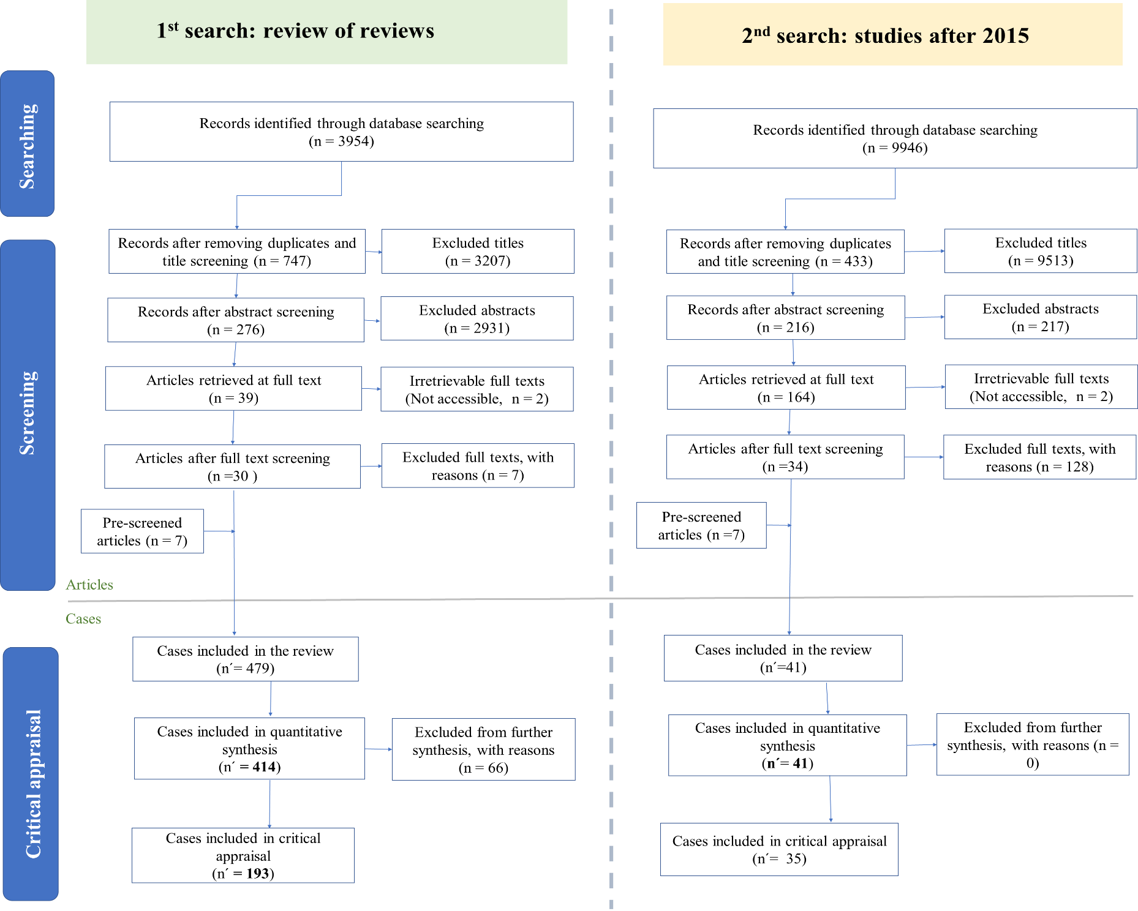

Data extraction
We are interested in three pieces of information:
- Information about interventions
- Information about transport-related behavioural outcomes
- Information about the studies from which the outcomes are extracted
We organize our data into three categories:
- Evidence about the effectiveness of behavioural interventions on transport behaviour includes information about intervention types as well as information about travel choices,
- Contextual information, such as intervention details (where the intervention took place, for how long, etc.),
- Information for evidence evaluation, such as study details (study design, randomization, control group tye, data collection methods, etc.).

Information about Interventions
In terms of interventions, we are interested in what type of intervention was carried out, before assessing its efficacy. For this reason, based on earlier literature we identified five different types of sub-components that are used in behavioural interventions to try to change travel behaviour. We classify components used in each intervention in our database.
Table A.3: Categorization of intervention components
Categorization | Details | Frequency
- Information | Information about the benefits of alternate modes and personal & social demerits of car use. Providing travel information. Two sub-categories: descriptive information, and normative information. | 42%
- Advice & goals | Expert advice, learning, giving people the opportunity to talk with somebody regarding the behavioural change. For example, at school, in a workshop, or with an advisor. Requesting that respondents make detailed plans for how to change their travel behaviour. | 33%
- Promotional programs, activities | Activities arranged for promoting alternative transport modes, cycle to work days, car-free days, etc. | 23%
- Incentives | (temporary) monetary, non-monetary incentives for behavioural change | 26%
- Soft infrastructure improvements | Infrastructure improvements are not directly related to transport, such as lockers for bicycle users. It may also involve special connecting bus schemes for workplaces or schools. Implementation of information and communication technologies. | 33%
A key aspect in considering the effectiveness of the intervention is the scope and setting where the intervention is carried out. Based on earlier studies, we define the following categories (Individualized, Workplace settings, Educational settings, Community settings, Area-wide).
Table A.4: intervention details in our sample
Variable | Stats / Values | Frequency (% of Valid)
Intervention scope | - Individualized: where intervention is targeted at the individualized settings (e.g. through websites, etc.).  - Work-place: where intervention is carried out in a workplace of some sort.  - Educational setting: where intervention is carried out in an educational institution of some sort (e.g. schools, universities).  - Community: where intervention is targeted at the community level.  - Area-wide: where intervention is carried out at the area level. | Individualized: 18  Workplace: 19  Educational setting: 24  Community: 20  Area-wide: 15
In addition to classifying interventions and their scope, we also collect information about the following aspects:
Variable | Description | Comments on data
(Intervention) Duration | Duration of the treatment in days, if possible (otherwise weeks, year, etc.)
Frequency of intervention | Whether intervention components were:  - one time, other discrete numbers  - continuous for the duration of the intervention,  - others.
start/end of the intervention, | Month & year for the Start as well as the end of the intervention
Targeted trip type | Whether or not a particular type of trip was targeted, and which trips:  - work commute  - school trips  - recreational trips  - others
Targeted population | Whether or not the intervention was targeted at a particular population segment:  - Workers, students, residents, others
Location of the intervention | Country and city in which intervention was conducted | We find interventions for more than 200 cities (and in some cases regions).
Region | United States, Asia, United Kingdom  Europe excl. The UK, Others | United States: 18  United Kingdom: 31  Australia: 19  Europe: 24  Asia: 8
Implementation authority | What kind of authority implemented the intervention:  - govt. authority  - private firm | Not enough information available on this for the majority of studies

Outcomes
Transport modes:
- Car use,
- Public transport use,
- Biking,
- Active travel/walking
Outcome indicator:
We consider three main outcome indicators:
Table A.5 (a) Classification of estimates
Indicator | Description
% Mode shift | Frequency of trips; Duration of trips; the distance of trips
% change in transport mode use | Whether an intervention encourages public transit use.
% change in VMT | Vehicle miles/kilometres travelled
Change in transport behaviour | Change in habit, change in dominant transport mode
Indicators not included in our database
Change in peak period traffic | Indicates whether a strategy reduces vehicle travel during peak periods.
Shifts in peak to off-peak periods | Indicates whether a strategy encourages motorists to shift from peak- to off-peak driving.

Outcome indicator scope:
We make the distinction between three different classifications, taking into consideration the outcome variable, the sampling strategy, and the scope of the intervention (more details in Methods & supplementary files). These three classifications are individual-level estimates, site-specific estimates, and area-wide estimates.
Table A.5 (b) Classification of estimates
Classification | Description
area-wide | The estimate and the treatment are implied to be representative of the area, or transport system (based on representative surveys, population estimates, network coverage, etc.).
site-specific | The estimate and the treatment are implied to be specific to the site or the particular group of population. Pilot projects are classified in this category.
Individual | The estimates are based on changes in travel behaviour at the individual level.

Study details
In terms of study design, more than half of the estimates (55%) come from studies with some form of before & after design. Out of these, at least 20% indicate that they include some form of the control group, while either the remaining 30% do not include a control group or don´t mention it. Additionally, 10% employ a quasi-experimental design. Nearly, 15% of the estimates employ experimental design. For 10% of the estimates, the study design is not mentioned or clarified.
Table A.6: Descriptive statistics
In terms of study details, we are interested in three different aspects of the study:
Variable | Description | Comments on data
1) Study details
year published | Year the report or paper from which intervention is reported/published.
type of study | research article, conference paper, report, etc.
publishing details
2) Study design
Study Design | BA, CBA, Experiment, Post-intervention, Other, Unclear | BA: 50  CBA: 20  Experiment: 16  Post-intervention: 4.7  Other: 0.3  Unclear: 8.6
Control group type | Randomized control group, non-random control group, matched comparison, others, not specified
Randomization type | Self-selection, non-random selection, randomized, unclear, NI | Missing information for a majority of studies
3) Data collection
Data collection method | Questionnaire, travel diary, pedometer, etc.
sampling_techniques | What kind of sampling methods were used to get a representative sample from the target population: Random, Systematic, Convenience, Cluster, and Stratified.
Method of measurement | Method of measurement  - (for questionnaire) Measurement questions  - (for travel diary) duration  - (for pedometer): duration  - (for counts): number of times, duration
Survey_period | The time period (month, year) survey was conducted. In case of multiple rounds, note the time period for each round.
Frequency_details | The number of times the survey was conducted.
Follow-up data | We collect the following information about the follow-up data:  - follow-up data collection (yes/no)  - The time period after the intervention ended
Stats Method | Pre-Post, DiD, Control-treatment
Response rate | The number of people who answered the survey was divided by the number of people in the sample who were contacted.
Attrition rate | Survey attrition involves the decrease of the sample size from the first wave to the subsequent waves of the data collection process.

Critical analysis

Information availability
Table A.7: information availability analysis
Intervention
Classification information | There is sufficient information available to classify the intervention in one or more sub-categories.
Scope | There is sufficient information in the source material to accurately assess the scope of the intervention (individualized, workplace, educational setting, community, and area-wide).
Frequency | There is sufficient information in the source material to accurately describe the frequency of intervention.
Duration (start & end timing) | There is sufficient information in the source material to accurately describe the duration of the intervention (including starting and ending dates).
Location (city, country) | There is sufficient information in the source material to accurately describe the location of intervention (including locality, city, and country).
Outcome
Variable information | There is sufficient information in the source material to accurately describe the outcome variable being used and its details.
Measurement method | There are sufficient details in the source material to accurately describe the measurement method for the transport outcome variable.
Stats | There are sufficient details in the source material to accurately describe the statistical methods used to obtain the results.
Baseline behaviour | There is information in the source material about the baseline i.e. before the intervention took place, transport indicators.
Study design/characteristics
Sample size | There is sufficient information in the source material to accurately describe the sample size (including for different treatments, etc.).
Study design | There is sufficient information in the source material to accurately describe the study design (before & after, experiments, etc.).
Control group | There is sufficient description of the presence and type of control group used for comparison.
Data collection method | There is a sufficient description of the type of data collection methods.
Survey (frequency, Response rate, Attrition rate) | There is a sufficient description of the details of the data collection process.
Follow-up | There is sufficient information to assess whether or not there was a follow-up evaluation after the intervention and how long after the intervention it took place.

Critical analysis:

Critical analysis for literature reviews
Table A.8.1: Review types
1 = Overview | 'Primer', 'literature review', 'traditional literature review
2 = State-of-the-art review
3 = Critical review
4 = Scoping review | 'Pilot review'
5 = Literature review | (Rapid review; So-called 'systematic review');
6 = Meta-analysis
7 = Systematic map
8 = Systematic review | 'qualitative evidence synthesis', quantitative synthesis' or 'mixed methods review'
9 = Umbrella review; literature review' | Systematic review of systematic reviews, 'review of  reviews', 'overview of reviews'
The main differentiation lies in the level of evidence aggregation for different types of literature reviews. In the case of systematic reviews, the evidence presented is aggregated across several different studies. On the other hand, traditional reviews highlight important/interesting results from individual studies. Therefore, extracting information across these different review types requires different criteria. We categorize the reviews in one of the 7 categories based on categories by Haddaway and Macura (2018) and summarized in Table A.8.1 Supplementary files: Methods. In terms of study criteria for review studies, we come up with the following main criteria:
Table A.8.2: a critical analysis of review studies
Study description | whether underlying studies are identified clearly | 0, 1, NA, unclear
Intervention description | whether interventions are identified and described consistently and appropriately | 0, 1, NA, unclear
Selection | whether there is a selection process | 0, 1, NA, unclear
comprehensiveness | appropriate scope and design of search query | 0, 1, NA, unclear
Protocol & transparency | if all steps are described transparently | 0, 1, NA, unclear
Quantitative or qualitative |  | Quantitative, Qualitative, NI, unclear
Outcome reporting | whether results are presented in a consistent and appropriate manner | 0, 1, unclear
Meta-analysis | whether results are analysed and standardized across studies using meta-analysis techniques | 0, 1, NA, unclear
Critical analysis | whether any critical appraisal of the studies is done or not | 0, 1, NA, NI, unclear

Critical analysis for underlying studies
In order to assess the quality of the studies included in our sample we code each study along the following dimensions:
Table A.9.1: Design & Sampling
Control group | Was there a control group in the study?
Randomization (d) | Were participants, groups, or areas randomly allocated to intervention and control groups?
Comparability (c) | Were baseline characteristics of intervention and control groups, populations, or areas comparable, or, if there were important differences in potential confounders at baseline, were these appropriately adjusted for in analysis?
Baseline characteristics | Did the differences between the baseline characteristics of the control and treatment groups suggest reliable randomization between treatment and control groups?
Follow-up (h) | Was there a follow-up?
Ethical review | Whether the study indicates getting an ethical review before intervention.
Sampling Biases | Are the individuals selected to participate in the study likely to be representative of the target population?
Out-of-sample bias | Was the control and treatment group representative of the average population of the corresponding area?
Control for confounders | If yes, indicate the relevant confounders that were controlled (either in the design (e.g. stratification, matching) or analysis)? The authors should indicate if confounders were controlled in the design (by stratification or matching) or the analysis.

Table A.9.2: Data collection methods and data quality
Tools for primary outcome measures must be described as reliable and valid. If content validity has been demonstrated, this is acceptable. Some sources from which data may be collected are described below: Self-reported data includes data that is collected from participants in the study (e.g. completing a questionnaire, survey, answering questions during an interview, etc.). Assessment/Screening includes objective data that is retrieved by the researchers. (e.g. observations by investigators). Records/Statistics refers to the types of formal records used for the extraction of the data. Reliability and validity can be reported in the study or a separate study. For example, some standard assessment tools have known reliability and validity.
measurement_type | Self-reported, observational, counts, statistical data, both (self-reported and independently observed/counted), unclear, no information, others
measurement_quality | Whether the measurement was done repeatedly and considered a period of time? Whether the measurement method was shown to reliable and valid for capturing transport behaviour?
Missing data | Were data for this outcome available for all, or nearly all, participants randomized?

Table A.9.3: Outcomes & analysis
Pre- and post-data | Were outcome data reported for both baseline and post-intervention stages?
Outcome & analysis reporting biases | Was the study free from outcome reporting bias and analysis reporting bias?
Stat_methods | Are the statistical methods appropriate for the study design? Was the quantitative analysis appropriate to the primary research question being asked?
Statistics | Was a test of statistical significance applied specifically to the observed net change in walking and/or cycling behaviour?

Supplementary material (B): results

Growth results
Estimates for percentage change in transport mode use show high variation across different transport modes. In particular, we are interested in the factors that can explain this heterogeneity in our findings. As explained earlier, baseline transport mode split is important as the growth indicators very much depend on the baseline. However, disappointingly the vast majority of studies that report growth in transport mode use as an outcome variable do not report the baseline transport mode split. Note that this is different from reporting baseline transport behaviour, in general. Overall, our analysis indicates that for bicycle use, higher growth estimates are from studies where the baseline bicycle use is low (less than 10% bike mode share, with the highest estimates coming from studies with baseline bike share lower than 5%), while the few estimates from studies with high baseline bike share do not indicate high growth potential. In particular, the very large estimates at low baseline bike share come from studies with site-specific estimates.
Another important aspect of transport outcomes is the aggregation level, i.e. whether the outcomes are estimated for area-level, site-specific or individual-level changes in behaviour. Our analysis indicates that the area-level estimates are significantly lower as compared to site-specific estimates. This is true for almost all transport modes. However, not all of these differences are statistically significant at the conventional levels. The results from our regression models show that estimates for car use show a statistically significant difference between estimates from area-level as compared to site-specific estimates, with area-level estimates showing a lower reduction in car-use growth.
- Estimates by information availability
We do not find any evidence to suggest that estimates show systematic variation in terms of the origin of evidence (whether it is an estimate from an original study, some kind of report or other reviews) or the information available about the different aspects of the underlying studies. The regression coefficient for info_type in our regression models (Table B.1.2) does not seem to indicate any systematic pattern across transport modes. Similarly, the breakdown of studies based on different levels of information availability across different aspects (outcome, intervention, and study design) (Table B.1.1) indicate the same.
- Estimates by study design
On the other hand, we find that effect size estimates vary depending on the study design. More specifically, we find that studies with experimental design report consistently lower the effectiveness of interventions on transport behaviour across all modes (Figure B.2). This is true for both area-level as well as site-specific estimates. The only exception is site-specific estimates for active travel.
- Others
Overall, Bike estimates show a very high degree of variation, both within and across study design categories. Active travel estimates show considerable variation based on the setting in which the interventions are conducted or targeted. More specifically, interventions conducted in workplace settings or targeting area-wide transport changes are more effective as compared to interventions targeted at the individual-level. Estimates from the EU are lower as compared to those from the US. 0.899 (4.167); -7.713 (13.08); -5.206 (40.41); -16.02* (8.293).

Figure B.1: Percentage growth estimates for different transport modes as a function of baseline transport mode share.

 |  | Site-specific |  |  |  | Area
 | Variable | Obs. | Mean | Std. dev. | % | Obs. | Mean | Std. dev. | %
Car mode | BA | 49 | -13.0 | 11.6 | 64 | 30 | -9.6 | 9.6 | 48
Car mode | CBA | 21 | -16.5 | 17.3 | 28 | 19 | -9.8 | 2.6 | 31
Car mode | Experimental | 4 | -7.2 | 11.4 | 5 | 13 | -4.4 | 4.4 | 21
Car mode | Post-intervention | 2 | -31.5 | 6.4 | 3 |  |  |  | 0
PT mode | BA | 15 | 31.5 | 29.6 | 31 | 40 | 33.7 | 65.9 | 63
PT mode | CBA | 26 | 33.9 | 49.4 | 53 | 13 | 23.3 | 20.7 | 20
PT mode | Experimental | 8 | 8.7 | 10.0 | 16 | 11 | 6.6 | 16.8 | 17
PT mode | Post-intervention |  |  |  | 0 |  |  |  | 0
Bike mode | BA | 30 | 38.1 | 36.7 | 43 | 13 | 77.9 | 128.3 | 59
Bike mode | CBA | 20 | 74.0 | 147.2 | 29 | 4 | 37.3 | 67.3 | 18
Bike mode | Experimental | 20 | -4.8 | 29.1 | 29 | 5 | 1.9 | 20.1 | 23
Bike mode | Post-intervention |  |  |  | 0 |  |  |  | 0
Active mode | BA | 39 | 17.1 | 16.1 | 38 | 13 | 5.4 | 20.9 | 45
Active mode | CBA | 31 | 14.6 | 29.7 | 30 | 6 | 17.0 | 15.1 | 21
Active mode | Experimental | 27 | 2.8 | 12.4 | 26 | 9 | 13.7 | 16.8 | 31
Active mode | Post-intervention | 5 | 2.2 | 3.2 | 5 | 1 | 1.3 |  | 3
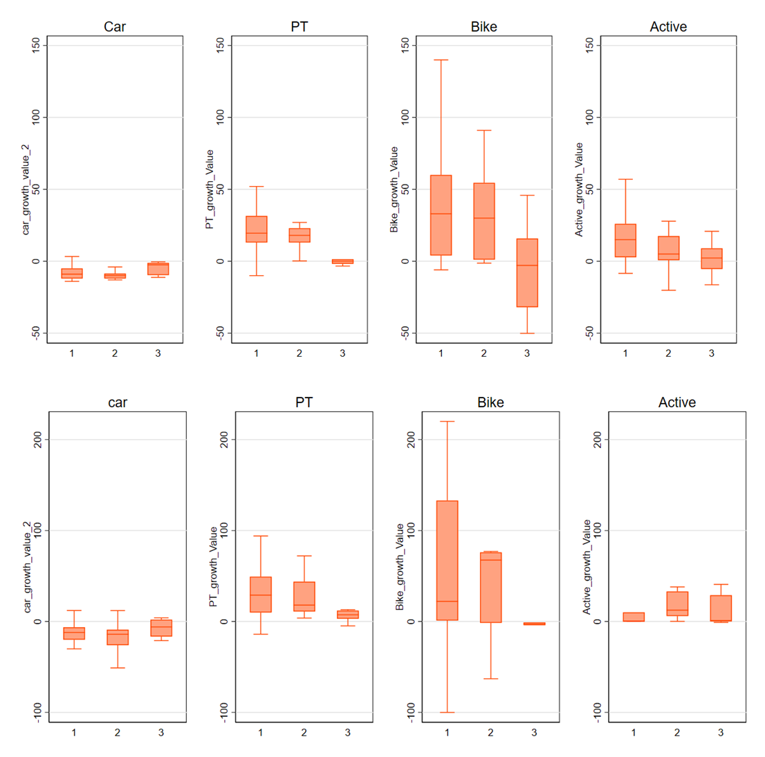
Figure B.2: (a) average percentage growth estimates for different transport modes across study designs (b) average percentage growth estimates for different transport modes across study designs (BA, CBA, and Experimental).
 | Intervention information |  |  |  |  | Outcome information |  |  |  | Study design information
 |  | Car | PT | Bike | Active | Car | PT | Bike | Active | Car | PT | Bike | Active
0 |  | 11 | 7 | 11 | 15 | 17 | 4 | 9 | 7 | 14 | 3 | 10 | 12
1 |  | 2 | 3 | 2 | 2 | 6 | 4 | 5 | 9 | 10 | 8 | 4 | 11
2 |  | 36 | 7 | 8 | 7 | 11 | 14 | 8 | 13 | 33 | 14 | 11 | 17
3 |  | 28 | 37 | 17 | 30 | 64 | 42 | 36 | 52 | 6 | 9 | 9 | 8
4 |  | 45 | 26 | 35 | 51 | 23 | 16 | 15 | 24 | 46 | 30 | 32 | 37
5 |  | - | - | - | - | 1 | 0 | 0 | 0 | 13 | 16 | 7 | 20
6 |  | - | - | - | - | - | - | - | - | 14 | 3 | 10 | 12

 | Intervention information |  |  |  | Outcome information |  |  |  | Study design information
 | Car | PT | Bike | Active | Car | PT | Bike | Active | Car | PT | Bike | Active
0 | -5.1 | 22.5 | 26.8 | 4.9 | -9.8 | 12.7 | 17.9 | 16.6 | -8.9 | 5.9 | 30.3 | 9.1
1 | -7.5 | 13.3 | 55.5 | 8.5 | -33.8 | 48.0 | 36.5 | 17.5 | - | - | - | -
2 | -16.8 | 13.0 | 38.8 | 8.3 | -9.3 | 20.9 | 58.4 | 4.2 | -12.7 | 17.5 | 40.5 | 3.5
3 | -11.4 | 20.5 | 69.0 | 7.0 | -9.5 | 16.0 | 33.9 | 4.8 | -16.2 | 69.0 | 40.2 | 11.1
4 | -7.5 | 51.6 | 13.8 | 7.4 | -10.9 | 73.9 | 22.7 | 6.6 | -31.1 | 68.2 | 35.1 | 8.7
5 | - | - | - | - | -3.02 |  |  |  | -6.0 | 18.2 | 26.9 | 1.1
6 | - | - | - | - | - | - | - | - | -6.5 | 6.7 | 41.1 | 14.3

Table B.1.1: Average percentage growth estimates for different transport modes across information availability in different domains.

Table B.1.2: Results from the Meta-regression model for average growth indicator
 | (1) | (2) | (3) | (4)
 | car_growth | PT_growth | Bike_growth | Active_growth
Sample_n | 0.0002  (0.0002) | 0.0002  (0.001) | -0.007  (0.007) | -0.00002*  (0.00001)
Study_design_code
2.Study_design_code | -3.02  (2.593) | 10.54  (11.37) | 22.99  (57.39) | -1.955  (4.970)
3.Study_design_code | 3.331  (5.170) | -31.00**  (13.91) | -60.57*  (33.17) | 2.88  (5.76)
4.Study_design_code | -18.99***  (4.959) | - | - | -10.10  (6.916)
Region | -18.99***  (4.959)
2.Region | -1.685 | 5.979 | -50.65 | 3.496
 | (5.081) | (38.19) | (73.79) | (9.470)
3.Region | -6.900 | 18.92 | -69.42 | -8.135
 | (5.985) | (46.09) | (56.71) | (7.446)
4.Region | 0.899 | -7.713 | -5.206 | -16.02*
 | (4.167) | (13.08) | (40.41) | (8.293)
5.Region | 3.145 | 25.30 | -21.25 | -3.208
 | (5.233) | (30.12) | (49.40) | (9.140)
Scope_sum
2.scope_sum | -8.071** | -13.61 | -43.18 | -1.852
 | (3.973) | (11.74) | (48.51) | (6.539)
3.scope_sum | 9.449* | -32.37 | -65.69 | -0.615
 | (5.074) | (19.59) | (74.74) | (8.454)
4.scope_sum | -0.675 | -36.09** | -123.0 | 25.54**
 | (5.635) | (17.89) | (90.83) | (11.86)
5.scope_sum | -2.975 | -0.200 | 21.04 | 12.15*
 | (3.411) | (12.94) | (38.65) | (6.324)
99.scope_sum | 5.001**
 | (2.255)
Year | 0.197 | 2.330* | 0.724 | -1.369**
 | (0.333) | (1.258) | (2.576) | (0.519)
info_type
2.info_type | 6.155 | -17.81 | -24.53 | -23.68
 | (5.286) | (38.57) | (76.66) | (14.59)
3.info_type | 5.199 | -1.964 | 13.24 | 6.200
 | (4.968) | (34.26) | (47.87) | (6.430)
25.info_type | -2.659 | -43.09
 | (5.556) | (45.85)
Car_area_wide | 8.704**
 | (3.449)
PT_growth_area |  | -26.54
 |  | (21.07)
Bike_growth_area |  |  | -30.19
 |  |  | (29.10)
Active_growth_area |  |  |  | -5.675
 |  |  |  | (4.983)
Cons | -408.8 | -4629.7* | -1312.7 | 2773.0***
 | (670.9) | (2527.0) | (5190.4) | (1045.6)
R² | 0.374 | 0.167 | 0.213 | 0.325
N | 133 | 110 | 85 | 121
Standard errors in parentheses. * p < 0.1, ** p < 0.05, *** p < 0.01

Shift results

´Figure B.3: average mode-shift estimates for different transport modes as a function of baseline transport mode share.

Results by information assessment
Below we provide estimates for average growth in transport modes as well as average mode shift across different levels of information availability. The purpose of this exercise is to check whether or not our estimates vary depending on information availability. More specifically we are interested in the possibility that studies with lower information availability correspond to higher estimates (implying more effectiveness) as compared to studies with higher information availability.
We are interested in three different categories of information availability: Information about intervention, information about travel behaviour outcomes, and lastly, information about study design. For each of these categories, we have a number of different specific components that are assessed for information availability. Our analysis indicates that there is considerable heterogeneity across studies, in terms of information available for critically analysing the strength of the reported outcomes.
Table B.2: Frequency (and average) of mode-shift estimates for different transport modes across information availability in different domains.
Score | Intervention information | Outcome information | Study design information
0 | 118 (24.2) | 116 (23.8) | 113 (23.2)
1 | 15 (3.08) | 17 (3.5) | 1 (0.2)
2 | 120 (24.6) | 60 (12.3) | 38 (7.8)
3 | 120 (24.6) | 218 (44.8) | 120 (24.6)
4 | 114 (23.4) | 75 (15.4) | 53 (10.9)
5 | - | 1 (0.2) | 92 (18.9)
6 | - | - | 70 (14.4)

Intervention | Car | PT | Bike | Active
Classification | 0.86 | 0.91 | 0.90 | 0.92
Scope | 0.94 | 0.97 | 0.97 | 0.98
Frequency | 0.11 | 0.13 | 0.20 | 0.08
Duration | 0.43 | 0.39 | 0.48 | 0.52
Outcome
Variable | 1.00 | 1.00 | 1.00 | 0.99
Baseline | 0.91 | 0.89 | 0.85 | 0.91
Measurement | 0.29 | 0.30 | 0.34 | 0.36
Stats | 0.79 | 0.85 | 0.90 | 0.86
Study design
Sample | 0.99 | 0.98 | 0.96 | 0.95
Study design | 0.98 | 0.96 | 0.96 | 0.97
Control group | 0.27 | 0.28 | 0.24 | 0.35
Data collection method | 0.86 | 0.96 | 0.95 | 0.94
Survey | 0.45 | 0.48 | 0.46 | 0.49
Followup | 0.31 | 0.25 | 0.27 | 0.32
 | Intervention information |  |  |  | Outcome information |  |  |  | Study design information
 | Car | PT | Bike | Active | car | PT | Bike | Active | car | PT | Bike | Active
0 | 30 | 17 | 7 | 28 | 22 | 13 | 7 | 12 | 17 | 13 | 10 | 22
1 | 8 | 3 | 3 | 4 | 0 | 0 | 0 | 1 | 0 | 0 | 0 | 0
2 | 72 | 54 | 41 | 51 | 28 | 12 | 10 | 11 | 26 | 8 | 11 | 12
3 | 42 | 30 | 32 | 33 | 93 | 73 | 64 | 75 | 61 | 50 | 41 | 47
4 | 10 | 6 | 13 | 7 | 19 | 12 | 15 | 24 | 22 | 16 | 16 | 17
5 | - | - | - | - | 0 | 0 | 0 | 0 | 19 | 9 | 8 | 5
6 | - | - | - | - | - | - | - | - | 17 | 14 | 10 | 20

Figure B.4: (a) proportion of interventions across information availability in different domains, (b) frequency of information availability across different domains.
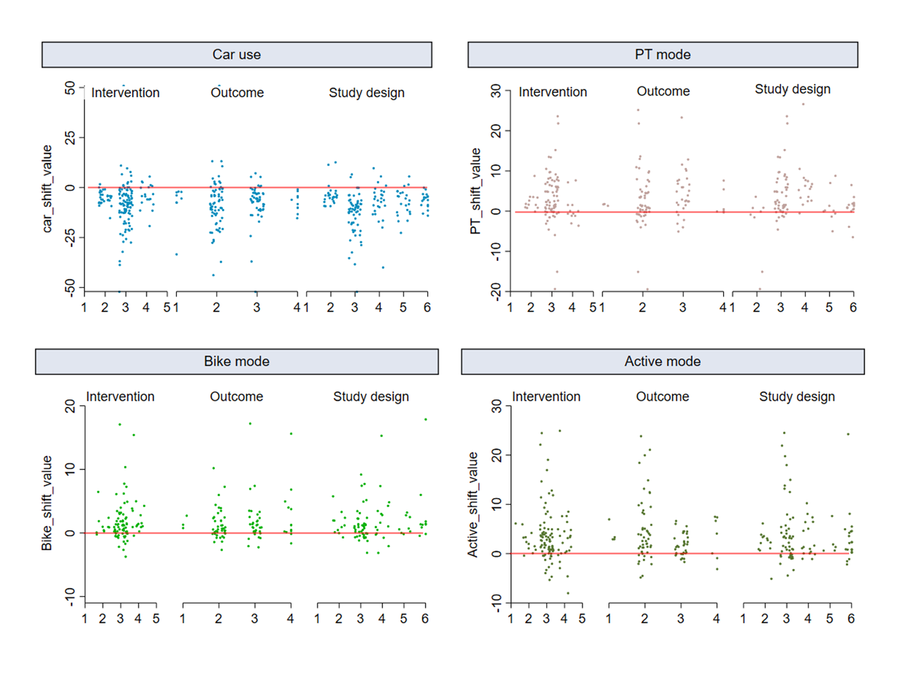
Figure B.5: Scatter plot of mode shift estimates based on the assessment of information availability.

Results by Study design
One of the most important differences between different estimates and studies is the study or research design employed by the underlying studies to arrive at the estimates for change in transport behaviour. Here, we distinguish between four broad categories of study design (Before/after design; Controlled before-after design, studies with experimental design, and lastly studies where changes in behaviour are only measured after the intervention). Although, different study designs have different strengths, especially when combined with the transportation behaviour measurement, however, for the sake of simplicity, all else being the same we consider the controlled before/after (CBA) and experimental design to be superior to the others.
In Figures (B.5 & B.6) and Table B.3, we present our findings with a breakdown of the study design, estimate scope, and transport mode (mode shift estimates). Concerning study design and transport modes, we observe a general tendency towards before/after studies for car-use and PT mode shift estimates. This is true for both site-specific and area-level estimates. Although, in the case of car use the area-wide estimates have a somewhat higher share of CBA studies as compared to site-specific estimates. The opposite is true for bike and active travel mode estimates. A larger share of site-specific estimates for these modes originates from studies with CBA design as compared to area-wide estimates. For PT mode shift estimates a large majority of estimates come from studies with BA design. In general, these findings reveal the (practical) difficulty in conducting area-wide studies with CBA or experimental design, making the estimates less likely to generalize over time or in different contexts.
A key concern with study design and intervention effectiveness estimates is that relatively lower quality study design will lead to estimates that are biased towards higher effectiveness. It must be noted that there is a large disparity in the number of studies with lower quality study designs as compared to studies with stronger study designs, which makes comparing effect size across these different designs more complicated. Nonetheless, even in our sample, we find that there is a general tendency toward higher estimates coming from low-quality study designs, even if there is a large degree of heterogeneity across estimates for different study designs. The strongest version is found in PT estimates, where both site-specific and area-wide estimates, drop considerably when we only consider studies with higher quality study designs (CBA and experiments). It is true for car-mode estimates as well as site-specific bike mode shift estimates.
 |  | Site-specific estimates |  |  | Area-wide estimates
Mode | Study design | Obs. | Mean | Std. Dev. | Obs. | Mean | Std. Dev.
Car | BA | 155 | -8.2 | 12.2 | 27 | -5.4 | 3.9
Car | CBA | 17 | -6.9 | 4.5 | 14 | -3.9 | 2.1
Car | Experimental | 11 | -3.2 | 6.4 | 1 | -8.1 | .
Car | post intervention | 7 | -3.1 | 8.2
PT | BA | 19 | 1.41 | 3.4 | 67 | 4.1 | 7.7
PT | CBA | 5 | 1.01 | 0.7 | 14 | 2.7 | 2.7
PT | Experimental | 2 | 0.27 | 1.0 | 2 | -0.9 | 1.5
PT | post-intervention |  |  |  | 7 | 4.4 | 2.6
Bike | BA | 23 | 2.8 | 5.6 | 55 | 1.1 | 2.4
Bike | CBA | 18 | 0.7 | 0.8 | 2 | 1.5 | 0.7
Bike | Experimental | 2 | 0.2 | 0.1 | 0
Active | BA | 31 | 2.7 | 2.6 | 63 | 4.8 | 7.0
Active | CBA | 19 | 2.0 | 3.0 | 2 | 3.0 | 0.0
Active | Experimental | 9 | 1.9 | 5.2 | 0
Active | post intervention | 4 | 2.0 | 4.8 | 3 | 1.0 | 0.0
Table B.3: average mode-shift estimates for different transport modes across different study designs (BA, CBA, and Experimental).
Area-specific mode shift estimates

Figure B.5: Boxplot of area-specific mode-shift estimates (median, upper/lower range) based on the study design.
Site-specific mode shift estimates

Figure B.6: Boxplot of site-specific mode-shift estimates (median, upper/lower range) based on the study design.

Evidence for publication bias
A funnel plot displaying the relationship between estimate quality and effect size is given below. Each dot represents an effect from included studies (e.g. measuring the effect of a certain intervention); the y-axis represents study precision (standard error) and the x-axis shows the effect estimate. This scatterplot is used for the visual detection of systematic heterogeneity between studies. It assumes that studies with high precision will be plotted near the average, and studies with low precision will be spread evenly on both sides of the average, creating a roughly funnel-shaped distribution. Deviation from this shape suggests small-study bias, which is the case here, with lower precision studies reporting stronger effects.
Figure B.7: Funnel plot displaying the relationship between standard error and effect size
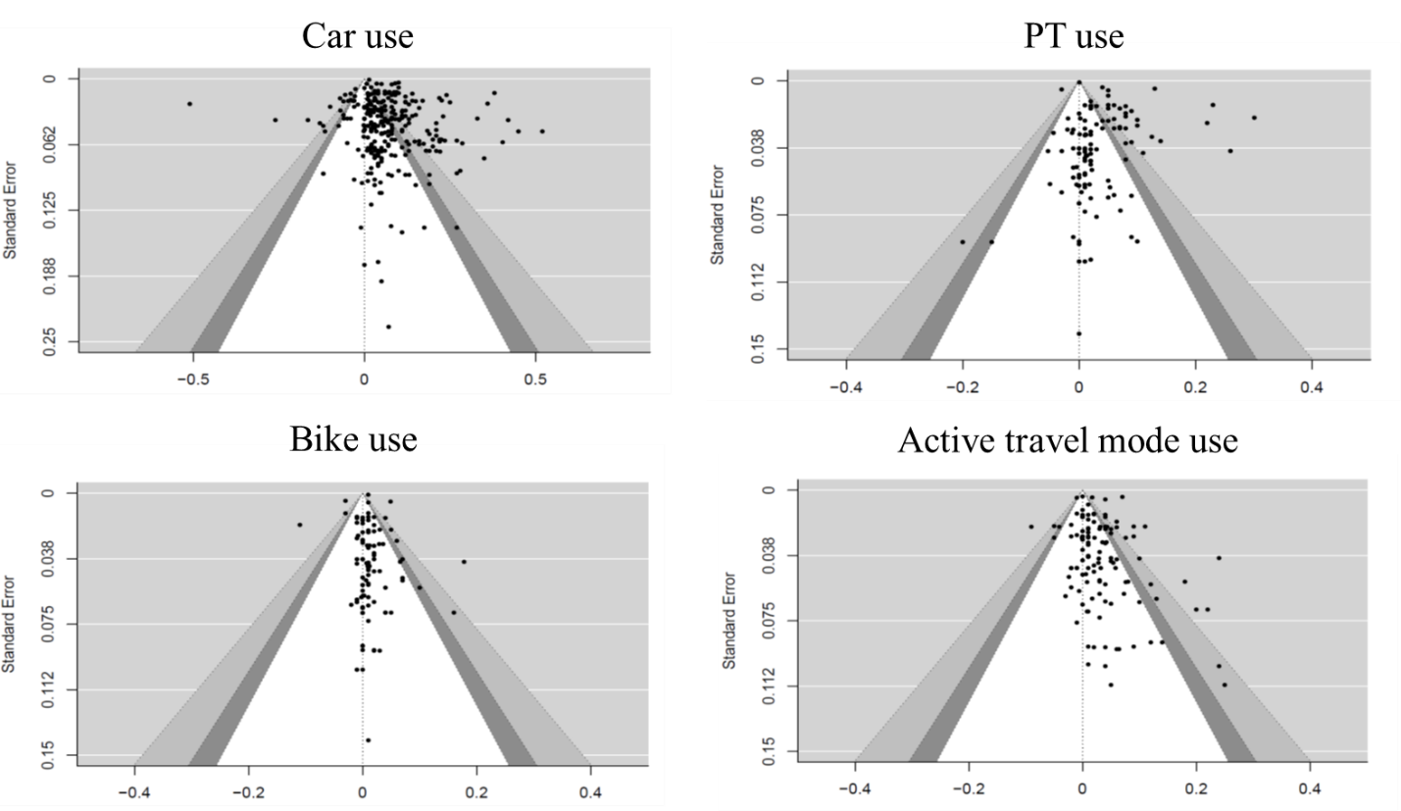
We also performed Egger's test for funnel plot asymmetry. We find that the mode shift estimates for public transit and walking show signs of small-study/publication bias, based on egger´s test result. The test statistic for egger´s test, Z = -3.01 (p-value = 0.003) for estimates on public transit mode shift, and Z = 2.26 (p-value = 0.02) for estimates on walking mode shift, both provide evidence for rejecting the null hypothesis of no publication bias. On the other hand, we cannot reject the null hypothesis of no small-study/publication bias for car use and biking. The test statistic, Z = 0.79 (p-value = 0.42) for estimates on public transit mode shift, and Z = 0.2 (p-value = 0.83) for estimates on walking mode shift.

If an appropriate method is used for the primary research question, but an inappropriate method is used for a secondary question, this item was still rated as a “yes”.

