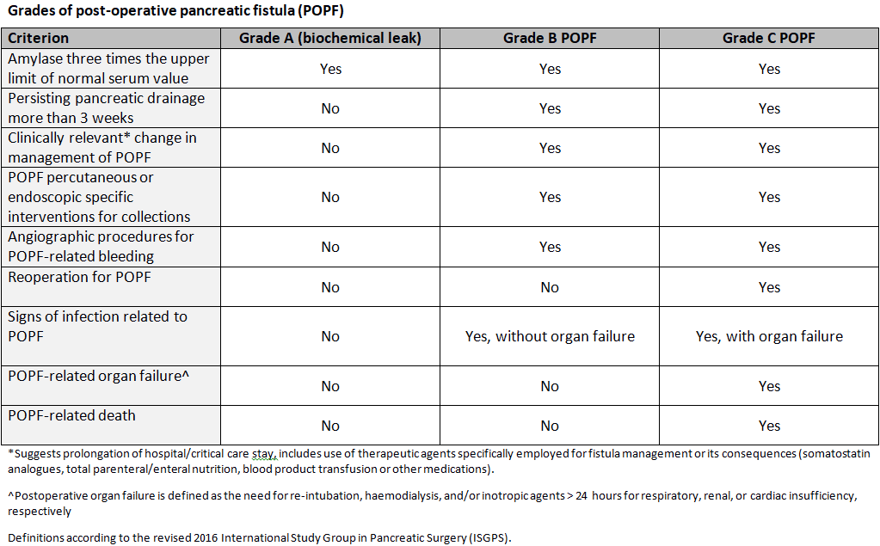
Supplementary Information

Table S1: Classification of postoperative pancreatic fistula (POPF). In the text Grade B and Grade C POPF have collectively been referred to as clinically-relevant POPF (CR-POPF).
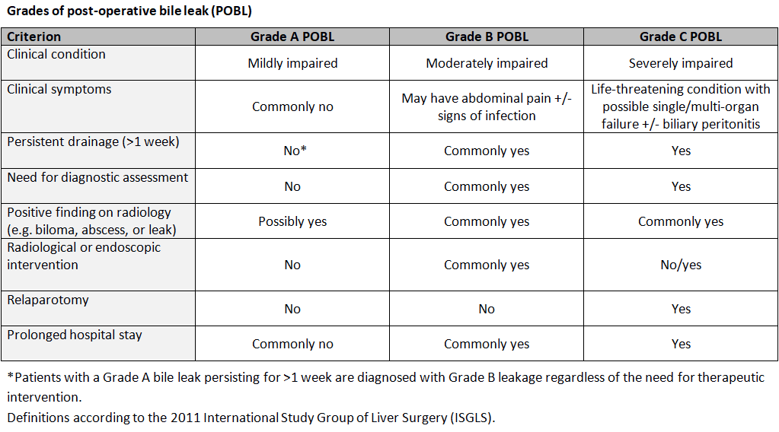
Table S2: Classification of postoperative bile leak (POBL).

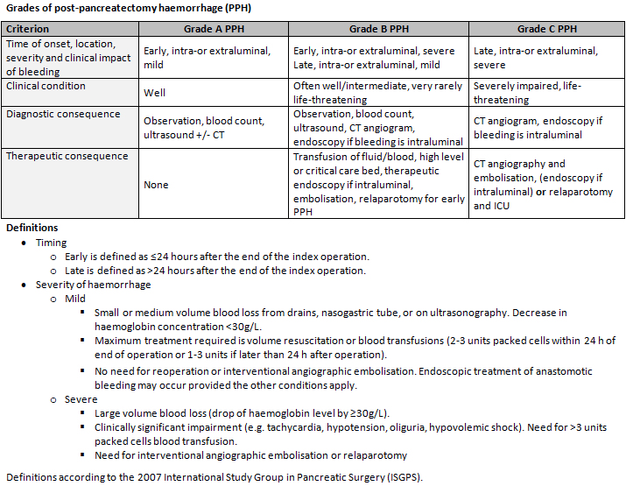
Table S3: Classification of postpancreatectomy haemorrhage (PPH).

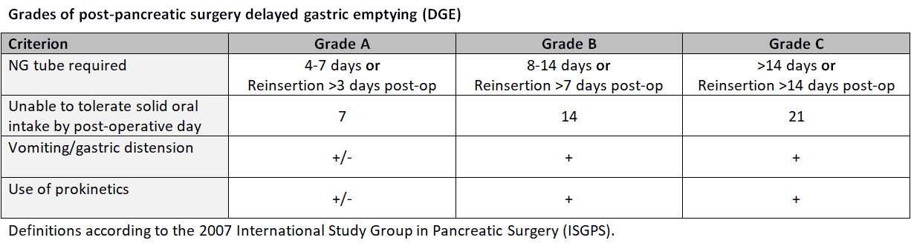
Table S4: Classification of delayed gastric emptying (DGE).

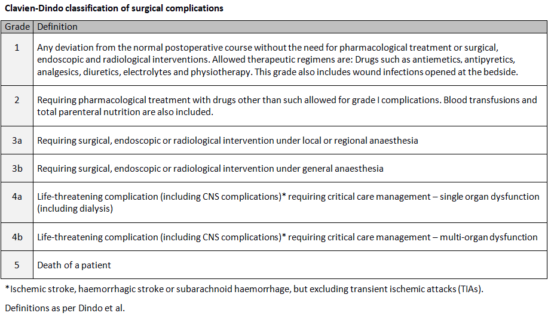
Table S5: Clavien-Dindo classification of surgical complications.

