Supplementary Information for
Suppressing non-radiative losses in organic semiconductors caused by high-frequency molecular vibrations

Pratyush Ghosh¹, Antonios M. Alvertis^{1,2}, Alexander J. Gillett¹, Shengzhi Dong³, Alexander J. Sneyd¹, Hwan-Hee Cho¹, Emrys W Evans^{1,4}, Bartomeu Monserrat^{1,5}, Feng Li³, Christoph Schnedermann¹, Richard H. Friend¹, Akshay Rao^{1*}

Affiliation:
¹Cavendish Laboratory, University of Cambridge, Cambridge, UK
²Materials Sciences Division, Lawrence Berkeley National Laboratory, Berkeley, California, USA
³State Key Laboratory of Supramolecular Structure and Materials, College of Chemistry, Jilin University, Changchun, China
⁴Department of Chemistry, Swansea University, Singleton Park, Swansea, UK
⁵Department of Materials Science and Metallurgy, University of Cambridge, Cambridge, UK

* Author to whom correspondence should be addressed;
E-mail: ar525@cam.ac.uk

Table of Contents
Section 1: Materials synthesis and characterization……………………………………….….3
Section 2: Off-resonant steady state Raman spectroscopy …………………………….......6
Section 3: Temporal characterization and correction of optical pulses
3.1: Effective Time Resolution…………………………………………………………...7
3.2: Time Resolution correction………………………………………………………….8
3.3: Effective Time Resolution for the band selective resolution………………........8
Section 4: Coherent oscillation maps of representative radical, TADF and NFA………….9
Section 5: Probe wavelength-resolved analysis of the resonant IVS
5.1: APDC-DTPA………………………………………………………………………….9
5.2: TTM-3PCz…………………………………………………………………………..11
Section 6: Assignment of the excited-state vibrational coherence based on phase analysis of the coherent oscillations……………………………………………………………12
Section 7: Excited-state impulsive vibrational spectroscopy of 4CzIPN in 3-pulse geometry…………………………………………………………………………………………..13
Section 8: Ultrafast dynamics of TTM-TPA (Band selective excitation) …………..……...15
Section 9: Analysis of the low frequency vibrational modes of TTM-3PCz……………….16
Section 10: Charge-transfer character………………………………………………………..16
Section 11: Electronic structure Calculation of TTM-TPA…………………………………..17
Section 12: Calculation of exciton-vibration interactions in studied molecules……….…..17
Section 13: Excited state energies along a pair of high-frequency normal modes……….19
Section 14: Molecular orbital (MO)-vibrational coupling
14.1: Electronic localisation of the HOMO of non-planar donor moieties …………..21
14.2: Electronic localisation of the HOMO of APDC-DTPA and TTM-TPA ……….24
14.3: Electronic localisation of the SOMO orbital of TTM-Donor radicals ………... 24
14.4: Electronic localisation and vibrational decoupling ……………………………..26
Section 15: Zero-point renormalisation of excited state energies using Monte Carlo sampling ……………………………………………………………………………………….….30
Section 16: Summary of the efficient red LEDs ……………………………………………..32
References

Section 1: Materials synthesis and characterizations
General information: All initial materials and solvents used were purchased from commercial supplier and used without further purification, unless otherwise stated. Column chromatography was performed using silica gel (200-300 mesh). The concentration of sample solutions used for the optical measurements is around 10⁻⁵ mol/L.
The ¹H-NMR spectrum was measured with a Bruker AVANCZIII 500 spectrometer at 500 MHz with tetramethylsilane (TMS) as the internal standard, using deuterated acetone (d-acetone) as solvent at 298 K. GC-MS mass spectra of all compounds were recorded on a Thermo Fisher ITQ1100 mass spectrometer. IR spectra of radical was recorded with Brucker VERTEX 80V. EPR spectrum of the radical was recorded on a Bruker ELEXSYSII E500 CW-EPR spectrometer.
Synthesis: The HTTM was prepared as reported^{1,2} (Scheme 1) (GC-MS (m/z): HTTM calculated for C₁₉H₇Cl₉, 554.32; found, 553.65) and TPA pinacole borane was purchased from commercially available source. The stepwise synthetic method for the TTM-TPA radical is outlined in Scheme 2.
Scheme 1. Synthesis of the HTTM

Scheme 2. Synthesis of the TTM-TPA radical

(1) Synthesis of HTTM-TPA
HTTM (1.0 g, 1.80 mmol) and the TPA pinacole borane (0.67 g, 1.80 mmol) was dissolved in a mixed solvent of toluene (12 ml), K₂PO₃ aqueous solution (8 ml, 2 mol / L) and ethanol (4 ml), and catalyst Pd(Pph₃)₄ (0.10 g, 0.09 mmol) was added under argon atmosphere. The mixture was stirred at 95℃ for 48 h under argon atmosphere and in the dark. After the reaction mixture cooling to room temperature, the solution was extracted with dichloromethane, organic layer was collected and dried. The solvent was removed under vacuum and the crude product was purified by silica gel column chromatography (using petroleum ether: dichloromethane = 10:1 v/v). HTTM-TPA was obtained as a white solid. GC-MS (m/z): calculated for C₃₇H₂₁Cl₈N, 763.18; found, 762.59; ¹H NMR (500 MHz, d-acetone) δ 7.80 (d, J = 1.9 Hz, 1H), 7.71 (d, J = 8.7 Hz, 2H), 7.68-7.61 (m, 3H), 7.48 (t, J = 2.6 Hz, 2H), 7.41-7.31 (m, 4H), 7.22-7.06 (m, 8H), 6.84 (s, 1H).

(2) Synthesis of TTM-TPA
Under argon atmosphere and in the dark, the HTTM-TPA (1.00 equiv) was dissolved in dry THF (40 ml). Then KO^{t}Bu (4.00 equiv) was added, the solution become claret-colored immediately. The solution was stirred for 2 h in the dark at room temperature, and then p-Chloranil (5 equiv) was added. The solution was stirred for further 3 h. After the reaction finished, the solvent was removed under vacuum and the crude product was purified by silica gel column chromatography (using petroleum ether: dichloromethane = 10:1v/v). The crude product was recrystallized twice from dichloromethane and methanol and a brown red solid was obtained. GC-MS (m/z): calculated for C₃₇H₂₀Cl₈N, 762.17; found, 761.83; IR, EPR and TGA spectra are shown below in Supplementary figure 1-2. Photoluminescence properties of the TTM-TPA solution (toluene) are shown in the Supplementary figure 3.

Supplementary Figure 1. IR spectrum of TTM-TPA

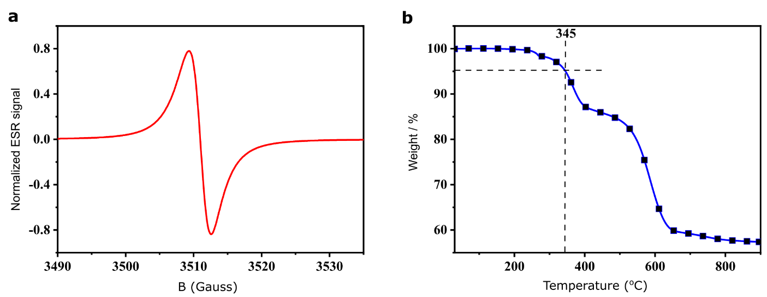
Supplementary Figure 2. Spin and thermal characterization of TTM-TPA a, EPR spectra for TTM-TPA (solid samples) at room temperature. ESR, electron spin resonance; B, magnetic field. b, Thermogravimetric analysis measurements show thermal decomposition temperatures of 345 °C (TTM-TPA)

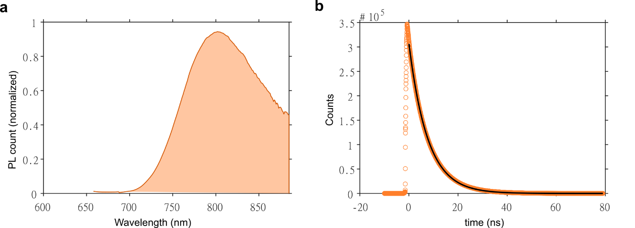
Supplementary Figure 3: Photoluminescence characterization: a, the steady-state PL spectra ($λmax=800 nm$) obtained for TTM-TPA (0.005mg/ml Toluene) while exciting at 350 nm. b, TCSPC decay kinetics showing the D₁ lifetime 8.4 ns

Section 2: Off-resonant steady state Raman spectroscopy
The off-resonant steady state Raman spectroscopy is performed on the investigated radical, TADF and representative NFA molecules. The photon energy of the incident laser beam is tuned below the optical absorption band of the studied systems. As can be visualised in the Supplementary Figure 4, the steady-state Raman spectra of TTM-3PCz has strong high-frequency modes at 1256, 1566, 1600, 1627 cm⁻¹ along with the low-frequency mode at 225 cm⁻¹ which is the most dominant mode in the experimental IVS spectra. Similarly, TADFs APDC-DTPA and 4CzIPN have a series of high-frequency Raman active modes at 1190, 1540, 1602 cm⁻¹ and 1352, 1436, 1662 cm⁻¹ respectively. The NFA, IO-4Cl has strong high-frequency modes at 1275, 1357, 1432, 1468, 1600 cm⁻¹ in the steady-state Raman spectra which are also present with reasonable intensity in the IVS spectra having frequencies 1270, 1368, 1422, 1470 and 1596 cm⁻¹ (see Extended Figure 2). This result suggests that the radical and TADFs studied feature Raman active high-frequency vibrational modes and the suppression of the intensity of these modes is a signature of the electronic transition which is involved in the resonant impulsive transition.
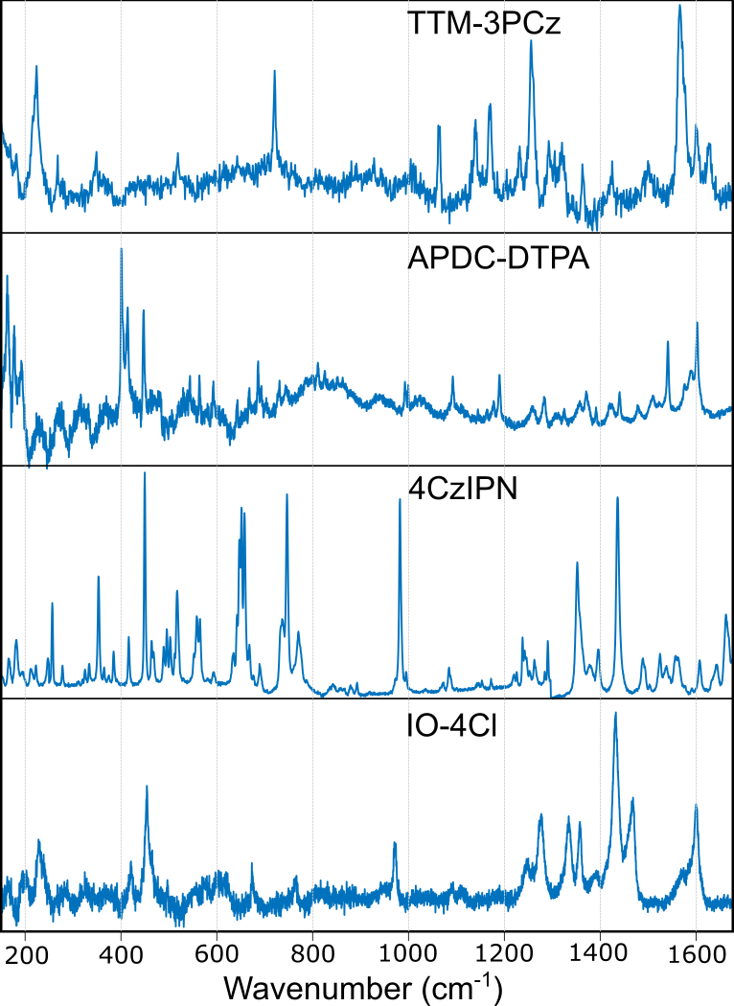
Supplementary Figure 4: Off-resonant steady state Raman spectra of representative radical (TTM-3PCz), TADF (APDC-DTPA, 4CzIPN) and NFA (IO-4Cl) molecules. Experient is performed on TTM-3PCz (powder), APDC-DTPA (powder), IO-4Cl (spin-coated neat film) with 785 nm laser and on 4CzIPN (evaporated neat film) with 633 nm laser.

Section 3: Temporal characterization and correction of optical pulses
3.1. Effective Time Resolution
As our detection scheme is spectrally-resolved, the time resolution (τ_{probe}) of the probe pulse is the transform limit which turns out to be ~4 fs for the 1030 nm seeded white light continuum³. The temporal profile retrieved from SHG-FROG shown in the Supplementary Figure 5, depicts the time resolution of the pump (τ_{pump}) to be 8.8 fs. Therefore, the time-resolution for the overall experiment in combination of pump and probe pulse is, $τ_{res}=\sqrt{\left(τ_{probe}^{2}+τ_{pump}^{2}\right)}=9.67 fs$.
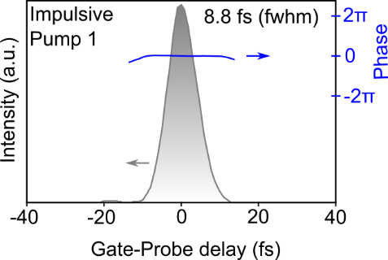
Supplementary Figure 5: Temporal profile of the impulsive pump 1 retrieved with SHG-FROG (pump pulse used for the all experiments reported in Fig. 2 in main text).
With the overall time resolution ($τ_{res}$) of 9.67 fs, we are theoretically able to impulsively excite and resolve vibrational modes up to ~3450 cm⁻¹.
3.2 Time Resolution Correction
The oscillatory signal recorded as a vibrational coherence in the time-domain is convolved with the intrinsic time resolution of the experiment. As a result, low frequency modes with longer oscillatory period are overemphasised in the frequency domain with respect to the high-frequency modes with shorter oscillatory period. To obtain the precise intensities we have employed a time-resolution correction method to account for the non-zero time-resolution ($τ_{res}$) of the experiment as previously reported⁴.
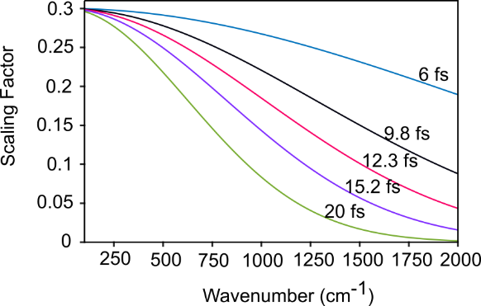
Supplementary Figure 6: Scaling Factor computed against the vibrational mode frequencies for different time resolution: 9.8 fs (black) corresponds to the resonant experiments reported in the Fig. 2 (main text); 12.3 fs (magenta), 15.2 fs (purple) corresponds to the P₁ and P₂ excitations in the experiment reported in the band-selective IVS experiment (Fig. 3, main text)
Briefly, to model the effect of the $τ_{res}$ on an oscillation with frequency ω, we convolve a particular oscillation with a gaussian profile with full width half maxima of $τ_{res}$. Fast Fourier transformation (FFT) is performed on both the pristine and convolved oscillation and a scaling factor is obtained. The mode-resolved scaling factor for all frequencies of interest (100-2000 cm⁻¹) can be generated by simulating this method which is plotted in Supplementary Figure 6 including all the experiments performed in this study.

3.3 Effective Time Resolution for the band selective resolution
As visualised in retrieved FROG traces shown in Extended Data Fig. 6a, the time resolution of the pump (τ_{pump}) are 14.6 fs and 11.6 fs for the P₂ (D₂-rich excitation) and P₁ (D₁-excitation) respectively. Therefore, the overall time-resolution ($τ_{res}$) become 15.2 fs (P₂) and 12.3 fs (P₁) as the same white light continuum is used as probe pulse for both experiments (see SI section 3.1). The dominance of high-frequency oscillation on the raw data (see Extended Data Fig. 6b) for the D₂-rich data excited with a slower pulse with comparison to D₁ data which is excited with faster P₁ pulse, support the data (Fig. 3) and interpretation presented in the main text.

Section 4: Coherent oscillation maps of representative radical, TADF and NFA
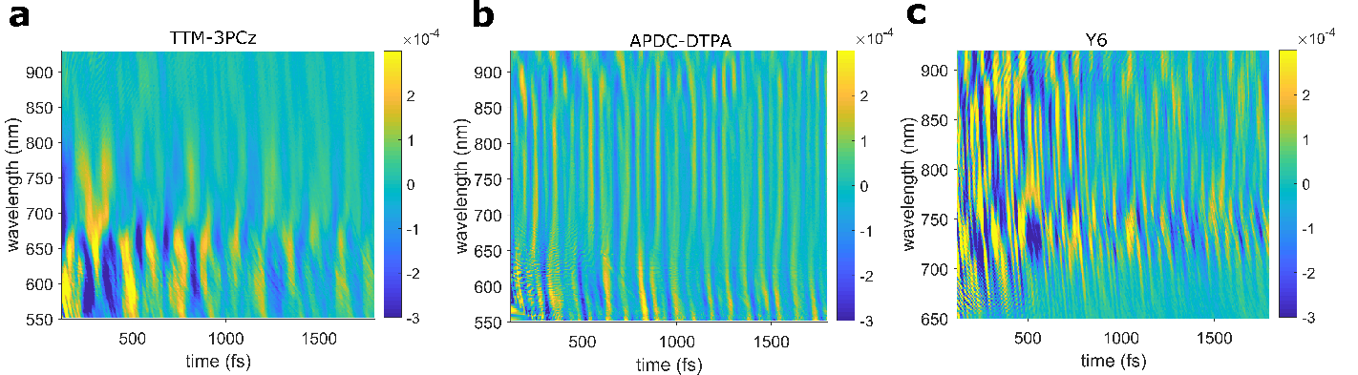
Supplementary Figure 7 Coherent oscillation maps of representative a, radical (TTM-3PCz), b, TADF (APDC-DTPA) and c, NFA (Y6). The maps after prepared by fitting and subsequently eliminating the electronic population dynamics from the pump-probe data at each probe wavelength.

Section 5: Probe wavelength-resolved analysis of the resonant IVS
5.1: APDC-DTPA
We remark that an alternative explanation for the absence of high-frequency modes in the excited state vibrational spectra of APDC-DTPA could be due to a lack of displacement between the charge-transfer S₁ state and the probed higher excited state(s), S_{n} (n≥2) which are involved in the PIA along the coordinates of the high-frequency modes.
The transient absorption spectra of APDC-DTPA in CHCl₃ (Supplementary Figure 8a) shows negative signal over the visible probe (530-940 nm) which can be attributed to the photo-induced absorption (PIA) of the initially excited CT S₁ state. As plotted in Supplementary Figure 8a, the photoluminescence spectra of APDC-DTPA spans from 650-800 nm which suggest the stimulated emission (SE) feature is convoluted within the TA spectrum (650-800 nm). Both the SE-rich PIA and pristine PIA share the same population kinetics (see Supplementary Figure 9) which indicates the origin of the SE and PIA from the same CT S₁ state. The early time (<2 ps) kinetics extracted from the SE+PIA (700-720 nm) and pristine PIA (880-900 nm) obtained from the resonant IVS are plotted in Supplementary Figure 8b, none of which shows fast oscillatory component (<30 fs) which corresponds to the carbon-carbon stretching modes. The Fourier transformed vibrational spectra are plotted in Supplementary Figure 8c and 8d, extracted from SE-rich PIA and pristine PIA respectively. Both spectra do not show strong coupling to the vibrational modes in the high-frequency regime.

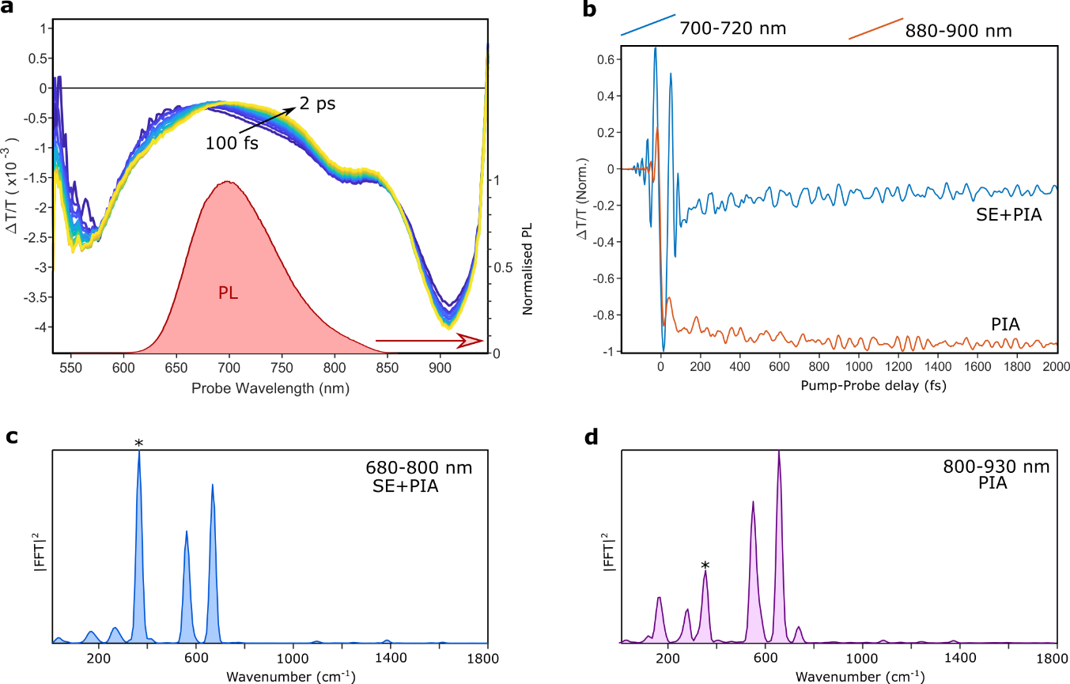
Supplementary Figure 8: Probe wavelength-resolved analysis of the resonant IVS (pump-probe) of the APDC-DTPA: a, Evolution of the transient absorption signal from 100fs to 2ps. The TA signals at each time steps are area normalized. The photoluminescence spectra of APDC-DTPA plotted in red area-plot. b, Temporal kinetic extracted from the 700-720 nm (SE-rich PIA) and 880-900 nm (pristine PIA). c, Fourier transformed vibrational spectra from the SE-rich (680-800 nm) transient absorption signal d, Fourier transformed vibrational spectra from the pristine PIA (800-930 nm) transient absorption signal. (Note: The Raman spectra presented on c-d panel are averaged over the probe wavelength in frequency domain after FFT to avoid artefacts that could arise in the time domain averaging due to phase-killing resulted from chirp artefact which could affect the intensity of high-frequency modes). The asterisk indicates CHCl₃ mode. SE: Stimulated Emission, PIA: Photo-induced emission.

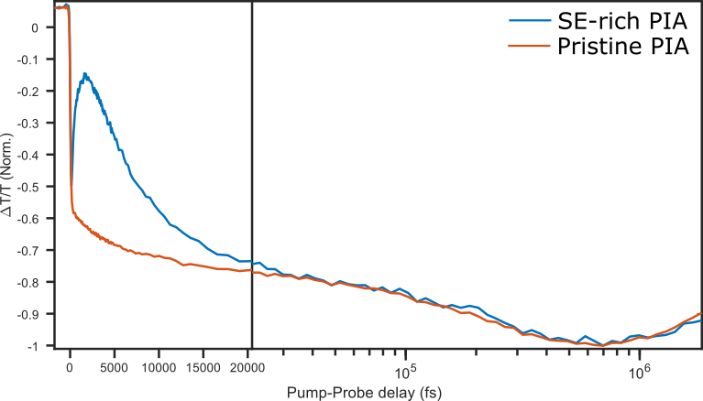
Supplementary Figure 9: Long time (up to 2 ns) TA data of the APDC-DTPA (CHCl₃): SE-rich kinetics obtained from the probe wavelength (670-690 nm) and the pristine PIA kinetics obtained for from the probe wavelength (880-900 nm). The mismatch in the ultrafast timescale (<20 ps) arises from the spectral shift happening in the SE-rich regime (see Supplementary Figure 5a). Both the traces share same kinetic (20 ps → 2 ns) which indicates both the features are arising from the same photoexcited species (S₁ CT)

5.2: TTM-3PCz
The absorption spectra of the charge-transfer band and the photoluminescence spectra of TTM-3PCz (CHCl₃) are plotted in Supplementary Figure 10a. The transient absorption spectra at different time delays (100 fs → 2 ps) are plotted in the Supplementary Figure 10b. From the absorption and photoluminescence spectra, it can be stated that the ground state bleach (GSB) and stimulated emission (SE) are convoluted with the TA spectrum for the wavelength span ~530-680 nm and 620-800 nm respectively. Supplementary Figure 10d-f visualises the Fourier transformed vibrational spectra extracted from the obtained vibrational coherence while probing PIA+GSB, PIA+SE and pristine PIA respectively. Similar like APDC-DTPA, no significant increase in the intensity of the Raman modes at high frequency regime moving from the pristine PIA to the SE-rich PIA. This confirms the nuclear wave packet motion generated on the D₁ potential energy surface after photoexcitation from D₀, is intrinsically decoupled from high-frequency modes and it is not arising from a non-displaced D₁ and D_{n} (n≥2) potential energy surface along the high frequency modes.
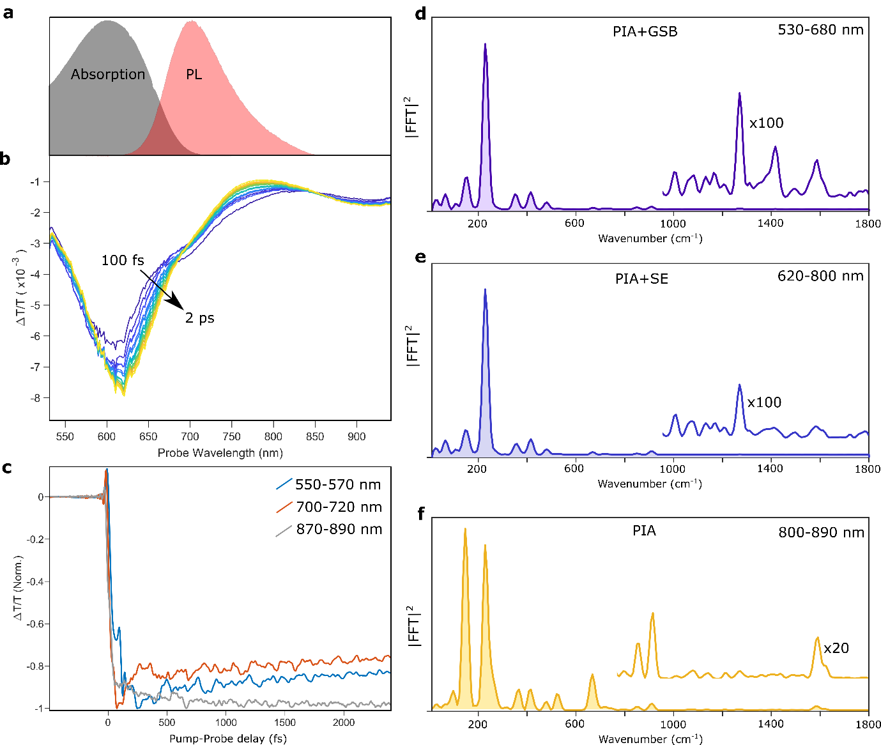
Supplementary Figure 10: Probe wavelength-resolved analysis of the resonant IVS (pump-probe) of the TTM-3PCz: a, the photoluminescence and absorption spectra of TTM-3PCz (CHCl₃) plotted in red and grey area-plot respectively. b, Evolution of the transient absorption signal from 100 fs to 2 ps. The TA signals at each time steps are area normalized. c, Temporal kinetic extracted from the 700-720 nm (SE-rich PIA) and 880-900 nm (pristine PIA). d, Fourier transformed vibrational spectra extracted from the PIA+GSB (530-680 nm) convoluted transient absorption signal. e, Fourier transformed vibrational extracted spectra from the PIA+SE (620-800 nm) convoluted transient absorption signal. f, Fourier transformed vibrational extracted spectra from the pristine-PIA (800-890 nm) convoluted transient absorption signal. (Note: The Raman spectra presented on d-f panel are averaged over the probe wavelength in frequency domain after FFT to avoid artefacts that could arise in the time domain averaging due to phase-killing resulted from chirp artefact which could affect the intensity of high-frequency modes)

Section 6: Assignment of the excited-state vibrational coherence based on phase analysis of the coherent oscillations
In broadband resonant IVS, a nuclear wavepacket motion is generated after projecting the ground-state population into the excited-state. When the excited electronic state is displaced with respect to the ground electronic state along a normal mode coordinate, the wavepacket motion is launched at one side of excited potential energy surface and its motion to the other side of the potential energy surface along the normal mode coordinate is detected as vibrational coherence at each probe wavelength. The vibrational coherence generated on the displaced excited state surface shows a phase shift at a particular probe wavelength which corresponds to the minima of the potential energy surface⁵. Therefore, this phase shift of the excited state coherence which appears as a node in the coherent oscillation map corresponds closely to the photoluminescence maxima. As depicted in the Supplementary Figure 11a, the vibrational coherence is highly dominated by the low frequency mode with almost no contribution from fast high-frequency modes, has a node at 685 nm which nearly corresponds to the PL maxima (~700 nm). When an excited-state wavepacket is generated upon impulsive excitation, the effective energy-gap between ground and excited electronic states increases, which explains the slight blue shift of the node position with respect to the PL maxima⁵. Thus, this analysis additionally supports the high-frequency decoupled exciton-vibrational coupling for TTM-3PCz exciton. The schematic of this phenomenon is illustrated in Supplementary Figure 11b.
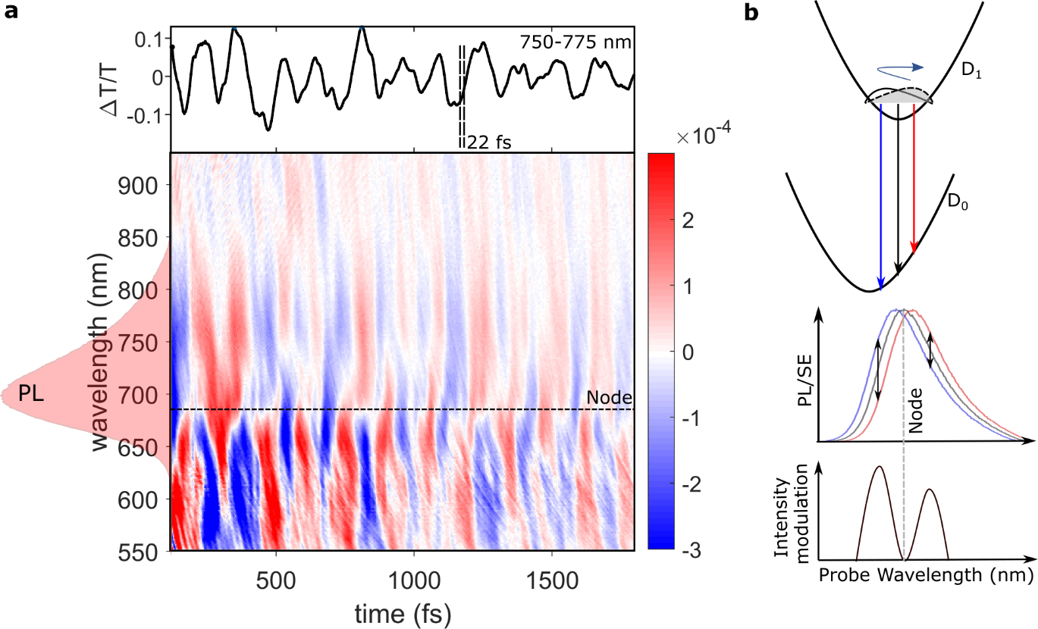
Supplementary Figure 11: Phase Analysis and origin of the high-frequency decoupled vibrational coherence: a, Pump-probe map (TTM-3PCz) showing coherent oscillations after fitting the population kinetics and subsequently subtracting from convoluted kinetics at each probe wavelength. The wavelength snap (750-775 nm) is plotted on the upper panel. The reference 22 fs indicates a typical oscillation period of a high frequency C=C stretching mode. b, Schematic illustration explaining the spectral position of the node.

Section 7: Excited-state impulsive vibrational spectroscopy of 4CzIPN in 3-pulse geometry
As the blue shifted charge-transfer absorption band of 4CzIPN (see absorption spectra in Supplementary Figure 12a) is not directly accessible by the impulsive pumps available to our system (see methods), we performed a 3-pulse actinic pump excitation followed by an impulsive ‘push’ pulse to generate nuclear wavepacket motion on the excited state surface⁶. The 200 fs actinic pump is spectrally tunned to 450 nm to photo-excite the ¹CT state⁷. The transient absorption spectra plotted in Supplementary Figure 12a reveal a negative differential transmittance signal (600-900 nm) which corresponds to the photo-induced absorption feature of the CT-type S₁ state to higher excited state. The impulsive push pulse (Supplementary Figure 12a, red) is spectrally tuned to the NIR region so that it has lower photon energy than lowest energy absorption band. The push pulse in compressed through the quartz window of the 200-micron cuvette by a pair of chirp mirror and the temporal profile of the compressed impulsive push pulse is characterised by SHG-FROG. The FWHM of the retrieved pulse is 8.2 fs (Supplementary Figure 12b). In Supplementary Figure 12c, the wavelength-resolved off-resonant IVS map of acetonitrile in 200-micron cuvette performed with the same impulsive push pulse is plotted. The observation of the C-H stretch mode at ~2900 cm⁻¹ with significant intensity demonstrates that the pump pulse in this case is well-compressed (< 11.5 fs, the period of oscillation for a mode at 2900 cm⁻¹) and is sufficient to observe modes having frequencies less than 2900 cm⁻¹. To reveal the excited state (¹CT) vibrational coupling, 500 fs after the initial photoexcitation with 450 nm actinic pump, the excited state population is re-excited with the impulsive push pulse. Vibrational coherence generated on the excited surface is probed by the time delayed white-light probe (same as described in the method section).
The impulsive vibrational map is generated by fast Fourier transforming the excited state coherence after excluding the ground state contribution which is plotted in the Extended Data Fig. 4b (1 mm cuvette) and Supplementary Figure 12d (200-micron cuvette). The excited state vibrational spectrum is dominated by low frequency modes (244, 428 cm⁻¹). No significant intensity is obtained from the high-frequency Raman modes. Additionally, as depicted in the Supplementary Figure 13, no significant difference in spectra is observed between the photo-induced absorption and stimulated emission-rich probe region which strongly indicates the low-frequency vibrational modes are the strongly coupled modes in the generated nuclear wavepacket on the ¹CT surface.
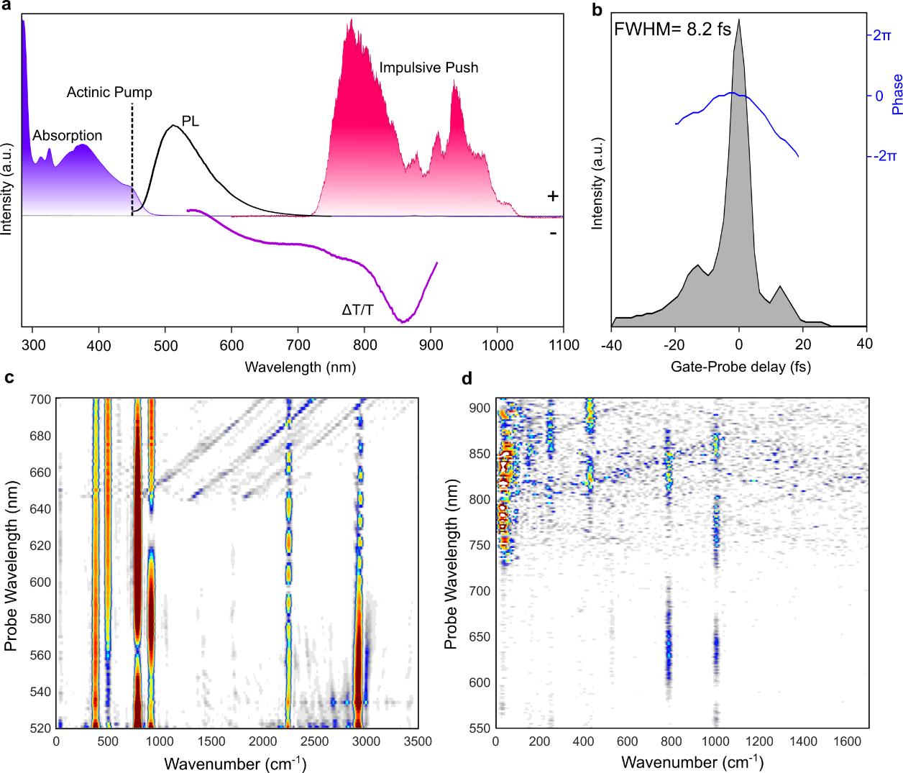
Supplementary Figure 12: Detailed description of the 3-pulse IVS experiment performed on 4CzIPN: a, absorption spectra of 4CzIPN solution in Toluene (blue), wavelength of actinic pump (dotted black), photoluminescence spectra (black line), transient absorption (photoinduced absorption) signature (purple), spectra of the impulsive push (red). b, Temporal profile of the impulsive push pulse retrieved with SHG-FROG. c, off-resonant IVS map of acetonitrile showing significant intensity at 2900 cm⁻¹. d, Experimental excited-state Raman map of 4CzIPN (toluene, 200-micron quartz cuvette)
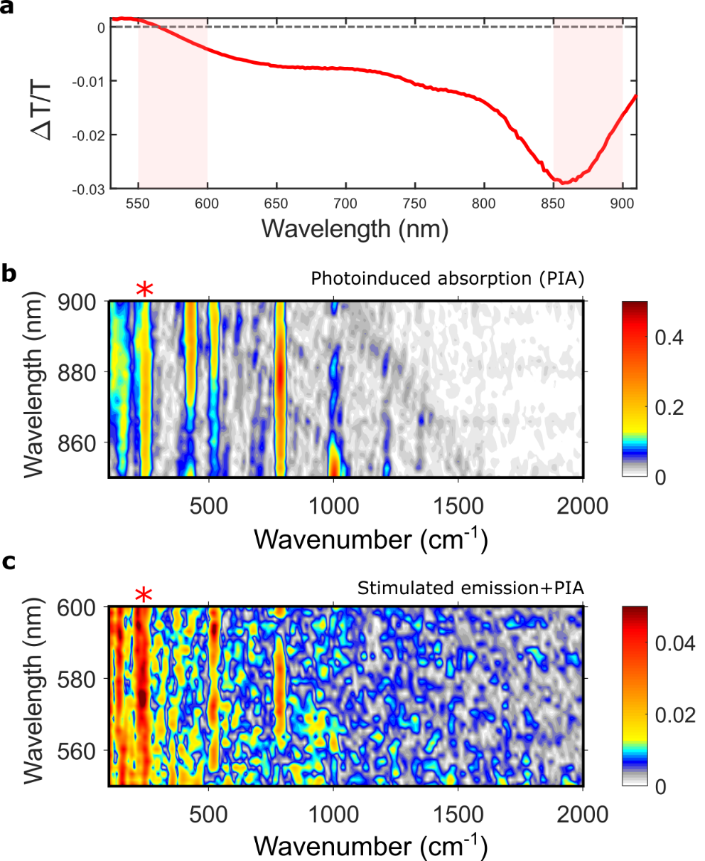
Supplementary Figure 13: Detailed description of the probe wavelength resolved IVS spectra of 4CzIPN: a, Transient absorption signal (at 10 ps) of 4CzIPN (toluene) upon pumping at 450 nm. b, IVS map (850-900 nm) extracted from the vibrational coherence generated at the PIA regime. c, IVS map (550-600 nm) extracted from the vibrational coherence generated at the SE+PIA regime. Asterisk indicates 244 cm⁻¹ mode which one of the prominent modes coupled to the 4CzIPN exciton.

Section 8: Ultrafast dynamics of TTM-TPA (Band selective excitation)
As reported earlier⁸, for this class of TTM-donor molecules, no significant difference in photoluminescence quantum yield is observed upon photoexciting to the higher lying local excited state and lower lying charge transfer state. Hence, it can be concluded that higher excited state population (D₂ exciton) rapidly internally convert to the lowest excited charge transfer state (D₁ exciton).
The ultrafast transient absorption response from TTM-TPA upon photo exciting the D₁ state (P₁ pulse) and the D₂-rich state (P₂ pulse) is shown in Extended Data Fig. 5a. The whole visible probe is dominated by the negative differential transmittance signal (photo-induced absorption) upon exciting with both pulses. At ultrafast timescale (100-200 fs), P₂ excited negative feature is red-shifted by 30 nm with respect to the P₁ excited feature. At later time scale (2 ps), the photo-excited absorption features excited by both pulses appear to be converged. As the higher-lying excited states (D_{n}, n≥3) are energetically very close⁹, the photo induced absorption (PIA) from the D₂ state is expected to be energetically lower with respect to the PIA from the D₁ state (schematised in the Extended Data Fig. 5b, inset). That indicates the early time population, which is photo generated by the P₂ pulse, corresponds to the D₂ excited state and the internal conversion from D₂ to the D₁ is almost completed in 2 ps. To estimate the temporal dynamics of the internal conversion, we compute a wavelength dependent scaling factor at 2 ps of the ΔT/T (P₁-excited) to the ΔT/T (P₂-excited). Therefore, temporal dynamics of the parameter $\left\{\frac{ΔT}{T}\left(P_{2}\right)-{\frac{ΔT}{T}}_{scaled}(P_{1})\right\}$, should obtain the lifetime of D₂ exciton (internal conversion timescale for D₂→ D₁), which is plotted in the Extended Data Fig. 5b for a representative wavelength (790-800 nm) and turns out to be 670±125 fs.

Section 9: Analysis of the low frequency vibrational modes of TTM-3PCz
The experimentally obtained excited state Raman spectra of TTM-3PCz (see Extended Data Fig. 3a) depicts vibrational modes with frequency 232 cm⁻¹ and 150 cm⁻¹ shows the strongest exciton-vibration coupling. To visualize the nature of these two normal modes we calculate all the normal modes of TTM-3PCz and corresponding coupling to the D₀ → D₁ transition (see the Huang-Rhys Factor vs mode frequency plot at Extended Data Fig. 3b). Very strongly coupled modes at 156, 202 and 204 cm-1 should correspond to experimentally obtained modes. As shown in Extended Data Fig. 3c, the mode at 150 (156) cm⁻¹ corresponds to structural deformation motion which include out of plane ring bending at the TTM part and in plane ring deformation at 3PCz part. The vibrational mode at 232 (202/204) cm⁻¹ is associated with a torsional mode predominantly localised in the junction of the donor(3PCz) and acceptor (TTM).
Section 10: Charge-transfer character
Supplementary Figure 14 visualises the frontier molecular orbitals of APDC-DTPA, ITIC and TTM-3PCz, as obtained from our DFT calculations. Our TD-DFT calculations indicate that the first excited state in these systems is predominantly HOMO to SOMO/LUMO, hence the spatial overlap of these orbitals determines the charge transfer character of the lowest excited state in these structures. Evidently, in APDC-DTPA and TTM-3PCz, there is little spatial overlap between the two, making the charge transfer character dominant. On the other hand, in ITIC (NFA) there is large overlap between the orbitals, giving the excitation a weak charge-transfer character.
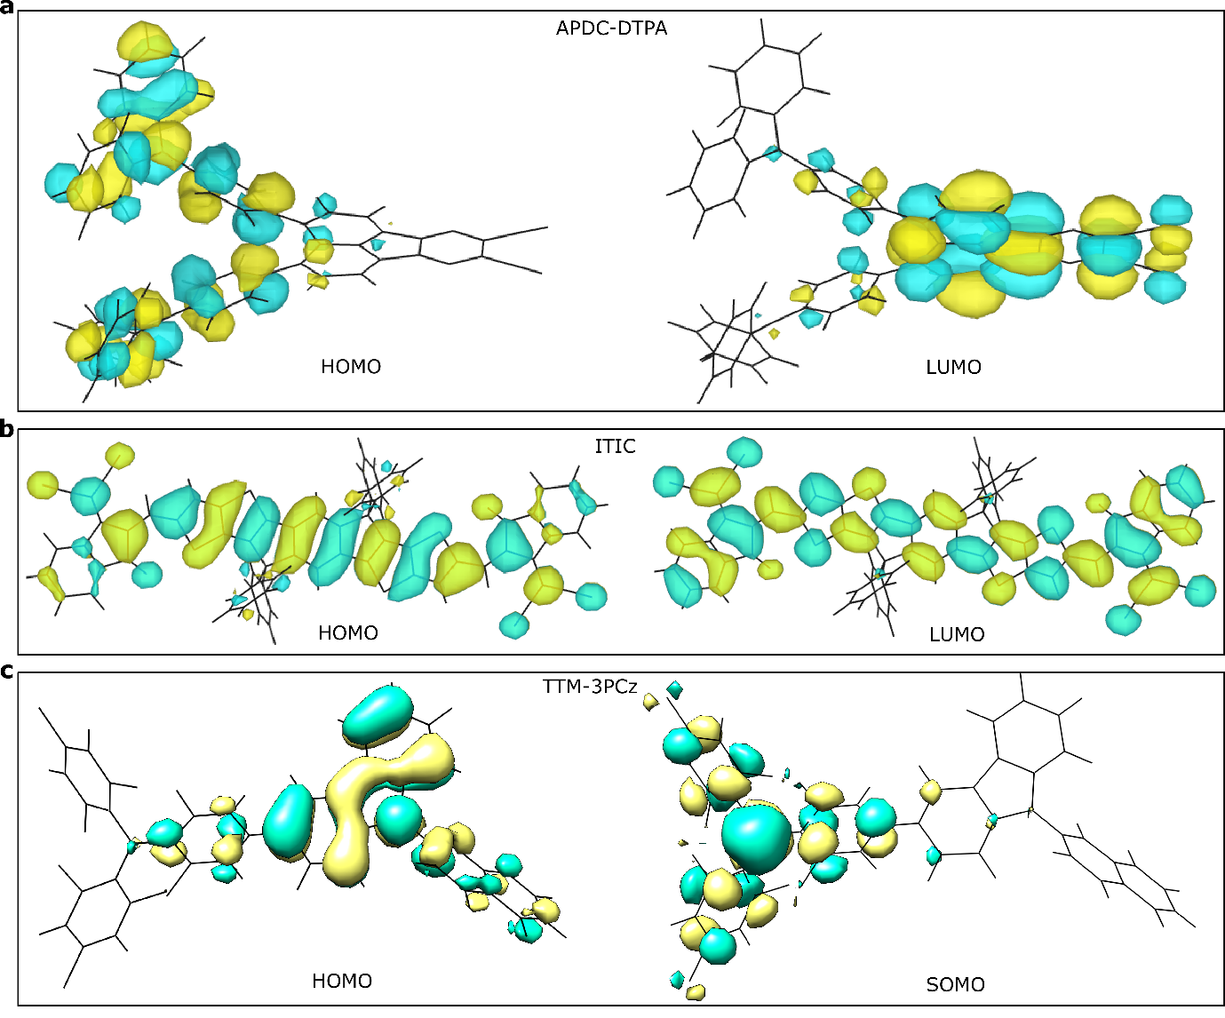
Supplementary Figure 14: HOMO and LUMO/SOMO of the representative TADF (APDC-DTPA), NFA (ITIC), radical (TTM-3PCz)
Section 11: Electronic structure Calculation of TTM-TPA
Unrestricted Kohn-Sham time-dependent density-functional theory (TDDFT) calculations using the B3LYP functional and cc-pVDZ basis set give good agreement with experiment for the transition energy of the lowest three absorption bands, which are listed in Extended Data Table 2. The contributions of the different molecular orbitals involved in the transitions are also given in Extended Data Table 2. This is in agreement with previous calculations¹⁰ performed on the similar derivative TTM-3NCz, showing electronic transitions taking place from closed-shell orbitals to the singly-occupied molecular orbitals (SOMO), for the first three excited states.
Section 12: Calculation of exciton-vibration interactions in studied molecules
We start by describing the mode frequency-resolved exciton-vibration coupling of TTM-TPA as a model system of an efficient radical emitter. Following a geometry optimization at the ground electronic state using the cc-pVDZ basis set and B3LYP functional, we calculate the vibrational modes within the harmonic approximation and a scaling factor of 0.9688 is applied to the vibrational frequencies¹¹. We analysed 172 out of 192 modes with vibrational frequencies $\left(100 cm^{-1}≤ω(k)≤2000 cm^{-1}\right)$, as the modes with extremely low frequency (<100 cm⁻¹) are highly anharmonic in nature¹². Likewise, Carbon-Hydrogen stretching modes with very high frequency (>2000 cm⁻¹) are known to couple to the exciton weakly¹³ at the single molecule level (excluding the H-bonding in an aggregate¹⁴) and are also beyond our experimental scope.
For the excited electronic states $i$ of interest we calculate the exciton-vibration coupling for each mode $k$ as:
$V_{ev(i) }(k)= \frac{E_{ex(i)}^{+{δu}_{k}}-E_{ex(i)}^{-{δu}_{k}}}{2δu\left(k\right)},\left(i=D_{0}→D_{1}/D_{0}→D_{2}\right)$ SI1
Where ${δu}_{k}$ represents a small unitless displacement of the equillibrium geometry along the vibrational mode, $k$. $E_{ex(i)}^{+δu\left(k\right)}$ and $E_{ex(i)}^{-δu\left(k\right)}$ refer to the excitation energy for an electronic transition$(i)$ upon displacing the equilibrium geometry by a small dimensionless quantity ($+δu,-δu$) along the $k$^{th} normal mode with frequency $ω$, in the harmonic limit.
Hence, for every vibrational mode, two TD-DFT calculations are required per excited state.
The Huang-Rhys factors are then obtained as
$S_{i}\left(k\right)={\left(\frac{V_{ev(i) }(k)}{ℏω(k)}\right)}^{2}$ SI2
The total reorganisation energy is approximated as^{15,16}
$λ=\sum_{k}{2ℏ}ω(k)S_{i}\left(k\right)$ SI3
The vibrational reorganisation energy is approximated as^{15,16}
$λ_{v}=\sum_{k}{ℏ}ω(k)S_{i}\left(k\right)$ SI4
In order to quantify the contribution of high-frequency versus low-frequency modes to the overall exciton-vibration coupling, we compute the ratio of the vibrational reorganization energy ($λ_{v}$) due to high-frequency motions $(>1000{ cm}^{-1})$ to that due to low-frequency modes $(<1000{ cm}^{-1})$:
$φ_{lf}^{hf}=\frac{λ_{v}^{hf}}{λ_{v}^{lf}}$; where $λ_{v}^{hf}=\sum_{ω_{k}=1000}^{2000}{ℏω_{k}S_{ev}\left(k\right); }λ_{v}^{lf}=\sum_{ω_{k}=100}^{1000}{ℏω_{k}S_{ev}\left(k\right)}$ SI5
Extended Data Fig. 8a-b visualizes the mode-resolved contributions to the vibrational reorganization energy ($λ_{v}$) of the $D_{1}$ and $D_{2}$ states of TTM-TPA, from where it becomes evident that high-frequency modes play a significantly less prominent role for the charge-transfer-like $D_{1}$ wavefunction. Indeed, the ratio defined above has a value of $0.66$ for this state, compared to $1.93$ for $D_{2}$, further emphasising this important difference.
It is important to emphasise that the larger contribution of high-frequency modes to the exciton-vibration coupling of non-CT excitons compared to charge transfer states is a general effect, which does not rely on the spin configuration of the state under question. The main parameter that controls the magnitude of this interaction is the spatial overlap of electron and hole. While for TTM-TPA this was shown for the case of doublets, the same trend holds for triplet states and singlets¹⁷. To highlight this fact, we compute the ratio of high-frequency to low-frequency contributions to the reorganization energy of the excited states of different molecules with varying degrees of charge transfer character, namely the first excited singlet $S_{1}$ of pentacene, the doublet $D_{1}$ of the TTM radical (rather than the TTM-TPA donor-acceptor structure which hosts a charge transfer exciton as its lowest excitation), and $S_{1}$ of APDC-DTPA molecule which exhibits thermally activated delayed fluorescence¹⁸. We visualise the result in Extended Data Fig. 8c, from where it becomes evident that increased charge transfer character is directly correlated with decreased coupling to high-frequency motions and hence suppressed non-radiative recombination.
Section 13: Exciton-vibrational coupling displacing along a pair of high-frequency normal modes
To investigate the effect of a pair of high-frequency modes on the D₀→D₁ exciton of TTM-TPA, we have performed the analysis outlined in the work of Monserrat et al¹⁹. We have chosen the 1561 cm⁻¹ normal mode as acceptor (TTM) centred high-frequency mode (Supplementary Figure 15a), the effect of which on the CT (D₀→D₁) and Non-CT (D₀→D₂) has been extensively discussed in the main text. We have also chosen the 1614 cm⁻¹ mode as a donor (TPA) centred high-frequency mode involving C=C stretching mode (Supplementary Figure 15b). The equilibrium geometry is displaced along both normal modes as shown in Supplementary Figure 15c which visualises the total ground state DFT energies along those geometries. In the harmonic limit, we choose the combinations of displacements of $u=±1$ (in units of the zero-point width $1/\sqrt{2ω}$ of each mode). The 2D interpolated colour plot (Supplementary Figure 15d) visualises the absolute value of the deviation of the excitation energy (D₀→D₁) of the displaced geometry from the equilibrium geometry (|E-E_{eq.}|). The black circles in Supplementary Figure 15d correspond to geometries where the structure is displaced along individual modes. The red and blue circles correspond to in-phase and out-of-phase combinations of the two modes respectively, when they are displaced simultaneously. When the modes are displaced in-phase the change in the excited state energy becomes higher (|E-E_{eq.}|=0.0388±0.0023 eV) with respect to geometries along the individual vibrational modes (0.0194± 0.0038 eV). The change in the excited state energy is significantly reduced (0.0063± 0.0026 eV) when the two modes are displaced in an out-of-phase manner.
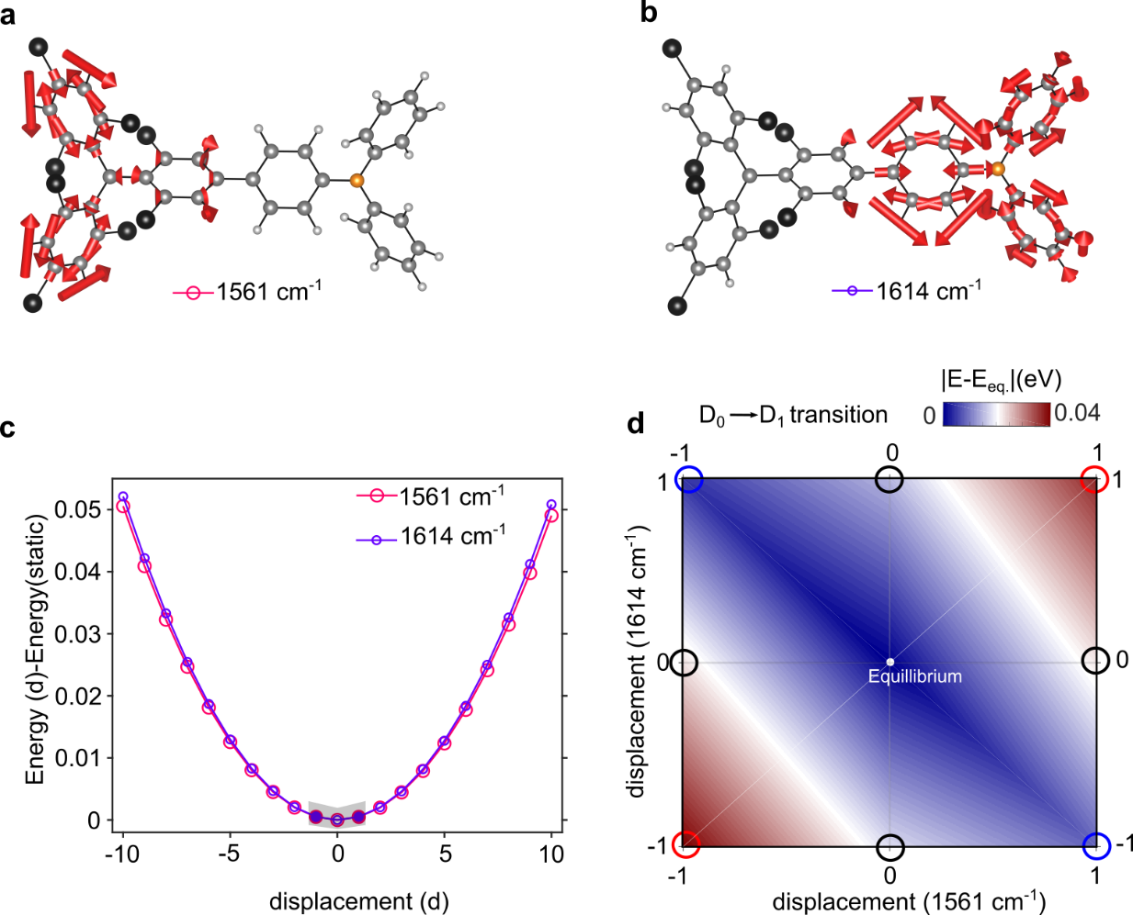
Supplementary Figure 15: Excited state energies along a pair of normal modes: a, vector displacement diagram of the SOMO (e⁻)- centered normal mode with frequency 1561 cm⁻¹. b, vector displacement diagram of the HOMO (h⁺)- centered normal mode with frequency 1614 cm⁻¹. c, ground state potential energy surface of the two normal modes. d, Interpolated contour plot of the differential transition energy (D₀→D₁) against displacement along the coordinate of 1561 cm⁻¹ and 1614 cm⁻¹ modes. The black circles represent the geometries corresponding to the displacement from the equilibrium geometry along the individual normal modes. The blue and red circles represent the geometry when the molecule is displaced along both normal modes. The in-phase and out-of-phase displacements are indicated by red and blue circles respectively.

Section 14: Molecular orbital (MO)-vibrational coupling
To gain insights about how individual molecular orbitals are coupled to the vibrational modes, we calculated the Huang-Rhys factor which is defined for k^{th} normal mode as -
$S\left(k\right)={\left(\frac{E_{mo}^{+{δu}_{k}}-E_{mo}^{-{δu}_{k}}}{2δu\left(k\right).ℏω\left(k\right)}\right)}^{2}$ SI6
Where ${δu}_{k}$ represents a small unitless displacement of the equillibrium geometry along the vibrational mode, $k$. $E_{mo}^{+{δu}_{k}}$ and $E_{mo}^{-{δu}_{k}}$ refer to the energy of a particular molecular orbital upon displacing the equilibrium geometry by a small dimensionless quantity ($+δu,-δu$) along the $k$^{th} normal mode with frequency $ω$, in the harmonic limit. Hence, for every vibrational mode, two DFT calculations are required per molecular orbital. Due to the highly anharmonic nature of the modes having frequency ≤100 cm⁻¹, we focus on the normal modes in the frequency range of 100-2000 cm⁻¹.
14.1: Electronic Localisation of the HOMO of non-planar donor moieties
In Supplementary Figure 16-17, we visualise the Huang-Rhys factor for the frontier molecular orbitals of the triphenylamine (TPA) and N-phenylcarbazole (PCz) which are representative of the donor moieties of the studied radical systems (TTM-3PCz, TTM-3NCz, TTM-TPA) and TADF systems (APDC-DTPA, 4CzIPN).
14.1.1: triphenylamine (TPA): As displayed in Supplementary Figure 16, for triphenylamine (TPA), the Huang-Rhys factor of the high-frequency modes (>1000 cm⁻¹) is significantly supressed for the HOMO with respect to the other frontier MOs (HOMO-2, HOMO-1, LUMO, LUMO+1, LUMO+2). For example, the C=C (Carbon double bond) stretching motion in the phenyl rings at 1611 cm⁻¹ (highlighted in red circle in Supplementary Figure 16) has a Huang-Rhys factor for the HOMO that is 1/9th of the LUMO. The HOMO orbital has nitrogen p_{z} non-bonding character. This non-bonding type HOMO of TPA is mostly localised on the N atom and has a very weak π-delocalisation over the phenyl rings due to the non-parallel arrangement of the π-orbitals of the phenyl rings with respect to the central N-atom. Hence, this non-bonding type HOMO which is localised on the N-orbital, will be weakly perturbed upon displacing the equilibrium geometry of the TPA along the high-frequency phenylic π-stretching modes, unlike other MOs which have higher orbital coefficients on the phenyl rings in the vicinity of the C=C bonds.
14.1.2: N-phenylcarbazole (PCz): A similar result has been found for the N-phenylcarbazole (PCz) which is the donor moiety of TTM-3PCz. As visualised in Supplementary Figure 17, the HOMO possesses supressed coupling to the high-frequency modes with respect to the other molecular orbitals. Similar to TPA, the HOMO of PCz has nitrogen p_{z} non-bonding like character. The localisation of the non-bonding type HOMO on the central N atom is not as pronounced as TPA for steric reason. Other MOs, for instance, the LUMO, are highly delocalised over the carbon-rings. This localisation of the non-bonding type HOMO on the N-atom contributes to its reduced coupling to high frequency π-ring stretching modes with respect to the other MOs.

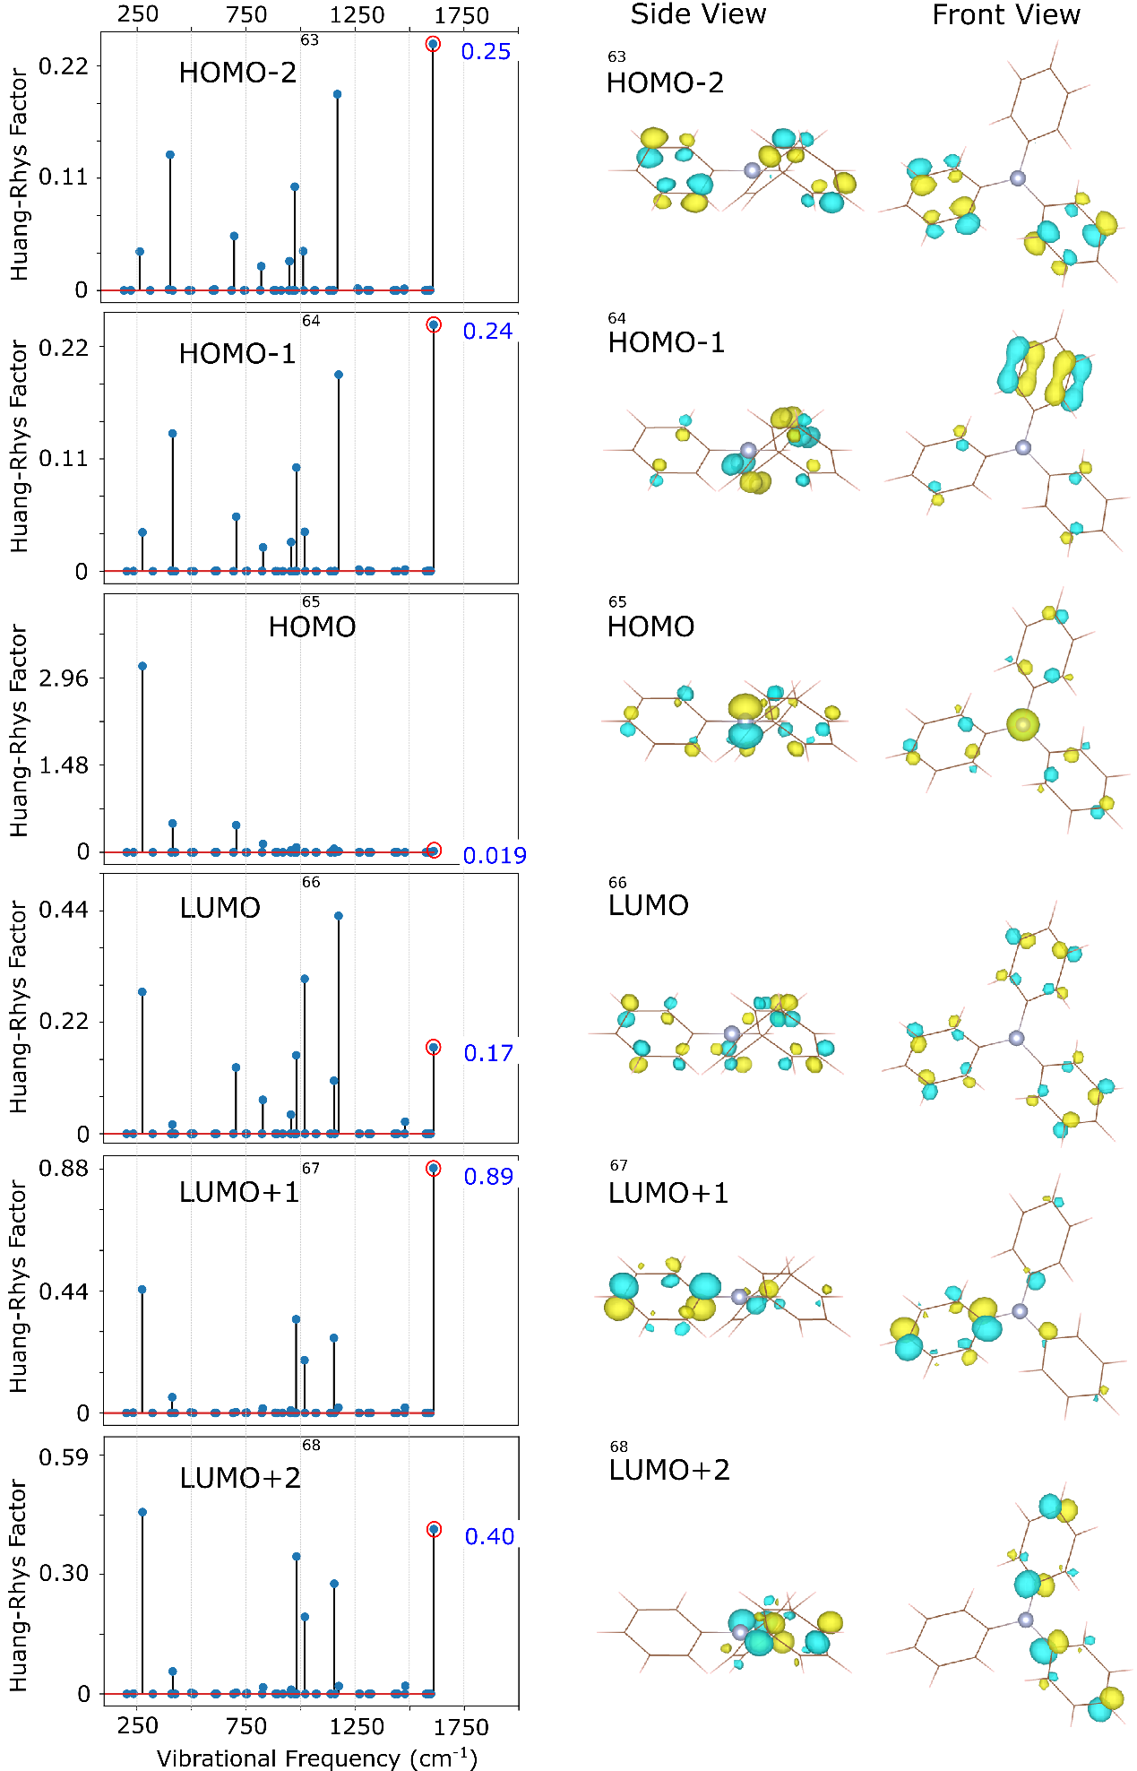
Supplementary Figure 16: Huang-Rhys Factor of the frontier molecular orbitals of triphenylamine (TPA). The red circle indicates the 1611 cm⁻¹ mode and the respective Huang-Rhys Factor for each MO. Frontier molecular are plotted in the right panel of the figure, at the ground state optimised geometry.
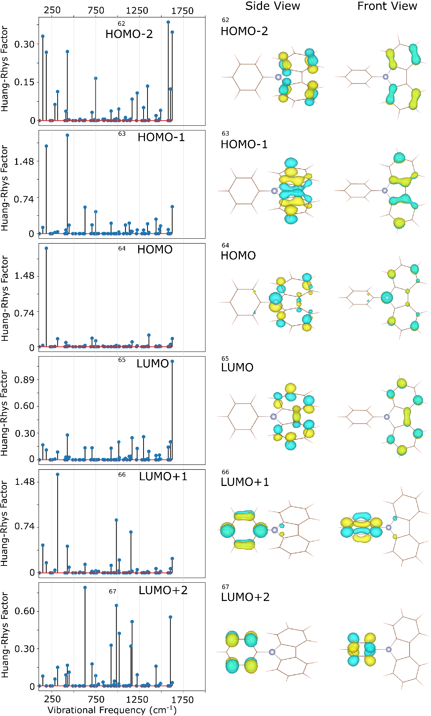
Supplementary Figure 17: Huang-Rhys Factor of the frontier molecular orbitals of the N-phenylcarbazole (PCz) Frontier molecular are plotted in the right panel of the figure at the ground state optimised geometry
14.2: Electronic Localization of the HOMO of APDC-DTPA (TADF) and TTM-TPA (radical)
In the previous subsection (14.1), we discussed how the HOMO of donor moieties (TPA, PCz) is decoupled from the high-frequency π-ring stretching vibrations due to the electronic localisation of the non-bonding type molecular orbital on the central N atom, which is more pronounced for the TPA. We have also evaluated the Huang-Rhys Factor for the frontier MOs of TTM-TPA (Supplementary Figure 18) and APDC-DTPA (Supplementary Figure 21). Both molecules have TPA as a donor moiety, where the non-bonding type HOMO localises. As expected from the results discussed in the previous subsection, the HOMO of both APDC-DTPA and TTM-TPA shows reduced coupling to high-frequency modes.

14.3: Electronic localisation of the SOMO orbital of TTM-Donor radicals
It is intriguing to notice that the SOMO in TTM-TPA shows reduced coupling compared to unoccupied MOs (LUMO, LUMO+1) for the high frequency modes. For example, along the 1572 cm⁻¹ normal mode, which is the C=C stretch at one of the phenyl rings on the TTM moiety (see Supplementary Figure 18, bottom right panel), the Huang-Rhys Factor of the SOMO is 1/60th of the HOMO. A potential explanation of the supressed coupling of the high-frequency ring stretching modes (C=C) to the orbital SOMO with respect to the LUMO and LUMO+1, is the non-bonding nature of the SOMO. As pointed out earlier^{10,20} TTM-donor based radicals’ non-bonding type SOMO has a very dominant orbital contribution on the central sp²-hybridised carbon atom (see the scheme Supplementary Figure 18, right bottom panel). As a result, it is mostly localised on the central Carbon atom and it has very weak orbital coefficients in the vicinity of the phenylic pi-bonds (See Supplementary Figure 19). Hence, the SOMO energy is less perturbed in comparison the other orbitals (LUMO, LUMO+1), upon displacing the molecular geometry along the ring stretching mode (1572 cm⁻¹).

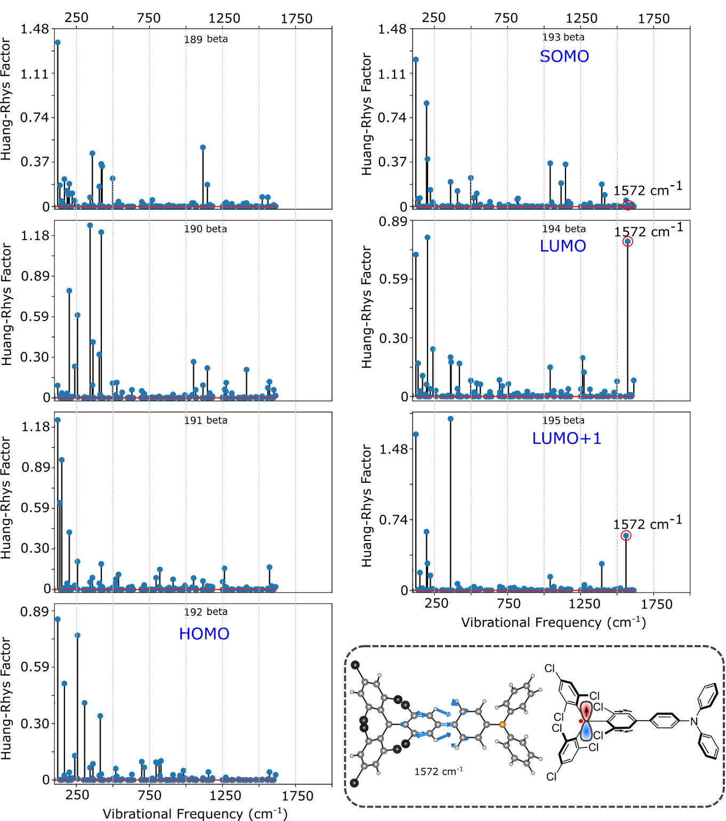
Supplementary Figure 18: Huang-Rhys Factor of the frontier molecular orbitals of the TTMTPA. The red circle highlights the 1572 cm⁻¹ mode. The vector displacement diagram of that mode is plotted in the right bottom panel.
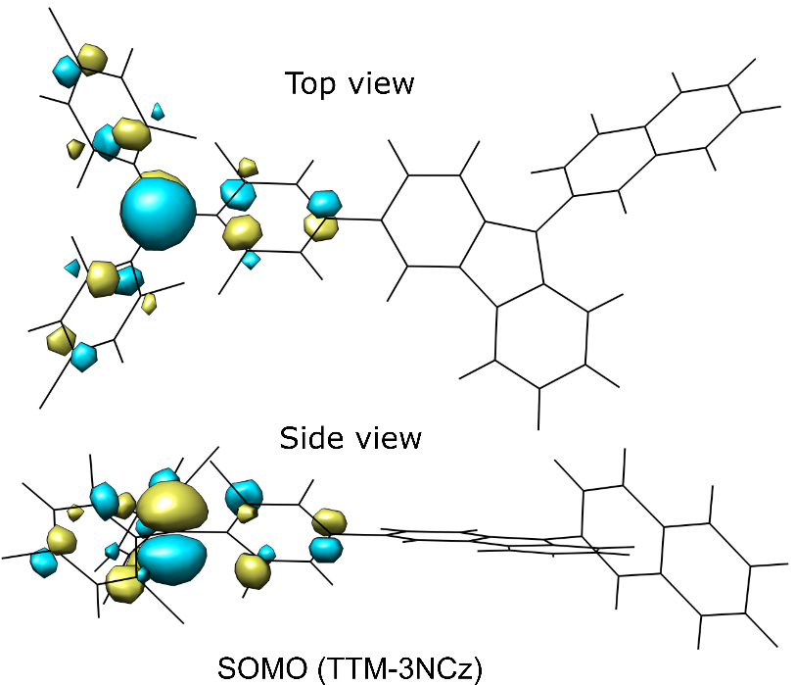
Supplementary Figure 19: SOMO of the TTM-donor radical (representative TTM-3NCz radical adapted from Ai et al¹⁰)

14.4: Electronic localization and vibrational decoupling
In TTM-Donor radicals (TTM-3PCz, TTM-3NCz, TTM-TPA), the charge transfer electronic transition takes place from the donor moiety (TPA, PCz)-centred HOMO to the TTM-centred SOMO as discussed in the main text. Our first-principles calculations show that both of these frontier molecular orbitals are individually weakly-coupled to C=C stretching modes on the phenyl rings, which can be explained by these non-bonding type molecular orbital’s electronic localisation on a single C or N atom.
This is further supported by visualising the exciton wavefunction (transition density) plotted in Supplementary Figure 20. For the charge transfer D₀ → D₁ state in TTM-3PCz and TTM-TPA, the wavefunction is mostly localised on the sp² hybridised central carbon and it has a reasonable contribution on the N atom’s p-orbital in the donor moiety which does not overlap with the phenylic C=C bonds. On the contrary, the exciton wavefunction/transition density for the D₀ → D₂ transition (HOMO-2 → SOMO: 80%) in TTM-TPA is spread over the phenyl rings of the TTM moiety as the lower lying occupied orbitals have π-character unlike the non-bonding p-orbital-centred SOMO¹⁰. Hence, the vibrational coupling in the high frequency regime (C=C stretch) for the D₀ → D₂ transition is higher than the D₀ → D₁ transition, which is consistent with the experimental results obtained for the TTM-TPA radical (Fig. 3, main text).
For the TADF molecule APDC-DTPA, the TDDFT results suggest that the lowest energy charge transfer transition takes place from the TPA-centred HOMO to the ACDC-centred LUMO (98.6%). As predicted from the vibrational coupling of the TPA HOMO (Supplementary Figure 16), the HOMO of APDC-DTPA, which is TPA-rich, shows suppressed coupling to high-frequency modes compared to other frontier MOs (see Supplementary Figure 21). The LUMO of APDC-DTPA, is mostly located on the acenaphthylene based acceptor APDC (see Supplementary Figure 21) and in the vicinity of the π-bonds, hence shows reasonably strong coupling to the high-frequency modes.
Overall, the hypothesis of individually high frequency vibrations decoupled from the HOMO and the LUMO/SOMO (see Supplementary Figure 22) clearly explains the results obtained for the TTM-donor type radicals (presented in Fig 2-3, main text). This hypothesis also explains part of the results obtained for the TADF molecules (APDC-DTPA, 4CzIPN), as the planar acceptor-moiety-rich LUMO still shows reasonable coupling to the high-frequency modes.
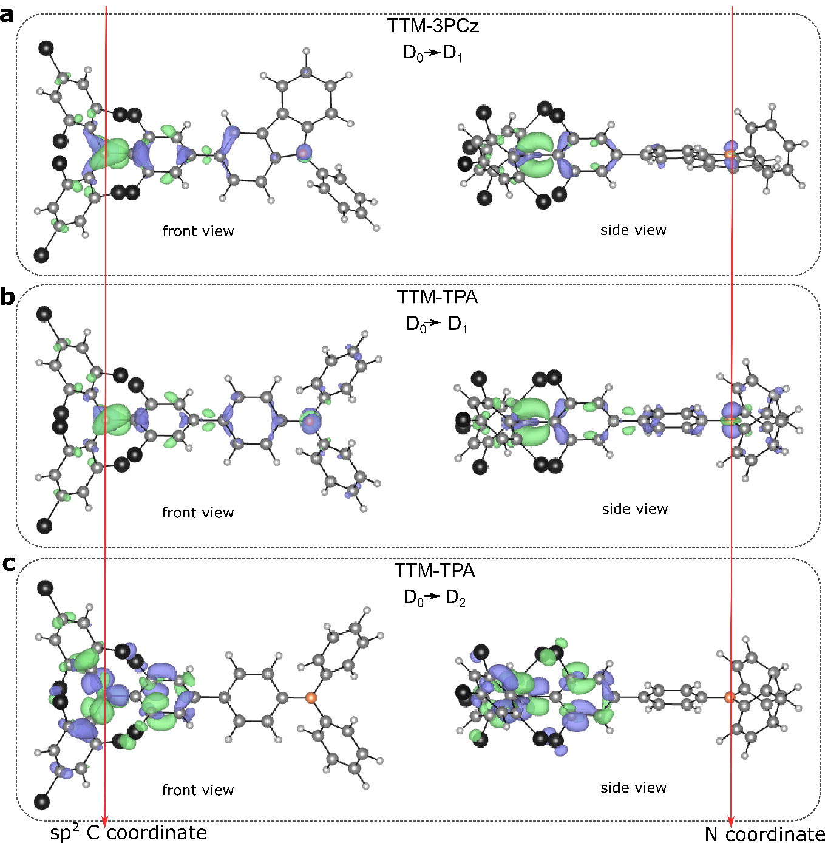
Supplementary Figure 20: High-resolution (higher isosurface value) exciton wavefunction (transition density) plots of the D₀ → D₁ transition in TTM-3PCz, D₀ → D₁ transition in TTM-TPA, D₀ → D₂ transition in TTM-TPA The red arrows indicate the atomic coordinate of the sp² hybridised Carbon (radical centre in TTM moiety) and N-atom in the donor moiety.
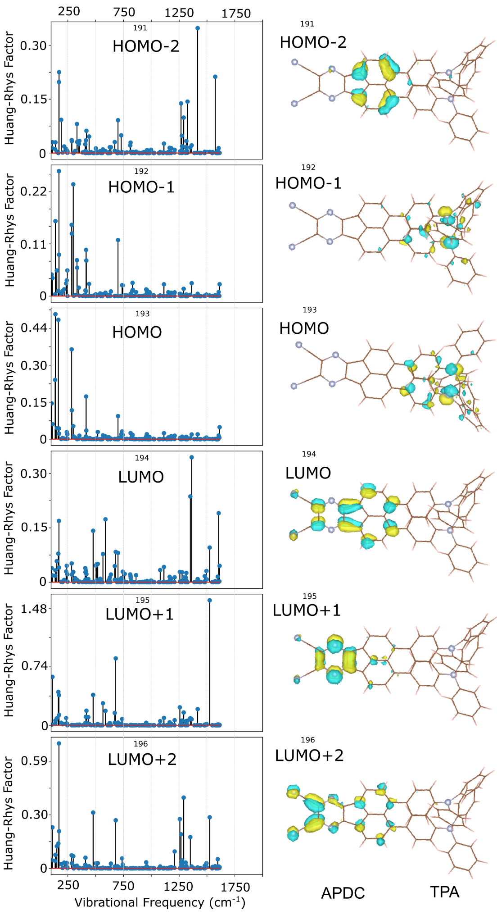
Supplementary Figure 21: Huang-Rhys Factor of the frontier molecular orbitals of the TADF studied APDC-DTPA.

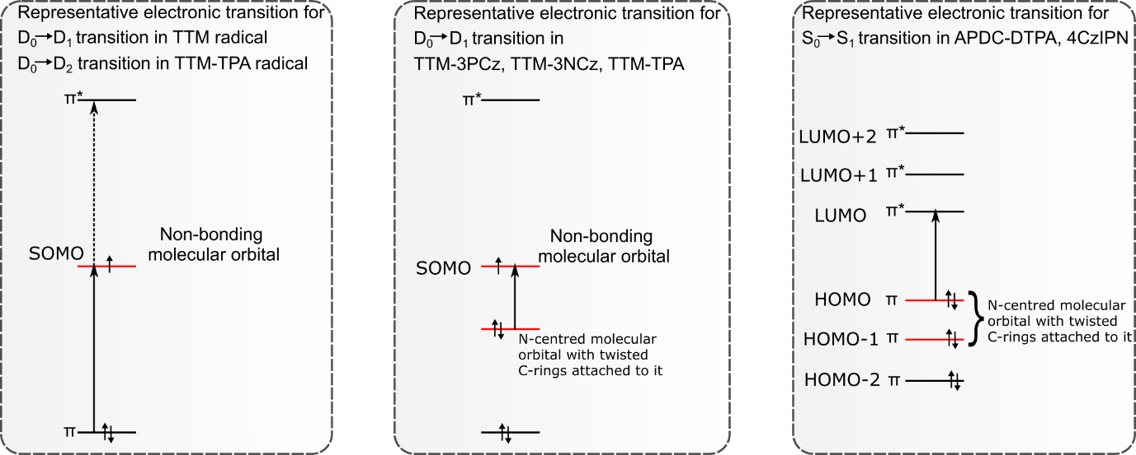
Supplementary Figure 22: Hypothesis of individually high-frequency decoupled HOMO and LUMO/SOMO: The MOs which are highlighted with red, have supressed high-frequency coupling revealed by first principles calculations

Section 15: Zero-point renormalisation of excited state energies using Monte Carlo sampling
Following the procedure outlined in detail in Hele et al.²¹, we compute the vibrationally-renormalised energies for the D₁ and D₂ states of TTM-TPA. Briefly, the excited state energy within the harmonic approximation is:
$E_{exc}\left(T\right)=\int{du{\left|Φ\left(u;T\right)\right|}^{2}E_{exc}(u)}$ SI7
where we integrate over the atomic configuration $u$ and ${|Φ\left(u;T\right)|}^{2}$ is the harmonic density distribution:
${|Φ\left(u;T\right)|}^{2}=\prod_{ν}{{(2πσ_{ν}^{2}(Τ))}^{-1/2}exp⁡(-\frac{u_{ν}^{2}}{2σ_{ν}^{2}\left(Τ\right)})}$ SI8
with every Gaussian having a temperature-dependent width:
$σ_{ν}^{2}\left(Τ\right)=\frac{1}{2ω_{ν}}∙coth⁡(\frac{ω_{ν}}{2k_{B}T})$ SI9
We perform a Monte Carlo sampling of the integral of equation SI7, by generating 100 atomic configurations $u$ distributed according to ${|Φ\left(u;T\right)|}^{2}$, and hence compute the vibrationally-renormalised excited state energy as the simple average:
$E_{exc}\left(T\right)=\frac{1}{N}\sum_{i}{E_{exc}(u_{i})}$ SI10
where $N=100$ in our case. At every configuration, the excited state energy is computed within TD-DFT, using the same computational setup as that outlined in Section 12 of the SI. We find that 100 configurations are well above the number required to reach convergence, as also shown in Supplementary Figure 23 for the example of the D₂ state of TTM-TPA, where we plot the vibrational renormalisation as a function of the atomic configuration of the molecule, also showing the running average in blue. Evidently 20-30 configurations are already sufficient for convergence, and similar results are found for all excited states studied here.
For the D₁ state, the vibrational renormalisation of its energy at 0 K due to molecular vibrations (i.e. the zero-point renormalisation – ZPR) is found to be $ZPR\left(D_{1}\right)=\left(-17±8\right)$ meV, while for the D₂ state this is equal to $ZPR\left(D_{2}\right)=\left(-65±9\right)$ meV. At 0 K vibrational modes are only active with their zero-point energy $ℏω/2$, making the effect of high-frequency modes more prevalent. For this reason, we find that the D₂ state is renormalised by a greater amount than the CT-like D₁ state, since its spatially-localised character dictates a stronger coupling to high-frequency intra-molecular motions. This further supports the mode-resolved picture discussed in the main manuscript, wherein CT-like excitons predominantly couple to low-frequency motions, whereas spatial localisation of excited states favours coupling to high-frequency motions.
Supplementary Figure 23: Convergence of Monte Carlo sampling of the D₂ excited state energy of TTM-TPA.

Section 16: Summary of the efficient red LEDs
Supplementary Table 1: Summary for maximum EQEs and peak wavelengths of different kinds of red LEDs with EL peak wavelength >650nm adapted from Ai et al¹⁰ (Purely organic emitting systems are highlighted in red).
LED | Emitting component |  | EL (nm) | EQE_{max} (%)
Radical LEDs | Spin radical based organic semiconducting molecule | TTM-3NCz¹⁰ | 710 | 26.5
Radical LEDs | Spin radical based organic semiconducting molecule | TTM-3PCz¹⁰ | 703 | 16.6
TADF LEDs | Thermally activated delayed fluorescence based organic molecule | APDC-DTPA¹⁸ | 693 | 10.19
TADF LEDs |  | TPA-QCN²² | 656 | 12.8
QLEDs | Quantum Dots | CdSe/CdTe²³ | 705 | 6.19
PLEDS | Perovskites | ²⁴ | 763 | 11.7
PhosLEDs | Phosphorescent metal-organic MLCT systems | Pt-based²⁵ | 740 | 24±1
Fluorescent LED | Organic fluorophore molecule | TPANSeD²⁶ | 664 | 3.8

References:
1. Gamero, V. et al. [4-(N-Carbazolyl)-2,6-dichlorophenyl]bis(2,4,6-trichlorophenyl)methyl radical an efficient red light-emitting paramagnetic molecule. Tetrahedron Lett. 47, 2305–2309 (2006).
2. Peng, Q., Blikim Obolda, A., Zhang, M. & Li, F. Organic Light-Emitting Diodes Using a Neutral π Radical as Emitter: The Emission from a Doublet. Angew. Chemie 127, 7197–7201 (2015).
3. Liebel, M., Schnedermann, C., Wende, T. & Kukura, P. Principles and Applications of Broadband Impulsive Vibrational Spectroscopy. J. Phys. Chem. A 119, 9506–9517 (2015).
4. Schnedermann, C., Liebel, M. & Kukura, P. Mode-specificity of vibrationally coherent internal conversion in rhodopsin during the primary visual event. J. Am. Chem. Soc. 137, 2886–2891 (2015).
5. Rafiq, S. & Scholes, G. D. Slow Intramolecular Vibrational Relaxation Leads to Long-Lived Excited-State Wavepackets. J. Phys. Chem. A 120, 6792–6799 (2016).
6. Schnedermann, C. et al. A molecular movie of ultrafast singlet fission. Nat. Commun. 10, 4207 (2019).
7. Hosokai, T. et al. 58-2: Revealing the Excited-state Dynamics of Thermally Activated Delayed Flourescence Molecules by using Transient Absorption Spectrospy. SID Symp. Dig. Tech. Pap. 47, 786–789 (2016).
8. Guo, H. et al. High stability and luminescence efficiency in donor–acceptor neutral radicals not following the Aufbau principle. Nat. Mater. 18, 977–984 (2019).
9. Cho, E., Coropceanu, V. & Brédas, J. L. Organic Neutral Radical Emitters: Impact of Chemical Substitution and Electronic-State Hybridization on the Luminescence Properties. J. Am. Chem. Soc. 142, 17782–17786 (2020).
10. Ai, X. et al. Efficient radical-based light-emitting diodes with doublet emission. Nature 563, 536–540 (2018).
11. Merrick, J. P., Moran, D. & Radom, L. An Evaluation of Harmonic Vibrational Frequency Scale Factors. J. Phys. Chem. A 111, 11683–11700 (2007).
12. Alvertis, A. M. et al. Switching between Coherent and Incoherent Singlet Fission via Solvent-Induced Symmetry Breaking. J. Am. Chem. Soc. 141, 17558–17570 (2019).
13. Benduhn, J. et al. Intrinsic non-radiative voltage losses in fullerene-based organic solar cells. Nat. Energy 2, (2017).
14. Zhang, K. et al. Theoretical Study of the Mechanism of Aggregation-Caused Quenching in Near-Infrared Thermally Activated Delayed Fluorescence Molecules: Hydrogen-Bond Effect. (2019) doi:10.1021/acs.jpcc.9b06388.
15. Gruhn, N. E. et al. The Vibrational Reorganization Energy in Pentacene: Molecular Influences on Charge Transport. J. Am. Chem. Soc. 124, 7918–7919 (2002).
16. Regimes of Exciton Transport in Molecular Crystals in the Presence of Dynamic Disorder. https://onlinelibrary.wiley.com/doi/epdf/10.1002/adfm.201503888.
17. Alvertis, A. M. et al. Impact of exciton delocalization on exciton-vibration interactions in organic semiconductors. Phys. Rev. B 102, (2020).
18. Yuan, Y. et al. Over 10% EQE Near-Infrared Electroluminescence Based on a Thermally Activated Delayed Fluorescence Emitter. Adv. Funct. Mater. 27, 1700986 (2017).
19. Monserrat, B., Drummond, N. D. & Needs, R. J. Anharmonic vibrational properties in periodic systems: energy, electron-phonon coupling, and stress. Phys. Rev. B 87, 144302 (2013).
20. Abdurahman, A. et al. Understanding the luminescent nature of organic radicals for efficient doublet emitters and pure-red light-emitting diodes. Nat. Mater. 19, 1224–1229 (2020).
21. Hele, T. J. H., Monserrat, B. & Alvertis, A. M. Systematic improvement of molecular excited state calculations by inclusion of nuclear quantum motion: A mode-resolved picture and the effect of molecular size. J. Chem. Phys. 154, (2021).
22. Li, C. et al. Deep-Red to Near-Infrared Thermally Activated Delayed Fluorescence in Organic Solid Films and Electroluminescent Devices. Angew. Chemie Int. Ed. 56, 11525–11529 (2017).
23. Lin, Q. et al. High-efficiency deep-red quantum-dot light-emitting diodes with type-II CdSe/CdTe core/shell quantum dots as emissive layers. J. Mater. Chem. C 4, 7223–7229 (2016).
24. Wang, N. et al. Perovskite light-emitting diodes based on solution-processed self-organized multiple quantum wells. Nat. Photonics 2016 1011 10, 699–704 (2016).
25. Tuong Ly, K. et al. Near-infrared organic light-emitting diodes with very high external quantum efficiency and radiance. Nat. Photonics 2016 111 11, 63–68 (2016).
26. Xue, J. et al. High-Efficiency Near-Infrared Fluorescent Organic Light-Emitting Diodes with Small Efficiency Roll-Off: A Combined Design from Emitters to Devices. Adv. Funct. Mater. 27, 1703283 (2017).

