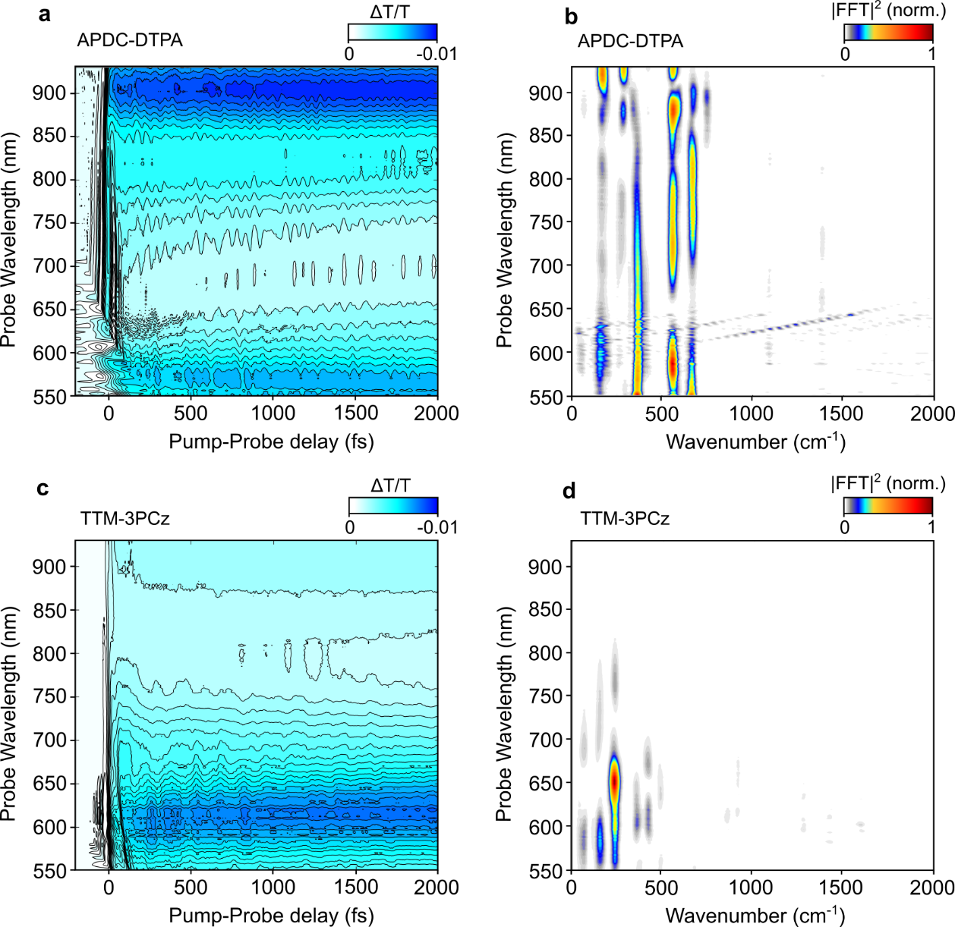
Extended Data Fig. 1 | Probe-wavelength-resolved resonant-IVS data of APDC-DTPA and TTM-3PCz: a (APDC-DTPA), c (TTM-3PCz), Differential transmission map following excitation with a 10-fs pulse centred at 575 nm, at room temperature. b (APDC-DTPA), d (TTM-3PCz), Wavelength-resolved impulsive Raman map of following impulsive photo-excitation into lowest excited CT state

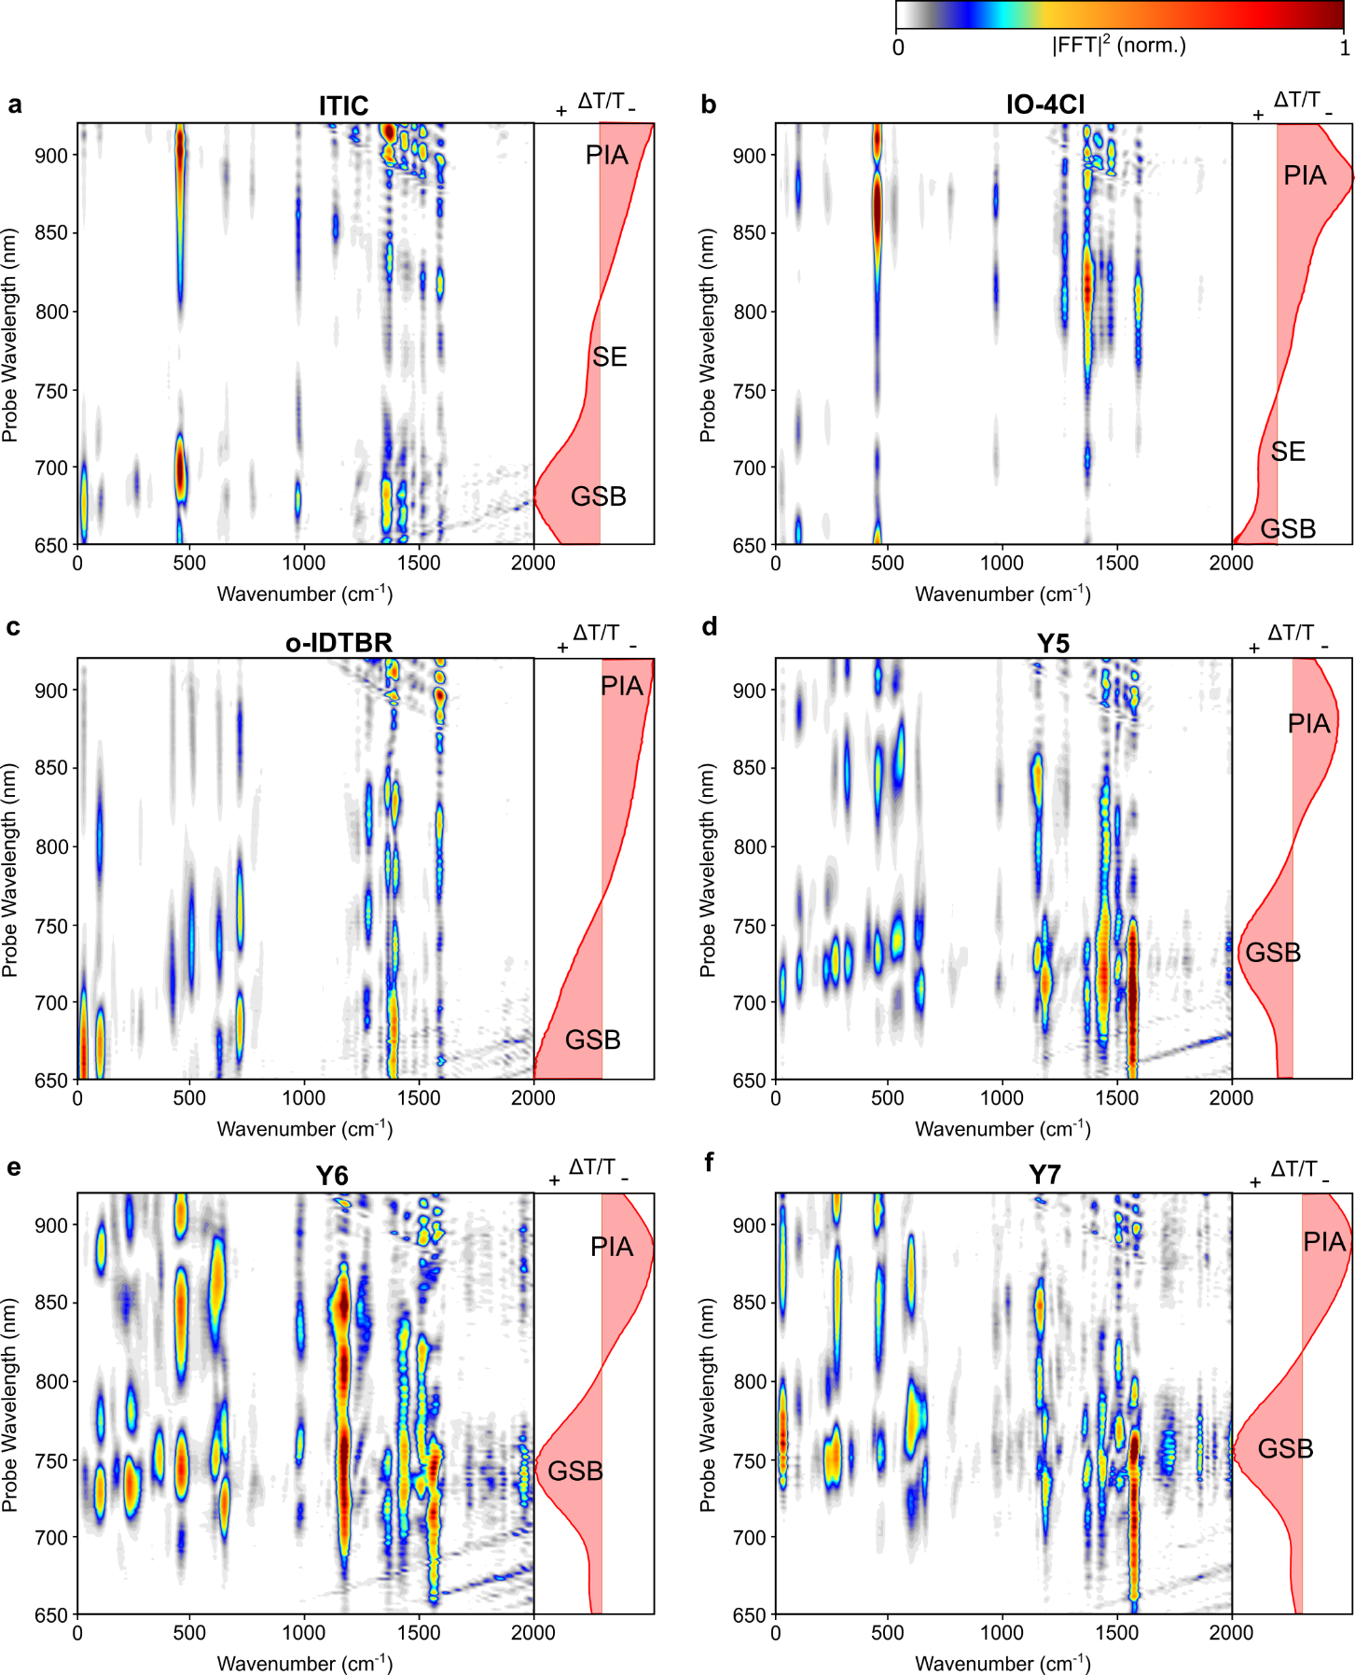
Extended Data Fig. 2 | Probe-wavelength-resolved resonant-IVS studies on non-fullerene acceptor (NFA) molecules in chloroform solution: The chemical structures of the NFA molecules studied and the corresponding absorption spectra in chloroform are shown in the top panel (dashed box). Wavelength-resolved impulsive Raman map of a ITIC, b IO-4Cl, c o-IDTBR, d Y5, e Y6, f Y7. Transient absorption spectra at 1-2 picosecond are plotted in the right inset of every panel.
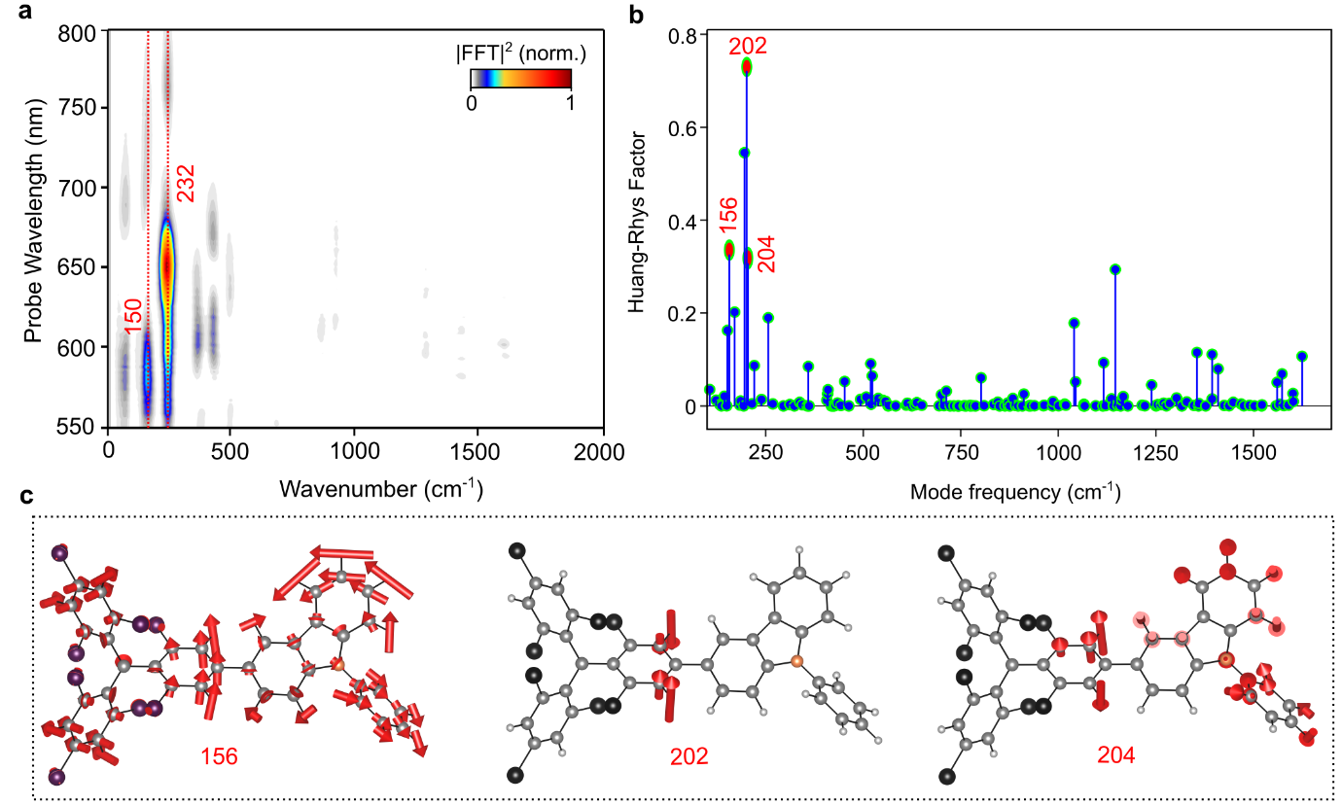Extended Data Fig. 3 | Analysis of the exciton-vibration coupling constant of TTM-3PCz and assignment of strongly coupled mode to the excited state: a, Excited-state Raman map of TTM-3PCz in CHCl₃, b Calculated Hung-Rhys factor associated with the lowest energy transition (D₀ → D₁) of TTM-3PCz, c vector displacement diagram of the normal modes with calculated frequency 156, 202, 204 cm⁻¹ which correspond to experimentally obtained 150, 232 cm⁻¹ mode.
The description of this figure is discussed in further detail in Supplementary Information (Section 9).
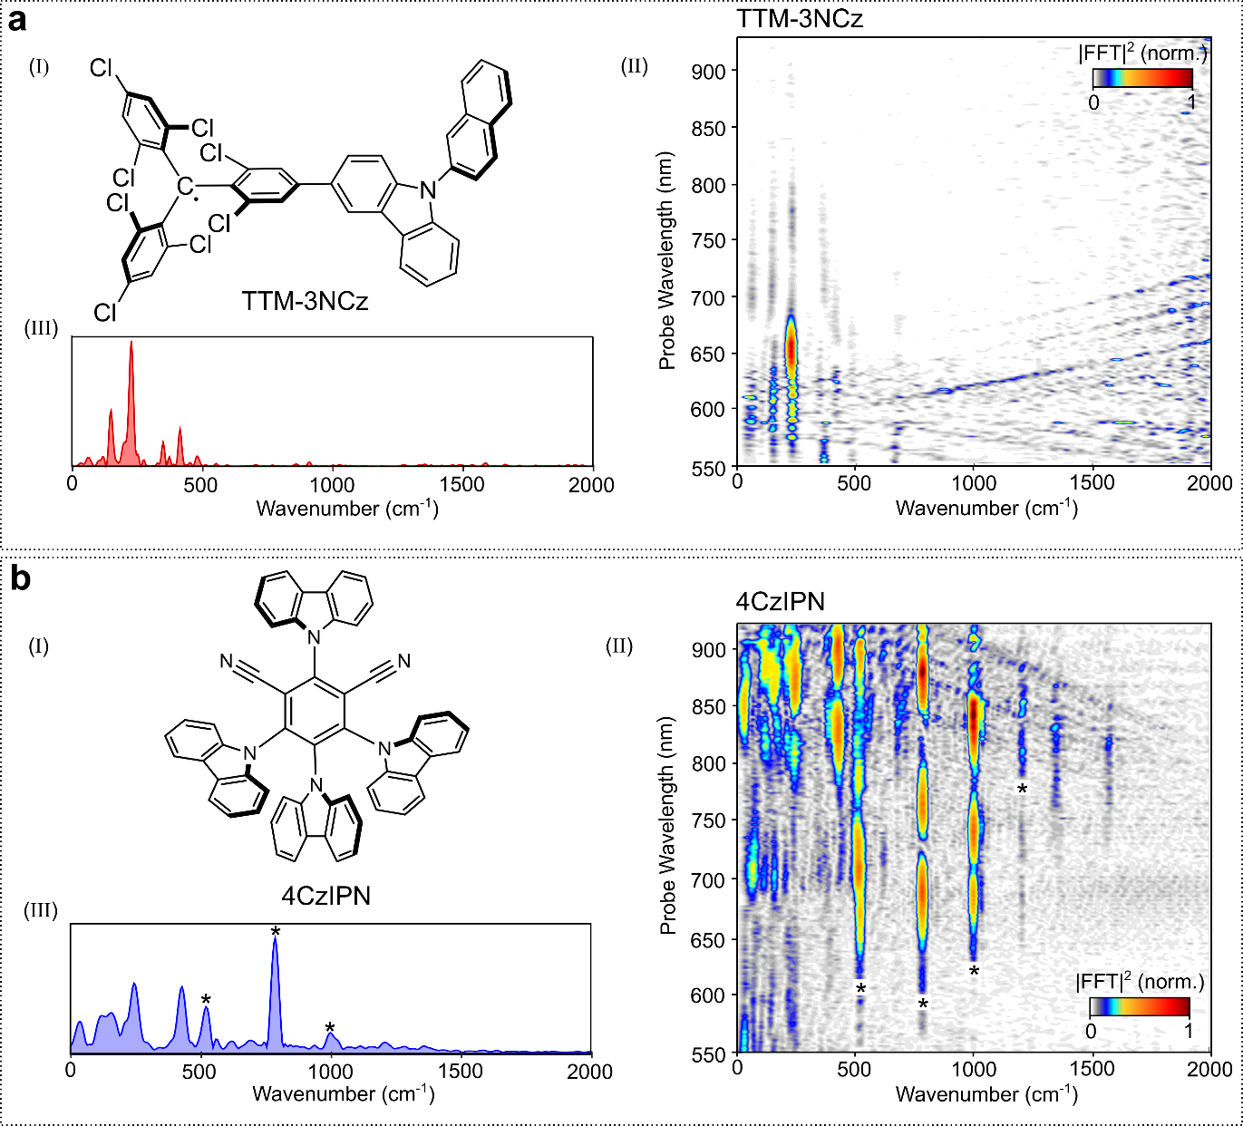
Extended Data Fig. 4 | Probe-wavelength-resolved IVS studies on a, TTM-3NCz (CHCl₃) and b, 4CzIPN (toluene): (I) Chemical structure, (II) probe wavelength-resolved impulsive Raman map, (III) excited-state Raman spectra shown for representative probe wavelength (625-635 nm for TTM-3NCz and 870-880 nm for 4CzIPN). Black asterisk (*) corresponds to the solvent modes.

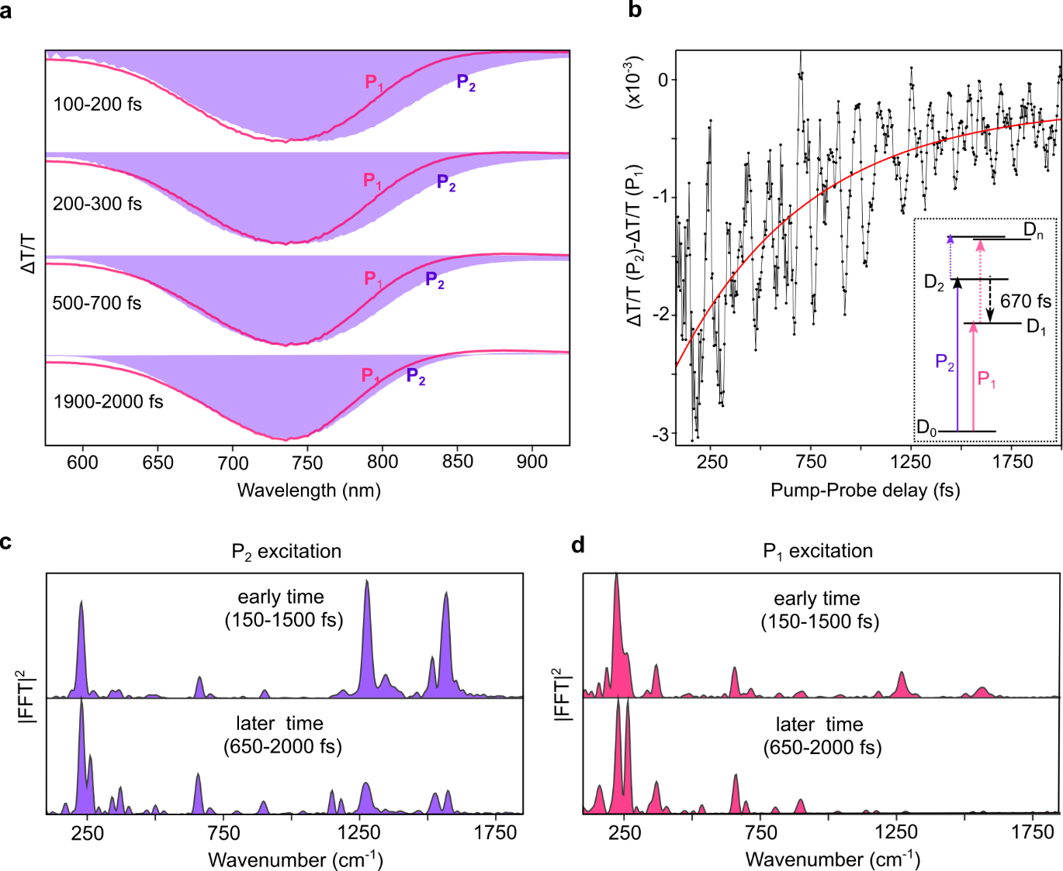
Extended Data Fig. 5 | Electronic and Vibrational dynamics of internal conversion from D₂ to D₁ state of TTM-TPA: a) transient absorption signal in the form of differential transmission (ΔT/T) upon photo-excitation with P₁ and P₂ pump pulse at different time delays (the purple shaded area: P₂ excitation; and magenta line: P₁ excitation). b) electronic population dynamics of the D₂ exciton for a representative wavelength (790-800 nm) which turns out to be 670±125 fs. (The method is described in SI section 8). c, d, the spectra obtained from the vibrational coherence at early time (150-1500 fs) and later time (650-2000 fs) in band selective excitation experiment with c) P₂ excitation and d) P₁ excitation at representative probe wavelength (710-750 nm). It is important to note that a very close resemblance of the later time spectra of P₂ excitation and early time spectra of the P₁ excitation is consistent with this barrierless and coherent internal conversion process from D₂ to D₁ state which was predicted from excitation wavelength dependent photoluminescence measurement⁴¹.

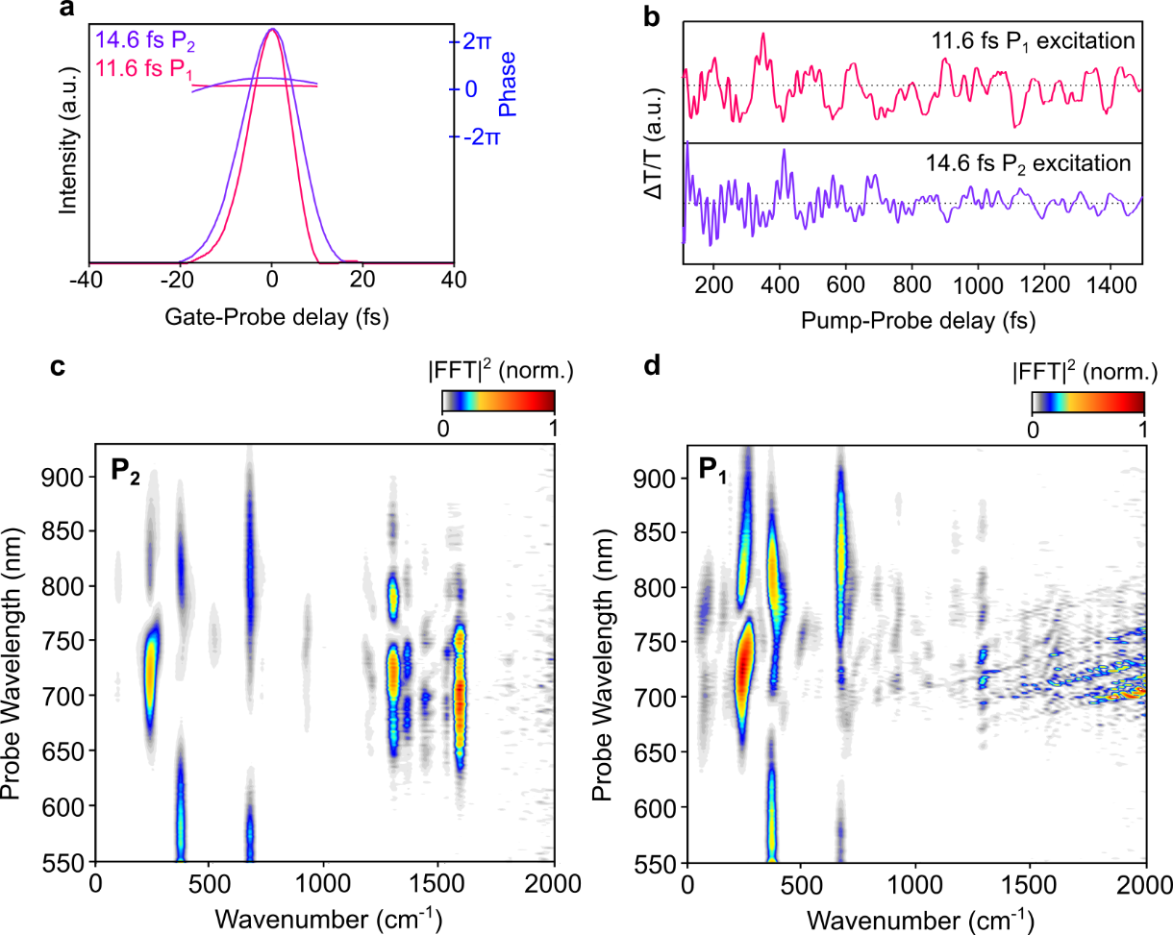
Extended Data Fig. 6 | Band selective Impulsive vibrational spectroscopy of TTM-TPA: a Temporal profile of the pulse P₁ and P₂ used in band selective experiment to excite charge transfer and local exciton-rich excited state respectively. b, Vibrational coherence generated after photo-excitation with P₁ and P₂ pulse for a representative probe window (680-700 nm). c, d, Wavelength-resolved impulsive Raman map (time-resolution corrected) of TTM-TPA following impulsive photo-excitation by c) the P₂ pulse to the D₂ rich state and d) the P₁ pulse to the D₁ state; The diagonal strips in the d, arise due to the interference scattering with the P₁ pump.
The fact that, the dominance of the high-frequency oscillations (time-period = 20-30 fs) is highly pronounced in the D₂ state even after photo-excited with the slower pump pulse, strongly support the data and calculation presented in the Fig. 3.
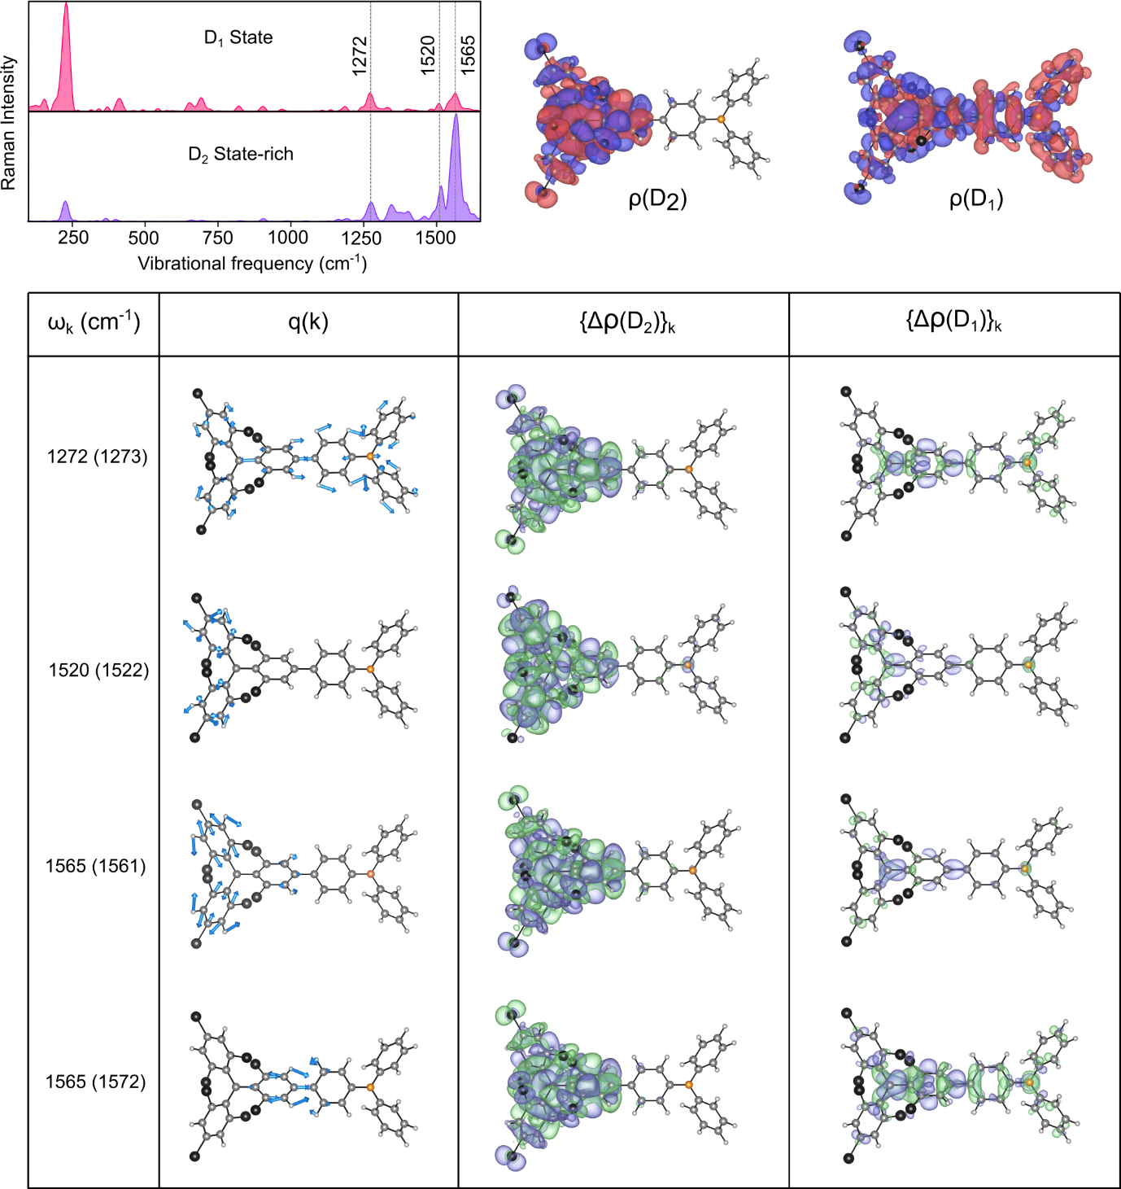
Extended Data Fig. 7 | Perturbational effect on the exciton wavefunction (transition density) of the D₂ and D₁ state along the coordinate of all experimentally obtained high-frequency vibrational modes (full mode resolved picture of the data represented in Fig. 3g-h): on the top left panel, experimentally obtained D₁ and D₂ state rich Raman spectra are reproduced. In the table, ω_{k}(cm⁻¹) corresponds to the frequency of the k^{th} vibrational mode. Inside parenthesis, the theoretically obtained frequencies are provided. q(k) corresponds to the vector displacement diagram of the k^{th} mode. {Δρ(D₂)}_{k} and {Δρ(D₁)}_{k} are the differential exciton wavefunction (transition density) upon displacement along the k^{th} mode for D₂ and D₁ exciton respectively.

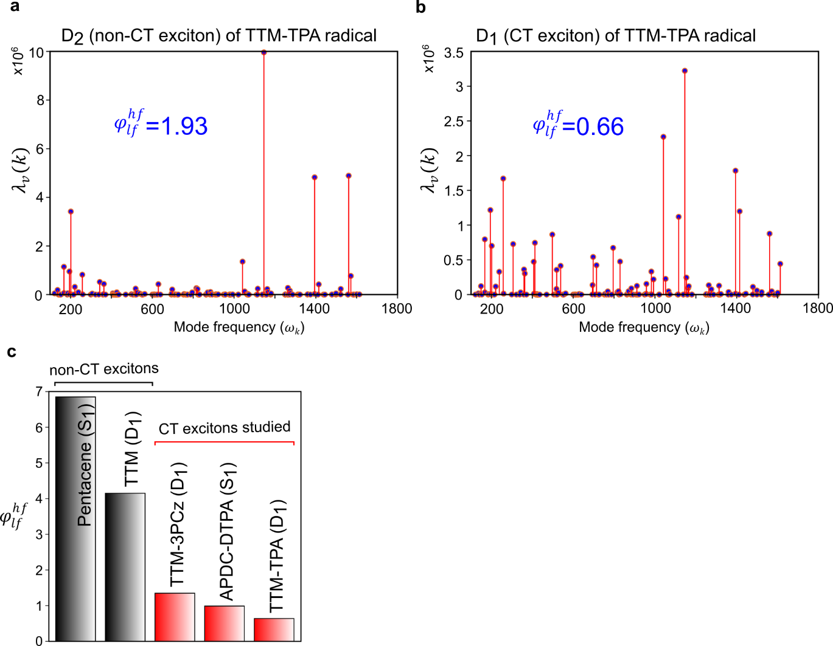
Extended Data Fig. 8 | Mode-resolved reorganization energy ($λ_{v}$) and contribution of the high-frequency modes to the vibrational reorganization energy: a, Mode-resolved picture of reorganisation energy for D₂ state of TTM-TPA obtained from TDDFT calculation displacing the ground state optimised geometry along the coordinate of each normal modes. b, Mode-resolved picture of reorganisation energy for D₁ state of TTM-TPA. c, $φ_{lf}^{hf}$ calculated for lowest excited state of Pentacene (S₁, non-CT exciton), TTM radical (D₁, non-CT exciton), TTM-3PCz (D₁, CT exciton), APDC-DTPA (S₁, CT exciton), TTM-TPA (D₁, CT exciton)
The reduced vibrational coupling to the high frequency regime in TTM-TPA and TTM-3PCz with respect to the TTM presented in c, is in agreement with previous non-adiabatic coupling calculations⁴¹. Kimura et al⁴⁸ have shown strong high-frequency vibrational coupling in the PyBTM and bisPyTM which are similar LE exciton like TTM.

Extended Data Table 1 | Experimentally obtained non-radiative rates of the studied molecules
 | System | λ_{em}  (nm) | τ  (ns) | Ф  (%) | $$kr$$  (10⁶ s⁻¹) | $$knr$$  (10⁶ s⁻¹) | $$\frac{kr}{knr }$$
Deep-red emission | TTM-3PCz¹⁷ | 695 | 22.2 | 65 ª / 46 ^{b} | 21 | 24 | 0.85
Deep-red emission | TTM-3NCz¹⁷ | 707 | 17.2 | 86 ª /49 ^{b} | 28 | 29 | 0.96
Deep-red emission | APDC-DTPA¹⁴ | 687 | 11.2 | 63 | 57 | 32 | 1.78
Deep-red emission | IO-4Cl | 678 | 1.8 | 36 | 200 | 356 | 0.56
Deep-red emission | o-IDTBR | 750 | 1.6 | 19 | 119 | 506 | 0.23
Deep-red emission | ITIC | 740 | 0.4 | 2 | 50 | 2450 | 0.02
NIR emission | TTM-TPA | 800 | 8.4 | 24 | 29 | 90 | 0.32
NIR emission | Y5 | 789 | 0.7 | 5 | 71 | 1357 | 0.05
NIR emission | Y6 | 797 | 1.1 | 8 | 73 | 836 | 0.08
λ_{em} : PL maxima; τ: PL lifetime; Ф: PLQE; $kr$: radiative rate; $knr$: non-radiative rate. (a: 3 wt% in CBP blend, b: Toluene solution). The ratio of kr/knr gives an estimate of how efficient radiative decay pathways are in comparisons to non-radiative decay pathways.

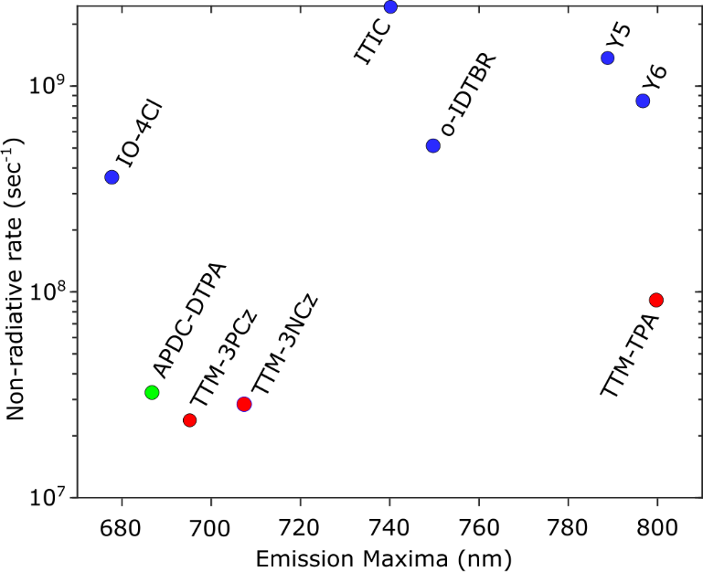
Extended Data Fig. 9 | Experimentally obtained non-radiative rates of the studied low energy-gap molecules (based on Extended Data Table 1)

Extended Data Table 2 | Experimental and calculated (TDDFT) values of the three lowest energy transition of TTM-TPA
Experimental Absorption (nm) | Calculated transition energy (nm) | Orbital excitation contribution (%)
670 | 718  (D₀ → D₁) | 192 beta (HOMO)→ 193 beta (SOMO): 97%
495 | 463  (D₀ → D₂) | 190 beta (HOMO-2) → 193 beta (SOMO): 80%  189 beta (HOMO-3) → 193 beta (SOMO): 10%
433 | 441 | 189 beta (HOMO-3) → 193 beta (SOMO): 69%  190 beta (HOMO-2) → 193 beta (SOMO): 15%  192 alpha (HOMO) →195 alpha (LUMO+1): 4%

The experiment performed on 4CzIPN, is a 3-optical pulse IVS experiment⁴⁶ due to the spectral bandwidth limitation of direct impulsive excitation high-energy transitions (>2.4 eV, see methods). 4CzIPN (toluene) is excited to ¹CT state²⁴ with 450 nm (200 fs) pulse followed by inducing vibrational coherence (VC) with 850 nm-centred broadband (8.5 fs) impulsive pulse, 500fs after initial photo-excitation. The impulsive pulse spectrally overlaps with the excited state absorption of 4CzIPN observed >550 nm⁴⁹. The result shown for 4CzIPN, was recorded in 1mm pathlength cuvette. This experiment is analysed in further detail in Supplementary information (Section 7 ).

