Supplementary Material
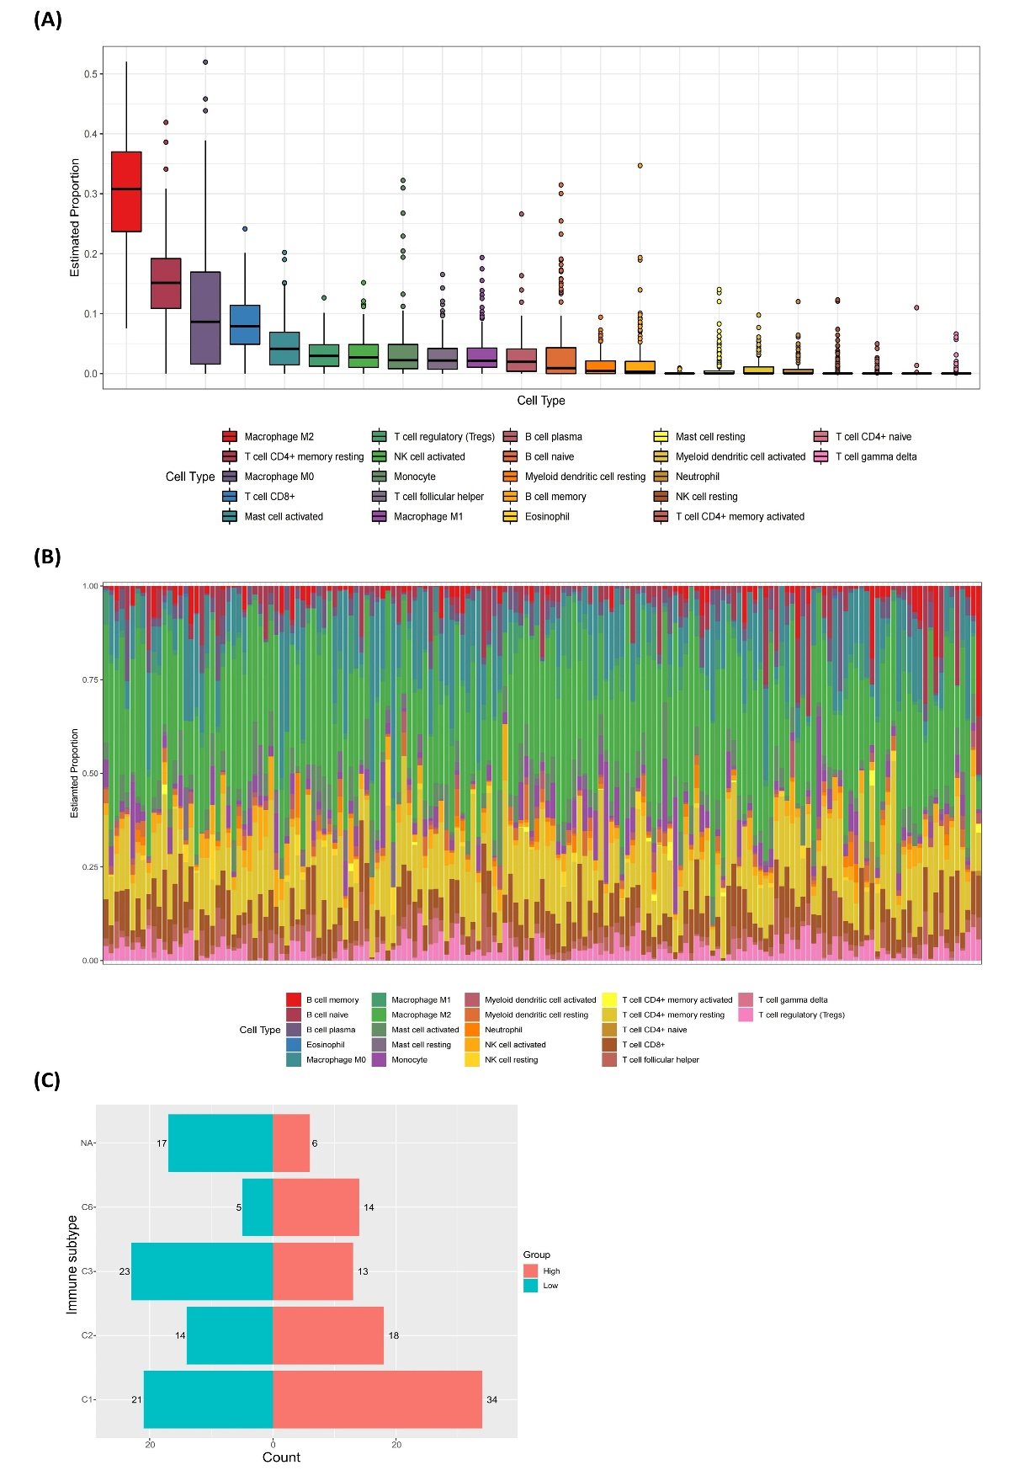
Figure S1. (A) Boxplots showing estimated proportions of various types of immune cells in the TCGA cohort. (B) Bar chart showing the infiltration of various types of immune cells in the TCGA cohort. (C) Bar chart showing the number of immune subtype categories in risk subgroups.
Table S1. Differentially expressed oxidative stress genes.
Gene | Log2FC | P-value | FDR
NOS2 | 2.779032263 | 1.96E-38 | 2.47E-38
NOS1 | -1.536506535 | 4.88E-33 | 5.49E-33
XDH | 4.528561706 | 1.80E-47 | 4.31E-47
OLR1 | 2.771618585 | 2.34E-39 | 2.97E-39
RYR2 | -2.17983282 | 1.67E-46 | 3.61E-46
PTGS2 | 4.861668832 | 5.37E-50 | 2.25E-49
CXCL8 | 2.510796502 | 3.20E-32 | 3.51E-32
XBP1 | -2.004001686 | 5.74E-46 | 1.17E-45
ALB | -4.291416705 | 4.89E-50 | 2.11E-49
APOE | 2.78664692 | 6.81E-47 | 1.54E-46
GAPDH | 2.88744103 | 5.80E-55 | 4.38E-53
CYP3A4 | -3.449960181 | 1.90E-14 | 1.92E-14
BDNF | 2.83588378 | 9.33E-43 | 1.47E-42
ACE | 2.453043777 | 2.47E-51 | 1.78E-50
PLA2G7 | 3.46053719 | 2.45E-50 | 1.16E-49
PPARG | 3.961837353 | 2.05E-49 | 7.35E-49
CYP2E1 | -1.504580659 | 2.40E-40 | 3.23E-40
ACADL | -4.448678591 | 1.69E-52 | 2.31E-51
NOX4 | 3.937534165 | 2.85E-49 | 9.16E-49
KCNJ5 | -1.54944401 | 3.12E-31 | 3.36E-31
POMC | -2.365851302 | 1.49E-42 | 2.32E-42
UCP2 | 2.826002596 | 4.35E-51 | 2.74E-50
ERN1 | -1.29443398 | 1.46E-40 | 2.03E-40
CYP2C9 | 4.018712834 | 1.20E-33 | 1.37E-33
CYP2C19 | 3.328106177 | 1.10E-23 | 1.16E-23
SLC2A1 | 5.12749705 | 1.01E-53 | 3.82E-52
CYP1B1 | 2.823972644 | 9.12E-37 | 1.09E-36
NCF2 | 2.420417715 | 1.59E-41 | 2.29E-41
IL1A | 4.448821196 | 5.30E-44 | 9.21E-44
MMP2 | 3.150839507 | 5.76E-44 | 9.89E-44
SERPINE1 | 3.045902074 | 1.76E-44 | 3.29E-44
SELP | 2.572998874 | 1.95E-34 | 2.25E-34
NPPA | -3.675632423 | 1.30E-31 | 1.41E-31
PIK3CG | 2.745781214 | 1.57E-42 | 2.42E-42
IL1RN | 4.382689171 | 3.75E-48 | 9.43E-48
PRKCB | 2.086050601 | 1.51E-35 | 1.75E-35
CBS | -4.317805521 | 5.51E-51 | 3.27E-50
MMP9 | 4.110498048 | 2.25E-52 | 2.83E-51
ANK2 | 2.538169548 | 6.30E-37 | 7.61E-37
NOX1 | 6.206438097 | 9.13E-44 | 1.53E-43
TERT | 4.709453754 | 1.35E-39 | 1.75E-39
REN | 4.5185884 | 1.61E-40 | 2.19E-40
HTR2A | 3.052648663 | 1.04E-37 | 1.29E-37
MYH7 | -4.560848448 | 2.69E-52 | 2.91E-51
DBH | -2.451001529 | 3.03E-46 | 6.36E-46
NCF1 | 2.101478578 | 6.22E-40 | 8.10E-40
CYP2B6 | 4.987372702 | 8.80E-38 | 1.10E-37
EDNRA | 3.649530525 | 3.89E-49 | 1.11E-48
EGF | -4.339142869 | 2.22E-50 | 1.08E-49
FN1 | 4.180708988 | 1.00E-49 | 3.78E-49
CDKN2A | 4.065634891 | 1.41E-41 | 2.04E-41
ASS1 | 2.671138561 | 3.01E-50 | 1.38E-49
TTN | -2.755660091 | 7.80E-52 | 6.93E-51
ACTA1 | -4.127322585 | 1.88E-36 | 2.24E-36
LOX | 2.875792283 | 9.72E-42 | 1.44E-41
AOX1 | -3.004907149 | 3.03E-49 | 9.52E-49
GPX2 | 4.720800595 | 3.68E-50 | 1.64E-49
OXTR | 3.435512314 | 7.21E-50 | 2.79E-49
CTSB | 2.714025556 | 3.91E-52 | 3.94E-51
TIMP1 | 3.334734914 | 3.16E-51 | 2.07E-50
MICB | 2.441999734 | 3.97E-43 | 6.38E-43
GPX8 | 2.768161551 | 1.74E-46 | 3.69E-46
ATP1A3 | 3.981243858 | 3.58E-36 | 4.23E-36
CDKN3 | 3.777519043 | 1.29E-53 | 3.91E-52
RAC2 | 3.084772807 | 8.84E-51 | 4.77E-50
SERPINA1 | 3.268150596 | 1.68E-43 | 2.78E-43
TRPA1 | 1.959779143 | 1.63E-22 | 1.69E-22
CRHR2 | -2.507518926 | 5.87E-30 | 6.28E-30
MMP1 | 7.000644509 | 1.15E-49 | 4.24E-49
F5 | 4.638597467 | 1.74E-45 | 3.45E-45
MYLK | 3.048010338 | 1.08E-40 | 1.50E-40
VDR | 3.283684737 | 2.87E-51 | 1.97E-50
MMP3 | 4.994749162 | 6.48E-43 | 1.03E-42
GSTM2 | -1.589486093 | 1.87E-43 | 3.07E-43
KLF2 | 2.381469106 | 8.95E-42 | 1.34E-41
PDIA2 | -3.981753968 | 4.18E-49 | 1.17E-48
DUOX2 | 4.936353934 | 5.26E-44 | 9.21E-44
TACR1 | 2.395231546 | 4.30E-23 | 4.48E-23
ALDH3A1 | 5.078498413 | 2.52E-42 | 3.85E-42
PLAT | 4.882811891 | 5.22E-53 | 1.13E-51
EPHX2 | -1.535780738 | 4.54E-42 | 6.85E-42
ABCB1 | 2.328125979 | 7.01E-33 | 7.84E-33
GSTA2 | -4.219602255 | 2.66E-49 | 8.74E-49
UGT1A1 | 6.80604178 | 2.23E-47 | 5.27E-47
IDO1 | 4.731479432 | 5.63E-51 | 3.27E-50
KCNJ2 | 2.569299798 | 7.01E-48 | 1.73E-47
PLAU | 4.387808822 | 7.99E-51 | 4.47E-50
TREM2 | 2.787747822 | 1.16E-46 | 2.54E-46
E2F1 | 3.167953757 | 9.04E-53 | 1.52E-51
TP53INP1 | -1.760817976 | 2.20E-44 | 4.03E-44
IGF2BP1 | 4.81157276 | 6.59E-36 | 7.72E-36
PLA2G2A | 3.610840291 | 0.014317147 | 0.014317147
MAPK8IP1 | -1.335977558 | 5.54E-40 | 7.27E-40
CYP17A1 | -2.350211086 | 1.52E-32 | 1.68E-32
UGT1A6 | 6.45207075 | 9.79E-49 | 2.59E-48
DMD | -1.809897435 | 4.37E-47 | 9.99E-47
CYP24A1 | 7.297889066 | 3.52E-49 | 1.04E-48
ACTB | 2.76354578 | 1.12E-51 | 9.42E-51
MSR1 | 2.783736471 | 4.31E-44 | 7.65E-44
PDLIM4 | 3.345521478 | 5.22E-49 | 1.43E-48
ALPP | 7.969976756 | 7.31E-41 | 1.03E-40
ATG9B | 3.607625423 | 3.69E-48 | 9.43E-48
BACE1 | -1.906442068 | 2.46E-47 | 5.71E-47
FGF1 | 3.499837274 | 1.47E-48 | 3.82E-48
AHR | 3.218632062 | 2.43E-51 | 1.78E-50
DNAH8 | 2.01156215 | 1.56E-19 | 1.60E-19
SCD | 2.626403975 | 5.75E-45 | 1.09E-44
SLC1A1 | 3.364858855 | 2.91E-45 | 5.70E-45
ITGB2 | 2.756140091 | 4.16E-46 | 8.61E-46
CXCR4 | 3.213016489 | 6.69E-49 | 1.80E-48
HLA-B | 2.751587475 | 1.18E-50 | 6.03E-50
RAD51 | 3.4432691 | 2.68E-52 | 2.91E-51
CD69 | 2.355571505 | 8.68E-33 | 9.64E-33
PTGIS | 3.29106139 | 4.01E-40 | 5.32E-40
VASP | 2.944555845 | 6.69E-52 | 6.31E-51
SELL | 2.860550583 | 1.34E-47 | 3.26E-47
TGM2 | 2.972647202 | 2.34E-43 | 3.80E-43
IL12B | 3.891551926 | 1.04E-41 | 1.53E-41
EPHA3 | 2.69168709 | 2.46E-40 | 3.29E-40
HBEGF | 2.831223353 | 6.88E-50 | 2.73E-49
LCN2 | 4.583347428 | 2.22E-44 | 4.03E-44
RETN | 2.362334357 | 1.25E-29 | 1.33E-29
NAT2 | 4.105253658 | 1.22E-37 | 1.50E-37
SLPI | 4.545463507 | 6.83E-50 | 2.73E-49
CSF2 | 5.582635525 | 5.83E-56 | 8.80E-54
UCN2 | 4.629421557 | 2.47E-49 | 8.49E-49
ANGPT2 | 3.145922193 | 3.24E-49 | 9.79E-49
CDK1 | 4.13275531 | 6.86E-54 | 3.45E-52
CD40LG | 3.176758222 | 1.52E-40 | 2.09E-40
LPA | -2.046280843 | 2.93E-37 | 3.57E-37
RUNX2 | 3.567668551 | 2.65E-49 | 8.74E-49
ACAD11 | -1.382712472 | 3.57E-49 | 1.04E-48
MUC5AC | 5.491844834 | 5.96E-41 | 8.49E-41
IGFBP3 | 4.660997373 | 6.30E-53 | 1.19E-51
ANXA2 | 3.18090546 | 2.46E-49 | 8.49E-49
TNFSF11 | 4.594599404 | 3.11E-49 | 9.57E-49
ALOX5AP | 2.524425153 | 6.33E-44 | 1.07E-43
PENK | 4.031557453 | 6.91E-28 | 7.30E-28
ITGAL | 1.853374611 | 1.68E-33 | 1.91E-33
CCNA2 | 2.912385771 | 1.20E-50 | 6.03E-50
ADRB3 | 3.345583242 | 2.22E-39 | 2.84E-39
CDC25C | 4.377011041 | 1.53E-52 | 2.31E-51
ITGA2 | 4.49256611 | 3.26E-53 | 8.19E-52
PLAUR | 4.361785442 | 1.69E-51 | 1.34E-50
CXCL10 | 3.744160066 | 4.82E-45 | 9.34E-45
IL11 | 3.775707308 | 1.13E-46 | 2.52E-46
GDNF | 3.377565219 | 4.14E-44 | 7.44E-44
HDAC9 | 2.538222154 | 5.51E-45 | 1.05E-44

