Extended Data Fig. 1: Study Design
COHORT 1 (n=72)

HER2 overexpressing: HER2 IHC 3+ or
IHC 2+/ISH+*

Previous taxanes
Resistant to trastuzumab and TDM-1

T-DXd 5,4 mg/kg every 3 weeks

OBJECTIVES
PRIMARY

Confirmed objective response in each cohort by investigator assessment

SECONDARY

  - EFFICACY
PFS
OS
DOR
CBR
  - SAFETY

EXPLORATORY
T-DXd distribution
HER2 expression patterns and treatment response
Modulation of tumor microenvironment
Mechanisms of resistance

COHORT 2 (n=74)

HER2-low:
HER2 IHC 2+/ISH- or
IHC 1+

Previous anthracyclines and taxanes
If HR-positive: resistant to CDK4/6 plus HT

Patients with metastatic breast cancer
≥ 18 years old
≥ 1 line of chemotherapy

n=186 patients

COHORT 3 (n=40)

HER2 non-expressing: HER2 IHC 0

Previous anthracyclines and taxanes
If HR-positive: resistant to CDK4/6 inhibitors plus HT

*1 patient bore HER2 IHC1+/ISH+ mBC
HER2: Human Epidermal growth factor Receptor 2; IHC: Immunohistochemistry; ISH: In situ hybridization; TDM-1: Ado trastuzumab emtansine; HR-positive: Hormone receptor positive; CDK4/6: Cyclin-dependent kinases 4 and 6; HT: Hormone therapy; PFS: Progression free survival; OS: Overall survival; DOR: Duration of response; CBR: Clinical benefit rate; T-DXd : Trastuzumab deruxtecan

Inclusion/Exclusion criteria not respected, n=79
DAISY Screening
n=265

Extended Data Fig. 2: CONSORT diagram

DAISY inclusion
n=186

COHORT 3

HER2 IHC 0
n=40

COHORT 2

HER2 IHC 2+/ISH- or IHC 1+
n=74

COHORT 1

HER2 IHC 3+ or
IHC 2+/ISH+
n=72

Patients who did not receive at least one dose of T-DXd, n=7

DAISY Safety Population
n=179

Patients who did not have a valid first post-baseline assessment of disease status or who did not have progressive disease, n=1

Patients who did not have at least one radiologically measurable lesion according to RECIST v1.1, n=1

DAISY Full Analysis Set (FAS)
n=177
COHORT 3

HER2 IHC 0
n=38

COHORT 2

HER2 IHC 2+/ISH- or IHC 1+
n=73

COHORT 1

HER2 IHC 3+ or
IHC 2+/ISH+
n=68*

COHORT 3

HER2 IHC 0
n=37

COHORT 2

HER2 IHC 2+/ISH- or IHC 1+
n=72

COHORT 1

HER2 IHC 3+ or
IHC 2+/ISH+
n=68*

*1 patient bore HER2 IHC1+/ISH+ mBC
HER2: Human Epidermal growth factor Receptor 2; IHC: Immunohistochemistry; ISH: In situ hybridization; T-DXd: Trastuzumab deruxtecan.

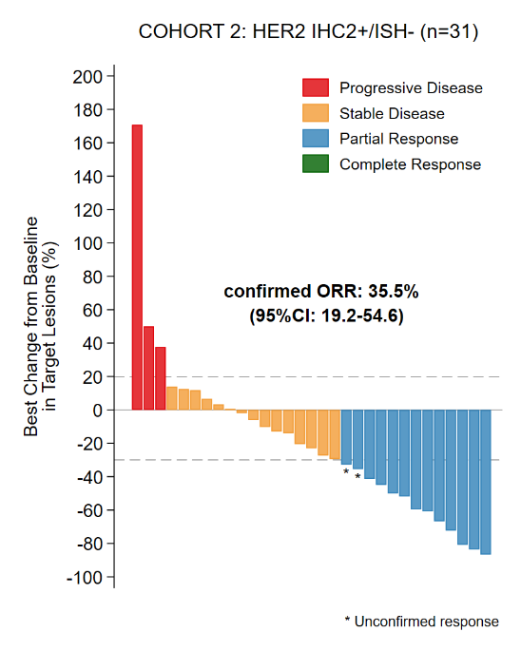
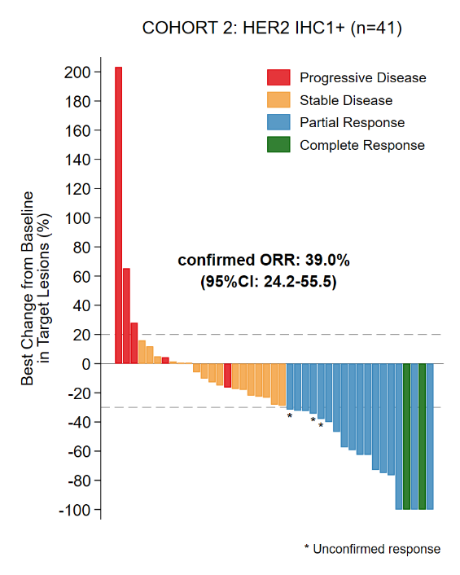

Extended Data Fig. 3: Waterfall plot of the best change from baseline in target lesions according to the best objective response of patients from cohort 2 in FAS population (n=72) according to HER2 status. On the left, patients with HER2 IHC 1+ (n=41) and on the right patients with HER2 IHC 2+/ISH- (n=31) treated with T-DXd.

HER2: Human Epidermal growth factor Receptor 2; IHC: Immunohistochemistry; ISH: In situ hybridization; T-DXd: Trastuzumab deruxtecan; FAS: Full Analysis Set; CI: confidence interval

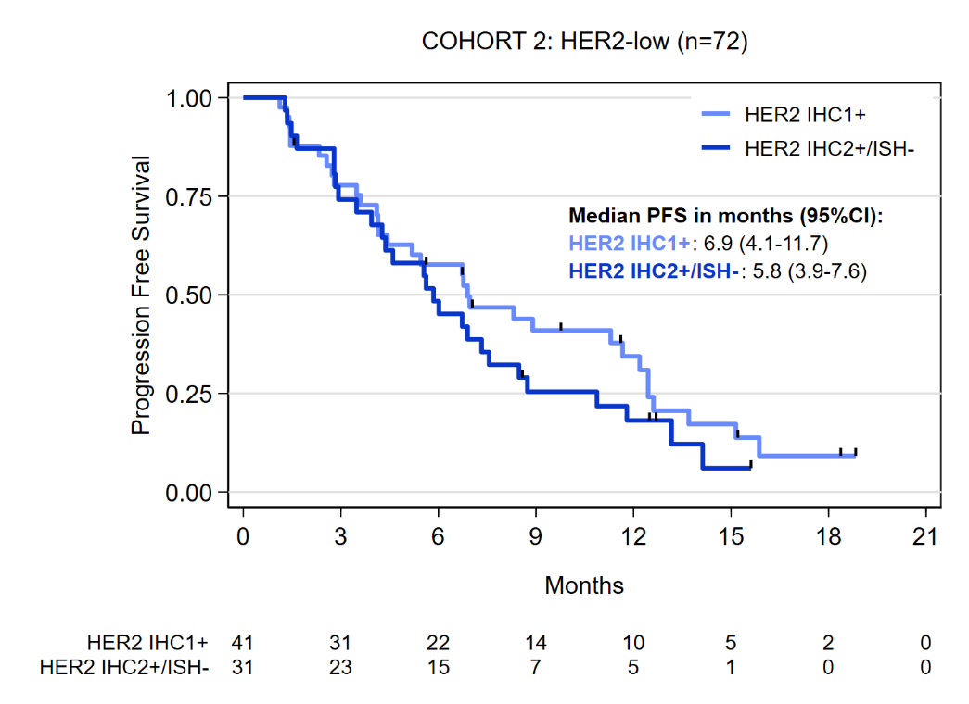

Extended Data Fig. 4: PFS of patients from cohort 2 (n=72) according to HER2 status in FAS population. The median PFS was 6.9 months (95% CI: 4.1-11.7) in patients with IHC 1+ mBC (n=41) and 5.8 months (95% CI: 3.9-7.6) in patients with IHC2+/ISH- mBC (n=31).
HER2: Human Epidermal growth factor Receptor 2; IHC: Immunohistochemistry; ISH: In situ hybridization; T-DXd: Trastuzumab deruxtecan; mBC: metastatic breast cancer; CI: confidence interval; FAS: Full Analysis Set; PFS: progression-free survival

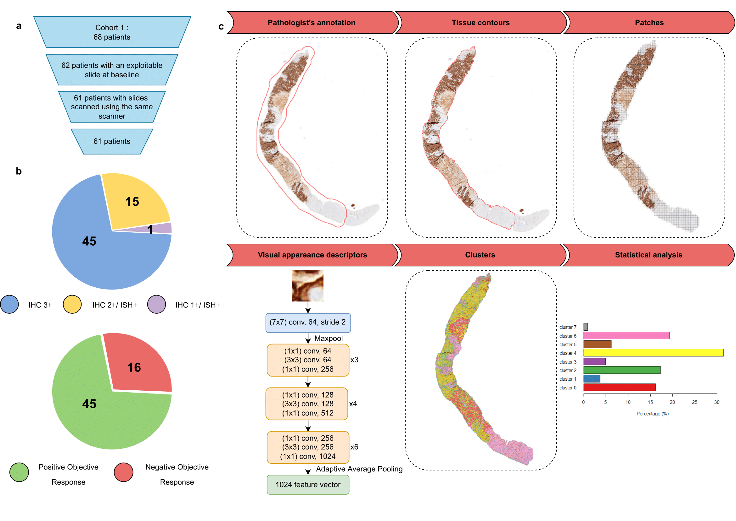
Extended Data Fig 5: Dataset description and pipeline overview. a, Description of the patient set considered for HER2 spatial distribution analysis. Among the 68 patients from cohort 1, six patients with no digitized HER2 slide at baseline or with a slide not exploitable after pathologist review were removed. One patient presenting only one digitized HER2 slide at baseline scanned with another scanner was also moved away to ensure homogeneous scanning conditions b, Number of patients according to the IHC score and objective response in the dataset c, Illustration of the proposed method on one sample. Patches are first extracted from the sample using contours detection and simple annotations. Visual appearance descriptors are then computed from each patch using the displayed architecture pre-trained on ImageNet to segment each slide into 8 clusters using Mini-Batch K-Means algorithm. The relationship of each cluster with the objective response to treatment is finally assessed through statistical analysis.

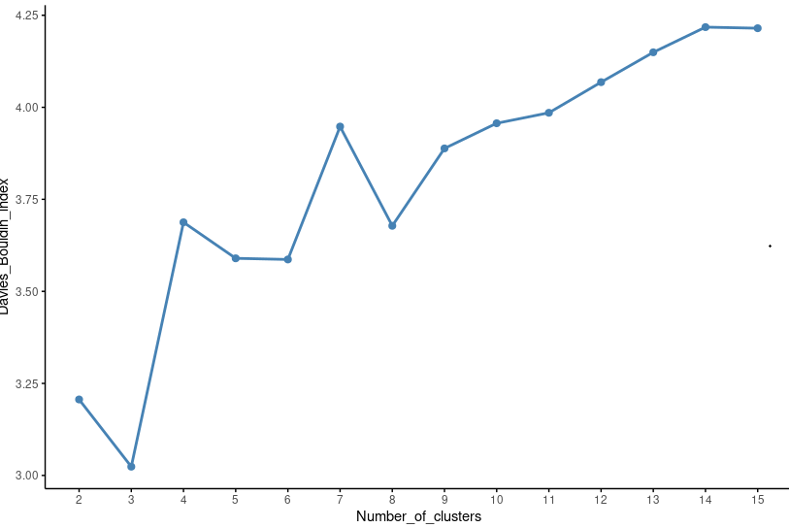

Extended Data Fig. 6: Identifying an optimal number of clusters. The Davies-Douldin index was computed from Mini-Batch K-Means clustering using a number of clusters ranging from 2 to 15. This index represents how the clusters are similar to each other, with a lower value pointing toward a better segmentation. Three local minimums are highlighted on the graph at 3, 6 and 8 clusters.

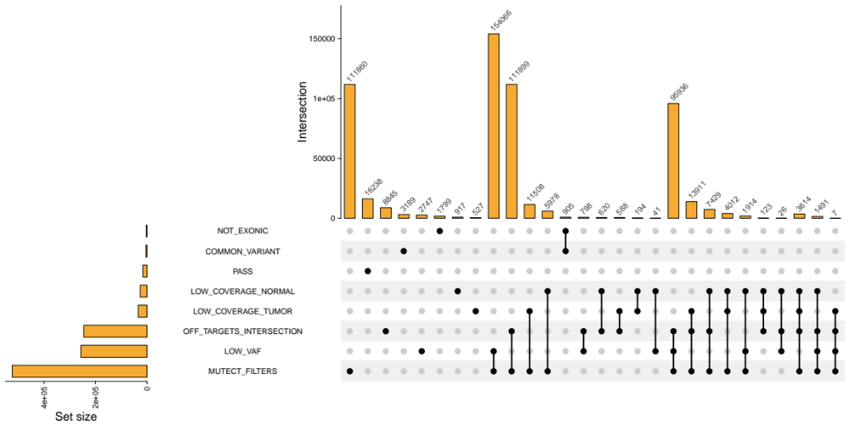

Extended Data Fig. 7: Upset plot that summarizes the effect of each filter individually and in combination with other filters.

Possible inclusion in DAISY
HER2 status locally determined for screening on primary or metastases

Biopsy at baseline* (n=186)

Absence of GEFPICS pathologist in the local center (n=2 centers)
GEFPICS’ pathologist in the local center
(n=13 centers)

Biopsy review: no need
Biopsy review by a GEFPICS’ pathologist

Digitized HER2 slides centralized to Gustave Roussy Cancer Center (n=68 cohort 1, n=72 cohort 2, n=37 cohort 3)
*An archived biopsy from a secondary or a primary site (if stage IV) could be used for the Cohort assignment provided that it was collected within 3 months prior enrolment
Planned Cohort (HER2 status at screening or before revision by GEFPICS’ pathologist; n=186) | Final Cohort (HER2 status after revision by GEFPICS’ pathologist; n=186)
 | Cohort 1 (n=72) | Cohort 2 (n=74) | Cohort 3 (n=40)
Cohort 1 (n=86) | 71 | 13 | 2
Cohort 2 (n=53) | 1 | 44 | 8
Cohort 3 (n=47) | 0 | 17 | 30
- No digitized HER2 slide at baseline (n=5)
- Not exploitable after pathologist review (n=1)
- Digitized HER2 slide at baseline scanned with another scanner (n=1)
- No digitized HER2 slide at baseline (n=4)
- Not exploitable after pathologist review (n=2)

*An archived biopsy from a secondary or a primary site (if stage 4) could be used for cohort assignment provided that it was collected within 3 months prior enrolment

Digitized HER2 slides from Cohort 3 reviewed by two breast cancer pathologists (n=31)
Digitized HER2 slides from Cohort 1 analyzed by deep-learning approach (n=61)

Extended Data Fig. 8: Determination of HER2 status for enrollment in DAISY trial and Cohort assignment

