Supporting Information

Breaking the trade-off between triplet up-conversion and singlet radiation in TADF emitters using multiresonance bridge

Guoyun Meng, Hengyi Dai, Qi Wang, Jianping Zhou, Tianjiao Fan, Xiangchen Hong, Xuan Zeng, Xiang Wang, Yuewei Zhang, Dezhi Yang, Dongge Ma, Dongdong Zhang,* and Lian Duan*

Table of Contents
1. Experimental section 2
1.1 General information 2
1.2 Computational methods 2
1.3 Measurement of absorption and emission characteristics 2
1.4 Ultraviolet photoelectron spectroscopy (UPS) characterizations 2
1.5 The rate constants calculation 3
1.6 Determination of the emitting dipole orientation 3
1.7 Device fabrication and measurement of EL characteristics 3
1.8 Synthesis 4
2. Supplementary figures and tables 6
3. References 20

1. Experimental Section

1.1 General Information. 5-phenyl-5,11-dihydroindolo[3,2-b]carbazole and 2-(4-bromophenyl)-4,6-diphenyl-1,3,5-triazine were purchased from the Suzhou ge’ao New Material Co Ltd. All other reagents used for reaction, purification and measurements were purchased from Shanghai Bide Medical Technology Co. Ltd. All other reagents used for device fabrication were purchased from Jilin Optical and Electronic Materials Co. Ltd. These materials were received and used without further purification. The other reagents and solvents were used as received from commercial sources without further purification. 600 MHz ¹H-NMR and 150 MHz ¹³C-NMR spectra were measured by a JEOL JNM-ECS600 spectrometer at room temperature in deuterated dichloromethane or chloroform respectively with tetramethyl silane as the internal standard. ¹¹B, ¹⁹F solid-state NMR spectrum was obtained on a JNM-ECZ600R spectrometer, tube diameter of 3.2 mm, the frequency of 12 kHz. MALDI-TOF-MS data was performed on a Shimadzu AXIMA Performance MALDI-TOF instrument in positive detection modes.

1.2 Computational methods. The calculations were performed with the Gaussian 09 package,¹ using the density functional theory (DFT) and time-dependent density functional theory (TD-DFT) method with the B3LYP hybrid functional.²⁻⁴ The structures were optimized using DFT/single-crystal (S₀ state) or TD-DFT (S₁ and T₁ state) methods with a 6-31G(d,p) basis set. Electron-hole analysis was carried out using the Multiwfn software.^{[5]}

1.3 Measurement of absorption and emission characteristics. 1 × 10⁻⁵ M solutions were prepared by stepwise dilution for solution measurements. Thin films for photophysical characterization were prepared by thermal evaporation on quartz substrates at 1-2 Å sec⁻¹ in a vacuum chamber with a base pressure of < 10⁻⁵ torr. UV-vis absorption and PL spectra were measured using UV-2600 (Shimadzu) and FluoroMax-4P (Horiba) instruments at 77 and 298 K. The PLQYs were obtained with an absolute photoluminescence quantum yield measurement system Hamamatsu C9920-03G in an integrating sphere. The solution sample was bubbled with nitrogen for 10 minutes before measurement while the films were measured in air. The transient spectra were collected on an Edinburgh Fluorescence Spectroscopy FLS1000.

1.4 Ultraviolet photoelectron spectroscopy characterizations. The ultraviolet photoelectron spectroscopy (UPS) characterizations were carried out on AXIS ULTRA DLD with monohromatized HeI radiation at 21.2 eV. The sample films were prepared by vacuum deposition upon ITO substrates with sheet resistances about 15 Ω, and measured at a bias voltage of -9 V inside a vacuum chamber at 3.0 × 10⁻⁸ Torr.

1.5 The rate constants calculation. The prompt fluorescence and delayed fluorescence quantum yield ratio (Φ_{PF} and Φ_{DF}) were determined from the total PL quantum efficiency (Φ_{PL}) and the proportion of the integrated area of each component in the transient spectra to the total integrated area, r_{PF} and r_{DF} are individual component ratio for prompt and delayed fluorescence. The quantum efficiencies and rate constants were determined using the following equations according to Adachi’s method.^{[6]}
(1) Φ_{PF} = Φ_{PL}r_{PF} r_{PF} = τ₁A₁/(τ₁A₁ + τ₂A₂)
(2) Φ_{DF} = Φ_{PL}r_{DF} r_{DF} = τ₂A₂/(τ₁A₁ + τ₂A₂)
(3) k_{r} = Φ_{PF}/τ_{PF}
(4) k_{ISC} =(1‒Φ_{PF})/τ_{PF}
(5) k_{RISC} =Φ_{DF}/(k_{ISC} . τ_{PF} . τ_{DF} . Φ_{PF})

1.6 Determination of the emitting dipole orientation. To determine emitting dipole orientation of an emitting film, angle-resolved and polarization-resolved PL measurements were performed by a Hamamatsu’s established molecular orientation measurement system (C14234-11, Hamamatsu Photonics). The sample consisted of a fused silica substrate with the 10-nm-thick film doped with emitters. The sample was attached to a fused silica half-cylinder prism by index matching liquid. The excitation of the samples was performed with the 360-nm line of the continuous- wave laser with a fixed excitation angle of 45º. The angle-dependent p-polarized emission intensity at the peak wavelength of the PL spectrum of the emitting layer was detected. The emitting dipole orientation was then determined by least-square fitting of the measured angle-dependent polarized emission intensity with calculated results.

1.7 Device fabrication and measurement of EL characteristics. All compounds were subjected to temperature-gradient sublimation under a high vacuum before use. OLEDs were fabricated on the ITO-coated glass substrates with multiple organic layers sandwiched between the transparent bottom indium-tin-oxide (ITO) anode and the top metal cathode. Before device fabrication, the ITO glass substrates were pre-cleaned carefully. All material layers were deposited by vacuum evaporation in a vacuum chamber with a base pressure of 10⁻⁶ torr. The deposition system permits the fabrication of the complete device structure in a single vacuum pump-down without breaking vacuum. The deposition rate of organic layers was kept at 0.1~0.2 nm s⁻¹. The doping was conducted by co-evaporation from separate evaporation sources with different evaporation rates. The current density, voltage, luminance, external quantum efficiency, electroluminescent spectra and other characteristics were measured with a Keithley 2400 source meter and an absolute EQE measurement system in an integrating sphere at the same time. The EQE measurement system is Hamamatsu C9920-12, which is equipped with Hamamatsu PMA-12 Photonic multichannel analyzer C10027-02 whose longest detection wavelength is 1100 nm.

1.8 Synthesis
Synthesis of 7-bromo-3,11-bis(trifluoromethyl)-5,9-dioxa-13b-boranaphtho[3,2,1-de]anthracene (BO-Br): This compound was synthesized according to the previous work⁷ and obtained as solid, yield 30%. ¹H NMR (600 MHz, Chloroform-d) δ (ppm): 8.66 (s, 2H), 7.77 (s, 2H), 7.61 (s, 2H), 7.40 (s, 2H).
Synthesis of 5-(4-(4,6-diphenyl-1,3,5-triazin-2-yl)phenyl)-11-phenyl-5,11-dihydroindolo[3,2-b]carbazole (1TICz): Compound 1TICz was synthesized according to the previous work⁸ and obtained as solid, yield 60%. ¹H NMR (600 MHz, Methylene Chloride-d₂) δ (ppm): 9.09 (d, J = 8.1 Hz, 2H), 8.84 (d, J = 7.3 Hz, 4H), 8.27 (s, 1H), 8.13 (t, J = 6.8 Hz, 2H), 8.10 (s, 1H), 7.97 (d, J = 8.1 Hz, 2H), 7.71 – 7.58 (m, 11H), 7.56 – 7.51 (m, 1H), 7.45 – 7.38 (m, 3H), 7.28 – 7.22 (m, 2H). ¹³C NMR (151 MHz, Methylene Chloride-d₂) δ (ppm): 176.62, 175.64, 171.86, 171.11, 157.31, 149.18, 148.99, 142.17, 141.60, 136.51, 136.27, 134.69, 132.73, 130.76, 130.09, 128.98, 128.78, 127.41, 127.26, 126.80, 126.30, 126.20, 124.14, 123.98, 123.76, 123.43, 120.33, 120.25, 120.00, 119.52, 109.77, 109.56, 100.20, 100.02. MALDI-TOF: Calculated: 639.2423, Found: 639.1927. Anal. Calcd (%) for C₄₅H₂₉N₅: C, 84.48; H, 4.57; N, 10.95; Found: C, 84.20; H, 4.67; N, 11.13.
Synthesis of 5-(3,11-bis(trifluoromethyl)-5,9-dioxa-13b-boranaphtho[3,2,1-de]anthracen-7-yl)-11-phenyl-5,11-dihydroindolo[3,2-b]carbazole (1BOICz): A mixture of 5-phenyl-5,11-dihydroindolo[3,2-b]carbazole (1.0 g, 3.00 mmol), 7-bromo-3,11-bis(trifluoromethyl)-5,9-dioxa-13b-boranaphtho[3,2,1-de]anthracene (1.60 g, 3.29 mmol), Pd₂(dba)₃ (200 mg, 0.22 mmol), [(t-Bu)₃PH][BF₄] (208 mg, 0.72 mmol) and t-BuONa (0.69 g, 7.18 mmol) in m-xylene (60 mL) was stirred at 140 °C under N₂ atmosphere for 24 h. After cooling to room temperature, the mixture was washed with brine and dried with anhydrous sodium sulfate. After removing of the solvent, the mixture was purified by column chromatography on silica gel using petroleum ether/dichloromethane (5:1, v/v) as an eluent to give the pure product as a yellow powder, 1.55 g, yield 70%. The compound was further purified by temperature-gradient sublimation under vacuum (train sublimation). ¹H NMR (600 MHz, Methylene Chloride-d₂) δ (ppm): 8.71 (d, J = 8.0 Hz, 2H), 8.28 (s, 1H), 8.08 (d, J = 7.8 Hz, 1H), 7.99 (d, J = 7.7 Hz, 1H), 7.93 (s, 1H), 7.73 (s, 2H), 7.71 – 7.64 (m, 7H), 7.62 (d, J = 8.0 Hz, 2H), 7.54 (t, J = 7.3 Hz, 1H), 7.40 (t, J = 7.6 Hz, 1H), 7.35 (d, J = 3.6 Hz, 2H), 7.24 (t, J = 7.4 Hz, 1H), 7.20 (dt, J = 7.9, 4.0 Hz, 1H). ¹³C NMR (151 MHz, Methylene Chloride-d₂) δ (ppm): 160.29, 158.56, 145.64, 142.17, 141.21, 138.17, 137.57, 136.01, 135.43, 135.36, 135.15, 130.07, 127.43, 127.18, 126.42, 126.30, 124.73, 124.57, 124.37, 124.04, 123.52, 123.34, 122.76, 120.62, 120.36, 120.15, 119.59, 119.30, 115.93, 109.81, 109.59, 100.26, 100.11. MALDI-TOF: Calculated: 736.1757, Found: 736.1260. Anal. Calcd (%) for C₄₄H₂₃BF₆N₂O₂: C, 71.76; H, 3.15; B, 1.47, F, 15.48, N, 3.80, O, 4.34; Found: C, 71.58; H, 3.23; B, 1.26, F, 15.69, N, 3.73, O, 4.51.
Synthesis of 5,11-bis(3,11-bis(trifluoromethyl)-5,9-dioxa-13b-boranaphtho[3,2,1-de]anthracen-7-yl)-5,11-dihydroindolo[3,2-b]carbazole (2BOICz): Compound 2BOICz was synthesized according to the same procedure described above for the synthesis of 1BOICz. After removed the solvent in vacuo, the solid materials were washed with hexane, collected by filtration. The obtained solid was sonicated with methanol, collected by filtration to give the title compound 2BOICz as blight yellow solid. This compound was further purified by temperature-gradient sublimation under vacuum to afford highly pure materials, yield 50%. ¹H NMR, ¹³C NMR could not be measured because of low solubility. ¹H NMR, ¹³C NMR could not be measured because of low solubility. ¹¹B solid-state NMR (192 MHz) δ (ppm): 22.55, 33.40. ¹⁹F solid-state NMR (564 MHz) δ (ppm): −50.01. MALDI-TOF: Calculated: 1064.1887, Found: 1064.2141. Anal. Calcd (%) for C₅₈H₂₆B₂F₁₂N₂O₄: C, 65.45; H, 2.46; B, 2.03, F, 21.42, N, 2.63, O, 6.01; Found: C, 65.21; H, 2.56; B, 2.33, F, 21.70, N, 2.41, O, 5.89.

2. Supplementary figures and tables
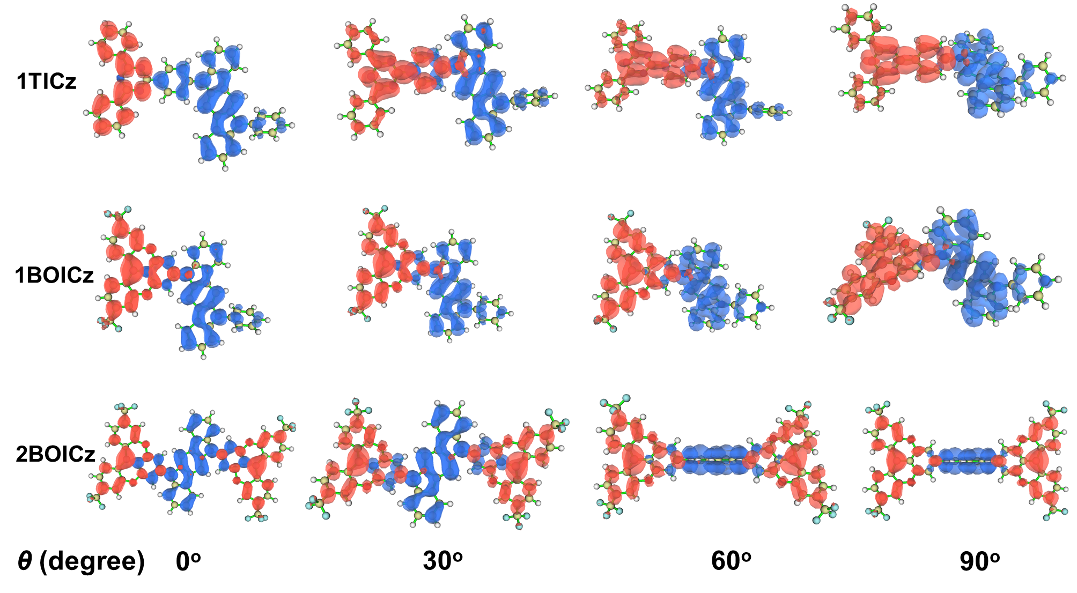
Figure S1. Effect of the varied θ between donor and acceptor on HOMOs (blue color) and LUMOs (red color) for 1TICz, 1BOICz and 2BOICz.

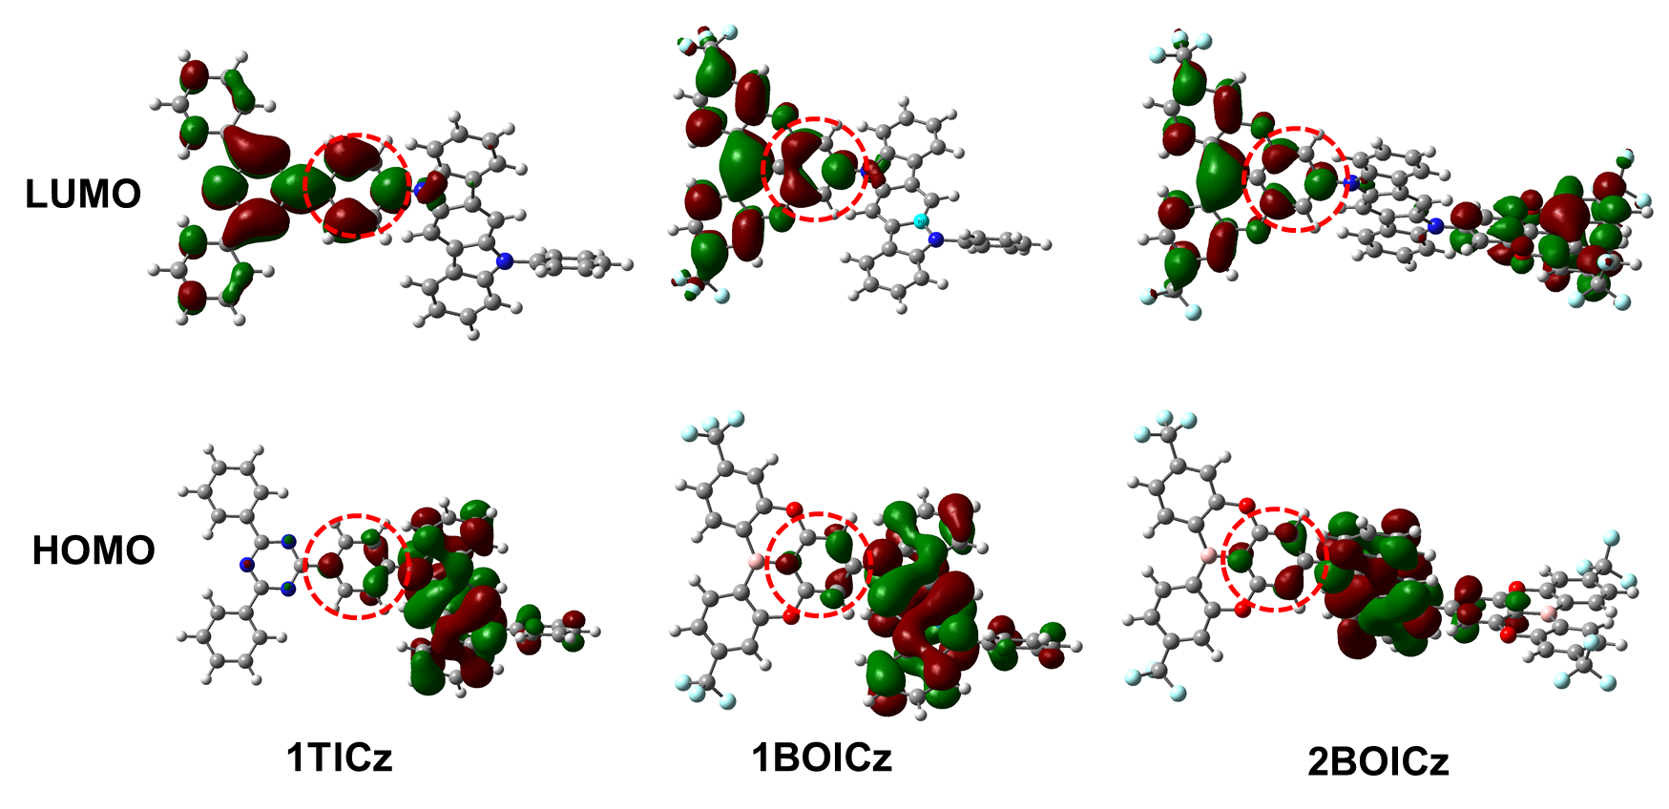
Figure S2. Distributions of HOMO and LUMO of 1TICz, 1BOICz and 2BOICz.

Table S1. Summary of TD-DFT calculation for 1TICz, 1BOICz and 2BOICz at the S₀ structures at the B3LYP/6-31G(d, p) level.
Compound | Optimized Structure | Transition | Wavelength (nm) | Energy (eV) | Oscillator Strength
1TICz | S₀ | S₀→S₁ | 469.09 | 2.6434 | 0.2361
1TICz | S₀ | S₀→T₁ | 506.08 | 2.4502 | 0
1BOICz | S₀ | S₀→S₁ | 513.84 | 2.4129 | 0.1426
1BOICz | S₀ | S₀→T₁ | 537.21 | 2.3075 | 0
2BOICz | S₀ | S₀→S₁ | 492.70 | 2.5164 | 0.3498
2BOICz | S₀ | S₀→T₁ | 513.13 | 2.4162 | 0

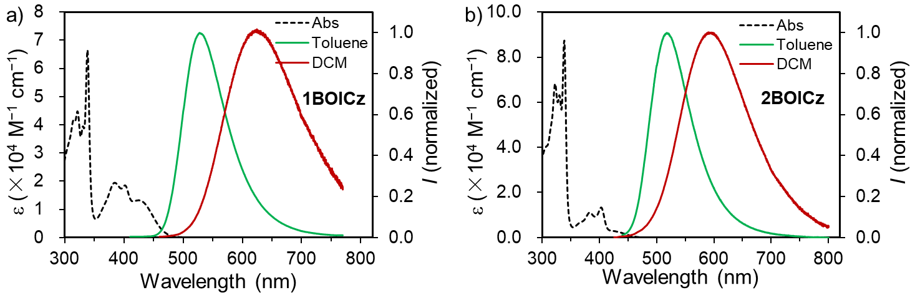
Figure S3. Ultraviolet–visible absorption (left axis) in toluene (10⁻⁵ M), and normalized PL spectra (right axis) of 2BOICz and 1BOICz in toluene and DCM (10⁻⁵ M), respectively.

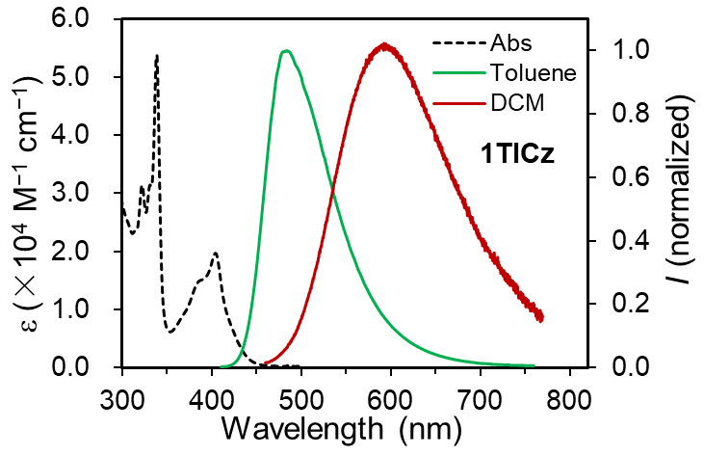
Figure S4. Ultraviolet–visible absorption (left axis) in toluene (10⁻⁵ M), and normalized PL spectra (right axis) of 1TICz in toluene and DCM (10⁻⁵ M).

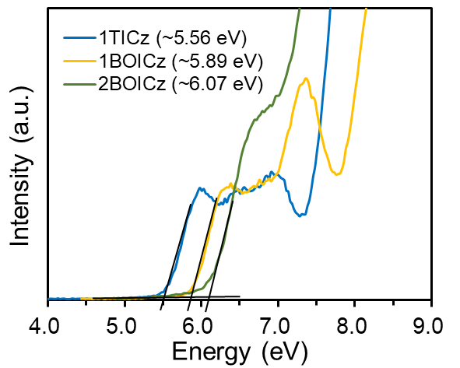
Figure S5. The ultraviolet photoelectron spectra of the vacuum-deposited thin films for 1TICz, 1BOICz and 2BOICz. The HOMO levels were determined to be −5.60 eV, −5.98 eV and −6.02 eV for 1TICz, 1BOICz and 2BOICz, combined with an emitting energy-band gap obtained from the absorption spectra, LUMO levels of −2.80 eV for 1TICz, −3.35 eV for 1BOICz and −3.38 eV for 2BOICz were obtained, respectively.
Table S2. Photophysical properties of emitters.
Compound | λ_{PL} [nm]ª | FWHM [nm]^{b} | ф_{PL} [%]^{c} | E_{g} [eV]^{d} | HOMO^{e}/LUMO [eV]
1TICz | 483 | 84 | 90 | 2.80 | -5.60/-2.80
1BOICz | 527 | 85 | 90 | 2.63 | -5.98/-3.35
2BOICz | 518 | 83 | 89 | 2.64 | -6.02/-3.38
ª Measured in toluene (10⁻⁵ M) at room temperature. ^{b} Full-width at half-maximum of the PL spectrum given in wavelength. ^{c} Absolute PL quantum yield evaluated using an integrating sphere. ^{d} Estimated from absorption edges of UV–vis spectra. ^{e} Determined from ultraviolet photoelectron spectra, LUMO was calculated by E_{g} and HOMO.
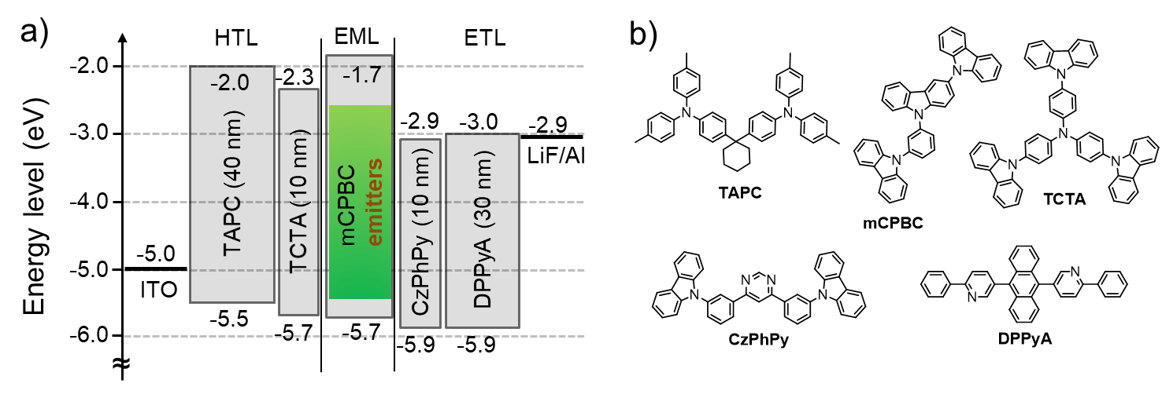
Figure S6. (a) Device architecture for TADF-OLEDs with energy levels of each layer material. (b) The major chemical structures of relevant materials.

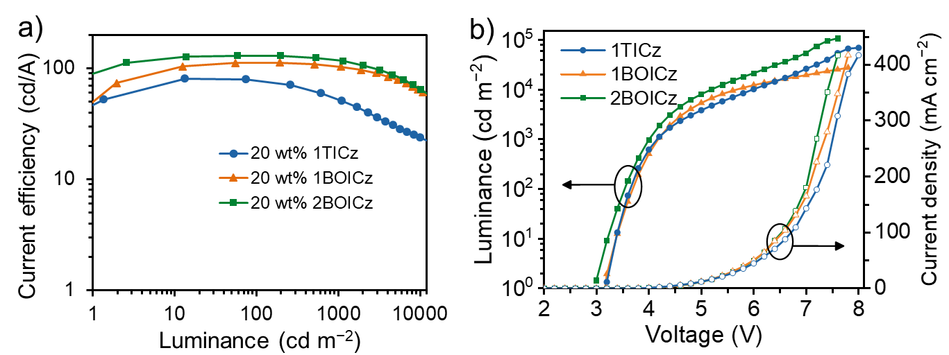
Figure S7. (a) The current efficiency versus brightness and (b) the current density–voltage–luminance (J–V–L) characteristics for devices based on 2BOICz, 1BOICz and 1TICz.

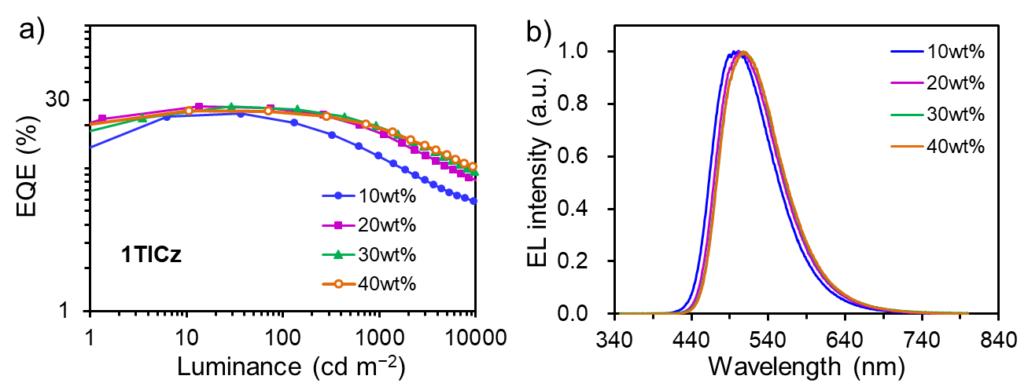
Figure S8. (a) External quantum efficiency (EQE) versus brightness for devices doped with 10 wt%, 20 wt%, 30 wt% and 40 wt% of 1TICz. (b) EL spectra of the devices under 1,000 cd m⁻².

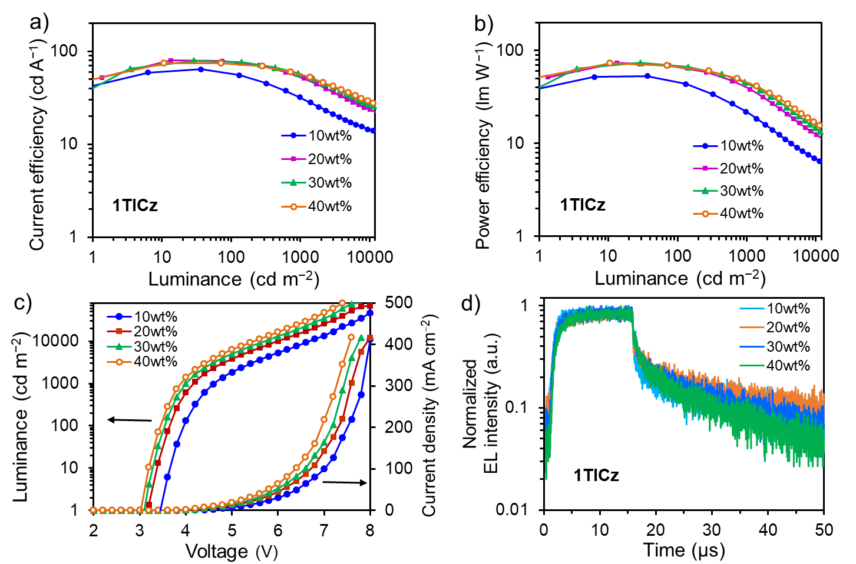
Figure S9. (a) Current efficiency (CE) and (b) power efficiency (PE) versus luminance (L), (c) Luminance–voltage–current density characteristics, and (d) EL transient spectra for the 10 wt%, 20 wt%, 30 wt% and 40 wt% doped devices based 1TICz.

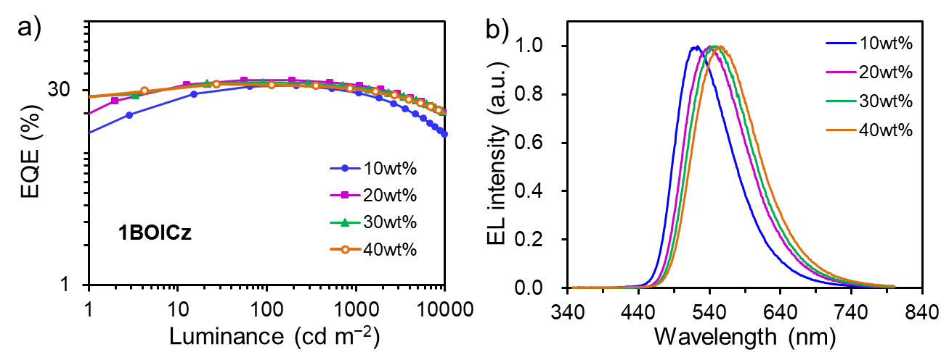
Figure S10. (a) External quantum efficiency (EQE) versus brightness for devices doped with 10 wt%, 20 wt%, 30 wt% and 40 wt% of 1BOICz. (b) EL spectra of the devices under 1,000 cd m⁻².

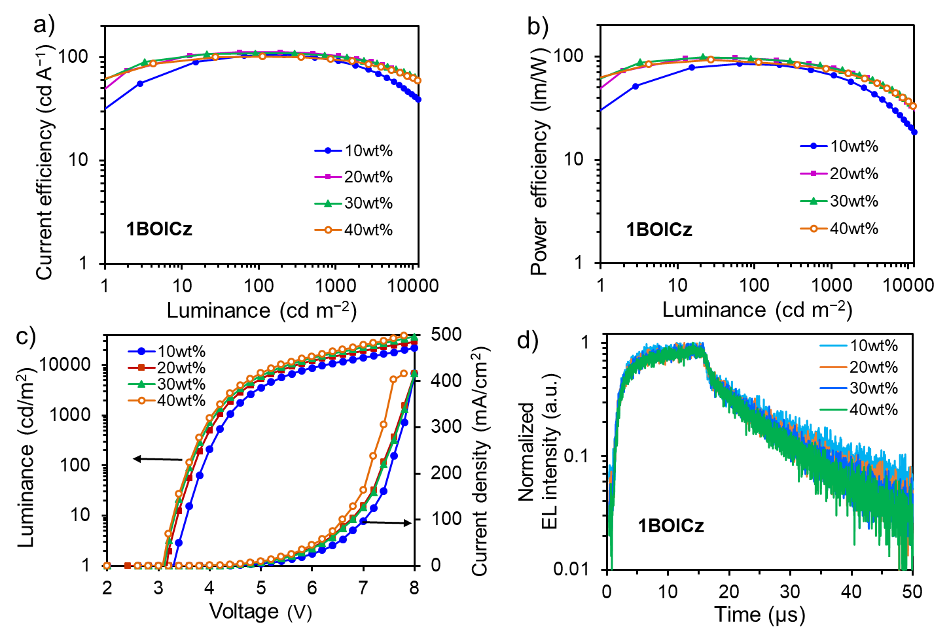
Figure S11. (a) Current efficiency (CE) and (b) power efficiency (PE) versus luminance (L), (c) Luminance–voltage–current density characteristics, and (d) EL transient spectra for the 10 wt%, 20 wt%, 30 wt% and 40 wt% doped devices based 1BOICz.

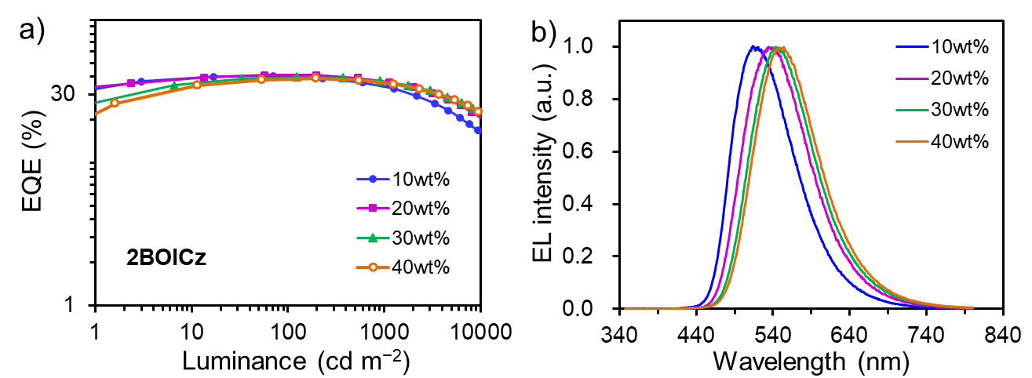
Figure S12. (a) External quantum efficiency (EQE) versus brightness for devices doped with 10 wt%, 20 wt%, 30 wt% and 40 wt% of 2BOICz. (b) EL spectra of the devices under 1,000 cd m⁻².

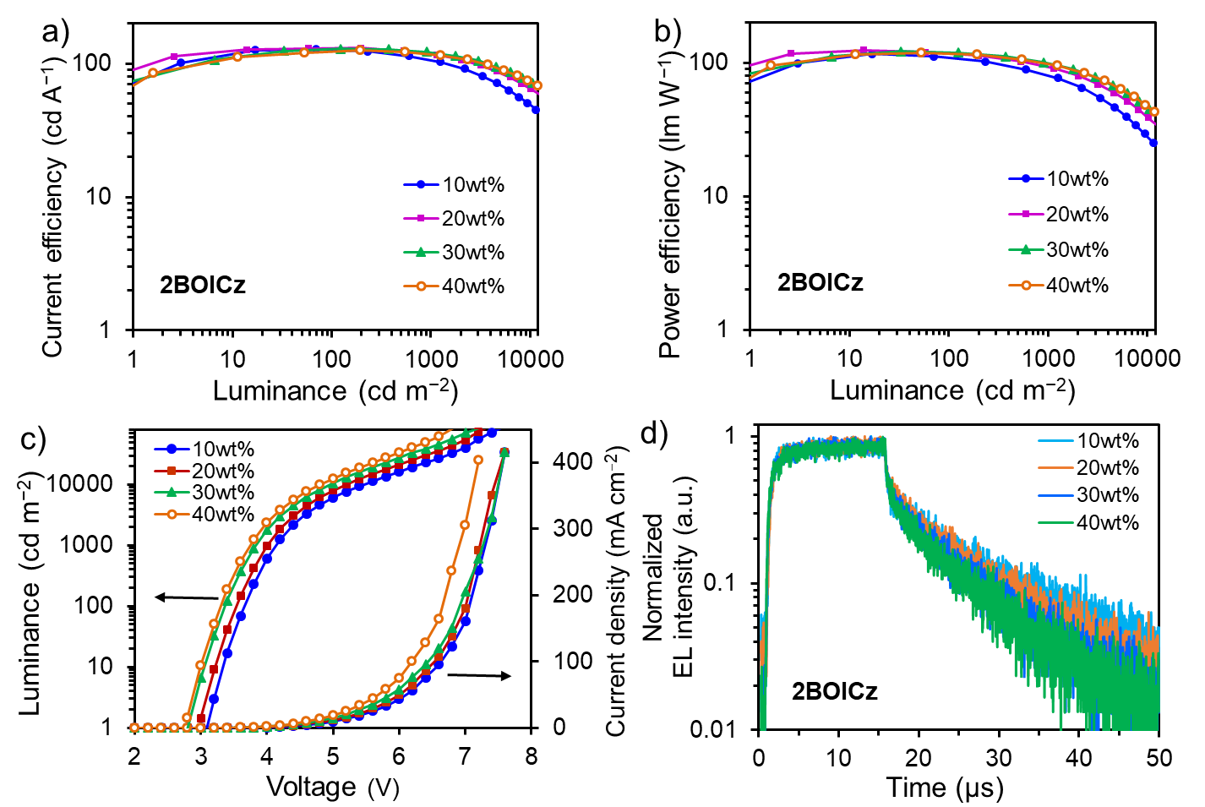
Figure S13. (a) Current efficiency (CE) and (b) power efficiency (PE) versus luminance (L), (c) Luminance–voltage–current density characteristics, and (d) EL transient spectra for the 10 wt%, 20 wt%, 30 wt% and 40 wt% doped devices based 2BOICz.

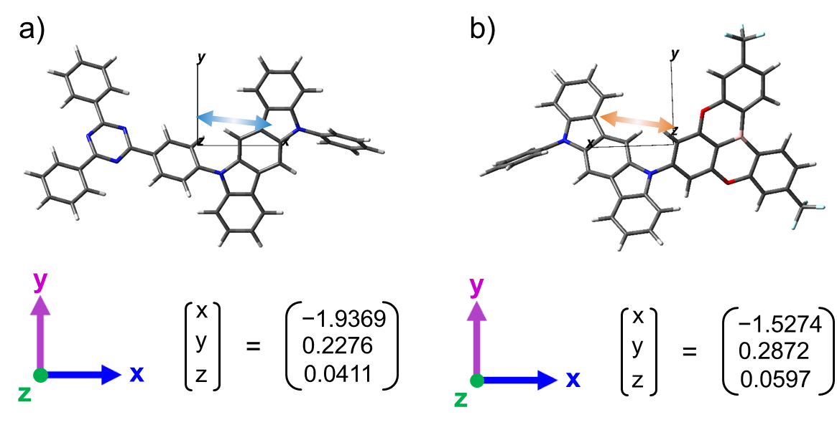
Figure S14. The direction of the calculated S₀–S₁ transition dipole moment (as indicated by the arrow) of (a) 1TICz and (b) 1BOICz based on optimized structure.

Table S3. Summary of the EL performance of 1TICz based-devices.
Doping concentration | λ_{EL} ª  [nm] | V_{on}^{b}  [V] | L_{max} ^{c}  [cd m⁻²] | CE_{max/1,000/5,000} ^{d}  [cd A⁻¹] | PE_{max/1,000/5,000} ^{e}  [lm W⁻¹] | EQE_{max/1,000/5,000} ^{f}  [%] | CIE  (x,y) ^{g}
10 wt% | 495 | 3.5 | 46,790 | 64.3/32.1/17.2 | 53.1/21.9/9.0 | 22.9/12.2/6.8 | (0.222, 0.446)
20 wt% | 504 | 3.2 | 68,910 | 80.0/51.1/30.6 | 73.9/38.2/18.5 | 26.9/17.2/10.4 | (0.247, 0.499)
30 wt% | 507 | 3.0 | 82,100 | 79.6/58.0/35.0 | 73.5/45.5/22.0 | 26.9/17.3/12.1 | (0.258, 0.522)
40 wt% | 508 | 3.0 | 84,950 | 74.8/52.4/35.8 | 69.1/41.1/23.4 | 25.1/17.7/12.3 | (0.265, 0.527)
ª EL peak wavelength; ^{b} Turn-on voltage (V_{on}); ^{c} Maximum luminescence (L ); ^{d} Maximum current efficiency (CE), value at 1,000 and 5,000 cd cm⁻²; ^{e} Maximum power efficiency (PE), value at 1,000 and 5,000 cd cm⁻²; ^{f} Maximum external quantum efficiency (EQE), value at 1,000 and 5,000 cd cm⁻²; ^{g} CIE coordinates at 1,000 cd cm⁻².

Table S4. Summary of the EL performance of 1BOICz based-devices.
Doping concentration | λ_{EL} ª  [nm] | V_{on}^{b}  [V] | L_{max} ^{c}  [cd m⁻²] | CE_{max/1,000/5,000} ^{d}  [cd A⁻¹] | PE_{max/1,000/5,000} ^{e}  [lm W⁻¹] | EQE_{max/1,000/5,000} ^{f}  [%] | CIE  (x,y) ^{g}
10 wt% | 524 | 3.3 | 62,250 | 105.4/92.2/63.2 | 85.4/65.8/38.2 | 32.6/28.7/19.9 | (0.314, 0.572)
20 wt% | 534 | 3.1 | 77,310 | 112.3/103.6/78.4 | 97.4/77.5/49.3 | 35.6/32.6/24.7 | (0.381, 0.566)
30 wt% | 550 | 3.1 | 80,770 | 109.0/98.8/81.4 | 98.9/73.9/53.3 | 34.3/30.7/25.0 | (0.403, 0.559)
40 wt% | 556 | 3.1 | 84,390 | 100.9/96.1/74.9 | 92.6/75.5/49.1 | 33.3/29.2/23.9 | (0.428, 0.544)
ª EL peak wavelength; ^{b} Turn-on voltage (V_{on}); ^{c} Maximum luminescence (L ); ^{d} Maximum current efficiency (CE), value at 1,000 and 5,000 cd cm⁻²; ^{e} Maximum power efficiency (PE), value at 1,000 and 5,000 cd cm⁻²; ^{f} Maximum external quantum efficiency (EQE), value at 1,000 and 5,000 cd cm⁻²; ^{g} CIE coordinates at 1,000 cd cm⁻².

Table S5. Summary of the EL performance of 2BOICz based-devices.
Doping concentration | λ_{EL} ª  [nm] | V_{on}^{b}  [V] | L_{max} ^{c}  [cd m⁻²] | CE_{max/1,000/5,000} ^{d}  [cd A⁻¹] | PE_{max/1,000/5,000} ^{e}  [lm W⁻¹] | EQE_{max/1,000/5,000} ^{f}  [%] | CIE  (x,y) ^{g}
10 wt% | 521 | 3.1 | 91,410 | 128.4/102.9/71.2 | 116.6/76.9/46.6 | 40.6/33.1/23.3 | (0.297, 0.554)
20 wt% | 528 | 3.0 | 106,800 | 130.4/116.3/87.3 | 124.9/91.4/59.6 | 41.2/36.6/27.7 | (0.383, 0.550)
30 wt% | 539 | 2.8 | 129,100 | 129.0/122.4/90.2 | 122.1/101.2/60.6 | 39.7/35.0/27.1 | (0.389, 0.564)
40 wt% | 554 | 2.7 | 133,100 | 124.8/115.2/88.7 | 118.5/95.2/63.3 | 38.9/35.6/27.3 | (0.406, 0.556)
ª EL peak wavelength; ^{b} Turn-on voltage (V_{on}); ^{c} Maximum luminescence (L ); ^{d} Maximum current efficiency (CE), value at 1,000 and 5,000 cd cm⁻²; ^{e} Maximum power efficiency (PE), value at 1,000 and 5,000 cd cm⁻²; ^{f} Maximum external quantum efficiency (EQE), value at 1,000 and 5,000 cd cm⁻²; ^{g} CIE coordinates at 1,000 cd cm⁻².

Table S6. Summary of the reports on k_{r} > k_{ISC} and k_{r} ˂ k_{ISC} TADF emitters.
Emitter | τ_{P}  (ns) | τ_{D}  (μs) | k_{r}  (10⁷s⁻¹) | k_{ISC}  (10⁶s⁻¹) | k_{RISC}  (10⁶s⁻¹) | λ_{EL}  (nm) | EQE_{max/1000/5000}  (%) | Ref.
 | 16 | 0.968 | 5.9 | 0.3 | 1.2 | 528 | 41.2/36.6/27.7 | This work
 | 20 | 0.884 | 4.5 | 0.5 | 1.1 | 534 | 35.6/32.6/24.7 | This work
 | 6.7 | 120 | 13 | 25 | 0.009 | 448 | 8.4/3.5/— | 9
 | 4.6 | 30 | 3.3 | 190 | 0.22 | 473 | 21.3/15.0/— | 9
 | 0.8 | 14 | 0.05 | 1100 | 180 | 481 | 23.4/20.0/— | 9
 | 34.2 | 4.5 | 2.9 | 5.5 | 1.2 | 482 | 32.6/20.7/— | 10
 | 26.3 | 1.64 | 1.38 | 16.4 | 1.09 | 550 | 13.31/10.35/— | 11
 | 32.6 | 2.0 | 0.99 | 12.6 | 0.84 | 595 | 21.8/20.1/— | 12
 | 44.6 | 2.63 | 0.98 | 20.9 | 1.19 | 576 | 30.3/28.4/— | 12
 | 19.6 | 16.2 | 33.4 | 32.4 | 0.99 | — | 38.15/34.3/25.2 | 13
 | 6.6 | 1.0 | 13.7 | 14.8 | 1.08 | — | 25.71/18.9/— | 13
 | 38 | 0.75 | 1.7 | 9 | 1.9 | 471 | 20.7/17.4/— | 14
 | 29 | 14.5 | 2.3 | 12 | 0.033 | 479 | 20.4/12.8/— | 14
ª EQE maximum value, EQE value at 1,000 cd/m² and EQE value at 10,000 cd m⁻².

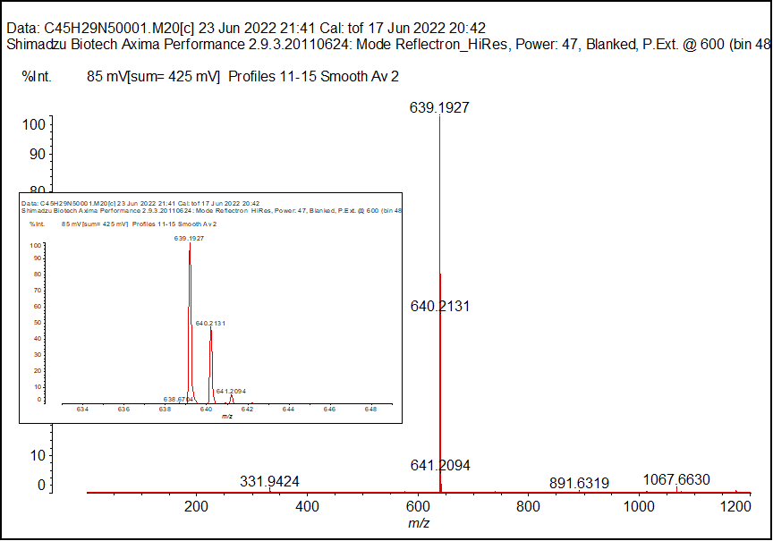
Figure S15. Mass spectrometry of 1TICz.
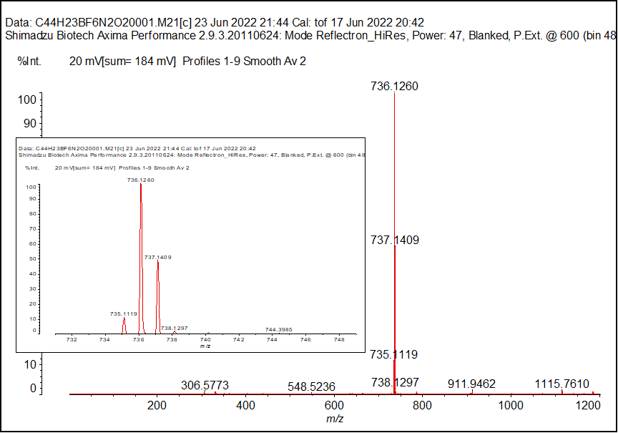
Figure S16. Mass spectrometry of 1BOICz.

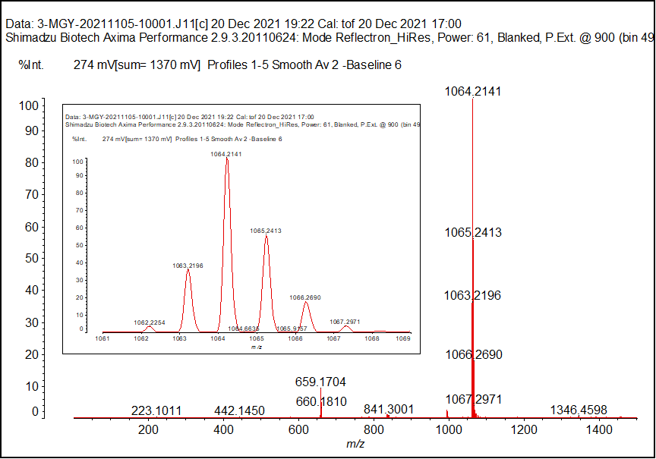
Figure S17. Mass spectrometry of 2BOICz.

Figure S18. ¹H NMR spectrum of BO-Br in CDCl₃.
Figure S19. ¹H NMR spectrum of 1TICz in CD₂Cl₂.
Figure S20. ¹³C NMR spectrum of 1TICz in CD₂Cl₂.
Figure S21. ¹H NMR spectrum of m 1BOICz in CD₂Cl₂.
Figure S22. ¹³C NMR spectrum of 1BOICz in CD₂Cl₂.
Figure S23. ¹¹B solid-state NMR spectra of 2BOICz and the parent core BO.

Figure S24. ¹⁹F solid-state NMR spectra of 2BOICz and the parent core BO. The * representing rotating sidebands.

3. Reference
1. Gaussian 09, Revision D.01, M. J. Frisch, G. W. Trucks, H. B. Schlegel, G. E. Scuseria, M. A. Robb, J. R. Cheeseman, G. Scalmani, V. Barone, B. Mennucci, G. A. Petersson, H. Nakatsuji, M. Caricato, X. Li, H. P. Hratchian, A. F. Izmaylov, J. Bloino, G. Zheng, J. L. Sonnenberg, M. Hada, M. Ehara, K. Toyota, R. Fukuda, J. Hasegawa, M. Ishida, T. Nakajima, Y. Honda, O. Kitao, H. Nakai, T. Vreven, J. A. Montgomery, Jr., J. E. Peralta, F. Ogliaro, M. Bearpark, J. J. Heyd, E. Brothers, K. N. Kudin, V. N. Staroverov, T. Keith, R. Kobayashi, J. Normand, K. Raghavachari, A. Rendell, J. C. Burant, S. S. Iyengar, J. Tomasi, M. Cossi, N. Rega, J. M. Millam, M. Klene, J. E. Knox, J. B. Cross, V. Bakken, C. Adamo, J. Jaramillo, R. Gomperts, R. E. Stratmann, O. Yazyev, A. J. Austin, R. Cammi, C. Pomelli, J. W. Ochterski, R. L. Martin, K. Morokuma, V. G. Zakrzewski, G. A. Voth, P. Salvador, J. J. Dannenberg, S. Dapprich, A. D. Daniels, O. Farkas, J. B. Foresman, J. V. Ortiz, J. Cioslowski, and D. J. Fox, Gaussian, Inc., Wallingford CT, 2013.
2. J.-D. Chai and M. H.-Gordon, Phys. Chem. Chem. Phys., 2008, 10, 6615.
3. L. Kronik, T. Stein, S. Refaely-Abramson, R. Baer, J. Chem. Theory Comput., 2012, 8, 1515.
4. H. Sun, C. Zhong, J. L. Brédas, J. Chem. Theory. Comput., 2015, 11, 3851.
5. T. Lu, F. Chen, J. Comput. Chem. 2012, 33, 580.
6. K. Masui, H. Nakanotani, C. Adachi, Organic Electronics 2013, 14, 2721.
7. Hirai, H. et al. One-Step Borylation of 1,3-Diaryloxybenzenes Towards Efficient Materials for Organic Light-Emitting Diodes. Angew. Chem. Int. Ed. 54, 13581-13585 (2015).
8. Xiang, S. et al. To improve the efficiency of thermally activated delayed fluorescence OLEDs by controlling the horizontal orientation through optimizing stereoscopic and linear structures of indolocarbazole isomers. J. Mater. Chem. C 6, 5812-5820 (2018).
9. Park, I. S., Min, H. & Yasuda, T. Ultrafast Triplet–Singlet Exciton Interconversion in Narrowband Blue Organoboron Emitters Doped with Heavy Chalcogens. Angew. Chem. Int. Ed., (2022). doi.org/10.1002/anie.202205684
10. Fu, Y., Liu, H., Yang, D., Ma, D., Zhao, Z. & Tang, B. Z. A Bipolar Delayed Fluorescence Luminogen with Fast Reverse Intersystem Crossing and High Horizontal Dipole Orientation for High‐Performance Sky‐Blue and White OLEDs. Adv. Opt. Mater. 10, (2022).
11. Qiu, Z. et al. Nanosecond-time-scale delayed fluorescence towards fast triplet-singlet spin conversion for efficient orange-red OLEDs with negligible efficiency roll-off. Chem. Eng. J. 415, (2021).
12. Karthik, D. et al. Acceptor-Donor-Acceptor-Type Orange-Red Thermally Activated Delayed Fluorescence Materials Realizing External Quantum Efficiency Over 30% with Low Efficiency Roll-Off. Adv. Mater. 33, 2007724 (2021).
13. Ahn, D. H. et al. Highly efficient blue thermally activated delayed fluorescence emitters based on symmetrical and rigid oxygen-bridged boron acceptors. Nat. Photonics 13, 540-546 (2019).
14. Kim, J. U. et al. Nanosecond-time-scale delayed fluorescence molecule for deep-blue OLEDs with small efficiency rolloff. Nat. Commun. 11, 1765 (2020).

