Supplementary information for
Prediction of phosphoric acid plus hydrogen peroxide (PHP) pretreatment efficiency using artificial neural network modeling
Qing Wang ^{a, b, c}, Jinguang Hu ^{c}, Li Zhao ^{b}, Mei Huang ^{b}, Dong Tian ^{b}, Yongmei Zeng ^{b}, Shihuai Deng ^{b}, Fei Shen ^{b*}, and Xinquan Zhang ^{a*}
ª College of Grassland Science and Technology, Sichuan Agricultural University, Chengdu, Sichuan 611130, P. R. China.
^{b} Institute of Ecological and Environmental Sciences, Sichuan Agricultural University, Chengdu, Sichuan 611130, P. R. China.
^{c} Department of Chemical and Petroleum Engineering, Schulich School of Engineering, the University of Calgary, Calgary T2N 4H9, Canada.
To whom correspondence should be addressed:
*Fei Shen Email: fishen@sicau.edu.cn
*Xinquan Zhang Email: zhangxq@sicau.edu.cn
Content:
Table S1 Experimental setups of PHP pretreatment and the obtained results for ANN modeling
Table S2 Experimental setups of PHP pretreatment and the obtained results for ANN testing
Table S3 Optimized key parameters of the ANN models
Fig. S1 Architecture of an artificial neuron

Table S1 Experimental setups of PHP pretreatment and the obtained results for ANN modeling
NO. | Pretreatment conditions |  |  |  | Cellulose content  (C-C, %) | Cellulose recovery  (C-R_{y}, %) | Hemicellulose content  (H-C, %) | Hemicellulose removal  (H-R_{l}, %) | Lignin content  (L-C, %) | Lignin removal  (L-R_{l}, %) | Solid recovery  (S-R_{y}, %)
NO. | Time  (t, h) | Temperature  (T, °C) | H₃PO₄  (C_{p}, %) | H₂O₂  (C_{h}, %)
1 | 2 | 30 | 65 | 7.06 | 34.86 | 67.60 | 19.66 | 30.46 | 20.53 | 42.96 | 68.06
2 | 2 | 30 | 70 | 5.29 | 42.23 | 75.90 | 20.31 | 33.40 | 17.93 | 53.83 | 63.08
3 | 2 | 30 | 80 | 1.76 | 45.63 | 100.00 | 18.33 | 16.17 | 19.91 | 28.50 | 88.00
4 | 2 | 30 | 85 | 0.00 | 66.40 | 100.00 | 0.00 | 100.00 | 26.32 | 8.61 | 85.06
5 | 3 | 30 | 65 | 7.06 | 54.25 | 96.32 | 0.00 | 100.00 | 14.80 | 62.36 | 62.31
6 | 3 | 30 | 70 | 5.29 | 44.15 | 66.93 | 0.00 | 100.00 | 12.97 | 71.84 | 53.21
7 | 3 | 30 | 80 | 1.76 | 56.43 | 80.39 | 14.23 | 63.02 | 17.01 | 65.29 | 49.99
8 | 3 | 30 | 85 | 0.00 | 70.70 | 100.00 | 0.00 | 100.00 | 28.01 | 21.88 | 68.32
9 | 4 | 30 | 65 | 7.06 | 43.99 | 79.68 | 10.08 | 66.69 | 12.23 | 68.27 | 63.58
10 | 4 | 30 | 70 | 5.29 | 51.05 | 80.42 | 17.63 | 49.33 | 9.98 | 77.48 | 55.28
11 | 4 | 30 | 80 | 1.76 | 71.83 | 100.00 | 0.00 | 100.00 | 14.91 | 68.51 | 51.72
12 | 4 | 30 | 85 | 0.00 | 67.92 | 100.00 | 0.00 | 100.00 | 26.35 | 22.48 | 72.07
13 | 2 | 40 | 65 | 7.06 | 54.15 | 75.91 | 0.00 | 100.00 | 14.86 | 70.17 | 49.20
14 | 2 | 40 | 70 | 5.29 | 70.27 | 87.49 | 0.00 | 100.00 | 12.08 | 78.46 | 43.69
15 | 2 | 40 | 80 | 1.76 | 84.19 | 100.00 | 0.00 | 100.00 | 17.99 | 66.38 | 45.78
16 | 2 | 40 | 85 | 0.00 | 63.14 | 100.00 | 0.00 | 100.00 | 25.92 | 14.17 | 81.13
17 | 3 | 40 | 65 | 7.06 | 52.52 | 65.58 | 0.00 | 100.00 | 11.12 | 80.12 | 43.82
18 | 3 | 40 | 70 | 5.29 | 76.54 | 87.26 | 0.00 | 100.00 | 10.86 | 82.26 | 40.01
19 | 3 | 40 | 80 | 1.76 | 100.00 | 100.00 | 0.00 | 100.00 | 17.21 | 71.55 | 40.52
20 | 3 | 40 | 85 | 0.00 | 71.31 | 100.00 | 0.00 | 100.00 | 31.78 | 24.40 | 58.29
21 | 4 | 40 | 65 | 7.06 | 54.35 | 61.75 | 0.00 | 100.00 | 12.50 | 79.66 | 39.87
22 | 4 | 40 | 70 | 5.29 | 75.93 | 87.28 | 0.00 | 100.00 | 10.46 | 82.78 | 40.34
23 | 4 | 40 | 80 | 1.76 | 80.30 | 95.53 | 0.00 | 100.00 | 16.21 | 72.38 | 41.75
24 | 4 | 40 | 85 | 0.00 | 71.50 | 100.00 | 0.00 | 100.00 | 23.58 | 16.60 | 86.67
25 | 2 | 50 | 65 | 7.06 | 47.14 | 52.23 | 0.00 | 100.00 | 11.87 | 81.16 | 38.89
26 | 2 | 50 | 70 | 5.29 | 80.68 | 85.67 | 0.00 | 100.00 | 13.78 | 79.04 | 37.26
27 | 2 | 50 | 80 | 1.76 | 78.83 | 100.00 | 0.00 | 100.00 | 22.56 | 57.54 | 46.10
28 | 2 | 50 | 85 | 0.00 | 64.98 | 79.62 | 0.00 | 100.00 | 28.84 | 49.39 | 43.00
29 | 3 | 50 | 65 | 7.06 | 54.50 | 57.67 | 0.00 | 100.00 | 12.09 | 81.67 | 37.14
30 | 3 | 50 | 70 | 5.29 | 81.14 | 84.22 | 0.00 | 100.00 | 12.33 | 81.66 | 36.43
31 | 3 | 50 | 80 | 1.76 | 72.39 | 78.62 | 0.00 | 100.00 | 26.34 | 59.02 | 38.11
32 | 3 | 50 | 85 | 0.00 | 79.40 | 100.00 | 0.00 | 100.00 | 33.28 | 32.17 | 49.94
33 | 4 | 50 | 65 | 7.06 | 51.05 | 55.36 | 0.00 | 100.00 | 11.44 | 82.23 | 38.06
34 | 4 | 50 | 70 | 5.29 | 84.71 | 86.33 | 0.00 | 100.00 | 12.70 | 81.46 | 35.77
35 | 4 | 50 | 80 | 1.76 | 79.03 | 83.40 | 0.00 | 100.00 | 25.57 | 61.35 | 37.03
36 | 4 | 50 | 85 | 0.00 | 58.27 | 79.94 | 0.00 | 100.00 | 19.44 | 61.80 | 48.14
Note: Some of the cellulose recoveries are calculated higher than 100%, and they are regarded as 100% in the table.

Table S2 Experimental setups of PHP pretreatment and the obtained results for ANN testing
NO. | Pretreatment parameters |  |  |  | Cellulose content  (C-C, %) | Cellulose recovery  (C-R_{y}, %) | Hemicellulose content  (H-C, %) | Hemicellulose removal  (H-R_{l}, %) | Lignin content  (L-C, %) | Lignin removal  (L-R_{l}, %) | Solid recovery  (S-R_{y}, %)
NO. | Time  (t, h) | Temperature  (T, °C) | H₃PO₄  (C_{p}, %) | H₂O₂  (C_{h}, %)
1 | 2 | 45 | 65 | 7.06 | 34.86 | 67.60 | 19.66 | 30.46 | 20.53 | 42.96 | 68.06
2 | 2 | 45 | 70 | 5.29 | 42.23 | 75.90 | 20.31 | 33.40 | 17.93 | 53.83 | 63.08
3 | 2 | 45 | 80 | 1.76 | 45.63 | 100.00 | 18.33 | 16.17 | 19.91 | 28.50 | 88.00
4 | 2 | 45 | 85 | 0.00 | 58.27 | 79.94 | 0.00 | 100.00 | 19.44 | 61.80 | 48.14
Note: Some of the cellulose recoveries are calculated higher than 100%, and they are regarded as 100% in the table.

Table S3 Optimized key parameters of the ANN models
Output variables | Parameters for ANN modeling
Output variables | Hidden layers | Activation functions | Iterations | Neurons
C-C | 1 | Tanh | 900 | 9
C-R_{y} | 1 | Tanh | 900 | 10
H-R_{l} | 1 | Tanh | 900 | 10
L-R_{l} | 1 | Tanh | 900 | 12

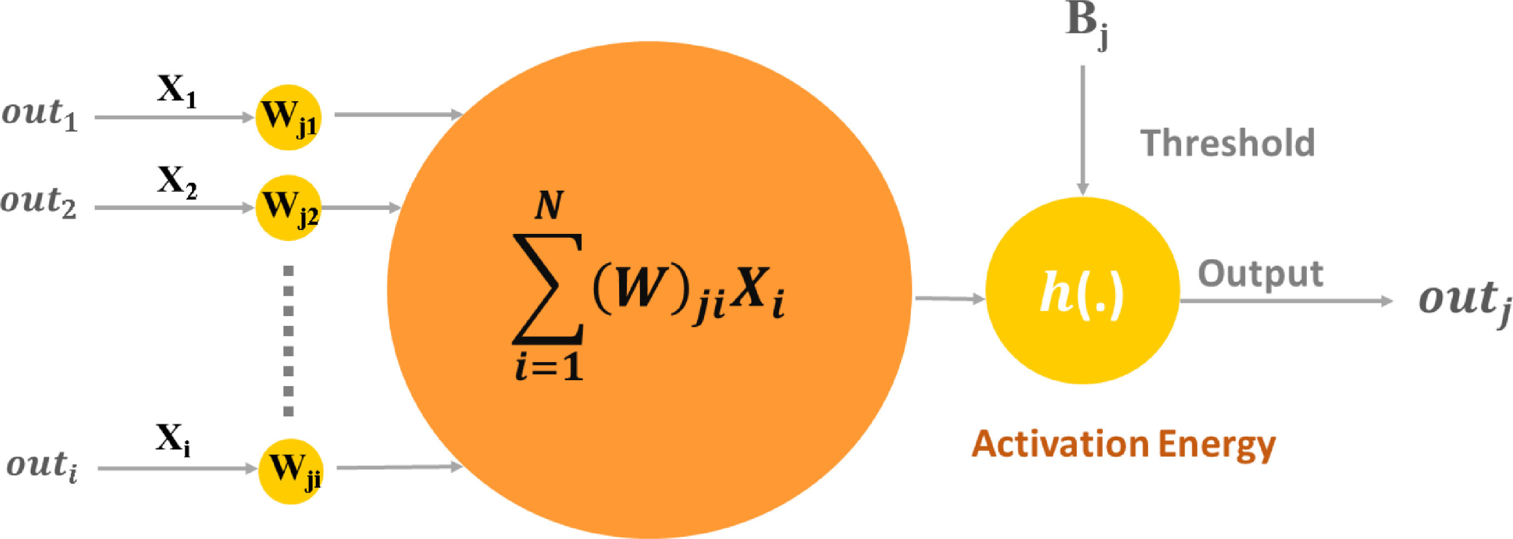
Fig. S1 Architecture of an artificial neuron (Kartal et al., 2021).
References
Kartal, F., Özveren, U., 2021. An improved machine learning approach to estimate hemicellulose, cellulose, and lignin in biomass. Carbohydr. Polym. Technol. Appl. 2, 100148. https://doi.org/10.1016/j.carpta.2021.100148.

