SUPPLEMENTARY INOFRMATION

Increases of phospho-Tau (Ser202/Thr205) in the olfactory regions are associated with impaired EEG and olfactory behavior in traumatic brain injury mice

Younghyun Yoon, YunHee Seol, Su-Hyun Kim, Hyoenjoo Im, Hio-Been Han,
Jee Hyun Choi, Hoon Ryu

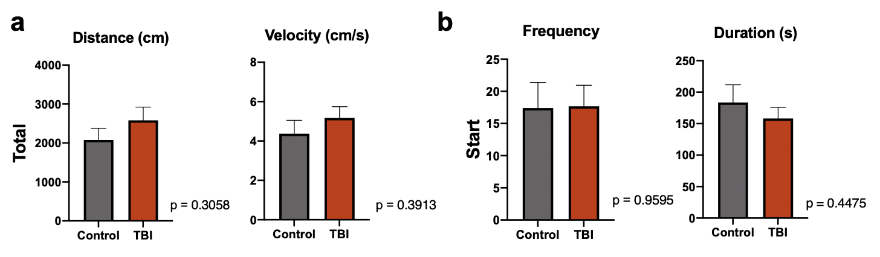
Supplementary Figure 1. Activity levels are not significantly changed between Control and TBI mice in Y-maze test. (a) Total distance and velocity measured during Y maze experiments. TBI mouse models exhibit a slight increase in physical activity compared to controls without reaching significance (distance, p=0.3058; velocity, p=0.3913). (b) Total frequency and duration measured during Y maze experiments in the starting arm of the apparatus. No significant difference was detected between controls vs. TBI mice (frequency, p=0.9595; duration, p=0.4475) [control, N=5; TBI, N=6].

Supplementary Movie 1. TBI mice shows an increased frequency of TBI mouse in the arm with new bedding. (a) Control mouse. (b) TBI mouse.

