Supplementary Information
A structure-based drug repurposing approach by considering the twenty four SARS-CoV2 Targets: A consensus scoring approach
Esther Jamir^{1,2}, Himakshi Sarma¹, Lipsa Priyadarsinee^{1,2}, Kikrusenuo Kiewhuo^{1,2}, Selvaraman Nagamani^{1,2} and G. Narahari Sastry*^{1,2}
¹Advanced Computation and Data Sciences Division, CSIR – North East Institute of Science and Technology, Jorhat – 785006, Assam, India
²Academy of Scientific and Innovative Research (AcSIR), Ghaziabad, India

*Corresponding Author: gnsastry@gmail.com; gnsastry@neist.res.in

Fig. S1 (a) 3D structure of structural (Envelope, Membrane, Spike, Nucleocapsid) and accessory (ORF3a, ORF6, ORF7a, ORF8, ORF9b) SARS CoV2 targets along with the active sites of the protein.
Fig. S1 (b) 3D structure of non-structural (NSP1, NSP2, NSP3, NSP4, NSP5, NSP6, NSP7, NSP8, NSP9, NSP10, NSP12, NSP13, NSP14, NSP15, NSP16) SARS CoV2 targets along with the active sites of the protein.
Fig. S2 (a) Distribution of binding scores of 4193 compounds against 4 structural and 5 accessory SARS-CoV-2 targets namely A) Envelope, B) Membrane, C) Spike and D) Nucleoprotein, E) ORF3a, F) ORF6, G) ORF7a, H) ORF8 and I) ORF9b.
Fig. S2 (b) Distribution of binding scores of 4193 compounds against 15 non-structural SARS-CoV-2 targets namely A) NSP1 B) NSP2, C) NSP3 D) NSP4, E) NSP5, F) NSP6, G) NSP7, H) NSP8, I) NSP9, J) NSP10, K) NSP12, L) NSP13, M) NSP14, N) NSP15, and O) NSP16.
Table S1 The grid box coordinates and size parameters used in AutoDock Vina for the 24 SARS-CoV2 proteins.
Table S2 List of FDA approved drugs (approved, authorised and under clinical trials) for the treatment of COVID-19 disease.

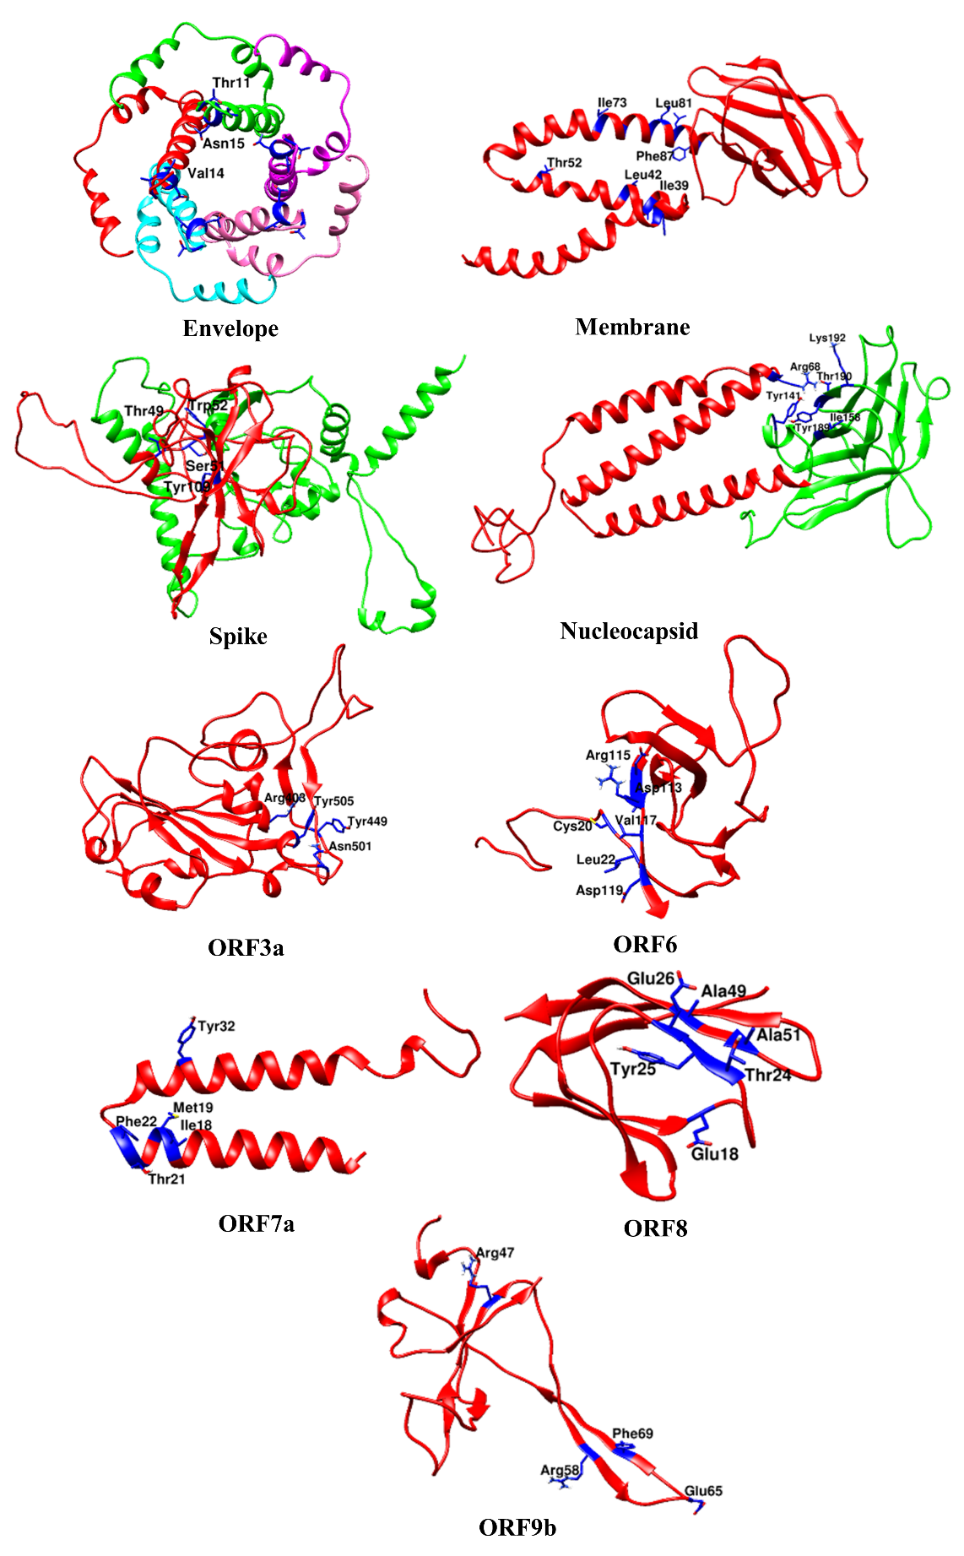

Fig. S1 (a) 3D structure of structural (Envelope, Membrane, Spike, Nucleocapsid) and accessory (ORF3a, ORF6, ORF7a, ORF8, ORF9b) SARS CoV2 targets along with the active sites of the protein.

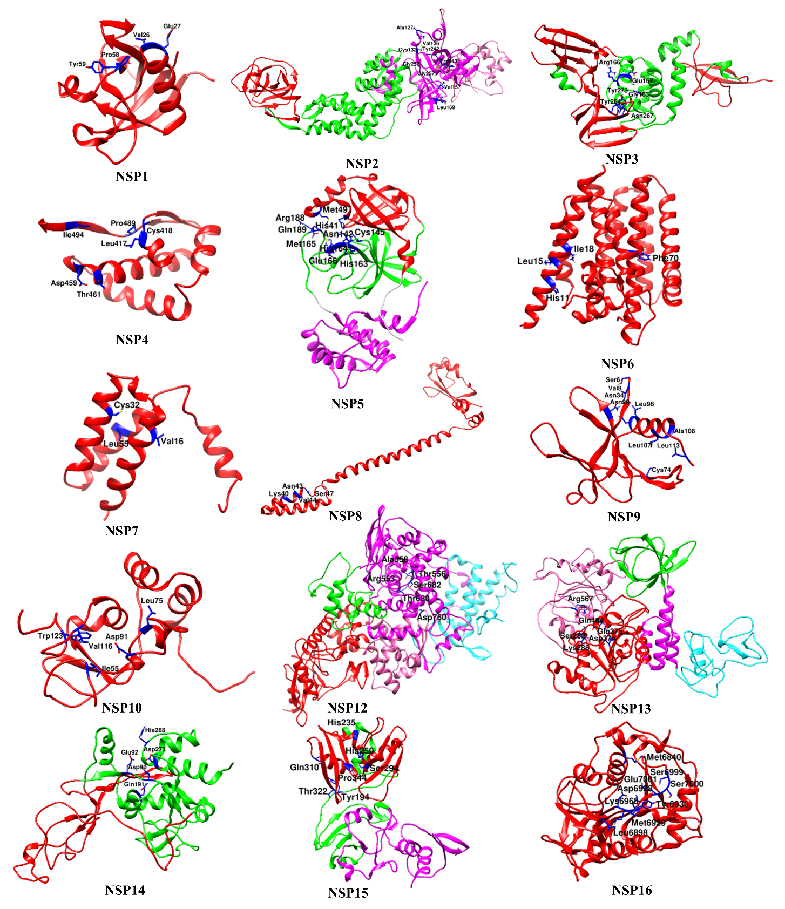

Fig. S1 (b) 3D structure of non-structural (NSP1, NSP2, NSP3, NSP4, NSP5, NSP6, NSP7, NSP8, NSP9, NSP10, NSP12, NSP13, NSP14, NSP15, NSP16) SARS CoV2 targets along with the active sites of the protein.

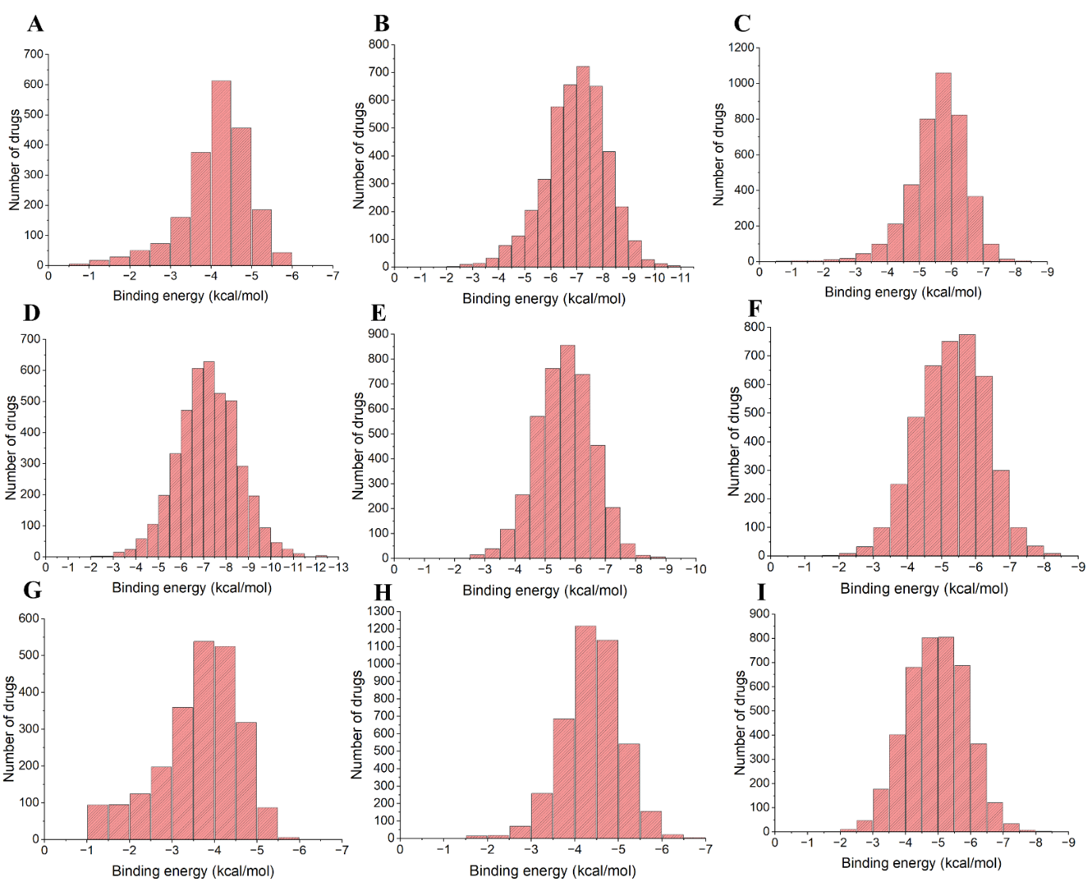

Fig. S2 (a) Distribution of binding scores of 4193 compounds against 4 structural and 5 accessory SARS-CoV-2 targets namely A) Envelope, B) Membrane, C) Spike and D) Nucleoprotein, E) ORF3a, F) ORF6, G) ORF7a, H) ORF8 and I) ORF9b.

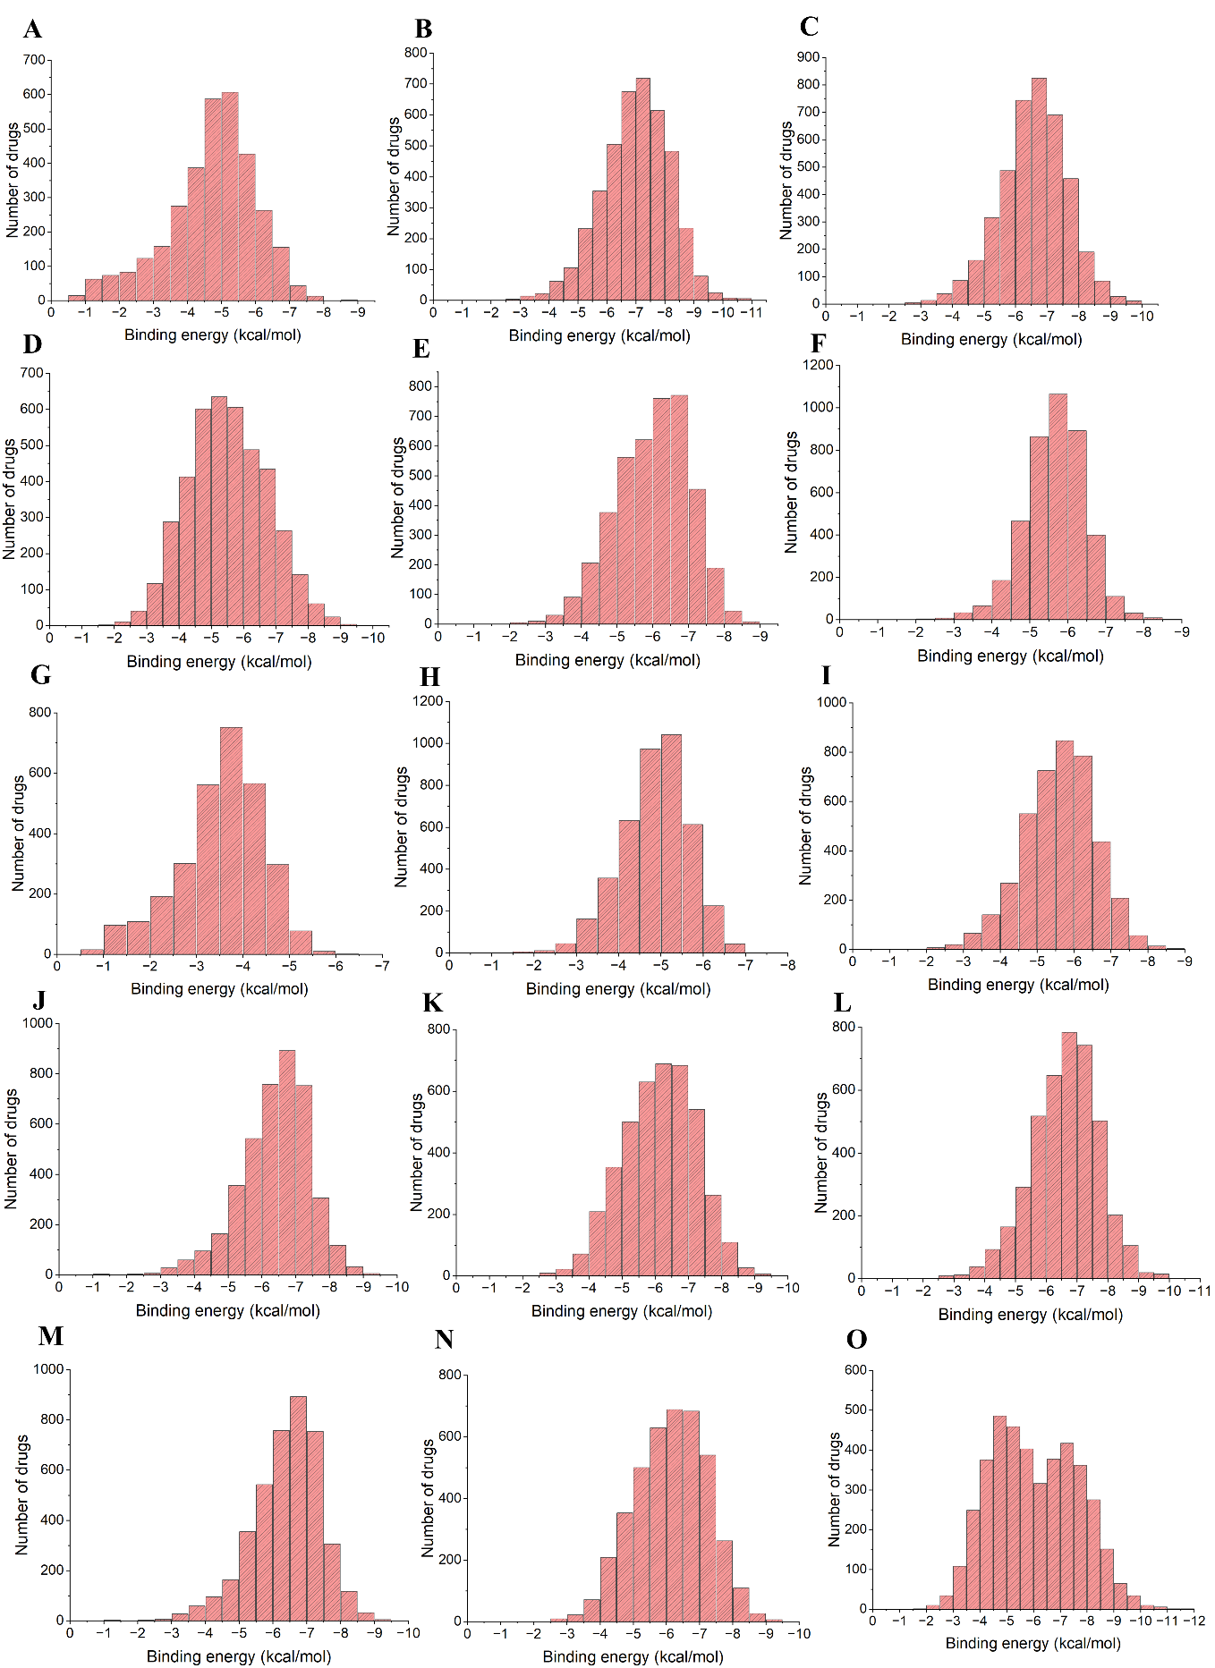

Fig. S2 (b) Distribution of binding score of 4193 compounds against 15 non-structural SARS-CoV-2 targets namely A) NSP1 B) NSP2, C) NSP3 D) NSP4, E) NSP5, F) NSP6, G) NSP7, H) NSP8, I) NSP9, J) NSP10, K) NSP12, L) NSP13, M) NSP14, N) NSP15, O) NSP16.

Table S1 The grid box coordinates and size parameters used in AutoDock Vina for the 24 SARS-CoV2 proteins.
Coordinates |  | Proteins
 |  | Envelope | Membrane | Spike | Nucleoprotein | ORF3a | ORF6 | ORF7a | ORF8 | ORF9b | NSP1 | NSP2 | NSP3
Center (Å) | x | 9.8 | 5.278 | -37.399 | 78.331 | 79.192 | 55.813 | -25.319 | 43.543 | 9.372 | 5.508 | 111.543 | 1.569
Center (Å) | y | 2.974 | -6.826 | 20.878 | 85.622 | 82.982 | 57.921 | 18.671 | 34.034 | -6.727 | -12.859 | 117.089 | 7.464
Center (Å) | z | -6.155 | 2.919 | 7.558 | 79.184 | 54.222 | 60.902 | 17.793 | 118.323 | -10.841 | 20.384 | 106.244 | 34.271
Box Size (Å) | x | 14 | 28 | 20 | 34 | 32 | 52 | 18 | 16 | 20 | 18 | 48 | 68
Box Size (Å) | y | 10 | 24 | 16 | 30 | 30 | 22 | 14 | 28 | 40 | 16 | 32 | 54
Box Size (Å) | z | 16 | 30 | 16 | 40 | 24 | 40 | 14 | 16 | 38 | 10 | 42 | 50
 |  | NSP4 | NSP5 | NSP6 | NSP7 | NSP8 | NSP9 | NSP10 | NSP12 | NSP13 | NSP14 | NSP15 | NSP16
Center (Å) | x | -2.583 | 15.001 | 57.093 | -20.321 | 174.111 | 44.798 | -40.598 | 89.486 | -57.825 | -27.091 | -51.175 | 86.941
Center (Å) | y | -2.998 | -16.402 | 62.528 | -27.202 | 125.217 | -10.821 | 5.367 | 92.499 | 2.01 | -1.648 | 23.763 | 24.217
Center (Å) | z | 15.26 | 22.172 | 62.16 | -5.998 | 171.567 | 19.821 | 25.819 | 96.486 | 26.436 | 1.615 | 30.092 | 30.756
Box Size (Å) | x | 20 | 26 | 38 | 12 | 16 | 26 | 28 | 26 | 28 | 28 | 20 | 24
Box Size (Å) | y | 16 | 28 | 28 | 10 | 18 | 32 | 20 | 34 | 24 | 24 | 26 | 26
Box Size (Å) | z | 22 | 22 | 26 | 16 | 14 | 30 | 18 | 34 | 20 | 20 | 26 | 28

Table S2 List of FDA approved drugs (approved, authorised and under clinical trials) for the treatment of COVID-19 disease.
Sl.no | Drugs | Indication | Status of approval for COVID-19
1 | Remdesivir | Antiviral | Approved
2 | Baricitinib | Anti-arthritis | Approved
3 | Bebtelovimab | Antiviral | Authorized for emergency use
4 | Sotrovimab | Antiviral | Authorized
5 | Nirmatrelvir | Antiviral | Authorized
6 | Ritonavir | Antiviral | Authorized
7 | Molnupiravir | Antiviral | Authorized
8 | Hydroxychloroquine | Antimalarial | Clinical trial
9 | Lopinavir | Antiviral | Clinical trial
10 | Favipiravir | Antiviral | Clinical trial
11 | Ivermectin | Anti-parasite | Clinical trial
12 | Dexamethasone | Anti-inflammatory | Clinical trial
13 | Tocilizumab | Anti-arteritis | Clinical trial
14 | Mavrilimumab | Antiviral | Clinical trial
15 | Sabizabulin | Anticancer | Clinical trial
16 | Ensovibep | Antiviral | Clinical trial
17 | Tocilizumab | Anti-arteritis | Clinical trial

