Appendix A

Prevalence and factors associated with suicidal ideation, cannabis, and alcohol misuse during the COVID-19 pandemic in Saskatchewan: findings from a joint-effect modeling
Running title: Suicidal ideation, cannabis, and alcohol misuse in Saskatchewan
Daniel A. Adeyinka^{1,2}, Nuelle Novik^{1,3}, Gabriela Novotna³, Mary Bartram^{4,5}, Gabrys Robert⁶, Nazeem Muhajarine^{1,2}

Affiliations and Addresses:
¹Saskatchewan Population Health and Evaluation Research Unit (SPHERU), University of Saskatchewan, 104 Clinic Place, Saskatoon, SK, S7N 2Z4
²Department of Community Health and Epidemiology, College of Medicine, University of Saskatchewan, 107 Wiggins Rd, Saskatoon, SK, S7N 5E5
³Faculty of Social Work, University of Regina, 3737 Wascana Parkway, Regina, SK, S4S 0A2
⁴School of Public Health and Administration, Carleton University, Ottawa, ON, K1S 5B6
⁵Mental Health Commission of Canada, Ottawa ON, K1R 1A4
⁶Canadian Centre on Substance Use and Addiction, Ottawa, ON, K1P 5E7

Corresponding Author: Nazeem Muhajarine, e: nazeem.muhajarine@usask.ca

Table A1: Coping strategy scale, MHCC-CCSA Survey

During the past month, have you engaged in more or less of the following activities?
 | List | I do not engage in this activity | Less | The same | More
Item | Value | 1 | 2 | 3 | 4
Connecting with friends and family through technology (e.g., Facetime) | 1 |  |  |  | 
Walking/jogging | 2 |  |  |  | 
Exercising | 3 |  |  |  | 
Online streaming channels (e.g., Netflix) | 4 |  |  |  | 
Time with pet | 5 |  |  |  | 
Eating food | 6 |  |  |  | 
Mindfulness (e.g., meditation) | 7 |  |  |  | 
Social media | 8 |  |  |  | 
Watching or reading the news | 9 |  |  |  | 
Relaxation activities (e.g., bath, hot tub) | 10 |  |  |  | 
Shopping (online or in-store) | 11 |  |  |  | 
Working more | 12 |  |  |  | 
Sexual activity | 13 |  |  |  | 
Drinking alcohol (beverages/drinks)* | 14 |  |  |  | 
Consuming cannabis * | 15 |  |  |  | 
Smoking cigarettes | 16 |  |  |  | 
Using e-cigarettes (e.g., vape pen) | 17 |  |  |  | 
Taking prescribed psychoactive drugs (e.g., Ativan, Xanax, Dilaudid, etc.) – excluding cannabis) | 18 |  |  |  | 
Taking other illegal psychoactive drugs (e.g., cocaine, opioids, meth, etc.) | 19 |  |  |  | 

*Items 14 and 15 were excluded from the factor analysis because they are part of the outcome factors

Table A2: Eigenvalues of the principal factor analysis of the retained11 items (after dropping items with factor loading <0.3)

 | Unrotated |  |  |  | Orthogonal varimax rotation*
Factor | Eigenvalue | Difference | Proportion | Cumulative | Eigenvalue | Difference | Proportion | Cumulative
Factor1 | 2.19011 | 0.90434 | 0.7506 | 0.7506 | 1.81091 | 0.14594 | 0.6206 | 0.6206
Factor2 | 1.28577 | 1.10212 | 0.4407 | 1.1912 | 1.66497 | . | 0.5706 | 1.1912
Factor3 | 0.18365 | 0.04302 | 0.0629 | 1.2542
Factor4 | 0.14063 | 0.12271 | 0.0482 | 1.3024
Factor5 | 0.01792 | 0.07924 | 0.0061 | 1.3085
Factor6 | -0.06133 | 0.03993 | -0.021 | 1.2875
Factor7 | -0.10126 | 0.0159 | -0.0347 | 1.2528
Factor8 | -0.11716 | 0.05933 | -0.0402 | 1.2126
Factor9 | -0.17648 | 0.02633 | -0.0605 | 1.1522
Factor10 | -0.20281 | 0.03835 | -0.0695 | 1.0827
Factor11 | -0.24117 | . | -0.0827 | 1
*Kaiser normalization

Table A3: Rotated factor loadings (pattern matrix) and unique variances of the retained items (based on absolute loading of 0.3)

Item | Factor1 | Factor2 | Uniqueness
Cronbach’s alpha | 0.7719 | 0.6533
Connecting with friends and family through technology (e.g., Facetime) |  | 0.3432 | 0.8628
Walking/jogging |  | 0.6723 | 0.5478
Exercising |  | 0.6517 | 0.5753
Mindfulness (e.g., meditation) |  | 0.4289 | 0.7829
Relaxation activities (e.g., bath, hot tub) |  | 0.4111 | 0.8306
Working more |  | 0.3085 | 0.9048
Sexual activity |  | 0.4049 | 0.825
Smoking cigarettes | 0.5784 |  | 0.6636
Using e-cigarettes (e.g., vape pen) | 0.7295 |  | 0.4516
Taking prescribed psychoactive drugs (e.g., Ativan, Xanax, Dilaudid, etc.) – excluding cannabis) | 0.5933 |  | 0.6228
Taking other illegal psychoactive drugs (e.g., cocaine, opioids, meth, etc.) | 0.7265 |  | 0.4569

Table A4: Kaiser-Meyer-Olkin measure of sampling adequacy
Item | KMO
Connecting with friends and family through technology (e.g., Facetime) | 0.7949
Walking/jogging | 0.6798
Exercising | 0.6776
Mindfulness (e.g., meditation) | 0.8335
Relaxation activities (e.g., bath, hot tub) | 0.8117
Working more | 0.7085
Sexual activity | 0.7997
Smoking cigarettes | 0.8181
Using e-cigarettes (e.g., vape pen) | 0.7533
Taking prescribed psychoactive drugs (e.g., Ativan, Xanax, Dilaudid, etc.) – excluding cannabis) | 0.8235
Taking other illegal psychoactive drugs (e.g., cocaine, opioids, meth, etc.) | 0.7642
Overall | 0.7610

Figure A1: Correlations of the 17 items from the coping index scale
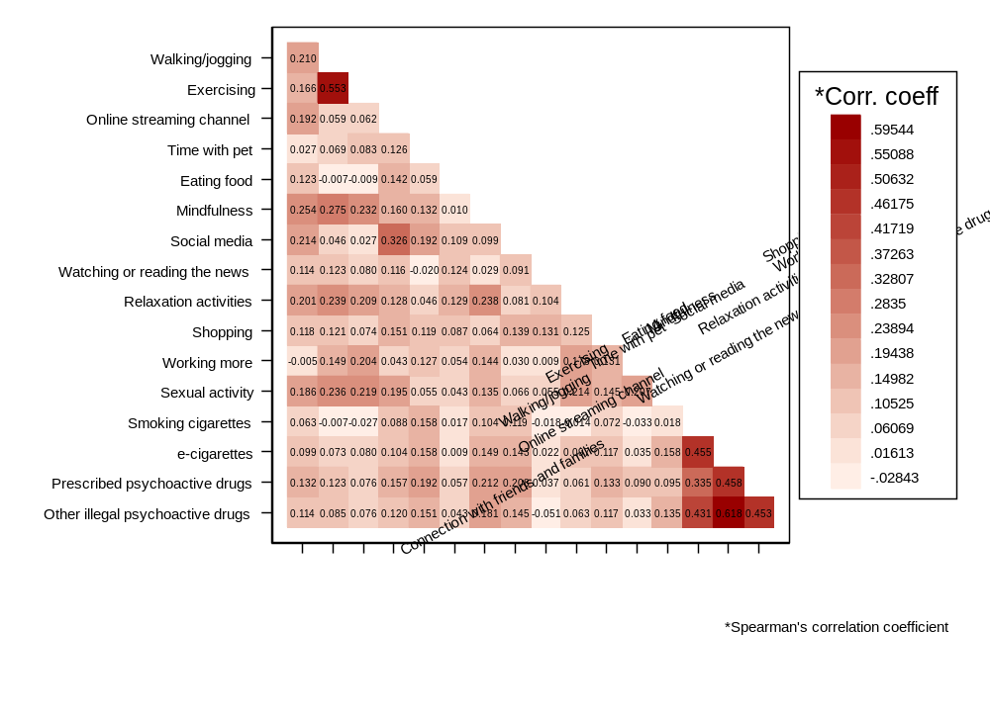
Figure A2: Scree plot of eigenvalues after factor analysis
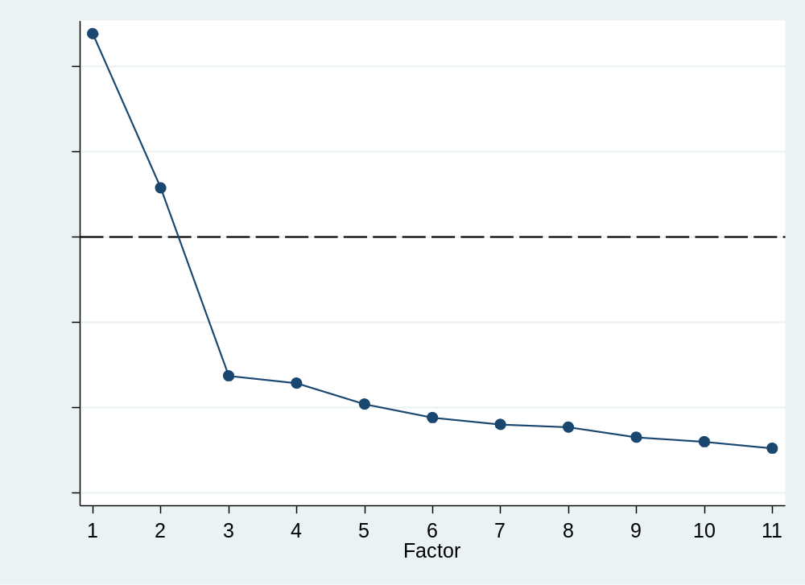

Figure A3: Score plot of the retained factors

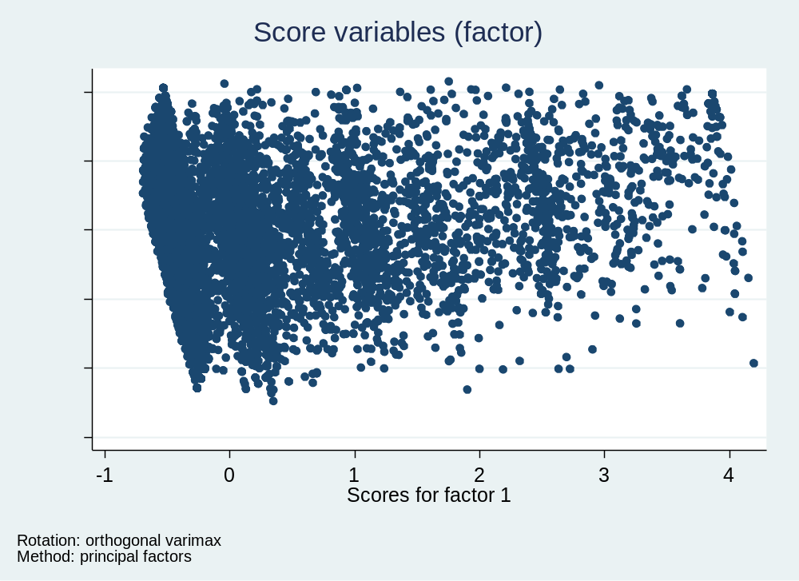

Figure A4: Loading plot of the retained factors and items
