Supplementary material
Multisystem Inflammatory Syndrome in Children and SARS-CoV-2 variants: a two-year ambispective multicentric cohort study in Catalonia, Spain.
Figure S1. Vaccination and MIS-C. Representation of the children that had been vaccinated and (A) how many doses they received or (B) if they received the last dose before or after the MIS-C episode.

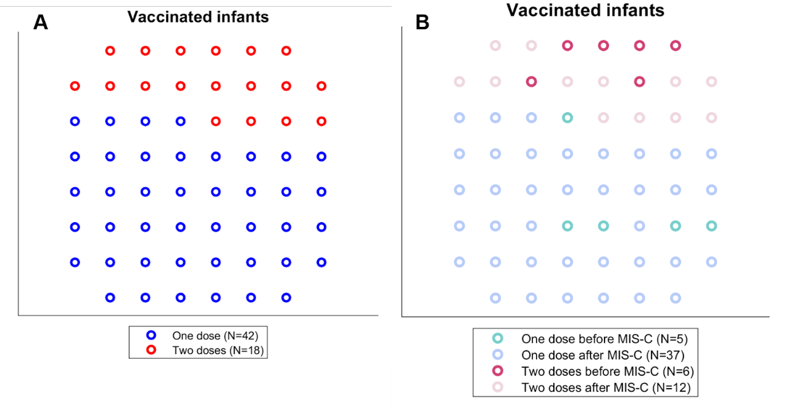

Table S1. Description of the characteristics of the severity of MIS-C cases that had been vaccinated less than 2 months prior to the inflammatory response and those who had not.
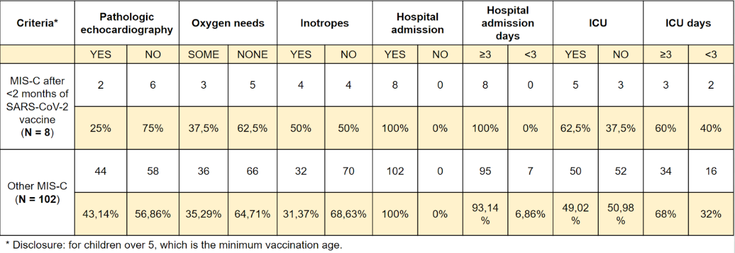
Figure S2. Diagnostic effort. Positivity rate (SARS-CoV-2 positive/SARS-CoV-2 tests performed) from 01/04/2020 to 01/04/2022.
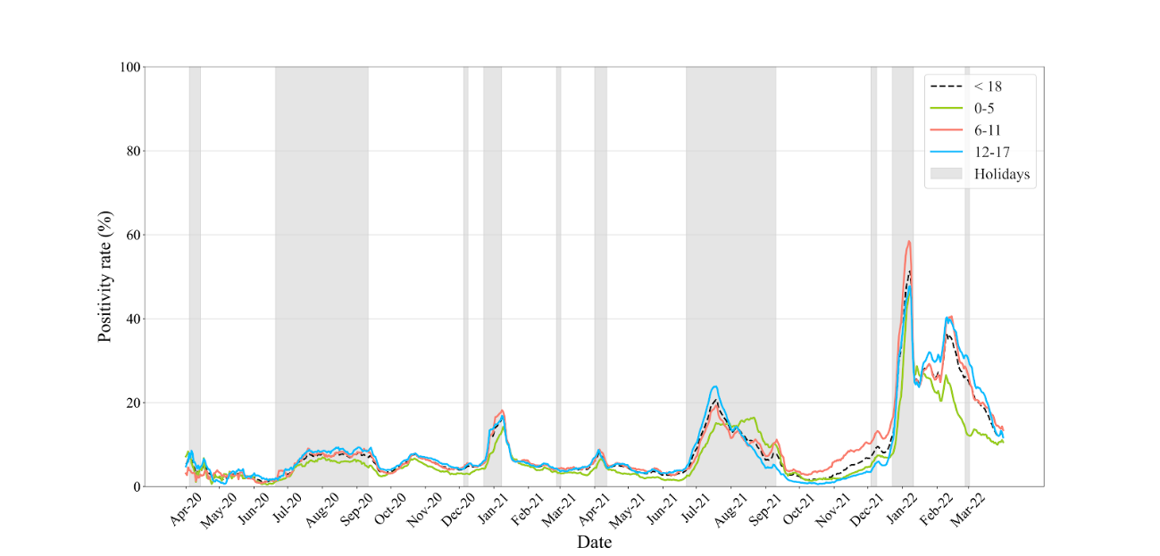
Figure S3. MIS-C laboratory measurements at admission (log scales) compared by variant periods
