Supporting Information

Fe₃O₄/SiO₂ decorated trimesic acid-melamine nanocomposite: A reusable supramolecular organocatalyst for efficient multicomponent synthesis of imidazole derivatives

Babak Fattahi and Mohammad G Dekamin*
Pharmaceutical and Heterocyclic Compounds Research Laboratory, Department of Chemistry, Iran University of Science and Technology, Tehran 16846-13114, Iran.
*Email: mdekamin@iust.ac.ir
Page | Content
S1 | Title page
S2 | General procedure for preparation of the Fe₃O₄/SiO₂-TMA-Me (1)
S3 | Schematic preparation of Fe₃O₄/SiO₂-TMA-Me (1) for the three-component condensation of benzil (2) or benzoin (3), aldehydes (4), ammonium source (5) to afford imidazole derivatives (6).
S4 | FTIR spectra of the Fe₃O₄/SiO₂ (a), Trimesic acid (b), Melamin (c) and Fe₃O₄/SiO₂-TMA-Mel(d) (1).
S5 | FESEM images of the Fe₃O₄/SiO₂ decorated trimesic acid-melamine nanocomposite (Fe₃O₄/SiO₂-TMA-Me, 1)
S6 | TEM images of the Fe₃O₄/SiO₂ decorated trimesic acid-melamine nanocomposite (Fe₃O₄/SiO₂-TMA-Me (1) in 0.1 µm and 300 nm scale
S7 | Energy dispersive spectroscopy (EDX) pattern of the Fe₃O₄/SiO₂ decorated trimesic acid-melamine nanocomposite (Fe₃O₄/SiO₂-TMA-Me ,1)
S7 | XRD patterns of of the Fe₃O₄/SiO₂ decorated trimesic acid-melamine nanocomposite (Fe₃O₄/SiO₂-TMA-Me, 1).
S8 | General procedure for the synthesis of imidazole 6a–j catalyzed by the Fe₃O₄/SiO₂-TMA-Me (1).
S8 | Spectral characterization of compounds 6a, 6c and and 6d

- General procedure for preparation of the Fe₃O₄/SiO₂-TMA-Me (1).
The magnetic core/shell (Fe₃O₄/SiO₂) materials were prepared according to the reported methods in literature with a slight modification²⁶.
The mixture of trimesicacid (3 eq), HOBT (3 eq) and EDCI (3 eq) was stirred in 50 mL deionized water/acetonitrile (1:1) for 30 min, then 1 eq of melamine was added and the obtained mixture was stirred for 24 h at room temperature. After this time, 0.3 g prepared Fe₃O₄/SiO₂ was mildly added and stirred for 24 h to afford the final precipitate. Afterward, the obtained solid was collected with magnet, washed several times and dried at 45 °C.

Fig. S1. Schematic preparation of Fe₃O₄/SiO₂-TMA-Me (1) for the three-component condensation of benzil (2) or benzoin (3), aldehydes (4), ammonium source (5) to afford imidazole derivatives (6).

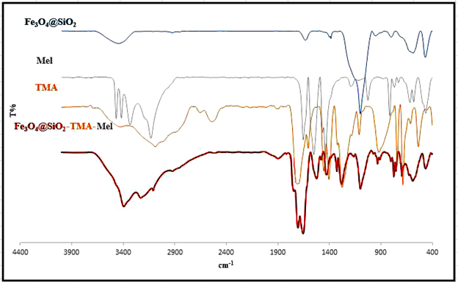
Fig. S2. FTIR spectra of the Fe₃O₄/SiO₂ (a), Trimesic acid (b), Melamin (c) and Fe₃O₄/SiO₂-TMA-Mel(d) (1).
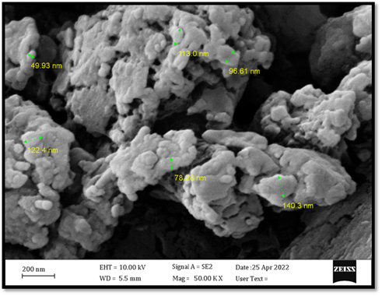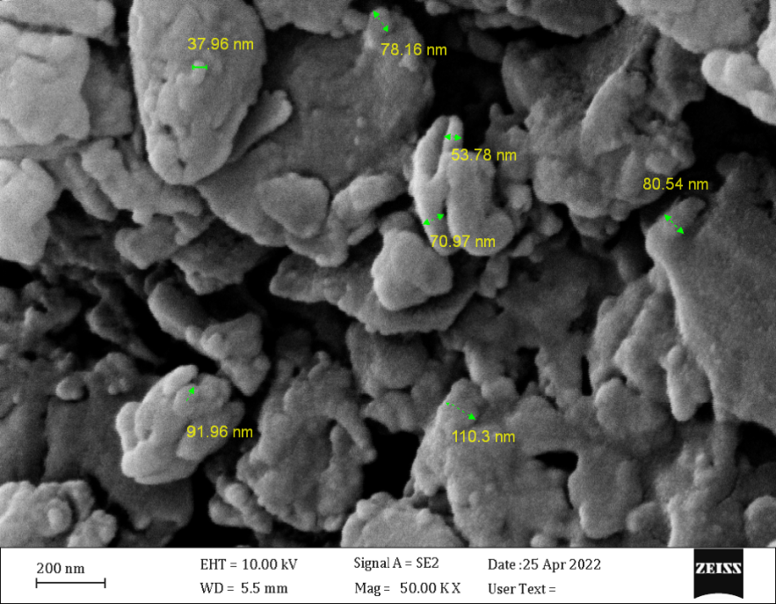
Fig. S3. FESEM images of the Fe₃O₄/SiO₂ decorated trimesic acid-melamine nanocomposite (Fe₃O₄/SiO₂-TMA-Me, 1).
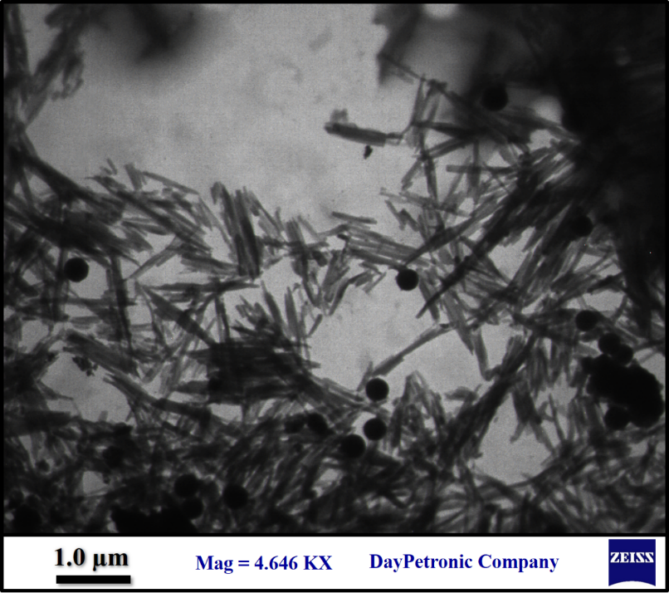
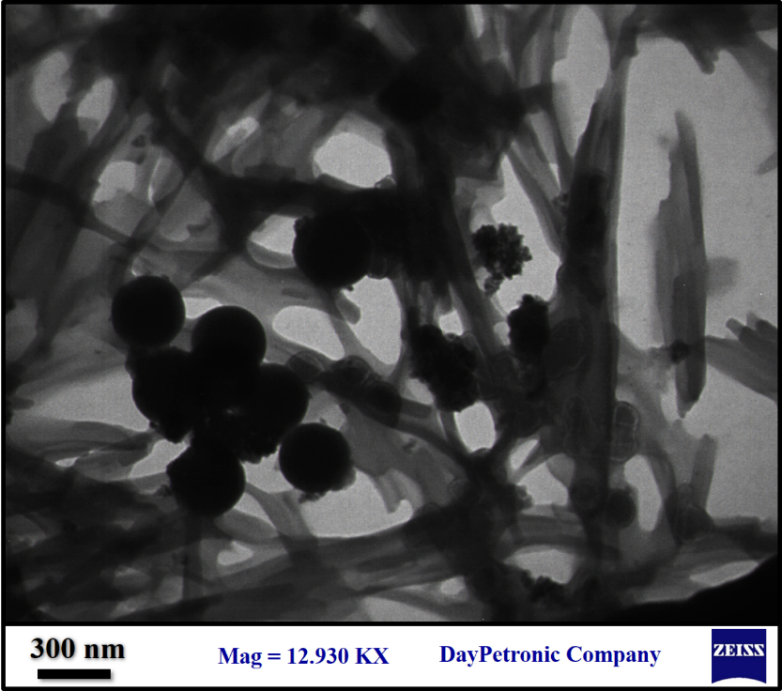
Fig. S4. TEM images of the Fe₃O₄/SiO₂ decorated trimesic acid-melamine nanocomposite (Fe₃O₄/SiO₂-TMA-Me (1) in 0.1 µm and 300 nm scale

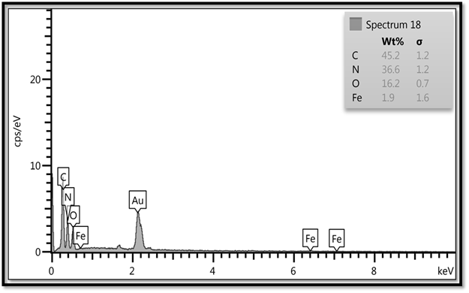
Fig. S5. Energy dispersive spectroscopy (EDX) pattern of the Fe₃O₄/SiO₂ decorated trimesic acid-melamine nanocomposite (Fe₃O₄/SiO₂-TMA-Me ,1).

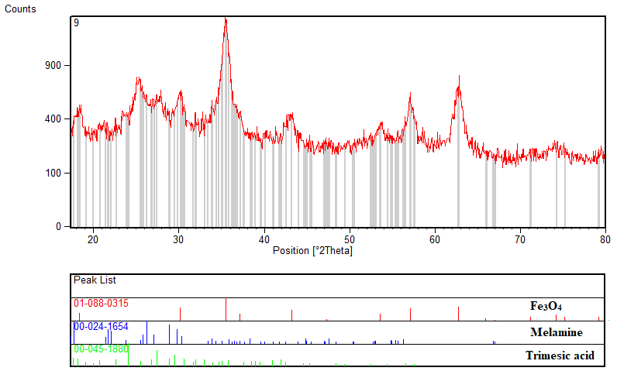
Fig. S6. XRD patterns of of the Fe₃O₄/SiO₂ decorated trimesic acid-melamine nanocomposite (Fe₃O₄/SiO₂-TMA-Me, 1).

- General procedure for the synthesis of imidazole 6a–j catalyzed by the Fe₃O₄/SiO₂-TMA-Me (1).
In a round-bottomed flask, benzoin (2, 1.0 mmol) or benzil (3, 1.0 mmol), various aldehydes (4, 1.0 mmol), ammonium acetate (5, 2.5 mmol) and Fe₃O₄/SiO₂-TMA-Me (1, 10 mg) were mixed in EtOH (5.0 mL) and stirred at room temperature. The reaction mixture was stirred for the appropriate times reported in Table 2. After completion of the reaction, the catalyst 1 was separated by an external magnet. Afterwards, H₂O was added drop wise into the solution until imidazole derivatives 6 were completely precipitated. The obtained mixture was filtered off and the precipitate were washed and then dried in an oven at 70 °C for 1 h. The recycled catalyst 1 was washed with acetone and n-hexane (1 mL), respectively and then dried at 50 °C for 2 h and stored for another run.
Spectral characterization of compounds 6a, 6c and and 6d
2-(4-chlorophenyl)-4,5-diphenyl-1H-imidazole (6a).
Mp.: 258-259°C; FTIR (KBr, cm^{–1}): 3434, 3032, 1599, 1493, 1420, 1172, 923, 760, 690; ¹HNMR (500 MHz, DMSO-d6): δ=7.32–7.87 (m, 14H), 10.31 (br, NH) ppm. ¹³CNMR (100 MHz, DMSO-d6): δ =127.45, 128.80, 128.05, 128.77, 129.09, 129.57, 129.67, 12.88, 130.51, 130.95, 132.40, 143.24 ppm.
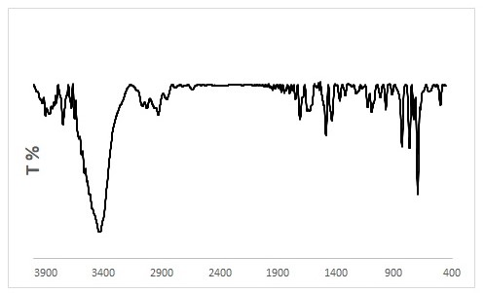
Fig. S7. FT-IR of 2-(4-chlorophenyl)-4,5-diphenyl-1H-imidazole (6a).

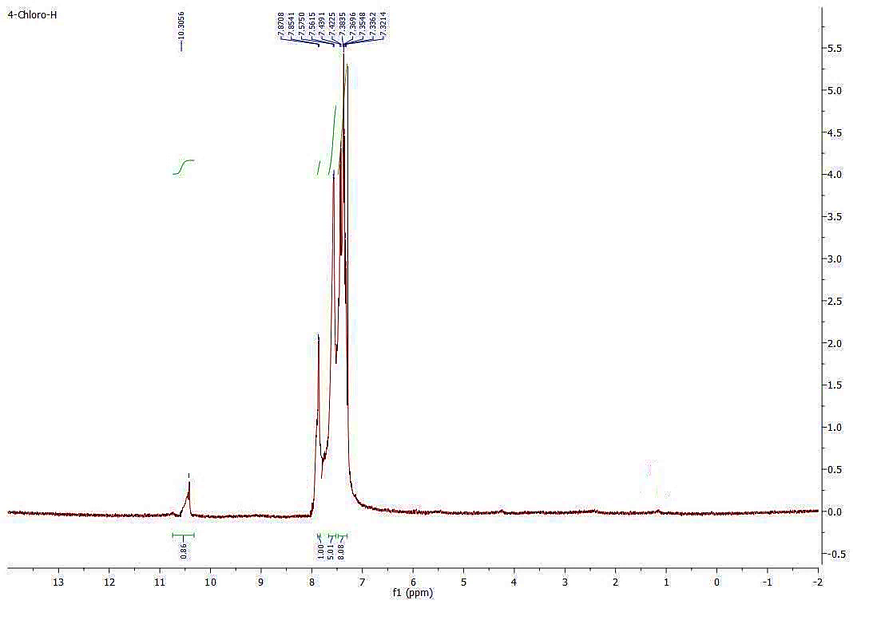
Fig. S8. ¹HNMR of 2-(4-chlorophenyl)-4,5-diphenyl-1H-imidazole (6a).

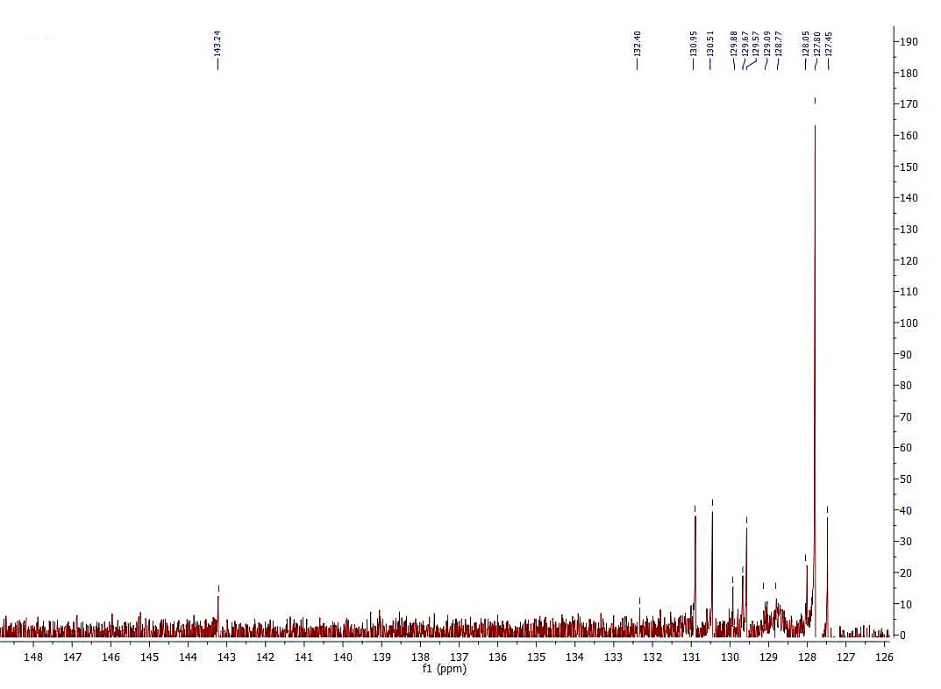
Fig. S9. ¹³CNMR of 2-(4-chlorophenyl)-4,5-diphenyl-1H-imidazole (6a).

2-(2-chlorophenyl)-4,5-diphenyl-1H-imidazole (6c).
Mp.: 197-199°C; FTIR (KBr, cm^{–1}): 3422, 3030, 1603, 1493, 1440, 1072, 823, 730, 696; ¹HNMR (500 MHz, DMSO-d6): δ=7.23–7.800 (m, 14H), 12.65 (br, NH) ppm.
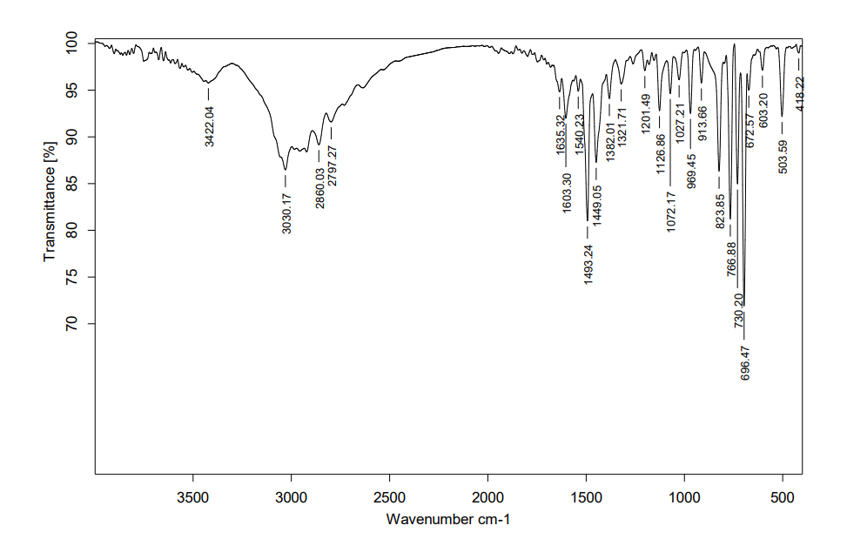
Fig. S10. FT-IR of 2-(2-chlorophenyl)-4,5-diphenyl-1H-imidazole (6c).

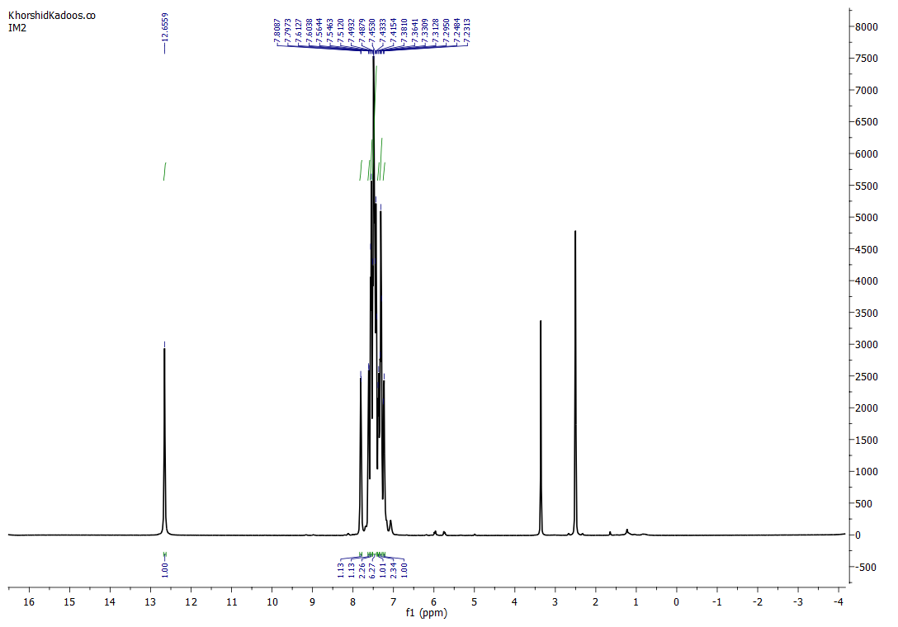
Fig. S11. ¹HNMR of 2-(2-chlorophenyl)-4,5-diphenyl-1H-imidazole (6c).

4,5-diphenyl-2-(p-tolyl)-1H-imidazole (6d)
Mp.: 188-190 °C; FTIR (KBr, cm^{–1}): 3444, 3025, 1602, 1476, 1445, 1392, 1063, 762, 694; ¹HNMR (500 MHz, DMSO-d6): δ=2.35 (s, Me), δ=7.20–7.99 (m, 14H), 12.6 (br, NH) ppm;
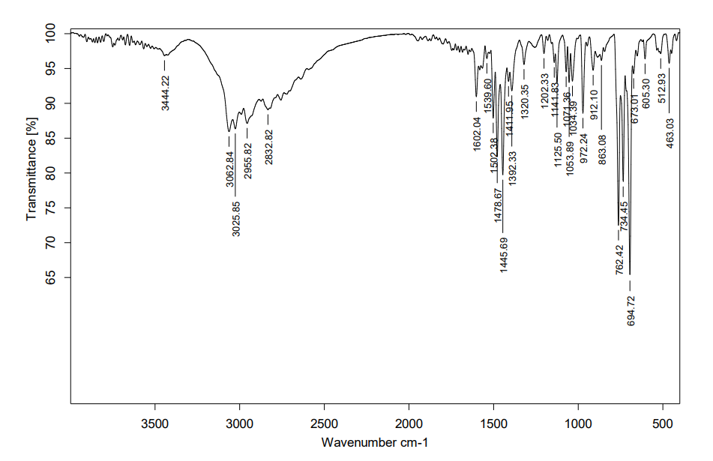
Fig. S12. FT-IR of 4,5-diphenyl-2-(p-tolyl)-1H-imidazole (6d)

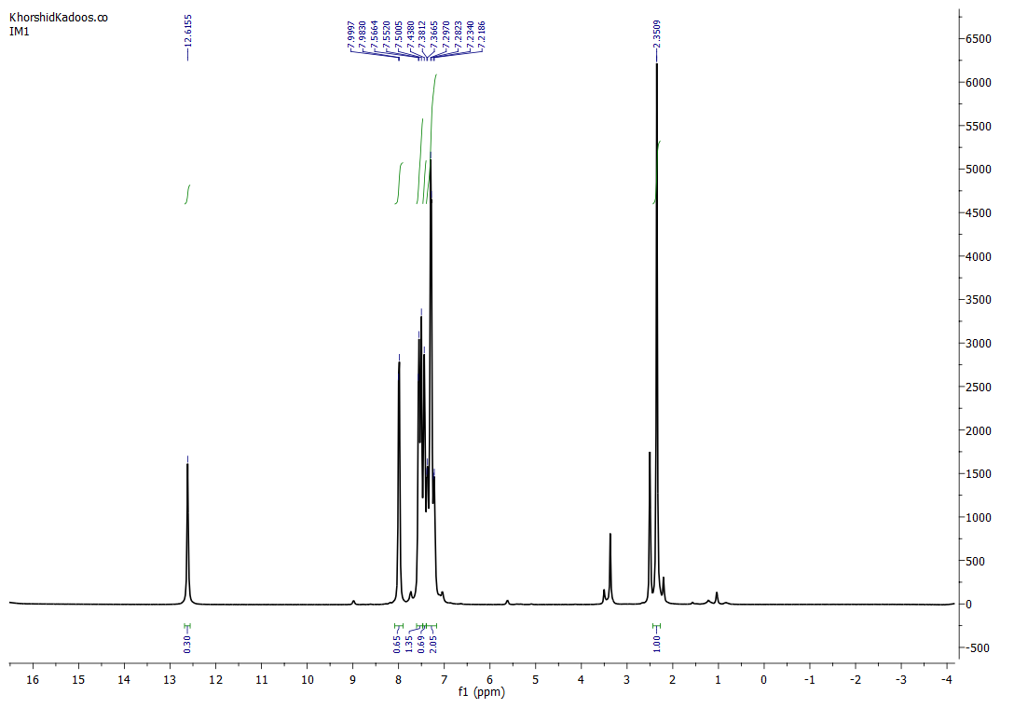
Fig. S13. ¹HNMR of 4,5-diphenyl-2-(p-tolyl)-1H-imidazole (6d)

