Supplementary Information

A novel procedure for measuring bacterial ATP in septic blood enables rapid antimicrobial susceptibility testing

Kazushige Sugie¹†, Hideki Niimi¹†, Tomohiro Ueno¹, Hideyuki Noda², Yuichi Uchiho², Shunsuke Kawabe², Masako Ishimaru², Hiroko Tada², Chihiro Uematsu², Fumiaki Hamazato² and Isao Kitajima³

1. Clinical Laboratory and Transfusion Medicine & Cell Therapy Center, Toyama University Hospital
2. Research & Development Group, Hitachi, Ltd.
3. Administrative office, University of Toyama

*Correspondence to:
Hideki Niimi, M.D. Ph.D. E-mail address: hiniimi@med.u-toyama.ac.jp
Isao Kitajima, M.D. Ph.D. E-mail address: kitajima@med.u-toyama.ac.jp
Clinical Laboratory and Transfusion Medicine & Cell Therapy Center, Toyama University Hospital
2630 Sugitani Toyama 930-0194 JAPAN
Phone: (+81)-76-434-7759, Fax: (+81)-76-434-7759
† Both authors contributed equally to this work.
Supplemental Figure S1

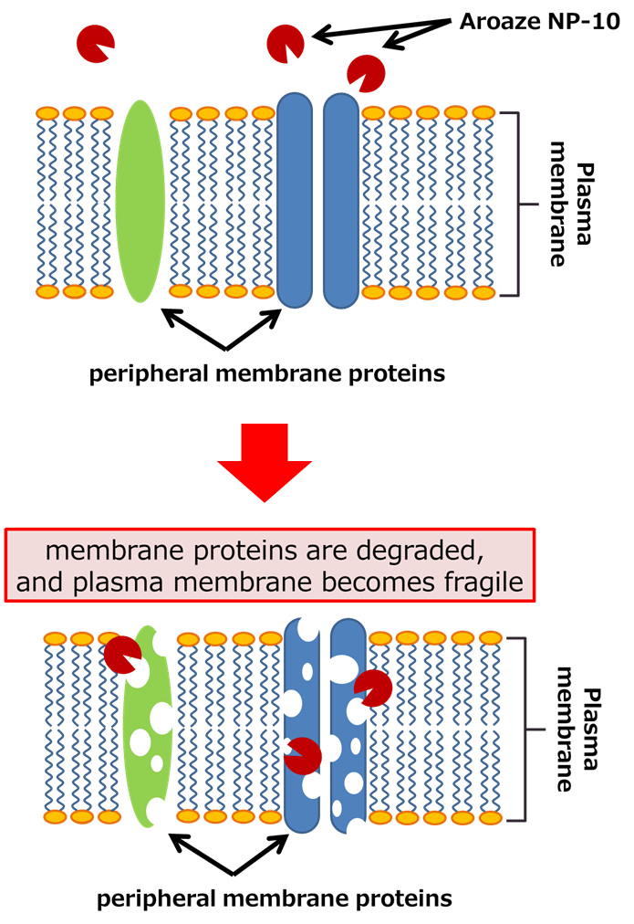

Peripheral membrane proteins of the platelet plasma membrane are proteolyzed by Aroaze NP-10
Aroaze NP-10 decomposes animal and plant proteins but does not proteolyze bacterial cell wall made of peptidoglycan.

Supplemental Figure S2

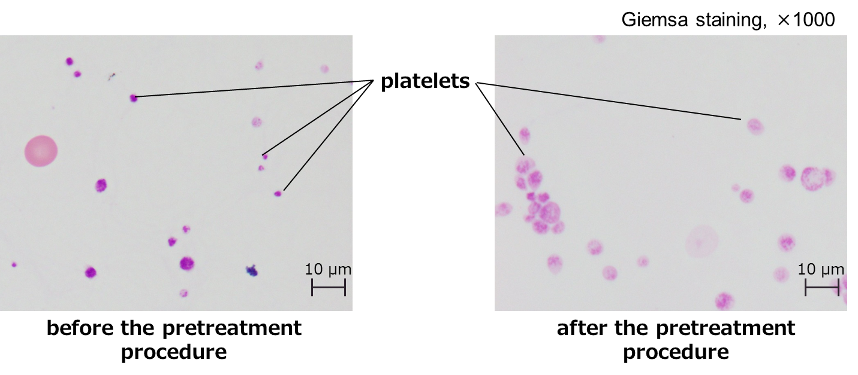

Swelling of platelets by treatment with hypotonic solution
After hypotonic treatment, platelets are swollen and easily broken.

Supplemental Figure S3

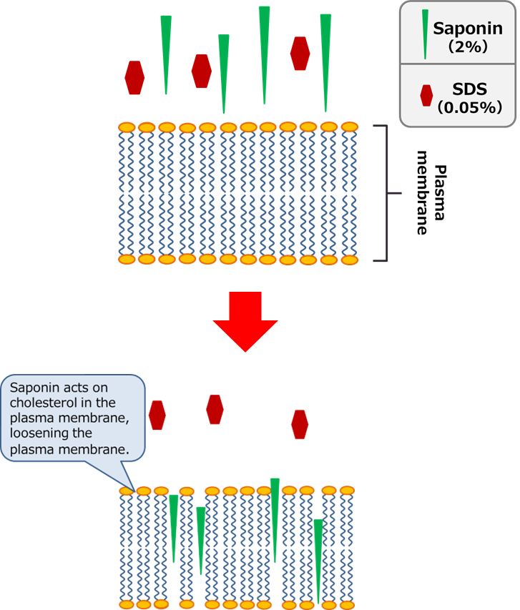

Destruction of plasma membrane by Detergent A
Saponin acts on cholesterol in the plasma membrane, loosening the plasma membrane, but does not act on bacterial cell wall with its peptidoglycan composition. As a result, the platelet plasma membrane is completely destroyed by detergent A (Saponin + SDS), but the bacterial cell wall with its peptidoglycan composition is damaged very little.

