Supplementary Figures

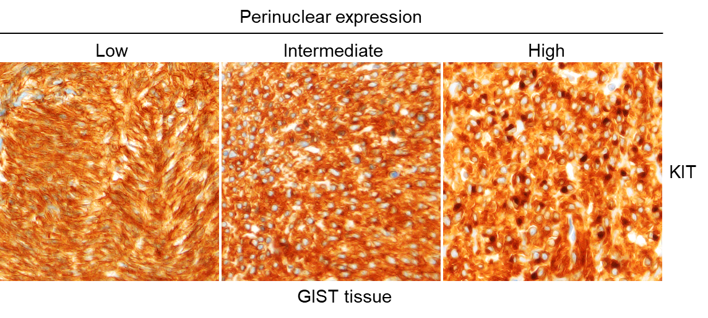
Supplementary Figure S1. GIST patients frequently show perinuclear mutant KIT (MT-KIT) expression. Immunohistochemistry analysis of tissues from patients with GIST (n = 42) was performed to evaluate the perinuclear expression of MT-KIT. The perinuclear expression status was classified into low, intermediate, and high categories.

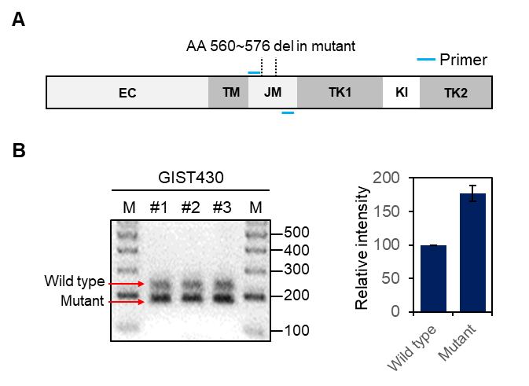
Supplementary Figure S2. GIST430 cells with heterozygous exon 11 deletion mutation in KIT predominantly express mutant KIT mRNAs. A. Schematic representation of KIT gene showing an exon 11 deletion mutation which GIST430 cells contain. B. Agarose gel electrophoresis analysis of PCR products obtained by performing RT-PCR with cDNA from GIST430 cells. The upper and lower band is the WT-KIT and MT-KIT mRNA, respectively. This experiment was performed in triplicate. Band intensity was quantified using ImageJ.

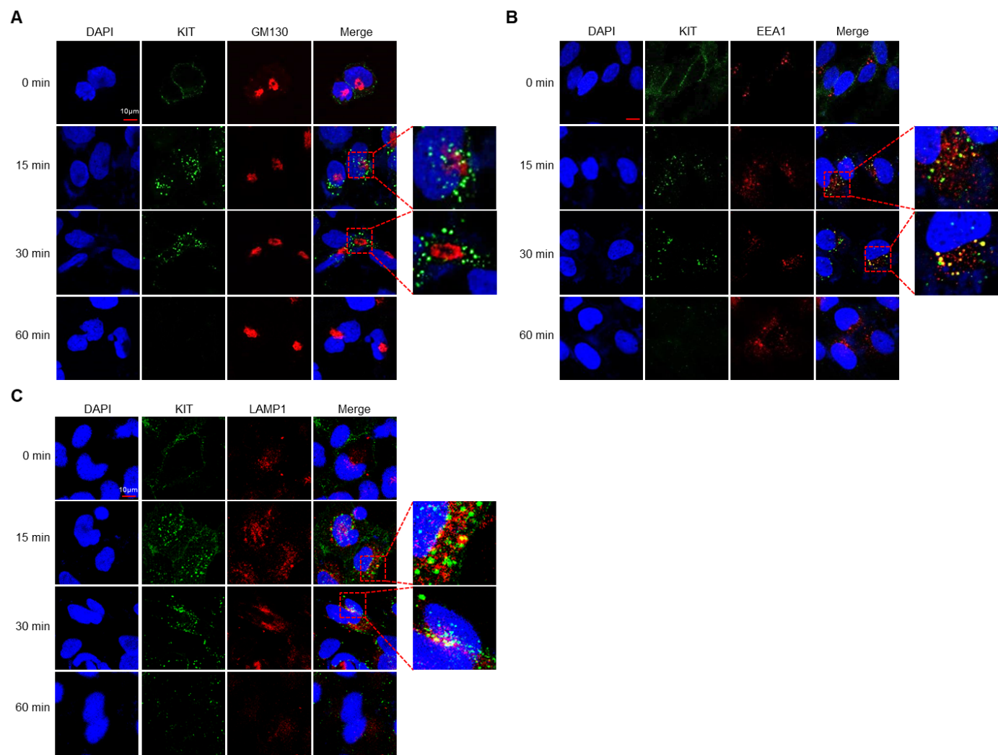
Supplementary Figure S3. Membranous MT-KIT is internalized and degraded without retrieval to the Golgi complex. A-C. Time-course confocal microscopic analysis of KIT, GM130 (a cis-Golgi marker), EEA1 (an early endosome marker), and LAMP1 (a lysosome marker) in GIST882 cells. GIST cells were labeled with a KIT antibody conjugated with a fluorescent dye, incubated for the indicated times, and analyzed for immunofluorescence.

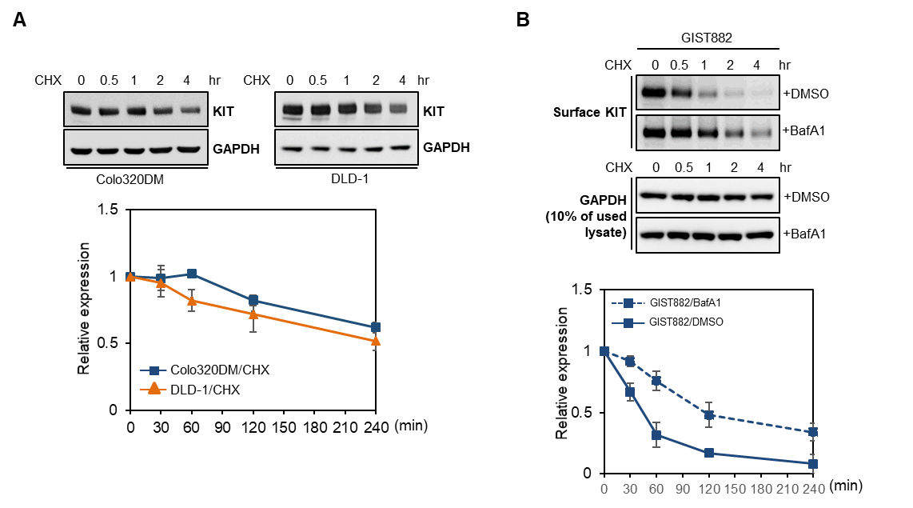
Supplementary Figure S4. Membranous MT-KIT is rapidly degraded by the plasma-membrane quality-control system. A. The stability of WT-KIT over time was measured by western blotting after treatment of DLD-1 and Colo320DM cells with CHX. B, The stability of MT-KIT over time was measured by biotin-labeling surface proteins, streptavidin pull-down, and western using GIST882 cells treated with or without a lysosomal inhibitor, Bafilomycin A1 (BafA1). Error bars in A and B represent the SD of the mean of three independent experiments.

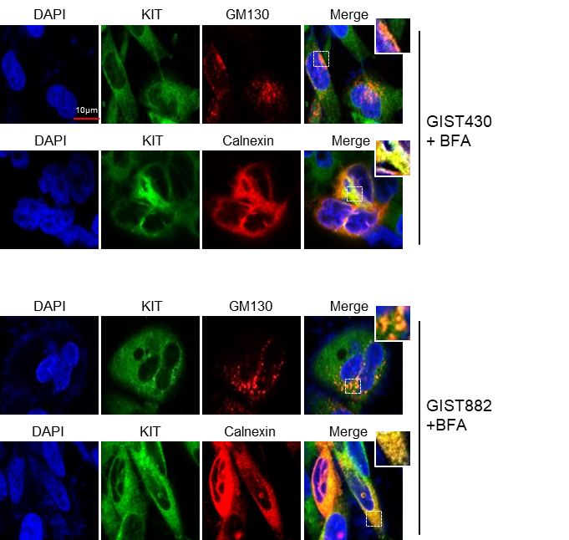
Supplementary Figure S5. Brefeldin A, which blocks ER to Golgi trafficking, leads to ER retention of MT-KIT and disrupts the Golgi structure. Confocal microscopic analysis of GIST cells treated with Brefeldin A (BFA). GM130, KIT, and Calnexin (an ER marker) were examined.

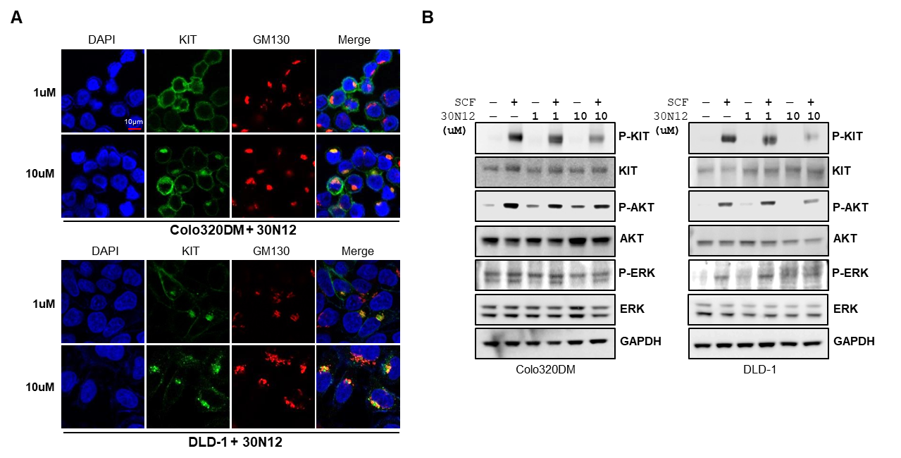
Supplementary Figure S6. 30N12, an inhibitor of trans-Golgi-to-plasma-membrane trafficking, causes retention of WT-KIT in the Golgi complex and perturbs SCF-activated KIT downstream signaling. A. DLD-1 and Colo320DM cells were treated with of 1 µM or 10 µM 30N12 for 18 h. KIT and GM130 were examined using confocal microscopy. B. Western blotting of KIT downstream effector molecules in SCF-activated DLD-1 and Colo320DMa cells with or without pre-treatment with 1 µM or 10 µM 30N12.

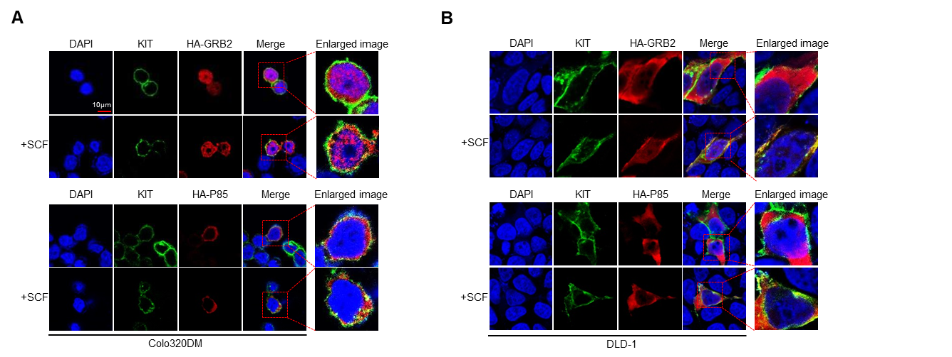
Supplementary Figure S7. WT-KIT activates downstream signaling pathways at the plasma membrane by recruiting P85 and GRB2 to the plasma membrane. A and B. After SCF treatment, confocal microscopic analysis was performed on DLD-1 and Colo320DM cells transfected with a HA-GRB2 or HA-P85 expression vector. GRB2 is the most upstream molecule of the MAPK/ERK pathway, and P85 is that of the PI3K/AKT pathway.

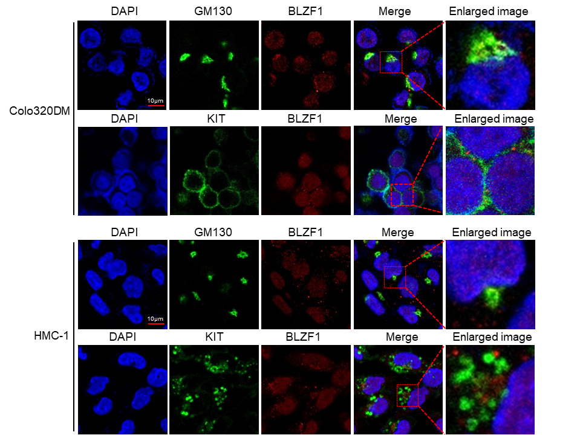
Supplementary Figure S8. Colocalization of KIT with BLZF1 is not observed in CC (Colo320DM) and leukemia (HMC-1) cells expressing WT-KIT and MT-KIT, respectively. Confocal microscopic analysis of KIT, GM130, and BLZF1 was performed in Colo320DM and HMC-1 cells.

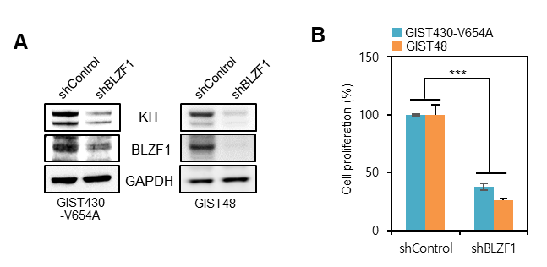
Supplementary Figure S9. BLZF1 knock-down strongly suppresses KIT expression and growth of imatinib-resistant GIST cells. A. Expression of KIT and BLZF1 were measured by western blotting in imatinib-resistant GIST cell lines (GIST48 and GIST430-V654A) treated with BLZF1 shRNA. B, Proliferation of GIST48 and GIST430-V654A cells was measured by MTT assay after 72 h of treatment with BLZF1 shRNA. Error bars in B represent the SD of the mean of three independent experiments. One-way ANOVA with a post-hoc test was performed to compare multiple means (*p < 0.05, **p < 0.01, ***p < 0.001).

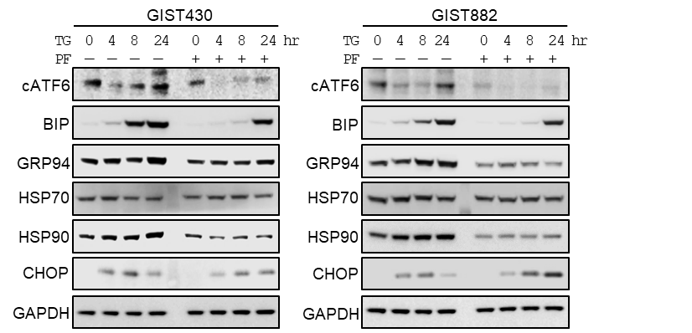
Supplementary Figure S10. ATF6 inhibition delays the expression of chaperones in response to mild ER stress and subsequent ER-stress-mediated cell death. GIST cells were resensitized to mild ER stress (0.1 µM thapsigargin, TG) when the ATF6 pathway was inhibited by PF429242 (PF). The expression of chaperones (BIP, HSP70, HSP90, and GRP94) and a cell-death marker (CHOP) over time was measured by western blotting following 0.1 µM TG treatment with or without PF.

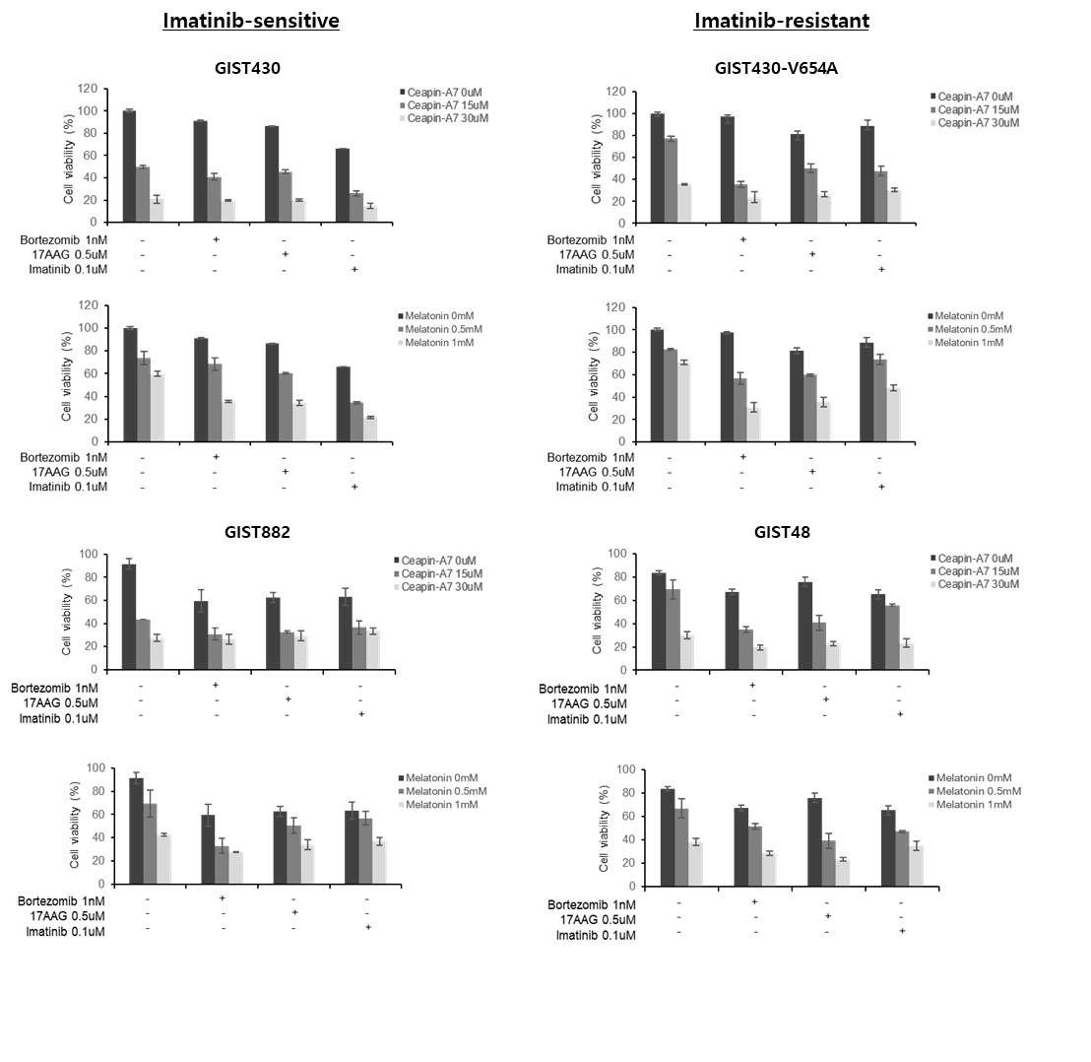Supplementary Figure S11. ATF6 inhibition efficiently suppresses GIST cell growth, irrespective of imatinib resistance and synergistic anti-tumor effect was observed when combined with ER stress-inducing drugs. Cell viability was measured by MTT assay in imatinib-sensitive GIST430 and GIST882 cells, and imatinib-resistant GIST48 and GIST430-V654A cells. GIST cells were treated with an ATF6 inhibitor alone (15 µM or 30 µM Ceapin-A7 and 0.5 mM or 1 mM melatonin) or with an ATF6 inhibitor and ER stress inducing drugs (0.5 µM 17AAG and 1 nM borteazomib) for 72 h. Imatinib (0.1 µM) was used as a positive control drug and synergistic effect with ATF6 inhibitors was analyzed.

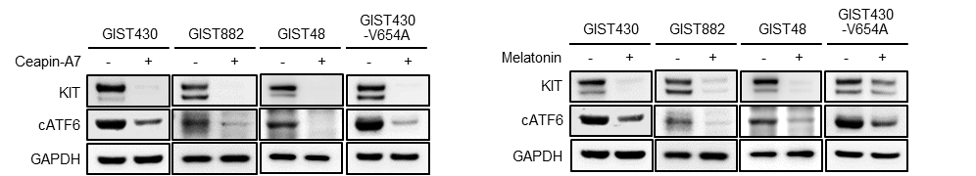
Supplementary Figure S12. Ceapin-A7 and melatonin strongly downregulate ATF6 activation and KIT expression. Western blotting against to ATF6 and KIT was performed in GIST cells treated with 30 µM Ceapin-A7 and 1 mM melatonin for 24 h.

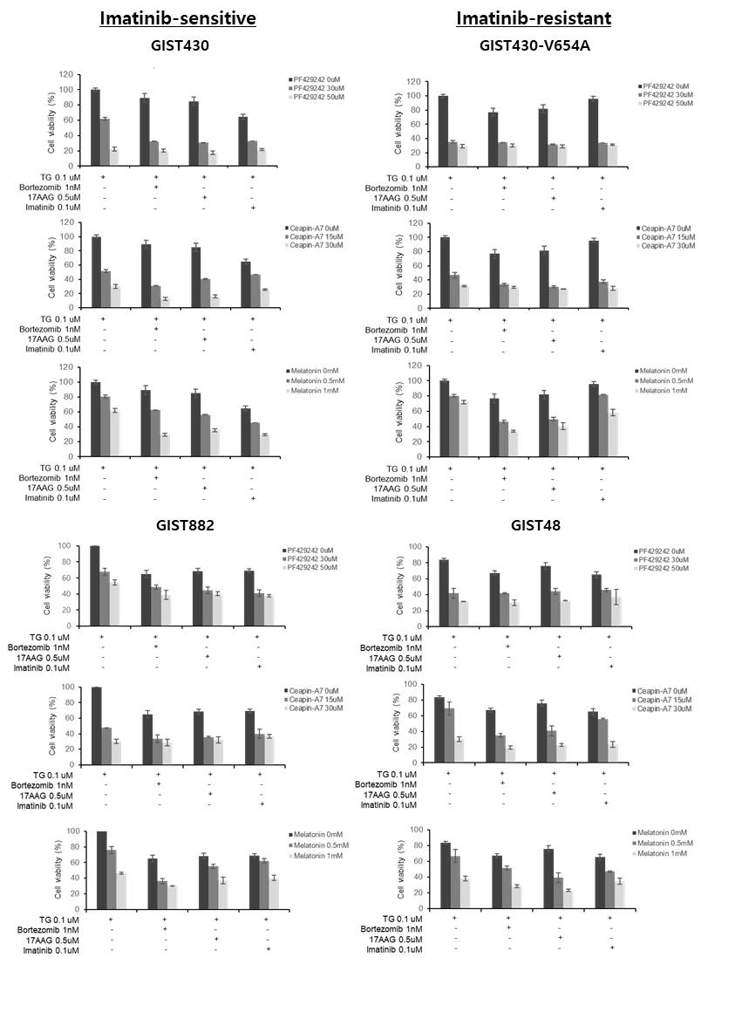

Supplementary Figure S13. Anti-tumor effects of ATF6 inhibition and ATF6 with ER stress-inducing drugs is augmented under thapsigargin treatment. A and B, Cell viability was measured by MTT assay in imatinib-sensitive GIST430 and GIST882 cells, and imatinib-resistant GIST48 and GIST430-V654A cells. GIST cells were treated with an ATF6 inhibitor alone (30 µM or 50 µM PF429242, 15 µM or 30 µM Ceapin-A7, and 0.5 mM or 1 mM melatonin) or an ATF6 inhibitor and ER stress inducing drugs (0.5 µM 17AAG and 1 nM borteazomib) for 72 h. Imatinib (0.1 µM) was used as a positive control drug and synergistic effect with ATF6 inhibitors was analyzed. This experiment was performed under a mild ER stress condition (0.1 µM thapsigargin) to mimic the in vivo tumor microenvironment.

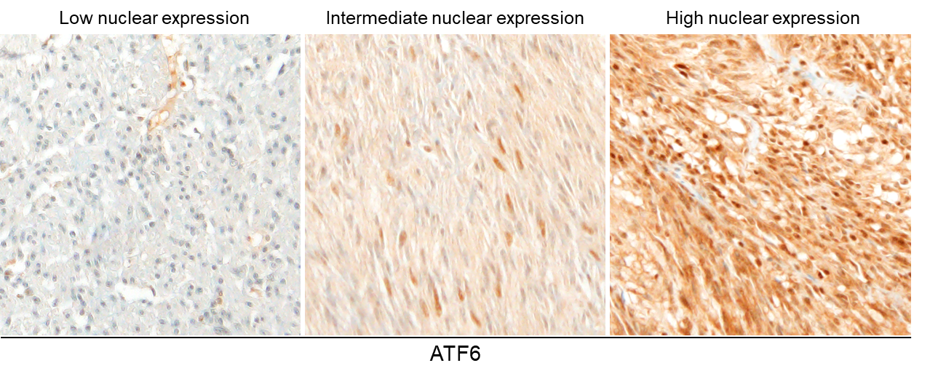
Supplementary Figure S14. Constitutive activation and nuclear expression of ATF6 is frequently detected in patients with GIST. Immunohistochemistry analysis of ATF6 was performed in 42 patients with GIST. The nuclear expression status of ATF6 was classified into low, moderate, and high categories.

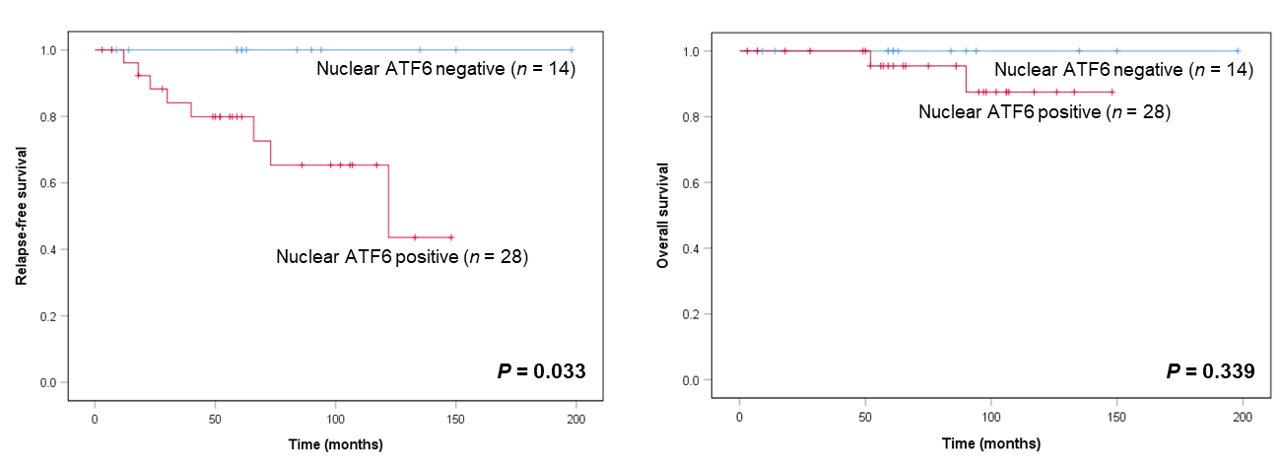
Supplementary Figure S15. Overall and relapse-free survival of 42 patients with GIST according to nuclear expression of ATF6.

