Supplementary materials
Table S1 Dates and amounts of compost and fertilizer application during the lysimeter experiment.
Period | Treatment | 19 Oct.2019 |  | 18 Mar. 2020 |  |  |  | 14 Apr. 2020 |  |  | 19 May 2020
 |  | Compost  (t ha⁻¹) |  | Yara  (kg ha⁻¹) | TSP  (kg ha⁻¹) |  |  | CAN  (kg ha⁻¹) |  |  | KAS  (kg ha⁻¹)
Winter  wheat | P1 |  |  | 300 |  |  |  | 300 |  |  | 130
Winter  wheat | P2 |  |  | 300 | 97.8 |  |  | 300 |  |  | 130
Winter  wheat | CP1 | 40 |  | 300 |  |  |  | 300 |  |  | 130
Winter  wheat | CP2 | 40 |  | 300 | 97.8 |  |  | 300 |  |  | 130
Winter  wheat | CCP1 | 80 |  | 300 |  |  |  | 300 |  |  | 130
 |  |  |  | 8 Mar. 2020 |  |  |  | 13 Apr. 2020 |  |  | 4 May 2020
 |  |  |  | Yara  (kg ha⁻¹) |  |  | CAN  (kg ha⁻¹) |  | TSP  (kg ha⁻¹) |  | KAS  (kg ha⁻¹)
Winter  barley | P1 |  |  | 400 |  |  |  | 250 |  |  | 250
Winter  barley | P2 |  |  | 400 |  |  |  | 250 | 130 |  | 250
Winter  barley | CP1 |  |  | 400 |  |  |  | 250 |  |  | 250
Winter  barley | CP2 |  |  | 400 |  |  |  | 250 | 130 |  | 250
Winter  barley | CCP1 |  |  | 400 |  |  |  | 250 |  |  | 250
Yara: YaraMila Universal; CAN: calcium ammonium nitrate; TSP: triple superphosphate

Table S2 Detailed application amounts of compost, N, and P in the different treatments.
Treatment | 2019 |  | 2020 (wheat season) |  |  | 2021 (barley season)
Treatment | Compost |  | N | P |  | N | P
Treatment | (t ha⁻¹) |  | (kg ha⁻¹) | (kg ha⁻¹) |  | (kg ha⁻¹) | (kg ha⁻¹)
P1 |  |  | 161 | 45 |  | 195 | 60
P2 |  |  | 161 | 90 |  | 195 | 120
CP1 | 40 |  | 161 | 45 |  | 195 | 60
CP2 | 40 |  | 161 | 90 |  | 195 | 120
CCP1 | 80 |  | 161 | 45 |  | 195 | 60

Table S3 Cumulative emissions of CO₂-C, CH₄-C, N₂O-N during the experiment. There was no significant differences between any treatment (P> 0.05).
Period | HCA | CO₂-C (t ha⁻¹) | CH₄-C (kg ha⁻¹) | N₂O-N (kg ha⁻¹)
Wheat growings eason | Bare | 2.127 ± 0.459 | -0.628 ± 0.065 | 0
Wheat growings eason | P1 | 3.053 ± 0.569 | -0.513 ± 0.267 | 0.141 ± 0.282
Wheat growings eason | P2 | 3.013 ± 0.607 | -0.730 ± 0.686 | 0.068 ± 0.096
Wheat growings eason | CP1 | 4.447 ± 1.351 | -0.139 ± 0.228 | 0.072 ± 0.144
Wheat growings eason | CP2 | 5.457 ± 1.322 | -0.471 ± 0.282 | 0.203 ± 0.159
Wheat growings eason | CCP1 | 3.495 ± 0.748 | -0.496 ± 0.426 | 0.610 ± 1.056
Barley growing season | Bare | 16.456 ± 3.888 | -0.352 ± 0.137 | 1.979 ± 2.288
Barley growing season | P1 | 16.173 ± 3.611 | -0.203 ± 0.406 | 1.088 ± 0.887
Barley growing season | P2 | 11.121 ± 2.583 | 0.029 ± 0.143 | 0.613 ± 0.281
Barley growing season | CP1 | 11.323 ± 4.429 | -0.066 ± 0.132 | 1.085 ± 0.672
Barley growing season | CP2 | 16.207 ± 5.216 | -0.293 ± 0.291 | 1.607 ± 0.832
Barley growing season | CCP1 | 20.765 ± 6.879 | -0.514 ± 0.518 | 2.140 ± 1.527

Table S4 Equations of the linear regressions of the soil DOC, P-CAL, and CO₂-C flux in response to time (T) (days since the beginning of the wheat or barley growing season), compost (C) (t ha⁻¹), and phosphorus (P) (kg ha⁻¹) fertilization. *P<0.05, **P< 0.01, ***P<0.001.
Category | Linear regression equation
DOC | 12.869*** – 0.826T*** – 0.003P + 0.084C***
P-CAL | 12.673** + 0.071T + 0.014P + 0.317C***
SOC | 3.349** + 0.264T – 0.005P + 0.062C***
TN | 0.345** + 0.33T* – 0.001P + 0.005C***
TP | 0.242*** + 0.038T*** + 0.001P + 0.001C***
CO₂-C (wheat season) | 20.236 + 9.333T*** – 1.007P + 1.546C**
CO₂-C (barley season) | – 358.981*** + 19.554T*** – 1.590P* + 0.001C

Table S5 Equations of the linear regressions of the crop aboveground biomass and grain yield in response to compost (C) (t ha⁻¹), phosphorus (P) (kg ha⁻¹) fertilization. *P<0.05, **P< 0.01, ***P<0.001.
Crop | Soil properties | Linear regression equation
Wheat | Above ground biomass | 118.879*** + 0.008P + 0.821C***
Wheat | Grain yield | 41.924*** + 0.107P + 0.311C**
Barley | Above ground biomass | 118.609*** + 0.070P + 0.385C*
Barley | Grain yield | 79.011*** + 0.037P + 0.278C*

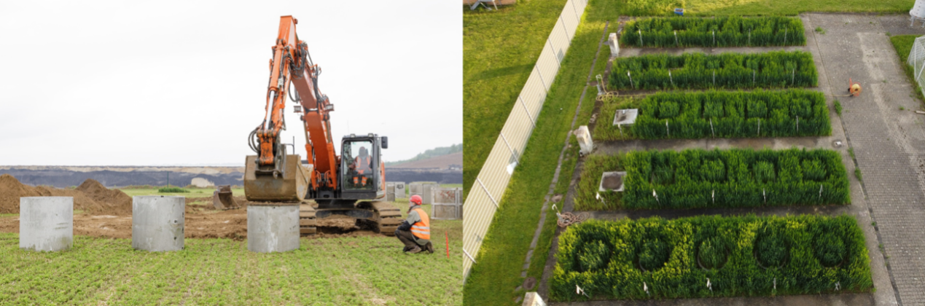
Figure S1 Filling of the lysimeters with intact soil (left) and the lysimeter installation on the campus of Forschungszentrum Jülich (right).

