Supplementary material
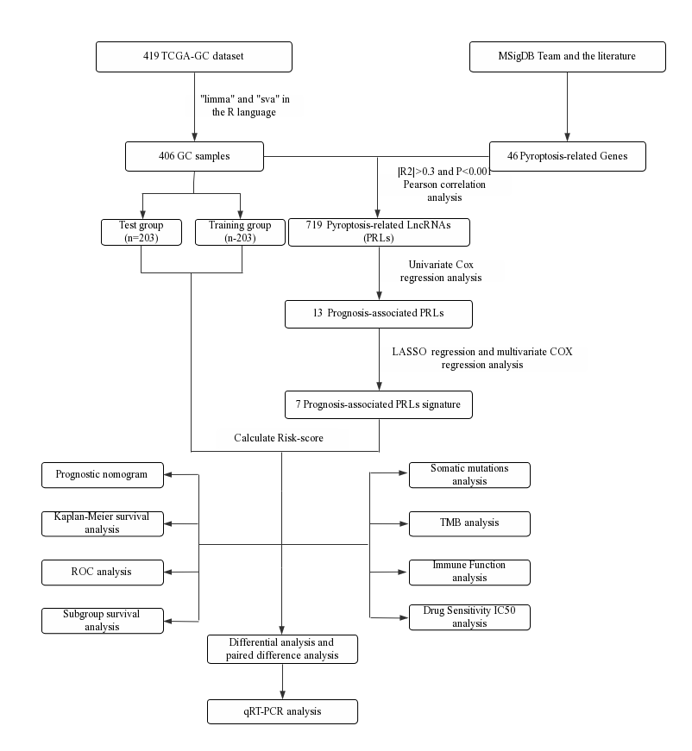
Supplementary Figure 1 The entire analytical process of the study.

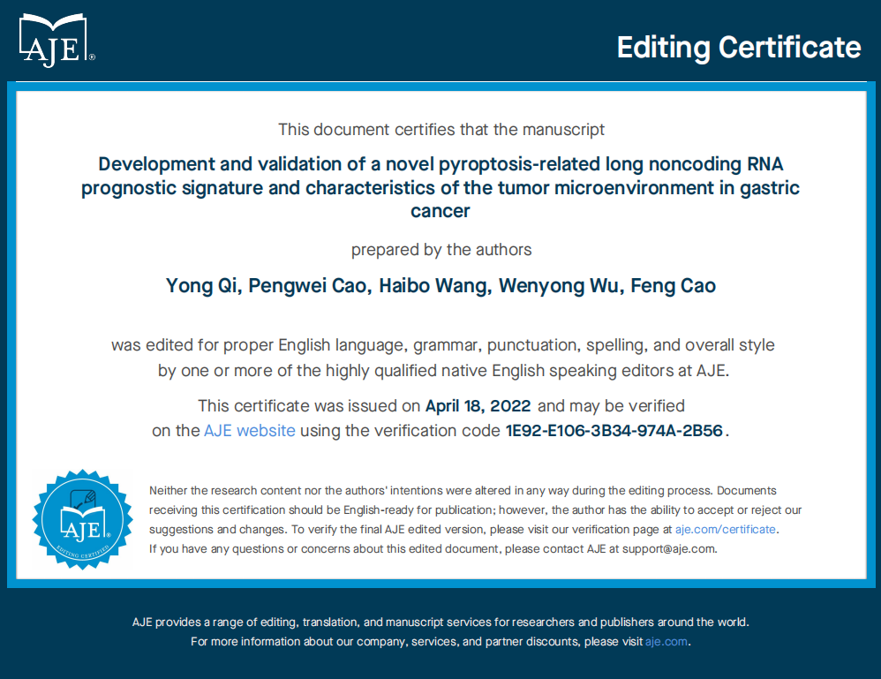
Supplementary Figure 2 Editing certificate of the manuscript.

