Supplementary data
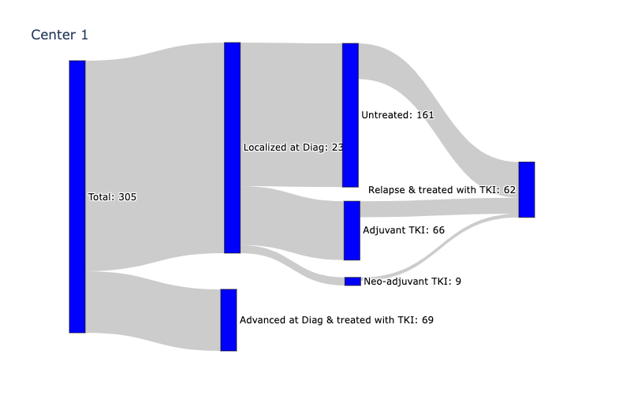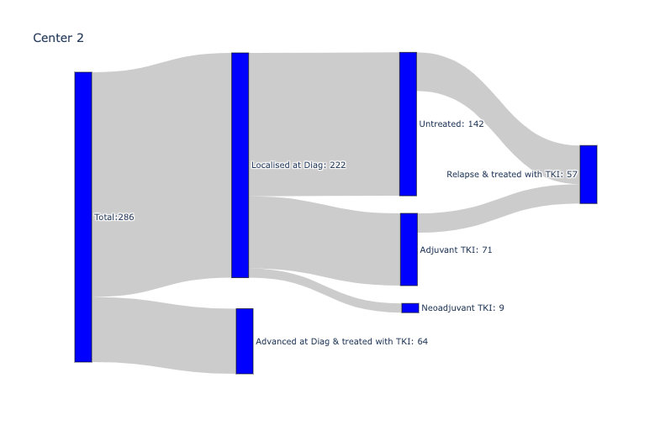
Supplementary Figure 1. Schema of patients' treatment pathway in center 1 and center 2.
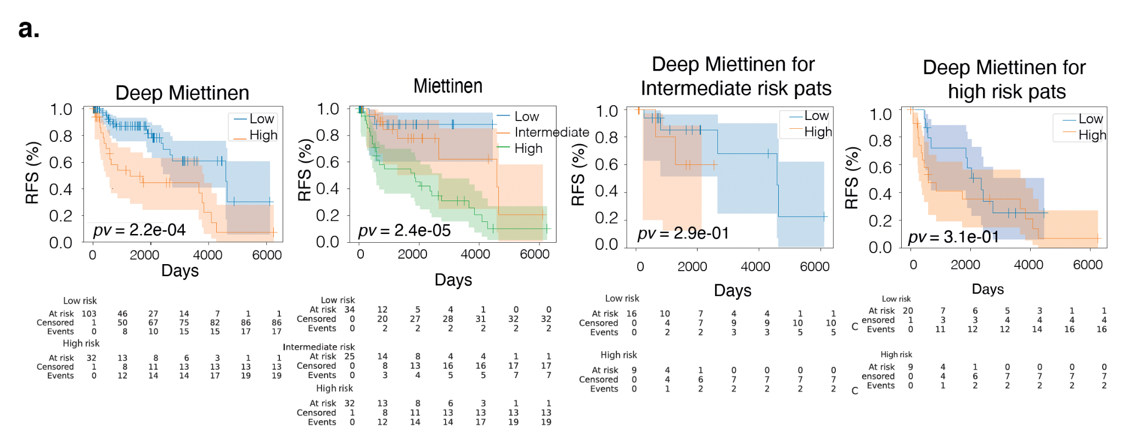
Supplementary Figure 2. Validation of Deep Miettinen model for localized, untreated GIST in center 2. Kaplan–Meier plots shown for RFS for localized untreated patients within different categories. From left to right: risk groups defined by Deep Miettinen; risk groups defined by Miettinen(cutoff for high risk was re-estimated so that the number of high risk patients is comparable to the number defined by Miettinen evaluation system high risk patients); risk groups defined by deep Miettinen for intermediate risk patients defined by Miettinen; risk groups defined by deep Miettinen for high risk patients defined by Miettinen.

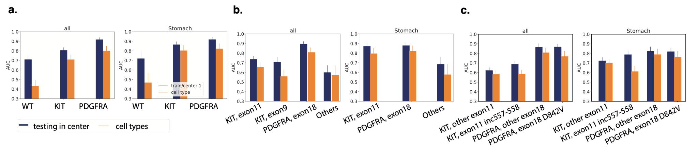
Supplementary Figure 3. Comparison of performance in mutation classification between DL with H&E slides and tumor cell types. a. Barplot with AUC values for mutation classification at gene level. Shown for all samples (left) and samples from stomach tumors only(right). Each bar corresponds to the average AUC from 4-fold cross validation. AUCs from left-out fold during training are shown in blue and AUCs from independent validation are shown in green. Error bars indicate the CI estimated using cvAUC. b. Barplot with AUC values for mutation classification at exon level. c. Barplot with AUC values for mutation classification at codon level.

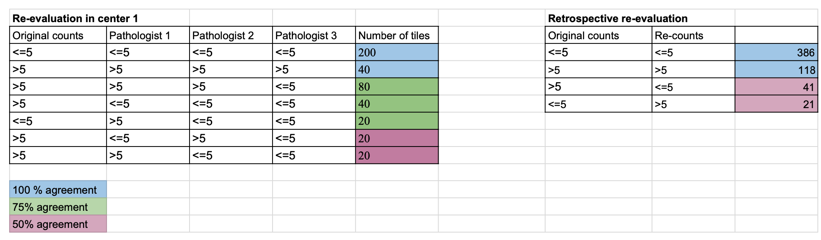
Supplementary Figure 4. Reproducibility of mitotic count in GIST.

