Supplementary file 3

Development and use of the ESBL coding gene panel in patients undergoing first-line eradication therapy of Helicobacter pylori

Authors: Dita Gudra¹, Ivars Silamikelis¹, Janis Pjalkovskis¹, Ilva Danenberga¹, Darta Pupola², Girts Skenders², Maija Ustinova¹, Kaspars Megnis¹, Marcis Leja^{2,3}, Reinis Vangravs², Davids Fridmanis¹*.

1 – Latvian Biomedical Research and Study Centre, Ratsupites 1K-1, LV-1067, Riga, Latvia.
2 – Institute of Clinical and Preventive Medicine, University of Latvia, LV-1586, Riga, Latvia.
3 – Faculty of Medicine, University of Latvia, LV-1586, Riga, Latvia.

* Correspondence and requests for materials should be addressed to:
Davids Fridmanis, e-mail: davids@biomed.lu.lv

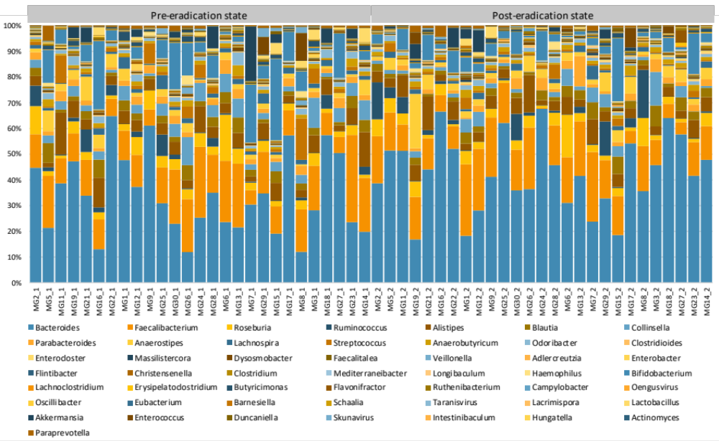

Supplementary 3.1. Taxonomical summary of all samples at the genus level (bacteria, viruses, and eukaryotes).

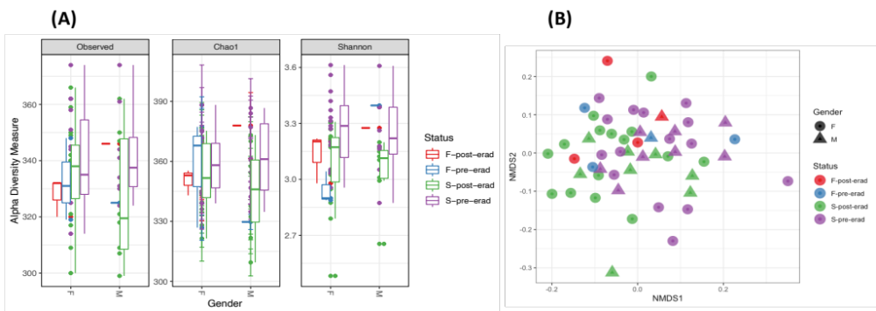
Supplementary 3.2. Estimated diversity characteristics of the validation group shotgun metagenomic analysis. Panel A – estimated alpha diversity metrics coloured by the treatment status and divided by gender. Panel B – non-metric multidimensional scaling of all samples, coloured by the treatment state and divided by gender. Abbreviations: F-post-erad - subjects in the post-eradication group with ineffective H. pylori eradication (HPE); F-pre-erad - subjects in pre-eradication group with ineffective HPE; S-post-erad - subjects in post-eradication group with successful HPE and S-pre-erad - subjects in pre-eradication group with successful HPE.

Shannon index
 | F-post-erad | F-pre-erad | S-post-erad | All-post-erad
F-pre-erad | 1 | - | - | -
S-post-erad | 1 | 1 | - | -
S-pre-erad | 1 | 0.736 | 0.019 | -
All-pre-erad | - |  |  | 0.019
Chao1 index
 | F-post-erad | F-pre-erad | S-post-erad | All-post-erad
F-pre-erad | 1 | - | - | -
S-post-erad | 1 | 1 | - | -
S-pre-erad | 1 | 1 | 0.85 | -
All-pre-erad | - |  |  | 0.21
Observed OTUs
 | F-post-erad | F-pre-erad | S-post-erad | All-post-erad
F-pre-erad | 1 | - | - | -
S-post-erad | 1 | 1 | - | -
S-pre-erad | 1 | 1 | 1 | -
All-pre-erad | - |  |  | 0.29

Supplementary 3.3. Pairwise comparisons using Wilcoxon rank sum test and holm P-value adjustment method for alpha diversity metrics. Abbreviations: F-post-erad - subjects in the post-eradication group with ineffective H. pylori eradication (HPE); F-pre-erad - subjects in pre-eradication group with ineffective HPE; S-post-erad - subjects in post-eradication group with successful HPE; S-pre-erad - subjects in pre-eradication group with successful HPE; All-pre-erad – all pre-eradication group samples; All-post-erad – all post-eradication group samples.

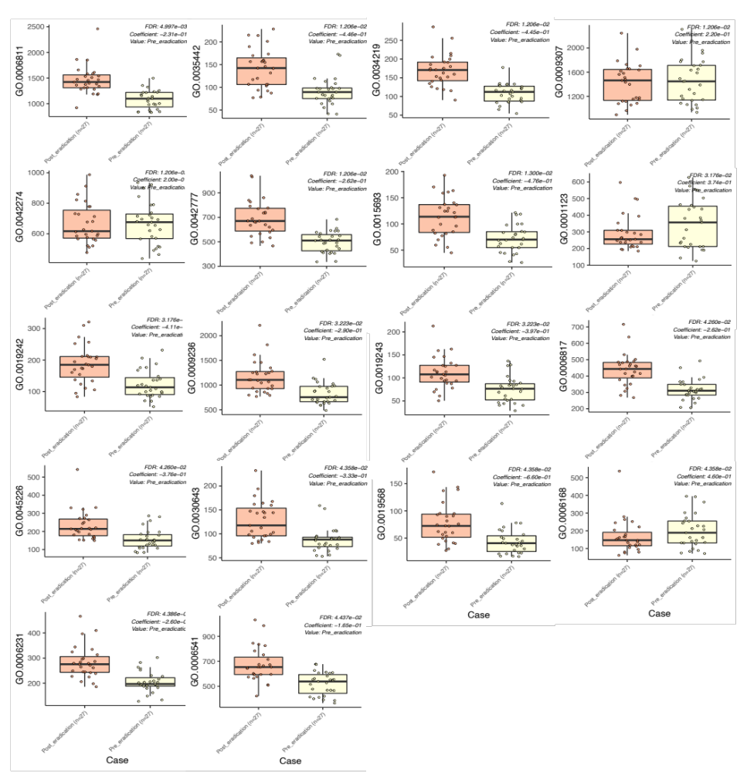
Supplementary 3.4. Significantly associated gene ontology (GO) entries from metagenomic data with the treatment state of H.pylori positive patients before and after eradication therapy. Decipherments of GO IDs: GO:0006811 – ion transport; GO:0035442 – dipeptide transmembrane transport; GO:0034219 – carbohydrate transmembrane transport; GO:0009307 – DNA restriction-modification system; GO:0042274 – ribosomal small subunit biogenesis; GO:0042777 – plasma membrane ATP synthesis coupled proton transport; GO:0015693 – magnesium ion transport; GO:0001123 – DNA-templated transcription, initiation; GO:0019242 – methylglyoxal biosynthetic process; GO:0009236 – cobalamin biosynthetic process; GO:0019243 – methylglyoxal catabolic process to D-lactate via S-lactoyl-glutathione; GO:0006817 – phosphate ion transport; GO:0045226 – extracellular polysaccharide biosynthetic process; GO:0030643 – cellular phosphate ion homeostasis; GO:0019568 – arabinose catabolic process; GO:0006168 – adenine salvage; GO:0006231 – dTMP biosynthetic process; GO:0006541 – glutamine metabolic process.

