Supplementary Information
Allyl bromide-enabled diversification of strong C(sp³)-H bonds: From stoichiometric reactions to catalysis
Ziqi Ye¹†, Ying Yu¹†, Yu-Mei Lin¹, Yuehua Chen¹, Silin Song¹, Lei Gong^{1,2}*
¹ Key Laboratory of Chemical Biology of Fujian Province, College of Chemistry and Chemical Engineering, Xiamen University, Xiamen, Fujian 361005, China.
² Innovation Laboratory for Sciences and Technologies of Energy Materials of Fujian Province (IKKEM), Xiamen 361005, China.
† These authors contributed equally to this work
Correspondence to: gongl@xmu.edu.cn
Contents
1. General Information | S3
2. Synthesis of the Substrates | S5
2.1 Synthesis of Allyl Bromides | S5
2.2 Synthesis of Benzylic Substrates | S7
3. Photochemical C(sp³)-H Allylation | S9
3.1 Optimization of Reaction Conditions | S9
3.2 Substrate Scope | S10
3.3 A Scale-up Reaction | S57
3.4 Structural Determination of Product 70 | S57
4. Mechanistic Investigations | S59
4.1 Spectroscopic Studies | S59
4.2 Radical Probing Experiments | S62
4.3 Investigation on Kinetic Isotope Effects | S66
4.4 Light-off/on Experiments | S67
5. Stoichiometric C(sp³)-H Heteroarylation and Alkylation Reactions | S68
5.1 Direct C(sp³)-H Heteroarylation | S68
5.2 Direct C(sp³)-H Alkylation | S69
6. Catalytic C(sp³)-H Hydrazination and Alkylation Reactions | S70
6.1 Optimization of Reaction Conditions | S70
6.2 Substrate Scope of C(sp³)-H Hydrazination | S71
6.3 Synthetic Utility of this Method in Amides Preparation | S95
6.4 Substrate Scope of C(sp³)-H Alkylation | S101
7. Computational Studies | S107
7.1. General Information | S107
7.2. Energetic Calculations on the NaF-Allyl Radical Complex and Electrostatic Potential Analysis | S107
7.3. Calculations on Energy Barriers of the C(sp³)-H Hydrazination Reaction | S109
8. ¹H and ¹³C NMR Spectrum | S123
9. References | S250

- General Information
General remarks
Dichloromethane (CH2Cl2) used for the reactions was distilled under argon from calcium hydride. Solvents for flash column chromatography (n-pentane, petroleum ether, EtOAc, CH2Cl2) were purchased from Shanghai Titan Scientific Co., Ltd.. Sodium fluoride was purchased from J&K Scientific (purity: 98%) and Alfa Aesar (99.99% metals basis). All others reagents were purchased from commercial suppliers (TCI, Sigma-Aldrich, Alfa Aesar, Macklin, Energy Chemical, Laajoo, Leyan, Bide Pharmatech, Adamas-beta® and J&K Scientific) and used without further purification.
Purification techniques
Flash column chromatography were performed using silica gel (Greagent, 300–400 mesh, pH = 6.7–7.0). Thin layer chromatography (TLC) were carried out on Leyan HPTLC Silica Gel 60 GF254, visualized with UV light (254 nm), stained with basic aqueous potassium permanganate (2.0 g KMnO₄ and 10 g K₂CO₃ in 200 mL of deionized water), ethanol solution of phosphomolybdic acid (10.0 g H₅Mo₁₂O₄₁P in 100 mL of ethanol, heated in 150 °C few minutes) and iodine fumigation (5.0 g iodine elemental in 50 g silica gel).
Analytical techniques
Proton and carbon magnetic resonance spectra (¹H NMR, and ¹³C NMR) were recorded on Bruker AVANCE II 400MHz, Bruker AVANCE III HD 500MHz, Bruker ASCEND 600 MHz, Bruker AVANCE III HD 850MHz. NMR standards were used as follows: CDCl₃ = 7.28 ppm (¹H NMR), 77.0 ppm (¹³C NMR), (CD₃)₂CO = 2.09 ppm (¹H NMR), 29.7 and 206.4 ppm (¹³C NMR), (CD₃)₂SO = 2.55 ppm (¹H NMR). Data are reported as follows: chemical shift, multiplicity (s =singlet, d = doublet, t = triplet, q = quartet, br = broad, m = multiplet), coupling constants (Hz), and integration. IR spectra were recorded on a Nicolet Avatar 330 FT-IR spectrophotometer. High-resolution mass spectra were performed on Agilent 1290-G6545XT QTOF instrument using ESI technique and Bruker En Apex Ultra 7.0 T FT-MS instrument using ESI technique. Electron paramagnetic resonance were performed on EMXplus-9.5/12. UV/Vis absorption spectra were recorded on an Agilent Cary F5000 in a 1.0 mm quartz cuvette. Emission spectrum were recorded on a Hitachi F7000 in a 10 mm quartz cuvette. Regional selectivity and diastereomeric ratio were determined by crude ¹H NMR analysis.
Set-up of visible light photochemical reactions
Visible light photochemical reactions were performed in 10 mL or 38 mL Schlenk tubes under argon and upon irradiation with a 50 W blue LEDs lamp (λ_{max} = 410 nm; commercial supplier: Hong Chang Lighting Co. Ltd., website: http://hongchang-led.taobao.com) or a 40 W Kessil LEDs lamp (PR160L, λ_{max} = 390 nm; commercial supplier: Anhui Kemi Instrument Co. Ltd., website: http://www.ahkemi.com). Direct Current (DC) fans NF-A14 industrialPPC-24V-3000 Q100 IP67 PWM, commercial supplier NOCTUA, website: https://noctua.at).
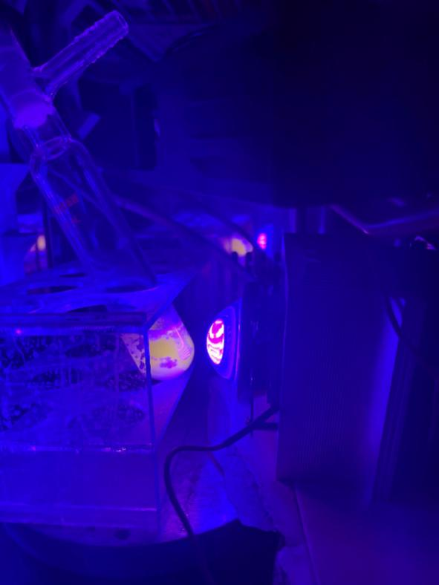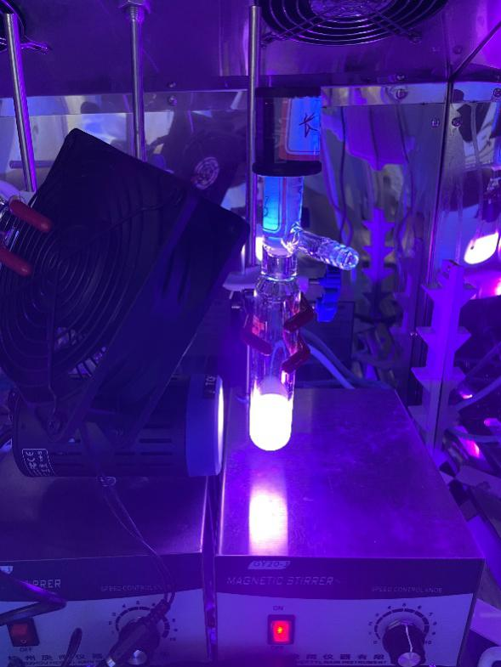
Figure S1. Reaction set‐up of the photochemical reactions.
Figure S2. Emission spectra of 50 W blue LEDs lamp (maxium emission at λ = 410 nm) and 40 W Kessil PR160L 390 (maxium emission at λ = 390 nm).
2. Synthesis of the Substrates
General remarks
Allyl bromides (1c, 1d, 1g, 1h and 1i) were prepared according to published procedures.^{[1]} Other bromide substances were purchased from Bide Pharmatech and further purification by silica gel chromatography.
Ethylbenzene derivatives, including 3-phenylpropyl methanesulfonate, ^{[2]} tert-butyl-phenethylcarbamate, ^{[3]} 4-ethyl-4'-methyl-1,1'-biphenyl, ^{[4]} 3-phenylpropyl 4-methylbenzenesulfonate, ^{[5]} 1-cyclohexyl-4-ethylbenzene, ^{[6]} 1-(4-ethylphenethyl)adamantane ^{[6]} and 1-(3,3-dimethylbutyl)-4-ethylbenzene ^{[6]} were prepared according to published procedures. Others were purchased from TCI, Sigma-Aldrich, Alfa, Macklin, Energy Chemical, Laajoo, Bide Pharmatech, Adamas-beta® and J&K Scientific) and used without further purification.
ethyl benzo[d]isothiazole-3-carboxylate 1,1-dioxide (76) was prepared according to a published method. ^{[7]}
Tris(trimethylsilyl)silanol was prepared according to a published method. ^{[8]}
2.1 Synthesis of Allyl Bromides
General Procedure
To a solution of an alcohol (S1e or S1f, 5.0 mmol) in CH₂Cl₂ (50 mL) at 0 ℃ was added acryloyl chloride (10.0 mmol) and triethylamine (20.0 mmol) dropwise. The reaction mixture was stirred over night at room temperature, then quenched with saturated aqueous solution of sodium bicarbonate and extracted with CH₂Cl₂ (3 × 25 mL). The combined organic layers were dried over anhydrous Na₂SO₄ and concentrated under reduced pressure. The crude product was subjected to silica gel chromatography (petroleum ether (PE): ethyl acetate (EA) = 10:1) to afford the pure acrylate (S2e or S2f).
To a solvent of paraformaldehyde (15.0 mmol) and acrylate (S2e or S2f, 5.0 mmol) in THF-H₂O (25 mL, v: v=4:1) was added DABCO (15.0 mmol) at room temperature. The reaction mixture was monitored by TLC, then quenched with H₂O and extracted with CH₂Cl₂ (3 × 25 mL). The combined organic layers were dried over anhydrous Na₂SO₄ and concentrated under reduced pressure. The residue was subjected to silica gel chromatography (PE: EA = 5:1) to afford the pure 2-hydroxymethacrylate (S3e or S3f).
To a solution of 2-hydroxymethacrylate (S3e or S3f, 5.0 mmol) was added phosphorus (III) bromide (6.0 mmol) in dry CH₂Cl₂ (20 mL) at -10 ℃. The reaction mixture was stirred over night at room temperature, then quenched with saturated aqueous solution of sodium bicarbonate. The combined organic layers were dried over anhydrous Na₂SO₄ and concentrated under reduced pressure. The residue was subjected to silica gel chromatography (PE: EA = 20:1) to afford the pure 1e or 1f.
cyclohexyl 2-(bromomethyl)acrylate (1e)
According to the general procedure, cyclohexanol (501 mg, 5.00 mmol) was converted into allyl bromide 1e as a pale-yellow oil (667 mg, 2.70 mmol, total yield of 3 steps: 54%).
¹H NMR (500 MHz, CDCl₃) δ 6.30 (d, J = 0.6 Hz, 1H), 5.91 (d, J = 0.7 Hz, 1H), 5.34–5.27 (m, 1H), 4.18 (d, J = 0.6 Hz, 2H), 1.95–1.86 (m, 2H), 1.87–1.69 (m, 5H), 1.70–1.48 (m, 3H).
¹³C NMR (126 MHz, CDCl₃) δ 164.58, 137.93, 128.58, 78.21, 32.66, 30.71, 29.49, 23.73.
IR (film): ν (cm⁻¹) 2966, 2873, 1723, 1436, 1333, 1193, 1167, 957, 813, 722.
HRMS (ESI-TOF, m/z) calcd for C₁₀H₁₅BrNaO₂ (M+Na)⁺: 269.0153, found: 269.0151.
((adamantan-1-yl)methyl)-2-(bromomethyl)acrylate (1f)
According to the general procedure, 1-adamantane methanol (832 mg, 5.00 mmol) was converted into corresponding 1f as a pale-yellow solid (548 mg, 1.75 mmol, total yield of 3 steps: 35%).
¹H NMR (500 MHz, CDCl₃) δ 6.37 (s, 1H), 5.96 (s, 1H), 4.21 (s, 2H), 3.83 (s, 2H), 2.02 (s, 3H), 1.76 (m, 3H), 1.71–1.62 (m, 3H), 1.61 (d, J = 2.9 Hz, 6H).
¹³C NMR (126 MHz, CDCl₃) δ 164.97, 137.66, 129.06, 74.79, 39.31, 39.23, 36.94, 36.88, 33.42, 29.36, 28.03, 27.97.
IR (film): ν (cm⁻¹) 2903, 2848, 1725, 1363, 1222, 1194, 1176, 989, 810, 721.
HRMS (ESI-TOF, m/z) calcd for C₁₅H₂₁BrNaO₂⁺ (M+Na)⁺: 335.0617, found: 335.0602.
2.2 Synthesis of Benzylic Substrates
General procedure
To a solution of p-bromotoluene (5.00 mmol) was added cuprous chloride (2.50 mmol) and potassium carbonate (10.0 mmol) in dry N-methylpyrrolidone (25.0 mL) then added 4-alkyl-phenol (S4 or S5, 5.50 mmol) at room temperature. The reaction mixture was stirred over night at 130 ℃ under argon. After 12 h, the reaction mixture was quenched with H₂O and extracted with CH₂Cl₂ (3 × 25 mL). The combined organic layers were dried over anhydrous Na₂SO₄ and concentrated under reduced pressure. The residue was subjected to silica gel chromatography (PE: EA = 20:1) to afford the pure S6 or S7.
1-ethyl-4-(p-tolyloxy)benzene (S6)
According to the general procedure, 4-ethylphenol (S4, 672 mg, 5.50 mmol) was converted into S6 as a colorless oil (859 mg, 4.10 mmol, 81% yield).
¹H NMR (500 MHz, CDCl₃) δ 7.18–7.14 (m, 4H), 7.00–6.87 (m, 4H), 2.66 (q, J = 7.6 Hz, 2H), 2.36 (s, 3H), 1.27 (t, J = 7.6 Hz, 3H).
¹³C NMR (126 MHz, CDCl₃) δ 155.51, 155.26, 138.87, 132.50, 130.16, 128.95, 118.70, 118.54, 28.14, 20.68, 15.76.
IR (film): ν (cm⁻¹) 3030, 2965, 2871, 1886, 1604, 1500, 1456, 1240, 1168, 1109, 1069, 1049, 1015, 960, 873, 826, 760, 690.
HRMS (ESI-TOF, m/z) calcd for C₁₅H₁₆ONa⁺ (M+Na)⁺: 235.1099, found: 235.1081.
1-isopropyl-4-(p-tolyloxy)benzene (S7)
According to the general procedure, 4-isopropylphenol (S5, 749 mg, 5.50 mmol) was converted into S7 as a colorless oil (950 mg, 4.20 mmol, 84% yield).
¹H NMR (500 MHz, CDCl₃) δ 7.22-7.16 (m, 4H), 6.97-6.95 (m, 4H), 2.96-2.91 (m, 1H), 2.37 (s, 3H), 1.29 (d, J = 7.0 Hz, 6H).
¹³C NMR (126 MHz, CDCl₃) δ 155.58, 155.19, 143.47, 132.54, 130.17, 127.50, 118.81, 118.39, 33.47, 24.19, 20.71.
IR (film): ν (cm⁻¹) 3030, 2959, 2924, 2871, 1885, 1602, 1502, 1460, 1383, 1338, 1280, 1242, 1170, 1104, 874, 825.
HRMS (ESI, m/z) calcd for C₁₆H₁₈ONa⁺ (M+Na)⁺: 249.1250, found: 249.1223.

3. Photochemical C(sp³)-H Allylation
3.1 Optimization of Reaction Conditions
General Procedure
A dried Schlenk tube (10 mL) was charged with ethylbenzene (106.2 mg, 1.0 mmol), ethyl 2-(bromomethyl)acrylate (1a, 38.6 mg, 0.20 mmol), the indicated salt (0.40 mmol) and solvent (1.0 mL). The mixture was degassed via three freeze-pump-thaw cycles. The Schlenk tube was positioned approximately 5 cm away from a 50 W blue LEDs lamp (λ_{max} = 410 nm) with a DC fan cooling. The reaction was stirred at room temperature for 48 h. The reaction mixture was purified by flash chromatography on silica gel (eluted with PE to PE: EA=30:1, v: v) to afford the allylated product (2) as a yellow oil.
Table S1. Optimization of reaction conditions for the photochemical C(sp³)-H allylation. ª
entry |  | salt | additive | solvent | t (h) | yield (%) ^{b}
1 |  | none | none | CH₂Cl₂ | 48 | 20
2 |  | NaOH | none | CH₂Cl₂ | 48 | 51
3 |  | NaOEt | none | CH₂Cl₂ | 48 | trace
4 |  | Na₂C₂O₄ | none | CH₂Cl₂ | 48 | 20
5 |  | NaH₂PO₄·2H₂O | none | CH₂Cl₂ | 48 | 24
6 |  | Na₂SO₄ | none | CH₂Cl₂ | 48 | 21
7 |  | NaPF₆ | none | CH₂Cl₂ | 48 | 26
8 |  | NaF | none | CH₂Cl₂ | 48 | 78
9 |  | NaCl | none | CH₂Cl₂ | 48 | 26
10 |  | NaBr | none | CH₂Cl₂ | 48 | 26
11 |  | NaI | none | CH₂Cl₂ | 48 | 0
12 |  | LiF | none | CH₂Cl₂ | 48 | 38
13 |  | KF | none | CH₂Cl₂ | 48 | 74
14 |  | CsF | none | CH₂Cl₂ | 48 | 74
15 |  | NH₄F | none | CH₂Cl₂ | 48 | 61
16 |  | MgF₂ | none | CH₂Cl₂ | 48 | 52
17 |  | CaF₂ | none | CH₂Cl₂ | 48 | 34
18 |  | (nBu)₄NF | none | CH₂Cl₂ | 48 | 0
19 |  | NaBPh₄ | none | CH₂Cl₂ | 48 | 0
20 |  | KCl | none | CH₂Cl₂ | 48 | 60
21 |  | NaF | none | CH₃CN | 48 | 41
22 |  | NaF | none | CHCl₃ | 48 | 70
23 |  | NaF | none | (CHCl₂)₂ | 48 | 72
24 |  | NaF | TEMPO  (3.0 equiv.) | CH₂Cl₂ | 48 | 0
25 |  | NaF | BHT  (3.0 equiv.) | CH₂Cl₂ | 48 | 0
26 |  | NaF | 15-crown-5  (3.0 equiv.) | CH₂Cl₂ | 48 | 31%
27 |  | KF | 18-crown-6  (3.0 equiv.) | CH₂Cl₂ | 48 | trace
28^{c} |  | NaF | none | CH₂Cl₂ | 48 | 0
29^{d} |  | NaF | none | CH₂Cl₂ | 48 | 0
30e |  | NaF | none | CH₂Cl₂ | 48 | 63
31^{f} |  | NaF | none | CH₂Cl₂ | 48 | 73
32 |  | NaF | none | CH₂Cl₂ | 72 | 82
 | ª Reaction conditions: ethylbenzene (1.0 mmol), 1a (0.20 mmol), the indicated solvent (1.0 mL), under irradiation with a blue LEDs lamp (50 W, λ_{max} = 410 nm), at 28 °C, under argon. ^{b} Isolated yield. ^{c} Reaction performed in dark and at 28 °C. ^{d} Reaction performed in dark and at 70 °C. ^{e} Reaction performed in air. ^{f} NaF was purchased from Alfa Aesar (99.99%).
3.2 Substrate Scope
ethyl-2-methylene-4-phenylpentanoate (2)
A dried Schlenk tube (10 mL) was charged with ethylbenzene (106.2 mg, 1.0 mmol), ethyl 2-(bromomethyl)acrylate (1a, 38.6 mg, 0.20 mmol), sodium fluoride (16.8 mg, 0.40 mmol) and dichloromethane (1.0 mL). The mixture was degassed via three freeze-pump-thaw cycles. The Schlenk tube was positioned approximately 5 cm away from a 50 W blue LEDs lamp (λ_{max} = 410 nm) with a DC fan cooling. The reaction was stirred at room temperature for 72 h. The reaction mixture was purified by flash chromatography on silica gel (eluted with PE to PE: EA = 30:1, v: v) to afford the allylated product (2) as a yellow oil (35.8 mg, 0.162 mmol, 82% yield).
¹H NMR (500 MHz, CDCl₃) δ 7.32–7.26 (m, 2H), 7.22–7.14 (m, 3H), 6.09 (s, 1H), 5.36 (s, 1H), 4.19 (q, J = 7.1 Hz, 2H), 3.02–2.95 (m, J = 7.1 Hz, 1H), 2.62 (dd, J = 13.8, 7.2 Hz, 1H), 2.52 (dd, J = 13.9, 7.5 Hz, 1H), 1.29 (t, J = 7.1 Hz, 3H), 1.26 (d, J = 7.0 Hz, 3H).
¹³C NMR (126 MHz, CDCl₃) δ 167.27, 146.60, 139.18, 128.31, 127.05, 126.27, 126.05, 60.59, 40.96, 38.79, 21.31, 14.21.
All other data was in agreement with the literature. ^{[9]}
methyl-2-methylene-4-phenylpentanoate (3)
A dried Schlenk tube (10 mL was charged with ethylbenzene (106.2 mg, 1.0 mmol), methyl 2-(bromomethyl)acrylate (1b, 35.8 mg, 0.20 mmol), sodium fluoride (16.8 mg, 0.40 mmol) and dichloromethane (1.0 mL). The mixture was degassed via three freeze-pump-thaw cycles. The Schlenk tube was positioned approximately 5 cm away from a 50 W blue LEDs lamp (λ_{max} = 410 nm) with a DC fan cooling. The reaction was stirred at room temperature for 72 h. The reaction mixture was purified by flash chromatography on silica gel (eluted with PE to PE: EA=30:1, v: v) to afford the allylated product (3) as a yellow oil (27.8 mg, 0.136 mmol, 68% yield).
¹H NMR (500 MHz, CDCl₃) δ 7.39–7.32 (m, 2H), 7.24 (dd, J = 10.9, 4.3 Hz, 3H), 6.16 (s, 1H), 5.43 (s, 1H), 3.80 (s, 3H), 3.08–3.01 (m, 1H), 2.78–2.62 (m, 1H), 2.62–2.51 (m, 1H), 1.33 (d, J = 7.0 Hz, 3H).
¹³C NMR (126 MHz, CDCl₃) δ 167.73, 146.50, 138.83, 128.32, 127.07, 126.61, 126.08, 51.80, 40.92, 38.73, 21.38.
All other data was in agreement with the literature. ^{[9]}

tert-butyl-2-methylene-4-phenylpentanoate (4)
A dried Schlenk tube (10 mL) was charged with ethylbenzene (106.2 mg, 1.0 mmol), tert-buthyl 2-(bromomethyl)acrylate (1c, 44.2 mg, 0.20 mmol), sodium fluoride (16.8 mg, 0.40 mmol) and dichloromethane (1.0 mL). The mixture was degassed via three freeze-pump-thaw cycles. The Schlenk tube was positioned approximately 5 cm away from a 50 W blue LEDs lamp (λ_{max} = 410 nm) with a DC fan cooling. The reaction was stirred at room temperature for 72 h. The reaction mixture was purified by flash chromatography on silica gel (eluted with PE to PE: EA=30:1, v: v) to afford the allylated product (4) as a yellow oil (22.1 mg, 0.090 mmol, 45% yield).
¹H NMR (500 MHz, CDCl₃) δ 7.29 (t, J = 7.6 Hz, 2H), 7.22–7.15 (m, 3H), 6.02 (s, 1H), 5.29 (s, 1H), 3.02–2.95 (m, 1H), 2.63–2.51 (m, 1H), 2.51–2.37 (m, 1H), 1.50 (s, 9H), 1.26 (d, J = 7.0 Hz, 3H).
¹³C NMR (126 MHz, CDCl₃) δ 166.51, 146.77, 140.54, 128.31, 127.06, 126.01, 125.55, 80.45, 41.14, 38.95, 28.09, 21.28.
IR (film): ν (cm⁻¹) 2976, 2930, 1711, 1631, 1495, 1454, 1392, 1368, 1339, 1038, 1255, 1213, 1148, 945, 851, 818, 764, 700.
HRMS (ESI-TOF, m/z) calcd for [C₁₆H₂₂O₂]²⁺ (M²⁺): 123.0810, found: 123.0807.
benzyl-2-methylene-4-phenylpentanoate (5)
A dried Schlenk tube (10 mL) was charged with ethylbenzene (106.2 mg, 1.0 mmol), benzyl 2-(bromomethyl)acrylate (1d, 51.1 mg, 0.20 mmol), sodium fluoride (16.8 mg, 0.40 mmol) and dichloromethane (1.0 mL). The mixture was degassed via three freeze-pump-thaw cycles. The Schlenk tube was positioned approximately 5 cm away from a 50 W blue LEDs lamp (λ_{max} = 410 nm) with a DC fan cooling. The reaction was stirred at room temperature for 72 h. The reaction mixture was purified by flash chromatography on silica gel (eluted with PE to PE: EA=30:1, v: v) to afford the allylated product (5) as a yellow oil (36.4 mg, 0.130 mmol, 65% yield).
¹H NMR (500 MHz, CDCl₃) δ 7.48–7.41 (m, 5H), 7.34 (dd, J = 12.4, 4.8 Hz, 2H), 7.26–7.20 (m, 3H), 6.23 (s,1H), 5.47 (s,1H), 5.31–5.13 (m, 2H), 3.10–3.03 (m, 1H), 2.73–2.69 (m, 1H), 2.68–2.55 (m, 1H), 1.33 (d, J = 7.0 Hz, 3H).
¹³C NMR (126 MHz, CDCl₃) δ 167.03, 146.48, 138.87, 136.12, 128.57, 128.33, 128.18, 128.06, 127.08, 126.97, 126.09, 66.41, 41.02, 38.76, 21.35.
All other data was in agreement with the literature. ^{[9]}
cyclohexyl-2-methylene-4-phenylpentanoate (6)
A dried Schlenk tube (10 mL) was charged with ethylbenzene (106.2 mg, 1.0 mmol), cyclohexyl 2-(bromomethyl)acrylate (1e, 49.4 mg, 0.20 mmol), sodium fluoride (16.8 mg, 0.40 mmol) and dichloromethane (1.0 mL). The mixture was degassed via three freeze-pump-thaw cycles. The Schlenk tube was positioned approximately 5 cm away from a 50 W blue LEDs lamp (λ_{max} = 410 nm) with a DC fan cooling. The reaction was stirred at room temperature for 72 h. The reaction mixture was purified by flash chromatography on silica gel (eluted with PE to PE: EA=30:1, v: v) to afford the allylated product (6) as a yellow oil (33.8 mg, 0.124 mmol, 62% yield).
¹H NMR (500 MHz, CDCl₃) δ 7.31–7.23 (m, 2H), 7.20–7.14 (m, 3H), 6.05 (d, J = 1.5 Hz, 1H), 5.34–5.31 (d, J = 0.9 Hz, 1H), 5.21 (dq, J = 6.0, 3.6, 3.2 Hz, 1H), 2.97 (h, J = 7.1 Hz, 1H), 2.60 (dd, J = 13.8, 7.1 Hz, 1H), 2.49 (dd, J = 13.8, 7.6 Hz, 1H), 1.94–1.83 (m, 2H), 1.72 (dd, J = 9.2, 4.5 Hz, 4H), 1.66–1.57 (m, 2H), 1.25 (d, J = 7.0 Hz, 3H).
¹³C NMR (126 MHz, CDCl₃) δ 167.04, 146.66, 139.49, 128.32, 127.03, 126.12, 126.05, 77.33, 41.06, 38.83, 32.71, 32.68, 23.79, 21.26.
IR (film): ν (cm⁻¹) 2963, 2872, 1713, 1630, 1495, 1453, 1405, 1376, 1332, 1301, 1197, 1153, 1082, 1034, 943, 817, 763, 700.
HRMS (ESI-TOF, m/z) calcd for [C₁₈H₂₄O₂Na₂]²⁺ (M+2Na)²⁺: 159.0780, found: 159.0781.
((adamantan-1-yl)methyl)-2-methylene-4-phenylpentanoate (7)
A dried Schlenk tube (10 mL) was charged with ethylbenzene (106.2 mg, 1.0 mmol), adamantan-1-yl 2-(bromomethyl)acrylate (1f, 62.6 mg, 0.20 mmol), sodium fluoride (16.8 mg, 0.40 mmol) and dichloromethane (1.0 mL). The mixture was degassed via three freeze-pump-thaw cycles. The Schlenk tube was positioned approximately 5 cm away from a 50 W blue LEDs lamp (λ_{max} = 410 nm) with a DC fan cooling. The reaction was stirred at room temperature for 72 h. The reaction mixture was purified by flash chromatography on silica gel (eluted with PE to PE: EA=30:1, v: v) to afford the allylated product (7) as a pale-yellow solid (41.9 mg, 0.124 mmol, 62% yield).
¹H NMR (500 MHz, CDCl₃) δ 7.27 (dd, J = 12.5, 4.8 Hz, 2H), 7.21–7.10 (m, 3H), 6.11 (s, 1H), 5.34 (s, 1H), 3.78–3.66 (m, 2H), 3.00 (m, 1H), 2.62 (dd, J = 13.8, 7.2 Hz, 1H), 2.53 (dd, J = 13.7, 7.5 Hz, 1H), 2.00 (s, 3H), 1.74 (d, J = 12.1 Hz, 3H), 1.67 (s, 3H), 1.57 (s, 6H), 1.26 (d, J = 6.9 Hz, 3H).
¹³C NMR (126 MHz, CDCl₃) δ 167.38, 146.60, 139.18, 128.30, 127.06, 126.37, 126.04, 74.25, 41.04, 39.43, 38.75, 37.00, 33.39, 28.08, 21.36.
IR (film): ν (cm⁻¹) 2962, 2869, 1714, 1634, 1495, 1453, 1405, 1378, 1332, 1304, 1148, 1102, 761, 693.
HRMS (ESI-TOF, m/z) calcd for C₂₃H₃₀NaO₂⁺ (M+Na)⁺: 361.2138, found: 361.2154.
diethyl (4-phenylpent-1-en-2-yl) phosphonate (8)
A dried Schlenk tube (10 mL) was charged with ethylbenzene (106.2 mg, 1.0 mmol), diethyl (3-bromoprop-1-en-2-yl) phosphonate (1g, 51.4 mg, 0.20 mmol), sodium fluoride (16.8 mg, 0.40 mmol) and dichloromethane (1.0 mL). The mixture was degassed via three freeze-pump-thaw cycles. The Schlenk tube was positioned approximately 5 cm away from a 50 W blue LEDs lamp (λ_{max} = 410 nm) with a DC fan cooling. The reaction was stirred at room temperature for 72 h. The reaction mixture was purified by flash chromatography on silica gel (eluted with PE to PE: EA=3:1, v: v) to afford the allylated product (8) as a yellow oil (32.8 mg, 0.116 mmol, 58% yield).
¹H NMR (500 MHz, CDCl₃) δ 7.40–7.22 (m, 2H), 7.22–7.05 (m, 3H), 6.08–5.87 (m, 1H), 5.59 (dd, J = 48.8, 1.4 Hz, 1H), 4.22–3.87 (m, 4H), 3.11 (m, 1H), 2.58 (dd, J = 14.6, 7.5 Hz, 1H), 2.46 (dd, J = 15.3, 7.5 Hz, 1H), 1.33 (q, J = 6.9 Hz, 6H), 1.26 (d, J = 6.9 Hz, 3H).
¹³C NMR (126 MHz, CDCl₃) δ 146.40, 137.96, 136.59, 131.04 (d, J = 9.3 Hz), 128.35, 127.06, 126.13, 61.79 (d, J = 5.8 Hz), 41.06 (d, J = 11.0 Hz), 37.94 (d, J = 4.0 Hz), 21.72 (s), 16.37 (d, J = 6.4 Hz).
IR (film): ν (cm⁻¹) 2980, 2929, 1636, 1443, 1394, 1234, 1164, 1053, 1023, 972, 796.
HRMS (ESI-TOF, m/z) calcd for C₁₅H₂₃NaO₃P⁺ (M+Na)⁺: 305.1277, found: 305.1287.
((4-phenylpent-1-en-2-yl)sulfonyl)benzene (9)
A dried Schlenk tube (10 mL) was charged with ethylbenzene (106.2 mg, 1.0 mmol), ((3-bromoprop-1-en-2-yl)sulfonyl)benzene (1h, 52.3 mg, 0.20 mmol), sodium fluoride (16.8 mg, 0.40 mmol) and dichloromethane (1.0 mL). The mixture was degassed via three freeze-pump-thaw cycles. The Schlenk tube was positioned approximately 5 cm away from a 50 W blue LEDs lamp (λ_{max} = 410 nm) with a DC fan cooling. The reaction was stirred at room temperature for 72 h. The reaction mixture was purified by flash chromatography on silica gel (eluted with PE to PE: EA=10:1, v: v) to afford the allylated product (9) as a pale-yellow oil (46.9 mg, 0.164 mmol, 82% yield).
¹H NMR (500 MHz, CDCl₃) δ 7.90–7.83 (m, 2H), 7.64 (t, J = 7.4 Hz, 1H), 7.55 (q, J = 7.5 Hz, 2H), 7.24–7.19 (m, 2H), 7.16 (t, J = 7.3 Hz, 1H), 7.01 (d, J = 7.2 Hz, 2H), 6.30 (s, 1H), 5.49 (s, 1H), 2.97 (m, 1H), 2.52 (t, J = 7.9 Hz, 2H), 1.19 (d, J = 6.9 Hz, 3H).
¹³C NMR (126 MHz, CDCl₃) δ 148.25, 145.14, 138.88, 133.49, 129.23, 128.49, 128.32, 126.84, 126.41, 125.35, 37.98, 37.74, 22.00.
IR (film): ν (cm⁻¹) 2966, 1637, 1494, 1447, 1331, 1136, 1081, 953, 745, 701, 689.
HRMS (ESI-TOF, m/z) calcd for C₁₇H₁₈NaO₂S⁺ (M+Na)⁺: 309.0920, found: 309.0932.
2-methylene-4-phenylpentanenitrile (10)
A dried Schlenk tube (10 mL) was charged with ethylbenzene (106.2 mg, 1.0 mmol), 2-(bromomethyl)acrylonitrile (1i, 29.2 mg, 0.20 mmol), sodium fluoride (16.8 mg, 0.40 mmol) and dichloromethane (1.0 mL). The mixture was degassed via three freeze-pump-thaw cycles. The Schlenk tube was positioned approximately 5 cm away from a 50 W blue LEDs lamp (λ_{max} = 410 nm) with a DC fan cooling. The reaction was stirred at room temperature for 72 h. The reaction mixture was purified by flash chromatography on silica gel (eluted with PE to PE: EA=30:1, v: v) to afford the allylated product (10) as a pale-yellow oil (20.5 mg, 0.120 mmol, 60% yield).
¹H NMR (500 MHz, CDCl₃) δ 7.32 (t, J = 7.5 Hz, 2H), 7.25–7.17 (m, 3H), 5.78 (s, 1H), 5.55 (s, 1H), 3.19–2.87 (m, 1H), 2.51 (m, 2H), 1.32 (d, J = 7.0 Hz, 3H).
¹³C NMR (126 MHz, CDCl₃) δ 144.82, 131.87, 128.61, 126.93, 126.64, 121.70, 118.62, 43.42, 38.38, 21.26.
IR (film): ν (cm⁻¹) 2964, 2929, 2873, 2221, 1878, 1720, 1622, 1603, 1494, 1452,1403, 1378, 1263, 1018, 939, 766, 701.
HRMS (ESI-TOF, m/z) calcd for C₁₂H₁₃NNa⁺ (M+Na)⁺: 194.0940, found: 194.0954.
4-(4-(phenylsulfonyl)pent-4-en-2-yl)-1,1'-biphenyl (11)
A dried Schlenk tube (10 mL) was charged with 4-ethyl-1,1'-biphenyl (182.2 mg, 1.0 mmol), ((3-bromoprop-1-en-2-yl)sulfonyl)benzene (1h, 52.3 mg, 0.20 mmol), sodium fluoride (16.8 mg, 0.40 mmol) and dichloromethane (1.0 mL). The mixture was degassed via three freeze-pump-thaw cycles. The Schlenk tube was positioned approximately 5 cm away from a 50 W blue LEDs lamp (λ_{max} = 410 nm) with a DC fan cooling. The reaction was stirred at room temperature for 72 h. The reaction mixture was purified by flash chromatography on silica gel (eluted with PE to PE: EA=10:1, v: v) to afford the allylated product (11) as a pale-yellow oil (47.9 mg, 0.132 mmol, 66% yield).
¹H NMR (500 MHz, CDCl₃) δ 7.91–7.83 (m, 2H), 7.67–7.60 (m, 1H), 7.60–7.54 (m, 4H), 7.49–7.40 (m, 4H), 7.33 (dd, J = 16.1, 8.8 Hz, 1H), 7.10 (d, J = 8.2 Hz, 2H), 6.34 (s, 1H), 5.56 (s, 1H), 3.04 (m, 1H), 2.56 (d, J = 7.4 Hz, 2H), 1.26 (t, J = 10.0 Hz, 3H).
¹³C NMR (126 MHz, CDCl₃) δ 148.26, 144.25, 140.79, 139.30, 138.87, 133.52, 129.25, 128.78, 128.34, 127.28, 127.20, 127.18, 126.96, 125.47, 37.77. 37.67, 22.02.
IR (film): ν (cm⁻¹) 2965, 1617, 1486, 1447, 1304, 1138, 1082, 1008, 915, 766, 749, 690.
HRMS (ESI-TOF, m/z) calcd for C₂₃H₂₂NaO₂S⁺ (M+Na)⁺: 385.1233, found: 385.1231.
1-fluoro-4-(4-(phenylsulfonyl)pent-4-en-2-yl)benzene (12)
A dried Schlenk tube (10 mL) was charged with 1-ethyl-4-fluorobenzene (125.2 mg, 1.0 mmol), ((3-bromoprop-1-en-2-yl)sulfonyl)benzene (1h, 52.3 mg, 0.20 mmol), sodium fluoride (16.8 mg, 0.40 mmol) and dichloromethane (1.0 mL). The mixture was degassed via three freeze-pump-thaw cycles. The Schlenk tube was positioned approximately 5 cm away from a 50 W blue LEDs lamp (λ_{max} = 410 nm) with a DC fan cooling. The reaction was stirred at room temperature for 72 h. The reaction mixture was purified by flash chromatography on silica gel (eluted with PE to PE: EA=10:1, v: v) to afford the allylated product (12) as a pale-yellow oil (34.7 mg, 0.114 mmol, 57% yield).
¹H NMR (500 MHz, CDCl₃) δ 7.88–7.78 (m, 2H), 7.69–7.58 (m, 1H), 7.54 (m, 2H), 7.01–6.91 (m, 2H), 6.89 (t, J = 8.7 Hz, 2H), 6.36–6.22 (m, 1H), 5.46 (s, 1H), 3.05–2.89 (m, 1H), 2.60–2.33 (m, 2H), 1.18 (d, J = 6.9 Hz, 3H).
¹³C NMR (126 MHz, CDCl₃) δ 161.4 (d, J_{C-F} = 244 Hz), 148.16, 140.74 (d, J_{C-F} = 3.8 Hz), 138.80, 129.25, 133.55, 128.31, 128.24 (d, J_{C-F} = 8.8 Hz), 125.46, 115.22 (d, J_{C-F} = 20.0 Hz), 38.06, 37.34, 22.10.
IR (film): ν (cm⁻¹) 2967, 1604, 1511, 1447, 1305, 1223, 1129, 1137, 1082, 1014, 951, 836, 748, 689, 665.
HRMS (ESI-TOF, m/z) calcd for C₁₇H₁₇FNaO₂S⁺ (M+Na)⁺: 327.0825, found: 327.0823.
1-chloro-4-(4-(phenylsulfonyl)pent-4-en-2-yl)benzene (13)
A dried Schlenk tube (10 mL) was charged with 1-chloro-4-ethylbenzene (140.5 mg, 1.0 mmol), ((3-bromoprop-1-en-2-yl)sulfonyl)benzene (1h, 52.3 mg, 0.20 mmol), sodium fluoride (16.8 mg, 0.40 mmol) and dichloromethane (1.0 mL). The mixture was degassed via three freeze-pump-thaw cycles. The Schlenk tube was positioned approximately 5 cm away from a 50 W blue LEDs lamp (λ_{max} = 410 nm) with a DC fan cooling. The reaction was stirred at room temperature for 72 h. The reaction mixture was purified by flash chromatography on silica gel (eluted with PE to PE: EA=10:1, v: v) to afford the allylated product (13) as a pale-yellow oil (46.1 mg, 0.144 mmol, 72% yield).
¹H NMR (500 MHz, CDCl₃) δ 7.84 (d, J = 8.1 Hz, 2H), 7.64 (dd, J = 10.7, 4.2 Hz, 1H), 7.54 (t, J = 7.7 Hz, 2H), 7.17 (d, J = 8.4 Hz, 2H), 6.94 (d, J = 8.3 Hz, 2H), 6.29 (s, 1H), 5.48 (s, 1H), 3.02–2.90 (m, 1H), 2.48 (m, 2H), 1.18 (d, J = 6.9 Hz, 3H).
¹³C NMR (126 MHz, CDCl₃) δ 148.07, 143.54, 138.72, 133.57, 132.01, 129.27, 128.59, 128.30, 128.23, 125.53, 37.84, 37.51, 21.97.
IR (film): ν (cm⁻¹) 2966, 2924, 1637, 1493, 1447, 1305, 1137, 1096, 1082, 1012, 827, 744, 688.
HRMS (ESI-TOF, m/z) calcd for C₁₇H₁₇ClNaO₂S⁺ (M+Na)⁺: 343.0530, found: 343.0530.
1-bromo-4-(4-(phenylsulfonyl)pent-4-en-2-yl)benzene (14)
A dried Schlenk tube (10 mL) was charged with 1-bromo-4-ethylbenzene (185.1 mg, 1.0 mmol), ((3-bromoprop-1-en-2-yl)sulfonyl)benzene (1h, 52.3 mg, 0.20 mmol), sodium fluoride (16.8 mg, 0.40 mmol) and dichloromethane (1.0 mL). The mixture was degassed via three freeze-pump-thaw cycles. The Schlenk tube was positioned approximately 5 cm away from a 50 W blue LEDs lamp (λ_{max} = 410 nm) with a DC fan cooling. The reaction was stirred at room temperature for 72 h. The reaction mixture was purified by flash chromatography on silica gel (eluted with PE to PE: EA=10:1, v: v) to afford the allylated product (14) as a pale-yellow oil (37.3 mg, 0.102 mmol, 51% yield).
¹H NMR (500 MHz, CDCl₃) δ 7.86–7.77 (m, 2H), 7.64 (t, J = 7.5 Hz, 1H), 7.53 (t, J = 7.8 Hz, 2H), 7.32 (d, J = 8.4 Hz, 2H), 6.88 (d, J = 8.4 Hz, 2H), 6.29 (s, 1H), 5.47 (s, 1H), 3.05–2.85 (m, 1H), 2.47 (m, 2H), 1.18 (d, J = 6.9 Hz, 3H).
¹³C NMR (126 MHz, CDCl₃) δ 148.05, 144.06, 138.71, 133.56, 131.54, 129.27, 128.63, 128.30, 125.54, 120.07, 37.78, 37.58, 21.92.
IR (film): ν (cm⁻¹) 2966, 2924, 1617, 1489, 1446, 1407, 1305, 1138, 1081, 1009, 950, 913, 823, 748, 689, 587.
HRMS (ESI-TOF, m/z) calcd for C₁₇H₁₇BrNaO₂S⁺ (M+Na)⁺: 387.0025, found: 387.0024.

4'-(4-(phenylsulfonyl)pent-4-en-2-yl)-[1,1'-biphenyl]-4-carbonitrile (15)
A dried Schlenk tube (10 mL) was charged with 4'-ethyl-[1,1'-biphenyl]-4-carbonitrile (207.3 mg, 1.0 mmol), ((3-bromoprop-1-en-2-yl)sulfonyl)benzene (1h, 52.3 mg, 0.20 mmol), sodium fluoride (16.8 mg, 0.40 mmol) and dichloromethane (1.0 mL). The mixture was degassed via three freeze-pump-thaw cycles. The Schlenk tube was positioned approximately 5 cm away from a 50 W blue LEDs lamp (λ_{max} = 410 nm) with a DC fan cooling. The reaction was stirred at room temperature for 72 h. The reaction mixture was purified by flash chromatography on silica gel (eluted with PE to PE: EA=5:1, v: v) to afford the allylated product (15) as a yellow oil (52.6 mg, 0.136 mmol, 68% yield).
¹H NMR (500 MHz, CDCl₃) δ 7.87 (d, J = 8.0 Hz, 2H), 7.76–7.59 (m, 5H), 7.54 (t, J = 7.7 Hz, 2H), 7.46 (d, J = 8.1 Hz, 2H), 7.15 (d, J = 8.0 Hz, 2H), 6.31 (s, 1H), 5.53 (s, 1H), 3.20–2.94 (m, 1H), 2.59–2.47 (m, 2H), 1.23 (d, J = 6.9 Hz, 3H).
¹³C NMR (126 MHz, CDCl₃) δ 148.17, 145.93, 145.25, 138.81, 137.22, 133.57, 132.61, 129.27, 128.33, 127.68, 127.50, 127.31, 125.53, 118.98, 110.75, 37.75, 37.73, 21.95.
IR (film): ν (cm⁻¹) 2964, 2927, 2226, 1606, 1494, 1447, 1398, 1304, 1139, 1082, 1014, 951, 914, 823, 748, 690, 556.
HRMS (ESI-TOF, m/z) calcd for C₂₄H₂₁NNaO₂S⁺ (M+Na)⁺: 410.1185, found: 410.1180.
1-methoxy-4-(4-(phenylsulfonyl)pent-4-en-2-yl)benzene (16)
A dried Schlenk tube (10 mL) was charged with 1-ethyl-4-methoxybenzene (136.2 mg, 1.0 mmol), ((3-bromoprop-1-en-2-yl)sulfonyl)benzene (1h, 52.3 mg, 0.20 mmol), sodium fluoride (16.8 mg, 0.40 mmol) and dichloromethane (1.0 mL). The mixture was degassed via three freeze-pump-thaw cycles. The Schlenk tube was positioned approximately 5 cm away from a 50 W blue LEDs lamp (λ_{max} = 410 nm) with a DC fan cooling. The reaction was stirred at room temperature for 72 h. The reaction mixture was purified by flash chromatography on silica gel (eluted with PE to PE: EA=10:1, v: v) to afford the allylated product (16) as a pale-yellow oil (26.6 mg, 0.084 mmol, 42% yield).
¹H NMR (500 MHz, CDCl₃) δ 7.85 (d, J = 7.7 Hz, 2H), 7.63 (t, J = 7.4 Hz, 1H), 7.53 (t, J = 7.7 Hz, 2H), 6.92 (d, J = 8.5 Hz, 2H), 6.76 (d, J = 8.5 Hz, 2H), 6.29 (s, 1H), 5.47 (s, 1H), 3.76 (s, 3H), 3.01–2.79 (m, 1H), 2.55–2.34 (m, 2H), 1.16 (d, J = 6.9 Hz, 3H).
¹³C NMR (126 MHz, CDCl₃) δ 158.04, 148.31, 138.91, 137.20, 133.47, 129.22, 128.31, 127.75, 125.35, 113.83, 55.23, 37.97, 37.20, 22.20.
IR (film): ν (cm⁻¹) 2932, 1642, 1446, 1305, 1147, 1080, 861, 850, 704, 605.
HRMS (ESI-TOF, m/z) calcd for C₁₈H₂₀NaO₃S⁺ (M+Na⁺): 339.1025, found: 339.1024.
4,4,5,5-tetramethyl-2-(4-(4-(phenylsulfonyl)pent-4-en-2-yl)phenyl)-1,3,2-dioxaborolane (17)
A dried Schlenk tube (10 mL) was charged with 2-(4-ethylphenyl)-4,4,5,5-tetramethyl-1,3,2-dioxaborolane (232.1 mg, 1.0 mmol), ((3-bromoprop-1-en-2-yl)sulfonyl)benzene (1h, 52.3 mg, 0.20 mmol), sodium fluoride (16.8 mg, 0.40 mmol) and dichloromethane (1.0 mL). The mixture was degassed via three freeze-pump-thaw cycles. The Schlenk tube was positioned approximately 5 cm away from a 50 W blue LEDs lamp (λ_{max} = 410 nm) with a DC fan cooling. The reaction was stirred at room temperature for 72 h. The reaction mixture was purified by flash chromatography on silica gel (eluted with PE to PE: EA=10:1, v: v) to afford the allylated product (17) as a white solid (58.6 mg, 0.142 mmol, 71% yield).
¹H NMR (500 MHz, CDCl₃) δ 7.90–7.77 (m, 2H), 7.69–7.58 (m, 3H), 7.53 (t, J = 7.7 Hz, 2H), 7.00 (d, J = 7.9 Hz, 2H), 6.27 (s, 1H), 5.46 (s, 1H), 3.07–2.78 (m, 1H), 2.57–2.42 (m, 2H), 1.33 (s, 12H), 1.19 (d, J = 6.9 Hz, 3H).
¹³C NMR (126 MHz, CDCl₃) δ 148.43, 148.15, 138.84, 135.04, 133.50, 129.23, 128.32, 126.30, 125.41, 83.74, 38.19, 37.51, 24.87, 21.97.
IR (film): ν (cm⁻¹) 2977, 1612, 1447, 1399, 1362, 1318, 1305, 1142, 1096, 1085, 1019, 963, 858, 747.
HRMS (ESI-TOF, m/z) calcd for C₂₃H₂₉BNaO₄S⁺ (M+Na)⁺: 435.1772, found: 435.1782.
((4-phenylhept-1-en-2-yl)sulfonyl)benzene (18)
A dried Schlenk tube (10 mL) was charged with butylbenzene (134.2 mg, 1.0 mmol), ((3-bromoprop-1-en-2-yl)sulfonyl)benzene (1h, 52.3 mg, 0.20 mmol), sodium fluoride (16.8 mg, 0.40 mmol) and dichloromethane (1.0 mL). The mixture was degassed via three freeze-pump-thaw cycles. The Schlenk tube was positioned approximately 5 cm away from a 50 W blue LEDs lamp (λ_{max} = 410 nm) with a DC fan cooling. The reaction was stirred at room temperature for 72 h. The reaction mixture was purified by flash chromatography on silica gel (eluted with PE to PE: EA=10:1, v: v) to afford the allylated product (18) as a yellow oil (40.8 mg, 0.130 mmol, 65% yield).
¹H NMR (500 MHz, CDCl₃) δ 7.84 (d, J = 7.5 Hz, 2H), 7.64 (t, J = 7.4 Hz, 1H), 7.54 (t, J = 7.7 Hz, 2H), 7.17 (dt, J = 26.8, 7.2 Hz, 3H), 6.92 (d, J = 7.2 Hz, 2H), 6.25 (s, 1H), 5.38 (s, 1H), 2.71 (m, 1H), 2.60 (dd, J = 15.7, 5.3 Hz, 1H), 2.45 (dd, J = 15.6, 9.7 Hz, 1H), 1.58–1.37 (m, 2H), 1.11–0.99 (m, 2H), 0.77 (t, J = 7.3 Hz, 3H).
¹³C NMR (126 MHz, CDCl₃) δ 147.89, 143.48, 138.84, 133.52, 129.26, 128.39, 128.35, 127.55, 126.38, 125.53, 43.60, 38.67, 36.43, 20.45, 13.99.
IR (film): ν (cm⁻¹) 2956, 2930, 2871, 1618, 1446, 1304, 1157, 1140, 1082, 953, 749, 702, 691, 620.
HRMS (ESI-TOF, m/z) calcd for C₁₉H₂₂NaO₂S⁺ (M+Na)⁺: 337.1233, found: 337.1241.
(6-methyl-2-(phenylsulfonyl)hept-1-en-4-yl)benzene (19)
A dried Schlenk tube (10 mL) was charged with isopentylbenzene (148.2 mg, 1.0 mmol), ((3-bromoprop-1-en-2-yl)sulfonyl)benzene (1h, 52.3 mg, 0.20 mmol), sodium fluoride (16.8 mg, 0.40 mmol) and dichloromethane (1.0 mL). The mixture was degassed via three freeze-pump-thaw cycles. The Schlenk tube was positioned approximately 5 cm away from a 50 W blue LEDs lamp (λ_{max} = 410 nm) with a DC fan cooling. The reaction was stirred at room temperature for 72 h. The reaction mixture was purified by flash chromatography on silica gel (eluted with PE to PE: EA=10:1, v: v) to afford the allylated product (19) as a yellow oil (40.1 mg, 0.122 mmol, 61% yield).
¹H NMR (500 MHz, CDCl₃) δ 7.91–7.78 (m, 2H), 7.64 (t, J = 7.4 Hz, 1H), 7.54 (t, J = 7.7 Hz, 2H), 7.17 (dt, J = 28.3, 7.2 Hz, 3H), 6.93 (d, J = 7.1 Hz, 2H), 6.24 (s, 1H), 5.35 (s, 1H), 2.85–2.67 (m, 1H), 2.59 (dd, J = 15.5, 5.3 Hz, 1H), 2.43 (dd, J = 15.5, 9.6 Hz, 1H), 1.46 (m, 1H), 1.36–1.18 (m, 2H), 0.76 (dd, J = 6.5, 2.8 Hz, 6H).
¹³C NMR (126 MHz, CDCl₃) δ 147.97, 143.52, 139.04, 133.46, 129.23, 128.39, 128.36, 127.55, 126.37, 125.46, 45.68, 41.68, 37.01, 25.23, 23.41, 21.62.
IR (film): ν (cm⁻¹) 2925, 1644, 1446, 1265, 1130, 951, 879, 754, 693.
HRMS (ESI-TOF, m/z) calcd for C₂₀H₂₄NaO₂S⁺ (M+Na)⁺: 351.1389, found: 351.1399.
(4-(phenylsulfonyl)pent-4-ene-1,2-diyl)dibenzene (20)
A dried Schlenk tube (10 mL) was charged with 1,2-diphenylethane (182.3 mg, 1.0 mmol), ((3-bromoprop-1-en-2-yl)sulfonyl)benzene (1h, 52.3 mg, 0.20 mmol), sodium fluoride (16.8 mg, 0.40 mmol) and dichloromethane (1.0 mL). The mixture was degassed via three freeze-pump-thaw cycles. The Schlenk tube was positioned approximately 5 cm away from a 50 W blue LEDs lamp (λ_{max} = 410 nm) with a DC fan cooling. The reaction was stirred at room temperature for 72 h. The reaction mixture was purified by flash chromatography on silica gel (eluted with PE to PE: EA=10:1, v: v) to afford the allylated product (20) as a yellow oil (44.2 mg, 0.122 mmol, 61% yield).
¹H NMR (500 MHz, CDCl₃) δ 7.85 (d, J = 7.4 Hz, 2H), 7.65 (t, J = 7.4 Hz, 1H), 7.55 (t, J = 7.7 Hz, 2H), 7.22 (m, 6H), 6.97 (d, J = 7.0 Hz, 4H), 6.29 (s, 1H), 5.48 (s, 1H), 3.11 (m, 1H), 2.89–2.76 (m, 2H), 2.61 (dd, J = 15.7, 5.9 Hz, 1H), 2.46 (dd, J = 15.7, 9.2 Hz, 1H),
¹³C NMR (126 MHz, CDCl₃) δ 147.72, 142.81, 139.53, 138.65, 133.35, 129.22, 128.39, 128.27, 127.69, 126.60, 126.18, 125.65, 45.91, 43.28, 35.23.
IR (film): ν (cm⁻¹) 3027, 2918, 1602, 1495, 147, 1305, 1147, 1082, 1024, 955, 746, 701.
HRMS (ESI-TOF, m/z) calcd for C₂₃H₂₂NaO₂S⁺ (M+Na)⁺: 385.1233, found: 385.1235.
(1-methoxy-4-(phenylsulfonyl)pent-4-en-2-yl)benzene (21)
A dried Schlenk tube (10 mL) was charged with (2-methoxyethyl)benzene (136.2 mg, 1.0 mmol), ((3-bromoprop-1-en-2-yl)sulfonyl)benzene (1h, 52.3 mg, 0.20 mmol), sodium fluoride (16.8 mg, 0.40 mmol) and dichloromethane (1.0 mL). The mixture was degassed via three freeze-pump-thaw cycles. The Schlenk tube was positioned approximately 5 cm away from a 50 W blue LEDs lamp (λ_{max} = 410 nm) with a DC fan cooling. The reaction was stirred at room temperature for 72 h. The reaction mixture was purified by flash chromatography on silica gel (eluted with PE to PE: EA=10:1, v: v) to afford the allylated product (21) as a yellow oil (36.7 mg, 0.116 mmol, r.r. = 6.0:1, 58% yield).
¹H NMR (500 MHz, CDCl₃) δ 7.85 (d, J = 7.4 Hz, 2H), 7.63 (t, J = 7.4 Hz, 1H), 7.53 (t, J = 7.7 Hz, 2H), 7.25–7.14 (m, 3H), 7.02 (d, J = 6.9 Hz, 2H), 6.42 (s, 1H), 6.27 (s, 1H), 3.46 (dd, J = 9.5, 5.6 Hz, 1H), 3.40 (dd, J = 9.5, 7.1 Hz, 1H), 3.26 (s, 3H), 3.11 (d, J = 5.7 Hz, 1H), 2.85 (dd, J = 15.7, 5.2 Hz, 1H), 2.49 (dd, J = 15.9, 10.0 Hz, 1H).
¹³C NMR (126 MHz, CDCl₃) δ 147.93, 140.74, 138.88, 133.43, 129.19, 128.48, 128.35, 127.80, 126.86, 125.47, 76.39, 58.74, 43.84, 32.12.
IR (film): ν (cm⁻¹) 2304, 1639, 1447, 1358, 1240, 1031, 804, 754.
HRMS (ESI-TOF, m/z) calcd for C₁₈H₂₀NaO₃S⁺ (M+Na)⁺: 339.1025, found: 339.1027.
tert-butyl (2-phenyl-4-(phenylsulfonyl)pent-4-en-1-yl)carbamate (22)
A dried Schlenk tube (10 mL) was charged with tert-butyl phenethylcarbamate (221.3 mg, 1.0 mmol), ((3-bromoprop-1-en-2-yl)sulfonyl)benzene (1h, 52.3 mg, 0.20 mmol), sodium fluoride (16.8 mg, 0.40 mmol) and dichloromethane (1.0 mL). The mixture was degassed via three freeze-pump-thaw cycles. The Schlenk tube was positioned approximately 5 cm away from a 50 W blue LEDs lamp (λ_{max} = 410 nm) with a DC fan cooling. The reaction was stirred at room temperature for 72 h. The reaction mixture was purified by flash chromatography on silica gel (eluted with PE to PE: EA=5:1, v: v) to afford the allylated product (22) as a yellow oil (32.9 mg, 0.082 mmol, r.r. = 10:1, 41% yield).
¹H NMR (500 MHz, CDCl₃) δ 7.97–7.80 (m, 2H), 7.69–7.57 (m, 1H), 7.54 (t, J = 7.8 Hz, 2H), 7.26–7.14 (m, 3H), 6.99 (d, J = 7.2 Hz, 2H), 6.27 (s, 1H), 5.51 (s, 1H), 4.46 (s, 1H), 3.42 (dt, J = 12.8, 6.5 Hz, 1H), 3.17–2.92 (m, 2H), 2.64 (dd, J = 15.9, 5.0 Hz, 1H), 2.50 (dd, J = 15.9, 9.2 Hz, 1H), 1.40 (s, 9H).
¹³C NMR (126 MHz, CDCl₃) δ 155.83, 147.37, 140.62, 138.69, 133.55, 129.28, 128.75, 128.33, 127.70, 127.12, 125.73, 79.37, 45.72, 44.01, 32.96, 28.36.
IR (film): ν (cm⁻¹) 2977, 2931, 1701, 1513, 1447, 1392, 1366, 1304, 1253, 1169, 1136, 1081, 1025, 955, 748, 702, 689.
HRMS (ESI-TOF, m/z) calcd for C₂₂H₂₇NNaO₄S⁺ (M+Na)⁺: 424.1553, found: 424.1550.
3-phenyl-5-(phenylsulfonyl)hex-5-en-1-ol (23)
A dried Schlenk tube (10 mL) was charged with 3-phenylpropan-1-ol (136.2 mg, 1.0 mmol), ((3-bromoprop-1-en-2-yl)sulfonyl)benzene (1h, 52.3 mg, 0.20 mmol), sodium fluoride (16.8 mg, 0.40 mmol) and dichloromethane (1.0 mL). The mixture was degassed via three freeze-pump-thaw cycles. The Schlenk tube was positioned approximately 5 cm away from a 50 W blue LEDs lamp (λ_{max} = 410 nm) with a DC fan cooling. The reaction was stirred at room temperature for 72 h. The reaction mixture was purified by flash chromatography on silica gel (eluted with PE to PE: EA=2:1, v: v) to afford the allylated product (23) as a yellow oil (43.6 mg, 0.138 mmol, 69% yield).
¹H NMR (500 MHz, CDCl₃) δ 7.84 (dt, J = 8.5, 1.6 Hz, 2H), 7.72–7.60 (m, 1H), 7.60–7.49 (m, 2H), 7.24–7.19 (m, 2H), 7.19–7.13 (m, 1H), 7.06–6.88 (m, 2H), 6.25 (s, 1H), 5.54 (s, 1H), 3.49 (dt, J = 11.6, 6.0 Hz, 1H), 3.39 (dt, J = 10.8, 7.3 Hz, 1H), 3.06–2.90 (m, 1H), 2.63 (m, 1H), 2.50 (dd, J = 15.6, 9.3 Hz, 1H), 1.97–1.82 (m, 1H), 1.73 (m, 1H), 1.34 (s, 1H).
¹³C NMR (126 MHz, CDCl₃) δ 147.77, 142.72, 138.79, 133.53, 129.26, 128.61, 128.32, 127.53, 126.73, 125.63, 60.51, 40.36, 38.88, 36.32.
IR (film): ν (cm⁻¹) 3062, 2929, 1636, 1494, 1447, 1304, 1149, 1134, 1081, 1046, 999, 952, 749, 703, 689.
HRMS (ESI-TOF, m/z) calcd for C₁₈H₂₀NaO₃S⁺ (M+Na)⁺: 339.1025, found: 339.1025.
3-phenyl-5-(phenylsulfonyl)hex-5-en-1-yl acetate (24)
A dried Schlenk tube (10 mL) was charged with 3-phenylpropyl acetate (177.2 mg, 1.0 mmol), ((3-bromoprop-1-en-2-yl)sulfonyl)benzene (1h, 52.3 mg, 0.20 mmol), sodium fluoride (16.8 mg, 0.40 mmol) and dichloromethane (1.0 mL). The mixture was degassed via three freeze-pump-thaw cycles. The Schlenk tube was positioned approximately 5 cm away from a 50 W blue LEDs lamp (λ_{max} = 410 nm) with a DC fan cooling. The reaction was stirred at room temperature for 72 h. The reaction mixture was purified by flash chromatography on silica gel (eluted with PE to PE: EA=5:1, v: v) to afford the allylated product (24) as a yellow oil (38.7 mg, 0.108 mmol, 54% yield).
¹H NMR (500 MHz, CDCl₃) δ 7.91–7.75 (m, 2H), 7.64 (t, J = 7.5 Hz, 1H), 7.54 (t, J = 7.7 Hz, 2H), 7.25–7.14 (m, 3H), 6.96 (d, J = 7.1 Hz, 2H), 6.25 (s, 1H), 5.41 (s, 1H), 3.99–3.83 (m, 1H), 3.76 (dt, J = 11.1, 7.1 Hz, 1H), 2.99–2.83 (m, 1H), 2.62 (dd, J = 15.6, 5.7 Hz, 1H), 2.51 (dd, J = 15.6, 9.4 Hz, 1H), 2.03–1.90 (m, 4H), 1.87–1.73 (m, 1H).
¹³C NMR (126 MHz, CDCl₃) δ 170.90, 147.67, 142.02, 138.85, 133.52, 129.25, 128.65, 128.32, 127.47, 126.87, 125.68, 62.33, 40.75, 36.47, 34.85, 20.87.
IR (film): ν (cm⁻¹) 2962, 1654, 1458, 1447, 1358, 1204, 973, 858, 709, 687.
HRMS (ESI-TOF, m/z) calcd for C₂₀H₂₂NaO₄S⁺ (M+Na)⁺: 381.1131, found: 381.1148.
((6-bromo-4-phenylhex-1-en-2-yl)sulfonyl)benzene (25)
A dried Schlenk tube (10 mL) was charged with (3-bromopropyl)benzene (198.1 mg, 1.0 mmol), ((3-bromoprop-1-en-2-yl)sulfonyl)benzene (1h, 52.3 mg, 0.20 mmol), sodium fluoride (16.8 mg, 0.40 mmol) and dichloromethane (1.0 mL). The mixture was degassed via three freeze-pump-thaw cycles. The Schlenk tube was positioned approximately 5 cm away from a 50 W blue LEDs lamp (λ_{max} = 410 nm) with a DC fan cooling. The reaction was stirred at room temperature for 72 h. The reaction mixture was purified by flash chromatography on silica gel (eluted with PE to PE: EA=10:1, v: v) to afford the allylated product (25) as a yellow oil (45.5 mg, 0.120 mmol, 60% yield).
¹H NMR (500 MHz, CDCl₃) δ 7.85 (d, J = 7.4 Hz, 2H), 7.65 (t, J = 7.4 Hz, 1H), 7.55 (t, J = 7.7 Hz, 2H), 7.22 (tt, J = 14.3, 7.0 Hz, 3H), 6.97 (d, J = 7.0 Hz, 2H), 6.29 (s, 1H), 5.48 (s, 1H), 3.21 (m, 1H), 3.06–2.91 (m, 2H), 2.63 (dd, J = 15.7, 5.9 Hz, 1H), 2.54 (dd, J = 15.7, 9.2 Hz, 1H), 2.11 (m, 1H), 2.00 (m, 1H).
¹³C NMR (126 MHz, CDCl₃) δ 147.55, 141.26, 138.78, 133.60, 129.33, 128.76 128.35, 127.55, 127.07, 125.68, 42.04, 38.90, 35.93, 31.24.
IR (film): ν (cm⁻¹) 2927, 1616, 1494, 1446, 1305, 1255, 1140, 1081, 953, 857, 748, 703, 688.
HRMS (ESI-TOF, m/z) calcd for C₁₈H₁₉NaBrO₂S⁺ (M+Na)⁺: 403.0162, found: 403.0160.
2-(4-(phenylsulfonyl)pent-4-en-2-yl)naphthalene (26)
A dried Schlenk tube (10 mL) was charged with 2-ethylnaphthalene (156.2 mg, 1.0 mmol), ((3-bromoprop-1-en-2-yl)sulfonyl)benzene (1h, 52.3 mg, 0.20 mmol), sodium fluoride (16.8 mg, 0.40 mmol) and dichloromethane (1.0 mL). The mixture was degassed via three freeze-pump-thaw cycles. The Schlenk tube was positioned approximately 5 cm away from a 50 W blue LEDs lamp (λ_{max} = 410 nm) with a DC fan cooling. The reaction was stirred at room temperature for 72 h. The reaction mixture was purified by flash chromatography on silica gel (eluted with PE to PE: EA=10:1, v: v) to afford the allylated product (26) as a pale-yellow oil (30.9 mg, 0.092 mmol, 46% yield).
¹H NMR (500 MHz, CDCl₃) δ 7.87–7.82 (m, 2H), 7.81–7.74 (m, 1H), 7.71 (t, J = 8.4 Hz, 2H), 7.63 (t, J = 7.5 Hz, 1H), 7.52 (t, J = 7.8 Hz, 2H), 7.47–7.37 (m, 2H), 7.18 (dd, J = 8.4, 1.6 Hz, 1H), 6.28 (s, 1H), 5.50 (s, 1H), 3.26–3.02 (m, 1H), 2.62 (d, J = 7.4 Hz, 2H), 1.29 (d, J = 6.9 Hz, 3H).
¹³C NMR (126 MHz, CDCl₃) δ 148.27, 142.48, 138.92, 133.46, 132.31, 129.20, 128.32, 128.19, 127.60, 127.57, 126.02, 125.46, 125.30, 125.23, 38.16, 37.66, 22.11.
IR (film): ν (cm⁻¹) 2982, 1635, 1501, 1447, 1304, 1137, 955, 872, 745, 692.
HRMS (ESI-TOF, m/z) calcd for C₂₁H₂₀NaO₂S⁺ (M+Na)⁺: 359.1076, found: 359.1083.
ethyl 2-methylene-4-(naphthalen-2-yl)pentanoate (27)
A dried Schlenk tube (10 mL) was charged with 2-ethylnaphthalene (156.2 mg, 1.0 mmol), ethyl 2-(bromomethyl)acrylate (1a, 38.6 mg, 0.20 mmol), sodium fluoride (16.8 mg, 0.40 mmol) and dichloromethane (1.0 mL). The mixture was degassed via three freeze-pump-thaw cycles. The Schlenk tube was positioned approximately 5 cm away from a 50 W blue LEDs lamp (λ_{max} = 410 nm) with a DC fan cooling. The reaction was stirred at room temperature for 72 h. The reaction mixture was purified by flash chromatography on silica gel (eluted with PE to PE: EA=30:1, v: v) to afford the allylated product (27) as a pale-yellow oil (23.1 mg, 0.086 mmol, 43% yield).
¹H NMR (500 MHz, CDCl₃) δ 7.80 (t, J = 8.0 Hz, 3H), 7.61 (s, 1H), 7.48–7.40 (m, 2H), 7.38 (dd, J = 8.4, 1.8 Hz, 2H), 6.09 (s, 1H), 5.39 (s, 1H), 4.19 (q, J = 7.5 Hz, 2H), 3.18 (h, J = 7.1 Hz, 1H), 2.74 (dd, J = 13.3, 7.9 Hz, 1H), 2.62 (dd, J = 13.9, 7.5 Hz, 1H), 1.36 (d, J = 7.0 Hz, 3H), 1.29 (t, J = 7.1 Hz, 3H).
¹³C NMR (126 MHz, CDCl₃) δ 167.28, 144.05, 139.10, 133.59, 132.26, 127.92, 127.61, 127.57, 126.37, 125.84, 125.24, 125.19, 60.62, 40.85, 38.91, 21.35, 14.20.
All other data was in agreement with the literature. ^{[9]}
1-(2-(phenylsulfonyl)allyl)-1,2,3,4-tetrahydronaphthalene (28)
A dried Schlenk tube (10 mL) was charged with 1,2,3,4-tetrahydronaphthalene (132.2 mg, 1.0 mmol), ((3-bromoprop-1-en-2-yl)sulfonyl)benzene (1h, 52.3 mg, 0.20 mmol), sodium fluoride (16.8 mg, 0.40 mmol) and dichloromethane (1.0 mL). The mixture was degassed via three freeze-pump-thaw cycles. The Schlenk tube was positioned approximately 5 cm away from a 50 W blue LEDs lamp (λ_{max} = 410 nm) with a DC fan cooling. The reaction was stirred at room temperature for 72 h. The reaction mixture was purified by flash chromatography on silica gel (eluted with PE to PE: EA=10:1, v: v) to afford the allylated product (28) as a yellow oil (32.5 mg, 0.104 mmol, 52% yield).
¹H NMR (500 MHz, CDCl₃) δ 7.92 (dd, J = 5.2, 3.3 Hz, 2H), 7.67–7.59 (m, 1H), 7.55 (dd, J = 10.5, 4.8 Hz, 2H), 7.13–7.00 (m, 4H), 6.50 (s, 1H), 5.77 (s, 1H), 3.15–2.99 (m, 1H), 2.77–2.55 (m, 3H), 2.45 (dd, J = 15.7, 10.7 Hz, 1H), 1.71 (m, 1H), 1.66–1.56 (m, 3H).
¹³C NMR (126 MHz, CDCl₃) δ 148.87, 139.25, 138.96, 137.07, 133.56, 129.27, 129.04, 128.73, 128.34, 126.07, 125.76, 125.24, 36.97, 35.59, 29.44, 26.12, 18.90.
IR (film): ν (cm⁻¹) 2935, 1618, 1490, 1447, 1304, 1145, 1082, 950, 747, 689.
HRMS (ESI-TOF, m/z) calcd for C₁₉H₂₀NaO₂S⁺ (M+Na)⁺: 335.1076, found: 335.1078.
1-(2-(phenylsulfonyl)allyl)-1,3-dihydroisobenzofuran (29)
A dried Schlenk tube (10 mL) was charged with 1,3-dihydroisobenzofuran (120.1 mg, 1.0 mmol), ((3-bromoprop-1-en-2-yl)sulfonyl)benzene (1h, 52.3 mg, 0.20 mmol), sodium fluoride (16.8 mg, 0.40 mmol) and dichloromethane (1.0 mL). The mixture was degassed via three freeze-pump-thaw cycles. The Schlenk tube was positioned approximately 5 cm away from a 50 W blue LEDs lamp (λ_{max} = 410 nm) with a DC fan cooling. The reaction was stirred at room temperature for 72 h. The reaction mixture was purified by flash chromatography on silica gel (eluted with PE to PE: EA=10:1, v: v) to afford the allylated product (29) as a yellow oil (37.2 mg, 0.124 mmol, 62% yield).
¹H NMR (500 MHz, CDCl₃) δ 7.96–7.85 (m, 2H), 7.63 (t, J = 7.4 Hz, 1H), 7.55 (t, J = 7.7 Hz, 2H), 7.31–7.23 (m, 2H), 7.19 (d, J = 7.1 Hz, 1H), 7.09 (d, J = 7.2 Hz, 1H), 6.49 (s, 1H), 6.07 (s, 1H), 5.42–5.29 (m, 1H), 4.99 (s, 2H), 2.82 (dd, J = 16.3, 2.6 Hz, 1H), 2.52 (dd, J = 16.3, 8.8 Hz, 1H).
¹³C NMR (126 MHz, CDCl₃) δ 146.88, 140.48, 139.05, 138.73, 133.58, 129.27, 128.39, 127.98, 127.45, 126.03, 121.27, 121.10, 81.39, 72.46, 35.99.
IR (film): ν (cm⁻¹) 2962, 1639, 1447, 1305, 1174, 1046, 889, 746, 694.
HRMS (ESI-TOF, m/z) calcd for C₁₇H₁₆NaO₃S⁺ (M+Na)⁺: 323.0712, found: 323.0722.

1-(2-(phenylsulfonyl)allyl)isochromane (30)
A dried Schlenk tube (10 mL) was charged with isochromane (134.2 mg, 1.0 mmol), ((3-bromoprop-1-en-2-yl)sulfonyl)benzene (1h, 52.3 mg, 0.20 mmol), sodium fluoride (16.8 mg, 0.40 mmol) and dichloromethane (1.0 mL). The mixture was degassed via three freeze-pump-thaw cycles. The Schlenk tube was positioned approximately 5 cm away from a 50 W blue LEDs lamp (λ_{max} = 410 nm) with a DC fan cooling. The reaction was stirred at room temperature for 72 h. The reaction mixture was purified by flash chromatography on silica gel (eluted with PE to PE: EA=10:1, v: v) to afford the allylated product (30) as a yellow oil (51.6 mg, 0.164 mmol, 82% yield).
¹H NMR (500 MHz, CDCl₃) δ 7.99–7.85 (m, 2H), 7.59 (dt, J = 15.4, 7.4 Hz, 3H), 7.18–7.02 (m, 3H), 6.98–6.86 (m, 1H), 6.50 (s, 1H), 6.05 (s, 1H), 4.83 (d, J = 8.5 Hz, 1H), 3.94 (dt, J = 11.3, 4.8 Hz, 1H), 3.63 (m, 1H), 2.95–2.77 (m, 2H), 2.77–2.58 (m, 2H).
¹³C NMR (126 MHz, CDCl₃) δ 146.68, 139.07, 136.59, 133.85, 133.48, 129.21, 129.01, 128.33, 126.75, 126.50, 126.33, 124.71, 73.53, 62.59, 35.43, 28.76.
IR (film): ν (cm⁻¹) 2769, 1640, 1447, 1304, 1172, 1046, 921, 889, 775.
HRMS (ESI-TOF, m/z) calcd for C₁₈H₁₈NaO₃S⁺ (M+Na)⁺: 337.0869, found: 337.0882.
((4-phenylbut-1-en-2-yl)sulfonyl)benzene (31)
A dried Schlenk tube (10 mL) was charged with toluene (92.1 mg, 1.0 mmol), ((3-bromoprop-1-en-2-yl)sulfonyl)benzene (1h, 52.3 mg, 0.20 mmol), sodium fluoride (16.8 mg, 0.40 mmol) and dichloromethane (1.0 mL). The mixture was degassed via three freeze-pump-thaw cycles. The Schlenk tube was positioned approximately 5 cm away from a 50 W blue LEDs lamp (λ_{max} = 410 nm) with a DC fan cooling. The reaction was stirred at room temperature for 72 h. The reaction mixture was purified by flash chromatography on silica gel (eluted with PE to PE: EA=10:1, v: v) to afford the allylated product (31) as a yellow oil (28.9 mg, 0.106 mmol, 53% yield).
¹H NMR (500 MHz, CDCl₃) δ 7.89–7.87 (m, 2H), 7.63–7.61 (m, 3H), 7.55–7.52 (m, 3H), 7.24 (dd, J = 8.1, 6.7 Hz, 2H), 7.19–7.18 (m, 1H), 7.07–7.05 (m, 2H), 6.38 (d, J = 0.5 Hz, 1H), 5.69 (d, 1.0 Hz, 1H), 2.79–2.76 (m, 2H), 2.56–2.53 (m, 2H).
¹³C NMR (126 MHz, CDCl₃) δ 149.55, 139.95, 138.82, 133.56, 129.27, 128.50, 128.34, 128.32, 126.36, 123.97, 33.81, 30.92.
IR (film): ν (cm⁻¹) 3025, 2926, 1654, 1618, 1486, 1446, 1305, 1147, 1009, 1009, 949, 845, 825, 762, 748, 689.
HRMS (ESI-TOF, m/z) calcd for C₁₆H₁₆NaO₂S⁺ (M+Na)⁺: 295.0763, found: 295.0765.
1-chloro-4-(3-(phenylsulfonyl)but-3-en-1-yl)benzene (32)
A dried Schlenk tube (10 mL) was charged with 1-chloro-4-methylbenzene (126.6 mg, 1.0 mmol), ((3-bromoprop-1-en-2-yl)sulfonyl)benzene (1h, 52.3 mg, 0.20 mmol), sodium fluoride (16.8 mg, 0.40 mmol) and dichloromethane (1.0 mL). The mixture was degassed via three freeze-pump-thaw cycles. The Schlenk tube was positioned approximately 5 cm away from a 50 W blue LEDs lamp (λ_{max} = 410 nm) with a DC fan cooling. The reaction was stirred at room temperature for 72 h. The reaction mixture was purified by flash chromatography on silica gel (eluted with PE to PE: EA=10:1, v: v) to afford the allylated product (32) as a yellow oil (28.8 mg, 0.094 mmol, 47% yield).
¹H NMR (500 MHz, CDCl₃) δ 7.86 (d, J = 7.6 Hz, 2H), 7.64 (t, J = 7.5 Hz, 1H), 7.55 (q, J = 7.4 Hz, 2H), 7.19 (d, J = 8.3 Hz, 2H), 6.98 (d, J = 8.3 Hz, 2H), 6.37 (s, 1H), 5.65 (s, 1H), 2.76 (t, J = 7.8 Hz, 2H), 2.52 (t, J = 7.7 Hz, 2H).
¹³C NMR (126 MHz, CDCl₃) δ 149.24, 138.72, 138.32, 133.59, 132.14, 129.70, 129.28, 128.59, 128.30, 124.21, 33.17, 30.90.
IR (film): ν (cm⁻¹) 2950, 2367, 1615, 1514, 1447, 1304, 1240, 1131, 1034, 952, 754, 692.
HRMS (ESI-TOF, m/z) calcd for C₁₆H₁₅ClNaO₂S⁺ (M+Na)⁺: 329.0373, found: 329.0384.

1-methoxy-4-(3-(phenylsulfonyl)but-3-en-1-yl)benzene (33)
A dried Schlenk tube (10 mL) was charged with 1-methoxy-4-methylbenzene (122.2 mg, 1.0 mmol), ((3-bromoprop-1-en-2-yl)sulfonyl)benzene (1h, 52.3 mg, 0.20 mmol), sodium fluoride (16.8 mg, 0.40 mmol) and dichloromethane (1.0 mL). The mixture was degassed via three freeze-pump-thaw cycles. The Schlenk tube was positioned approximately 5 cm away from a 50 W blue LEDs lamp (λ_{max} = 410 nm) with a DC fan cooling. The reaction was stirred at room temperature for 72 h. The reaction mixture was purified by flash chromatography on silica gel (eluted with PE to PE: EA=10:1, v: v) to afford the allylated product (33) as a yellow oil (24.8 mg, 0.082 mmol, 41% yield).
¹H NMR (500 MHz, CDCl₃) δ 7.96–7.79 (m, 2H), 7.63 (t, J = 7.4 Hz, 1H), 7.54 (t, J = 7.7 Hz, 2H), 6.97 (d, J = 8.5 Hz, 2H), 6.78 (d, J = 8.6 Hz, 2H), 6.38 (s, 1H), 5.67 (s, 1H), 3.77 (s, 3H), 2.71 (t, J = 7.8 Hz, 2H), 2.51 (t, J = 7.8 Hz, 2H).
¹³C NMR (126 MHz, CDCl₃) δ 158.11, 149.55, 138.86, 133.52, 131.98, 129.28, 129.25, 128.31, 123.96, 113.88, 55.25, 32.93, 31.18.
IR (film): ν (cm⁻¹) 2936, 2836, 1612, 1513, 1446, 1304, 1247, 1147, 1132, 1081, 1034, 950, 821, 746, 689.
HRMS (ESI-TOF, m/z) calcd for C₁₇H₁₈NaO₃S⁺ (M+Na)⁺: 325.0869, found: 325.0874.
(2-methyl-4-(phenylsulfonyl)pent-4-en-2-yl)benzene (34)
A dried Schlenk tube (10 mL) was charged with cumene (120.2 mg, 1.0 mmol), ((3-bromoprop-1-en-2-yl)sulfonyl)benzene (1h, 52.3 mg, 0.20 mmol), sodium fluoride (16.8 mg, 0.40 mmol) and dichloromethane (1.0 mL). The mixture was degassed via three freeze-pump-thaw cycles. The Schlenk tube was positioned approximately 5 cm away from a 50 W blue LEDs lamp (λ_{max} = 410 nm) with a DC fan cooling. The reaction was stirred at room temperature for 72 h. The reaction mixture was purified by flash chromatography on silica gel (eluted with PE to PE: EA=10:1, v: v) to afford the allylated product (34) as a yellow oil (36.1 mg, 0.120 mmol, 60% yield).
¹H NMR (500 MHz, CDCl₃) δ 7.77 (dd, J = 5.2, 3.4 Hz, 2H), 7.61–7.52 (m, 1H), 7.47 (dd, J = 10.6, 4.8 Hz, 2H), 7.23–7.14 (m, 4H), 7.14–7.01 (m, 1H), 6.20–6.01 (m, 1H), 4.91 (d, J = 0.6 Hz, 1H), 2.55 (s, 2H), 1.19 (s, 6H).
¹³C NMR (126 MHz, CDCl₃) δ 147.47, 147.43, 139.03, 133.36, 129.15, 128.44, 128.36, 126.12, 125.80, 125.68, 41.15, 38.29, 29.24.
IR (film): ν (cm⁻¹) 2354, 1647, 1474, 1303, 1180, 1152, 805, 791, 694.
HRMS (ESI-TOF, m/z) calcd for C₁₈H₂₀NaO₂S⁺ (M+Na)⁺: 323.1076, found: 323.1096.
4-(2-methyl-4-(phenylsulfonyl)pent-4-en-2-yl)-1,1'-biphenyl (35)
A dried Schlenk tube (10 mL) was charged with 4-isopropyl-1,1'-biphenyl (196.3 mg, 1.0 mmol), ((3-bromoprop-1-en-2-yl)sulfonyl)benzene (1h, 52.3 mg, 0.20 mmol), sodium fluoride (16.8 mg, 0.40 mmol) and dichloromethane (1.0 mL). The mixture was degassed via three freeze-pump-thaw cycles. The Schlenk tube was positioned approximately 5 cm away from a 50 W blue LEDs lamp (λ_{max} = 410 nm) with a DC fan cooling. The reaction was stirred at room temperature for 72 h. The reaction mixture was purified by flash chromatography on silica gel (eluted with PE to PE: EA=10:1, v: v) to afford the allylated product (35) as a yellow oil (37.7 mg, 0.100 mmol, 50% yield).
¹H NMR (500 MHz, CDCl₃) δ 7.77 (dd, J = 5.2, 3.4 Hz, 2H), 7.61–7.52 (m, 1H), 7.47 (dd, J = 10.6, 4.8 Hz, 2H), 7.23–7.14 (m, 4H), 7.14–7.01 (m, 1H), 6.13 (s, 1H), 4.91 (s, 1H), 2.55 (d, J = 9.8 Hz, 2H), 1.19 (s, 6H).
¹³C NMR (126 MHz, CDCl₃) δ 147.38, 146.59, 140.53, 138.99, 138.90, 133.41, 129.18, 128.79, 128.37, 127.27, 127.05, 126.94, 126.28, 125.87, 41.12, 38.18, 29.29.
IR (film): ν (cm⁻¹) 2962, 1639, 1304, 1200, 1180, 814, 750, 623.
HRMS (ESI-TOF, m/z) calcd for C₂₄H₂₄NaO₂S⁺ (M+Na)⁺: 399.1389, found: 399.1394.

1-methyl-4-(4-(phenylsulfonyl)pent-4-en-2-yl)benzene (36)
A dried Schlenk tube (10 mL) was charged with 1-ethyl-4-methylbenzene (119.2 mg, 1.0 mmol), ((3-bromoprop-1-en-2-yl)sulfonyl)benzene (1h, 52.3 mg, 0.20 mmol), sodium fluoride (16.8 mg, 0.40 mmol) and dichloromethane (1.0 mL). The mixture was degassed via three freeze-pump-thaw cycles. The Schlenk tube was positioned approximately 5 cm away from a 50 W blue LEDs lamp (λ_{max} = 410 nm) with a DC fan cooling. The reaction was stirred at room temperature for 72 h. The reaction mixture was purified by flash chromatography on silica gel (eluted with PE to PE: EA=10:1, v: v) to afford the allylated product (36) as a yellow oil (46.9 mg, 0.156 mmol, r.r. = 12:1, 78% yield).
¹H NMR (500 MHz, CDCl₃) δ 7.85 (d, J = 7.9 Hz, 2H), 7.62 (dd, J = 10.7, 4.2 Hz, 1H), 7.53 (t, J = 7.6 Hz, 2H), 7.03 (d, J = 7.6 Hz, 2H), 6.90 (d, J = 7.6 Hz, 2H), 6.30 (s, 1H), 5.50 (s, 1H), 2.92 (m, 1H), 2.49 (d, J = 7.5 Hz, 2H), 2.29 (s, 3H), 1.17 (d, J = 6.9 Hz, 3H).
¹³C NMR (126 MHz, CDCl₃) δ 148.34, 142.14, 138.92, 135.88, 133.47, 129.22, 129.17, 128.32, 126.70, 125.30, 37.74, 37.56, 22.13, 20.99.
IR (film): ν (cm⁻¹) 2922, 1637, 1514, 1447, 1305, 1137, 947, 818, 745, 688.
HRMS (ESI-TOF, m/z) calcd for C₁₈H₂₀NaO₂S⁺ (M+Na)⁺: 323.1076, found: 323.1084.
4-methyl-4'-(4-(phenylsulfonyl)pent-4-en-2-yl)-1,1'-biphenyl (37)
A dried Schlenk tube (10 mL) was charged with 4-ethyl-4'-methyl-1,1'-biphenyl (196.3 mg, 1.0 mmol), ((3-bromoprop-1-en-2-yl)sulfonyl)benzene (1h, 52.3 mg, 0.20 mmol), sodium fluoride (16.8 mg, 0.40 mmol) and dichloromethane (1.0 mL). The mixture was degassed via three freeze-pump-thaw cycles. The Schlenk tube was positioned approximately 5 cm away from a 50 W blue LEDs lamp (λ_{max} = 410 nm) with a DC fan cooling. The reaction was stirred at room temperature for 72 h. The reaction mixture was purified by flash chromatography on silica gel (eluted with PE to PE: EA=10:1, v: v) to afford the allylated product (37) as a yellow oil (40.8 mg, 0.108 mmol, r.r. = 20:1, 54% yield).
¹H NMR (500 MHz, CDCl₃) δ 7.87 (t, J = 6.8 Hz, 2H), 7.67–7.56 (m, 1H), 7.53 (t, J = 7.7 Hz, 2H), 7.45 (dd, J = 15.4, 6.8 Hz, 4H), 7.23 (d, J = 7.9 Hz, 2H), 7.06 (d, J = 8.1 Hz, 2H), 6.33 (s, 1H), 5.54 (s, 1H), 3.01 (m 1H), 2.54 (d, J = 7.5 Hz, 2H), 2.38 (s, 3H), 1.22 (d, J = 6.9 Hz, 3H).
¹³C NMR (126 MHz, CDCl₃) δ 148.24, 143.92, 139.23, 138.86, 137.91, 136.94, 133.49, 129.49, 129.24, 128.34, 127.21, 126.97, 126.78, 125.45, 37.75, 37.65, 22.02, 21.11.
IR (film): ν (cm⁻¹) 2960, 1640, 1447, 1306, 1180, 870, 806, 745, 696.
HRMS (ESI-TOF, m/z) calcd for C₂₄H₂₄NaO₂S⁺ (M+Na)⁺: 399.1389, found: 399.1393.
4-methyl-4'-(4-(phenylsulfonyl)pent-4-en-2-yl)-1,1'-biphenyl (38)
A dried Schlenk tube (10 mL) was charged with 1-ethyl-4-(p-tolyloxy)benzene (S6, 211.3 mg, 1.0 mmol), ((3-bromoprop-1-en-2-yl)sulfonyl)benzene (1h, 52.3 mg, 0.20 mmol), sodium fluoride (16.8 mg, 0.40 mmol) and dichloromethane (1.0 mL). The mixture was degassed via three freeze-pump-thaw cycles. The Schlenk tube was positioned approximately 5 cm away from a 50 W blue LEDs lamp (λ_{max} = 410 nm) with a DC fan cooling. The reaction was stirred at room temperature for 72 h. The reaction mixture was purified by flash chromatography on silica gel (eluted with PE to PE: EA=10:1, v: v) to afford the allylated product (38) as a yellow oil (59.7 mg, 0.152 mmol, r.r. = 6.5:1, 76% yield).
¹H NMR (500 MHz, CDCl₃) δ 8.00–7.72 (m, 2H), 7.63 (t, J = 7.4 Hz, 1H), 7.54 (t, J = 7.7 Hz, 2H), 7.13 (d, J = 8.3 Hz, 2H), 6.95 (d, J = 8.6 Hz, 2H), 6.89 (d, J = 8.5 Hz, 2H), 6.84 (d, J = 8.6 Hz, 2H), 6.32 (s, 1H), 5.51 (s, 1H), 3.08–2.86 (m, 1H), 2.49 (d, J = 7.5 Hz, 2H), 2.33 (s, 3H), 1.19 (d, J = 6.9 Hz, 3H).
¹³C NMR (126 MHz, CDCl₃) δ 156.13, 154.79, 148.25, 139.57, 138.86, 133.52, 132.83, 130.22, 129.24, 128.32, 127.96, 125.40, 118.94, 118.34, 38.00, 37.33, 22.08, 20.72.
IR (film): ν (cm⁻¹) 2982, 1635, 1541, 1501, 1447, 1304, 1240, 1137, 1082, 955, 872, 830, 745, 692.
HRMS (ESI-TOF, m/z) calcd for C₂₄H₂₄NaO₃S⁺ (M+Na)⁺: 415.1338, found: 415.1352.

3-phenyl-5-(phenylsulfonyl)hex-5-en-1-yl 4-methylbenzenesulfonate (39)
A dried Schlenk tube (10 mL) was charged with 3-phenylpropyl 4-methylbenzenesulfonate (290.4 mg, 1.0 mmol), ((3-bromoprop-1-en-2-yl)sulfonyl)benzene (1h, 52.3 mg, 0.20 mmol), sodium fluoride (16.8 mg, 0.40 mmol) and dichloromethane (1.0 mL). The mixture was degassed via three freeze-pump-thaw cycles. The Schlenk tube was positioned approximately 5 cm away from a 50 W blue LEDs lamp (λ_{max} = 410 nm) with a DC fan cooling. The reaction was stirred at room temperature for 72 h. The reaction mixture was purified by flash chromatography on silica gel (eluted with PE to PE: EA=10:1, v: v) to afford the allylated product (39) as a yellow oil (48.0 mg, 0.102 mmol, r.r. > 50:1, 51% yield).
¹H NMR (500 MHz, CDCl₃) δ 7.81 (d, J = 7.5 Hz, 2H), 7.69 (d, J = 8.2 Hz, 2H), 7.64 (t, J = 7.4 Hz, 1H), 7.54 (t, J = 7.7 Hz, 2H), 7.31 (d, J = 8.0 Hz, 2H), 7.20–7.07 (m, 3H), 6.89–6.75 (m, 2H), 6.23 (s, 1H), 5.40 (s, 1H), 3.86 (dt, J = 10.6, 5.5 Hz, 1H), 3.66 (m, 1H), 2.94–2.77 (m, 1H), 2.55 (dd, J = 15.7, 5.8 Hz, 1H), 2.51–2.46 (m, 1H), 2.44 (s, 3H), 1.99 (m, 1H), 1.75 (m, 1H).
¹³C NMR (126 MHz, CDCl₃) δ 147.48, 144.77, 141.13, 138.73, 133.61, 132.95, 129.84, 129.32, 128.68, 128.31, 127.87, 127.43, 126.98, 125.65, 68.04, 39.86, 36.09, 35.19, 21.62.
IR (film): ν (cm⁻¹) 2962, 1646, 1500, 1303, 1174, 1086, 819, 742, 673.
HRMS (ESI-TOF, m/z) calcd for C₂₅H₂₆NaO₅S₂⁺ (M+Na)⁺: 493.1114, found: 493.1123.
1-methyl-4-(2-methyl-4-(phenylsulfonyl)pent-4-en-2-yl)benzene (40)
A dried Schlenk tube (10 mL) was charged with p-cymene (134.2 mg, 1.0 mmol), ((3-bromoprop-1-en-2-yl)sulfonyl)benzene (1h, 52.3 mg, 0.20 mmol), sodium fluoride (16.8 mg, 0.40 mmol) and dichloromethane (1.0 mL). The mixture was degassed via three freeze-pump-thaw cycles. The Schlenk tube was positioned approximately 5 cm away from a 50 W blue LEDs lamp (λ_{max} = 410 nm) with a DC fan cooling. The reaction was stirred at room temperature for 72 h. The reaction mixture was purified by flash chromatography on silica gel (eluted with PE to PE: EA=10:1, v: v) to afford the allylated product (40) as a yellow oil (52.1 mg, 0.166 mmol, r.r. = 11:1, 83% yield).
¹H NMR (500 MHz, CDCl₃) δ 7.87 (dd, J = 16.4, 7.9 Hz, 2H), 7.67–7.58 (m, 1H), 7.55 (t, J = 7.6 Hz, 2H), 7.11 (dd, J = 20.8, 8.0 Hz, 4H), 6.22 (s, 1H), 5.03 (s, 1H), 2.73–2.49 (m, 2H), 2.31 (s, 3H), 1.24 (s, 6H).
¹³C NMR (126 MHz, CDCl₃) δ 147.42, 144.44, 139.02, 135.61, 133.37, 129.15, 129.13, 128.36, 125.72, 125.69, 41.10, 37.96, 29.32, 20.87.
IR (film): ν (cm⁻¹) 2965, 1618, 1515, 1389, 1305, 1144, 1082, 1023, 955, 818, 750, 688, 564.
HRMS (ESI-TOF, m/z) calcd for C₁₉H₂₂NaO₂S⁺ (M+Na)⁺: 337.1233, found: 337.1243.
1,3-dimethyl-5-(2-methyl-4-(phenylsulfonyl)pent-4-en-2-yl)benzene (41)
A dried Schlenk tube (10 mL) was charged with 1-isopropyl-3,5-dimethylbenzene (148.2 mg, 1.0 mmol), ((3-bromoprop-1-en-2-yl)sulfonyl)benzene (1h, 52.3 mg, 0.20 mmol), sodium fluoride (16.8 mg, 0.40 mmol) and dichloromethane (1.0 mL). The mixture was degassed via three freeze-pump-thaw cycles. The Schlenk tube was positioned approximately 5 cm away from a 50 W blue LEDs lamp (λ_{max} = 410 nm) with a DC fan cooling. The reaction was stirred at room temperature for 72 h. The reaction mixture was purified by flash chromatography on silica gel (eluted with PE to PE: EA=10:1, v: v) to afford the allylated product (41) as a yellow oil (41.4 mg, 0.126 mmol, r.r. = 4.5:1, 63% yield).
¹H NMR (500 MHz, CDCl₃) δ 7.86 (dd, J = 12.1, 4.8 Hz, 2H), 7.63 (m, 3H), 7.55 (t, J = 7.6 Hz, 2H), 6.85 (d, J = 15.5 Hz, 3H), 6.24 (s, 1H), 5.06 (s, 1H), 2.61 (s, 2H), 2.25 (d, J = 23.0 Hz, 6H), 1.23 (d, J = 9.5 Hz, 6H).
¹³C NMR (126 MHz, CDCl₃) δ 147.42, 147.32, 139.08, 137.76, 133.34, 129.24, 129.14, 128.33, 127.71, 125.80, 123.62, 41.09, 38.01, 29.35, 21.54.
IR (film): ν (cm⁻¹) 2965, 1602, 1447, 1305, 1147, 1082, 949, 848, 750, 689, 619.
HRMS (ESI-TOF, m/z) calcd for C₂₀H₂₄NaO₂S⁺ (M+Na)⁺: 351.1389 found: 351.1398.

1-methyl-4-(4-(2-methyl-4-(phenylsulfonyl)pent-4-en-2-yl)phenoxy)benzene (42)
A dried Schlenk tube (10 mL) was charged with 1-isopropyl-4-(p-tolyloxy)benzene (S7,226.3 mg, 1.0 mmol), ((3-bromoprop-1-en-2-yl)sulfonyl)benzene (1h, 52.3 mg, 0.20 mmol), sodium fluoride (16.8 mg, 0.40 mmol) and dichloromethane (1.0 mL). The mixture was degassed via three freeze-pump-thaw cycles. The Schlenk tube was positioned approximately 5 cm away from a 50 W blue LEDs lamp (λ_{max} = 410 nm) with a DC fan cooling. The reaction was stirred at room temperature for 72 h. The reaction mixture was purified by flash chromatography on silica gel (eluted with PE to PE: EA=10:1, v: v) to afford the allylated product (42) as a yellow oil (31.7 mg, 0.078 mmol, r.r. = 8.5:1, 39% yield).
¹H NMR (500 MHz, CDCl₃) δ 7.78 (dd, J = 8.3, 1.3 Hz, 2H), 7.59–7.52 (m, 1H), 7.47 (t, J = 7.7 Hz, 2H), 7.16–7.00 (m, 4H), 6.85–6.79 (m, 4H), 6.17 (s, 1H), 5.00 (s, 1H), 2.53 (s, 2H), 2.26 (s, 3H), 1.19 (s, 6H).
¹³C NMR (126 MHz, CDCl₃) δ 155.95, 154.68, 147.51, 141.87, 139.04, 133.36, 132.94, 130.23, 129.15, 128.36, 127.07, 125.74, 119.00, 118.12, 41.28, 37.92, 29.35, 20.69.
IR (film): ν (cm⁻¹) 2962, 1637, 1500, 1447, 1314, 1241, 848, 722, 664.
HRMS (ESI-TOF, m/z) calcd for C₂₅H₂₆NaO₃S⁺ (M+Na)⁺: 429.1495, found: 429.1501.
1-isopropyl-4-(4-(phenylsulfonyl)pent-4-en-2-yl)benzene (43)
A dried Schlenk tube (10 mL) was charged with 1-ethyl-4-isopropylbenzene (148.2 mg, 1.0 mmol), ((3-bromoprop-1-en-2-yl)sulfonyl)benzene (1h, 52.3 mg, 0.20 mmol), sodium fluoride (16.8 mg, 0.40 mmol) and dichloromethane (1.0 mL). The mixture was degassed via three freeze-pump-thaw cycles. The Schlenk tube was positioned approximately 5 cm away from a 50 W blue LEDs lamp (λ_{max} = 410 nm) with a DC fan cooling. The reaction was stirred at room temperature for 72 h. The reaction mixture was purified by flash chromatography on silica gel (eluted with PE to PE: EA=10:1, v: v) to afford the allylated product (43) as a yellow oil (40.7 mg, 0.124 mmol, r.r. = 1.1:1, 62% yield).
¹H NMR (500 MHz, CDCl₃) δ 7.89–7.80 (m, 2H), 7.63 (t, J = 7.4 Hz, 1H), 7.54 (m, 2H), 7.15 (d, J = 8.3 Hz, 1H), 7.09 (dd, J = 12.8, 8.1 Hz, 2H), 6.94 (d, J = 8.0 Hz, 1H), 6.32 (s, 0.5H), 6.21 (s, 0.5H), 5.52 (s, 0.5H), 5.02 (s, 0.5H), 2.88 (m, 1H), 2.65–2.57 (m, 2H), 2.56–2.41 (m, 1H), 1.27–1.19 (m, 7.5H), 1.17 (d, J = 6.9 Hz, 1.5H).
¹³C NMR (151 MHz, CDCl₃) δ 148.32, 147.37, 146.88, 144.65, 142.49, 141.98, 139.01, 138.91, 133.45, 133.36, 129.20, 129.15, 128.37, 128.33, 127.87, 126.68, 126.47, 125.75, 125.73, 125.30, 41.12, 37.99, 37.78, 37.48, 33.62, 29.27, 28.24, 24.01, 21.87, 15.46.
IR (film): ν (cm⁻¹) 2362, 1636, 1447, 1399, 1314, 1241, 1100, 1050, 801, 707, 695.
HRMS (ESI-TOF, m/z) calcd for C₂₀H₂₄NaO₂S⁺ (M+Na)⁺: 351.1389, found: 351.1397.
1-cyclohexyl-4-(4-(phenylsulfonyl)pent-4-en-2-yl)benzene (44-1) and 1-ethyl-4-(1-(2-(phenylsulfonyl)allyl)cyclohexyl)benzene (44-2)
A dried Schlenk tube (10 mL) was charged with 1-cyclohexyl-4-ethylbenzene (188.2 mg, 1.0 mmol), ((3-bromoprop-1-en-2-yl)sulfonyl)benzene (1h, 52.3 mg, 0.20 mmol), sodium fluoride (16.8 mg, 0.40 mmol) and dichloromethane (1.0 mL). The mixture was degassed via three freeze-pump-thaw cycles. The Schlenk tube was positioned approximately 5 cm away from a 50 W blue LEDs lamp (λ_{max} = 410 nm) with a DC fan cooling. The reaction was stirred at room temperature for 72 h. The reaction mixture was purified by flash chromatography on silica gel (eluted with PE to PE: EA=10:1, v: v) to afford the allylated products (44-1 and 44-2) as yellow oils (46.4 mg, 0.126 mmol, r.r. = 1.2:1, 63% yield in total).
analytic data for 1-cyclohexyl-4-(4-(phenylsulfonyl)pent-4-en-2-yl)benzene (44-1)
¹H NMR (500 MHz, CDCl₃) δ 7.96–7.75 (m, 2H), 7.63 (t, J = 7.4 Hz, 1H), 7.53 (t, J = 7.7 Hz, 2H), 7.06 (d, J = 8.1 Hz, 2H), 6.93 (d, J = 8.1 Hz, 2H), 6.32 (s, 1H), 5.52 (s, 1H), 3.11–2.83 (m, 1H), 2.45 (m, 3H), 1.89–1.78 (m, 4H), 1.78–1.69 (m, 1H), 1.40–1.31 (m, 4H), 1.25–1.20 (m, 1H), 1.17 (d, J = 6.9 Hz, 3H).
¹³C NMR (126 MHz, CDCl₃) δ 148.34, 146.14, 142.48, 138.92, 133.44, 129.20, 128.32, 126.84, 126.66, 125.29, 44.08, 37.80, 37.48, 34.49, 34.46, 26.92, 26.17, 21.83.
IR (film): ν (cm⁻¹) 2362, 1636, 1447, 1399, 1314, 1241, 1100, 1050, 801, 707, 695.
HRMS (ESI-TOF, m/z) calcd for C₂₃H₂₈NaO₂S⁺ (M+Na)⁺: 391.1702, found: 391.1708.
analytic data for 1-ethyl-4-(1-(2-(phenylsulfonyl)allyl)cyclohexyl)benzene (44-2)
¹H NMR (500 MHz, CDCl₃) δ 7.94–7.72 (m, 2H), 7.60 (t, J = 7.4 Hz, 1H), 7.52 (t, J = 7.7 Hz, 2H), 7.13 (q, J = 8.3 Hz, 4H), 6.14 (s, 1H), 4.74 (s, 1H), 2.62 (q, J = 7.6 Hz, 2H), 2.49 (s, 2H), 2.04 (dd, J = 13.0, 4.9 Hz, 2H), 1.57–1.49 (m, 2H), 1.42 (m, 3H), 1.32 (m, 3H), 1.22 (t, J = 7.6 Hz, 3H).
¹³C NMR (126 MHz, CDCl₃) δ 146.76, 141.82, 139.38, 133.22, 129.09, 128.31, 127.82, 127.10, 126.85, 41.95, 36.25, 28.23, 27.15, 26.18, 22.19, 15.44.
1-(2-(4-ethylphenyl)-4-(phenylsulfonyl)pent-4-en-1-yl)adamantane (45-1) and 1-(4-(4-(phenylsulfonyl)pent-4-en-2-yl)phenethyl)adamantane (45-2)
A dried Schlenk tube (10 mL) was charged with 1-(4-ethylphenethyl)adamantane (268.4 mg, 1.0 mmol), ((3-bromoprop-1-en-2-yl)sulfonyl)benzene (1h, 52.3 mg, 0.20 mmol), sodium fluoride (16.8 mg, 0.40 mmol) and dichloromethane (1.0 mL). The mixture was degassed via three freeze-pump-thaw cycles. The Schlenk tube was positioned approximately 5 cm away from a 50 W blue LEDs lamp (λ_{max} = 410 nm) with a DC fan cooling. The reaction was stirred at room temperature for 72 h. The reaction mixture was purified by flash chromatography on silica gel (eluted with PE to PE: EA=10:1, v: v) to afford the allylated products (45-1 and 45-2) as yellow oils (62.8 mg, 0.140 mmol, r.r. = 5.5:1, 70% yield in total).

analytic data for 1-(2-(4-ethylphenyl)-4-(phenylsulfonyl)pent-4-en-1-yl)adamantane (45-1)
¹H NMR (500 MHz, CDCl₃) δ 7.88–7.79 (m, 2H), 7.66–7.57 (m, 1H), 7.52 (dd, J = 8.3, 7.1 Hz, 2H), 7.18–7.09 (m, 4H), 6.14 (s, 1H), 4.74 (s, 1H), 2.62 (q, J = 7.6 Hz, 2H), 2.51–2.47 (m, 2H), 2.04 (dd, J = 13.3, 5.4 Hz, 2H), 1.55–1.24 (m, 12H), 1.23 (t, J = 7.6 Hz, 3H).
¹³C NMR (126 MHz, CDCl₃) δ 148.40, 142.20, 141.79, 138.97, 133.38, 129.15, 128.36, 128.30, 126.67, 125.20, 46.73, 42.44, 37.78, 37.52, 37.25, 32.46, 28.77, 28.61, 21.93.
analytic data for 1-(4-(4-(phenylsulfonyl)pent-4-en-2-yl)phenethyl)adamantane (45-2)
¹H NMR (500 MHz, CDCl₃) δ 7.90–7.85 (m, 2H), 7.67–7.62 (m, 1H), 7.56 (t, J = 7.7 Hz, 2H), 7.05 (d, J = 7.9 Hz, 2H), 6.93 (d, J = 7.9 Hz, 2H), 6.33 (s, 1H), 5.53 (s, 1H), 2.94 (q, J = 7.2 Hz, 1H), 2.55–2.47 (m, 4H), 2.03–1.95 (s, 3H), 1.75 (d, J = 11.2 Hz, 3H), 1.72–1.64 (d, 3H), 1.56 (s, 3H), 1.39–1.32 (m, 2H), 1.19 (d, J = 6.9 Hz, 3H).
¹³C NMR (126 MHz, CDCl₃) δ 148.33, 142.21, 141.82, 138.92, 133.45, 129.20, 128.40, 128.32, 126.70, 125.29, 46.78, 42.82, 42.44, 37.78, 37.53, 37.26, 36.98, 32.48, 29.72, 28.77, 28.63, 21.98.
IR (film): ν (cm⁻¹) 2901, 2844, 1514, 1447, 1305, 1137, 1083, 888, 795, 626.
HRMS (ESI-TOF, m/z) calcd for C₂₉H₃₆NaO₂S⁺ (M+Na)⁺: 471.2328, found: 471.2336.
1-(3,3-dimethylbutyl)-4-(4-(phenylsulfonyl)pent-4-en-2-yl)benzene (46)
A dried Schlenk tube (10 mL) was charged with 1-(3,3-dimethylbutyl)-4-ethylbenzene (190.4 mg, 1.0 mmol), ((3-bromoprop-1-en-2-yl)sulfonyl)benzene (1h, 52.3 mg, 0.20 mmol), sodium fluoride (16.8 mg, 0.40 mmol) and dichloromethane (1.0 mL). The mixture was degassed via three freeze-pump-thaw cycles. The Schlenk tube was positioned approximately 5 cm away from a 50 W blue LEDs lamp (λ_{max} = 410 nm) with a DC fan cooling. The reaction was stirred at room temperature for 72 h. The reaction mixture was purified by flash chromatography on silica gel (eluted with PE to PE: EA=10:1, v: v) to afford the allylated product (46) as a yellow oil (44.5 mg, 0.120 mmol, r.r. = 4.0:1, 60% yield).
¹H NMR (500 MHz, CDCl₃) δ 7.85 (dd, J = 10.0, 8.9 Hz, 2H), 7.63 (t, J = 7.4 Hz, 1H), 7.54 (t, J = 7.7 Hz, 2H), 7.03 (dd, J = 17.2, 8.0 Hz, 2H), 6.89 (dd, J = 31.2, 8.0 Hz, 2H), 6.37–6.18 (m, 1H), 5.50–5.30 (m, 1H), 3.05–2.69 (m, 1H), 2.60–2.34 (m, 4H), 1.53–1.37 (m, 2H), 1.22–1.15 (m, 3H), 0.95 (s, 7.2H), 0.71 (s, 1.8H).
¹³C NMR (126 MHz, CDCl₃) δ148.42, 147.99, 142.39, 142.29, 141.99, 141.59, 139.18, 139.00, 133.42, 133.36, 129.19, 129.16, 128.38, 128.36,128.32, 127.70, 127.69,126.72, 125.57, 125.24, 49.96, 46.29, 40.36, 39.11, 37.82, 37.56, 31.22, 30.75, 30.53, 30.00, 29.35, 28.35, 21.97, 15.45.
IR (film): ν (cm⁻¹) 2955, 2933, 2846, 1560, 1447, 1304, 1139, 1040, 747, 692.
HRMS (ESI-TOF, m/z) calcd for C₂₃H₃₁O₂S⁺ (M+H)⁺: 371.2039, found: 371.2046.
((4,4,5-trimethylhex-1-en-2-yl)sulfonyl)benzene (47)
A dried Schlenk tube (10 mL) was charged with 2,3-dimethylbutane (172.4 mg, 2.0 mmol), ((3-bromoprop-1-en-2-yl)sulfonyl)benzene (1h, 52.3 mg, 0.20 mmol), sodium fluoride (16.8 mg, 0.40 mmol) and dichloromethane (4.0 mL). The mixture was degassed via three freeze-pump-thaw cycles. The Schlenk tube was positioned approximately 3 cm away from a 40 W Kessil PR160L LED lamp (λ_{max} = 390 nm) with a DC fan cooling. The reaction was stirred at room temperature for 72 h. The reaction mixture was purified by flash chromatography on silica gel (eluted with PE to PE: EA=10:1, v: v) to afford the allylated product (47) as a yellow oil (26.1 mg, 0.098 mmol, 49% yield).
¹H NMR (500 MHz, CDCl₃) δ 7.92–7.87 (m, 2H), 7.67–7.60 (m, 1H), 7.56 (dd, J = 8.4, 7.0 Hz, 2H), 6.50 (s, 1H), 5.90 (s, 1H), 2.24 (s, 2H), 1.55 (hept, J = 6.8 Hz, 1H), 0.82 (m, 12H).
¹³C NMR (126 MHz, CDCl₃) δ 149.05, 139.45, 133.29, 129.09, 128.43, 126.34, 37.46, 36.62, 36.51, 24.07, 17.45.
IR (film): ν (cm⁻¹) 2362, 1640, 1447, 1304, 1204, 959, 864, 794, 698, 629.
HRMS (ESI-TOF, m/z) calcd for C₁₅H₂₂NaO₂S⁺ (M+Na)⁺: 289.1233, found: 289.1247.
((4,4,6-trimethylhept-1-en-2-yl)sulfonyl)benzene (48)
A dried Schlenk tube (10 mL) was charged with 2,4-dimethylpentane (200.4 mg, 2.0 mmol), ((3-bromoprop-1-en-2-yl)sulfonyl)benzene (1h, 52.3 mg, 0.20 mmol), sodium fluoride (16.8 mg, 0.40 mmol) and dichloromethane (4.0 mL). The mixture was degassed via three freeze-pump-thaw cycles. The Schlenk tube was positioned approximately 3 cm away from a 40 W Kessil PR160L LED lamp (λ_{max} = 390 nm) with a DC fan cooling. The reaction was stirred at room temperature for 72 h. The reaction mixture was purified by flash chromatography on silica gel (eluted with PE to PE: EA=10:1, v: v) to afford the allylated product (48) as a yellow oil (33.1 mg, 0.118 mmol, 59% yield).
¹H NMR (500 MHz, CDCl₃) δ 7.86 (dd, J = 5.2, 3.3 Hz, 2H), 7.74–7.43 (m, 3H), 6.47 (s, 1H), 5.87 (d, J = 0.5 Hz, 1H), 2.21 (d, J = 0.8 Hz, 2H), 1.62 (dd, J = 9.4, 3.9 Hz, 1H), 1.13 (d, J = 5.3 Hz, 2H), 0.95–0.77 (m, 12H).
¹³C NMR (126 MHz, CDCl₃) δ 148.82, 139.40, 133.32, 129.11, 128.44, 126.47, 51.46, 40.63, 34.97, 27.33, 25.40, 24.15.
IR (film): ν (cm⁻¹) 2957, 1652, 1521, 1446, 1304, 1192, 1149, 1082, 1059, 727, 689.
HRMS (ESI-TOF, m/z) calcd for C₁₆H₂₄O₂SNa⁺ (M+Na)⁺: 303.1395, found: 303.1401.
((4,4,7-trimethyloct-1-en-2-yl)sulfonyl)benzene (49)
A dried Schlenk tube (10 mL) was charged with 2,5-dimethylhexane (228.4, 2.0 mmol), ((3-bromoprop-1-en-2-yl)sulfonyl)benzene (1h, 52.3 mg, 0.20 mmol), sodium fluoride (16.8 mg, 0.40 mmol) and dichloromethane (4.0 mL). The mixture was degassed via three freeze-pump-thaw cycles. The Schlenk tube was positioned approximately 3 cm away from a 40 W Kessil PR160L LED lamp (λ_{max} = 390 nm) with a DC fan cooling. The reaction was stirred at room temperature for 72 h. The reaction mixture was purified by flash chromatography on silica gel (eluted with PE to PE: EA=10:1, v: v) to afford the allylated product (49) as a yellow oil (34.2 mg, 0.116 mmol, 58% yield).
¹H NMR (500 MHz, CDCl₃) δ 7.87 (dd, J = 5.2, 3.4 Hz, 2H), 7.69–7.46 (m, 3H), 6.47 (s, 1H), 5.86 (s, 1H), 2.19 (d, J = 0.7 Hz, 2H), 1.47–1.34 (m, 1H), 1.22–1.15 (m, 2H), 1.08–1.01 (m, 2H), 0.84 (t, J = 3.3 Hz, 12H).
¹³C NMR (126 MHz, CDCl₃) δ 148.82, 139.38, 133.31, 129.11, 128.43, 126.26, 39.98, 39.61, 34.12, 33.01, 28.64, 27.08, 22.69.
IR (film): ν (cm⁻¹) 3067, 2964, 2928, 1899, 1603, 1510, 1447, 1304, 1221, 1136, 951, 835, 689.
HRMS (ESI-TOF, m/z) calcd for C₁₇H₂₆NaO₂S⁺ (M+Na)⁺: 317.1546, found: 317.1553.
((4,4-dimethylhex-1-en-2-yl)sulfonyl)benzene (50)
A dried Schlenk tube (10 mL) was charged with isopentane (144.2 mg, 2.0 mmol), ((3-bromoprop-1-en-2-yl)sulfonyl)benzene (1h, 52.3 mg, 0.20 mmol), sodium fluoride (16.8 mg, 0.40 mmol) and dichloromethane (4.0 mL). The mixture was degassed via three freeze-pump-thaw cycles. The Schlenk tube was positioned approximately 3 cm away from a 40 W Kessil PR160L LED lamp (λ_{max} = 390 nm) with a DC fan cooling. The reaction was stirred at room temperature for 72 h. The reaction mixture was purified by flash chromatography on silica gel (eluted with PE to PE: EA=10:1, v: v) to afford the allylated product (50) as a yellow oil (28.3 mg, 0.112 mmol, 56% yield).
¹H NMR (500 MHz, CDCl₃) δ 7.85–7.74 (m, 2H), 7.57–7.54 (m, 1H), 7.54–7.51 (m, 2H), 6.40 (s, 1H), 5.79 (s, 1H), 2.12 (s, 2H), 1.20 (q, J = 7.6 Hz, 2H), 0.77 (s, 6H), 0.72 (t, J = 7.5 Hz, 3H).
¹³C NMR (126 MHz, CDCl₃) δ 148.81, 139.40, 133.30, 129.10, 128.42, 126.35, 39.24, 34.52, 34.34, 26.52, 8.39.
IR (film): ν (cm⁻¹) 2979, 2896, 1652, 1407, 1315, 1162, 1032, 966, 833, 743.
HRMS (ESI-TOF, m/z) calcd for C₁₄H₂₀NaO₂S⁺ (M+Na)⁺: 275.1076, found: 275.1059.
((4,4-dimethylhept-1-en-2-yl)sulfonyl)benzene (51)
A dried Schlenk tube (10 mL) was charged with 2-methylpentane (172.4 mg, 2.0 mmol), ((3-bromoprop-1-en-2-yl)sulfonyl)benzene (1h, 52.3 mg, 0.20 mmol), sodium fluoride (16.8 mg, 0.40 mmol) and dichloromethane (4.0 mL). The mixture was degassed via three freeze-pump-thaw cycles. The Schlenk tube was positioned approximately 3 cm away from a 40 W Kessil PR160L LED lamp (λ_{max} = 390 nm) with a DC fan cooling. The reaction was stirred at room temperature for 72 h. The reaction mixture was purified by flash chromatography on silica gel (eluted with PE to PE: EA=10:1, v: v) to afford the allylated product (51) as a yellow oil (33.1 mg, 0.124 mmol, 62% yield).
¹H NMR (500 MHz, CDCl₃) δ 7.87 (dd, J = 8.1, 0.8 Hz, 2H), 7.61 (t, J = 7.4 Hz, 1H), 7.53 (t, J = 7.6 Hz, 2H), 6.47 (s, 1H), 5.85 (s, 1H), 2.19 (s, 2H), 1.23–1.12 (m, 4H), 0.90–0.79 (m, 9H).
¹³C NMR (126 MHz, CDCl₃) δ 148.83, 139.42, 133.29, 129.09, 128.43, 126.32, 44.74, 39.70, 34.31, 27.08, 17.19, 14.76.
IR (film): ν (cm⁻¹) 2959, 1654, 1447, 1305, 1149, 1083, 953, 868, 747, 690.
HRMS (ESI-TOF, m/z) calcd for C₁₅H₂₂NaO₂S⁺ (M+Na)⁺: 289.1233, found: 289.1238.
((4,4,6,6-tetramethylhept-1-en-2-yl)sulfonyl)benzene (52)
A dried Schlenk tube (10 mL) was charged with 2,2,4-trimethylpentane (228.4 mg, 2.0 mmol), ((3-bromoprop-1-en-2-yl)sulfonyl)benzene (1h, 52.3 mg, 0.20 mmol), sodium fluoride (16.8 mg, 0.40 mmol) and dichloromethane (4.0 mL). The mixture was degassed via three freeze-pump-thaw cycles. The Schlenk tube was positioned approximately 3 cm away from a 40 W Kessil PR160L LED lamp (λ_{max} = 390 nm) with a DC fan cooling. The reaction was stirred at room temperature for 72 h. The reaction mixture was purified by flash chromatography on silica gel (eluted with PE to PE: EA=10:1, v: v) to afford the allylated product (52) as a yellow oil (36.5 mg, 0.124 mmol, 62% yield).
¹H NMR (500 MHz, CDCl₃) δ 7.94–7.81 (m, 2H), 7.60 (t, J = 7.4 Hz, 1H), 7.53 (t, J = 7.7 Hz, 2H), 6.48 (s, 1H), 5.89 (s, 1H), 2.27 (s, 2H), 1.25 (s, 2H), 0.99 (s, 6H), 0.93 (s, 9H).
¹³C NMR (126 MHz, CDCl₃) δ 149.00, 139.51, 133.29, 129.10, 128.41, 126.57, 54.99, 42.40, 36.15, 32.25, 31.98, 28.62.
All other data was in agreement with the literature. ^{[10]}

((4,4,7,7-tetramethyloct-1-en-2-yl)sulfonyl)benzene (53)
A dried Schlenk tube (10 mL) was charged with 2,2,5-trimethylhexane (255.0 mg, 2.0 mmol), ((3-bromoprop-1-en-2-yl)sulfonyl)benzene (1h, 52.3 mg, 0.20 mmol), sodium fluoride (16.8 mg, 0.40 mmol) and dichloromethane (4.0 mL). The mixture was degassed via three freeze-pump-thaw cycles. The Schlenk tube was positioned approximately 3 cm away from a 40 W Kessil PR160L LED lamp (λ_{max} = 390 nm) with a DC fan cooling. The reaction was stirred at room temperature for 72 h. The reaction mixture was purified by flash chromatography on silica gel (eluted with PE to PE: EA=10:1, v: v) to afford the allylated product (53) as a yellow oil (31.5 mg, 0.102 mmol, 51% yield).
¹H NMR (500 MHz, CDCl₃) δ 7.92–7.87 (m, 2H), 7.67–7.60 (m, 1H), 7.56 (t, J = 7.6 Hz, 2H), 6.49 (s, 1H), 5.89 (s, 1H), 2.22 (s, 2H), 1.24–1.04 (m, 4H), 0.87 (s, 6H), 0.85 (s, 9H).
¹³C NMR (126 MHz, CDCl₃) δ 148.89, 139.40, 133.31, 129.11, 128.43, 126.11, 39.58, 37.65, 36.68, 33.95, 30.04, 29.34, 27.05.
IR (film): ν (cm⁻¹) 2958, 2335, 1469, 1307, 1150, 742, 593.
HRMS (ESI-TOF, m/z) calcd for C₁₈H₂₈NaO₂S⁺ (M+Na)⁺: 331.1702, found: 331.1708.
((4-ethyl-4-methylhex-1-en-2-yl)sulfonyl)benzene (54)
A dried Schlenk tube (10 mL) was charged with 3-methylpentane (174.4 mg, 2.0 mmol), ((3-bromoprop-1-en-2-yl)sulfonyl)benzene (1h, 52.3 mg, 0.20 mmol), sodium fluoride (16.8 mg, 0.40 mmol) and dichloromethane (4.0 mL). The mixture was degassed via three freeze-pump-thaw cycles. The Schlenk tube was positioned approximately 3 cm away from a 40 W Kessil PR160L LED lamp (λ_{max} = 390 nm) with a DC fan cooling. The reaction was stirred at room temperature for 72 h. The reaction mixture was purified by flash chromatography on silica gel (eluted with PE to PE: EA=10:1, v: v) to afford the allylated product (54) as a yellow oil (22.4 mg, 0.084 mmol, 42% yield).
¹H NMR (500 MHz, CDCl₃) δ 7.92–7.87 (m, 2H), 7.67–7.60 (m, 1H), 7.56 (t, J = 7.7 Hz, 2H), 6.50 (s, 1H), 5.87 (s, 1H), 2.19 (s, 2H), 1.27 (m, 4H), 0.77 (m, 9H).
¹³C NMR (500 MHz, CDCl₃) δ 148.71, 139.36, 133.30, 129.09, 128.42, 126.09, 36.74, 36.47, 30.74, 23.92, 7.92.
All other data was in agreement with the literature. ^{[10]}
(4,4,5-trimethylhept-1-en-2-yl)sulfonyl)benzene (55)
A dried Schlenk tube (10 mL) was charged with 2,3-dimethylpentane (200.4 mg, 2.0 mmol), ((3-bromoprop-1-en-2-yl)sulfonyl)benzene (1h, 52.3 mg, 0.20 mmol), sodium fluoride (16.8 mg, 0.40 mmol), sodium carbonate (42.4 mg, 0.40 mmol) and dichloromethane (4.0 mL). The mixture was degassed via three freeze-pump-thaw cycles. The Schlenk tube was positioned approximately 3 cm away from a 40 W Kessil PR160L LED lamp (λ_{max} = 390 nm) with a DC fan cooling. The reaction was stirred at room temperature for 72 h. The reaction mixture was purified by flash chromatography on silica gel (eluted with PE to PE: EA=10:1, v: v) to afford the allylated product (55) as a yellow oil (17.9 mg, 0.064 mmol, r.r. = 2.3:1, 32% yield).
¹H NMR (500 MHz, CDCl₃) δ 7.86–7.72 (m, 2H), 7.54 (t, J = 7.4 Hz, 1H), 7.46 (t, J = 7.6 Hz, 2H), 6.41 (d, J = 6.1 Hz, 1H), 5.80 (d, J = 3.1 Hz, 1H), 2.27–2.07 (m, 2H), 1.52–1.37 (m, 1H), 1.29–1.19 (m, 1H), 1.16–1.00 (m, 1H), 0.82–0.75 (m, 3H), 0.75 (d, J = 2.0 Hz, 3H), 0.73–0.62 (m, 6H).
¹³C NMR (126 MHz, CDCl₃) δ 149.05, 148.98, 139.46, 133.29, 129.09, 128.42, 126.30, 126.00, 43.94, 38.82, 37.46, 37.09, 33.67, 33.15, 28.89, 24.67, 24.42, 23.87, 21.13, 17.03, 13.28, 13.10, 7.81.
IR (film): ν (cm⁻¹) 2966, 2338, 1684, 1146, 1304, 1149, 751, 599.
HRMS (ESI-TOF, m/z) calcd for C₁₆H₂₄NaO₂S⁺ (M+Na)⁺: 303.1389, found: 303.1400.
((4,4,5,6-tetramethylhept-1-en-2-yl)sulfonyl)benzene (56)
A dried Schlenk tube (10 mL) was charged with 2,3,4-trimethylpentane (228.4 mg, 2.0 mmol), ((3-bromoprop-1-en-2-yl)sulfonyl)benzene (1h, 52.3 mg, 0.20 mmol), sodium fluoride (16.8 mg, 0.40 mmol), sodium carbonate (42.4 mg, 0.40 mmol) and dichloromethane (4.0 mL). The mixture was degassed via three freeze-pump-thaw cycles. The Schlenk tube was positioned approximately 3 cm away from a 40 W Kessil PR160L LED lamp (λ_{max} = 390 nm) with a DC fan cooling. The reaction was stirred at room temperature for 72 h. The reaction mixture was purified by flash chromatography on silica gel (eluted with PE to PE: EA=10:1, v: v) to afford the allylated product (56) as a yellow oil (20.0 mg, 0.068 mmol, r.r. = 19:1, 34% yield).
¹H NMR (500 MHz, CDCl₃) δ 7.91–7.86 (m, 2H), 7.66–7.60 (m, 1H), 7.55 (t, J = 7.7 Hz, 2H), 6.49 (s,1H), 5.96 (s, 0.06H), 5.88 (s, 1H), 2.28 (q, J = 15.3 Hz, 2H), 1.90 (m,1H), 1.32–1.20 (m, 1H), 0.93–0.80 (m, 9H), 0.77 (d, J = 6.8 Hz, 3H), 0.73 (d, J = 7.2 Hz, 3H).
¹³C NMR (126 MHz, CDCl₃) δ 149.11, 139.46, 133.31, 129.10, 128.41, 126.35, 46.61, 38.19, 37.92, 33.77, 26.79, 25.35, 24.93, 24.71, 17.76, 8.29.
IR (film): ν (cm⁻¹) 3068, 2962, 2931, 2872, 1900, 1585, 1434, 1382, 1304, 1147, 1084, 953, 690, 605.
HRMS (ESI-TOF, m/z) calcd for C₁₇H₂₆NaO₂S⁺ (M+Na)⁺: 317.1546, found: 317.1553.
((4-ethyl-4-methylhept-1-en-2-yl)sulfonyl)benzene (57)
A dried Schlenk tube (10 mL) was charged with 3-methylhexane (200.4 mg, 2.0 mmol), ((3-bromoprop-1-en-2-yl)sulfonyl)benzene (1h, 52.3 mg, 0.20 mmol), sodium fluoride (16.8 mg, 0.40 mmol), sodium carbonate (42.4 mg, 0.40 mmol) and dichloromethane (4.0 mL). The mixture was degassed via three freeze-pump-thaw cycles. The Schlenk tube was positioned approximately 3 cm away from a 40 W Kessil PR160L LED lamp (λ_{max} = 390 nm) with a DC fan cooling. The reaction was stirred at room temperature for 72 h. The reaction mixture was purified by flash chromatography on silica gel (eluted with PE to PE: EA=10:1, v: v) to afford the allylated product (57) as a yellow oil (22.4 mg, 0.08 mmol, 40% yield).
¹H NMR (500 MHz, CDCl₃) δ 7.96–7.79 (m, 2H), 7.61 (t, J = 7.4 Hz, 1H), 7.53 (t, J = 7.6 Hz, 2H), 6.48 (s, 1H), 5.84 (s, 1H), 2.18 (s, 2H), 1.25 (m, 3H), 1.15–1.11 (m, 3H), 0.86–0.81 (m, 3H), 0.78 (s, 3H), 0.74 (t, J = 7.5 Hz, 3H).
¹³C NMR (126 MHz, CDCl₃) δ 148.74, 139.38, 133.28, 129.08, 128.43, 126.03, 41.04, 36.93, 36.75, 31.35, 24.44, 16.67, 14.76, 7.97.
IR (film): ν (cm⁻¹) 3061, 3025, 2977, 2933, 2873, 1729, 1599, 1561, 1403, 1288, 1111, 1023, 908, 742.
HRMS (ESI-TOF, m/z) calcd for C₁₆H₂₅O₂S⁺ (M+H)⁺: 281.1570, found: 281.1578.
((4,4-dimethylpent-1-en-2-yl)sulfonyl)benzene (58)
A dried Schlenk tube (38 mL) was charged with isobutane (200 μL at -78 ℃), ((3-bromoprop-1-en-2-yl)sulfonyl)benzene (1h, 52.6 mg, 0.20 mmol), sodium fluoride (16.8 mg, 0.40 mmol), sodium carbonate (42.4 mg, 0.40 mmol) and dichloromethane (8.0 mL). The mixture was degassed via three freeze-pump-thaw cycles. The Schlenk tube was positioned approximately 3 cm away from a 40 W Kessil PR160L LED lamp (λ_{max} = 390 nm) with a DC fan cooling. The reaction was stirred at room temperature for 72 h. The reaction mixture was purified by flash chromatography on silica gel to afford the allylated product (58) as a yellow oil (36.2 mg, 0.152 mmol, 76% yield).
¹H NMR (500 MHz, CDCl₃) δ 7.93–7.78 (m, 2H), 7.57 (dt, J = 15.3, 7.4 Hz, 3H), 6.46 (s, 1H), 5.87 (s, 1H), 2.20 (s, 2H), 0.91 (s, 9H).
¹³C NMR (126 MHz, CDCl₃) δ 148.88, 139.40, 133.32, 129.11, 128.41, 126.51, 41.58, 31.82, 29.62.
All other data was in agreement with the literature. ^{[11]}
((4-methylpent-1-en-2-yl)sulfonyl)benzene (59)
A dried Schlenk tube (38 mL) was charged with propane (200 μL at -78 ℃), ((3-bromoprop-1-en-2-yl)sulfonyl)benzene (1h, 52.6 mg, 0.20 mmol), sodium fluoride (16.8 mg, 0.40 mmol), sodium carbonate (42.4 mg, 0.40 mmol) and dichloromethane (8.0 mL). The mixture was degassed via three freeze-pump-thaw cycles. The Schlenk tube was positioned approximately 3 cm away from a 40 W Kessil PR160L LED lamp (λ_{max} = 390 nm) with a DC fan cooling. The reaction was stirred at room temperature for 72 h. The reaction mixture was purified by flash chromatography on silica gel to afford the allylated product (59) as a yellow oil (10.2 mg, 0.046 mmol, 23% yield).
¹H NMR (500 MHz, CDCl₃) δ 7.89 (d, J = 7.6 Hz, 2H), 7.63 (t, J = 7.0, 7.4 Hz, 1H), 7.58 (t, J = 7.4 Hz, 2H), 6.40 (s, 1H), 5.72 (s, 1H), 2.01 (d, 2H), 1.76 (m, 1H), 0.82 (d, 6H).
¹³C NMR (126 MHz, CDCl₃) δ 149.48, 139.02, 133.40, 129.12, 128.30, 124.27, 38.65, 26.52, 21.99.
IR (film): ν (cm⁻¹) 2962, 1621, 1447, 1147, 946, 857, 705, 654.
HRMS (ESI-TOF, m/z) calcd for C₁₂H₁₆NaO₂S⁺ (M+Na)⁺: 247.0763, found: 247.0769.
3,3-dimethyl-5-(phenylsulfonyl)hex-5-en-1-yl-acetate (60)
A dried Schlenk tube (10 mL) was charged with isopentyl acetate (260.4 mg, 2.0 mmol), ((3-bromoprop-1-en-2-yl)sulfonyl)benzene (1h, 52.3 mg, 0.20 mmol), sodium fluoride (16.8 mg, 0.40 mmol) and dichloromethane (4.0 mL). The mixture was degassed via three freeze-pump-thaw cycles. The Schlenk tube was positioned approximately 3 cm away from a 40 W Kessil PR160L LED lamp (λ_{max} = 390 nm) with a DC fan cooling. The reaction was stirred at room temperature for 72 h. The reaction mixture was purified by flash chromatography on silica gel (eluted with PE to PE: EA=5:1, v: v) to afford the allylated product (60) as a yellow oil (42.2 mg, 0.136 mmol, 68% yield).
¹H NMR (500 MHz, CDCl₃) δ 7.86 (d, J = 7.6 Hz, 2H), 7.58 (m, 3H), 6.48 (s, 1H), 5.90 (s, 1H), 4.08 (t, J = 7.3 Hz, 2H), 2.24 (s, 2H), 2.01 (s, 3H), 1.61 (t, J = 7.3 Hz, 2H), 0.94 (s, 6H).
¹³C NMR (126 MHz, CDCl₃) δ 171.07, 148.33, 139.31, 133.40, 129.18, 128.39, 127.07, 61.38, 40.20, 39.83, 33.61, 27.20, 21.02.
IR (film): ν (cm⁻¹) 2963, 1638, 1446, 1304, 1204, 1147, 976, 819, 799, 655.
HRMS (ESI-TOF, m/z) calcd for C₁₆H₂₂NaO₄S⁺ (M+Na)⁺: 333.1131, found: 333.1146.
methyl 3,3-dimethyl-5-(phenylsulfonyl)hex-5-enoate (61)
A dried Schlenk tube (10 mL) was charged with methyl 3-methylbutanoate (232.4 mg, 2.0 mmol), ((3-bromoprop-1-en-2-yl)sulfonyl)benzene (1h, 52.3 mg, 0.20 mmol), sodium fluoride (16.8 mg, 0.40 mmol) and dichloromethane (4.0 mL). The mixture was degassed via three freeze-pump-thaw cycles. The Schlenk tube was positioned approximately 3 cm away from a 40 W Kessil PR160L LED lamp (λ_{max} = 390 nm) with a DC fan cooling. The reaction was stirred at room temperature for 72 h. The reaction mixture was purified by flash chromatography on silica gel (eluted with PE to PE: EA=5:1, v: v) to afford the allylated product (61) as a yellow oil (21.9 mg, 0.074 mmol, 37% yield).
¹H NMR (500 MHz, CDCl₃) δ 7.87 (d, J = 7.4 Hz, 2H), 7.61 (t, J = 7.4 Hz, 1H), 7.53 (t, J = 7.6 Hz, 2H), 6.50 (s, 1H), 5.96 (s, 1H), 3.64 (s, 3H), 2.38 (s, 2H), 2.28 (s, 2H), 1.03 (s, 6H).
¹³C NMR (126 MHz, CDCl₃) δ 172.27, 148.28, 139.35, 133.38, 129.15, 128.42, 127.79, 51.24, 45.19, 39.26, 34.12, 27.65.
IR (film): ν (cm⁻¹) 2841, 1635, 1410, 1305, 1151, 1071, 914, 867, 804, 776, 699.
HRMS (ESI-TOF, m/z) calcd for C₁₅H₂₀NaO₄S⁺ (M+Na)⁺: 319.0975, found: 319.0978.
((5,6-dimethylhepta-1,5-dien-2-yl)sulfonyl)benzene (62)
A dried Schlenk tube (10 mL) was charged with 2,3-dimethylbut-2-ene (84.2 mg, 1.0 mmol), ((3-bromoprop-1-en-2-yl)sulfonyl)benzene (1h, 52.3 mg, 0.20 mmol), sodium fluoride (16.8 mg, 0.40 mmol) and dichloromethane (1.0 mL). The mixture was degassed via three freeze-pump-thaw cycles. The Schlenk tube was positioned approximately 5 cm away from a 50 W blue LEDs lamp (λ_{max} = 410 nm) with a DC fan cooling. The reaction was stirred at room temperature for 72 h. The reaction mixture was purified by flash chromatography on silica gel (eluted with PE to PE: EA=10:1, v: v) to afford the allylated product (62) as a yellow oil (23.8 mg, 0.090 mmol, 45% yield).
¹H NMR (500 MHz, CDCl₃) δ 7.89 (d, J = 7.5 Hz, 2H), 7.62 (t, J = 7.4 Hz, 1H), 7.54 (t, J = 7.7 Hz, 2H), 6.37 (s, 1H), 5.73 (s, 1H), 2.30–2.21 (m, 2H), 2.19–2.09 (m, 2H), 1.59 (s, 3H), 1.54 (d, J = 4.8 Hz, 6H).
¹³C NMR (151 MHz, CDCl₃) δ 150.57, 139.08, 133.50, 129.24, 128.35, 126.06, 125.55, 123.42, 33.13, 27.72, 20.64, 20.13, 18.14.
IR (film): ν (cm⁻¹) 1640, 1447, 1204, 1147, 926, 837, 781, 688.
HRMS (ESI-TOF, m/z) calcd for C₁₅H₂₀NaO₂S⁺ (M+Na)⁺: 287.1076, found: 287.1086.
5-(2-(phenylsulfonyl)allyl)-1,2,3,4,4a,5,8,8a-octahydro-1,4-methanonaphthalene (63)
A dried Schlenk tube (10 mL) was charged with 1,2,3,4,4a,5,8,8a-octahydro-1,4-methanonaphthalene (148.2 mg, 1.0 mmol), ((3-bromoprop-1-en-2-yl)sulfonyl)benzene (1h, 52.3 mg, 0.20 mmol), sodium fluoride (16.8 mg, 0.40 mmol) and dichloromethane (1.0 mL). The mixture was degassed via three freeze-pump-thaw cycles. The Schlenk tube was positioned approximately 5 cm away from a 50 W blue LEDs lamp (λ_{max} = 410 nm) with a DC fan cooling. The reaction was stirred at room temperature for 72 h. The reaction mixture was purified by flash chromatography on silica gel (eluted with PE to PE: EA=10:1, v: v) to afford the allylated product (63) as a white solid (27.6 mg, 0.084 mmol, 42% yield).
¹H NMR (500 MHz, CDCl₃) δ 7.88 (t, J = 7.0 Hz, 2H), 7.62 (t, J = 7.4 Hz, 1H), 7.59–7.49 (m, 2H), 6.43 (s, 1H), 5.76 (s, 1H), 5.63–5.36 (m, 2H), 2.29–2.08 (m, 3H), 1.94 (d, J = 3.6 Hz, 1H), 1.91–1.85 (m, 1H), 1.73 (s, 1H), 1.67–1.62 (m, 1H), 1.54–1.40 (m, 3H), 1.31 (dd, J = 12.6, 4.3 Hz, 1H), 1.23 (d, J = 9.9 Hz, 1H), 1.19–1.14 (m, 2H), 0.89 (d, J = 9.9 Hz, 1H).
¹³C NMR (126 MHz, CDCl₃) δ 148.95, 139.08, 133.43, 132.31, 130.66, 129.16, 128.30, 124.44, 43.41, 42.62, 42.59, 38.92, 34.76, 33.80, 31.87, 30.77, 30.17, 29.25.
IR (film): ν (cm⁻¹) 2945, 1646, 1446, 1305, 1144, 1081, 952, 745, 687.
HRMS (ESI-TOF, m/z) calcd for C₂₀H₂₄NaO₂S⁺ (M+Na)⁺: 351.1389, found: 351.1397.
((4-(tert-butoxy)pent-1-en-2-yl)sulfonyl)benzene (64)
A dried Schlenk tube (10 mL) was charged with 2-ethoxy-2-methylpropane (102.2 mg, 1.0 mmol), ((3-bromoprop-1-en-2-yl)sulfonyl)benzene (1h, 52.3 mg, 0.20 mmol), sodium fluoride (16.8 mg, 0.40 mmol) and dichloromethane (1.0 mL). The mixture was degassed via three freeze-pump-thaw cycles. The Schlenk tube was positioned approximately 5 cm away from a 50 W blue LEDs lamp (λ_{max} = 410 nm) with a DC fan cooling. The reaction was stirred at room temperature for 72 h. The reaction mixture was purified by flash chromatography on silica gel (eluted with PE to PE: EA=5:1, v: v) to afford the allylated product (64) as a yellow oil (26.0 mg, 0.092 mmol, 46% yield).
¹H NMR (500 MHz, CDCl₃) δ 7.92–7.77 (m, 2H), 7.68–7.46 (m, 3H), 6.39 (s, 1H), 5.85 (s, 1H), 3.87 (m, 1H), 2.34 (dd, J = 14.6, 6.4 Hz, 1H), 2.23 (dd, J = 14.7, 6.5 Hz, 1H), 1.13 (s, 9H), 1.03 (t, J = 12.3 Hz, 3H).
¹³C NMR (126 MHz, CDCl₃) δ 147.27, 138.92, 133.49, 129.20, 128.30, 126.80, 73.86, 65.74, 39.32, 28.52, 22.62
IR (film): ν (cm⁻¹) 2962, 1646, 1447, 1317, 1204, 927, 857, 727, 621.
HRMS (ESI-TOF, m/z) calcd for C₁₅H₂₂NaO₃S⁺ (M+Na)⁺: 305.1182, found: 305.1190.
2-(2-(phenylsulfonyl)allyl)tetrahydrofuran (65)
A dried Schlenk tube (10 mL) was charged with tetrahydrofuran (72.1 mg, 1.0 mmol), ((3-bromoprop-1-en-2-yl)sulfonyl)benzene (1h, 52.3 mg, 0.20 mmol), sodium fluoride (16.8 mg, 0.40 mmol) and dichloromethane (1.0 mL). The mixture was degassed via three freeze-pump-thaw cycles. The Schlenk tube was positioned approximately 5 cm away from a 50 W blue LEDs lamp (λ_{max} = 410 nm) with a DC fan cooling. The reaction was stirred at room temperature for 72 h. The reaction mixture was purified by flash chromatography on silica gel (eluted with PE to PE: EA=5:1, v: v) to afford the allylated product (65) as a yellow oil (25.7 mg, 0.102 mmol, 51% yield).
¹H NMR (500 MHz, CDCl₃) δ 7.88 (d, J = 7.5 Hz, 2H), 7.62 (t, J = 7.4 Hz, 1H), 7.54 (t, J = 7.7 Hz, 2H), 6.43 (s, 1H), 5.97 (s, 1H), 4.02–3.89 (m, 1H), 3.77 (dd, J = 15.0, 6.9 Hz, 1H), 3.67 (dd, J = 14.7, 7.6 Hz, 1H), 2.42 (m, 2H), 2.03–1.90 (m, 1H), 1.90–1.72 (m, 2H), 1.43 (m, 1H).
¹³C NMR (126 MHz, CDCl₃) δ 147.70, 138.76, 133.50, 129.20, 128.32, 125.36, 76.64, 67.88, 35.05, 31.26, 25.41.
All other data was in agreement with the literature. ^{[12]}
2-methyl-2-(2-(phenylsulfonyl)allyl)tetrahydrofuran (66)
A dried Schlenk tube (10 mL) was charged with 2-methyltetrahydrofuran (86.2 mg, 1.0 mmol), ((3-bromoprop-1-en-2-yl)sulfonyl)benzene (1h, 52.3 mg, 0.20 mmol), sodium fluoride (16.8 mg, 0.40 mmol) and dichloromethane (1.0 mL). The mixture was degassed via three freeze-pump-thaw cycles. The Schlenk tube was positioned approximately 5 cm away from a 50 W blue LEDs lamp (λ_{max} = 410 nm) with a DC fan cooling. The reaction was stirred at room temperature for 72 h. The reaction mixture was purified by flash chromatography on silica gel (eluted with PE to PE: EA=5:1, v: v) to afford the allylated product (66) as a yellow oil (32.5 mg, 0.121 mmol, r.r. = 3.3:1, 61% yield).
¹H NMR (500 MHz, CDCl₃) δ 7.86 (d, J = 7.4 Hz, 2H), 7.61 (t, J = 7.4 Hz, 1H), 7.53 (t, J = 7.7 Hz, 2H), 6.49 (s, 1H), 6.40 (s, 0.27H), 6.22 (s, 1H), 6.00 (s, 0.26H), 3.80 (dd, J = 13.7, 7.8 Hz, 1H), 3.72 (dd, J = 14.9, 7.1 Hz, 1H), 2.45 (d, J = 7.1 Hz, 2H), 1.92–1.75 (m, 3H), 1.65 (m, 1H), 1.09 (s, 3H).
¹³C NMR (126 MHz, CDCl₃) δ 146.96, 139.03, 133.35, 129.13, 128.36, 127.10, 82.13, 67.31, 38.19, 37.16, 25.85, 25.64.
IR (film): ν (cm⁻¹) 2335, 1640, 1447, 1208, 1150, 1031, 918, 869, 671.
HRMS (ESI-TOF, m/z) calcd for C₁₄H₁₈O₃SNa⁺ (M+Na)⁺: 289.0869, found: 289.0873.
4-(4-methoxyphenyl)-6-(phenylsulfonyl)hept-6-en-2-one (67)
A dried Schlenk tube (10 mL) was charged with 4-(4-methoxyphenyl)butan-2-one (178.2 mg, 1.0 mmol), ((3-bromoprop-1-en-2-yl)sulfonyl)benzene (1h, 52.3 mg, 0.20 mmol), sodium fluoride (16.8 mg, 0.40 mmol) and dichloromethane (1.0 mL). The mixture was degassed via three freeze-pump-thaw cycles. The Schlenk tube was positioned approximately 5 cm away from a 50 W blue LEDs lamp (λ_{max} = 410 nm) with a DC fan cooling. The reaction was stirred at room temperature for 72 h. The reaction mixture was purified by flash chromatography on silica gel (eluted with PE to PE: EA=5:1, v: v) to afford the allylated product (67) as a yellow oil (35.7 mg, 0.100 mmol, 50% yield).
¹H NMR (500 MHz, CDCl₃) δ 7.83 (d, J = 7.3 Hz, 2H), 7.63 (t, J = 7.4 Hz, 1H), 7.53 (t, J = 7.7 Hz, 2H), 6.89 (d, J = 8.6 Hz, 2H), 6.72 (d, J = 8.6 Hz, 2H), 6.28 (s, 1H), 5.45 (s, 1H), 3.74 (s, 3H), 3.38–3.24 (m, 1H), 2.72–2.50 (m, 3H), 2.50–2.31 (m, 1H), 1.98 (s, 3H).
¹³C NMR (126 MHz, CDCl₃) δ 207.17, 158.24, 147.37, 138.55, 134.06, 133.61, 129.29, 128.37, 128.36, 126.10, 113.91, 55.21, 49.96, 38.28, 35.62, 30.52.
IR (film): ν (cm⁻¹) 2921, 1713, 1612, 1514, 1447, 1304, 1250, 1149, 1132, 1083, 950, 831, 748, 689.
HRMS (ESI-TOF, m/z) calcd for C₂₀H₂₂NaO₄S⁺ (M+Na)⁺: 381.1131, found: 381.1131.

tert-butyl-(1-(2-methyl-6-(3-(phenylsulfonyl)but-3-en-1-yl)phenoxy)propan-2-yl)-carbamate (68)
A dried Schlenk tube (10 mL) was charged with tert-butyl (1-(2,6-dimethylphenoxy)propan-2-yl)carbamate (279.4 mg, 1.0 mmol), ((3-bromoprop-1-en-2-yl)sulfonyl)benzene (1h, 52.3 mg, 0.20 mmol), sodium fluoride (16.8 mg, 0.40 mmol) and dichloromethane (1.0 mL). The mixture was degassed via three freeze-pump-thaw cycles. The Schlenk tube was positioned approximately 5 cm away from a 50 W blue LEDs lamp (λ_{max} = 410 nm) with a DC fan cooling. The reaction was stirred at room temperature for 72 h. The reaction mixture was purified by flash chromatography on silica gel (eluted with PE to PE: EA=5:1, v: v) to afford the allylated product (68) as a yellow oil (46.8 mg, 0.102 mmol, 51% yield).
¹H NMR (500 MHz, CDCl₃) δ 7.95–7.78 (m, 2H), 7.66–7.56 (m, 1H), 7.56–7.40 (m, 2H), 7.06–6.95 (m, 1H), 6.88 (dt, J = 7.4, 6.9 Hz, 2H), 6.39 (s, 1H), 5.74 (s, 1H), 4.86 (s, 1H), 3.94 (s, 1H), 3.77–3.53 (m, 2H), 2.87–2.65 (m, 2H), 2.53 (t, J = 7.8 Hz, 2H), 2.24 (s, 3H), 1.45 (s, 9H), 1.28 (d, J = 6.8 Hz, 3H).
¹³C NMR (126 MHz, CDCl₃) δ 155.31, 154.87, 149.69, 138.84, 133.48, 132.91, 131.22, 129.87, 129.22, 128.31, 127.78, 124.22, 123.82, 77.24, 75.08, 30.02, 28.42, 28.39, 24.86, 17.74, 16.26.
IR (film): ν (cm⁻¹) 2977, 2929, 1710, 1507, 1447, 1390, 1366, 1305, 1250, 1166, 1082, 1022, 982, 944, 916, 848, 748, 688.
HRMS (ESI-TOF, m/z) calcd for C₂₅H₃₃NNaO₅S⁺ (M+Na)⁺: 482.1972, found: 482.1971.
tert-butyl-5-((3-methyl-5-(3-(phenylsulfonyl)but-3-en-1-yl)phenoxy)methyl)-2-oxooxazolidine-3-carboxylate (69)
A dried Schlenk tube (10 mL) was charged with tert-butyl 5-((3,5-dimethylphenoxy)methyl)-2-oxooxazolidine-3-carboxylate (321.4 mg, 1.0 mmol), ((3-bromoprop-1-en-2-yl)sulfonyl)benzene (1h, 52.3 mg, 0.20 mmol), sodium fluoride (16.8 mg, 0.40 mmol) and dichloromethane (1.0 mL). The mixture was degassed via three freeze-pump-thaw cycles. The Schlenk tube was positioned approximately 5 cm away from a 50 W blue LEDs lamp (λ_{max} = 410 nm) with a DC fan cooling. The reaction was stirred at room temperature for 72 h. The reaction mixture was purified by flash chromatography on silica gel (eluted with PE to PE: EA=2:1, v: v) to afford the allylated product (69) as a yellow oil (36.1 mg, 0.070 mmol, 35% yield).
¹H NMR (500 MHz, CDCl₃) δ 7.95–7.79 (m, 2H), 7.70–7.59 (m, 1H), 7.59–7.45 (m, 2H), 6.60–6.50 (m, 2H), 6.42 (s, 1H), 6.38 (s, 1H), 5.70 (s, 1H), 4.80 (m, 1H), 4.13–4.01 (m, 3H), 3.93 (dd, J = 10.3, 6.0 Hz, 1H), 2.78–2.63 (m, 2H), 2.52 (t, J = 7.8 Hz, 2H), 2.26 (s, 3H), 1.55 (s, 9H).
¹³C NMR (126 MHz, CDCl₃) δ 158.05, 151.54, 149.46, 149.44, 141.58, 139.82, 138.79, 133.61, 129.29, 128.28, 124.04, 122.72, 113.27, 111.78, 84.06, 70.47, 67.63, 45.47, 33.74, 30.78, 28.00, 21.44.
IR (film): ν (cm⁻¹) 2926, 1647, 1617, 1508, 1447, 1305, 1262, 1198, 1141, 1083, 810, 747, 618.
HRMS (ESI-TOF, m/z) calcd for C₂₆H₃₁NO₇S⁺ (M+Na)⁺: 524.1713, found: 524.1711.
methyl-2,2-dimethyl-5-(5-methyl-2-(3-(phenylsulfonyl)but-3-en-1-yl)-phenoxy)pentano ate (70)
A dried Schlenk tube (10 mL) was charged with methyl 5-(2,5-dimethylphenoxy)-2,2-dimethylpentanoate (264.4 mg, 1.0 mmol), ((3-bromoprop-1-en-2-yl)sulfonyl)benzene (1h, 52.3 mg, 0.20 mmol), sodium fluoride (16.8 mg, 0.40 mmol) and dichloromethane (1.0 mL). The mixture was degassed via three freeze-pump-thaw cycles. The Schlenk tube was positioned approximately 5 cm away from a 50 W blue LEDs lamp (λ_{max} = 410 nm) with a DC fan cooling. The reaction was stirred at room temperature for 72 h. The reaction mixture was purified by flash chromatography on silica gel (eluted with PE to PE: EA=5:1, v: v) to afford the allylated product (70) as a yellow oil (40.1 mg, r.r. = 3:1, 0.090 mmol, 45% yield).
¹H NMR (500 MHz, CDCl₃) δ 7.95–7.82 (m, 2H), 7.61 (t, J = 7.5 Hz, 1H), 7.51 (t, J = 7.7 Hz, 2H), 6.82 (d, J = 7.5 Hz, 1H), 6.62 (d, J = 7.6 Hz, 1H), 6.57 (s, 1H), 6.38 (s, 1H), 5.73 (s, 1H), 3.91–3.77 (m, 2H), 3.65 (s, 3H), 2.72 (t, J = 7.7 Hz, 2H), 2.51 (t, J = 7.7 Hz, 2H), 2.28 (s, 3H), 1.66 (d, J = 2.8 Hz, 4H), 1.20 (s, 6H).
¹³C NMR (126 MHz, CDCl₃) δ 178.21, 156.52, 150.18, 139.06, 137.47, 133.32, 129.70, 129.11, 128.29, 125.31, 123.50, 120.84, 112.04, 67.79, 51.75, 42.06, 37.13, 29.24, 28.48, 25.21, 25.11, 21.43.
IR (film): ν (cm⁻¹) 2924, 1959, 1728, 1637, 1617, 1508, 1447, 1305, 1260, 1198, 1144, 1083, 820, 747, 618, 597.
HRMS (ESI-TOF, m/z) calcd for C₂₅H₃₂NaO₅S⁺ (M+Na)⁺: 467.1863, found: 467.1863.
methyl-(1R,4aS,10aR)-7-isopropyl-1,4a-dimethyl-9-(2-(phenylsulfonyl)allyl)-1,2,3,4,4a,9,10,10a-octahydrophenanthrene-1-carboxylate (71)
A dried Schlenk tube (10 mL) was charged with methyl (1R,4aS,10aR)-7-isopropyl-1,4a-dimethyl-1,2,3,4,4a,9,10,10a-octahydrophenanthrene-1-carboxylate (314.5 mg, 1.0 mmol), ((3-bromoprop-1-en-2-yl)sulfonyl)benzene (1h, 52.3 mg, 0.20 mmol), sodium fluoride (16.8 mg, 0.40 mmol) and dichloromethane (1.0 mL). The mixture was degassed via three freeze-pump-thaw cycles. The Schlenk tube was positioned approximately 5 cm away from a 50 W blue LEDs lamp (λ_{max} = 410 nm) with a DC fan cooling. The reaction was stirred at room temperature for 72 h. The reaction mixture was purified by flash chromatography on silica gel (eluted with PE to PE: EA=5:1, v: v) to afford the allylated product (71) as a colorless oil (68.3 mg, r.r. = 6.0:1, d.r. = 3.0:1, 0.139 mmol, 69% yield).
¹H NMR (500 MHz, CDCl₃) δ 8.04–7.75 (m, 2H), 7.75–7.43 (m, 3H), 7.13 (dd, J = 8.3, 3.6 Hz, 1H), 7.00 (dd, J = 8.2, 1.7 Hz, 1H), 6.89 (t, J = 7.2 Hz, 1H), 6.43 (s, 0.8H), 6.28 (s, 0.06H), 6.23 (s, 0.11H), 5.90 (s, 0.81H), 5.72 (d, J = 1.5 Hz, 0.07H), 5.04 (s, 0.12H), 3.67 (s, 0.4H), 3.65 (s, 2.4H), 3.32–2.93 (m, 1H), 2.91–2.62 (m, 2H), 2.46–2.14 (m, 3H), 1.87 (m, 1H), 1.81–1.55 (m, 5H), 1.49–1.33 (m, 1H), 1.29–1.13 (m, 12H).
¹³C NMR (126 MHz, CDCl₃) δ 179.20, 149.16, 146.74, 146.01, 139.39, 137.61, 133.42, 129.20, 129.12, 128.35, 128.31, 128.27, 127.37, 126.07, 124.82, 124.00, 52.05, 47.55, 44.92, 40.31, 38.76, 37.69, 37.30, 37.15, 36.33, 33.49, 30.13, 29.14, 26.93, 25.30, 24.37, 24.05, 23.82, 21.68, 18.54, 16.35.
IR (film): ν (cm⁻¹) 2959, 1653, 1446, 1305, 1149, 1038, 953, 868, 798, 741, 690, 660.
HRMS (ESI-TOF, m/z) calcd for (C₃₀H₄₂NO₄S)⁺ (M+NH₄)⁺: 512.2829, found: 512.2843.
3.3 A Scale-up Reaction
((4-phenylpent-1-en-2-yl)sulfonyl)benzene (9)
A dried Schlenk tube (10 mL) was charged with ethylbenzene (531 mg, 5.0 mmol), ((3-bromoprop-1-en-2-yl)sulfonyl)benzene (1h, 261 mg, 1.0 mmol), sodium fluoride (84.0 mg, 2.0 mmol) and dichloromethane (5.0 mL). The mixture was degassed via three freeze-pump-thaw cycles. The Schlenk tube was positioned approximately 5 cm away from a 50 W blue LEDs lamp (λ_{max} = 410 nm) with a DC fan cooling. The reaction was stirred at room temperature for 72 h. The reaction mixture was purified by flash chromatography on silica gel (eluted with PE to PE: EA=10:1, v: v) to afford the allylated product (9) as a yellow oil (203 mg, 0.710 mmol, 71% yield).
3.4 Structure Determination of Product 70
Note: The structure of product 70 was determined by heteronuclear multiple quantum correlation (HMQC) and heteronuclear multiple bond correlation (HMBC).
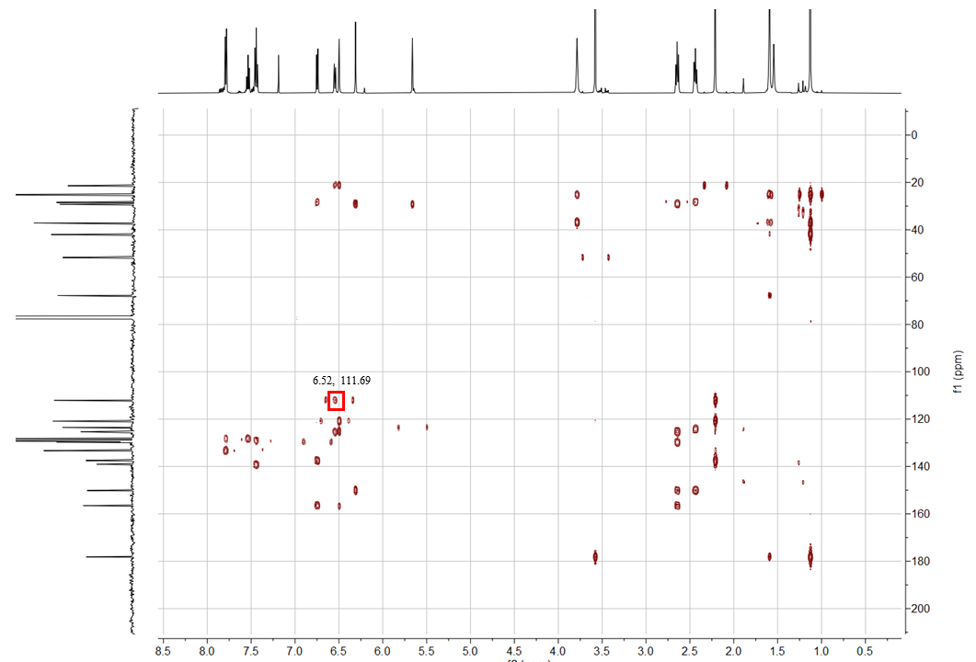
Figure S3. ¹H detected heteronuclear multiple quantum correlation (HMQC) for compound 70.
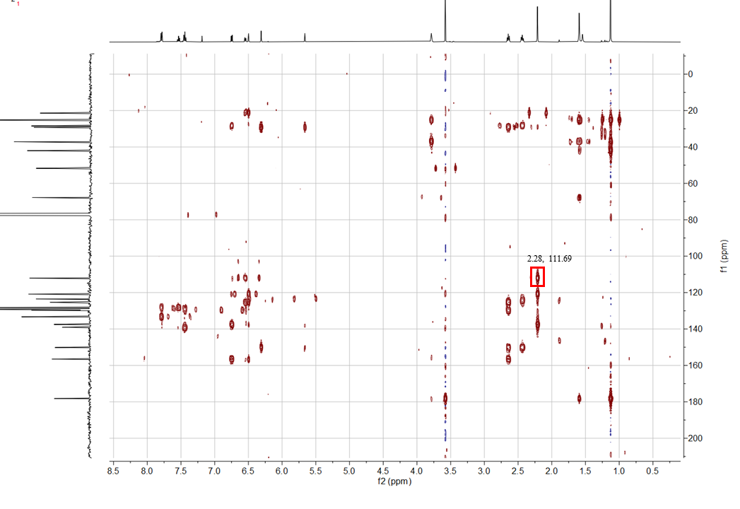
Figure S4. ¹H detected heteronuclear multiple bond correlation (HMBC) for compound 70.

4. Mechanistic Investigations
4.1 Spectroscopic Studies
4.1.1 Time-Course Emission Spectra of the Reaction Mixture
Figure S5. Time-course emission spectra of a reaction mixture of 2-ethylnaphthalene+1a→27.
Preparation of the samples for emission spectra measurement.
A dried Schlenk tube (10 mL) was charged with 2-ethylnaphthalene (624.8 mg, 4.0 mmol), ethyl 2-(bromomethyl)acrylate (1a, 154.4 mg, 0.80 mmol), sodium fluoride (67.2 mg, 0.40 mmol) and dichloromethane (4.0 mL). The mixture was degassed via three freeze-pump-thaw cycles. The Schlenk tube was positioned approximately 5 cm away from a 50 W blue LEDs lamp (λ_{max} = 410 nm) with a DC fan cooling. The reaction was stirred at room temperature for the indicated time. Then 0.50 mL of reaction mixture was extracted each time and tested the emission spectrum under 410 nm excitation
Note: All samples were filtered with 200 nanometer filter membrane before measurement, then used freshly for emission spectra measurement.
4.1.2 UV/Vis-Absorption Spectra of the Reaction Components
Figure S6. UV-Vis spectra of the reaction components.
Preparation of the samples for UV-Vis spectra measurement.
2-Ethylnaphthalene in dichloromethane (1.0 M): 2-Ethylnaphthalene (157.0 mg, 1.0 mmol) was dissolved in distilled dichloromethane (1.0 mL).
Compound 1a in dichloromethane (0.20 M): Compound 1a (38.6 mg, 0.20 mmol) was dissolved in distilled dichloromethane (1.0 mL).
2-Ethylnaphthalene + 1a in dichloromethane (0.20 M): 2-Ethylnaphthalene (157.0 mg, 1.0 mmol) and 2a (38.6 mg, 0.20 mmol) were dissolved in distilled dichloromethane (1.0 mL).
2-Ethylnaphthalene + sodium fluoride in dichloromethane (0.20 M): 2-Ethylnaphthalene (157.0 mg, 1.0 mmol) and sodium fluoride (16.8 mg, 0.40 mmol) were dissolved in distilled dichloromethane (1.0 mL).
Compound 1a + sodium fluoride in dichloromethane (0.20 M): Compound 1a (38.6 mg, 0.20 mmol) and sodium fluoride (16.8 mg, 0.40 mmol) were dissolved in distilled dichloromethane (1.0 mL).
2-Ethylnaphthalene + 1a + sodium fluoride in dichloromethane (1.0 M): 2-Ethylnaphthalene (157.0 mg, 1.0 mmol), 1a (38.6 mg, 0.20 mmol) and sodium fluoride (16.8 mg, 0.40 mmol) were dissolved in distilled dichloromethane (1.0 mL).
Product 27 in dichloromethane (0.20 M): Product 27 (53.4 mg, 0.20 mmol) was dissolved in distilled dichloromethane (1.0 mL).
Product 27 + sodium fluoride in dichloromethane (0.20 M): Product 27 (53.4 mg, 0.20 mmol) and sodium fluoride (16.8 mg, 0.40 mmol) were dissolved in distilled dichloromethane (1.0 mL).
Note: All samples were stirred for 6 h, filtered with 200 nanometer filter membrane, then used directly for the measurement.

4.2 Radical Probing Experiments.
4.2.1 Evidence for the engagement of benzyl radicals and allyl radicals
A dried Schlenk tube (10 mL) was charged with ethylbenzene (106.2 mg, 1.0 mmol), ethyl 2-(bromomethyl)acrylate (1a, 38.6 mg, 0.20 mmol), 2,2,6,6-tetramethyl-1-piperidinyloxy (TEMPO) (93.7 mg, 0.60 mmol), sodium fluoride (16.8 mg, 0.40 mmol) and dichloromethane (1.0 mL). The mixture was degassed via three freeze-pump-thaw cycles. The Schlenk tube was positioned approximately 5 cm away from a 50 W blue LEDs lamp (λ_{max} = 410 nm) with a DC fan cooling. The reaction was stirred at room temperature for 72 h. The reaction mixture was detected by HRMS. For compound 72, HRMS (ESI, m/z): calcd for C₁₇H₂₈NO⁺(M+H)⁺: 262.2165, found: 262.2164. For compound 73, HRMS (ESI, m/z): calcd for C₁₅H₂₇NO₃Na⁺ (M+Na)⁺: 292.1889, found: 292.1893.
ethyl 2-(((2,2,6,6-tetramethylpiperidin-1-yl)oxy)methyl)acrylate (73)
¹H NMR (500 MHz, CDCl₃) δ 6.29 (s, 1H), 5.91 (s, 1H), 4.51 (d, J = 1.8 Hz, 2H), 4.26–4.18 (m, 2H), 1.48 (d, J = 3.9 Hz, 4H), 1.31 (m, 5H), 1.19 (s, 3H), 1.14 (s, 3H).
All other data was in agreement with the literature. ^{[13]}
A dried Schlenk tube (10 mL) was charged with tetrahydrofuran (106.2 mg, 1.0 mmol), ((3-bromoprop-1-en-2-yl)sulfonyl)benzene (1h, 52.3 mg, 0.20 mmol), sodium fluoride (16.8 mg, 0.40 mmol), 5,5-dimethyl-1-pyrroline N-oxide (DMPO) (purchased by Energy Chemical, 67.9 mg, 0.60 mmol) and dichloromethane (1.0 mL). The mixture was degassed via three freeze-pump-thaw cycles. The Schlenk tube was positioned approximately 5 cm away from a 50 W blue LEDs lamp (λ_{max} = 410 nm) with a DC fan cooling. The reaction was stirred at room temperature for 3 h. The reaction mixture was detected by HRMS. For compound S8, HRMS (ESI-TOF, m/z): calcd for C₁₄H₂₀NO⁺ (M⁺): 218.1541, found: 218.1539. For compound S9, HRMS (ESI-TOF, m/z): calcd for C₁₅H₂₀SNO₃⁺ (M⁺): 294.1160, found: 294.1158.
A dried 10 mL Schlenk tube (10 mL) was charged with ethylbenzene (106.2 mg, 1.0 mmol), ((3-bromoprop-1-en-2-yl)sulfonyl)benzene (1h, 52.3 mg, 0.20 mmol), sodium fluoride (16.8 mg, 0.40 mmol), N-Benzylidene-tert-butylamine N-Oxide (PNB) (purchased by J&K Scientific, 106.3 mg, 0.60 mmol) and dichloromethane (1.0 mL). The mixture was degassed via three freeze-pump-thaw cycles. The Schlenk tube was positioned approximately 5 cm away from a 50 W blue LEDs lamp (λ_{max} = 410 nm) with a DC fan cooling. The reaction was stirred at room temperature for 6 h. The test solution was drawn through a capillary tube, then the reaction mixture in situ was analyzed by electron paramagnetic resonance (EPR) in air.
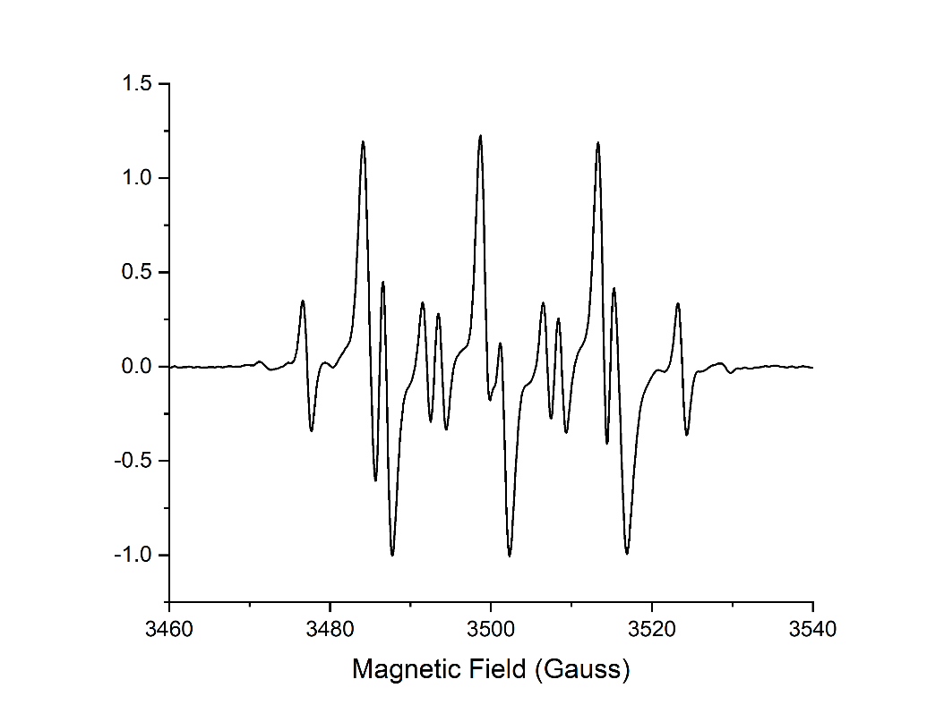
Figure S7. EPR spectra of the reaction mixture.
Results: Obvious signals of the adduct (Component-I) of a C-centered radical to PNB was observed in the EPR spectra.
4.2.2 Evidence for the engagement of bromine radicals
Figure S8. The mechanism for trapping the bromine radical.
((6-bromo-4-phenylhex-1-en-2-yl)sulfonyl)benzene (25)
A dried Schlenk tube (10 mL) (10 mL) was charged with cyclopropylbenzene (118.2 mg, 1.0 mmol), ((3-bromoprop-1-en-2-yl)sulfonyl)benzene (1h, 52.3 mg, 0.20 mmol), sodium fluoride (16.8 mg, 0.40 mmol) and dichloromethane (1.0 mL). The mixture was degassed via three freeze-pump-thaw cycles. The Schlenk tube was positioned approximately 5 cm away from a 50 W blue LEDs lamp (λ_{max} = 410 nm) with a DC fan cooling. The reaction was stirred at room temperature for 72 h. The reaction mixture was purified by flash chromatography on silica gel (eluted with PE to PE: EA=10:1, v: v) to afford the allylated product (25) as a colorless oil (23.4 mg, 0.062 mmol, 31% yield).
¹H NMR (500 MHz, CDCl₃) δ 7.85 (d, J = 7.4 Hz, 2H), 7.65 (t, J = 7.4 Hz, 1H), 7.55 (t, J = 7.7 Hz, 2H), 7.22 (m, 3H), 6.97 (d, J = 7.0 Hz, 2H), 6.29 (s, 1H), 5.48 (s, 1H), 3.21 (m, 1H), 3.06–2.91 (m, 2H), 2.63 (dd, J = 15.7, 5.9 Hz, 1H), 2.54 (dd, J = 15.7, 9.2 Hz, 1H), 2.11 (m, 1H), 2.00(m, 1H).
¹³C NMR (126 MHz, CDCl₃) δ 147.55, 141.26, 138.78, 133.60, 129.33, 128.76 128.35, 127.55, 127.07, 125.68, 42.04, 38.90, 35.93, 31.24.
IR (film): ν (cm⁻¹) 2927, 1616, 1494, 1446, 1305, 1255, 1140, 1081, 953, 857, 748, 703, 688.
HRMS (ESI-TOF, m/z) calcd for C₁₈H₁₉NaBrO₂S⁺ (M+Na)⁺: 403.0162, found: 403.0160.
A dried Schlenk tube (10 mL) was charged with ethylbenzene (1a, 106.2 mg, 1.0 mmol), ((3-chloroprop-1-en-2-yl)sulfonyl)benzene (1h', 42.3 mg, 0.20 mmol) or 2-(phenylsulfonyl)allyl trifluoromethanesulfonate (1h'', 66.0 mg, 0.20 mmol), sodium fluoride (16.8 mg, 0.40 mmol) and dichloromethane (1.0 mL). The mixture was degassed via three freeze-pump-thaw cycles. The Schlenk tube was positioned approximately 5 cm away from a 50 W blue LEDs lamp (λ_{max} = 410 nm) with a DC fan cooling. The reaction was stirred at room temperature for 72 h. The reaction mixture was concentrated under reduced pressure. The crude product was subjected to ¹H NMR analysis.
As a result, both of the two reactions failed in the product formation.
4.3 Investigation on Kinetic Isotope Effects
A dried 10 mL Schlenk tube (10 mL) was charged with ethylbenzene (106.2 mg, 1.0 mmol) and ethylbenzene-[D₁₀] (116.2 mg, 1.0 mmol), ((3-bromoprop-1-en-2-yl)sulfonyl)benzene (1h, 52.3 mg, 0.20 mmol), sodium fluoride (16.8 mg, 0.40 mmol) and dichloromethane (1.0 mL). The mixture was degassed via three freeze-pump-thaw cycles. The Schlenk tube was positioned approximately 5 cm away from a 50 W blue LEDs lamp (λ_{max} = 410 nm) with a DC fan cooling. The reaction was stirred at room temperature for 72 h. The reaction mixture was purified by flash chromatography on silica gel (eluted with PE to PE: EA=10:1, v: v) to afford the allylated product (9) and (9-[D₉]) as a colorless oil. The ratio of hydrogen to deuterium in the product is 2.1:1, so the KIE value was estimated as K_{H}/K_{D} = 2.1.
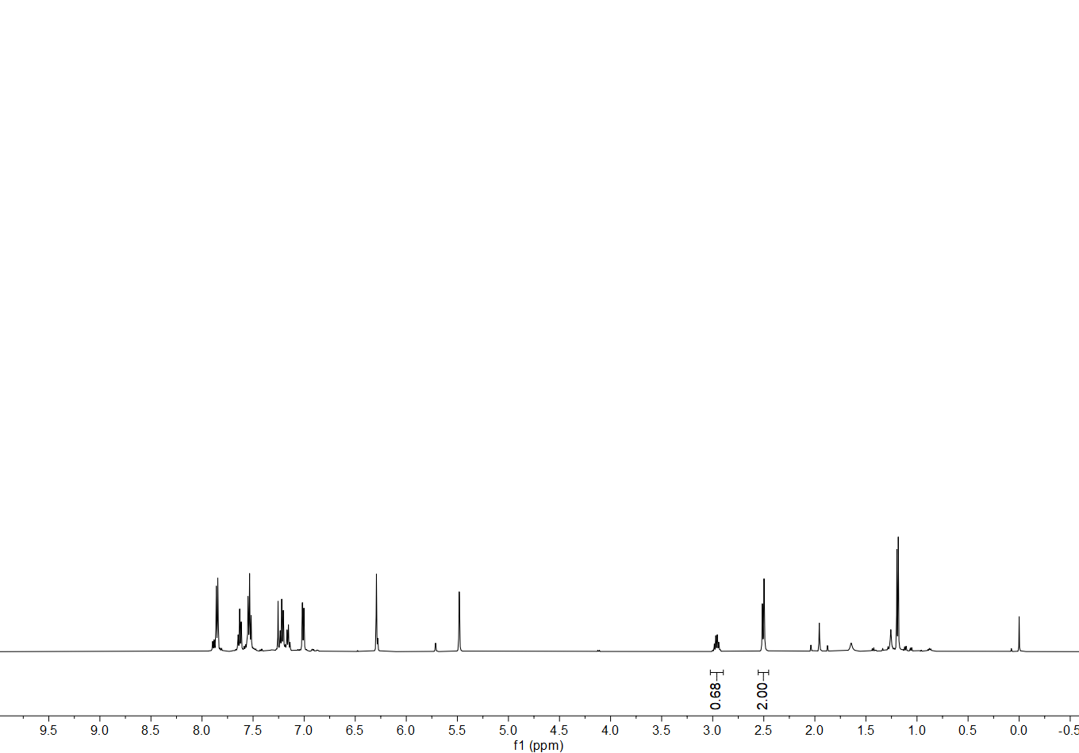
Figure S9. ¹H NMR of the mixture of 9 and 9-[D₉]
4.4 Light-off/on Experiments
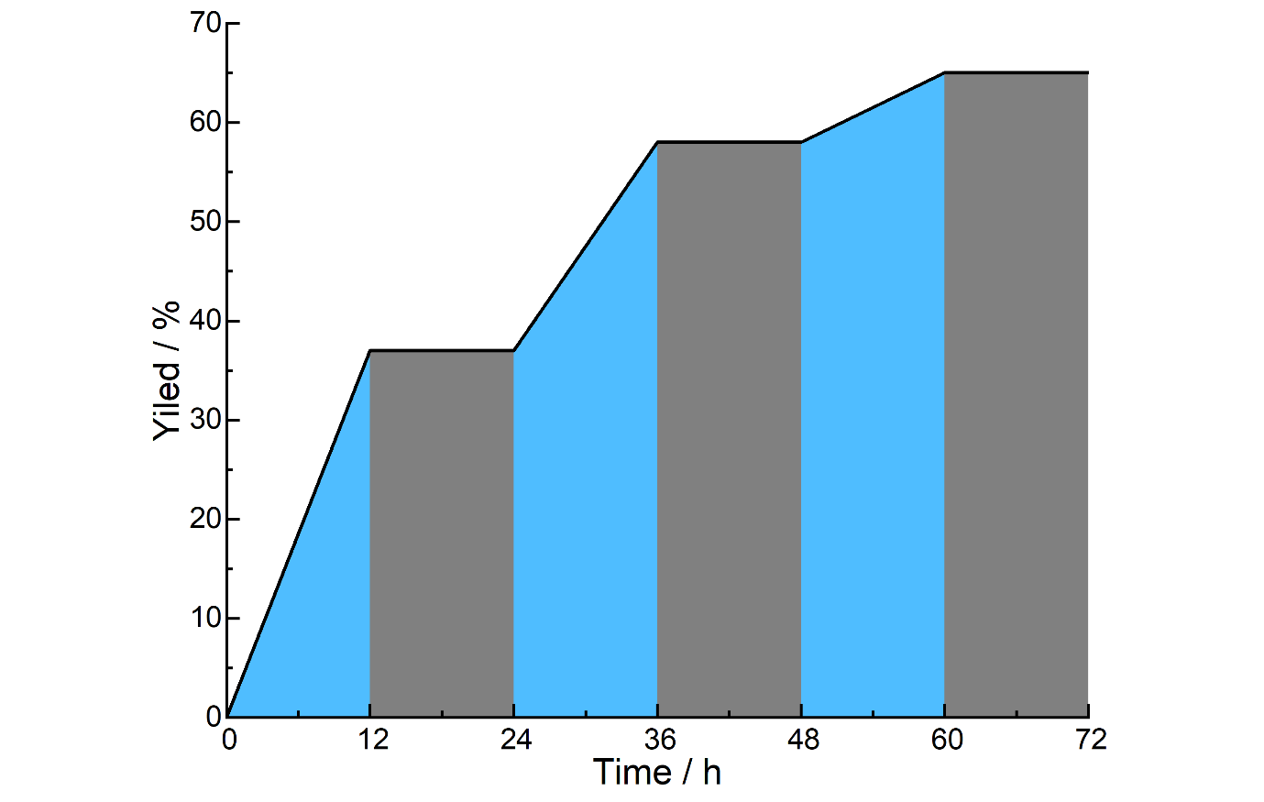
Figure S10. Light-off/on experiments of the reaction ethylbenzene+1h→9.
A dried Schlenk tube (10 mL) was charged with ethylbenzene (106.2 mg, 1.0 mmol), ((3-bromoprop-1-en-2-yl)sulfonyl)benzene (1h, 52.3 mg, 0.20 mmol), sodium fluoride (16.8 mg, 0.40 mmol) and dichloromethane (1.0 mL). The mixture was degassed via three freeze-pump-thaw cycles. The Schlenk tube was positioned approximately 5 cm away from a 50 W blue LEDs lamp (λ_{max} = 410 nm) with a DC fan cooling. The reaction was stirred at room temperature for the indicated time. A solution (0.1 mL) was taken from the reaction mixture, and the yield was analyzed by crude ¹H NMR analysis using 1,3,5-trimethoxybenzene as an internal standard.

Results: The light-dark interval reaction of ethylbenzene+1h→9 revealed that the continuous light irradiation was essential for the transformation, and radical chain propagation might not be the predominant mechanism.

5. Stoichiometric C(sp³)-H Heteroarylation and Alkylation Reactions
5.1 Direct C(sp³)-H Heteroarylation
ethyl 2-(1-phenylethyl)isonicotinate (75)
A dried Schlenk tube (10 mL) was charged with ethylbenzene (21.2 mg, 0.20 mmol), ethyl isonicotinate (74, 151.2 mg, 1.0 mmol), ethyl 2-(bromomethyl)acrylate (1a, 38.6 mg, 0.20 mmol), sodium fluoride (16.8 mg, 0.40 mmol) and dry dichloromethane (1.0 mL). The mixture was degassed via three freeze-pump-thaw cycles. The Schlenk tube was positioned approximately 5 cm away from a 50 W blue LEDs lamp (λ_{max} = 410 nm) with a DC fan cooling. The reaction was stirred at room temperature for 72 h. The reaction mixture was concentrated in vacuum, then purified by flash chromatography on silica gel (PE: EA = 10:1) to afford the product (75) as a yellow oil (38.8 mg, 0.148 mmol, 74% yield).
¹H NMR (500 MHz, CDCl₃) δ 8.73 (d, J = 5.1 Hz, 1H), 7.75 (s, 1H), 7.68 (dd, J = 5.1, 1.6 Hz, 1H), 7.36–7.28 (m, 4H), 7.22 (m, 1H), 4.40 (m, 3H), 1.76 (d, J = 7.2 Hz, 3H), 1.40 (t, J = 7.1 Hz, 3H).
¹³C NMR (126 MHz, CDCl₃) δ 166.06, 165.32, 149.84, 144.56, 138.27, 128.58, 127.66, 126.52, 121.45, 120.49, 61.73, 47.38, 20.72, 14.20.
IR (film): ν (cm⁻¹) 2921, 2850, 1732, 1447, 1304, 1142, 745, 664.
HRMS (ESI-TOF, m/z) calcd for C₁₆H₁₈NO₂⁺ (M+H)⁺: 256.1332, found: 256.1337.

5.2 Direct C(sp³)-H Alkylation
ethyl 3-benzyl-2,3-dihydrobenzo[d]isothiazole-3-carboxylate 1,1-dioxide (77)
A dried Schlenk tube (10 mL) was charged with toluene (55.3 mg, 0.60 mmol), ethyl benzo[d]isothiazole-3-carboxylate 1,1-dioxide (76, 47.8 mg, 0.20 mmol), tris(trimethylsilyl)silanol (52.8 mg, 0.20 mmol), ethyl 2-(bromomethyl)acrylate (1a, 115.8 mg, 0.60 mmol), sodium fluoride (16.8 mg, 0.40 mmol) and dry dichloromethane (1.0 mL). The mixture was degassed via three freeze-pump-thaw cycles. The Schlenk tube was positioned approximately 5 cm away from a 50 W blue LEDs lamp (λ_{max} = 410 nm) with a DC fan cooling. The reaction was stirred at room temperature for 72 h. The reaction mixture was concentrated, then purified by flash chromatography on silica gel (PE: EA = 2:1) to afford the product (77) as a white solid (41.6 mg, 0.126 mmol, 68% yield).
¹H NMR (500 MHz, CDCl₃) δ 7.83 (d, J = 7.9 Hz, 1H), 7.73 (d, J = 7.8 Hz, 1H), 7.68–7.58 (m, 1H), 7.59–7.50 (m, 1H), 7.27–7.19 (m, 5H), 5.50 (s, 1H), 4.17 (qq, J = 10.9, 7.2 Hz, 1H), 3.50 (d, J = 13.6 Hz, 1H), 3.13 (d, J = 13.6 Hz, 1H), 1.22 (d, J = 6.8 Hz, 3H).
¹³C NMR (126 MHz, CDCl₃) δ 169.05, 138.21, 134.43, 133.47, 130.56, 130.44, 128.38, 127.69, 125.08, 121.57, 69.67, 63.47, 46.25, 14.05.
All other data was in agreement with the literature. ^{[14]}

6. Catalytic C(sp³)-H Hydrazination
6.1 Optimization of Reaction Conditions
General Procedure
A dried Schlenk tube (10 mL) was charged with ethylbenzene (106.2 mg, 1.0 mmol), ethyl 2-(bromomethyl)acrylate (1a, 7.74 mg, 0.040 mmol), diethyl azodicarboxylate (78, 34.8 mg, 0.20 mmol), salt (0.40 mmol) and the indicated solvent (1.0 mL). The mixture was degassed via three freeze-pump-thaw cycles. The Schlenk tube was positioned approximately 3 cm away from a 50 W blue LEDs lamp (λ_{max} = 410 nm) with a DC fan cooling. The reaction was stirred at room temperature for 72 h. The reaction mixture was concentrated, then purified by flash chromatography on silica gel (PE: EA = 4:1) to afford the product (80) as a colorless oil.
Table S2. Optimization of reaction conditions for the catalytic C(sp³)-H hydrazination reaction.
entry |  | salt | solvent | t (h) | yield (%) ª
1 |  | NaCl | CH₂Cl₂ | 72 | 64
2 |  | NaBr | CH₂Cl₂ | 72 | 59
3 |  | Na₂SO₄ | CH₂Cl₂ | 72 | 56
4 |  | LiF | CH₂Cl₂ | 72 | 58
5 |  | KF | CH₂Cl₂ | 72 | trace
6 |  | CsF | CH₂Cl₂ | 72 | <20
7 |  | CaF₂ | CH₂Cl₂ | 72 | 63
8 |  | NaF | (CH₃)₂SO | 72 | <10%
9 |  | NaF | MeCN | 72 | trace
10 |  | NaF | (CH₂Cl)₂ | 72 | 55
11 |  | NaF | CH₂Cl₂ | 72 | 75
 | Reaction conditions: ethylbenzene (1.0 mmol), 78 (0.20 mmol), 1a (0.040 mol), salt (0.40 mmol), the indicated solvent (1.0 mL), under irradiation with a blue LEDs lamp (50 W, λ_{max} = 410 nm), at 28 °C, under argon. ª Isolated yield.
6.2 Substrate Scope of C(sp³)-H Hydrazination
diethyl 1-(1-phenylethyl)hydrazine-1,2-dicarboxylate (80)
A dried Schlenk tube (10 mL) was charged with ethylbenzene (106.2 mg, 1.0 mmol), ethyl 2-(bromomethyl)acrylate (1a, 7.74 mg, 0.040 mmol), diethyl azodicarboxylate (78, 34.8 mg, 0.20 mmol), sodium fluoride (16.8 mg, 0.40 mmol) and dichloromethane (1.0 mL). The mixture was degassed via three freeze-pump-thaw cycles. The Schlenk tube was positioned approximately 3 cm away from a 50 W blue LEDs lamp (λ_{max} = 410 nm) with a DC fan cooling. The reaction was stirred at room temperature for 72 h. The reaction mixture was concentrated, then purified by flash chromatography on silica gel (PE: EA = 4:1) to afford the product (80) as a colorless oil (42.0 mg, 0.150 mmol, 75% yield).
¹H NMR (500 MHz, CDCl₃) δ 7.46–7.13 (m, 5 H), 6.14–5.85 (br, 1H), 5.50 (br, 1H), 4.18 (br, 4H), 1.56 (d, J = 7.7 Hz, 3H), 1.26 (t, J = 7.8 Hz, 6H).
¹³C NMR (151 MHz, CDCl₃) δ 156.70, 155.88, 140.60, 128.53, 127.70, 127.20, 62.55, 61.99, 56.03, 16.56, 14.51, 14.43.
IR (film): ν (cm⁻¹) 3293, 3031, 2982, 2936, 1709, 1518, 1495, 1454, 1412, 1383, 1311, 1227, 1173, 1135, 1097, 1058, 1029, 913, 848, 760, 700, 582.
HRMS (ESI-TOF, m/z) calcd for C₁₄H₂₁N₂O₄⁺ (M+H)⁺: 281.1496, found: 281.1496.
diethyl 1-(1-(4-fluorophenyl)ethyl)hydrazine-1,2-dicarboxylate (81)
A dried Schlenk tube (10 mL) was charged with 1-ethyl-4-fluorobenzene (124.2 mg, 1.0 mmol), ethyl 2-(bromomethyl)acrylate (1a, 7.74 mg, 0.040 mmol), diethyl azodicarboxylate (78, 34.8 mg, 0.20 mmol), sodium fluoride (16.8 mg, 0.40 mmol) and dichloromethane (1.0 mL). The mixture was degassed via three freeze-pump-thaw cycles. The Schlenk tube was positioned approximately 3 cm away from a 50 W blue LEDs lamp (λ_{max} = 410 nm) with a DC fan cooling. The reaction was stirred at room temperature for 72 h. The reaction mixture was concentrated, then purified by flash chromatography on silica gel (PE: EA = 4:1) to afford the product (81) as a colorless oil (35.2 mg, 0.119 mmol, 59% yield).
¹H NMR (500 MHz, CDCl₃) δ 7.32 (t, J = 6.8 Hz, 2H), 7.01 (t, J = 8.6 Hz, 2H), 6.01 (br, 1H), 5.51 (br, 1H), 4.27–4.08 (m, 4H), 1.54 (d, J = 7.1 Hz, 3H), 1.26 (t, J = 7.1 Hz, 6H).
¹³C NMR (151 MHz, CDCl₃) δ 162.24 (d, J = 245.9 Hz), 156.67, 155.77, 136.41, 128.95, 115.26 (d, J = 22.0 Hz), 62.60, 62.05, 55.46, 16.82, 14.49, 14.41.
IR (film): ν (cm⁻¹) 3292, 2983, 2937, 1709, 1604, 1510, 1467, 1413, 1383, 1312, 1225, 1161, 1135, 1105, 1061, 1015, 840, 761.
HRMS (ESI-TOF, m/z) calcd for C₁₄H₁₉FNaN₂O₄⁺ (M+Na)⁺: 321.1221, found: 321.1224.
diethyl 1-(1-(4-chlorophenyl)ethyl)hydrazine-1,2-dicarboxylate (82)
A dried Schlenk tube (10 mL) was charged with 1-chloro-4-ethylbenzene (140.6 mg, 1.0 mmol), ethyl 2-(bromomethyl)acrylate (1a, 7.74 mg, 0.040 mmol), diethyl azodicarboxylate (78, 34.8 mg, 0.20 mmol), sodium fluoride (16.8 mg, 0.40 mmol) and dichloromethane (1.0 mL). The mixture was degassed via three freeze-pump-thaw cycles. The Schlenk tube was positioned approximately 3 cm away from a 50 W blue LEDs lamp (λ_{max} = 410 nm) with a DC fan cooling. The reaction was stirred at room temperature for 72 h. The reaction mixture was concentrated, then purified by flash chromatography on silica gel (PE: EA = 4:1) to afford the product (82) as a colorless oil (36.9 mg, 0.117 mmol, 58% yield).
¹H NMR (500 MHz, CDCl₃) δ 7.65 (d, J = 8.1 Hz, 2H), 7.27−7.09 (br, 2H), 6.15 (br, 1H), 5.42 (br, 1H), 4.18 (m, 4H), 1.52 (d, J = 7.3 Hz, 3H), 1.25 (t, J = 7.2 Hz, 6H).
¹³C NMR (151 MHz, CDCl₃) δ 156.64, 155.72, 140.37, 137.57, 136.98, 136.82, 130.08, 129.23, 93.28, 62.67, 62.11, 16.61, 14.50, 14.43, 14.18.
IR (film): ν (cm⁻¹) 3293, 2981, 2934, 1709, 1587, 1485, 1405, 1381, 1309, 1227, 1172, 1137, 1094, 1062, 1006, 827, 760, 730.
HRMS (ESI-TOF, m/z) calcd C₁₄H₁₉ClNaN₂O₄⁺ (M+Na)⁺: 337.0926, found: 337.0959.
diethyl 1-(1-([1,1'-biphenyl]-4-yl)ethyl)hydrazine-1,2-dicarboxylate (83)
A dried Schlenk tube (10 mL) was charged with 4-ethyl-1,1'-biphenyl (182.2 mg, 1.0 mmol), ethyl 2-(bromomethyl)acrylate (1a, 7.74 mg, 0.040 mmol), diethyl azodicarboxylate (78, 34.8 mg, 0.20 mmol), sodium fluoride (16.8 mg, 0.40 mmol) and dichloromethane (1.0 mL). The mixture was degassed via three freeze-pump-thaw cycles. The Schlenk tube was positioned approximately 3 cm away from a 50 W blue LEDs lamp (λ_{max} = 410 nm) with a DC fan cooling. The reaction was stirred at room temperature for 72 h. The reaction mixture was concentrated, then purified by flash chromatography on silica gel (PE: EA = 4:1) to afford the product (83) as a white soild (53.5 mg, 0.150 mmol, 75% yield).
¹H NMR (500 MHz, CDCl₃) δ 7.56 (t, J = 7.4 Hz, 4H), 7.42 (q, J = 7.4 Hz, 4H), 7.34 (t, J = 7.4 Hz, 1H), 6.27 (br, 1H), 5.54 (br, 1H), 4.19 (br, 4H), 1.60 (d, J = 7.6 Hz, 3H), 1.26 (t, J = 7.6 Hz, 6H).
¹³C NMR (151 MHz, CDCl₃) δ 156.73, 155.90, 140.68, 140.60, 139.67, 139.23, 128.82, 127.66, 127.39, 127.24, 127.08, 62.60, 62.02, 16.73, 14.54, 14.46.
IR (film): ν (cm⁻¹) 3290, 3029, 2982, 2935, 1709, 1601, 1466, 1487, 1410, 1382, 1311, 1227, 1172, 1116, 1094, 1060, 1023, 1008, 912, 843, 741, 698.
HRMS (ESI-TOF, m/z) calcd for C₂₀H₂₄NaN₂O₄⁺ (M+Na)⁺: 379.1628, found: 379.1627.
diethyl 1-(1-(4-acetoxyphenyl)ethyl)hydrazine-1,2-dicarboxylate (84)
A dried Schlenk tube (10 mL) was charged with 4-ethylphenyl acetate (164.2 mg, 1.0 mmol), ethyl 2-(bromomethyl)acrylate (1a, 7.74 mg, 0.040 mmol), diethyl azodicarboxylate (78, 34.8 mg, 0.20 mmol), sodium fluoride (16.8 mg, 0.40 mmol) and dichloromethane (1.0 mL). The mixture was degassed via three freeze-pump-thaw cycles. The Schlenk tube was positioned approximately 3 cm away from a 50 W blue LEDs lamp (λ_{max} = 410 nm) with a DC fan cooling. The reaction was stirred at room temperature for 72 h. The reaction mixture was concentrated, then purified by flash chromatography on silica gel (PE: EA = 3:1) to afford the product (84) as a colorless oil (54.1 mg, 0.160 mmol, 80% yield).
¹H NMR (500 MHz, (CD₃)₂CO) δ 8.03 (m, 1H), 7.27 (m, 2H), 6.91 (d, J = 8.2 Hz, 2H), 5.29 (br, 1H), 3.96 (m, 4H), 2.11 (s, 3H), 1.38 (d, J = 7.1 Hz, 3H), 1.15–0.98 (m, 6H).
¹³C NMR (151 MHz, CDCl₃) δ 169.54, 156.70, 155.77, 150.07, 138.17, 128.40, 121.57, 62.60, 62.04, 21.13, 16.65, 14.50, 14.42.
IR (film): ν (cm⁻¹) 3296, 2983, 2936, 1752, 1709, 1606, 1508, 1466, 1412, 1374, 1310, 1220, 1168, 1136, 1094, 1060, 1017, 912, 852, 761.
HRMS (ESI-TOF, m/z) calcd for C₁₆H₂₂NaN₂O₆⁺ (M+Na)⁺: 361.1370, found: 361.1372.
diethyl 1-(1-(4-acetoxyphenyl)ethyl)hydrazine-1,2-dicarboxylate (85)
A dried Schlenk tube (10 mL) was charged with 1-ethyl-3,5-difluorobenzene (142.1 mg, 1.0 mmol), ethyl 2-(bromomethyl)acrylate (1a, 7.74 mg, 0.040 mmol), diethyl azodicarboxylate (78, 34.8 mg, 0.20 mmol), sodium fluoride (16.8 mg, 0.40 mmol) and dichloromethane (1.0 mL). The mixture was degassed via three freeze-pump-thaw cycles. The Schlenk tube was positioned approximately 3 cm away from a 50 W blue LEDs lamp (λ_{max} = 410 nm) with a DC fan cooling. The reaction was stirred at room temperature for 72 h. The reaction mixture was concentrated, then purified by flash chromatography on silica gel (PE: EA = 3:1) to afford the product (85) as a colorless oil (30.9 mg, 0.098 mmol, 49% yield).
¹H NMR (600 MHz, CDCl₃) δ 7.06–6.78 (m, 2H), 6.73 (tt, J = 8.8, 2.4 Hz, 1H), 6.21 (br, 1H), 5.43 (s, 1H), 4.35–3.95 (m, 4H), 1.54 (d, J = 7.1 Hz, 3H), 1.27 (t, J = 7.0 Hz, 6H).
¹³C NMR (151 MHz, CDCl₃) δ 163.85 (d, J = 13.0 Hz), 162.20 (d, J = 12.4 Hz), 156.72, 155.65, 144.96, 110.10 (d, J = 21.4 Hz), 103.03 (t, J = 25.2 Hz), 62.81, 62.20, 55.36, 16.58, 14.44, 14.39.
IR (film): ν (cm⁻¹) 3293, 2985, 2939, 1712, 1625, 1597, 1513, 1465, 1412, 1381, 1314, 1231, 1173, 1118, 1097, 1068, 1021, 979, 927, 860, 762, 681.
HRMS (ESI-TOF, m/z) calcd for C₁₄H₁₈F₂NaN₂O₄⁺ (M+Na)⁺: 339.1127, found: 339.1130.
diethyl 1-(2,3-dihydro-1H-inden-1-yl)hydrazine-1,2-dicarboxylate (86)
A dried Schlenk tube (10 mL) was charged with 2,3-dihydro-1H-indene (118.2 mg, 1.0 mmol), ethyl 2-(bromomethyl)acrylate (1a, 7.74 mg, 0.040 mmol), diethyl azodicarboxylate (78, 34.8 mg, 0.20 mmol), sodium fluoride (16.8 mg, 0.40 mmol) and dichloromethane (1.0 mL). The mixture was degassed via three freeze-pump-thaw cycles. The Schlenk tube was positioned approximately 3 cm away from a 50 W blue LEDs lamp (λ_{max} = 410 nm) with a DC fan cooling. The reaction was stirred at room temperature for 72 h. The reaction mixture was concentrated, then purified by flash chromatography on silica gel (PE: EA = 4:1) to afford the product (86) as a colorless oil (32.7 mg, 0.112 mmol, 56% yield).
¹H NMR (500 MHz, CDCl₃) δ 7.26–7.17 (m, 4H), 6.25 (br, 1H), 5.82 (m, 1H), 4.46–4.11 (m, 4H), 2.98 (br, 1H), 2.82 (dt, J = 15.8, 7.9 Hz, 1H), 2.43–2.38 (m, 1H), 2.21–2.16 (m, 1H), 1.34–0.88 (m, 6H).
¹³C NMR (151 MHz, CDCl₃) δ 156.72, 156.21, 145.09, 144.04, 143.30, 140.53, 128.26, 128.12, 126.67, 126.58, 124.99, 124.87, 124.21, 124.04, 63.88, 62.64, 61.95, 30.41, 29.79, 28.96, 14.53, 14.39, 14.20, 14.14.
IR (film): ν (cm⁻¹) 3292, 2981, 2852, 2251, 1709, 1606, 1518, 1480, 1460, 1412, 1383, 1229, 1152, 1124, 1095, 1062, 1022, 920, 874, 828, 760, 647, 592.
HRMS (ESI-TOF, m/z) calcd for C₁₅H₂₀NaN₂O₄⁺ (M+Na)⁺: 315.1321, found: 315.1306.
diethyl 1-(1,3-dihydroisobenzofuran-1-yl)hydrazine-1,2-dicarboxylate (87)
A dried Schlenk tube (10 mL) was charged with 1,3-dihydroisobenzofuran (120.2 mg, 1.0 mmol), ethyl 2-(bromomethyl)acrylate (1a, 7.74 mg, 0.040 mmol), diethyl azodicarboxylate (78, 34.8 mg, 0.20 mmol), sodium fluoride (16.8 mg, 0.40 mmol) and dichloromethane (1.0 mL). The mixture was degassed via three freeze-pump-thaw cycles. The Schlenk tube was positioned approximately 3 cm away from a 50 W blue LEDs lamp (λ_{max} = 410 nm) with a DC fan cooling. The reaction was stirred at room temperature for 72 h. The reaction mixture was concentrated, then purified by flash chromatography on silica gel (PE: EA = 2:1) to afford the product (87) as a colorless oil (50.1 mg, 0.170 mmol, 85% yield).
¹H NMR (500 MHz, CDCl₃) δ 7.55–7.28 (m, 3H), 7.26–7.02 (m, 2H), 6.66–6.18 (br, 1H), 5.33–5.13 (m, 1H), 5.03 (d, J = 12.2 Hz, 1H), 4.40–3.82 (m, 4H), 1.37–0.96 (m, 6H).
¹³C NMR (151 MHz, CDCl₃) δ 156.70, 155.66, 139.90, 129.06, 129.04, 127.50, 127.11, 125.80, 123.72, 120.67, 92.40, 73.02, 69.63, 63.03, 62.21, 61.83, 14.38, 14.28.
IR (film): ν (cm⁻¹) 3298, 2981, 1719, 1465, 1407, 1232, 1098, 1062, 1028, 924, 742.
HRMS (ESI-TOF, m/z) calcd for C₁₄H₁₈NaN₂O₅⁺ (M+Na)⁺: 317.1108, found: 317.1111.
diethyl 1-(2,3-dihydrobenzofuran-3-yl)hydrazine-1,2-dicarboxylate (88)
A dried Schlenk tube (10 mL) was charged with 2,3-dihydrobenzofuran (120.2 mg, 1.0 mmol), ethyl 2-(bromomethyl)acrylate (1a, 7.74 mg, 0.040 mmol), diethyl azodicarboxylate (78, 34.8 mg, 0.20 mmol), sodium fluoride (16.8 mg, 0.40 mmol) and dichloromethane (1.0 mL). The mixture was degassed via three freeze-pump-thaw cycles. The Schlenk tube was positioned approximately 3 cm away from a 50 W blue LEDs lamp (λ_{max} = 410 nm) with a DC fan cooling. The reaction was stirred at room temperature for 72 h. The reaction mixture was concentrated, then purified by flash chromatography on silica gel (PE: EA = 4:1) to afford the product (88) as a colorless oil (55.9 mg, 0.190 mmol, 95% yield).
¹H NMR (500 MHz, CDCl₃) δ 7.26–7.16 (m, 2H), 6.90 (t, J = 7.4 Hz, 1H), 6.84 (d, J = 8.1 Hz, 1H), 6.39–5.69 (br, 2H), 4.85–4.60 (br, 1H), 4.58 (dd, J = 10.4, 8.6 Hz, 1H), 4.37–4.00 (m, 4H), 1.35–1.11 (m, 6H).
¹³C NMR (151 MHz, CDCl₃) δ 161.01, 156.57, 155.56, 150.64, 130.49, 128.03, 127.05, 125.73–124.25 (m), 123.61, 120.82, 111.90, 110.37, 108.88, 73.73, 64.28, 62.92, 62.49, 62.24, 60.78, 14.47, 14.34, 14.19, 14.14.
IR (film): ν (cm⁻¹) 3297, 2982, 1718, 1611, 1514, 1466, 1378, 1408, 1301, 1248, 1178, 1127, 1028, 835, 762.
HRMS (ESI-TOF, m/z) calcd for C₁₄H₁₈NaN₂O₅⁺ (M+Na)⁺: 317.1108, found: 317.1109.
diethyl 1-(chroman-4-yl)hydrazine-1,2-dicarboxylate (89)
A dried Schlenk tube (10 mL) was charged with chromane (134.3 mg, 1.0 mmol), ethyl 2-(bromomethyl)acrylate (1a, 7.74 mg, 0.040 mmol), diethyl azodicarboxylate (78, 34.8 mg, 0.20 mmol), sodium fluoride (16.8 mg, 0.40 mmol) and dichloromethane (1.0 mL). The mixture was degassed via three freeze-pump-thaw cycles. The Schlenk tube was positioned approximately 3 cm away from a 50 W blue LEDs lamp (λ_{max} = 410 nm) with a DC fan cooling. The reaction was stirred at room temperature for 72 h. The reaction mixture was concentrated, then purified by flash chromatography on silica gel (PE: EA = 4:1) to afford the product (89) as a colorless oil (54.8 mg, 0.178 mmol, 89% yield).
¹H NMR (500 MHz, CDCl₃) δ 7.21–7.13 (m, 1H), 7.06 (s, 1H), 6.89 (t, J = 7.5 Hz, 1H), 6.83 (d, J = 8.2 Hz, 1H), 6.20 (br, 1H), 5.54 (br, 1H), 4.46–3.89 (m, 6H), 2.25 (s, 2H), 1.27 (m, 6H).
¹³C NMR (151 MHz, CDCl₃) δ 156.30, 129.08, 127.47, 120.77, 120.49, 117.45, 64.68, 62.89, 62.14, 53.03, 51.89, 26.59, 14.51, 14.39.
IR (film): ν (cm⁻¹) 3294, 2980, 2933, 1711, 1608, 1583, 1489, 1454, 11411, 1380, 1314, 1297, 1253, 1224, 1172, 1134, 1096, 1063, 1023, 943, 913, 861, 817, 757.
HRMS (ESI-TOF, m/z) calcd for C₁₅H₂₀NaN₂O₅⁺ (M+Na)⁺: 331.1264, found: 331.1268.
diethyl 1-(benzo[d][1,3]dioxol-2-yl)hydrazine-1,2-dicarboxylate (90)
A dried Schlenk tube (10 mL) was charged with benzo[d][1,3]dioxole (122.2 mg, 1.0 mmol), ethyl 2-(bromomethyl)acrylate (1a, 7.74 mg, 0.040 mmol), diethyl azodicarboxylate (78, 34.8 mg, 0.20 mmol), sodium fluoride (16.8 mg, 0.40 mmol) and dichloromethane (1.0 mL). The mixture was degassed via three freeze-pump-thaw cycles. The Schlenk tube was positioned approximately 3 cm away from a 50 W blue LEDs lamp (λ_{max} = 410 nm) with a DC fan cooling. The reaction was stirred at room temperature for 72 h. The reaction mixture was concentrated, then purified by flash chromatography on silica gel (PE: EA = 3:1) to afford the product (90) as a colorless oil (58.0 mg, 0.196 mmol, 98% yield).
¹H NMR (600 MHz, CDCl₃) δ 7.73 (s, 1H), 6.86 (s, 4H), 6.47–6.06 (br, 1H), 4.36–4.10 (m, 4H), 1.37–1.12 (m, 6H).
¹³C NMR (151 MHz, CDCl₃) δ 155.60, 153.39, 146.26, 121.75, 108.04, 63.58, 62.38, 14.32, 14.28.
IR (film): ν (cm⁻¹) 3307, 2983, 2935, 1732, 1633, 1604, 1487, 1445, 1412, 1376, 1360, 1342, 1297, 1227, 1175, 1095, 1050, 1004, 938, 864, 819, 782, 740.
HRMS (ESI-TOF, m/z) calcd for C₁₃H₁₆NaN₂O₆⁺ (M+Na)⁺: 319.0901, found: 319.0906.
diethyl 1-(1-phenylpropyl)hydrazine-1,2-dicarboxylate (91)
A dried Schlenk tube (10 mL) was charged with n-propylbenzene (120.9 mg, 1.0 mmol), ethyl 2-(bromomethyl)acrylate (1a, 7.74 mg, 0.040 mmol), diethyl azodicarboxylate (78, 34.8 mg, 0.20 mmol), sodium fluoride (16.8 mg, 0.40 mmol) and dichloromethane (1.0 mL). The mixture was degassed via three freeze-pump-thaw cycles. The Schlenk tube was positioned approximately 3 cm away from a 50 W blue LEDs lamp (λ_{max} = 410 nm) with a DC fan cooling. The reaction was stirred at room temperature for 72 h. The reaction mixture was concentrated, then purified by flash chromatography on silica gel (PE: EA = 4:1) to afford the product (91) as a colorless oil (49.5 mg, 0.168 mmol, 84% yield).
¹H NMR (500 MHz, CDCl₃) δ 7.45–7.16 (m, 5H), 6.35–5.57 (br, 1H), 5.18 (br, 1H), 4.40–3.77 (br, 4H), 2.16–1.94 (m, 1H), 1.91 (m, 1H), 1.42–1.15 (m, 6H), 0.98 (t, J = 7.4 Hz, 3H).
¹³C NMR (151 MHz, CDCl₃) δ 156.64, 156.19, 139.12, 138.71, 128.51, 128.06, 127.85, 62.54, 61.93, 23.68, 14.52, 14.44, 11.15.
IR (film): ν (cm⁻¹) 3289, 2978, 2934, 1708, 1494, 1466, 1411, 1381, 1301, 1221, 1172, 1138, 1104, 1062, 939, 878, 760, 699.
HRMS (ESI-TOF, m/z) calcd for C₁₅H₂₂NaN₂O₄⁺ (M+Na)⁺: 317.1472, found: 317.1473.

diethyl 1-(2-methyl-1-phenylpropyl)hydrazine-1,2-dicarboxylate (92)
A dried Schlenk tube (10 mL) was charged with ibutylbenzene (134.2 mg, 1.0 mmol), ethyl 2-(bromomethyl)acrylate (1a, 7.74 mg, 0.040 mmol), diethyl azodicarboxylate (78, 34.8 mg, 0.20 mmol), sodium fluoride (16.8 mg, 0.40 mmol) and dichloromethane (1.0 mL). The mixture was degassed via three freeze-pump-thaw cycles. The Schlenk tube was positioned approximately 3 cm away from a 50 W blue LEDs lamp (λ_{max} = 410 nm) with a DC fan cooling. The reaction was stirred at room temperature for 72 h. The reaction mixture was concentrated, then purified by flash chromatography on silica gel (PE: EA = 4:1) to afford the product (92) as a colorless oil (47.5 mg, 0.154 mmol, 77% yield).
¹H NMR (500 MHz, CDCl₃) δ 7.46–7.16 (m, 5H), 6.67–5.56 (br, 1H), 5.04–4.52 (m, 1H), 4.37–3.21 (m, 4H), 2.54–2.13 (br, 1H), 1.35–0.65 (br, 12H).
¹³C NMR (151 MHz, CDCl₃) δ 156.36, 138.04, 128.88, 128.43, 128.11, 127.83, 127.58, 62.52, 61.79, 28.32, 28.08, 20.48, 20.17, 19.93, 14.46, 13.65.
IR (film): ν (cm⁻¹) 3287, 3062, 3031, 2978, 2873, 2252, 1709, 1603, 1585, 1493, 1468, 1411, 1381, 1333, 1286, 1220, 1172, 1140, 1108, 1062, 1018, 956, 912, 862, 831, 758, 719, 669, 648, 620.
HRMS (ESI-TOF, m/z) calcd for C₁₆H₂₄NaN₂O₄⁺ (M+Na)⁺: 331.1628, found: 331.1645.
diethyl 1-(3-bromo-1-phenylpropyl)hydrazine-1,2-dicarboxylate (93)
A dried Schlenk tube (10 mL) was charged with (3-bromopropyl)benzene (199.1 mg, 1.0 mmol), ethyl 2-(bromomethyl)acrylate (1a, 7.74 mg, 0.040 mmol), diethyl azodicarboxylate (78, 34.8 mg, 0.20 mmol), sodium fluoride (16.8 mg, 0.40 mmol) and dichloromethane (1.0 mL). The mixture was degassed via three freeze-pump-thaw cycles. The Schlenk tube was positioned approximately 3 cm away from a 50 W blue LEDs lamp (λ_{max} = 410 nm) with a DC fan cooling. The reaction was stirred at room temperature for 72 h. The reaction mixture was concentrated, then purified by flash chromatography on silica gel (PE: EA = 4:1) to afford the product (93) as a colorless oil (41.1 mg, 0.110 mmol, 55% yield).
¹H NMR (500 MHz, CDCl₃) δ 7.37–7.27 (m, 5H), 5.86 (br, 1H), 5.55 (br, 1H), 4.44–3.92 (m, 4H), 3.88–3.34 (m, 2H), 2.64 (br, 1H), 2.32 (br, 1H), 1.45–1.03 (m, 6H).
¹³C NMR (151 MHz, CDCl₃) δ 156.84, 156.10, 138.12, 128.80, 128.42 (d, J = 4.3 Hz), 128.31, 127.91, 62.91, 62.21, 59.22, 33.88, 30.50, 14.50, 14.42, 14.14.
IR (film): ν (cm⁻¹) 3288, 2981, 1717, 1409, 1382, 1303, 1230, 1120, 1060, 760, 700.
HRMS (ESI-TOF, m/z) calcd for C₁₅H₂₁NaBrN₂O₄⁺ (M+Na)⁺: 395.0577, found: 395.0579.
diethyl 1-(4-acetoxybenzyl)hydrazine-1,2-dicarboxylate (94)
A dried Schlenk tube (10 mL) was charged with p-tolyl acetate (150.2 mg, 1.0 mmol), ethyl 2-(bromomethyl)acrylate (1a, 7.74 mg, 0.040 mmol), diethyl azodicarboxylate (78, 34.8 mg, 0.20 mmol), sodium fluoride (16.8 mg, 0.40 mmol) and dichloromethane (1.0 mL). The mixture was degassed via three freeze-pump-thaw cycles. The Schlenk tube was positioned approximately 3 cm away from a 50 W blue LEDs lamp (λ_{max} = 410 nm) with a DC fan cooling. The reaction was stirred at room temperature for 72 h. The reaction mixture was concentrated, then purified by flash chromatography on silica gel (PE: EA = 3:1) to afford the product (94) as a colorless oil (24.0 mg, 0.074 mmol, 47% yield).
¹H NMR (500 MHz, CDCl₃) δ 7.37–7.29 (m, 2H), 7.11–7.02 (m, 2H), 6.38 (br, 1H), 4.70 (s, 2H), 4.36–4.11 (m, 4H), 2.32 (s, 3H), 1.45–1.13 (m, 6H).
¹³C NMR (151 MHz, CDCl₃) δ 169.53, 156.28, 155.47, 150.25, 134.10, 129.88, 129.38, 121.76, 64.17, 62.78, 62.10, 53.37, 52.57, 21.13, 14.52, 14.41, 14.15.
IR (film): ν (cm⁻¹) 3301, 2983, 1712, 1507, 1467, 1411, 1371, 1260, 1196, 1166, 1096, 1127, 1060, 1017, 910, 856, 762.
HRMS (ESI-TOF, m/z) calcd for C₁₅H₂₁N₂O₆⁺ (M+H)⁺: 325.1394, found: 325.1398.

diethyl 1-(2-phenylpropan-2-yl)hydrazine-1,2-dicarboxylate (95)
A dried Schlenk tube (10 mL) was charged with cumene (120.2 mg, 1.0 mmol), ethyl 2-(bromomethyl)acrylate (1a, 7.74 mg, 0.040 mmol), diethyl azodicarboxylate (78, 34.8 mg, 0.20 mmol), sodium fluoride (16.8 mg, 0.40 mmol) and dichloromethane (1.0 mL). The mixture was degassed via three freeze-pump-thaw cycles. The Schlenk tube was positioned approximately 3 cm away from a 50 W blue LEDs lamp (λ_{max} = 410 nm) with a DC fan cooling. The reaction was stirred at room temperature for 72 h. The reaction mixture was concentrated, then purified by flash chromatography on silica gel (PE: EA = 4:1) to afford the product (95) as a colorless oil (32.9 mg, 0.112 mmol, 56% yield).
¹H NMR (500 MHz, CDCl₃) δ 7.49 (m, 2H), 7.30 (t, J = 7.8 Hz, 2H), 7.20 (t, J = 7.3 Hz, 1H), 6.71 (br, 1H), 4.41–3.79 (m, 4H), 1.72–1.60 (m, 6H), 1.45–0.78 (m, 6H).
¹³C NMR (151 MHz, CDCl₃) δ 157.43, 155.63, 148.08, 128.11, 126.24, 124.65, 124.51, 64.18, 62.35, 62.03, 61.92, 29.71, 28.48, 28.27, 27.74, 14.51, 14.14, 13.96.
IR (film): ν (cm⁻¹) 3726, 3299, 2983, 1718, 1496, 1447, 1376, 1341, 1260, 1185, 1095, 1030, 764, 700.
HRMS (ESI-TOF, m/z) calcd for C₁₅H₂₂NaN₂O₄⁺ (M+Na)⁺: 317.1472, found: 317.1472.
diethyl 1-(1-phenylcyclohexyl)hydrazine-1,2-dicarboxylate (96)
A dried Schlenk tube (10 mL) was charged with cyclohexylbenzene (160.3 mg, 1.0 mmol), ethyl 2-(bromomethyl)acrylate (1a, 7.74 mg, 0.040 mmol), diethyl azodicarboxylate (78, 34.8 mg, 0.20 mmol), sodium fluoride (16.8 mg, 0.40 mmol) and dichloromethane (1.0 mL). The mixture was degassed via three freeze-pump-thaw cycles. The Schlenk tube was positioned approximately 3 cm away from a 50 W blue LEDs lamp (λ_{max} = 410 nm) with a DC fan cooling. The reaction was stirred at room temperature for 72 h. The reaction mixture was concentrated, then purified by flash chromatography on silica gel (PE: EA = 4:1) to afford the product (96) as a colorless oil (43.5 mg, 0.130 mmol, 65% yield).
¹H NMR (500 MHz, CDCl₃) δ 7.53 (d, J = 7.9 Hz, 2H), 7.33 (t, J = 7.8 Hz, 2H), 7.24 (t, J = 7.3 Hz, 1H), 6.30 (br, 1H), 4.33–3.85 (m, 4H), 2.48 (s, 2H), 2.36–2.09 (m, 2H), 1.86–1.63 (m, 2H), 1.57–1.38 (m, 4H), 1.29 (q, J = 7.5 Hz, 3H), 1.16–0.90 (m, 3H).
¹³C NMR (151 MHz, CDCl₃) δ 157.38, 157.13, 155.86, 155.61, 144.33, 143.74, 128.00, 126.65, 66.60, 62.11, 61.94, 61.92, 35.39, 34.99, 25.68, 23.07, 22.72, 14.53, 14.12.
IR (film): ν (cm⁻¹) 3297, 2932, 2862, 1712, 1497, 1448, 1401, 1375, 1330, 1240, 1192, 1097, 1056, 1030, 760, 700.
HRMS (ESI-TOF, m/z) calcd for C₁₈H₂₆NaN₂O₄⁺ (M+Na)⁺: 357.1785, found: 357.1800.
diethyl 1-(2-phenylbutan-2-yl)hydrazine-1,2-dicarboxylate (97)
A dried Schlenk tube (10 mL) was charged with sec-butylbenzene (134.2 mg, 1.0 mmol), ethyl 2-(bromomethyl)acrylate (1a, 7.74 mg, 0.040 mmol), diethyl azodicarboxylate (78, 34.8 mg, 0.20 mmol), sodium fluoride (16.8 mg, 0.40 mmol) and dichloromethane (1.0 mL). The mixture was degassed via three freeze-pump-thaw cycles. The Schlenk tube was positioned approximately 3 cm away from a 50 W blue LEDs lamp (λ_{max} = 410 nm) with a DC fan cooling. The reaction was stirred at room temperature for 72 h. The reaction mixture was concentrated, then purified by flash chromatography on silica gel (PE: EA = 4:1) to afford the product (97) as a colorless oil (39.5 mg, 0.128 mmol, 64% yield).
¹H NMR (500 MHz, CDCl₃) δ 7.54 (d, J = 7.9 Hz, 2H), 7.35–7.23 (m, 2H), 7.19 (m, 1H), 6.73–6.36 (br, 1H), 4.40–3.73 (m, 4H), 2.22 (br, 1H), 1.95 (dt, J = 14.4, 7.2 Hz, 1H), 1.63 (d, J = 10.7 Hz, 3H), 1.44–0.83 (m, 6H), 0.85–0.54 (m, 3H).
¹³C NMR (151 MHz, CDCl₃) δ 157.50, 157.37, 155.81, 147.66, 145.89, 127.96, 127.93, 126.21, 126.11, 125.65, 125.16, 67.53, 66.99, 62.41, 62.05, 61.91, 33.59, 31.82, 25.11, 24.84, 21.91, 14.52, 14.14, 13.96, 8.91, 8.87.
IR (film): ν (cm⁻¹) 3296, 2980, 1718, 1522, 1495, 1447, 1401, 1324, 1248, 1174, 1093, 1059, 1029, 916, 763, 701.
HRMS (ESI-TOF, m/z) calcd for C₁₆H₂₄NaN₂O₄⁺ (M+Na)⁺: 331.1628, found: 331.1645.

diethyl 1-(1-(4'-methyl-[1,1'-biphenyl]-4-yl)ethyl)hydrazine-1,2-dicarboxylate (98)
A dried Schlenk tube (10 mL) was charged with 4-ethyl-4'-methyl-1,1'-biphenyl (196.3 mg, 1.0 mmol), ethyl 2-(bromomethyl)acrylate (1a, 7.74 mg, 0.040 mmol), diethyl azodicarboxylate (78, 34.8 mg, 0.20 mmol), sodium fluoride (16.8 mg, 0.40 mmol) and dichloromethane (1.0 mL). The mixture was degassed via three freeze-pump-thaw cycles. The Schlenk tube was positioned approximately 3 cm away from a 50 W blue LEDs lamp (λ_{max} = 410 nm) with a DC fan cooling. The reaction was stirred at room temperature for 72 h. The reaction mixture was concentrated, then purified by flash chromatography on silica gel (PE: EA = 4:1) to afford the product (98) as a white solid (43.7 mg, 0.108 mmol, r.r. = 6.0 :1, 59% yield).
¹H NMR (500 MHz, CDCl₃) δ 6.92–6.26 (m, 3H), 6.20 (br, 1H), 5.61 (br, 1H), 4.30–4.07 (m, 4H), 2.43 (s, 3H), 1.56 (d, J = 7.0 Hz, 3H), 1.28 (dt, J = 10.7, 7.2 Hz, 6H).
¹³C NMR (151 MHz, CDCl₃) δ 156.71, 155.90, 140.76, 140.55, 139.29, 137.78, 137.19, 129.54, 128.36, 127.62, 127.21, 127.17, 127.04, 127.01, 126.90, 62.60, 62.03, 21.12, 16.66, 15.59, 14.55, 14.45, 14.44.
IR (film): ν (cm⁻¹) 3293, 2981, 1709, 1412, 1499, 1412, 1382, 1311, 1227, 1060, 813.
HRMS (ESI-TOF, m/z) calcd for C₂₁H₂₆NaN₂O₄⁺ (M+Na)⁺: 393.1787, found: 393.1785.
diethyl 1-(1-(5-methylthiophen-2-yl)ethyl)hydrazine-1,2-dicarboxylate (99)
A dried Schlenk tube (10 mL) was charged with 2-ethyl-5-methylthiophene (126.2 mg, 1.0 mmol), ethyl 2-(bromomethyl)acrylate (1a, 7.74 mg, 0.040 mmol), diethyl azodicarboxylate (78, 34.8 mg, 0.20 mmol), sodium fluoride (16.8 mg, 0.40 mmol) and dichloromethane (1.0 mL). The mixture was degassed via three freeze-pump-thaw cycles. The Schlenk tube was positioned approximately 3 cm away from a 50 W blue LEDs lamp (λ_{max} = 410 nm) with a DC fan cooling. The reaction was stirred at room temperature for 72 h. The reaction mixture was concentrated, then purified by flash chromatography on silica gel (PE: EA = 4:1) to afford the product (99) as a colorless oil (42.0 mg, 0.140 mmol, r.r. = 4.0:1, 70% yield).
¹H NMR (500 MHz, CDCl₃) δ 6.89–6.27 (m, 3H), 6.20 (br, 1H), 4.76 (br, 1H), 4.29–4.03 (m, 4H), 2.43 (s, 3H), 1.56 (d, J = 7.0 Hz, 3H), 1.28 (dt, J = 10.7, 7.2 Hz, 6H).
¹³C NMR (126 MHz, CDCl₃) δ 158.73, 155.88, 141.64, 139.36, 124.73, 122.98, 62.67, 62.02, 29.70, 29.32, 23.51, 18.02, 15.86, 15.28, 14.52, 14.42.
IR (film): ν (cm⁻¹) 3292, 2981, 1710, 1412, 1382, 1307, 1228, 1063, 761.
HRMS (ESI-TOF, m/z) calcd for C₁₃H₂₀NaN₂O₄S⁺ (M+Na)⁺: 324.1065, found: 324.1069.
diethyl 1-(1-(5-methylthiophen-2-yl)ethyl)hydrazine-1,2-dicarboxylate (100)
A dried Schlenk tube (10 mL) was charged with 4-isopropyl-4'-methyl-1,1'-biphenyl (210.3 mg, 1.0 mmol), ethyl 2-(bromomethyl)acrylate (1a, 7.74 mg, 0.040 mmol), diethyl azodicarboxylate (78, 34.8 mg, 0.20 mmol), sodium fluoride (16.8 mg, 0.40 mmol) and dichloromethane (1.0 mL). The mixture was degassed via three freeze-pump-thaw cycles. The Schlenk tube was positioned approximately 3 cm away from a 50 W blue LEDs lamp (λ_{max} = 410 nm) with a DC fan cooling. The reaction was stirred at room temperature for 72 h. The reaction mixture was concentrated, then purified by flash chromatography on silica gel (PE: EA = 4:1) to afford the product (100) as a white solid (51.5 mg, 0.134 mmol, r.r. = 4.0:1, 67% yield).
¹H NMR (500 MHz, CDCl₃) δ 7.60–7.49 (m, 7H), 7.39–7.27 (m, 1H), 7.26 (d, J = 7.8 Hz, 2H), 6.66 (br, 1H), 4.43–4.11 (m, 3H), 3.98 (d, J = 6.5 Hz, 1H), 2.41 (s, 3H), 1.66 (s, 6H), 1.44–0.91 (m, 6H).
¹³C NMR (151 MHz, CDCl₃) 157.40, 155.55, 148.20, 146.84, 140.77, 138.98, 138.19, 138.08, 136.82, 129.55, 129.43, 127.24, 127.01, 126.92, 126.86, 126.63, 125.11, 64.05, 62.45, 62.10, 62.00, 24.01, 21.10, 14.56, 14.52, 14.43, 14.02.
IR (film): ν (cm⁻¹) 3297, 2981, 1717, 1499, 1260, 1095, 1057, 811.
HRMS (ESI-TOF, m/z) calcd for C₂₂H₂₈NaN₂O₄⁺ (M+Na)⁺: 407.1941, found: 407.1943.

diethyl 1-(1-(4-(isopentyloxy)phenyl)ethyl)hydrazine-1,2-dicarboxylate (101)
A dried Schlenk tube (10 mL) was charged with 1-ethyl-4-(isopentyloxy)benzene (192.2 mg, 1.0 mmol), ethyl 2-(bromomethyl)acrylate (1a, 7.74 mg, 0.040 mmol), diethyl azodicarboxylate (78, 34.8 mg, 0.20 mmol), sodium fluoride (16.8 mg, 0.40 mmol) and dichloromethane (1.0 mL). The mixture was degassed via three freeze-pump-thaw cycles. The Schlenk tube was positioned approximately 3 cm away from a 50 W blue LEDs lamp (λ_{max} = 410 nm) with a DC fan cooling. The reaction was stirred at room temperature for 72 h. The reaction mixture was concentrated, then purified by flash chromatography on silica gel (PE: EA = 4:1) to afford the product (101) as a colorless oil (53.5 mg, 0.146 mmol, 73% yield).
¹H NMR (500 MHz, CDCl₃) δ 7.24 (d, J = 8.3 Hz, 2H), 6.84 (d, J = 8.4 Hz, 2H), 5.97 (br, 1H), 5.45 (br, 1H), 4.36–4.04 (m, 4H), 3.97 (t, J = 6.7 Hz, 2H), 1.84 (m, 1H), 1.66 (q, J = 6.8 Hz, 2H), 1.53 (d, J = 6.9 Hz, 2H), 1.28–1.23 (m, 6H), 0.96 (d, J = 6.7 Hz, 6H).
¹³C NMR (126 MHz, CDCl₃) δ 158.67, 155.84, 140.66, 132.38, 128.38, 114.37, 66.38, 62.43, 61.90, 55.75, 55.69, 37.98, 25.05, 22.56, 16.78, 14.51, 14.41, 14.11.
IR (film): ν (cm⁻¹) 3293, 2958, 1709, 1612, 1513, 1413, 1384, 1246, 1178, 1062, 834, 761.
HRMS (ESI-TOF, m/z) calcd for C₁₉H₃₀NaN₂O₅⁺ (M+Na)⁺: 389.2047, found: 389.2056.
diethyl 1-(1-(4-(cyclopentyloxy)phenyl)ethyl)hydrazine-1,2-dicarboxylate (102)
A dried Schlenk tube (10 mL) was charged with 1-(cyclopentyloxy)-4-ethylbenzene (190.3 mg, 1.0 mmol), ethyl 2-(bromomethyl)acrylate (1a, 7.74 mg, 0.040 mmol), diethyl azodicarboxylate (78, 34.8 mg, 0.20 mmol), sodium fluoride (16.8 mg, 0.40 mmol) and dichloromethane (1.0 mL). The mixture was degassed via three freeze-pump-thaw cycles. The Schlenk tube was positioned approximately 3 cm away from a 50 W blue LEDs lamp (λ_{max} = 410 nm) with a DC fan cooling. The reaction was stirred at room temperature for 72 h. The reaction mixture was concentrated, then purified by flash chromatography on silica gel (PE: EA = 4:1) to afford the product (102) as a colorless oil (43.7 mg, 0.120 mmol, 60% yield).
¹H NMR (500 MHz, CDCl₃) δ 7.34–7.08 (m, 2H), 6.81 (d, J = 8.2 Hz, 2H), 5.96 (br, 1H), 5.45 (br, 1H), 4.73 (tt, J = 6.0, 2.6 Hz, 1H), 4.41 – 3.96 (m, 4H), 1.95–1.73 (m, 7H), 1.62 (m, 2H), 1.53 (m, 2H), 1.33–1.22 (m, 6H).
¹³C NMR (126 MHz, CDCl₃) δ 157.66, 155.87, 132.09, 128.34, 115.38, 79.21, 62.43, 61.90, 55.29, 32.82, 25.59, 24.00, 16.75, 14.51, 14.41.
IR (film): ν (cm⁻¹) 3289, 2964, 1708, 1611, 1510, 1413, 1312, 1243, 1175, 1041, 988, 834.
HRMS (ESI-TOF, m/z) calcd for C₁₉H₂₈NaN₂O₄⁺ (M+Na)⁺: 387.1890, found: 387.1895.
diethyl 1-(1-(4-(cyclopentyloxy)phenyl)ethyl)hydrazine-1,2-dicarboxylate (103)
A dried Schlenk tube (10 mL) was charged with 4-ethylphenyl 3-cyclopentylpropanoate (246.4 mg, 1.0 mmol), ethyl 2-(bromomethyl)acrylate (1a, 7.74 mg, 0.040 mmol), diethyl azodicarboxylate (78, 34.8 mg, 0.20 mmol), sodium fluoride (16.8 mg, 0.40 mmol) and dichloromethane (1.0 mL). The mixture was degassed via three freeze-pump-thaw cycles. The Schlenk tube was positioned approximately 3 cm away from a 50 W blue LEDs lamp (λ_{max} = 410 nm) with a DC fan cooling. The reaction was stirred at room temperature for 72 h. The reaction mixture was concentrated, then purified by flash chromatography on silica gel (PE: EA = 4:1) to afford the product (103) as a colorless oil (59.7 mg, 0.142 mmol, 71% yield).
¹H NMR (500 MHz, CDCl₃) δ 7.48–7.27 (m, 2H), 7.03 (d, J = 8.1 Hz, 2H), 6.21 (br, 1H), 5.75–5.20 (br, 1H), 4.37–3.99 (m, 4H), 2.59–2.53 (m, 2H), 1.92–1.73 (m, 5H), 1.70–1.53 (m, 7H), 1.35–1.08 (m, 8H).
¹³C NMR (126 MHz, CDCl₃) δ 172.41, 155.76, 150.20, 138.03, 128.33, 121.54, 65.86, 62.54, 62.00, 55.63, 39.70, 33.74, 32.42, 31.07, 25.12, 16.67, 14.47, 14.39, 14.11.
IR (film): ν (cm⁻¹) 3293, 2947, 2868, 1757, 1709, 1508, 1413, 1382, 1311, 1228, 1206, 1061, 761.
HRMS (ESI-TOF, m/z) calcd for C₂₂H₃₂NaN₂O₆⁺ (M+Na)⁺: 443.2153, found: 443.2159.
diethyl 1-(1-(4-methoxyphenyl)-3-oxobutyl)hydrazine-1,2-dicarboxylate (104)
A dried Schlenk tube (10 mL) was charged with 4-(4-methoxyphenyl)butan-2-one (178.2 mg, 1.0 mmol), ethyl 2-(bromomethyl)acrylate (1a, 7.74 mg, 0.040 mmol), diethyl azodicarboxylate (78, 34.8 mg, 0.20 mmol), sodium fluoride (16.8 mg, 0.40 mmol) and dichloromethane (1.0 mL). The mixture was degassed via three freeze-pump-thaw cycles. The Schlenk tube was positioned approximately 3 cm away from a 50 W blue LEDs lamp (λ_{max} = 410 nm) with a DC fan cooling. The reaction was stirred at room temperature for 72 h. The reaction mixture was concentrated, then purified by flash chromatography on silica gel (PE: EA = 2:1) to afford the product (104) as a colorless oil (47.7 mg, 0.136 mmol, 68% yield).
¹H NMR (500 MHz, CDCl₃) δ 7.59–7.05 (m, 2H), 6.84 (dd, J = 7.7, 5.6 Hz, 2H), 6.15 (br, 1H), 5.79 (br, 1H), 4.30–4.08 (m, 4H), 3.78 (s, 3H), 3.36–2.72 (m, 2H), 2.15 (s, 3H), 1.35–1.16 (m, 6H).
¹³C NMR (151 MHz, CDCl₃) δ 208.12, 205.51, 159.33, 156.85, 155.66, 130.65, 129.73, 129.20, 128.84, 113.95, 113.92, 113.40, 113.18, 64.51, 64.26, 63.78, 62.70, 62.11, 56.33, 55.25, 45.43, 45.09, 30.25, 30.07, 28.90, 14.47, 14.42, 14.39, 14.31, 14.13.
IR (film): ν (cm⁻¹) 3297, 2982, 1718, 1611, 1514, 1466, 1378, 1408, 1301, 1248, 1178, 1127, 1028, 835, 762.
HRMS (ESI-TOF, m/z) calcd for C₁₇H₂₄NaN₂O₆⁺ (M+Na)⁺: 375.1527, found: 375.1537.
diethyl 1-(1-(4-(1-methoxy-1-oxopropan-2-yl)phenyl)-2-methylpropyl)hydrazine-1,2-dicarboxylate (105)
A dried Schlenk tube (10 mL) was charged with methyl 2-(4-isobutylphenyl)propanoate (220.3 mg, 1.0 mmol), ethyl 2-(bromomethyl)acrylate (1a, 7.74 mg, 0.040 mmol), diethyl azodicarboxylate (78, 34.8 mg, 0.20 mmol), sodium fluoride (16.8 mg, 0.40 mmol) and dichloromethane (1.0 mL). The mixture was degassed via three freeze-pump-thaw cycles. The Schlenk tube was positioned approximately 3 cm away from a 50 W blue LEDs lamp (λ_{max} = 410 nm) with a DC fan cooling. The reaction was stirred at room temperature for 72 h. The reaction mixture was concentrated, then purified by flash chromatography on silica gel (PE: EA = 4:1) to afford the product (105) as a colorless oil (58.4 mg, 0.148 mmol, 74% yield).
¹H NMR (500 MHz, CDCl₃) δ 7.27–7.25 (br, 4H), 6.73–5.45 (br, 1H), 5.00–4.52 (br, 1H), 4.35–3.95 (m, 4H), 3.83–3.47 (m, 4H), 2.38 (br, 1H), 1.48 (d, J = 7.3 Hz, 3H), 1.39–1.08 (m, 8H), 1.09–0.99 (m, 1H), 0.74 (m, 3H).
¹³C NMR (151 MHz, CDCl₃) δ 174.90, 156.78, 156.33, 155.99, 139.98, 139.76, 136.89, 129.12, 127.53, 127.17, 67.66, 66.73, 62.51, 62.17, 61.79, 61.47, 52.02, 45.04, 28.33, 28.04, 20.47, 20.21, 19.97, 19.85, 18.51, 14.43, 13.64.
IR (film): ν (cm⁻¹) 3854, 3821, 3650, 3299, 2978, 2874, 2254, 1910, 1732, 1613, 1513, 1413, 1381, 1286, 1170, 1142, 1103, 1063, 1021, 962, 917, 883, 861, 759, 733, 647, 547.
HRMS (ESI-TOF, m/z) calcd for C₂₀H₃₁N₂O₆⁺ (M+H)⁺: 395.2177, found: 395.2166.
diethyl 1-(4-acetyl-6-(tert-butyl)-3,3-dimethyl-2,3-dihydro-1H-inden-1-yl)hydrazine-1,2-dicarboxylate (106)
A dried Schlenk tube (10 mL) was charged with 1-(6-(tert-butyl)-3,3-dimethyl-2,3-dihydro-1H-inden-4-yl)ethan-1-one (244.4 mg, 1.0 mmol), ethyl 2-(bromomethyl)acrylate (1a, 7.74 mg, 0.040 mmol), diethyl azodicarboxylate (78, 34.8 mg, 0.20 mmol), sodium fluoride (16.8 mg, 0.40 mmol) and dichloromethane (1.0 mL). The mixture was degassed via three freeze-pump-thaw cycles. The Schlenk tube was positioned approximately 3 cm away from a 50 W blue LEDs lamp (λ_{max} = 410 nm) with a DC fan cooling. The reaction was stirred at room temperature for 72 h. The reaction mixture was concentrated, then purified by flash chromatography on silica gel (PE: EA = 4:1) to afford the product (106) as a colorless oil (65.3 mg, 0.156 mmol, 78% yield).
¹H NMR (500 MHz, CDCl₃) δ 7.33 (br, 2H), 6.55 (br, 1H), 5.96 (br, 1H), 4.40–3.89 (m, 4H), 2.55 (s, 3H), 2.48–1.91 (m, 2H), 1.53–0.85 (m, 21H).
¹³C NMR (151 MHz, CDCl₃) δ 201.50, 199.98, 156.67, 156.25, 155.95, 154.36, 151.92, 135.41, 133.33, 124.51, 123.00, 81.35, 62.31, 61.89, 61.70, 60.81, 45.71, 41.49, 34.84, 31.40, 30.55, 29.37, 29.08, 14.43, 14.12.
IR (film): ν (cm⁻¹) 3291, 2958, 2868, 2252, 1716, 1603, 1575, 1466, 1410, 1363, 1302, 1224, 1124, 1095, 1031, 947, 911, 881, 760, 732, 647.
HRMS (ESI-TOF, m/z) calcd for C₂₃H₃₄NaN₂O₅⁺ (M+Na)⁺: 442.2392, found: 442.2394.
diethyl 1-(cyclopent-2-en-1-yl)hydrazine-1,2-dicarboxylate (107)
A dried Schlenk tube (10 mL) was charged with cyclopentene (68.1 mg, 1.0 mmol), ethyl 2-(bromomethyl)acrylate (1a, 7.74 mg, 0.040 mmol), diethyl azodicarboxylate (78, 34.8 mg, 0.20 mmol), sodium fluoride (16.8 mg, 0.40 mmol) and dichloromethane (1.0 mL). The mixture was degassed via three freeze-pump-thaw cycles. The Schlenk tube was positioned approximately 3 cm away from a 50 W blue LEDs lamp (λ_{max} = 410 nm) with a DC fan cooling. The reaction was stirred at room temperature for 72 h. The reaction mixture was concentrated, then purified by flash chromatography on silica gel (PE: EA = 4:1) to afford the product (107) as a colorless oil (37.3 mg, 0.154 mmol, 77% yield).
¹H NMR (500 MHz, CDCl₃) δ 6.34 (br, 1H), 5.97 (br, 1H), 5.64 (br, 1H), 5.33 (br, 1H), 4.18 (m, 4H), 2.54–1.99 (m, 3H), 1.75 (s, 1H), 1.26 (m, 6H).
¹³C NMR (151 MHz, CDCl₃) δ 156.92, 155.85, 135.19, 128.77, 64.27, 62.40, 61.90, 31.41, 29.69, 14.51, 14.43, 14.12.
IR (film): ν (cm⁻¹) 3294, 2936, 1709, 1522, 1212, 1381, 1307, 1231, 1124, 1067, 1021, 761.
HRMS (ESI-TOF, m/z) calcd for C₁₁H₁₈NaN₂O₄⁺ (M+Na)⁺: 265.1159, found: 265.1164.
diethyl 1-(cyclohex-2-en-1-yl)hydrazine-1,2-dicarboxylate (108)
A dried Schlenk tube (10 mL) was charged with cyclohexene (82.1 mg, 1.0 mmol), ethyl 2-(bromomethyl)acrylate (1a, 7.74 mg, 0.040 mmol), diethyl azodicarboxylate (78, 34.8 mg, 0.20 mmol), sodium fluoride (16.8 mg, 0.40 mmol) and dichloromethane (1.0 mL). The mixture was degassed via three freeze-pump-thaw cycles. The Schlenk tube was positioned approximately 3 cm away from a 50 W blue LEDs lamp (λ_{max} = 410 nm) with a DC fan cooling. The reaction was stirred at room temperature for 72 h. The reaction mixture was concentrated, then purified by flash chromatography on silica gel (PE: EA = 4:1) to afford the product (103) as a colorless oil (37.4 mg, 0.146 mmol, 73% yield).
¹H NMR (500 MHz, CDCl₃) δ 6.39 (br, 1H), 5.97–5.75 (br, 1H), 5.59 (br, 1H), 4.79 (br, 1H), 4.37–4.05 (m, 4H), 2.05–1.62 (m, 6H), 1.27 (t, J = 7.1 Hz, 6H).
¹³C NMR (151 MHz, CDCl₃) δ 156.99, 155.89, 132.41, 131.42, 126.75, 126.43, 64.27, 62.42, 61.93, 54.53, 26.72, 24.43, 20.97, 14.51, 14.43, 14.12.
IR (film): ν (cm⁻¹) 3294, 2981, 2919, 2852, 1709, 1522, 1414, 1385, 1320, 1228, 1063, 761.
HRMS (ESI-TOF, m/z) calcd for C₁₂H₂₀NaN₂O₄⁺ (M+Na)⁺: 279.1315, found: 279.1326.
bis(2,2,2-trichloroethyl) 1-cyclopentylhydrazine-1,2-dicarboxylate (109)
A dried Schlenk tube (10 mL) was charged with cyclopentane (140.4 mg, 2.0 mmol), ethyl 2-(bromomethyl)acrylate (1a, 15.5 mg, 0.080 mmol), bis(2,2,2-trichloroethyl) azodicarboxylate (79, 76.2 mg, 0.20 mmol), sodium fluoride (16.8 mg, 0.40 mmol) and dichloromethane (1.0 mL). The mixture was degassed via three freeze-pump-thaw cycles. The Schlenk tube was positioned approximately 3 cm away from a 40 W Kessil PR160L LED lamp (λ_{max} = 390 nm) with a DC fan cooling. The reaction was stirred at room temperature for 72 h. The reaction mixture was concentrated, then purified by flash chromatography on silica gel (PE: EA = 10:1) to afford the product (109) as a colorless oil (58.3 mg, 0.130 mmol, 65% yield).
¹H NMR (500 MHz, (CD₃)₂CO) δ 10.20–8.29 (m, 1H), 5.06–4.57 (m, 4H), 4.57–4.36 (m, 1H), 1.8–0.65 (m, 9H). Note: Multiple singles were observed in some region of ¹H NMR of compound 109, which were probably derived from the rotameric amide.
¹³C NMR (214 MHz, (CD₃)₂CO) δ 155.11, 153.82, 95.57, 95.48, 95.24, 75.07, 74.56, 74.39, 36.03, 23.71, 13.57, 13.53, 13.49.
IR (film): ν (cm⁻¹) 3202, 2960, 2873, 1733, 1512, 1411, 1262, 1105, 1048, 810, 719, 570.
HRMS (ESI-TOF, m/z) calcd for C₁₁H₁₄Cl₆NaN₂O₄⁺ (M+Na)⁺: 470.8977, found: 470.8982.
bis(2,2,2-trichloroethyl) 1-cycloheptylhydrazine-1,2-dicarboxylate (110)
A dried Schlenk tube (10 mL) was charged with cycloheptane (196.4 mg, 2.0 mmol), ethyl 2-(bromomethyl)acrylate (1a, 15.5 mg, 0.080 mmol), bis(2,2,2-trichloroethyl) azodicarboxylate (79, 76.2 mg, 0.20 mmol), sodium fluoride (16.8 mg, 0.40 mmol) and dichloromethane (1.0 mL). The mixture was degassed via three freeze-pump-thaw cycles. The Schlenk tube was positioned approximately 3 cm away from a 40 W Kessil PR160L LED lamp (λ_{max} = 390 nm) with a DC fan cooling. The reaction was stirred at room temperature for 72 h. The reaction mixture was concentrated, then purified by flash chromatography on silica gel (PE: EA = 10:1) to afford the product (110) as a colorless oil (62.9 mg, 0.132 mmol, 66% yield).
¹H NMR (500 MHz, (CD₃)₂CO) δ 9.28–8.20 (m, 1H), 5.02–4.34 (m, 4H), 4.25–3.93 (m, 1H), 2.29–1.06 (m, 13H). Note: Multiple singles were observed in some region of ¹H NMR of compound 110, which were probably derived from the rotameric amide.
¹³C NMR (214 MHz, (CD₃)₂CO) δ 155.04, 154.45, 153.29, 95.57, 95.43, 95.28, 74.99, 74.43, 59.87, 32.24, 31.75, 31.45, 29.50, 27.77, 24.38, 24.18.
IR (film): ν (cm⁻¹) 3300, 2928, 2858, 1732, 1521, 1410, 1305, 1213, 1181, 1107, 1049, 812, 751, 720, 571.
HRMS (ESI-TOF, m/z) calcd for C₁₃H₁₈Cl₆NaN₂O₄⁺ (M+Na)⁺: 498.9288, found: 498.9290.
bis(2,2,2-trichloroethyl) 1-cyclooctylhydrazine-1,2-dicarboxylate (111)
A dried Schlenk tube (10 mL) was charged with cyclooctane (224.4 mg, 2.0 mmol), ethyl 2-(bromomethyl)acrylate (1a, 15.5 mg, 0.080 mmol), bis(2,2,2-trichloroethyl) azodicarboxylate (79, 76.2 mg, 0.20 mmol), sodium fluoride (16.8 mg, 0.40 mmol) and dichloromethane (1.0 mL). The mixture was degassed via three freeze-pump-thaw cycles. The Schlenk tube was positioned approximately 3 cm away from a 40 W Kessil PR160L LED lamp (λ_{max} = 390 nm) with a DC fan cooling. The reaction was stirred at room temperature for 72 h. The reaction mixture was concentrated, then purified by flash chromatography on silica gel (PE: EA = 10:1) to afford the product (111) as a colorless oil (71.7 mg, 0.146 mmol, 73% yield).
¹H NMR (500 MHz, (CD₃)₂CO) δ 9.21–8.33 (m, 1H), 5.14–4.42 (m, 4H), 4.20 (m, 1H), 1.89–1.05 (m, 15H). Note: Multiple singles were observed in some region of ¹H NMR of compound 111, which were probably derived from the rotameric amide.
¹³C NMR (214 MHz, (CD₃)₂CO) δ 155.28, 155.06, 153.35, 95.55, 95.28, 75.01, 74,59, 74.43, 59.07, 58.70, 30.79, 30.22, 29.97, 29.49, 26.47, 26.25, 24.38, 24.25.
IR (film): ν (cm⁻¹) 3299, 2925, 2855, 1732, 1448, 1411, 1307, 1261, 1206, 1106, 1050, 810, 719, 571.
HRMS (ESI-TOF, m/z) calcd for C₁₄H₂₀Cl₆NaN₂O₄⁺ (M+Na)⁺: 512.9446, found: 512.9451.
bis(2,2,2-trichloroethyl) 1-cyclododecylhydrazine-1,2-dicarboxylate (112)
A dried Schlenk tube (10 mL) was charged with cyclododecane (336.6 mg, 2.0 mmol), ethyl 2-(bromomethyl)acrylate (1a, 15.5 mg, 0.080 mmol), bis(2,2,2-trichloroethyl) azodicarboxylate (79, 76.2 mg, 0.20 mmol), sodium fluoride (16.8 mg, 0.40 mmol) and dichloromethane (1.0 mL). The mixture was degassed via three freeze-pump-thaw cycles. The Schlenk tube was positioned approximately 3 cm away from a 40 W Kessil PR160L LED lamp (λ_{max} = 390 nm) with a DC fan cooling. The reaction was stirred at room temperature for 72 h. The reaction mixture was concentrated, then purified by flash chromatography on silica gel (PE: EA = 10:1) to afford the product (112) as a colorless oil (71.9 mg, 0.130 mmol, 65% yield).
¹H NMR (500 MHz, CDCl₃) δ 6.86–6.58 (m, 1H), 4.96–4.58 (m, 4H), 4.56–4.36 (s, 1H), 1.54–1.19 (m, 23H). Note: Multiple singles were observed in some region of ¹H NMR of compound 112, which were probably derived from the rotameric amide.
¹³C NMR (214 MHz, (CD₃)₂CO) δ 155.26, 155.04, 154.17, 153.99, 95.66, 95.56, 95.50, 75.31, 75.03, 74.45,74.31, 54.19, 53.45, 28.00, 27.81, 24.10, 24.05, 23.97, 23.72, 22.69, 22.58, 22.25, 22.11, 21.95, 21.84.
IR (film): ν (cm⁻¹) 3294, 2931, 2861, 1732, 1492, 1470, 1408, 1262, 1212, 1122, 1106, 1051, 804, 776, 753,720, 571.
HRMS (ESI-TOF, m/z) calcd for C₁₈H₂₈Cl₆NaN₂O₄⁺ (M+Na)⁺: 569.0072, found: 569.0090.
bis(2,2,2-trichloroethyl) 1-(2-methylpentan-2-yl)hydrazine-1,2-dicarboxylate (113)
A dried Schlenk tube (10 mL) was charged with 2-methylpentane (172.4 mg, 2.0 mmol), ethyl 2-(bromomethyl)acrylate (1a, 15.5 mg, 0.080 mmol), bis(2,2,2-trichloroethyl) azodicarboxylate (79, 76.2 mg, 0.20 mmol), sodium fluoride (16.8 mg, 0.40 mmol) and dichloromethane (1.0 mL). The mixture was degassed via three freeze-pump-thaw cycles. The Schlenk tube was positioned approximately 3 cm away from a 40 W Kessil PR160L LED lamp (λ_{max} = 390 nm) with a DC fan cooling. The reaction was stirred at room temperature for 72 h. The reaction mixture was concentrated, then purified by flash chromatography on silica gel (PE: EA = 10:1) to afford the product (113) as a colorless oil (51.4 mg, 0.110 mmol, 55% yield).
¹H NMR (400 MHz, (CD₃)₂SO, 80 °C) δ 10.74–8.75 (m, 1H), 5.15–4.54 (m, 4H), 2.06–1.60 (m, 2H), 1.62–0.92 (m, 8H), 0.87 (t, J = 7.2 Hz, 3H). Note: Multiple singles were observed in some region of ¹H NMR of compound 113, which were probably derived from the rotameric amide.
¹³C NMR (126 MHz, (CD₃)₂CO) δ 160.18, 155.04, 100.14, 99.44, 79.52, 68.60, 47.14, 22.64, 22.46, 19.22, 19.10.
IR (film): ν (cm⁻¹) 3409, 2960, 1735, 1617, 1383, 1211, 1113, 1050, 813, 720.
HRMS (ESI-TOF, m/z) calcd for C₁₂H₁₈Cl₆NaN₂O₄⁺ (M+Na)⁺: 488.9261, found: 488.9264.
bis(2,2,2-trichloroethyl) 1-(tert-butyl)hydrazine-1,2-dicarboxylate (114)
A dried Schlenk tube (10 mL) was charged with isobutane (250 μL at -78 ℃), ethyl 2-(bromomethyl)acrylate (1a, 15.5 mg, 0.080 mmol), bis(2,2,2-trichloroethyl) azodicarboxylate (79, 76.2 mg, 0.20 mmol), sodium fluoride (16.8 mg, 0.40 mmol) and dichloromethane (1.0 mL). The mixture was degassed via three freeze-pump-thaw cycles. The Schlenk tube was positioned approximately 3 cm away from a 40 W Kessil PR160L LED lamp (λ_{max} = 390 nm) with a DC fan cooling. The reaction was stirred at room temperature for 72 h. The reaction mixture was concentrated, then purified by flash chromatography on silica gel (PE: EA = 10:1) to afford the product (114) as a colorless oil (61.3 mg, 0.140 mmol, 70% yield).
¹H NMR (400 MHz, (CD₃)₂SO, 80 ℃) δ 10.66–9.02 (m, 1H), 5.15–4.62 (m, 4H), 1.58–1.28 (m, 9H). Note: Multiple singles were observed in some region of ¹H NMR of compound 114, which were probably derived from the rotameric amide.
¹³C NMR (126 MHz, (CD₃)₂CO) δ 154.93, 95.62, 95.51, 74.73, 74.55, 74.34, 60.51, 60.36, 27.31.
IR (film): ν (cm⁻¹) 3320, 2958, 1735, 1617, 1437, 1383, 1260, 1208, 1113, 1051, 814, 720.
HRMS (ESI-TOF, m/z) calcd for C₁₀H₁₄Cl₆NaN₂O₄⁺ (M+Na)⁺: 462.8914, found: 462.8919.
bis(2,2,2-trichloroethyl) 1-isopropylhydrazine-1,2-dicarboxylate (115)
A dried Schlenk tube (10 mL) was charged with isobutane (300 μL at -78 ℃), ethyl 2-(bromomethyl)acrylate (1a, 15.5 mg, 0.080 mmol), bis(2,2,2-trichloroethyl) azodicarboxylate (79, 76.2 mg, 0.20 mmol), sodium fluoride (16.8 mg, 0.40 mmol) and dichloromethane (1.0 mL). The mixture was degassed via three freeze-pump-thaw cycles. The Schlenk tube was positioned approximately 3 cm away from a 40 W Kessil PR160L LED lamp (λ_{max} = 390 nm) with a DC fan cooling. The reaction was stirred at room temperature for 72 h. The reaction mixture was concentrated, then purified by flash chromatography on silica gel (PE: EA = 10:1) to afford the product (115) as a colorless oil (39.5 mg, 0.092 mmol, 46% yield).
¹H NMR (500 MHz, (CD₃)₂CO) δ 9.33–8.41 (m, 1H), 4.96–4.54 (m, 4H), 4.53–4.23 (m, 1H), 1.38–1.01 (m, 6H). Note: Multiple singles were observed in some region of ¹H NMR of compound 115, which were probably derived from the rotameric amide.
¹³C NMR (126 MHz, (CD₃)₂CO) δ 155.08, 153.47, 95.52, 95.23, 77.37–70.60 (m), 19.04, 18.65, 17.86.
IR (film): ν (cm⁻¹) 3309, 2961, 2855, 1735, 1408, 1262, 1214, 1110, 1049, 810, 720, 570.
HRMS (ESI-TOF, m/z) calcd for C₉H₁₂Cl₆NaN₂O₄⁺ (M+Na)⁺: 444.8825, found: 444.8820.

6.3 Synthetic Utility of this Method in Amide Preparation
ethyl (1-(4-bromophenyl)ethyl)carbamate (116)
A dried Schlenk tube (10 mL) (10 mL) was charged with 1-bromo-4-ethylbenzene (185.1 mg, 1.0 mmol), ethyl 2-(bromomethyl)acrylate (1a, 7.74 mg, 0.040 mmol), diethyl azodicarboxylate (78, 34.8 mg, 0.20 mmol), sodium fluoride (16.8 mg, 0.40 mmol) and dichloromethane (1.0 mL). The mixture was degassed via three freeze-pump-thaw cycles. The Schlenk tube was positioned approximately 3 cm away from a 50 W blue LEDs lamp (λ_{max} = 410 nm) with a DC fan cooling. The reaction was stirred at room temperature for 72 h. The reaction mixture was concentrated, then purified by flash chromatography on silica gel to afford the hydrazine product as a colorless oil.
A dried Schlenk tube (10 mL) was charged with the above-mentioned hydrazine product, cesium carbonate (261 mg, 0.80 mmol), methyl bromoacetate (61.1 mg, 0.40 mmol) and acetonitrile (0.80 mL). The mixture was degassed via three freeze-pump-thaw cycles, then stirred at 80 °C for 12 h. The reaction was quenched with saturated aqueous ammonium chloride and extracted with EtOAc (3×10 mL). The organic layers were combined, washed with brine, dried over sodium sulphate, and concentrated to dryness. To a solution of the residue in acetonitrile (0.80 mL) was added cesium carbonate (261 mg, 0.80 mmol) at room temperature. The mixture was stirred at 80 °C for 24 h, quenched with saturated aqueous ammonium chloride and extracted with EtOAc (3×10 mL). The reaction mixture was purified by flash chromatography on silica gel (PE: EA = 10:1) to afford the product (116) as a white solid (39.7 mg, 0.146 mmol, 73% yield).
¹H NMR (500 MHz, CDCl₃) δ 7.4–7.42 (m, 2H), 7.18 (d, J = 8.0 Hz, 2H), 4.94 (s, 1H), 4.78 (s, 1H), 4.09 (qq, J = 7.5, 3.6 Hz, 2H), 1.44 (d, J = 6.9 Hz, 3H), 1.22 (d, J = 7.2 Hz, 3H).
¹³C NMR (151 MHz, CDCl₃) δ 155.78, 142.88, 131.68, 127.70, 121.02, 60.92, 50.05, 22.42, 14.58.
IR (film): ν (cm⁻¹) 3321, 2978, 1694, 1529, 1489, 1378, 1248, 1064, 1010, 824, 779.
HRMS (ESI-TOF, m/z) calcd for C₁₁H₁₄BrNaNO₂⁺ (M+Na)⁺: 294.0100, found: 294.0101.

ethyl (1-(4-methoxyphenyl)ethyl)carbamate (117)
A dried Schlenk tube (10 mL) was charged with 1-ethyl-4-methoxybenzene (136.2 mg, 1.0 mmol), ethyl 2-(bromomethyl)acrylate (1a, 7.74 mg, 0.040 mmol), diethyl azodicarboxylate (78, 34.8 mg, 0.20 mmol), sodium fluoride (16.8 mg, 0.40 mmol) and dichloromethane (1.0 mL). The mixture was degassed via three freeze-pump-thaw cycles. The Schlenk tube was positioned approximately 3 cm away from a 50 W blue LEDs lamp (λ_{max} = 410 nm) with a DC fan cooling. The reaction was stirred at room temperature for 72 h. The reaction mixture was concentrated, then purified by flash chromatography on silica gel to afford the hydrazine product product as a colorless oil.
A dried Schlenk tube (10 mL) was charged with hydrazination product, cesium carbonate (261 mg, 0.80 mmol), methyl bromoacetate (61.1 mg, 0.40 mmol) and acetonitrile (0.80 mL). The mixture was degassed via three freeze-pump-thaw cycles. The mixture was stirred at 80 °C for 12 h. The reaction was quenched with saturated aqueous ammonium chloride and extracted with EtOAc (3×10 mL)). The extracts were combined, washed with brine, dried over sodium sulphate, and concentrated without further purification. To a solution of the mixture in acetonitrile (0.80 mL) was added cesium carbonate (261 mg, 0.80 mmol) at room temperature. The mixture was stirred at 80 °C for 24 h. The reaction was quenched with saturated aqueous ammonium chloride and extracted with EtOAc (3×10 mL). The reaction mixture was purified by flash chromatography on silica gel (PE: EA = 10:1) to afford the product (117) as a white soild (29.4 mg, 0.132 mmol, 66% yield).
¹H NMR (500 MHz, CDCl₃) δ 7.23 (d, J = 8.3 Hz, 2H), 6.91–6.83 (m, 2H), 4.86 (s, 1H), 4.79 (s, 1H), 4.09 (qq, J = 7.8, 3.6 Hz, 2H), 3.79 (s, 3H), 1.46 (d, J = 6.8 Hz, 3H), 1.22 (t, J = 7.1 Hz, 3H).
¹³C NMR (151 MHz, CDCl₃) δ 158.77, 155.81, 135.82, 127.14, 113.95, 60.74, 55.30, 49.94, 22.38, 14.61.
IR (film): ν (cm⁻¹) 3337, 2931, 1700, 1612, 1586, 1513, 1464, 1379, 1245, 1175, 1137, 1034, 818.
HRMS (ESI-TOF, m/z) calcd for C₁₂H₁₇NaNO₃⁺ (M+Na)⁺: 246.1101, found: 246.1097.

ethyl (1,2,3,4-tetrahydronaphthalen-1-yl)carbamate (118)
A dried Schlenk tube (10 mL) was charged with 1,2,3,4-tetrahydronaphthalene (132.2 mg, 1.0 mmol), ethyl 2-(bromomethyl)acrylate (1a, 7.74 mg, 0.040 mmol), diethyl azodicarboxylate (78, 34.8 mg, 0.20 mmol), sodium fluoride (16.8 mg, 0.40 mmol) and dichloromethane (1.0 mL). The mixture was degassed via three freeze-pump-thaw cycles. The Schlenk tube was positioned approximately 3 cm away from a 50 W blue LEDs lamp (λ_{max} = 410 nm) with a DC fan cooling. The reaction was stirred at room temperature for 72 h. The reaction mixture was concentrated, then purified by flash chromatography on silica gel to afford the hydrazine product as a colorless oil.
A dried Schlenk tube (10 mL) was charged with hydrazination product, cesium carbonate (261 mg, 0.80 mmol), methyl bromoacetate (61.1 mg, 0.40 mmol) and acetonitrile (0.80 mL). The mixture was degassed via three freeze-pump-thaw cycles. The mixture was stirred at 80 °C for 12 h. The reaction was quenched with saturated aqueous ammonium chloride and extracted with EtOAc (3×10 mL). The extracts were combined, washed with brine, dried over sodium sulphate, and concentrated without further purification. To a solution of the mixture in acetonitrile (0.80 mL) was added cesium carbonate (261 mg, 0.80 mmol) at room temperature. The mixture was stirred at 80 °C for 24 h. The reaction was quenched with saturated aqueous ammonium chloride and extracted with EtOAc (3×10 mL). The reaction mixture was purified by flash chromatography on silica gel (PE: EA = 10:1) to afford the product (118) as a white soild (32.9 mg, 0.150 mmol, 75% yield).
¹H NMR (500 MHz, CDCl₃) δ 7.33 (dd, J = 5.4, 3.7 Hz, 1H), 7.2–7.13 (m, 2H), 7.08 (dd, J = 5.4, 3.6 Hz, 1H), 4.89 (br, 2H), 4.15 (q, J = 7.1 Hz, 2H), 2.8–2.69 (m, 2H), 2.05 (dt, J = 8.4, 3.8 Hz, 1H), 1.83 (dd, J = 8.0, 4.2 Hz, 3H), 1.26 (t, J = 7.1 Hz, 3H).
¹³C NMR (151 MHz, CDCl₃) δ 156.20, 137.45, 136.89, 129.12, 128.68, 127.27, 126.21, 60.82, 49.12, 30.50, 29.21, 19.88, 14.66.
IR (film): ν (cm⁻¹) 3329, 2926, 1701, 1617, 1513, 1459, 1243, 1178, 1064, 831.
HRMS (ESI-TOF, m/z) calcd for C₁₃H₁₇NaNO₂⁺ (M+Na)⁺: 242.1151, found: 242.1152.

ethyl (4-methoxybenzyl)carbamate (119)
A dried Schlenk tube (10 mL) was charged with 1-methoxy-4-methylbenzene (122.2 mg, 1.0 mmol), ethyl 2-(bromomethyl)acrylate (1a, 7.74 mg, 0.040 mmol), diethyl azodicarboxylate (78, 34.8 mg, 0.20 mmol), sodium fluoride (16.8 mg, 0.40 mmol) and dichloromethane (1.0 mL). The mixture was degassed via three freeze-pump-thaw cycles. The Schlenk tube was positioned approximately 3 cm away from a 50 W blue LEDs lamp (λ_{max} = 410 nm) with a DC fan cooling. The reaction was stirred at room temperature for 72 h. The reaction mixture was concentrated, then purified by flash chromatography on silica gel to afford the hydrazine product product as a colorless oil.
A dried Schlenk tube (10 mL) was charged with hydrazination product, cesium carbonate (261 mg, 0.80 mmol), methyl bromoacetate (61.1 mg, 0.40 mmol) and acetonitrile (0.80 mL). The mixture was degassed via three freeze-pump-thaw cycles. The mixture was stirred at 80 °C for 12 h. The reaction was quenched with saturated aqueous ammonium chloride and extracted with EtOAc (3×10 mL). The extracts were combined, washed with brine, dried over sodium sulphate, and concentrated without further purification. To a solution of the mixture in acetonitrile (0.80 mL) was added cesium carbonate (261 mg, 0.80 mmol) at room temperature. The mixture was stirred at 80 °C for 24 h. The reaction was quenched with saturated aqueous ammonium chloride and extracted with EtOAc (3×10 mL). The reaction mixture was purified by flash chromatography on silica gel (PE: EA = 10:1) to afford the product (119) as a white soild (21.8 mg, 0.104 mmol, 52% yield).
¹H NMR (500 MHz, CDCl₃) δ 7.21 (d, J = 8.2 Hz, 2H), 6.89–6.83 (m, 2H), 4.91 (s, 1H), 4.29 (d, J = 5.9 Hz, 2H), 4.14 (q, J = 7.1 Hz, 2H), 3.79 (s, 3H), 1.24 (t, J = 7.1 Hz, 3H).
¹³C NMR (151 MHz, CDCl₃) δ 159.00, 156.64, 130.74, 128.91, 114.03, 60.91, 55.30, 44.50, 14.66.
IR (film): ν (cm⁻¹) 3520, 2927, 2856, 1701, 1529, 1450, 1327, 1240, 1069, 946, 772, 744.
HRMS (ESI-TOF, m/z) calcd for C₁₁H₁₅NaNO₂⁺ (M+Na)⁺: 232.0944, found: 232.0955.

ethyl (1-(p-tolyl)ethyl)carbamate (120)
A dried Schlenk tube (10 mL) was charged with 1-ethyl-4-methylbenzene (120.2 mg, 1.0 mmol), ethyl 2-(bromomethyl)acrylate (1a, 7.74 mg, 0.040 mmol), diethyl azodicarboxylate (78, 34.8 mg, 0.20 mmol), sodium fluoride (16.8 mg, 0.40 mmol) and dichloromethane (1.0 mL). The mixture was degassed via three freeze-pump-thaw cycles. The Schlenk tube was positioned approximately 3 cm away from a 50 W blue LEDs lamp (λ_{max} = 410 nm) with a DC fan cooling. The reaction was stirred at room temperature for 72 h. The reaction mixture was concentrated, then purified by flash chromatography on silica gel to afford the hydrazine product product as a colorless oil.
A dried Schlenk tube (10 mL) was charged with hydrazination product, cesium carbonate (261 mg, 0.80 mmol), methyl bromoacetate (61.1 mg, 0.40 mmol) and acetonitrile (0.80 mL). The mixture was degassed via three freeze-pump-thaw cycles. The mixture was stirred at 80 °C for 12 h. The reaction was quenched with saturated aqueous ammonium chloride and extracted with EtOAc (3×10 mL). The extracts were combined, washed with brine, dried over sodium sulphate, and concentrated without further purification. To a solution of the mixture in acetonitrile (0.80 mL) was added cesium carbonate (261 mg, 0.80 mmol) at room temperature. The mixture was stirred at 80 °C for 24 h. The reaction was quenched with saturated aqueous ammonium chloride and extracted with EtOAc (3×10 mL). The reaction mixture was purified by flash chromatography on silica gel (PE: EA = 10:1) to afford the product (120) as a white soild (26.1 mg, 0.122 mmol, r.r. = 5.7:1, 61% yield).
¹H NMR (600 MHz, CDCl₃) δ 7.22 (d, J = 7.7 Hz, 2H), 7.17 (d, J = 7.8 Hz, 2H), 4.91 (br, 1H), 4.83 (s, 1H), 4.12 (t, J = 6.9 Hz, 2H), 2.35 (s, 3H), 1.49 (d, J = 6.8 Hz, 3H), 1.24 (t, J = 7.1 Hz, 3H).
¹³C NMR (151 MHz, CDCl₃) δ 155.80, 140.71, 136.93, 129.29, 125.87, 60.74, 50.26, 21.05, 14.67, 14.62.
IR (film): ν (cm⁻¹) 3528, 2977, 2929, 1701, 1514, 1449, 1377, 1247, 1064, 817, 778.
HRMS (ESI-TOF, m/z) calcd for C₁₂H₁₇NaNO₂⁺ (M+Na)⁺: 230.1151, found: 230.1153.

ethyl (2-(p-tolyl)propan-2-yl)carbamate (121)
A dried Schlenk tube (10 mL) was charged with p-cymene (120.2 mg, 1.0 mmol), ethyl 2-(bromomethyl)acrylate (1a, 7.74 mg, 0.040 mmol), diethyl azodicarboxylate (78, 34.8 mg, 0.20 mmol), sodium fluoride (16.8 mg, 0.40 mmol) and dichloromethane (1.0 mL). The mixture was degassed via three freeze-pump-thaw cycles. The Schlenk tube was positioned approximately 3 cm away from a 50 W blue LEDs lamp (λ_{max} = 410 nm) with a DC fan cooling. The reaction was stirred at room temperature for 72 h. The reaction mixture was concentrated, then purified by flash chromatography on silica gel to afford the hydrazine product product as a colorless oil.
A dried Schlenk tube (10 mL) was charged with hydrazination product, cesium carbonate (261 mg, 0.80 mmol), methyl bromoacetate (61.1 mg, 0.40 mmol) and acetonitrile (0.80 mL). The mixture was degassed via three freeze-pump-thaw cycles. The mixture was stirred at 80 °C for 12 h. The reaction was quenched with saturated aqueous ammonium chloride and extracted with EtOAc (3×10 mL). The extracts were combined, washed with brine, dried over sodium sulphate, and concentrated without further purification. To a solution of the mixture in acetonitrile (0.80 mL) was added cesium carbonate (261 mg, 0.80 mmol) at room temperature. The mixture was stirred at 80 °C for 24 h. The reaction was quenched with saturated aqueous ammonium chloride and extracted with EtOAc (3×10 mL). The reaction mixture was purified by flash chromatography on silica gel (PE: EA = 10:1) to afford the product (121) as a white soild (19.1 mg, 0.086 mmol, r.r. =6.0:1, 43% yield).
¹H NMR (600 MHz, CDCl₃) δ 7.32 (d, J = 7.8 Hz, 2H), 7.16 (d, J = 7.8 Hz, 2H), 5.06 (br, 1H), 4.05 (q, J = 7.3 Hz, 2H), 2.35 (s, 3H), 1.68 (s, 6H), 1.23 (br, 3H).
¹³C NMR (151 MHz, CDCl₃) δ 154.76, 144.19, 136.16, 129.04, 124.72, 60.22, 54.88, 29.34, 20.95, 14.59.
IR (film): ν (cm⁻¹) 3343, 2977, 1701, 1513, 1382, 1260, 1083, 816, 779.
HRMS (ESI-TOF, m/z) calcd for C₁₃H₂₀NO₂⁺ (M+H)⁺: 222.1489, found: 222.1495.

6.4 Substrate Scope of C(sp³)-H Alkylation
2-(1,2-diphenylbutyl)malononitrile (123)
A dried Schlenk tube (10 mL) was charged with npropylbenzene (120.2 mg, 1.0 mmol), ethyl 2-(bromomethyl)acrylate (1a, 7.74 mg, 0.040 mmol), 2-benzylidenemalononitrile (122, 30.8 mg, 0.20 mmol), sodium fluoride (16.8 mg, 0.40 mmol) and 1,1,1,3,3,3-hexafluoro-2-propanol (2.0 mL). The mixture was degassed via three freeze-pump-thaw cycles. The Schlenk tube was positioned approximately 3 cm away from a 50 W blue LEDs lamp (λ_{max} = 410 nm) with a DC fan cooling. The reaction was stirred at room temperature for 72 h. The reaction mixture was concentrated, then purified by flash chromatography on silica gel (PE: EA = 10:1) to afford the product (123) as a colorless oil (46.6 mg, 0.170 mmol, d.r. = 1.6:1, 85% yield).
¹H NMR (500 MHz, CDCl₃) (for mixture of diastereomers) δ 7.50–7.06 (m, 9H), 6.87–6.78 (m, 1H), 3.98–3.46 (m, 1H), 3.46–2.98 (m, 2H), 1.82–1.28 (m, 1H), 0.75 (t, J = 7.3 Hz, 1H), 0.74–0.52 (m, 3H).
¹³C NMR (151 MHz, CDCl₃) (for mixture of diastereomers) δ 140.26, 138.13, 135.84, 134.81, 129.64, 129.33, 129.11, 129.06, 128.86, 128.58, 128.53, 128.47, 128.37, 128.12, 127.40, 112.61, 112.17, 111.99, 111.49, 52.68, 51.42, 49.62, 49.13, 28.80, 27.40, 27.03, 26.51, 11.99, 11.94.
IR (film): ν (cm⁻¹) (for mixture of diastereomers) 3064, 3031, 2965, 2931, 2875, 2254, 1719, 1602, 1496, 1455, 1182, 1072, 1030, 911, 750, 704.
HRMS (ESI-TOF, m/z) calcd for C₁₉H₁₈N₂Na⁺ (M+Na)⁺: 297.1362, found: 297.1369.
2-(1,2-diphenylpentyl)malononitrile (124)
A dried Schlenk tube (10 mL) was charged with nbutylbenzene (134.2 mg, 1.0 mmol), ethyl 2-(bromomethyl)acrylate (1a, 7.74 mg, 0.040 mmol), 2-benzylidenemalononitrile (122, 30.8 mg, 0.20 mmol), sodium fluoride (16.8 mg, 0.40 mmol) and 1,1,1,3,3,3-hexafluoro-2-propanol (2.0 mL). The mixture was degassed via three freeze-pump-thaw cycles. The Schlenk tube was positioned approximately 3 cm away from a 50 W blue LEDs lamp (λ_{max} = 410 nm) with a DC fan cooling. The reaction was stirred at room temperature for 72 h. The reaction mixture was concentrated, then purified by flash chromatography on silica gel (PE: EA = 10:1) to afford the product (124) as a colorless oil (54.8 mg, 0.190 mmol, d.r. = 2.0:1, 95% yield).
¹H NMR (500 MHz, CDCl₃) (for mixture of diastereomers) δ 7.49–7.09 (m, 9H), 6.87–6.79 (m, 1H), 4.00–3.45 (m, 1H), 3.47–3.03 (m, 2H), 1.74–1.47 (m, 1H), 1.34 (m, 1H), 1.11–0.85 (m, 2H), 0.90–0.71 (m, 1H), 0.62 (t, J = 7.3 Hz, 2H).
¹³C NMR (151 MHz, CDCl₃) (for mixture of diastereomers) δ 140.56, 138.39, 135.80, 134.83, 129.64, 129.33, 129.28, 129.11, 128.99, 128.88, 128.57, 128.55, 128.46, 128.36, 128.20, 128.08, 127.84, 127.79, 127.37, 112.61, 112.19, 111.98, 111.48, 52.80, 51.59, 47.46, 47.11, 35.98, 35.64, 28.81, 27.40, 20.45, 20.44, 13.83, 13.60.
IR (film): ν (cm⁻¹) (for mixture of diastereomers) 3429, 2959, 2932, 2872, 2254, 1717, 1602, 1496, 1455, 1183, 1073, 913, 703.
HRMS (ESI-TOF, m/z) calcd for C₂₀H₂₀N₂Na⁺ (M+Na)⁺: 311.1519, found: 311.1520.
2-(4-methyl-1,2-diphenylpentyl)malononitrile (125)
A dried Schlenk tube (10 mL) was charged with isoamylbenzene (148.2 mg, 1.0 mmol), ethyl 2-(bromomethyl)acrylate (1a, 7.74 mg, 0.040 mmol), 2-benzylidenemalononitrile (122, 30.8 mg, 0.20 mmol), sodium fluoride (16.8 mg, 0.40 mmol) and 1,1,1,3,3,3-hexafluoro-2-propanol (2.0 mL). The mixture was degassed via three freeze-pump-thaw cycles. The Schlenk tube was positioned approximately 3 cm away from a 50 W blue LEDs lamp (λ_{max} = 410 nm) with a DC fan cooling. The reaction was stirred at room temperature for 72 h. The reaction mixture was concentrated, then purified by flash chromatography on silica gel (PE: EA = 10:1) to afford the product (125) as a colorless oil (36.3 mg, 0.120 mmol, d.r. = 1.9:1, 60% yield).
¹H NMR (500 MHz, CDCl₃) (for mixture of diastereomers) δ 7.51–7.07 (m, 9H), 6.90 (td, J = 7.5, 1.7 Hz, 1H), 4.09–3.49 (m, 1H), 3.44–3.07 (m, 2H), 1.73 – 1.41 (m, 1H), 1.33–1.03 (m, 2H), 1.00–0.52 (m, 6H).
¹³C NMR (151 MHz, CDCl₃) (for mixture of diastereomers) δ 140.53, 138.32, 135.70, 134.88, 129.67, 129.32, 129.12, 129.00, 128.88, 128.57, 128.46, 128.35, 128.22, 128.10, 127.79, 127.37, 112.57, 112.18, 111.95, 111.47, 53.09, 51.86, 45.51, 45.23, 42.98, 42.57, 28.85, 27.37, 25.29, 25.27, 23.83, 23.65, 21.21, 20.59.
IR (film): ν (cm⁻¹) (for mixture of diastereomers) 3436, 3064, 3031, 2957, 2928, 2869, 1602, 1496, 1467, 1455, 1386, 1368, 704.
HRMS (ESI-TOF, m/z) calcd for C₂₁H₂₂N₂Na⁺ (M+ Na)⁺: 325.1675, found: 325.1676.
2-((2,3-dihydro-1H-inden-1-yl)(phenyl)methyl)malononitrile (126)
A dried Schlenk tube (10 mL) was charged with hydrindene (118.2 mg, 1.0 mmol), ethyl 2-(bromomethyl)acrylate (1a, 7.74 mg, 0.040 mmol), 2-benzylidenemalononitrile (122, 30.8 mg, 0.20 mmol), sodium fluoride (16.8 mg, 0.40 mmol) and 1,1,1,3,3,3-hexafluoro-2-propanol (2.0 mL). The mixture was degassed via three freeze-pump-thaw cycles. The Schlenk tube was positioned approximately 3 cm away from a 50 W blue LEDs lamp (λ_{max} = 410 nm) with a DC fan cooling. The reaction was stirred at room temperature for 72 h. The reaction mixture was concentrated, then purified by flash chromatography on silica gel (PE: EA = 10:1) to afford the product (126) as a colorless oil (53.4 mg, 0.196 mmol, d.r. = 1.4:1, 98% yield).
¹H NMR (500 MHz, CDCl₃) (for mixture of diastereomers) δ 7.47–7.11 (m, 8H), 7.04–6.52 (m, 1H), 4.18 (dd, J = 8.4, 5.8 Hz, 1H), 4.00–3.74 (m, 1H), 3.38–3.04 (m, 1H), 2.94–2.14 (m, 3H), 1.99–1.68 (m, 1H).
¹³C NMR (151 MHz, CDCl₃) (for mixture of diastereomers) δ 144.84, 144.52, 142.89, 141.83, 136.30, 135.92, 129.21, 129.13, 129.11, 129.00, 128.61, 128.59, 128.30, 127.71, 126.84, 126.34, 125.85, 124.91, 124.58, 124.51, 112.14, 112.09, 111.94, 111.81, 51.12, 49.34, 46.78, 46.27, 31.27, 30.94, 30.53, 30.12, 28.43, 28.37.
IR (film): ν (cm⁻¹) (for mixture of diastereomers) 3413, 2924, 1654, 1478, 1456, 1183, 756, 706.
HRMS (ESI-TOF, m/z) calcd for C₁₉H₁₆N₂Na⁺ (M+Na)⁺: 295.1206, found: 295.1203.
2-(2-(4-ethylphenyl)-1-phenylpropyl)malononitrile (127)
A dried Schlenk tube (10 mL) was charged with p-diethylbenzene (134.2 mg, 1.0 mmol), ethyl 2-(bromomethyl)acrylate (1a, 7.74 mg, 0.040 mmol), 2-benzylidenemalononitrile (122, 30.8 mg, 0.20 mmol), sodium fluoride (16.8 mg, 0.40 mmol) and 1,1,1,3,3,3-hexafluoro-2-propanol (2.0 mL). The mixture was degassed via three freeze-pump-thaw cycles. The Schlenk tube was positioned approximately 3 cm away from a 50 W blue LEDs lamp (λ_{max} = 410 nm) with a DC fan cooling. The reaction was stirred at room temperature for 72 h. The reaction mixture was concentrated, then purified by flash chromatography on silica gel (PE: EA = 10:1) to afford the product (127) as a colorless oil (48.4 mg, 0.164 mmol, d.r. = 2.5:1, 84% yield).
¹H NMR (500 MHz, CDCl₃) (for mixture of diastereomers) δ 7.49–7.16 (m, 7H), 7.04–6.70 (m, 2H), 4.02–3.48 (m, 1H), 3.45–3.02 (m, 2H), 2.55 (m, 2H), 1.35–0.98 (m, 6H).
¹³C NMR (151 MHz, CDCl₃) (for mixture of diastereomers) δ 144.17, 143.31, 139.57, 137.58, 135.71, 134.90, 129.27, 129.12, 129.08, 128.87, 128.59, 128.49, 128.09, 127.88, 127.02, 112.57, 112.27, 112.01, 111.55, 53.72, 52.60, 41.68, 41.13, 28.73, 28.48, 28.34, 27.53, 20.62, 20.07, 15.42, 15.31.
IR (film): ν (cm⁻¹) (for mixture of diastereomers) 3432, 2966, 1564, 1455, 705.
HRMS (ESI-TOF, m/z) calcd for C₂₀H₂₀N₂Na⁺ (M+Na)⁺: 311.1519, found: 311.1518.
2-(2-(3,5-diethylphenyl)-1-phenylpropyl)malononitrile (128)
A dried Schlenk tube (10 mL) was charged with 1,3,5-triethylbenzene (162.2 mg, 1.0 mmol), ethyl 2-(bromomethyl)acrylate (1a, 7.74 mg, 0.040 mmol), 2-benzylidenemalononitrile (122, 30.8 mg, 0.20 mmol), sodium fluoride (16.8 mg, 0.40 mmol) and 1,1,1,3,3,3-hexafluoro-2-propanol (2.0 mL). The mixture was degassed via three freeze-pump-thaw cycles. The Schlenk tube was positioned approximately 3 cm away from a 50 W blue LEDs lamp (λ_{max} = 410 nm) with a DC fan cooling. The reaction was stirred at room temperature for 72 h. The reaction mixture was concentrated, then purified by flash chromatography on silica gel (PE: EA = 10:1) to afford the product (128) as a colorless oil (44.3 mg, 0.140 mmol, d.r. = 1.8:1, 70% yield).
¹H NMR (500 MHz, CDCl₃) (for mixture of diastereomers) δ 7.48–7.31 (m, 3H), 7.21–6.45 (m, 5H), 3.99–3.49 (m, 1H), 3.4–3.04 (m, 2H), 2.51 (m, 4H), 1.32 (d, J = 6.7 Hz, 1H), 1.20 (t, J = 7.6 Hz, 4H), 1.12–0.95 (m, 4H).
¹³C NMR (151 MHz, CDCl₃) (for mixture of diastereomers) δ 145.76, 144.33, 142.43, 140.04, 135.77, 134.80, 129.26, 129.05, 128.96, 128.60, 128.53, 128.37, 127.22, 126.62, 125.20, 123.88, 112.66, 112.37, 112.08, 111.57, 53.68, 52.65, 42.09, 41.49, 28.86, 28.75, 27.39, 20.47, 19.83, 15.56.
IR (film): ν (cm⁻¹) (for mixture of diastereomers) 3432, 2966, 1654, 705, 422.
HRMS (ESI-TOF, m/z) calcd for C₂₂H₂₄N₂Na⁺ (M+Na)⁺: 339.1832, found: 339.1834.
2-(1-phenyl-2-(p-tolyl)propyl)malononitrile (129)
A dried Schlenk tube (10 mL) was charged with 4-ethyltoluene (120.2 mg, 1.0 mmol), ethyl 2-(bromomethyl)acrylate (1a, 7.74 mg, 0.040 mmol), 2-benzylidenemalononitrile (122, 30.8 mg, 0.20 mmol), sodium fluoride (16.8 mg, 0.40 mmol) and 1,1,1,3,3,3-hexafluoro-2-propanol (2.0 mL). The mixture was degassed via three freeze-pump-thaw cycles. The Schlenk tube was positioned approximately 3 cm away from a 50 W blue LEDs lamp (λ_{max} = 410 nm) with a DC fan cooling. The reaction was stirred at room temperature for 72 h. The reaction mixture was concentrated, then purified by flash chromatography on silica gel (PE: EA = 10:1) to afford the product (129) as a colorless oil (43.3 mg, 0.158 mmol, r.r = 10.4:1, d.r. = 2.3:1, 79% yield).
¹H NMR (500 MHz, CDCl₃) (for mixture of diastereomers) δ 7.50–7.07 (m, 7H), 7.06–6.73 (m, 2H), 4.04–3.46 (m, 1H), 3.42–3.01 (m, 2H), 2.30–2.18 (m, 3H), 1.32 (d, J = 6.9 Hz, 1H), 1.04 (d, J = 6.8 Hz, 2H).
¹³C NMR (151 MHz, CDCl₃) (for mixture of diastereomers) δ 143.70, 139.36, 137.85, 137.47, 136.94, 135.70, 134.95, 130.32, 129.28, 129.17, 129.13, 129.09, 129.03, 128.85, 128.66, 128.59, 128.52, 128.07, 128.00, 126.97, 112.53, 112.24, 111.98, 111.53, 53.70, 52.58, 48.40, 41.68, 41.13, 38.12, 29.71, 28.70, 28.42, 27.55, 21.07, 20.98, 20.63, 20.14, 15.46.
IR (film): ν (cm⁻¹) (for mixture of diastereomers) 3423, 3062, 2968, 2924, 2254, 1515, 1455, 1185, 911, 820, 706.
HRMS (ESI-TOF, m/z) calcd for C₁₉H₁₈N₂Na⁺ (M+Na)⁺: 297.1362, found: 297.1368.

7. Computational Studies
7.1. General information
DFT calculations were performed with Gaussian 09. ^{[15]} Optimization of the geometries of key intermediates and transition states (TS) were conducted at M06-2X/def2-TZVP level of theory ^{[16-17]} and solvation (dichloromethane) with SMD model. ^{[18]} Frequency analysis was performed at the same level to provide correction to thermodynamic functions and confirm the nature of optimized structures (minima and transition states featured zero or one imaginary frequency, respectively). All calculations are included semi-empirical dispersion correction (DFT-D3). ^{[19]} Calculations of frequency were performed with the optimized structures. Every transition state is confirmed by the numbers of virtual frequency and the intrinsic reaction coordinate (IRC) paths. ^{[20]} Molecular structures were visualized in Multiwfn, VMD and CYLview 1.0b. ^{[21-23]}
7.2. Energetic Calculations on the NaF-Allyl Radical Complex and Electrostatic Potential Analysis
Atom | X | Y | Z
C | 2.14705300 | -1.19727400 | 1.45365800
H | 2.63198100 | -1.22984500 | 2.42028100
H | 1.89577600 | -2.12794400 | 0.96695300
C | 1.88420200 | 0.01930000 | 0.86510000
C | 2.17825000 | 1.26414600 | 1.37290000
H | 1.94918600 | 2.16703100 | 0.82659800
H | 2.66545700 | 1.34722600 | 2.33541400
C | -0.67513000 | -0.00582000 | -0.26474400
C | -1.31738800 | 1.21399700 | -0.09841400
C | -2.65504200 | 1.22007500 | 0.26898300
C | -3.32783100 | 0.02001800 | 0.46634900
C | -2.67138800 | -1.19284500 | 0.29529700
C | -1.33344400 | -1.21275900 | -0.07136500
H | -0.78131400 | 2.13925900 | -0.26604900
H | -3.17250700 | 2.16182900 | 0.39713100
H | -4.37218000 | 0.03024000 | 0.75140200
H | -3.20140500 | -2.12462900 | 0.44346500
H | -0.80940100 | -2.14830300 | -0.21820400
S | 1.03692200 | -0.02157500 | -0.71007500
O | 1.32965000 | 1.20427300 | -1.40984800
O | 1.32384600 | -1.28461000 | -1.34294900
Atom | X | Y | Z
Na | 0.00000000 | 0.00000000 | 0.89599500
F | 0.00000000 | 0.00000000 | -1.09510400
Atom | X | Y | Z
C | -0.17927800 | 2.85257000 | -1.07178200
H | -0.43675900 | 2.36982200 | -2.00263600
H | 0.02534800 | 3.91488200 | -1.07391000
O | -1.12639400 | 0.11109300 | -1.21494600
O | -1.11499600 | -0.01697600 | 1.22836500
C | -0.12356100 | 2.16019900 | 0.11271000
C | 0.17529400 | 2.65313700 | 1.36618000
H | 0.17728700 | 2.02170400 | 2.24274400
H | 0.40261600 | 3.70408100 | 1.48271500
S | -0.42858800 | 0.40840300 | 0.02237000
C | 1.16426700 | -0.33509300 | -0.01991500
C | 1.84063100 | -0.39009900 | -1.23255000
C | 3.10566400 | -0.95504600 | -1.25790400
C | 3.67119000 | -1.44861900 | -0.08719100
C | 2.97888300 | -1.38550900 | 1.11534000
C | 1.71203300 | -0.82138100 | 1.15907200
H | 1.38299700 | -0.00846900 | -2.13655000
H | 3.64836300 | -1.01366700 | -2.19198800
H | 4.65932800 | -1.88982300 | -0.11423300
H | 3.42211200 | -1.77803900 | 2.02087600
H | 1.15363100 | -0.77039500 | 2.08445200
Na | -2.98784300 | -0.96322900 | -0.04348900
F | -4.76120700 | -1.91365700 | -0.08912500
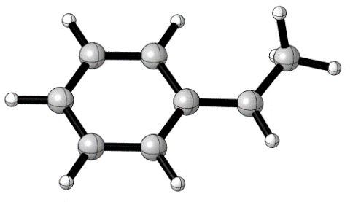
Atom | X | Y | Z
C | 1.32136077 | -1.36419403 | 0.00000934
C | 2.28892390 | -0.35813584 | -0.00000321
C | 1.88714929 | 0.98109920 | -0.00001423
C | 0.54381819 | 1.30900484 | -0.00000453
C | -0.45772374 | 0.30408941 | 0.00000796
C | -0.02753009 | -1.04706749 | 0.00000574
H | 1.62613411 | -2.40538490 | 0.00002116
H | 3.34262938 | -0.61267427 | -0.00000408
H | 2.63272993 | 1.76916397 | -0.00003215
H | 0.23818260 | 2.35091337 | -0.00001106
H | -0.76398802 | -1.84348388 | 0.00001306
C | -1.83098628 | 0.65753193 | 0.00002706
H | -2.07733338 | 1.71395421 | 0.00010461
C | -2.94016783 | -0.33852454 | -0.00002279
H | -3.91229447 | 0.15401910 | 0.00005371
H | -2.89759349 | -0.99457814 | -0.87793831
H | -2.89753201 | -0.99475038 | 0.87776099
7.3. Calculations on Energy Barriers of the C(sp³)-H Hydrazination Reaction
Figure S12. Energy barrier of C(sp³)-H hydrazination
Figure S13. Optimized geometries of key intermediates and transition states (TS).

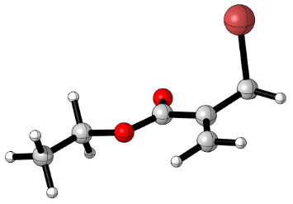
1a
Atom | X | Y | Z
C | 1.43287700 | 0.76760100 | 0.82947800
H | 1.40770700 | 0.26154200 | 1.78901800
H | 2.05267000 | 1.65629800 | 0.87371300
C | 0.06995700 | 1.07416600 | 0.31855100
C | -0.94968900 | -0.00015900 | 0.51869900
C | -0.23926600 | 2.24058100 | -0.23720200
H | -1.24109900 | 2.45236800 | -0.58579900
H | 0.51031400 | 3.01523100 | -0.34982100
O | -2.09189500 | 0.23144100 | -0.11954600
C | -3.13423600 | -0.74533000 | 0.06312100
H | -3.35272200 | -0.82416900 | 1.12884200
H | -2.76710300 | -1.71190700 | -0.28407600
C | -4.33228000 | -0.28202800 | -0.72406800
H | -5.14198600 | -1.00309300 | -0.60779900
H | -4.67966000 | 0.68787000 | -0.36655800
H | -4.09155200 | -0.20098600 | -1.78448600
O | -0.75031900 | -0.97216300 | 1.20445400
Br | 2.37019900 | -0.47818200 | -0.37439400
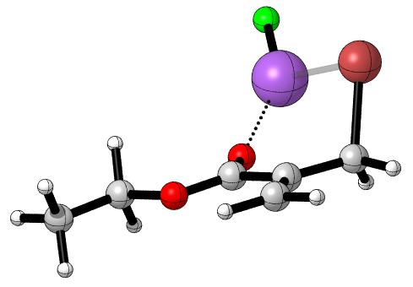
Int-0
Atom | X | Y | Z
C | -0.84684200 | -1.63546000 | 0.88152300
H | -0.98099600 | -1.06342700 | 1.79466800
H | -1.19542900 | -2.65374400 | 1.01422900
C | 1.20481400 | -0.26074200 | 0.35415700
Br | -2.10337800 | -0.82334400 | -0.41323900
O | 2.46029000 | -0.27331200 | -0.02996600
C | 3.14140200 | 1.00225700 | -0.08839500
H | 2.59284700 | 1.64979900 | -0.77269500
H | 3.11752500 | 1.44612500 | 0.90689000
C | 4.54667500 | 0.74034300 | -0.55997800
H | 5.08644200 | 1.68601500 | -0.61442800
H | 5.07202300 | 0.08157800 | 0.13180000
H | 4.54505100 | 0.28586600 | -1.55090100
O | 0.61520500 | 0.75583100 | 0.67005000
C | 0.55263500 | -1.59926700 | 0.37878400
C | 1.19834800 | -2.69584700 | -0.00468400
H | 2.22472400 | -2.65738800 | -0.34411500
H | 0.70751400 | -3.66139200 | 0.01689300
Na | -1.18947500 | 2.01253000 | 0.32652200
F | -1.98371200 | 3.82199000 | -0.06664600
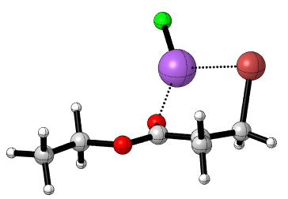
Int-0*
Atom | X | Y | Z
C | -0.83241800 | -1.55896800 | 0.96852500
H | -0.94828400 | -0.91672400 | 1.83615200
H | -1.18114000 | -2.56739900 | 1.16206900
C | 1.20930600 | -0.23453000 | 0.40748200
Br | -2.13861600 | -0.82229600 | -0.36695900
O | 2.45398900 | -0.29912900 | -0.02353200
C | 3.19966800 | 0.93903300 | -0.05164900
H | 2.66890100 | 1.64215300 | -0.69430700
H | 3.22633000 | 1.34456500 | 0.96010300
C | 4.57622400 | 0.62369700 | -0.57313100
H | 5.16476800 | 1.54084000 | -0.60533700
H | 5.08300800 | -0.09004800 | 0.07667900
H | 4.52388300 | 0.21058700 | -1.58060800
O | 0.67895200 | 0.80182900 | 0.78216300
C | 0.51607800 | -1.52415300 | 0.38803900
C | 1.08877600 | -2.68775700 | -0.26074500
H | 0.94714900 | -2.85342300 | -1.32203400
H | 1.67354400 | -3.40135000 | 0.30607000
Na | -1.12227000 | 2.04198400 | 0.33044900
F | -1.95233100 | 3.78264500 | -0.25226000
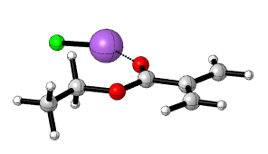
II
Atom | X | Y | Z
C | -2.23787800 | -0.81599500 | -0.01601100
C | -2.32576000 | -2.19484200 | -0.01132500
H | -1.43922700 | -2.81034600 | 0.01078800
H | -3.29331100 | -2.67666800 | -0.03023300
C | -3.33173800 | 0.02746600 | -0.04324000
H | -4.32942500 | -0.38939400 | -0.06277500
H | -3.22352000 | 1.10077100 | -0.04523300
C | -0.85733000 | -0.23404300 | 0.01142000
O | 0.14945100 | -0.91496500 | 0.04633000
O | -0.83218500 | 1.08084300 | -0.00555000
C | 0.46123600 | 1.72327000 | 0.02258800
H | 0.98252500 | 1.40614900 | 0.92716200
H | 1.02690500 | 1.39494400 | -0.85066700
C | 0.22805700 | 3.21081500 | 0.00711100
H | 1.19037000 | 3.72257300 | 0.02742400
H | -0.30449800 | 3.50963600 | -0.89587100
H | -0.34829500 | 3.52127300 | 0.87873900
F | 4.23043100 | -0.68250600 | -0.09470000
Na | 2.31881300 | -1.29667500 | 0.06758700

Int-1
Atom | X | Y | Z
Br | 0.96824100 | -2.83871900 | -1.35109900
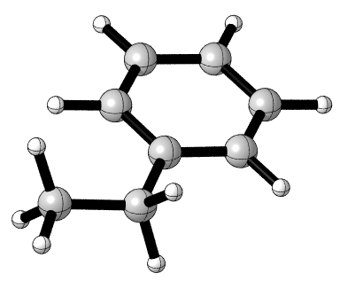
Ethylbenzene
Atom | X | Y | Z
C | -1.36275600 | 1.35861100 | 0.00005300
C | -0.00825200 | 1.03486500 | 0.00009100
C | 0.40897200 | -0.29291600 | 0.00005600
C | -0.56991200 | -1.29032100 | -0.00002600
C | -1.91889100 | -0.97345600 | -0.00006400
C | -2.32250800 | 0.35848700 | -0.00002400
H | -1.66362900 | 2.39921800 | 0.00008000
H | 0.72294000 | 1.83329700 | 0.00014500
H | -0.26172900 | -2.33061600 | -0.00006300
H | -2.65846000 | -1.76494400 | -0.00013100
H | -3.37562800 | 0.61015400 | -0.00005600
C | 1.86663200 | -0.69542300 | 0.00012800
H | 2.04346900 | -1.33229000 | 0.87167700
H | 2.04343000 | -1.33273400 | -0.87110200
C | 2.86693200 | 0.44966000 | -0.00017800
H | 2.75183900 | 1.08136800 | 0.88264600
H | 3.88478200 | 0.05848300 | -0.00018300
H | 2.75168600 | 1.08101900 | -0.88323400

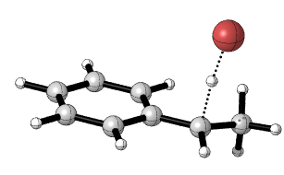
TS-1
Atom | X | Y | Z
C | 2.80713900 | 0.12807700 | -1.20363400
C | 1.69303300 | 0.84219800 | -0.80190100
C | 1.04954800 | 0.53979400 | 0.41394500
C | 1.56417700 | -0.51349000 | 1.19742200
C | 2.67503700 | -1.22404800 | 0.78835200
C | 3.30263100 | -0.90691900 | -0.41486000
H | 3.29564500 | 0.37565200 | -2.13767500
H | 1.31844900 | 1.64517500 | -1.42377300
H | 1.07132900 | -0.75872200 | 2.13132400
H | 3.05798300 | -2.02860200 | 1.40333900
H | 4.17318000 | -1.46449400 | -0.73595700
C | -0.12314900 | 1.23968000 | 0.85331500
H | -1.22069700 | 0.21634800 | 0.32024100
H | -0.41112800 | 1.07349500 | 1.88841600
C | -0.62130100 | 2.48710400 | 0.20033200
H | -0.71175000 | 2.37726300 | -0.88172500
H | -1.59482700 | 2.76908300 | 0.59913700
H | 0.07190600 | 3.31555100 | 0.38754000
Br | -2.37522200 | -0.65928900 | -0.22139100
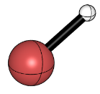
HBr
Atom | X | Y | Z
Br | 0.00000000 | 0.00000000 | 0.03952000
H | 0.00000000 | 0.00000000 | -1.38321300
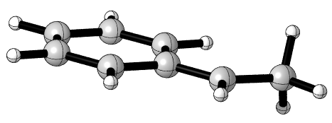
Int-2
Atom | X | Y | Z
C | -1.82759300 | -0.65538100 | -0.00001300
H | -2.07139000 | -1.71055900 | 0.00000900
C | -2.93428500 | 0.33763900 | -0.00000200
H | -2.88848700 | 0.99305500 | -0.87682300
H | -3.90496100 | -0.15484300 | -0.00016300
H | -2.88866600 | 0.99282600 | 0.87700300
C | -0.45688500 | -0.30290100 | -0.00000800
C | -0.02717900 | 1.04530000 | 0.00000600
C | 0.54224400 | -1.30627100 | -0.00001100
C | 1.31904900 | 1.36129600 | 0.00001400
H | -0.76330800 | 1.83947600 | 0.00001400
C | 1.88281000 | -0.97963700 | -0.00000400
H | 0.23539100 | -2.34599800 | -0.00002000
C | 2.28416200 | 0.35684300 | 0.00000900
H | 1.62409600 | 2.40068700 | 0.00002600
H | 2.62707900 | -1.76663400 | -0.00000700
H | 3.33630300 | 0.61065500 | 0.00001500
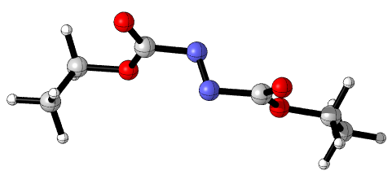
78
Atom | X | Y | Z
N | -0.32307000 | -0.57880600 | 0.65066900
N | 0.22661300 | -0.59878600 | -0.44245100
C | -1.76453700 | -0.46597700 | 0.53861600
C | 1.65843200 | -0.79858700 | -0.33458000
O | -2.10439200 | 0.78191600 | 0.34242500
O | 2.25560200 | 0.33636000 | -0.07781100
O | -2.46429200 | -1.42157500 | 0.68995200
O | 2.14577800 | -1.87009900 | -0.53418600
C | 3.70758400 | 0.29603700 | -0.03564600
H | 4.05939800 | -0.08403200 | -0.99460000
H | 3.99964200 | -0.40038800 | 0.74989200
C | 4.18658300 | 1.69611700 | 0.23509500
H | 5.27621200 | 1.69707600 | 0.27336500
H | 3.86712000 | 2.37506500 | -0.55553800
H | 3.80615200 | 2.05837200 | 1.19022500
C | -3.52855200 | 1.06307900 | 0.26697500
H | -4.03173200 | 0.47988100 | 1.03672100
H | -3.60016200 | 2.12062000 | 0.50765800
C | -4.05501300 | 0.76116500 | -1.11366800
H | -3.51906100 | 1.34243300 | -1.86430000
H | -3.95955900 | -0.29911400 | -1.34731000
H | -5.11135100 | 1.02940400 | -1.15742700
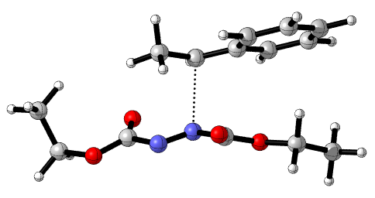
TS-2
Atom | X | Y | Z
C | 1.41780000 | -1.41300800 | 0.26368400
C | 2.18573200 | -1.07676800 | 1.39687600
C | 2.09151600 | -1.70817900 | -0.93871200
C | 3.56522500 | -1.05168000 | 1.33386200
H | 1.67326100 | -0.83515100 | 2.32098400
C | 3.47343900 | -1.68780600 | -0.99194400
H | 1.52425500 | -1.96189200 | -1.82506200
C | 4.21527000 | -1.35911300 | 0.13977100
H | 4.14147500 | -0.79455600 | 2.21369900
H | 3.97915500 | -1.92540800 | -1.91930600
H | 5.29688300 | -1.34358200 | 0.09248300
C | -0.87840100 | -1.92856700 | -0.73429400
H | -0.69057000 | -1.39137100 | -1.66792400
H | -0.67835400 | -2.98898200 | -0.92559400
H | -1.93136600 | -1.83424600 | -0.47516500
N | -1.75650500 | 0.92772800 | -0.47961800
N | -0.69078500 | 0.85092800 | 0.18084700
O | -2.82707400 | -0.00993300 | 1.39490100
C | -2.87847600 | 0.51267000 | 0.31396200
C | 0.45113800 | 1.21982200 | -0.62276200
O | 0.55413600 | 1.06253100 | -1.80677700
O | 1.36531500 | 1.71901500 | 0.18431200
O | -3.97938000 | 0.78356500 | -0.36685900
C | 2.63774400 | 2.03358600 | -0.41817400
H | 2.46956900 | 2.72950300 | -1.24072400
H | 3.05426400 | 1.10910700 | -0.82195000
C | 3.51135200 | 2.62910700 | 0.65397600
H | 4.48982000 | 2.86170600 | 0.23243600
H | 3.07449800 | 3.54935000 | 1.04298500
H | 3.64630100 | 1.92716600 | 1.47730600
C | -5.22524200 | 0.38285900 | 0.23793700
H | -5.19657100 | 0.63209500 | 1.29807500
H | -5.97412500 | 0.99842300 | -0.25533800
C | -5.48463000 | -1.08869900 | 0.01434200
H | -4.73087700 | -1.69938400 | 0.51118000
H | -6.46163000 | -1.34821100 | 0.42439500
H | -5.48561600 | -1.31861900 | -1.05169900
C | -0.00636600 | -1.44603500 | 0.36183900
H | -0.42991000 | -1.36709900 | 1.35383300
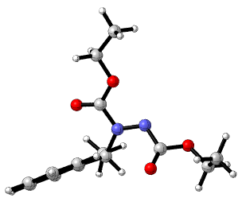
Int-3
Atom | X | Y | Z
N | -0.17480500 | 0.39692600 | 0.53117000
C | 0.47949800 | 1.64111800 | 0.36600600
C | -2.10241800 | -0.81575400 | 0.12414800
O | 1.63426700 | 1.79146700 | 0.66468300
O | -1.62692500 | -1.72813200 | -0.51395800
O | -0.31165200 | 2.55371900 | -0.15700200
O | -3.34833600 | -0.77820800 | 0.58556400
C | -4.20092800 | -1.88254700 | 0.22601100
H | -4.99426400 | -1.86233500 | 0.97016500
H | -3.63979000 | -2.81063400 | 0.32704100
C | -4.75042400 | -1.71029300 | -1.17077000
H | -3.94871200 | -1.71680100 | -1.90904800
H | -5.43175200 | -2.53241000 | -1.39477800
H | -5.30162600 | -0.77285600 | -1.25207200
C | 0.29457800 | 3.84801300 | -0.36995400
H | 0.65290200 | 4.22133000 | 0.58964400
H | 1.14909800 | 3.72087400 | -1.03500800
C | -0.75941400 | 4.74179200 | -0.96723200
H | -1.60922800 | 4.84343900 | -0.29206900
H | -0.33359500 | 5.73052400 | -1.14035800
H | -1.11055500 | 4.34418400 | -1.91962900
C | 1.80131600 | -1.06399100 | 0.24435200
C | 3.05392700 | -1.33467400 | 0.78330500
C | 1.62571300 | -1.15462900 | -1.13571100
C | 4.11461500 | -1.68767900 | -0.04331600
H | 3.21628600 | -1.26564400 | 1.85090800
C | 2.68515100 | -1.50065000 | -1.96115600
H | 0.64930100 | -0.95567200 | -1.56194900
C | 3.93550400 | -1.76963600 | -1.41661100
H | 5.08503200 | -1.89310700 | 0.39125000
H | 2.53328500 | -1.56335100 | -3.03153500
H | 4.76362300 | -2.04029200 | -2.05945600
C | 0.91988200 | -0.42657000 | 2.58453400
H | 0.00005400 | -0.13675600 | 3.09378800
H | 1.29759200 | -1.32993900 | 3.06341800
H | 1.65608300 | 0.36693400 | 2.69387900
C | 0.61266000 | -0.72297100 | 1.12229800
H | -0.06383400 | -1.57274500 | 1.08990300
N | -1.48329400 | 0.39526300 | 0.40828400
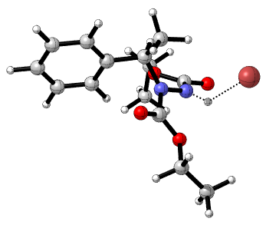
TS-3a
Atom | X | Y | Z
N | 0.02698700 | -0.24048000 | -0.01457000
C | -0.21007800 | -1.43131500 | 0.70145000
C | -0.67638700 | 2.08619500 | 0.08968900
O | 0.45120200 | -2.41676800 | 0.53164100
O | -1.59053300 | 2.85808500 | 0.12439900
O | -1.21407300 | -1.28242700 | 1.54146800
O | 0.61193000 | 2.35393800 | 0.10837000
C | 0.98218200 | 3.75300300 | 0.22247300
H | 0.32207400 | 4.33547800 | -0.41781200
H | 1.99441800 | 3.78659600 | -0.17295500
C | 0.92503200 | 4.20047400 | 1.66163700
H | 1.58118800 | 3.58725600 | 2.28008400
H | 1.25976400 | 5.23658100 | 1.72463600
H | -0.09137800 | 4.14334500 | 2.05073000
C | -1.60120300 | -2.46766400 | 2.28022400
H | -1.83154100 | -3.25206200 | 1.55954200
H | -0.74925400 | -2.78030900 | 2.88366400
C | -2.79350300 | -2.09758300 | 3.11979200
H | -3.62194900 | -1.77175400 | 2.49046600
H | -3.11211100 | -2.97129800 | 3.68872400
H | -2.54366700 | -1.30019700 | 3.81984400
C | 2.38409300 | -0.54389500 | -0.68178300
C | 3.25959500 | -1.29424500 | -1.45930600
C | 2.83851300 | -0.01680500 | 0.52633600
C | 4.56677200 | -1.51114200 | -1.03889200
H | 2.92954900 | -1.72148700 | -2.39678000
C | 4.14053700 | -0.23910700 | 0.94890400
H | 2.16740300 | 0.56621400 | 1.14516000
C | 5.01190200 | -0.98599100 | 0.16523500
H | 5.23464500 | -2.09942100 | -1.65558700
H | 4.47514800 | 0.17210700 | 1.89312600
H | 6.02864200 | -1.15966500 | 0.49412600
C | 0.43778600 | -1.16247600 | -2.25933000
H | -0.61378400 | -0.93363000 | -2.43809500
H | 0.98487100 | -0.96891300 | -3.18179800
H | 0.53938200 | -2.21347200 | -1.99566400
C | 0.97500900 | -0.25264300 | -1.16051900
H | 0.95085900 | 0.76970400 | -1.53366000
Br | -3.29492100 | -0.15325000 | -1.36832100
N | -0.91240800 | 0.70048800 | 0.05948100
H | -1.89379000 | 0.39517900 | 0.19663100
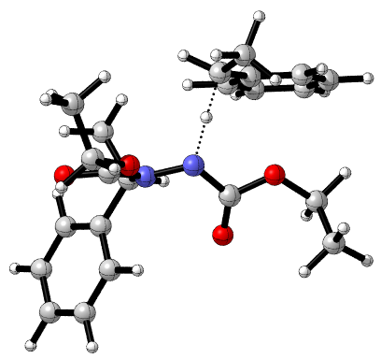
TS-3b
Atom | X | Y | Z
N | -0.99674600 | 0.53327300 | 0.00861900
C | -1.90666800 | 1.57219800 | -0.08209200
C | 0.73413000 | -0.18453300 | 1.39311900
O | -2.93848600 | 1.47386200 | -0.70396800
O | 0.13959400 | -1.14012900 | 1.83557600
O | -1.52469100 | 2.64658500 | 0.60000400
O | 2.00130000 | 0.12340000 | 1.67037000
C | 2.71226600 | -0.78674700 | 2.52713900
H | 3.76161700 | -0.60160600 | 2.30525600
H | 2.46448200 | -1.80846400 | 2.23987900
C | 2.40351300 | -0.52248500 | 3.98246900
H | 1.35108800 | -0.70544600 | 4.19721100
H | 3.00454200 | -1.18565300 | 4.60653800
H | 2.64577300 | 0.50872000 | 4.24259200
C | -2.40159100 | 3.78695300 | 0.52494000
H | -3.43309500 | 3.44753900 | 0.60578700
H | -2.14919900 | 4.37553700 | 1.40451500
C | -2.16742100 | 4.56834100 | -0.74655600
H | -2.40898700 | 3.96713900 | -1.62304200
H | -2.80433500 | 5.45414700 | -0.75058600
H | -1.12767300 | 4.89166800 | -0.81109500
C | -2.47375000 | -1.42560700 | -0.37929600
C | -3.18205400 | -2.20222400 | -1.29232600
C | -2.91496600 | -1.38284400 | 0.94222100
C | -4.30422100 | -2.92080700 | -0.89518800
H | -2.86807200 | -2.25216100 | -2.32644500
C | -4.03836900 | -2.09376300 | 1.33801600
H | -2.37092200 | -0.78960700 | 1.66520200
C | -4.73864200 | -2.86847100 | 0.42081300
H | -4.84085000 | -3.51764700 | -1.62236300
H | -4.36789700 | -2.04221900 | 2.36846700
H | -5.61569000 | -3.42315100 | 0.72991400
C | -1.16368300 | -0.35552800 | -2.29866500
H | -0.34139900 | 0.33258400 | -2.49361700
H | -0.98299100 | -1.26272200 | -2.87530200
H | -2.09100400 | 0.10163100 | -2.63871200
C | -1.21917200 | -0.68046700 | -0.80710200
H | -0.36465700 | -1.31441200 | -0.56506300
N | 0.20769700 | 0.79100700 | 0.56611900
H | 1.16799200 | 1.10583000 | -0.33622200
C | 2.10852100 | 1.40798600 | -1.15470300
H | 1.52114000 | 1.56635100 | -2.06005100
C | 2.96806600 | 0.21397800 | -1.24229800
C | 4.18631900 | 0.11962400 | -0.56069300
C | 2.54335900 | -0.89160500 | -1.99166200
C | 4.95069900 | -1.03614300 | -0.62896400
H | 4.53912400 | 0.95652800 | 0.02863800
C | 3.30222500 | -2.04911600 | -2.05300900
H | 1.60527900 | -0.83342600 | -2.53201800
C | 4.51145700 | -2.12701200 | -1.36976200
H | 5.89325900 | -1.08723700 | -0.09768700
H | 2.95322700 | -2.89177500 | -2.63688400
H | 5.10745700 | -3.02958400 | -1.41716500
C | 2.66333700 | 2.67743500 | -0.56193000
H | 3.00587300 | 2.52243400 | 0.46216600
H | 3.50992000 | 3.04722400 | -1.14903700
H | 1.89747800 | 3.45309100 | -0.54671600
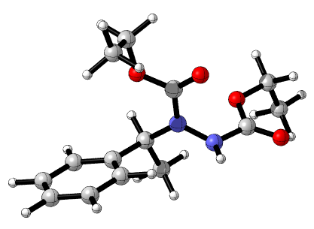
80
Atom | X | Y | Z
N | 0.36614800 | 0.01127100 | 0.14798500
C | 0.20026200 | 1.37320300 | 0.05869900
C | 2.61099500 | -0.28375900 | 0.90444400
O | 0.78145800 | 2.17153300 | 0.75462500
O | 3.40569700 | -0.41237100 | 1.80315200
O | -0.67826700 | 1.68252700 | -0.89633600
O | 2.91645500 | -0.02333600 | -0.36478900
C | -1.06626100 | 3.05855600 | -0.99425700
H | -0.17364400 | 3.68962100 | -0.89061200
H | -1.46255700 | 3.16548100 | -2.01118300
C | -2.11097500 | 3.39839200 | 0.04603800
H | -2.44218000 | 4.43848100 | -0.08296800
H | -2.98433700 | 2.73801100 | -0.05496000
H | -1.69750000 | 3.29053300 | 1.05870300
C | 4.31102500 | 0.09456700 | -0.67555400
H | 4.34158300 | 0.68005100 | -1.60234200
H | 4.80506700 | 0.66534300 | 0.12210600
C | 4.95071200 | -1.26415500 | -0.85828100
H | 6.00558000 | -1.14164100 | -1.14203600
H | 4.90915500 | -1.84105700 | 0.07578600
H | 4.44251200 | -1.82966700 | -1.65242700
C | -0.38833100 | -0.93708100 | -0.68231000
H | -0.37257100 | -0.54380700 | -1.70810900
C | 0.28881700 | -2.30301100 | -0.68352500
H | -0.23632300 | -2.95878000 | -1.39080900
H | 1.33820100 | -2.21197900 | -0.99775900
H | 0.25332800 | -2.76465300 | 0.31227400
C | -1.84310100 | -1.03643100 | -0.24779800
C | -2.81179600 | -1.43147200 | -1.17706600
C | -2.23602100 | -0.77503700 | 1.06827700
C | -4.14706100 | -1.56581100 | -0.79922600
H | -2.51529200 | -1.62759500 | -2.21101400
C | -3.57275400 | -0.90748000 | 1.44872000
H | -1.49554800 | -0.45348500 | 1.80495500
C | -4.53196900 | -1.30401800 | 0.51701400
H | -4.89195100 | -1.86947300 | -1.53717000
H | -3.86493100 | -0.69660400 | 2.47913600
H | -5.57747700 | -1.40411200 | 0.81368600
N | 1.25366200 | -0.43409400 | 1.08506100
H | 0.95622300 | -0.41050500 | 2.05914700

8. ¹H and ¹³C NMR Spectrum
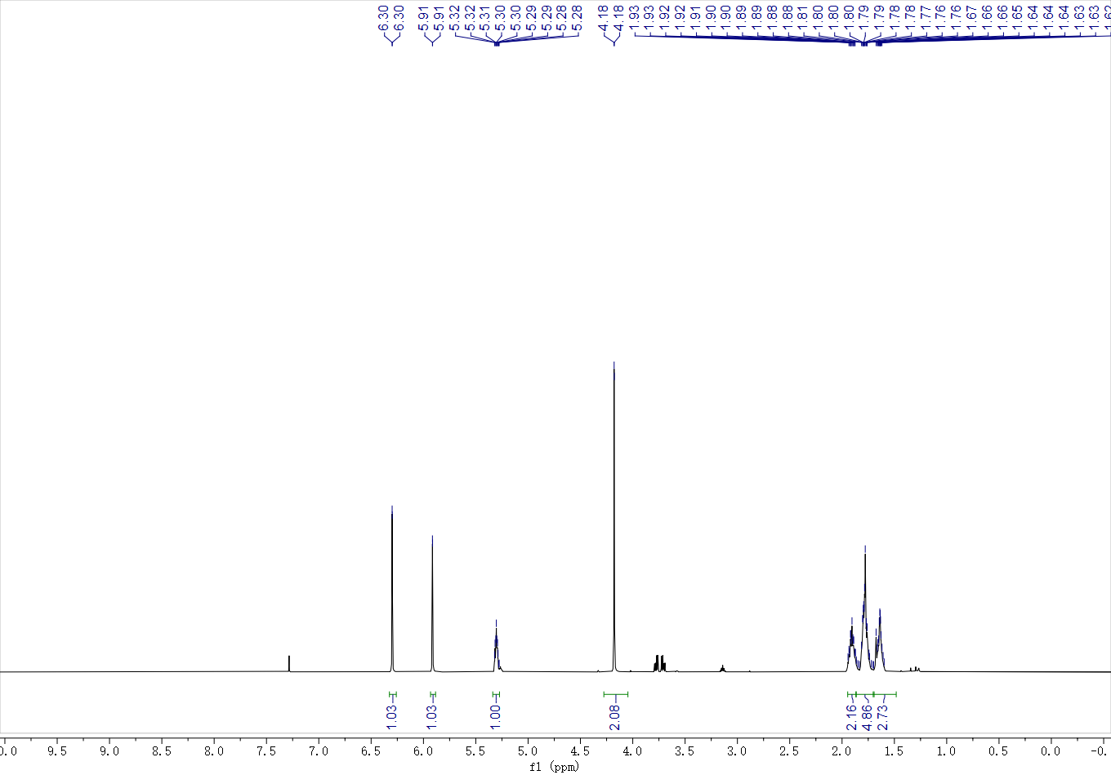
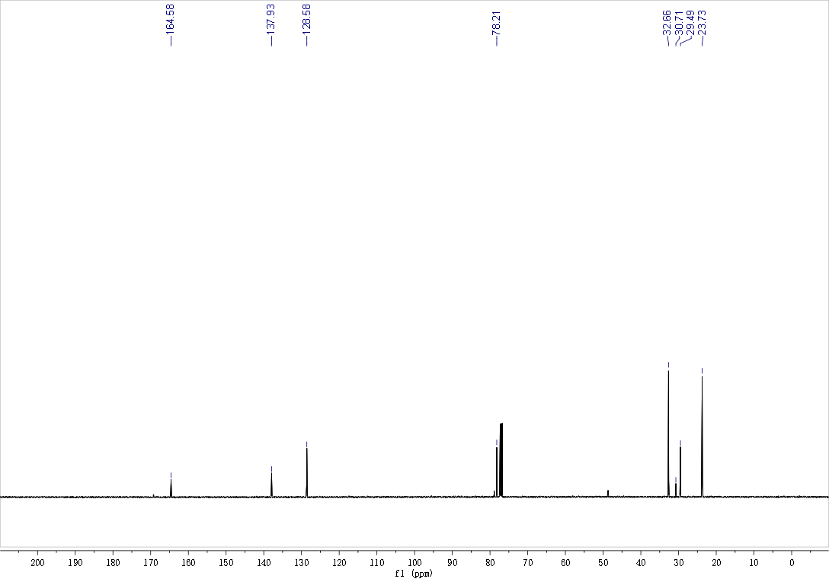
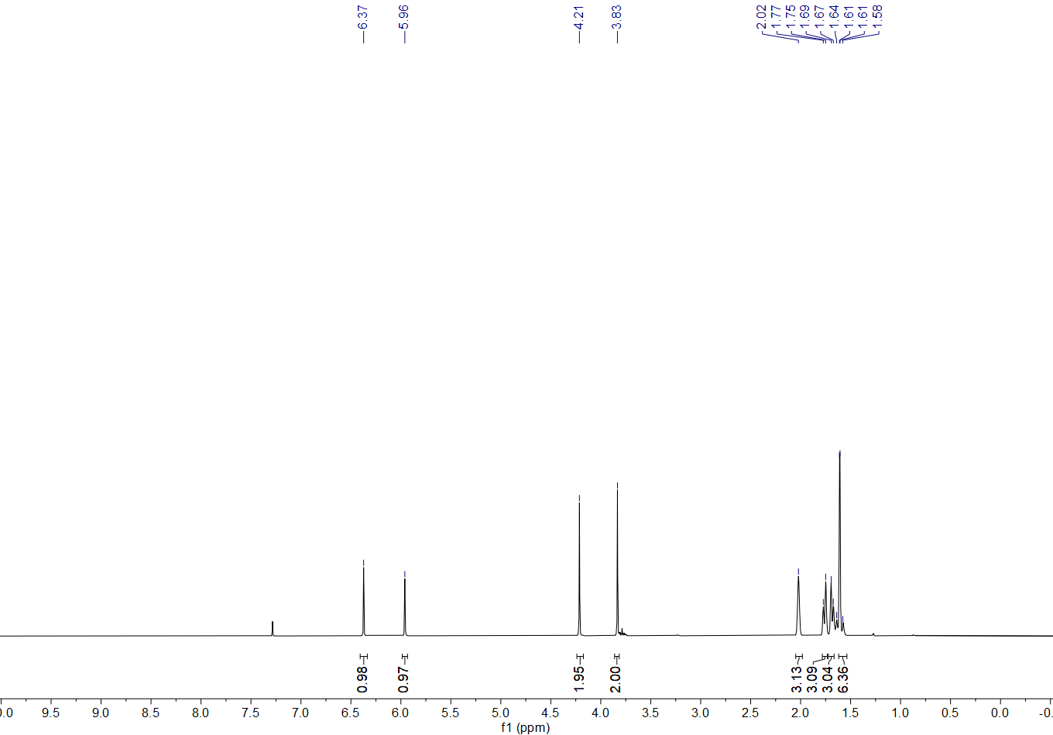
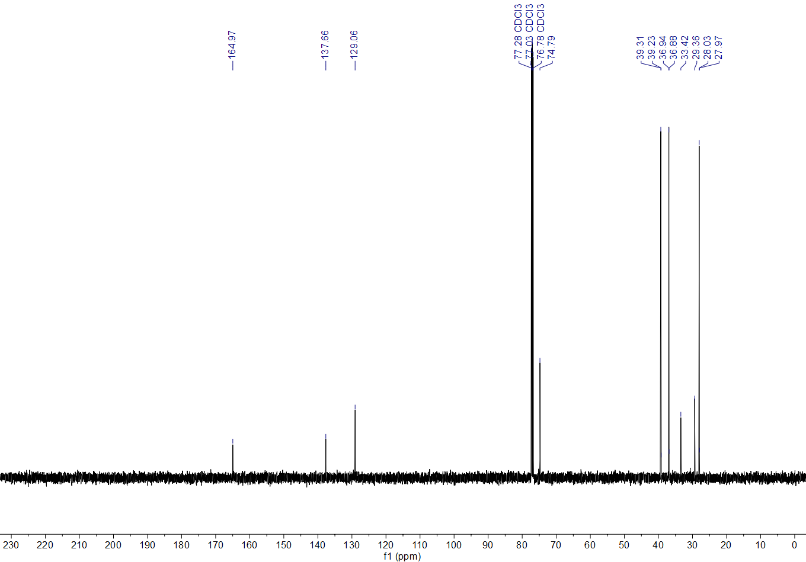
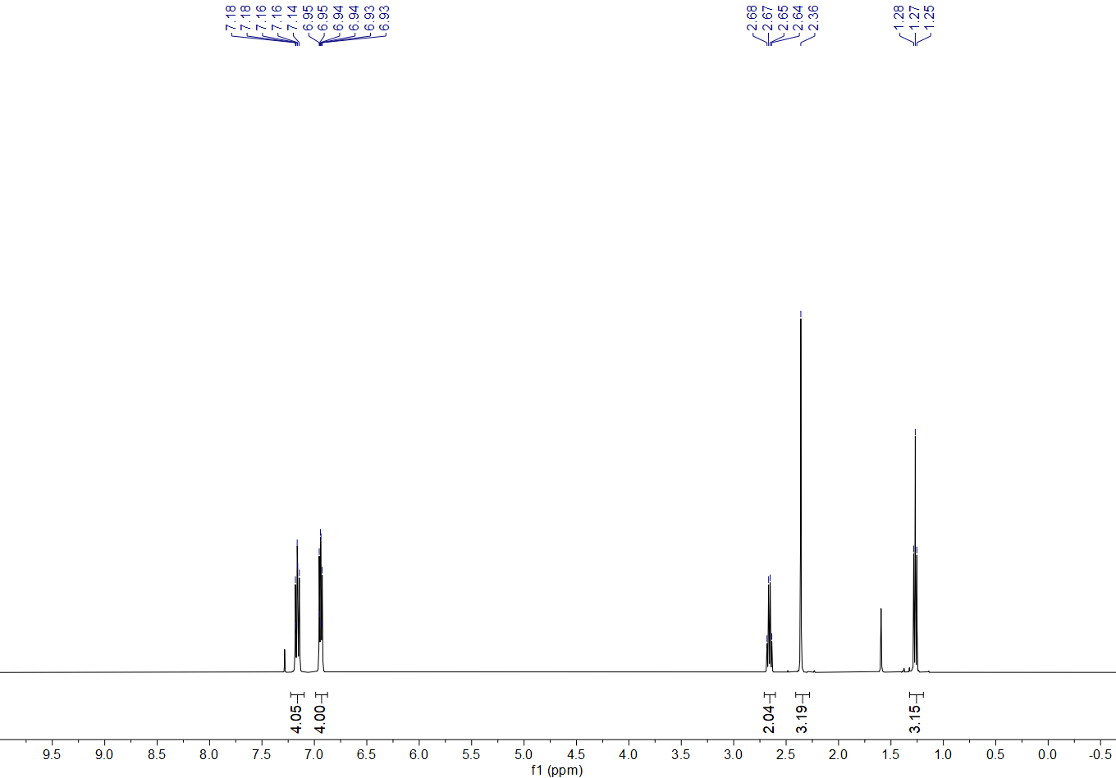
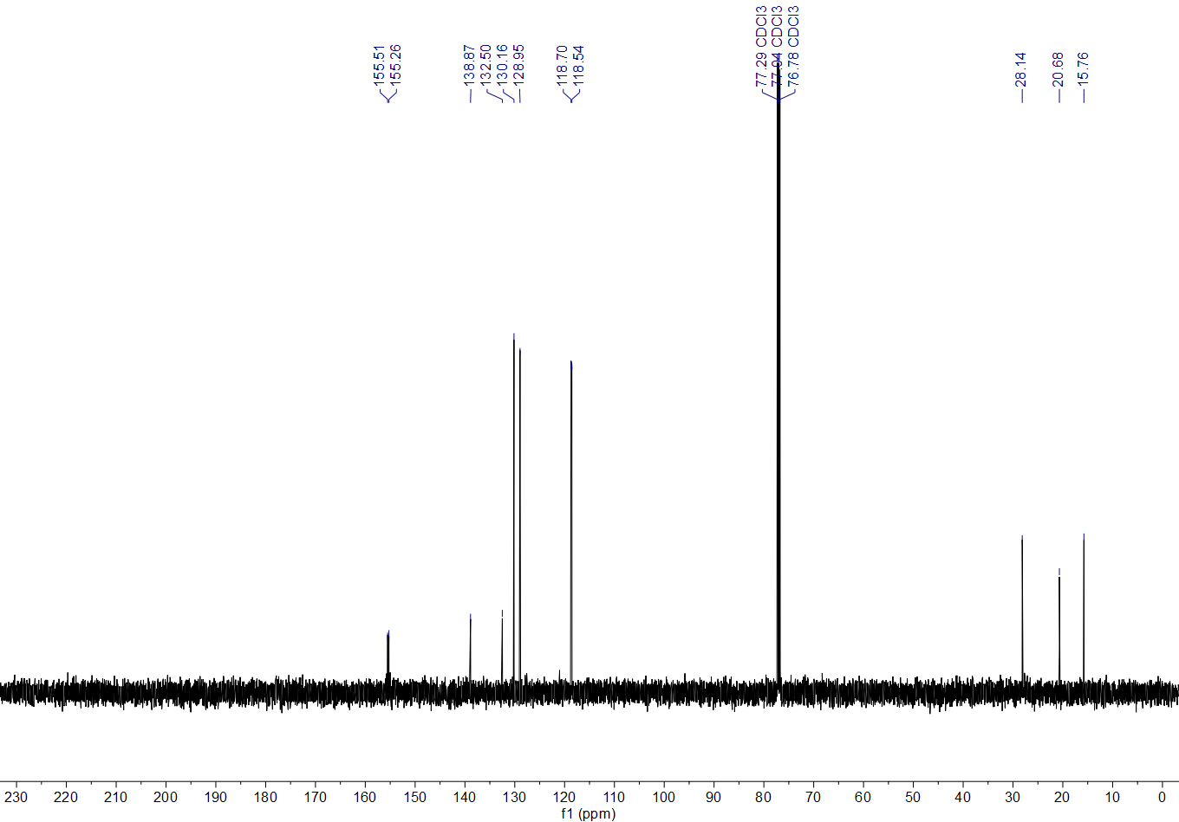
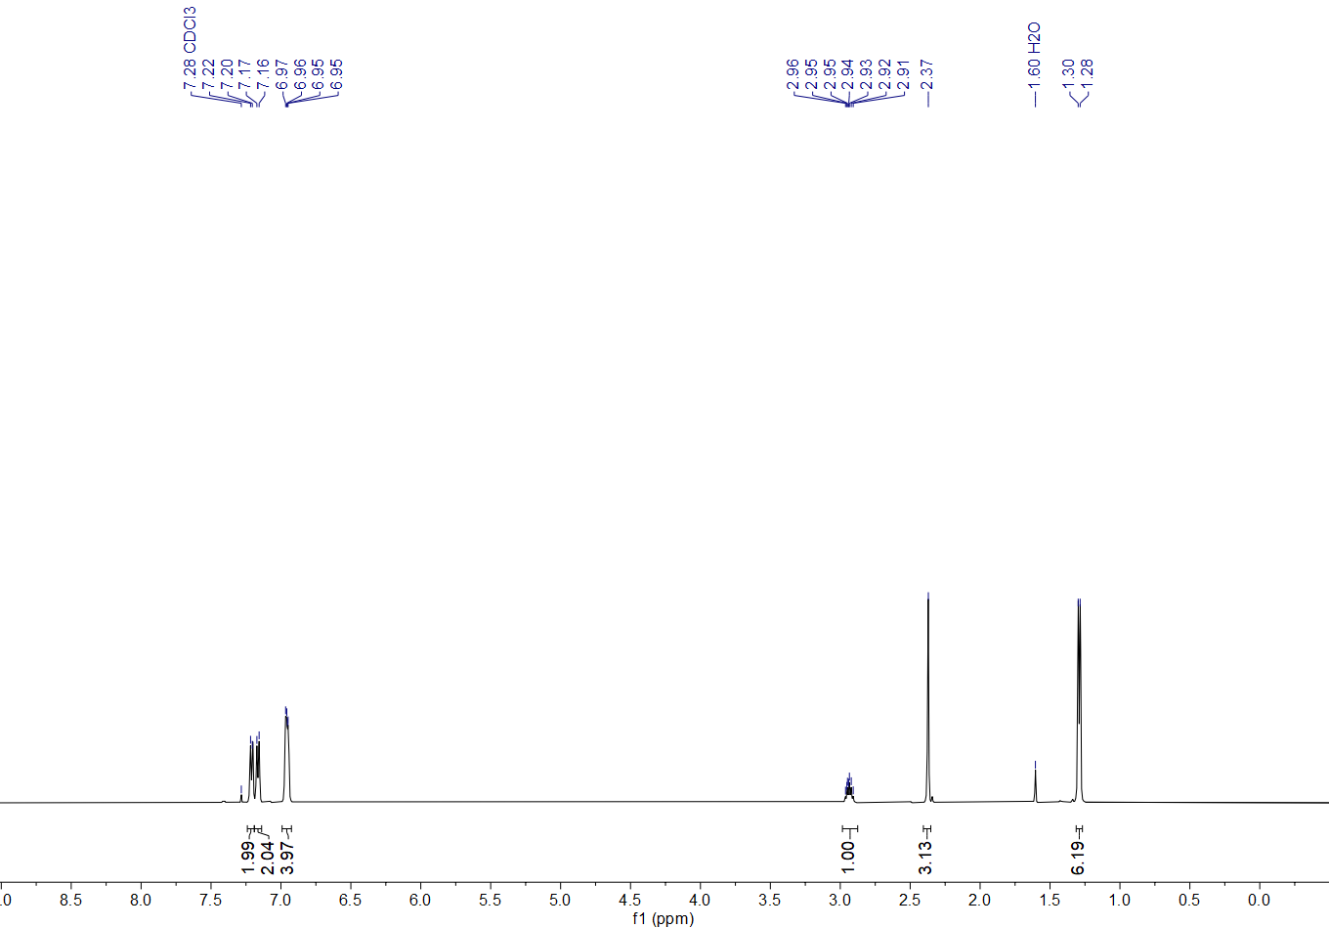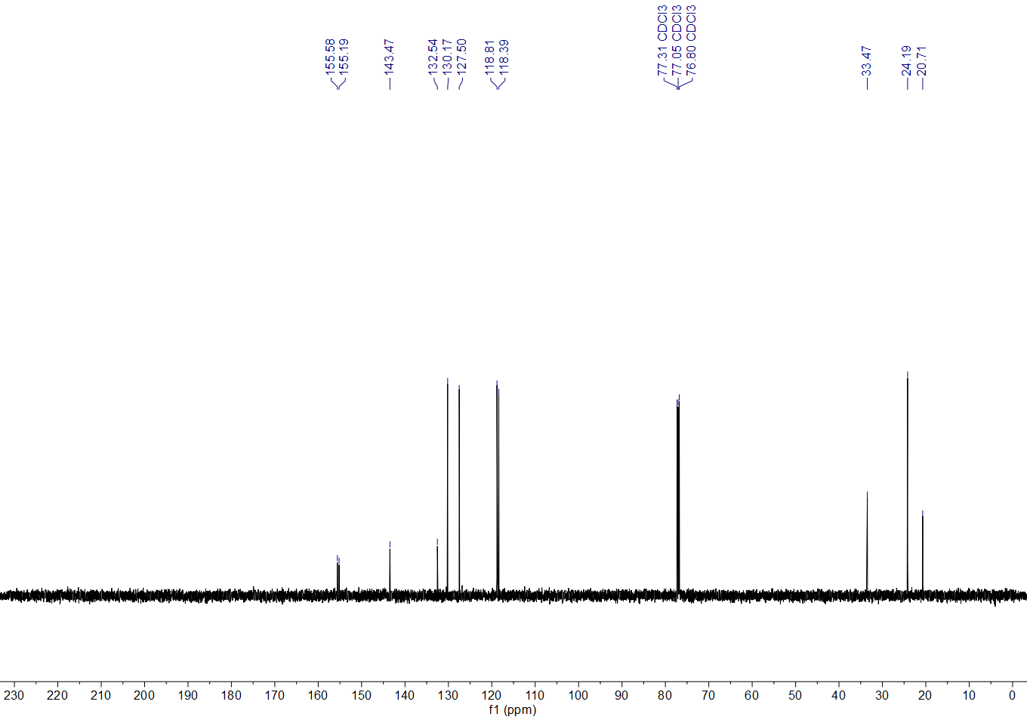
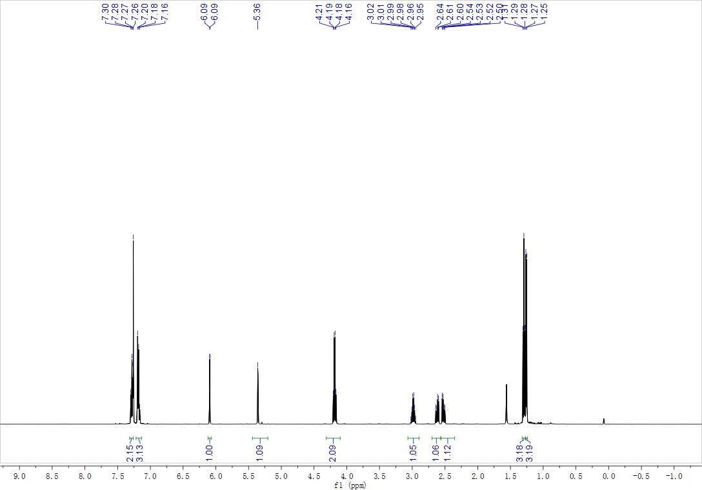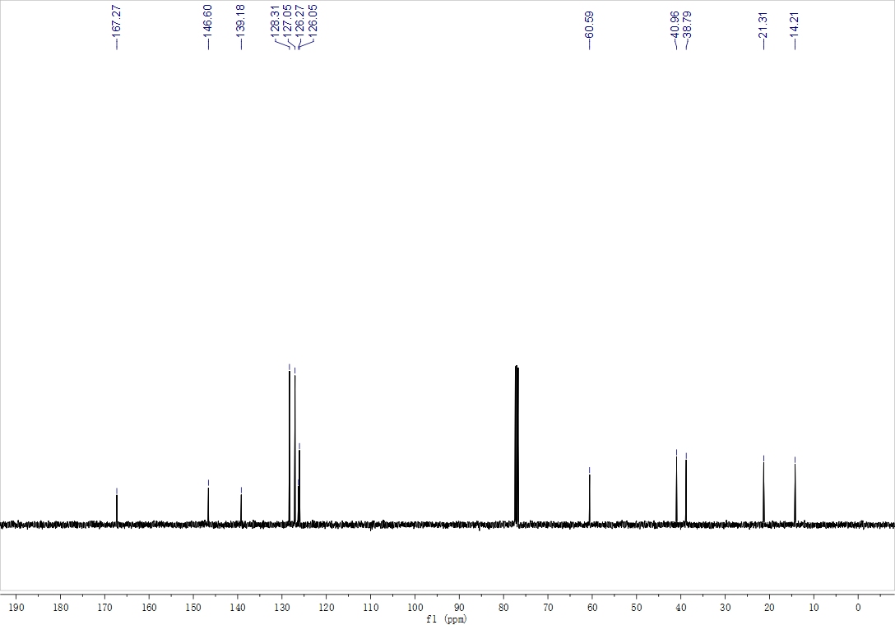
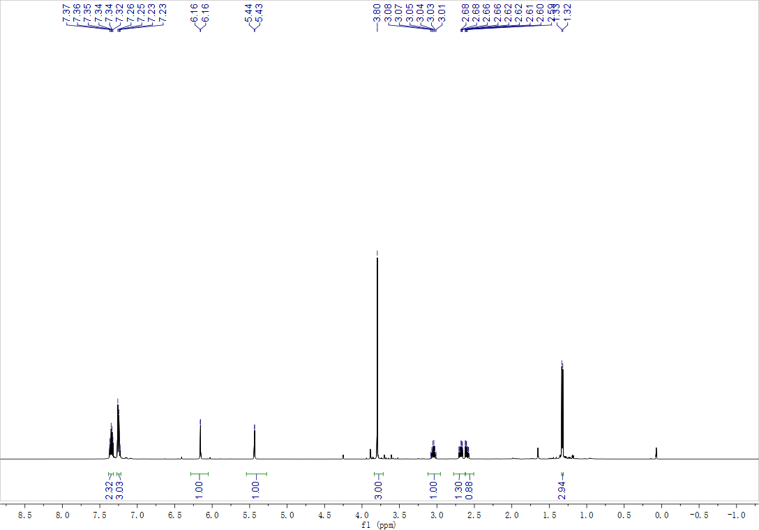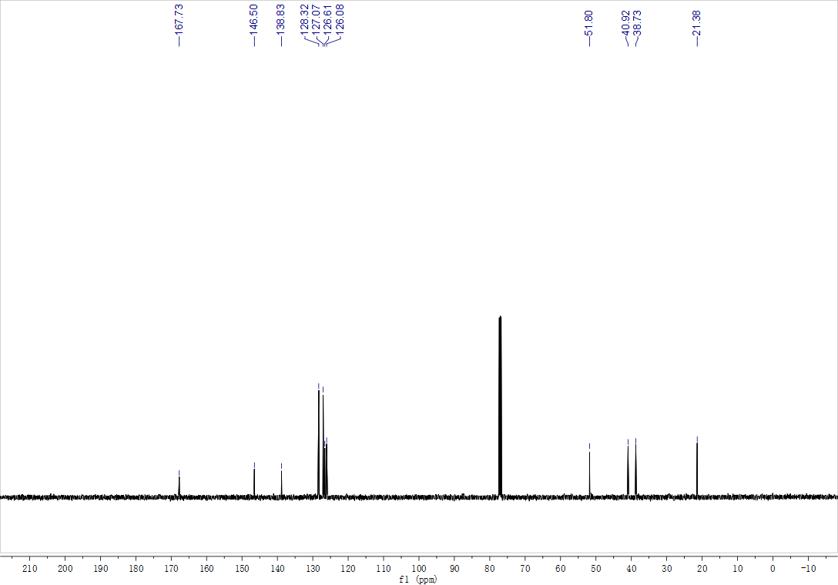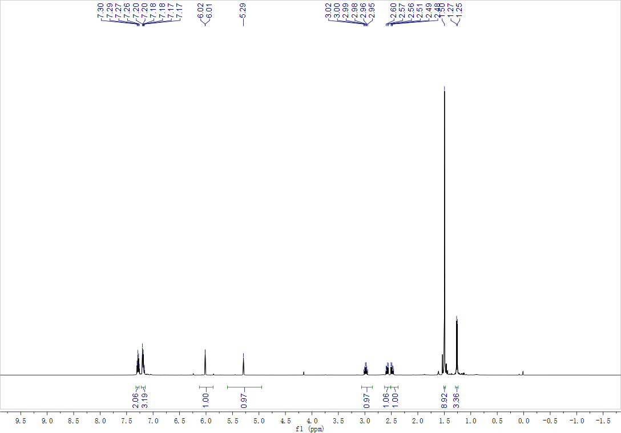
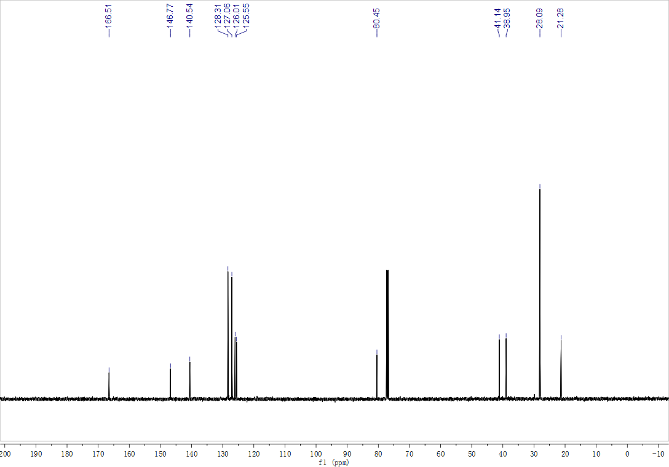
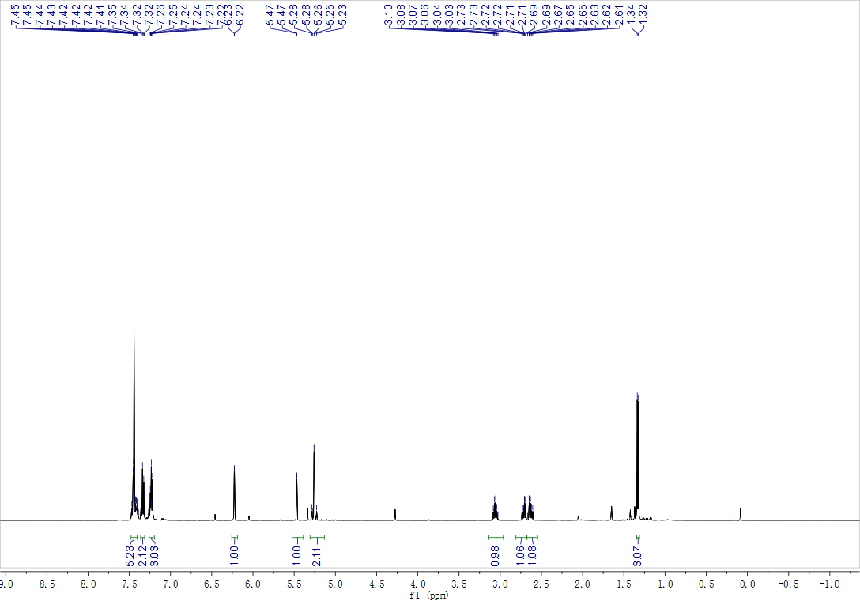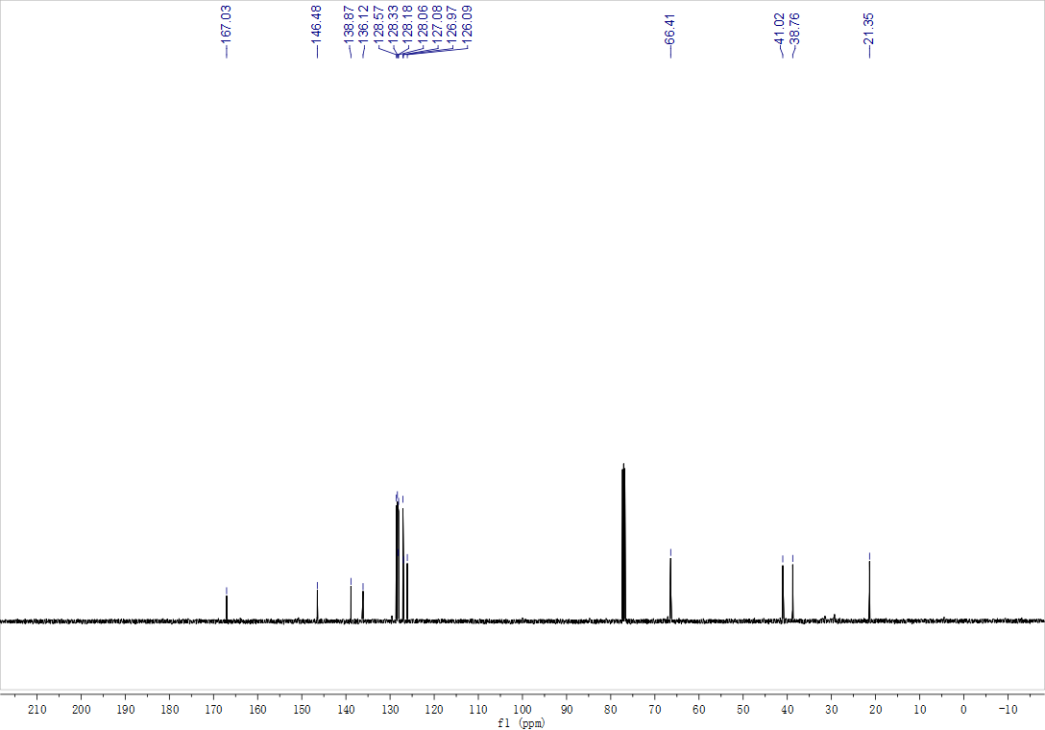
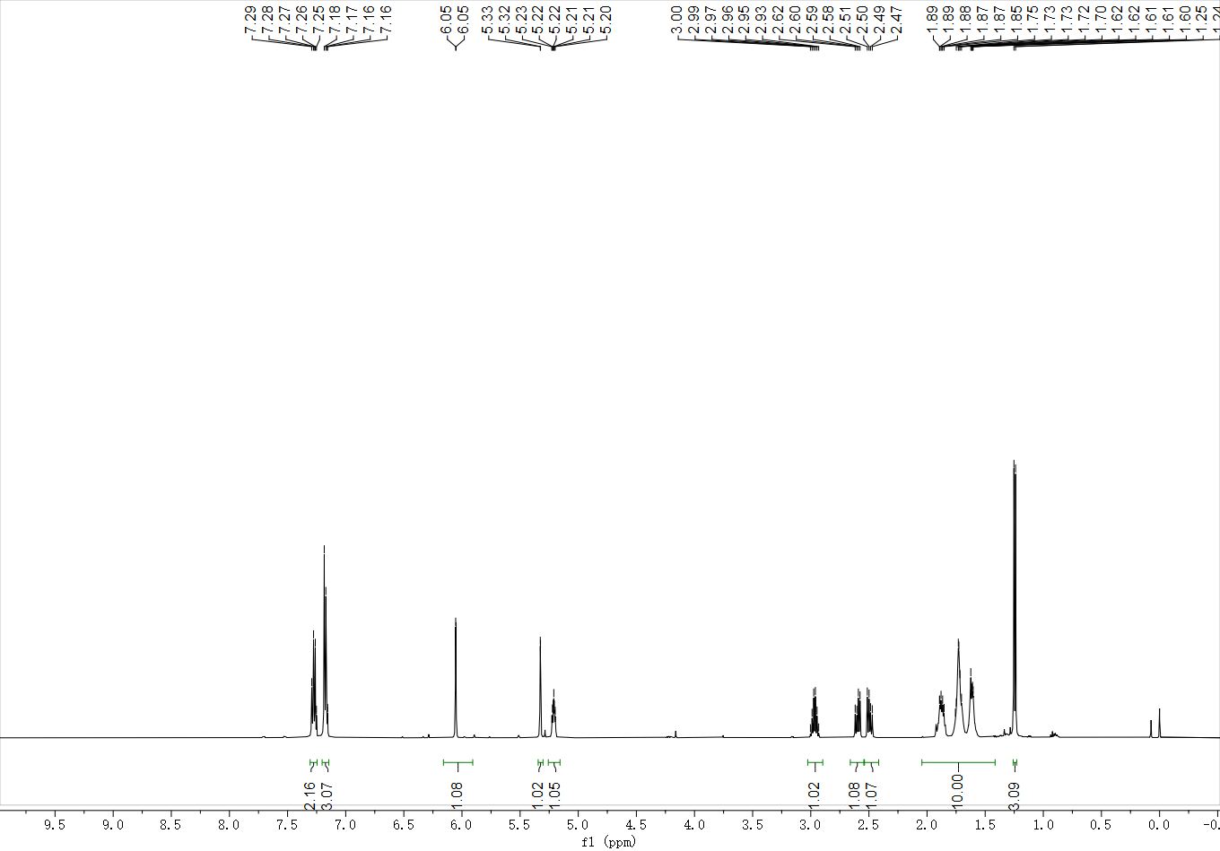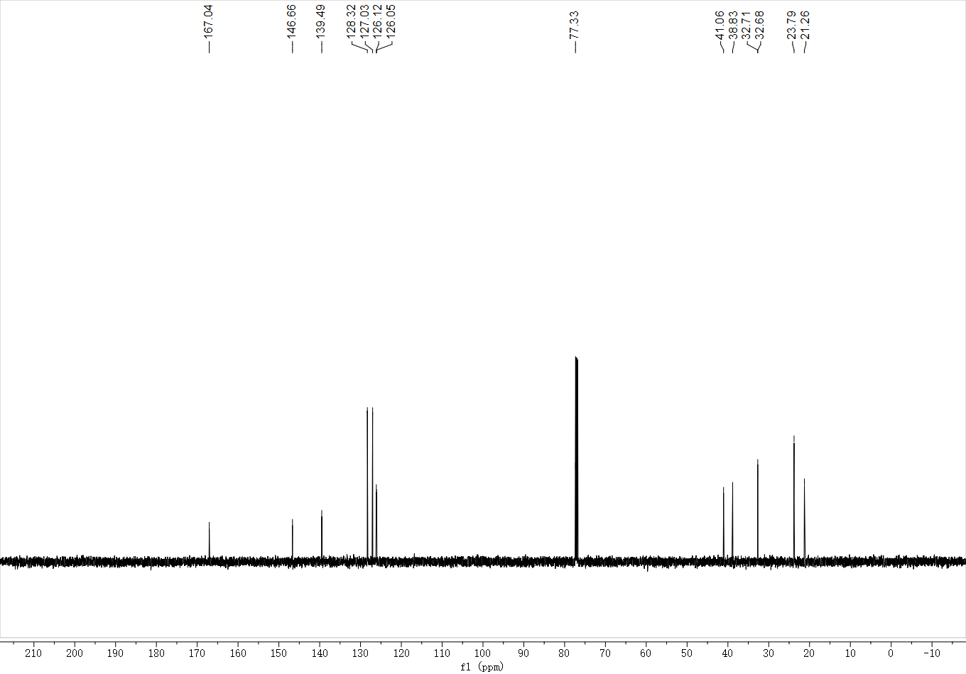

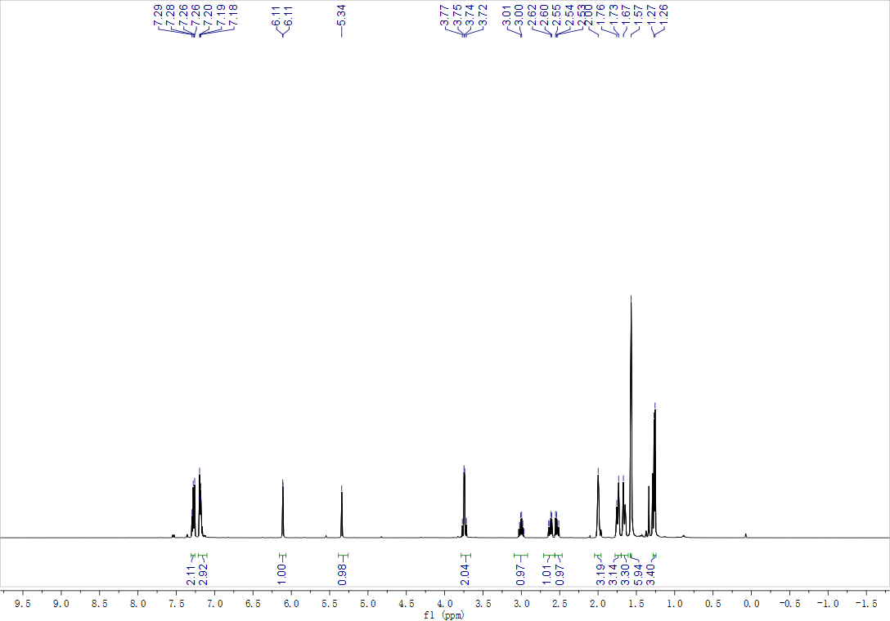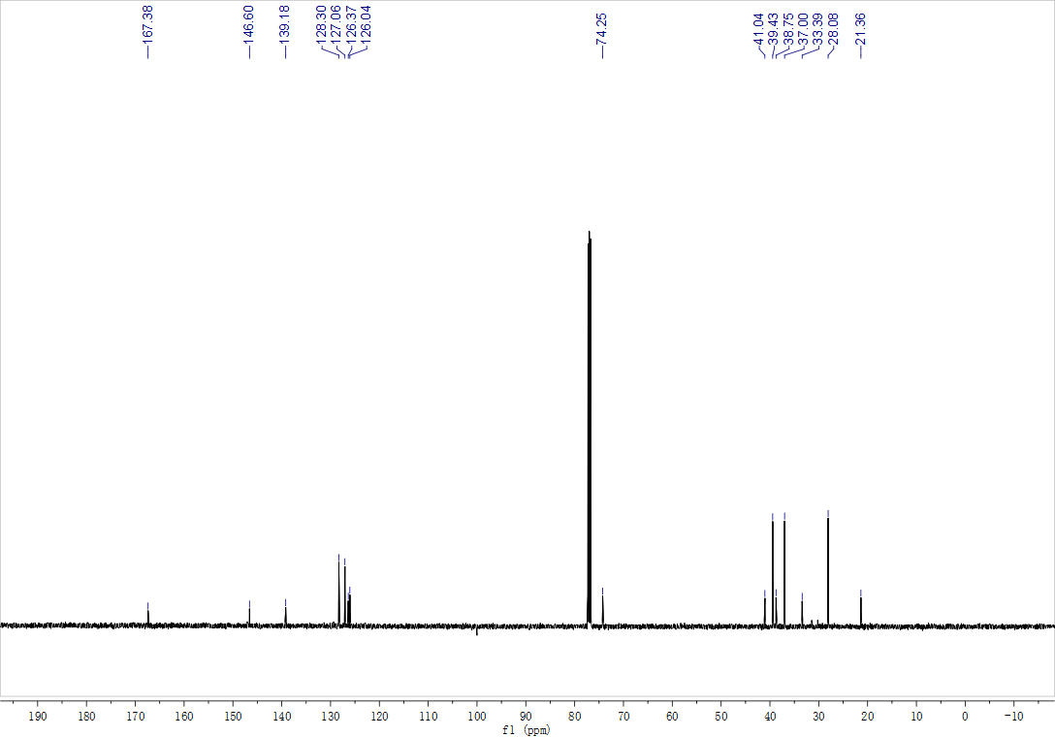
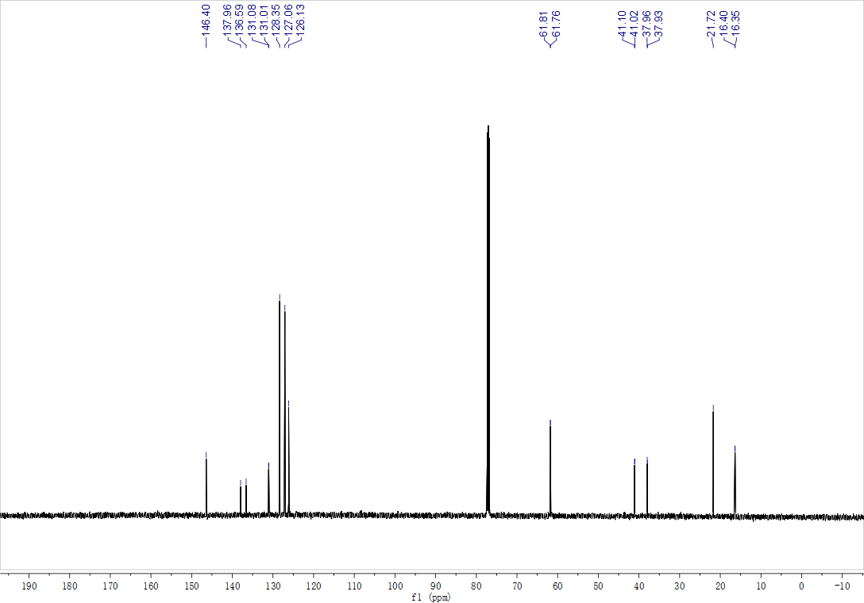
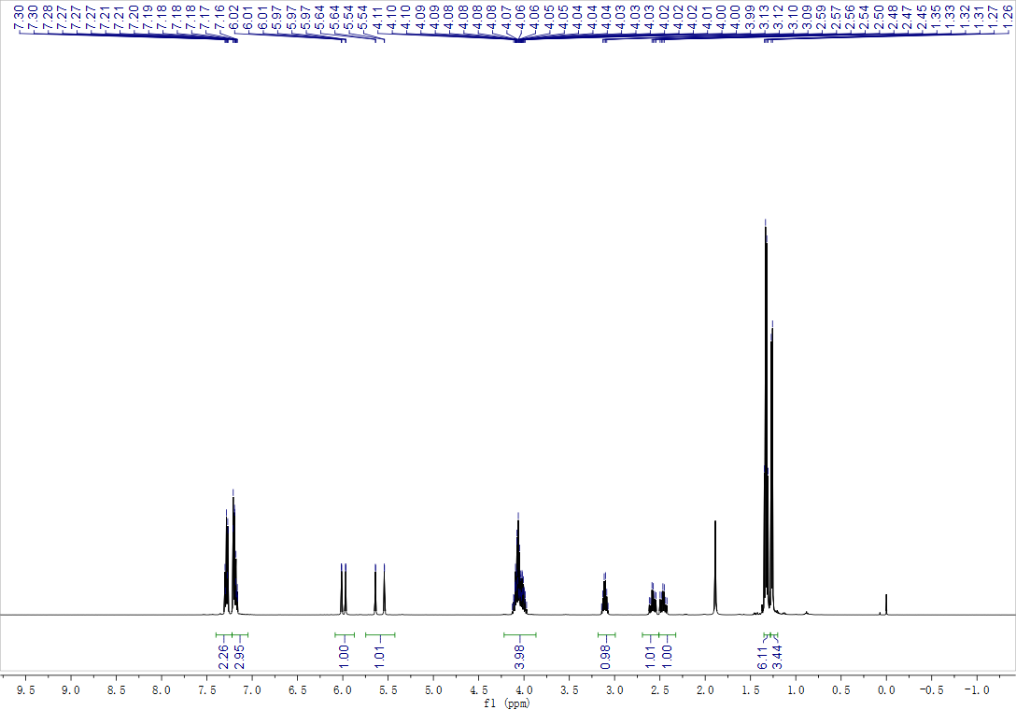

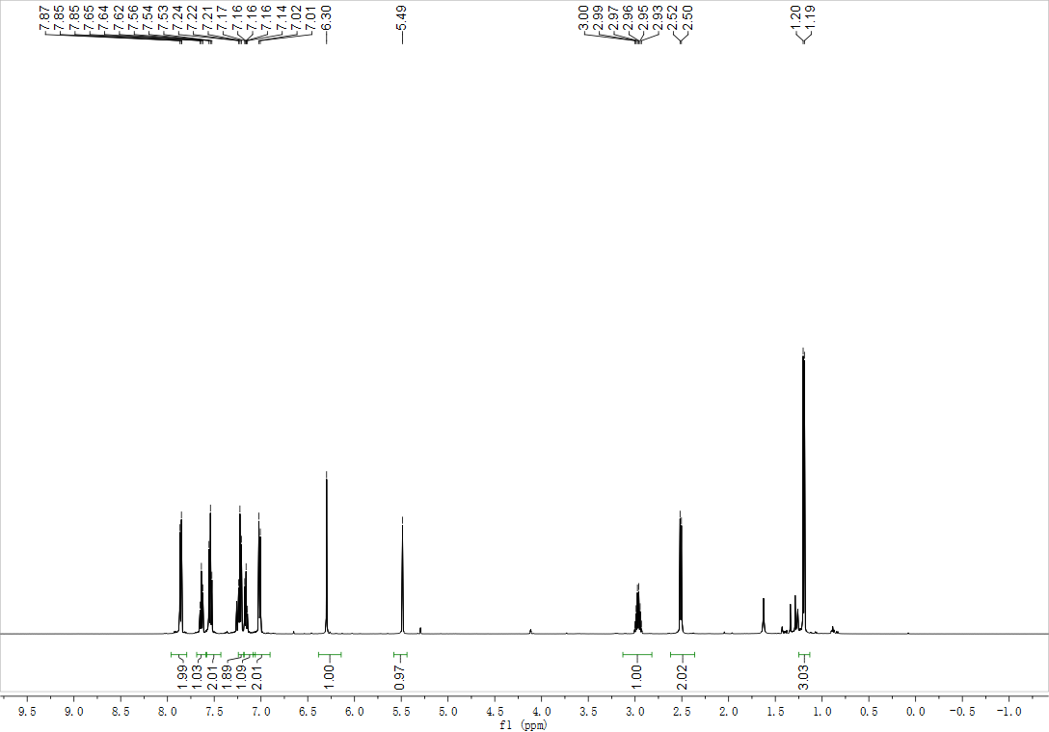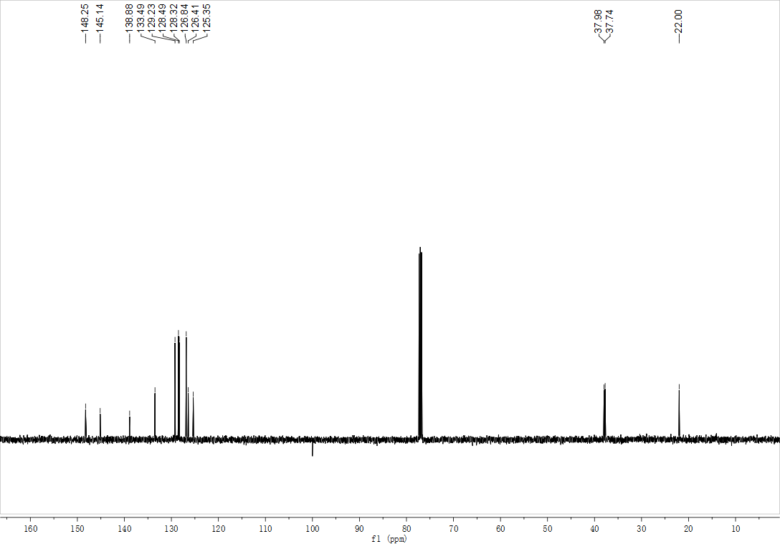
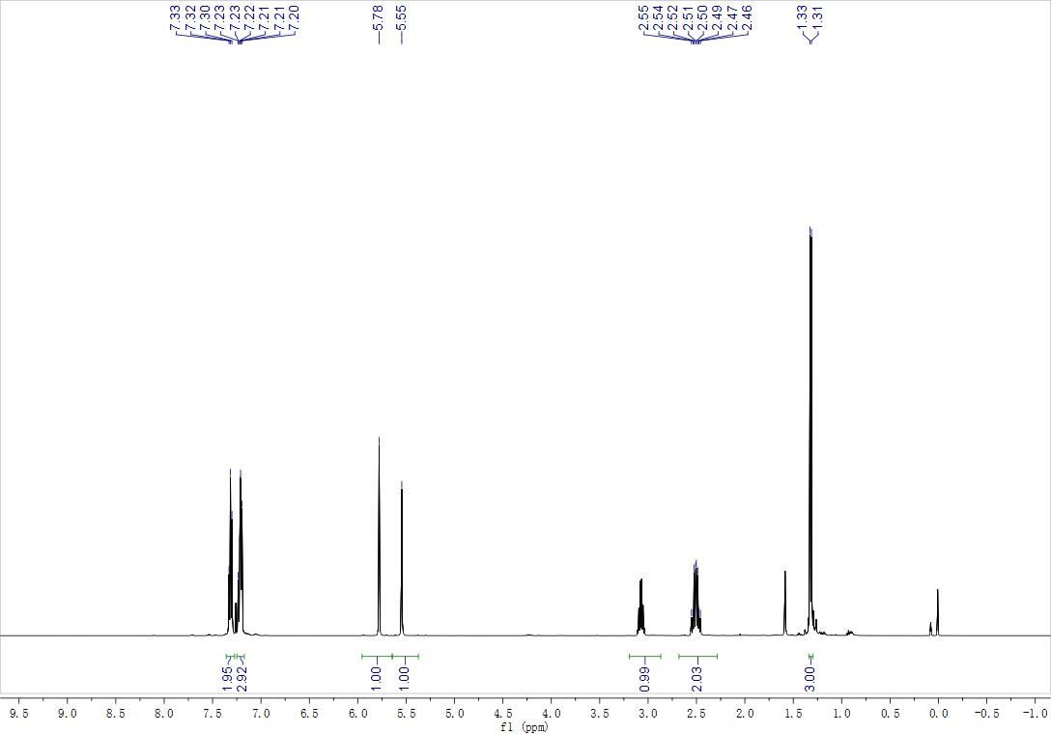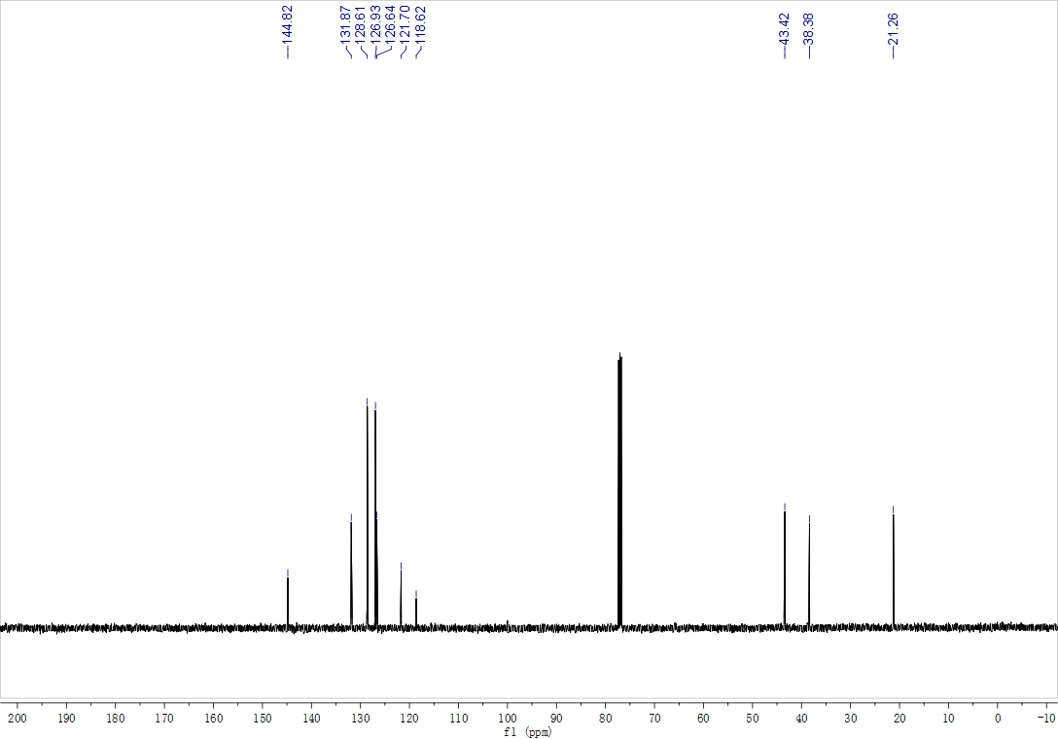
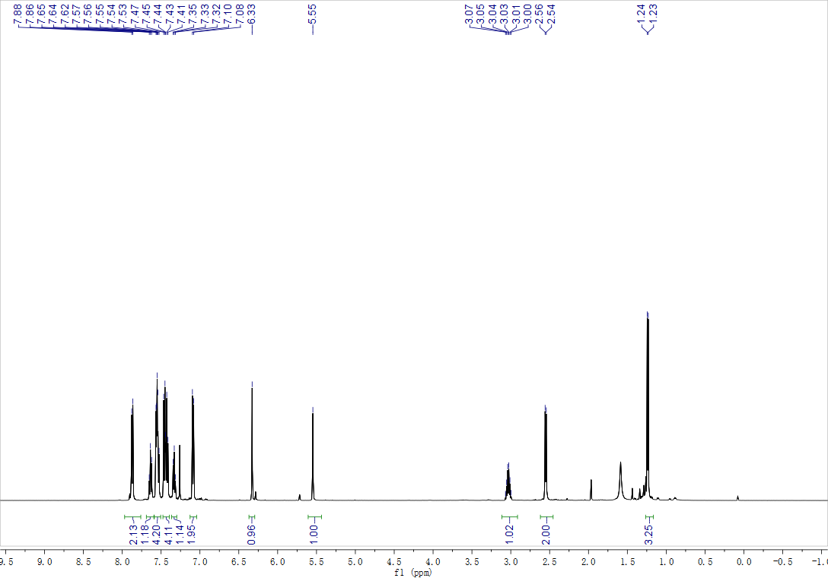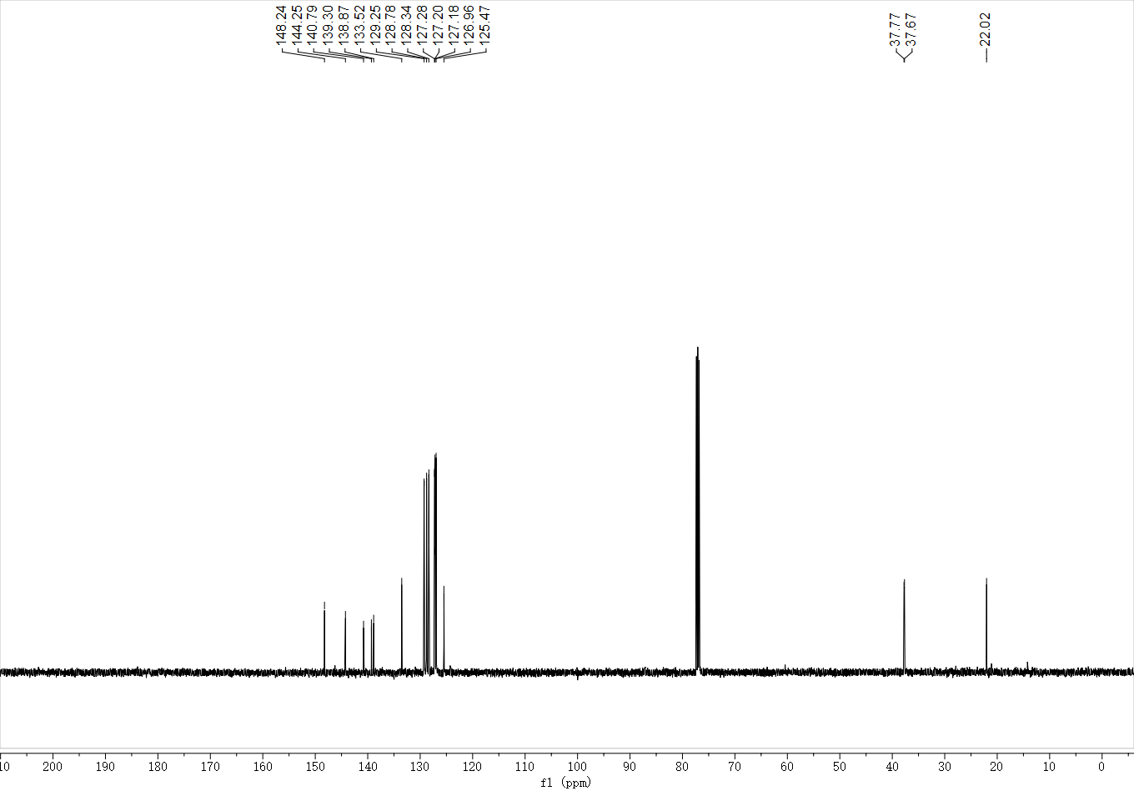
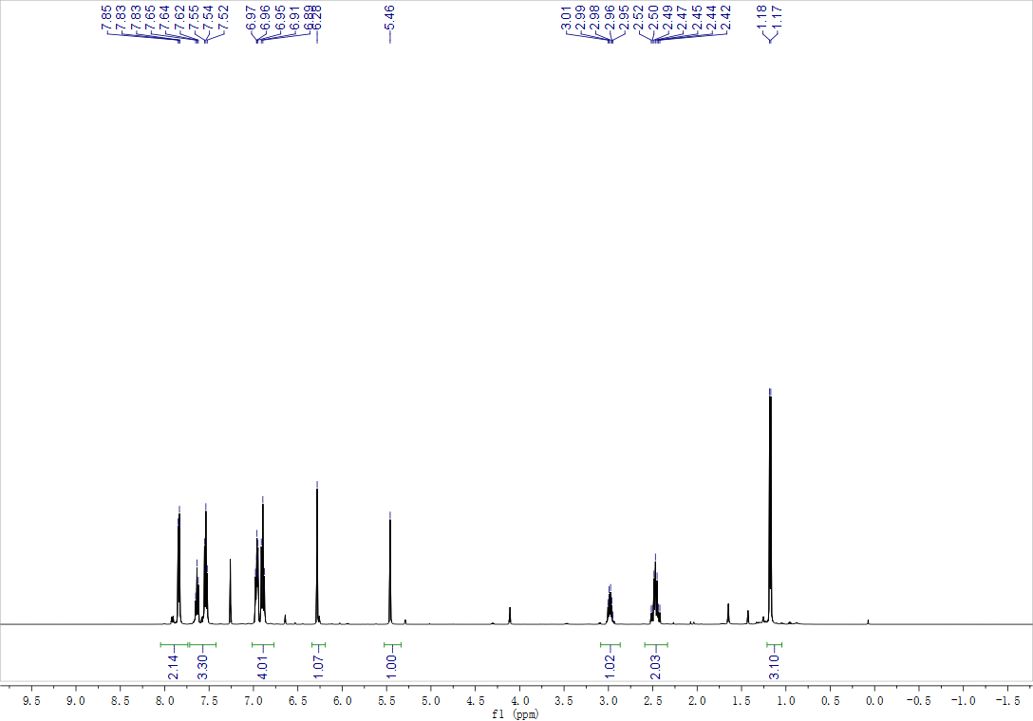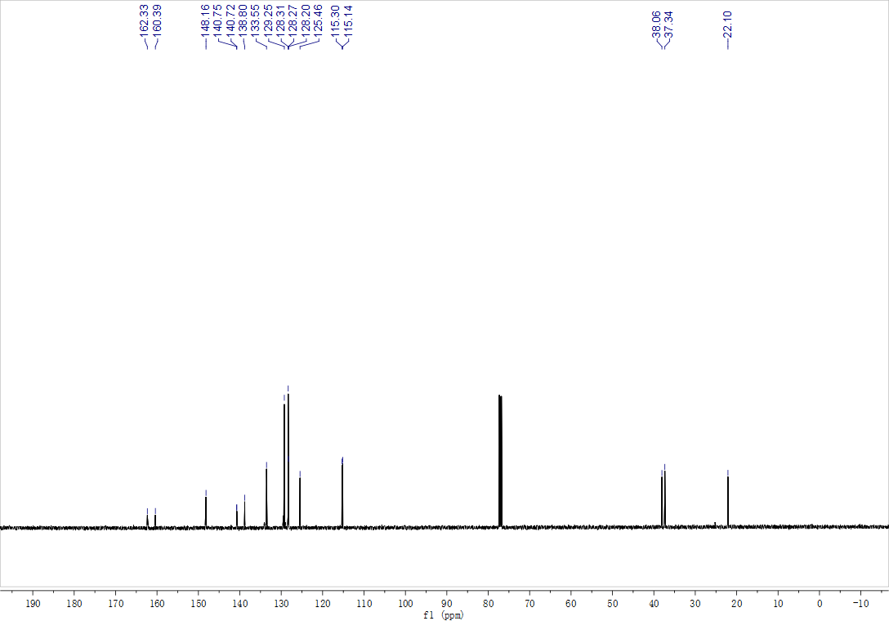
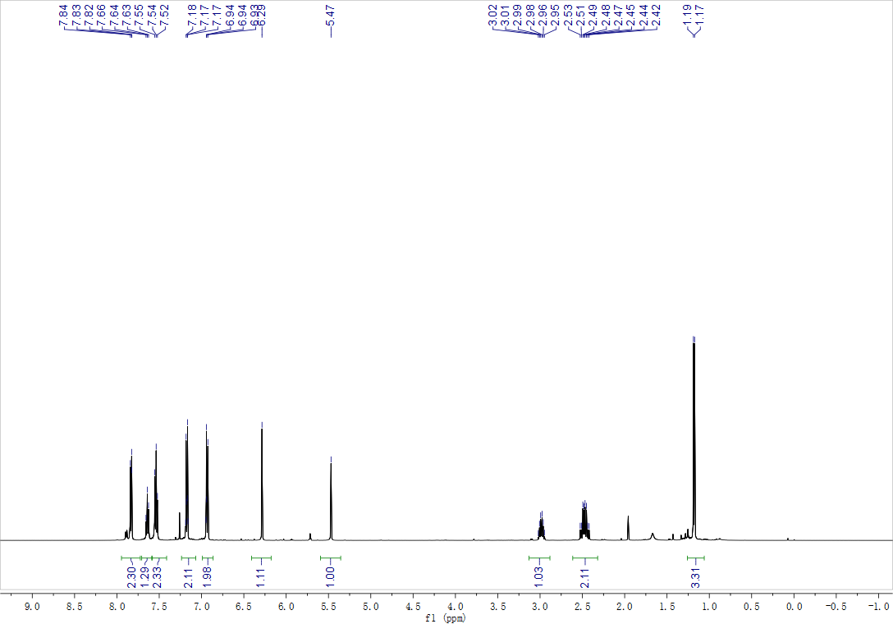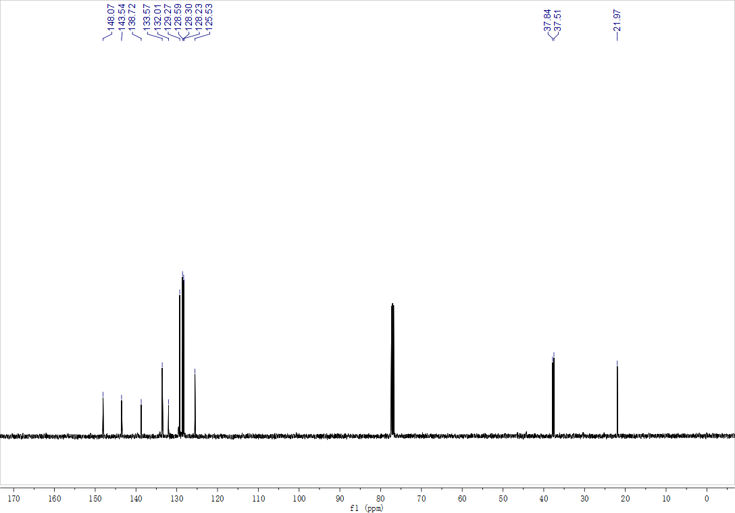
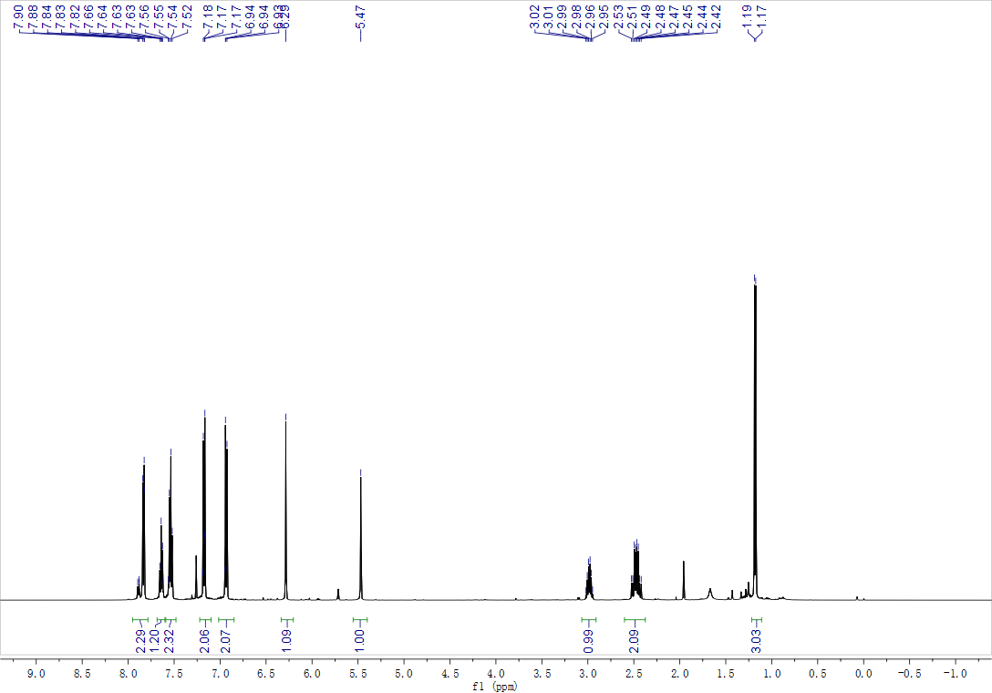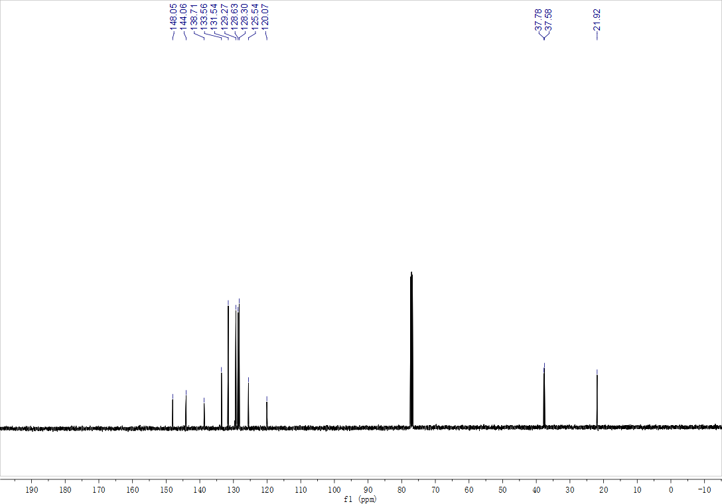
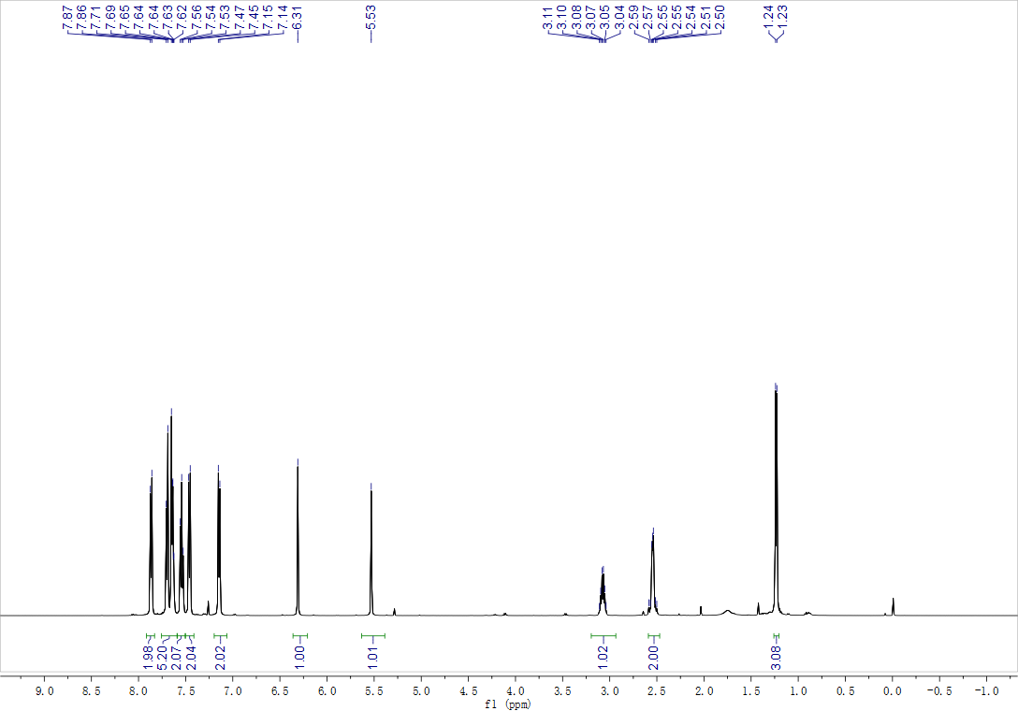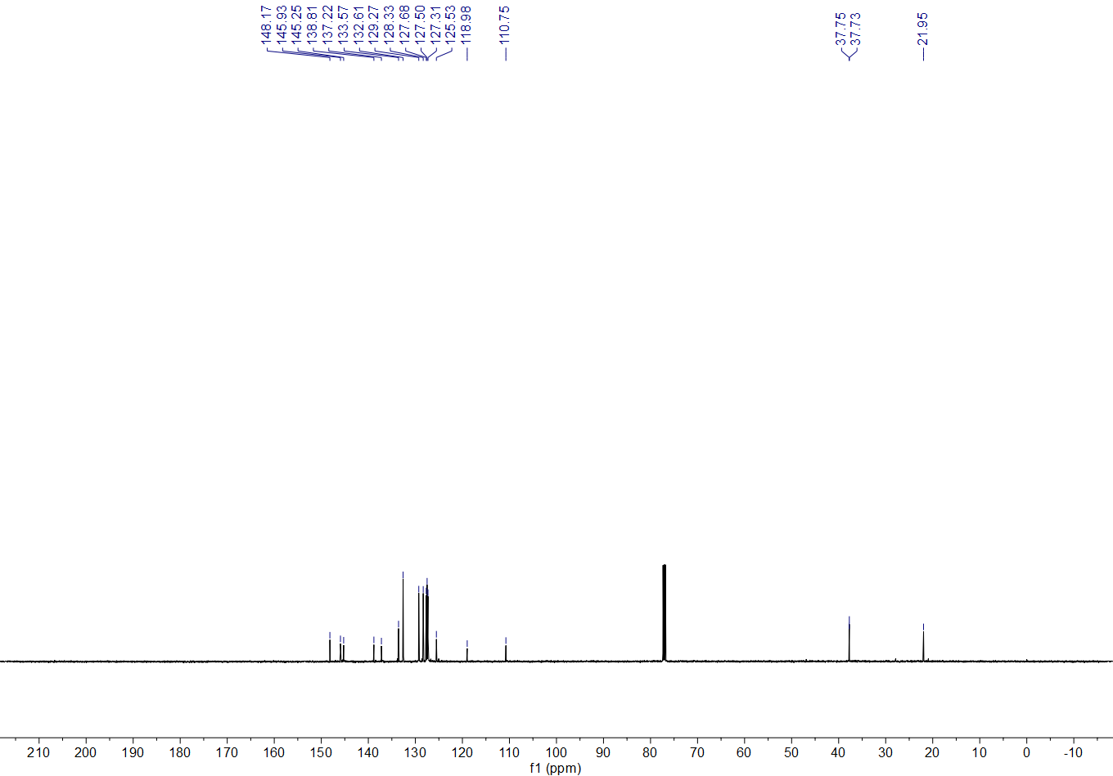
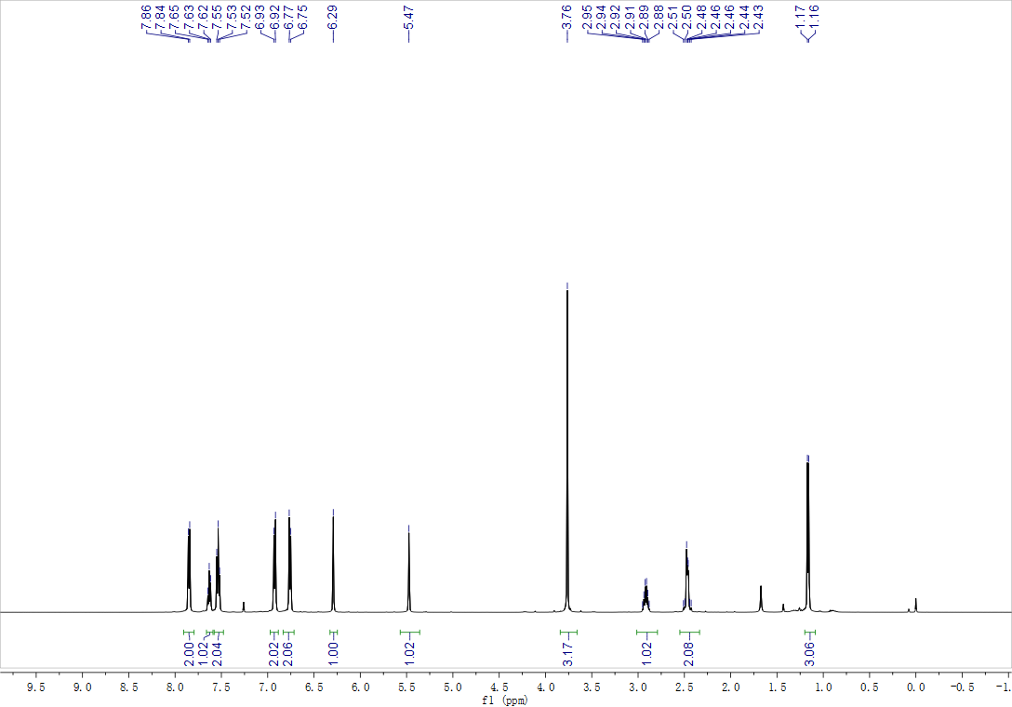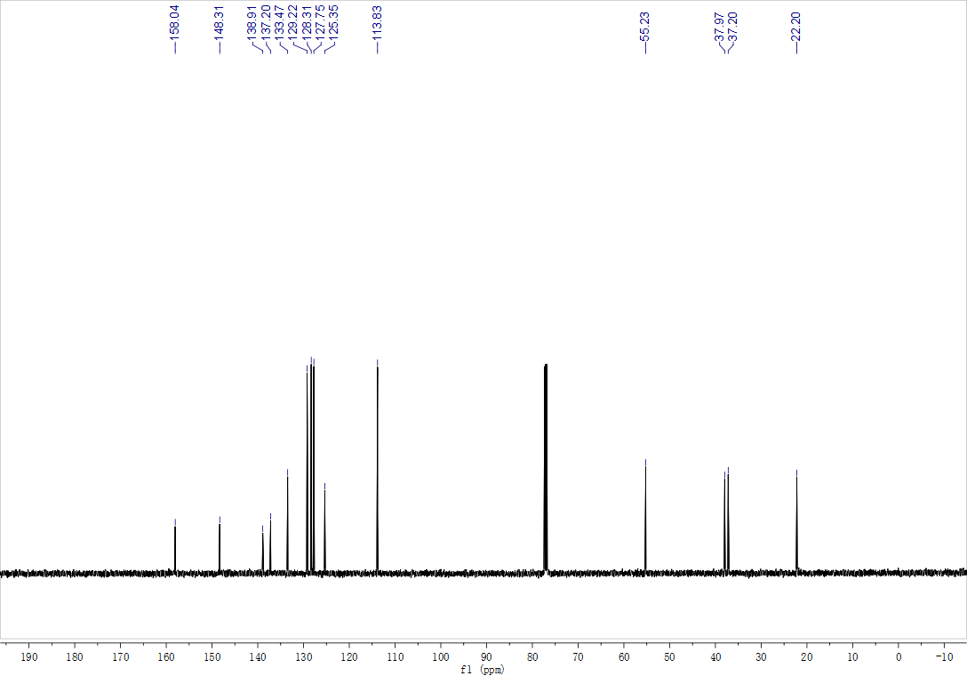
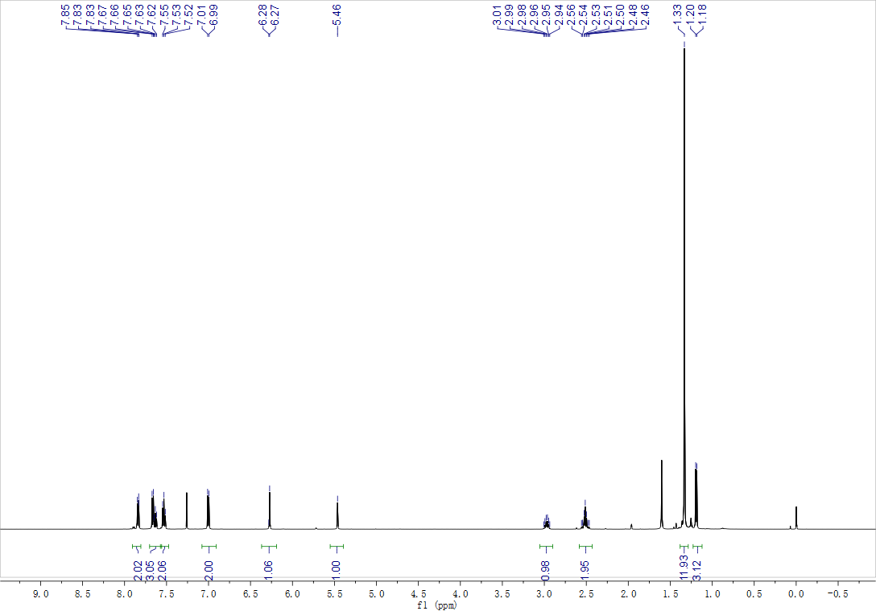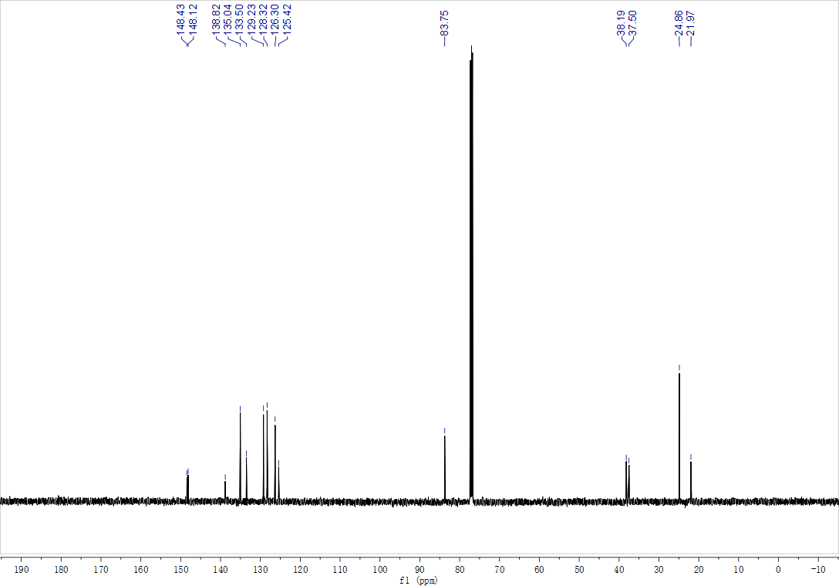
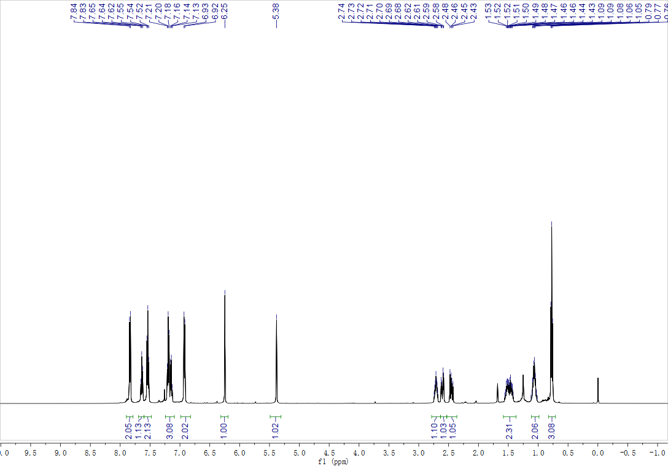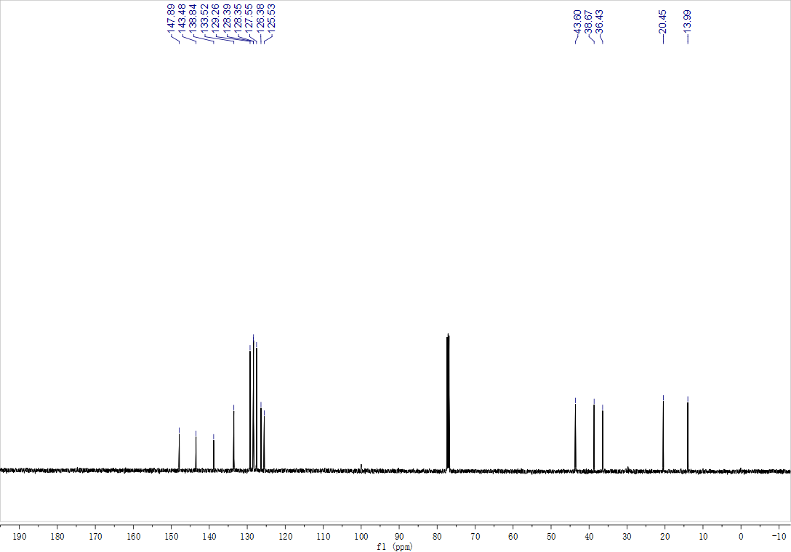
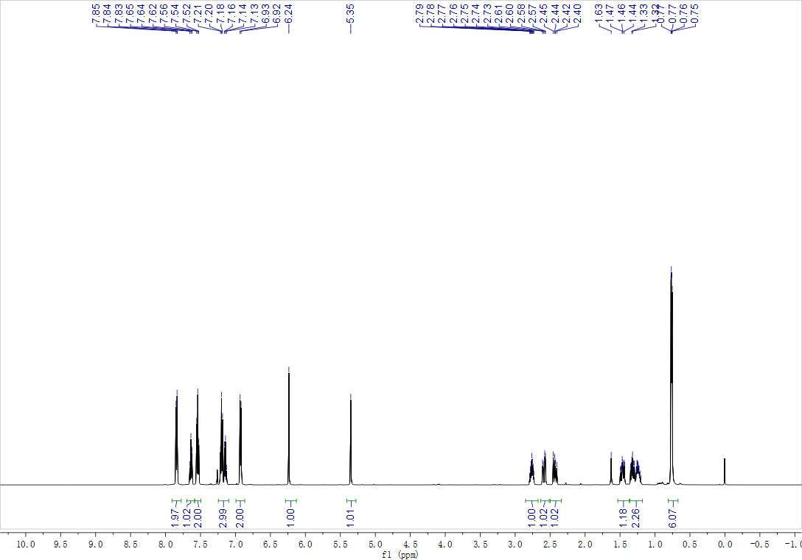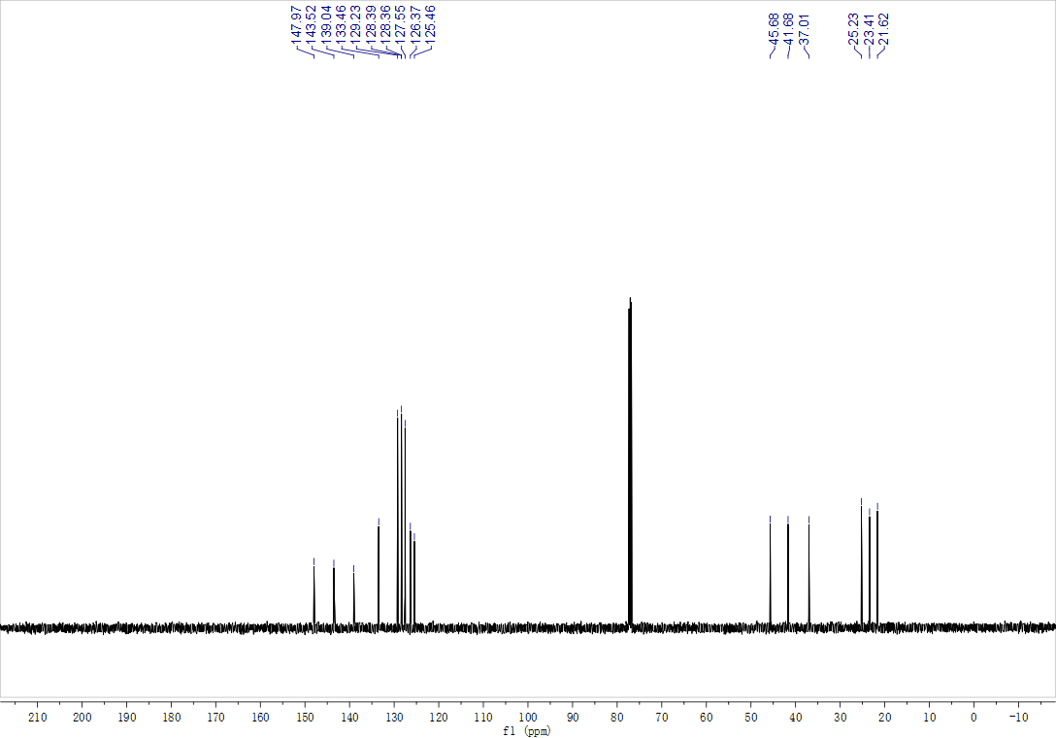
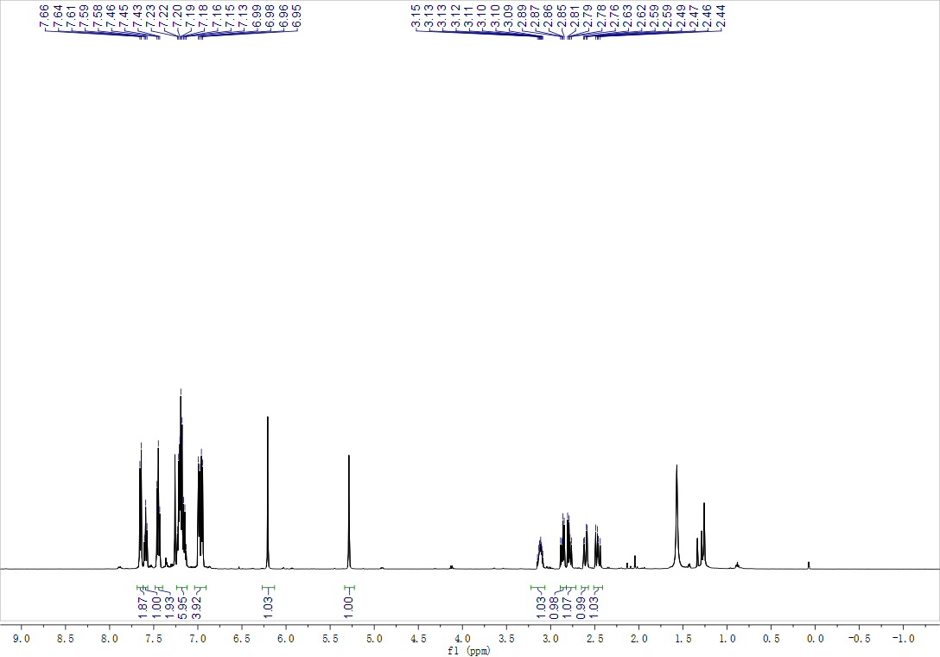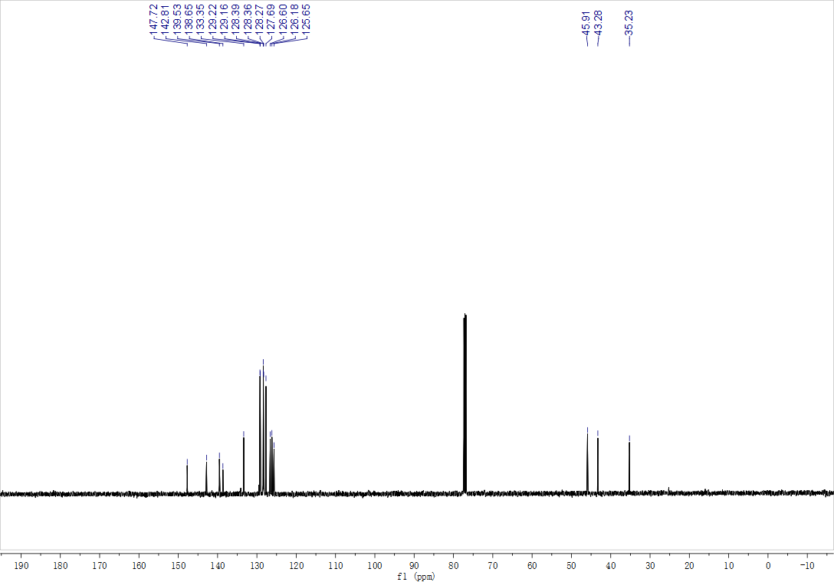
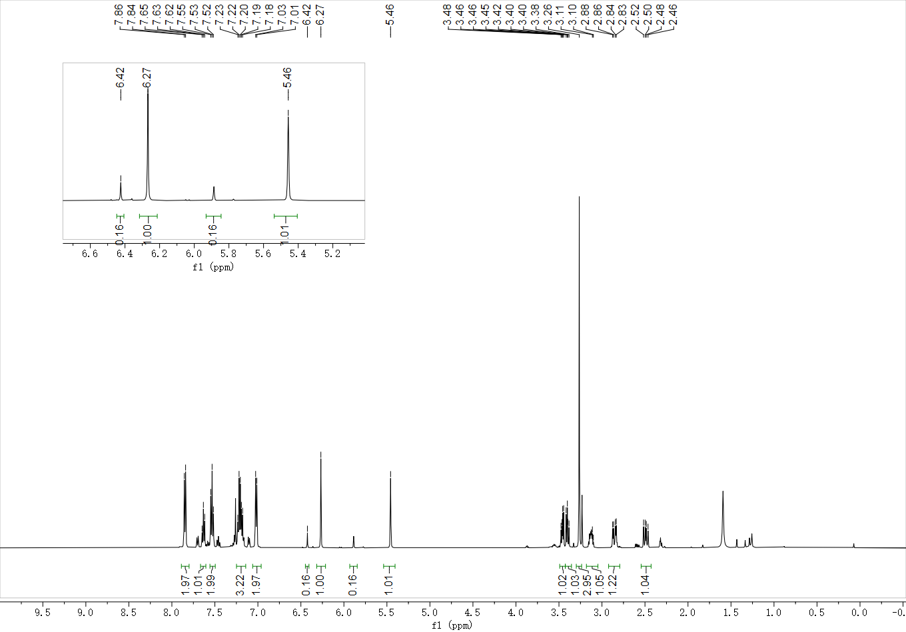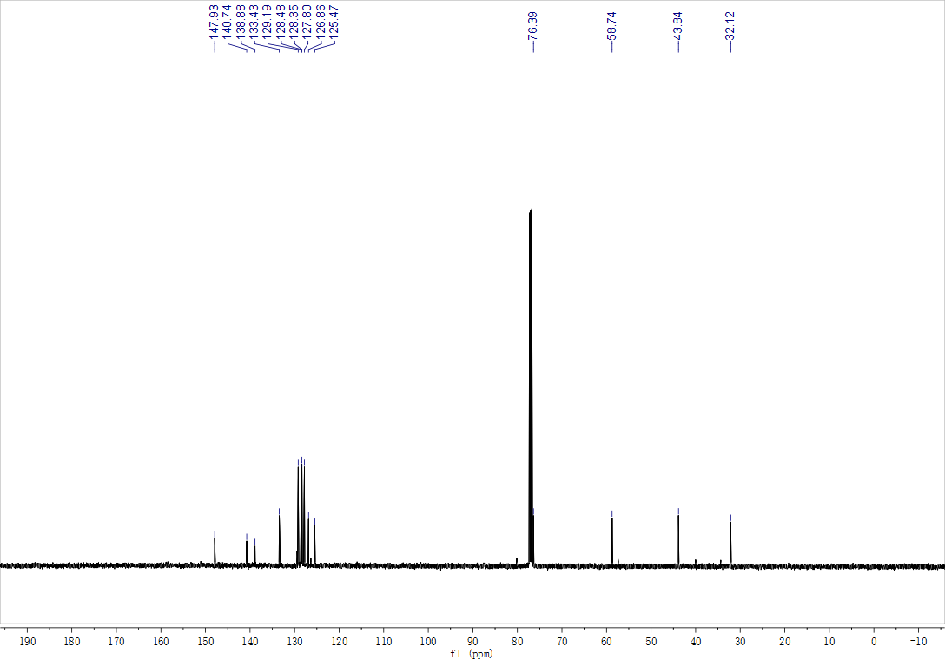
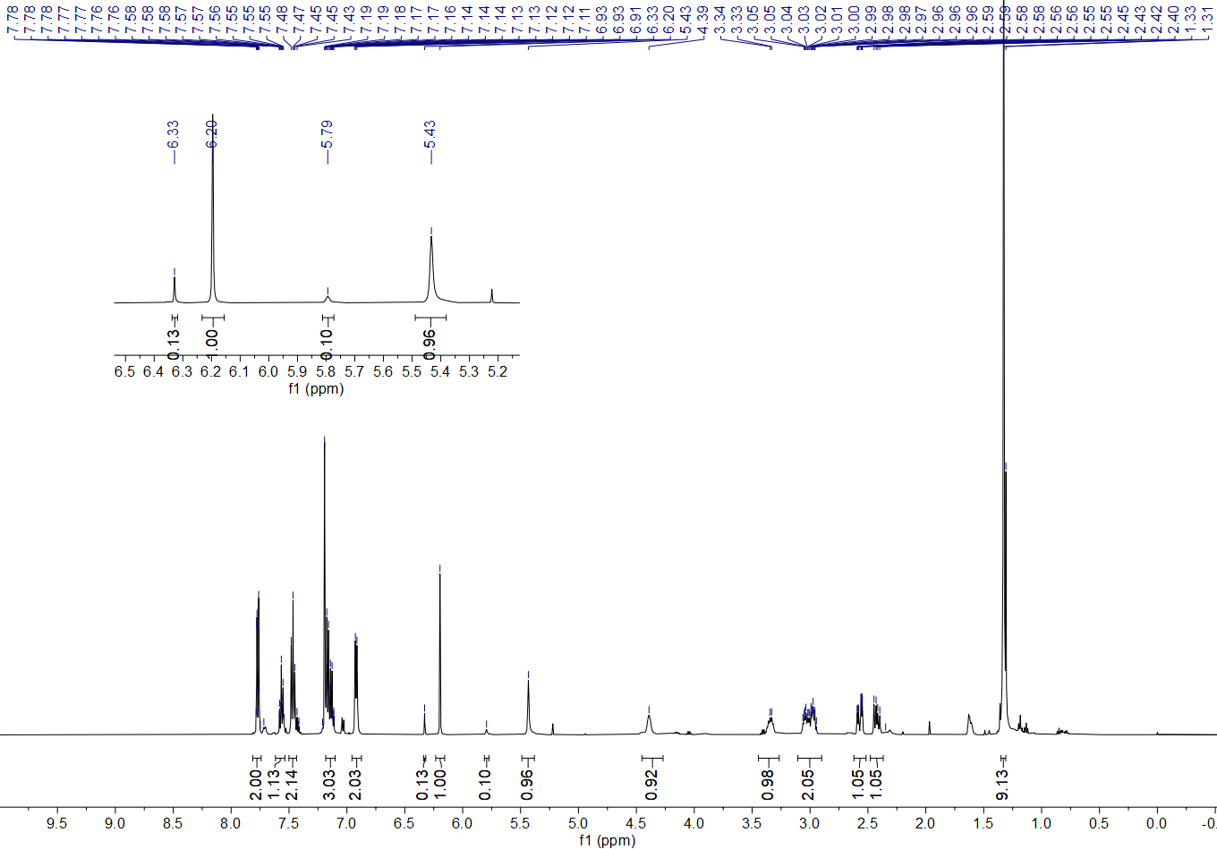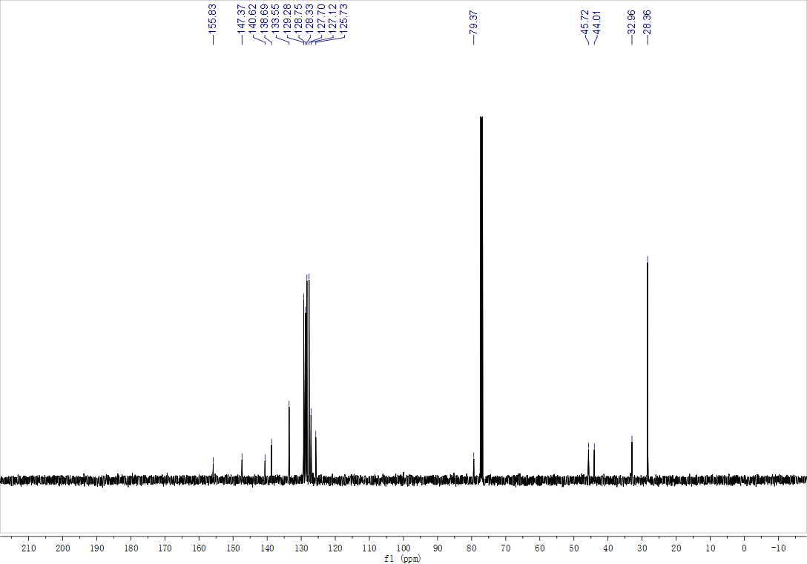
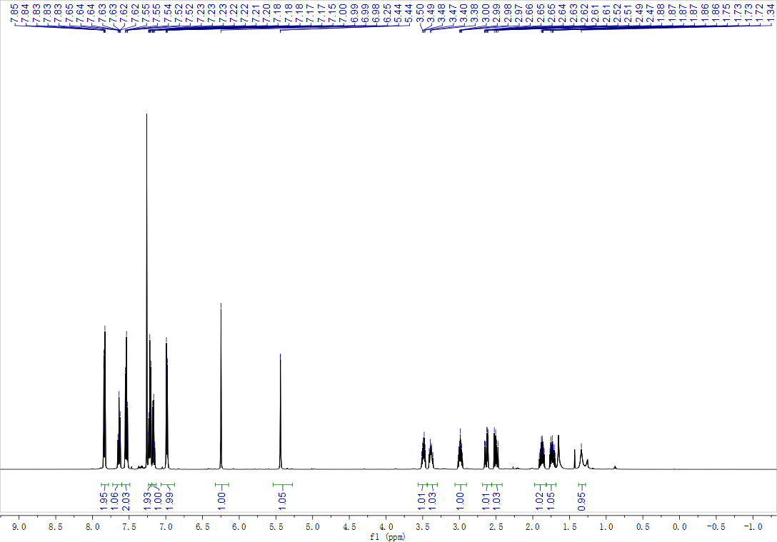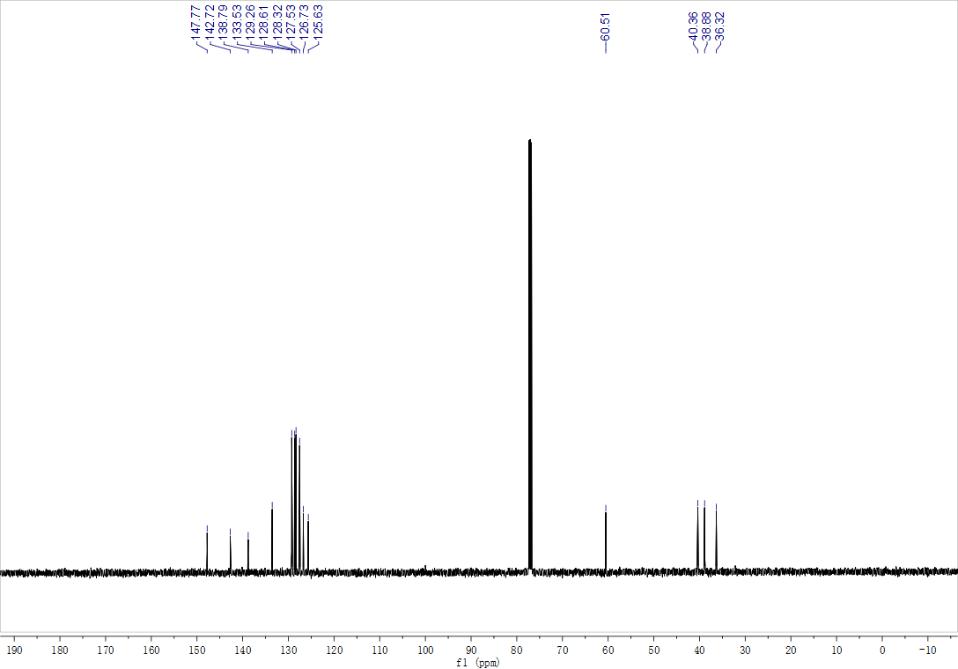
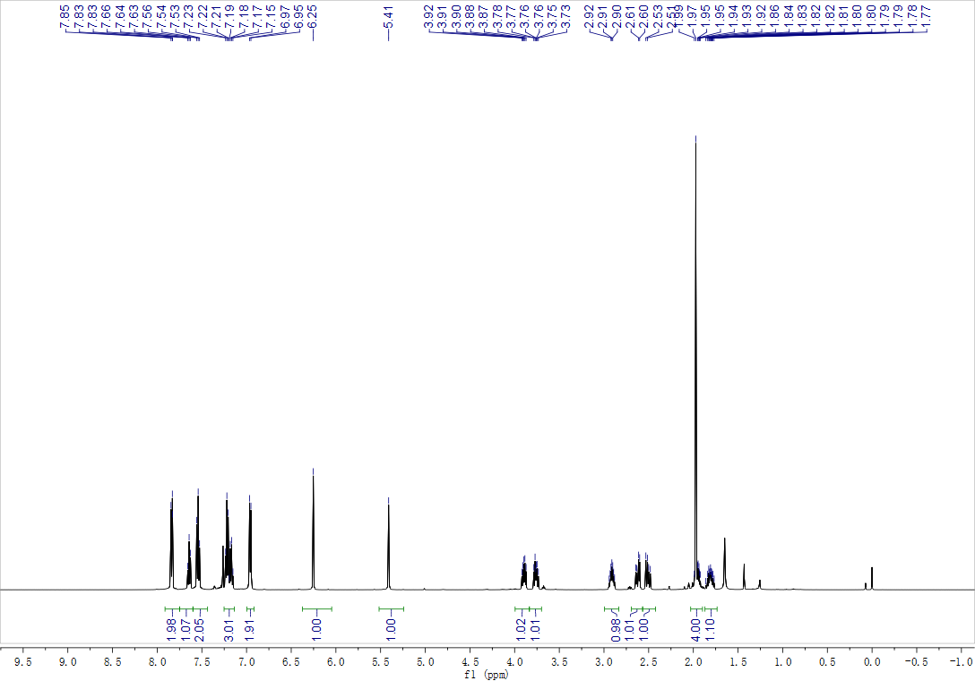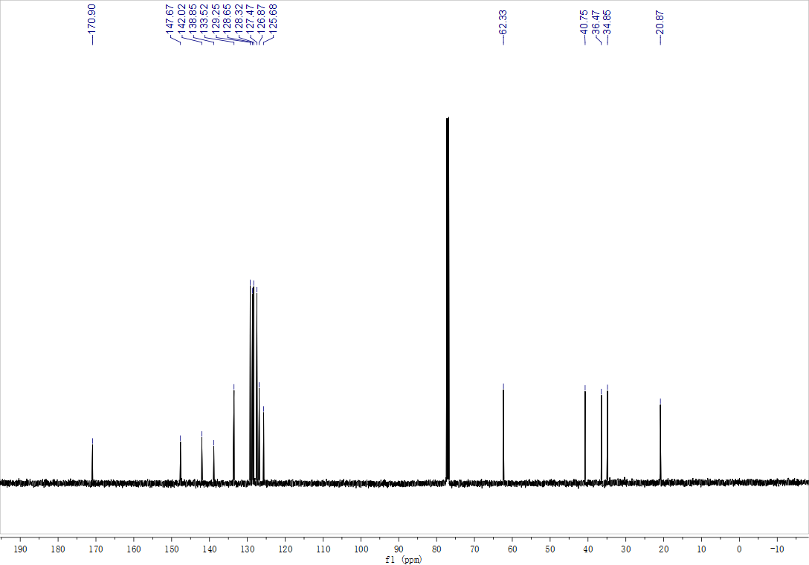
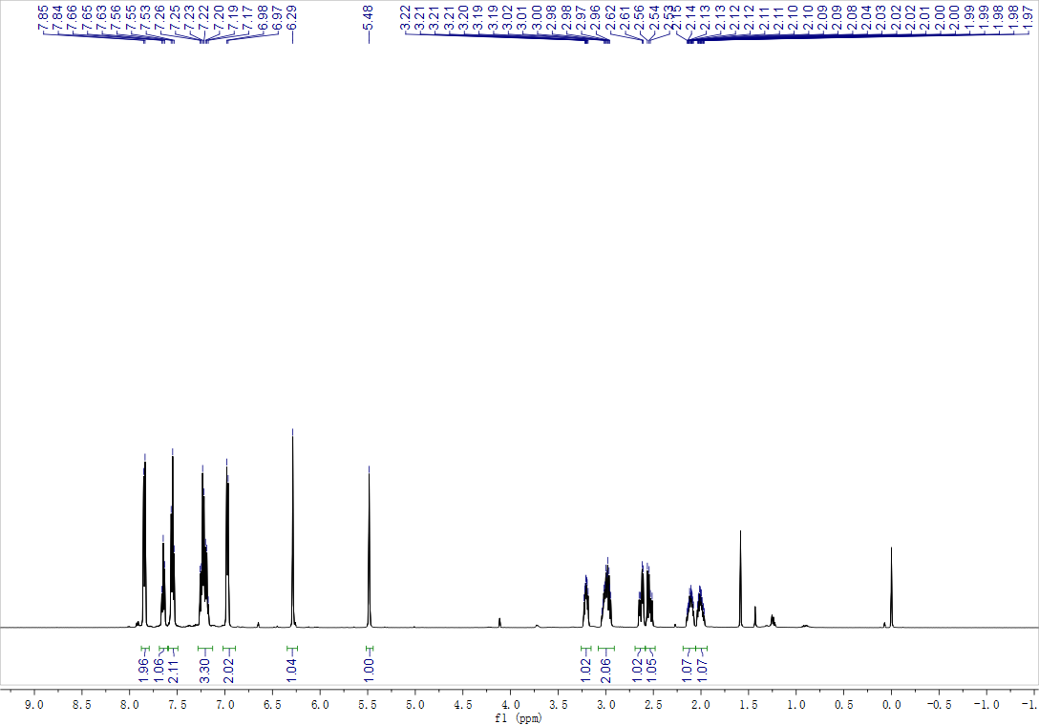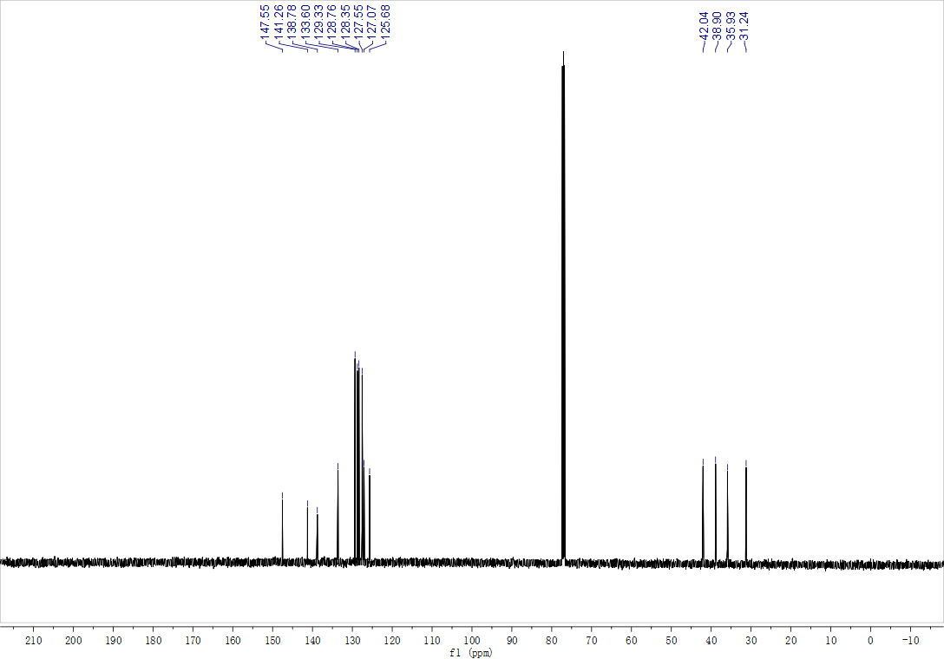
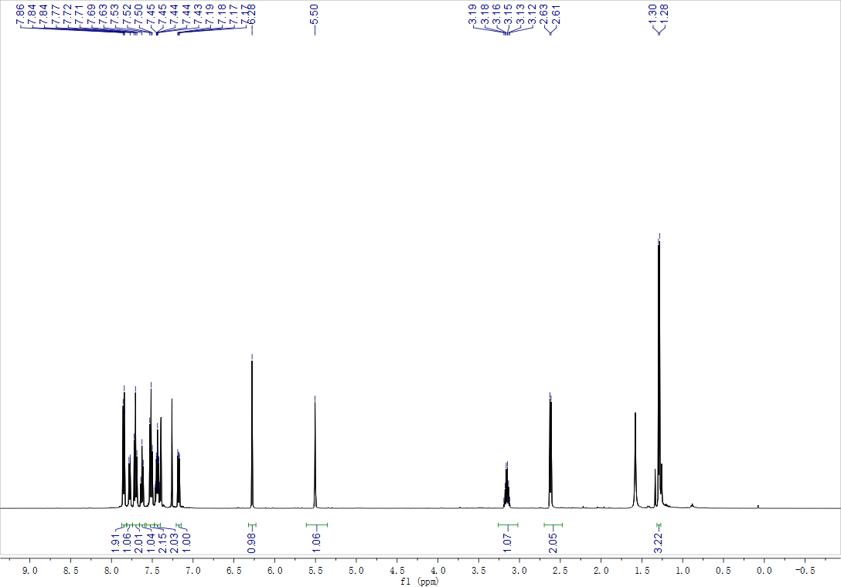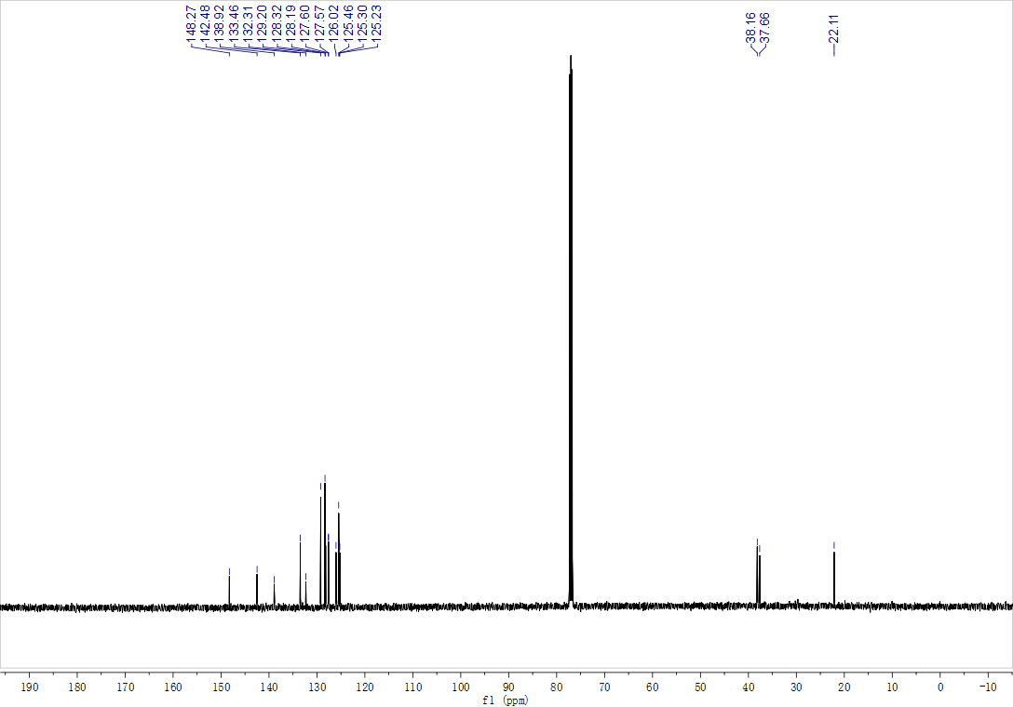
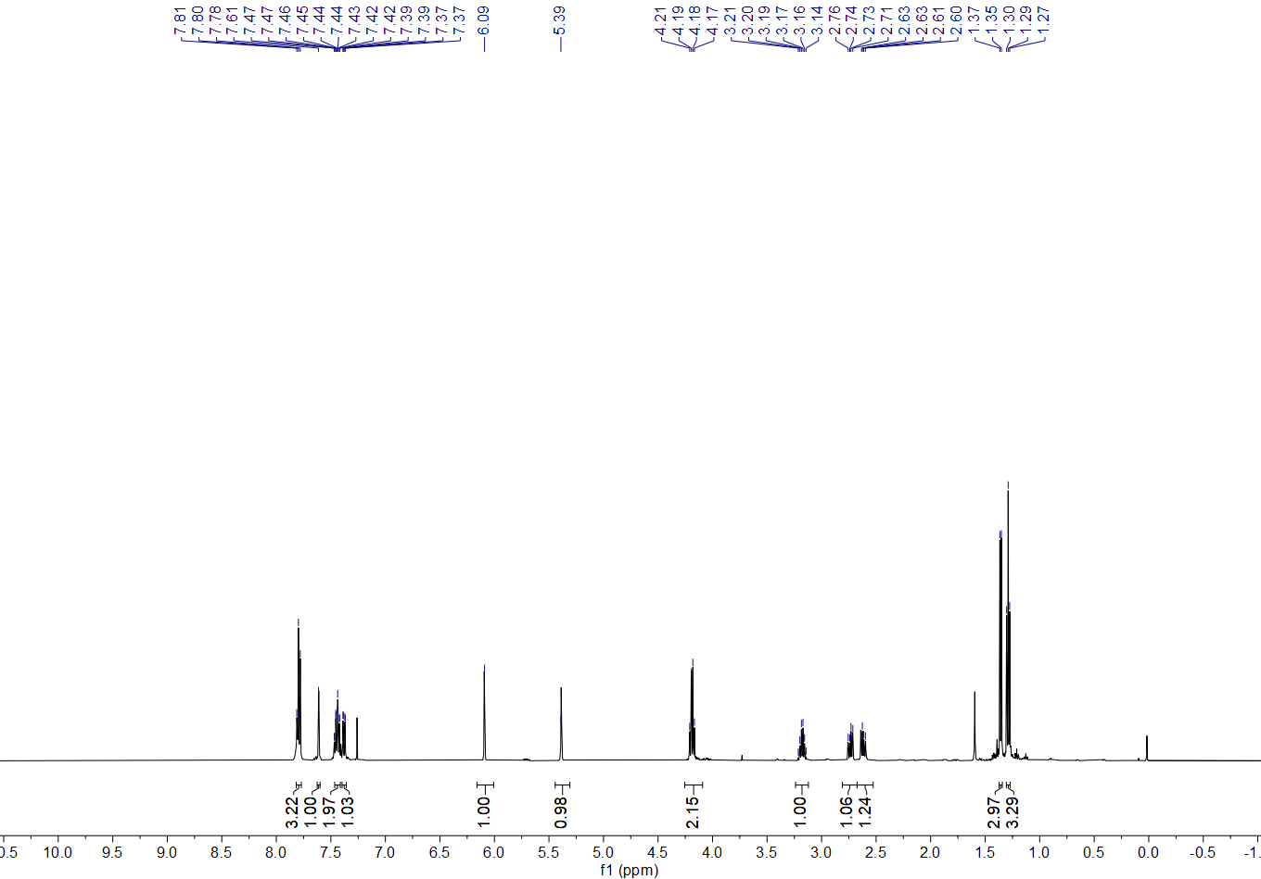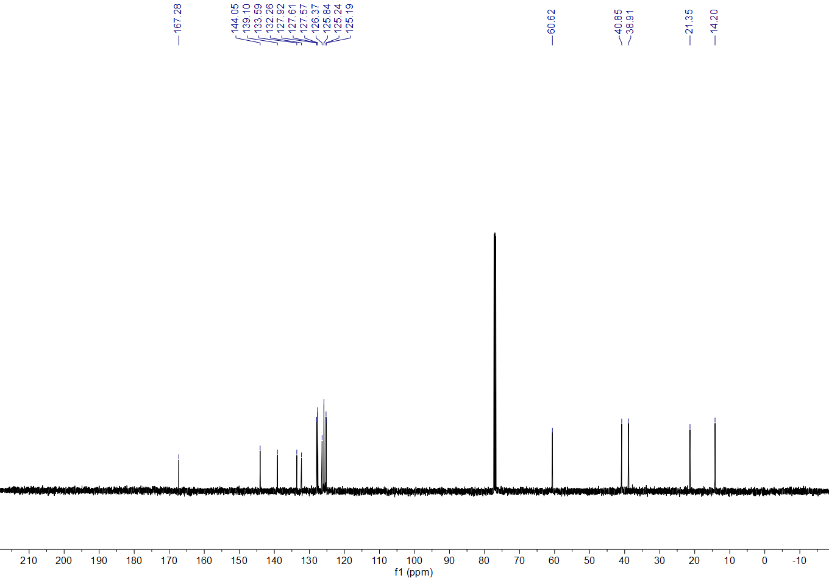
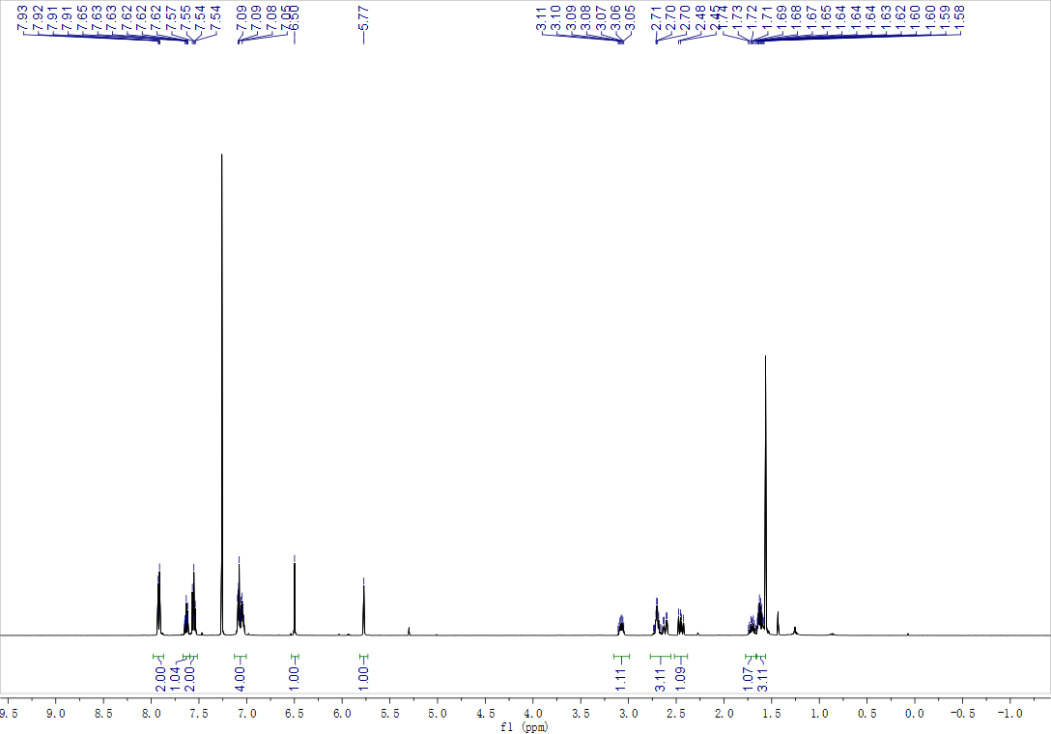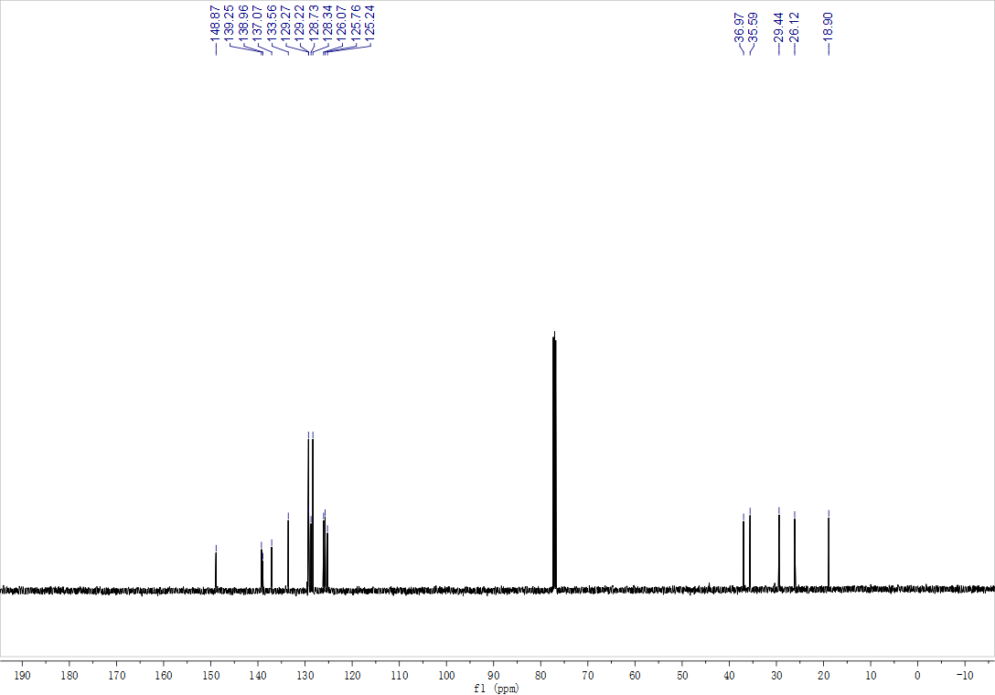
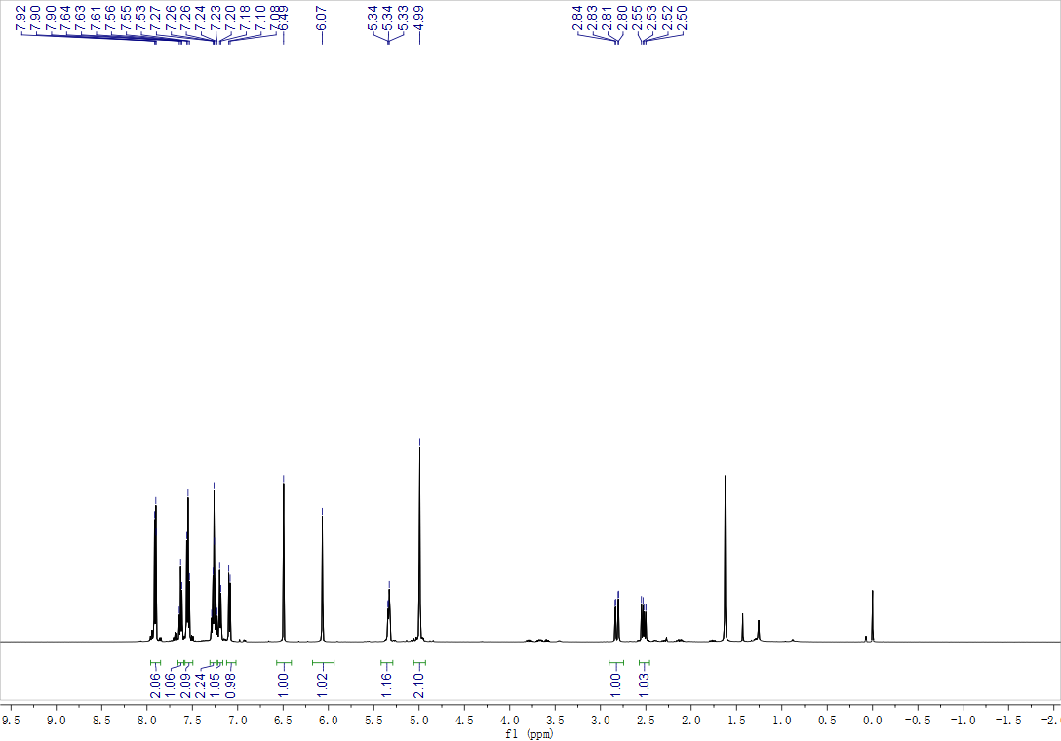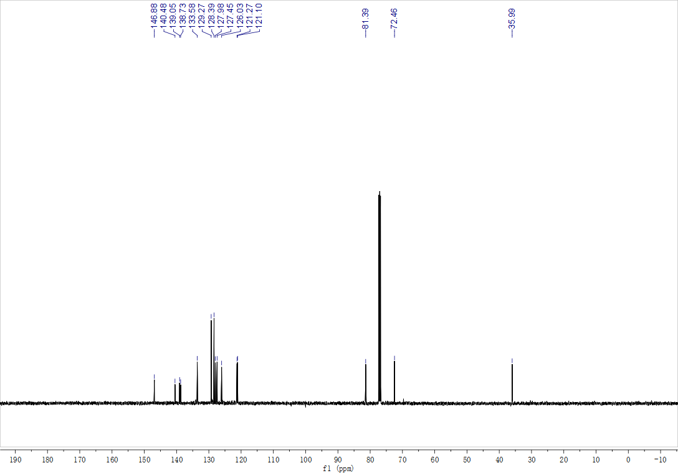
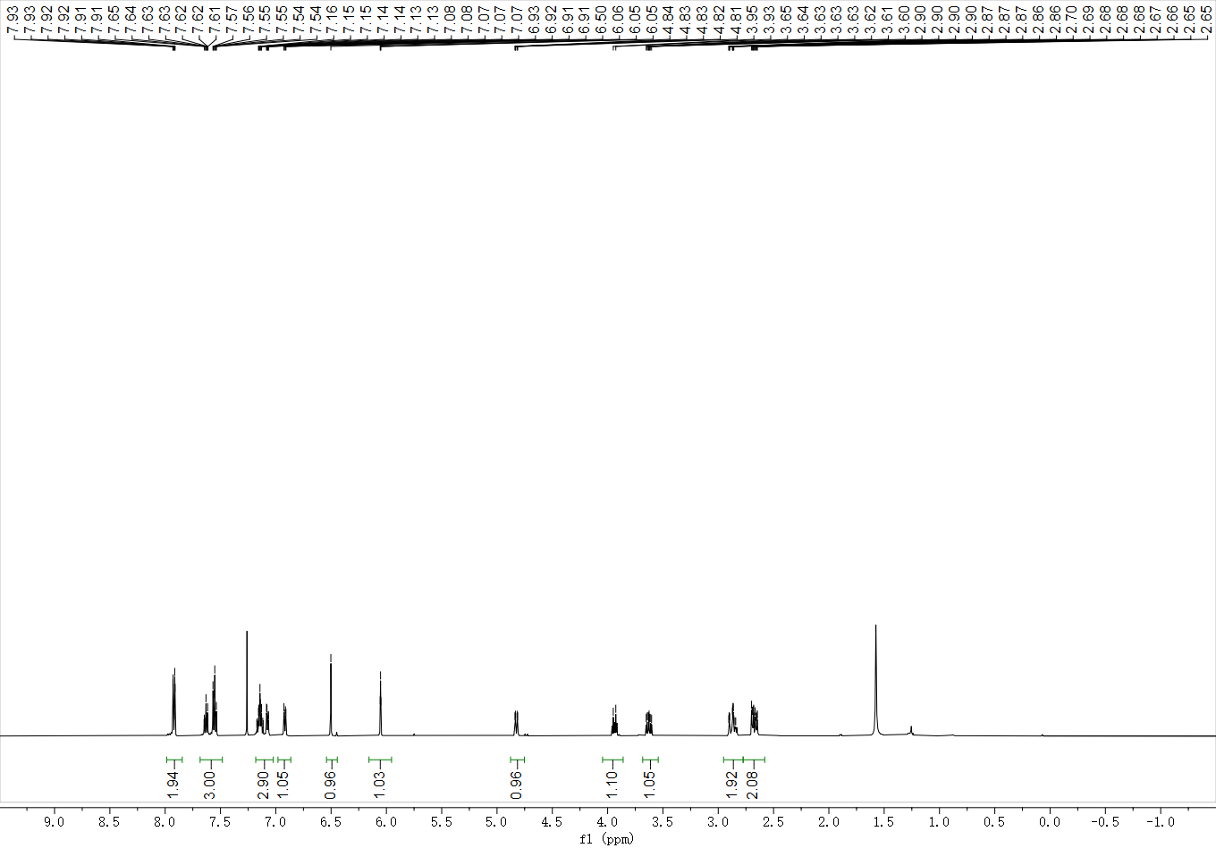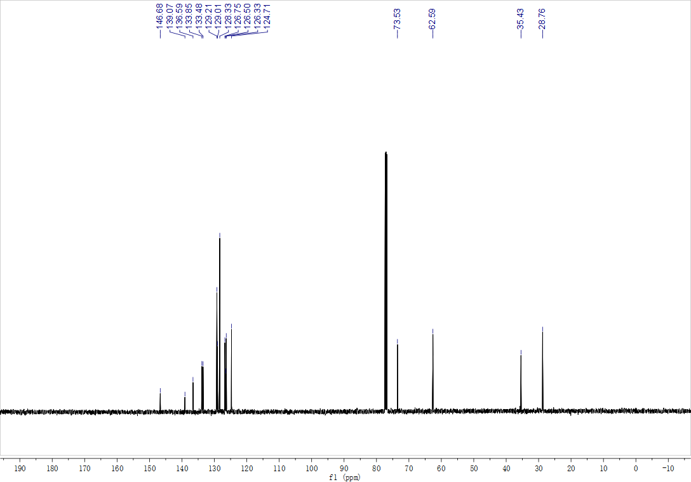
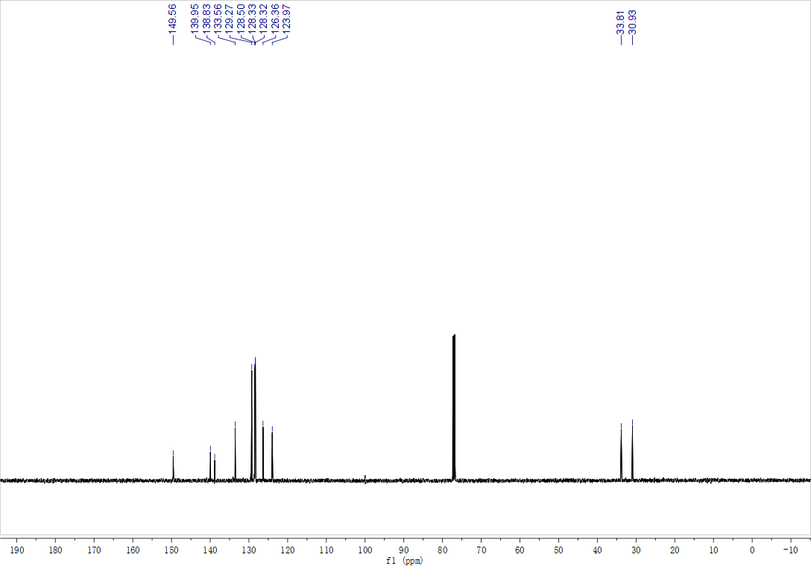
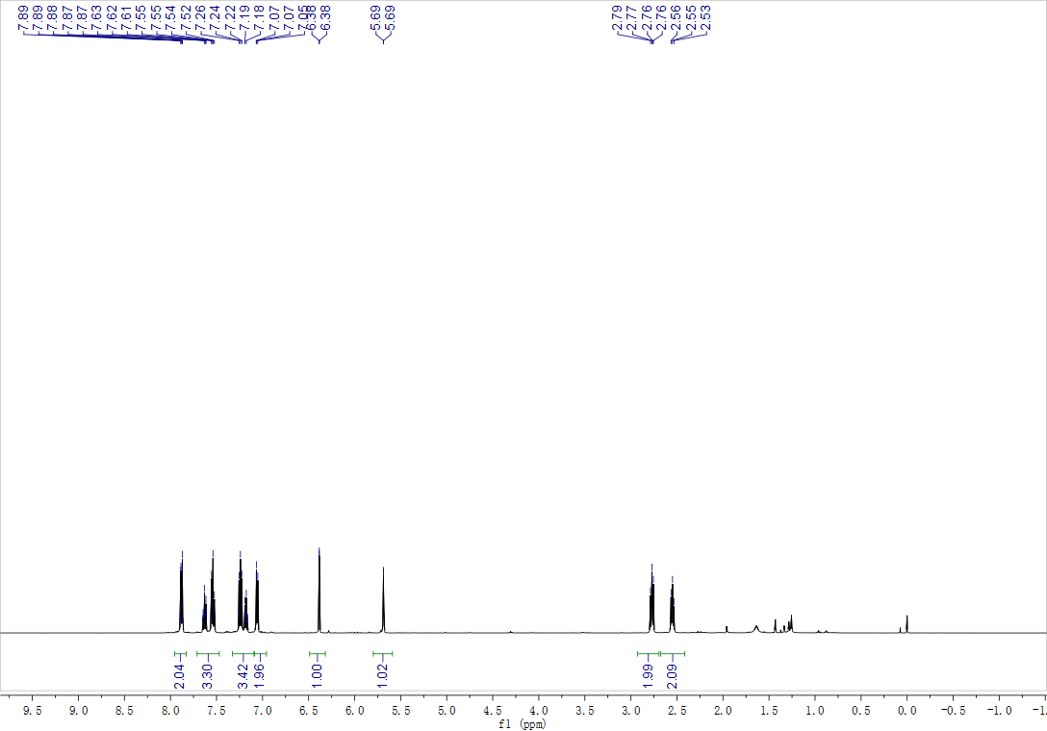
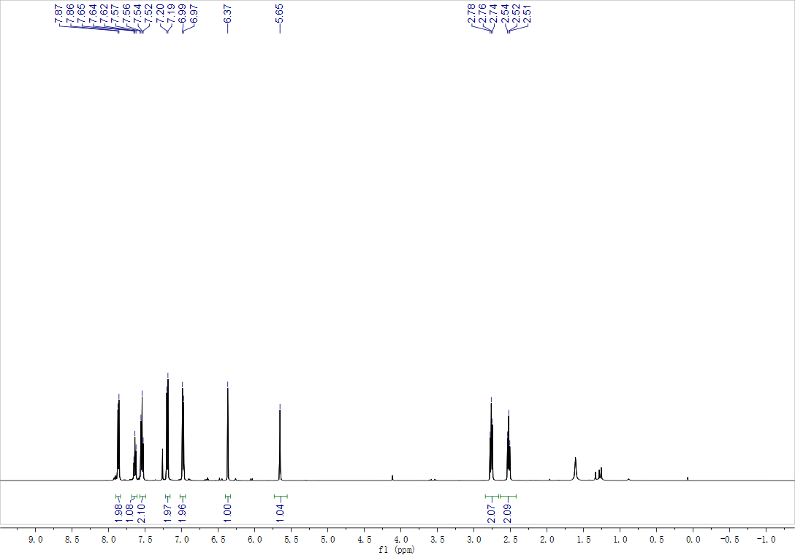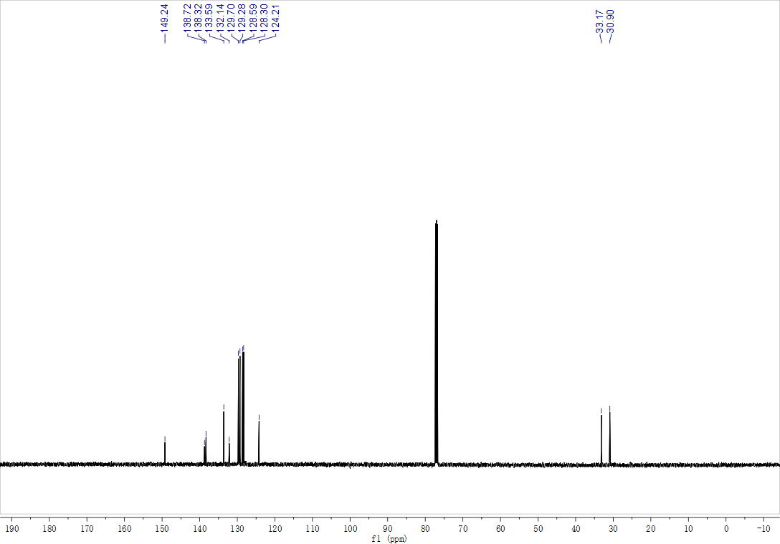

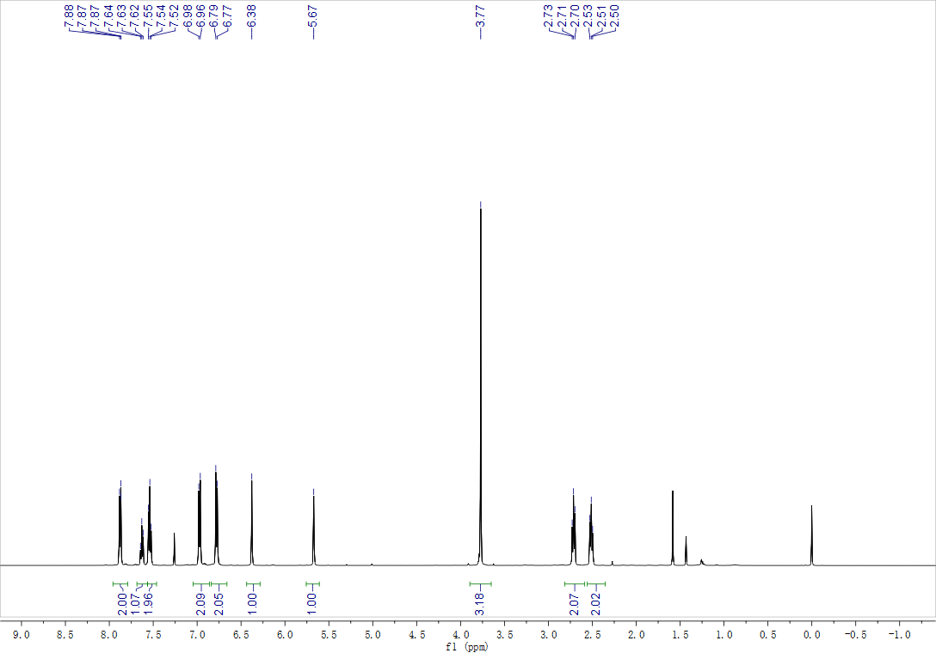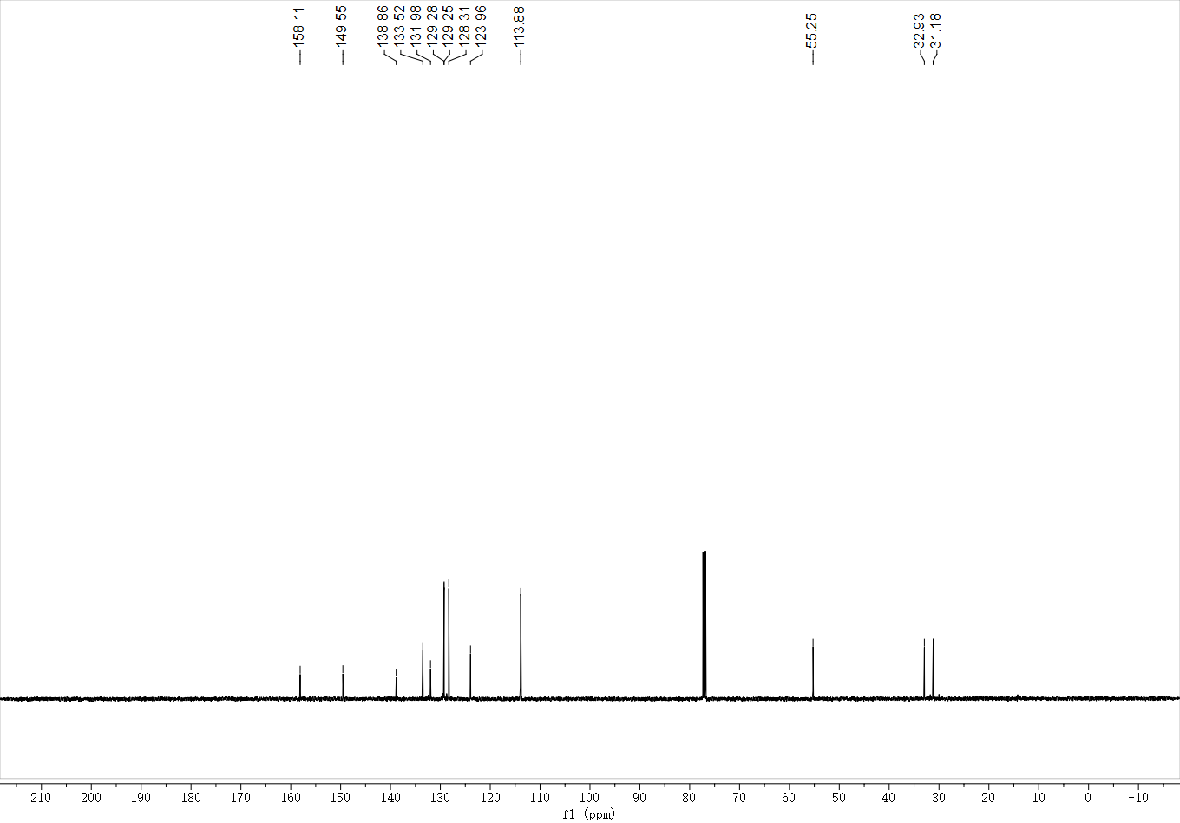
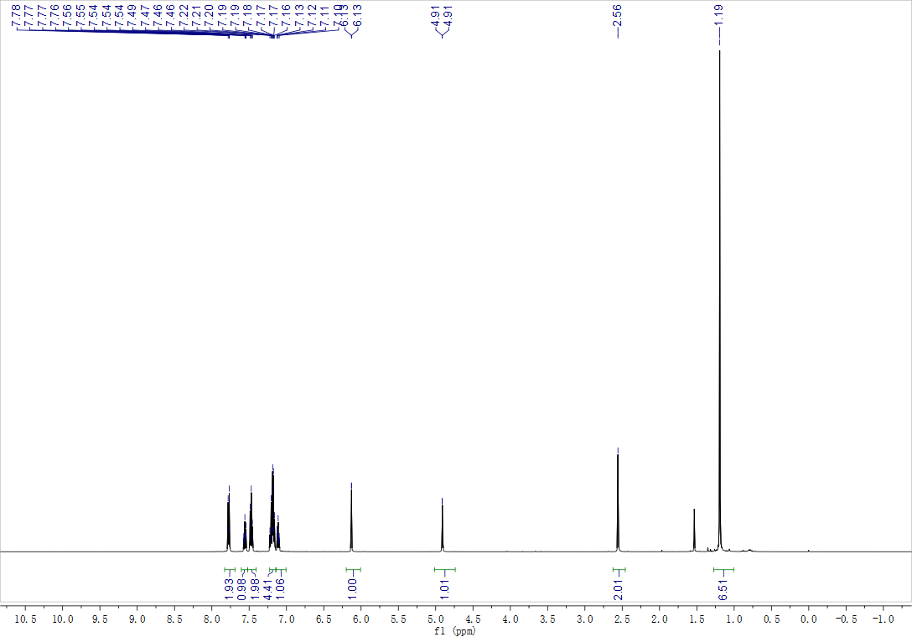
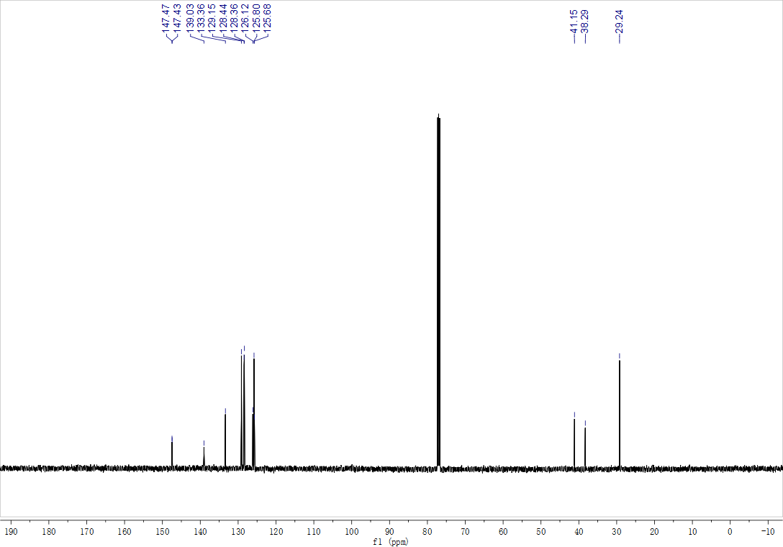
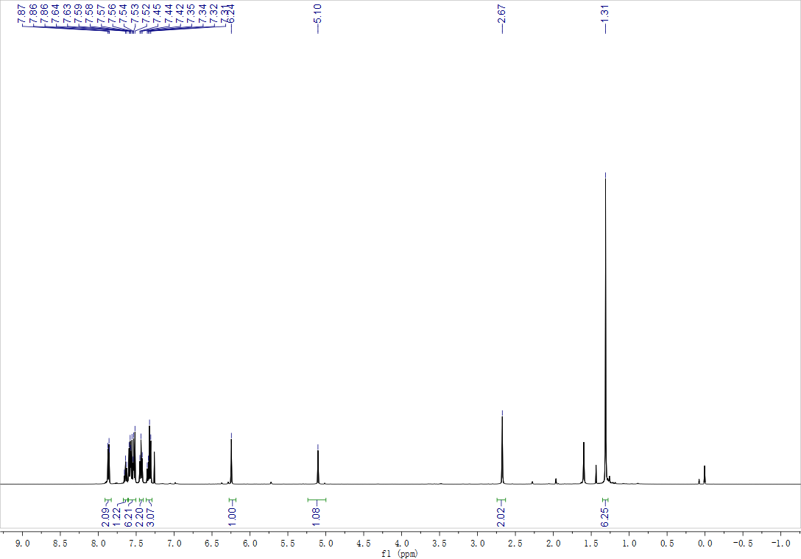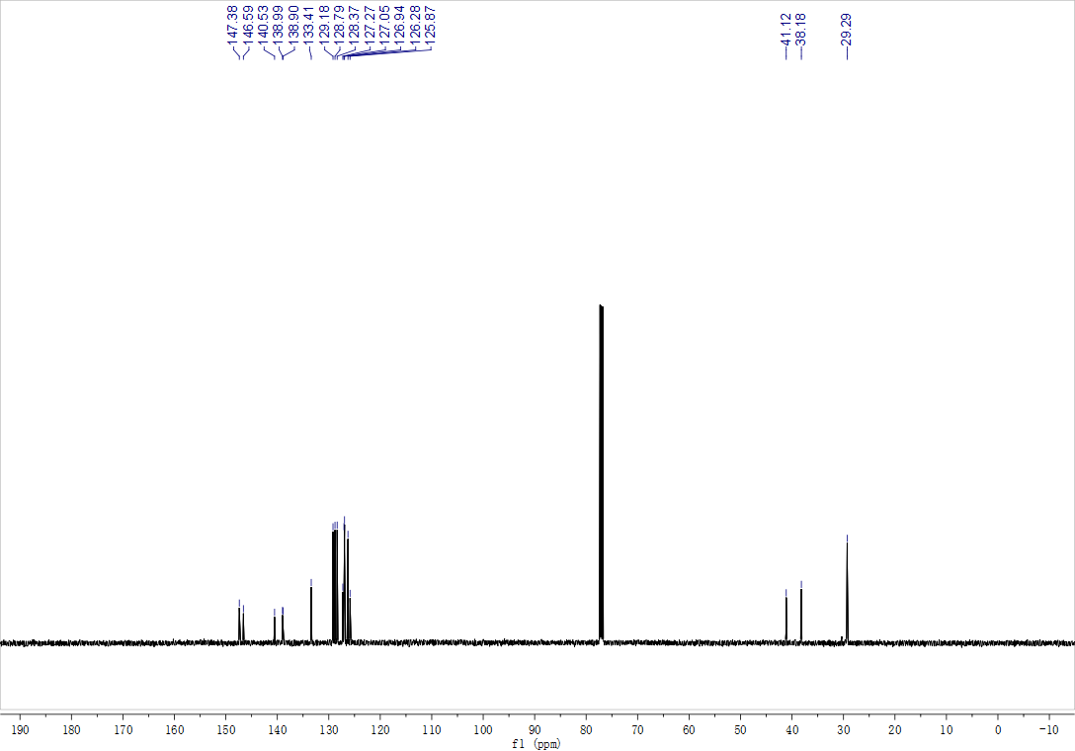
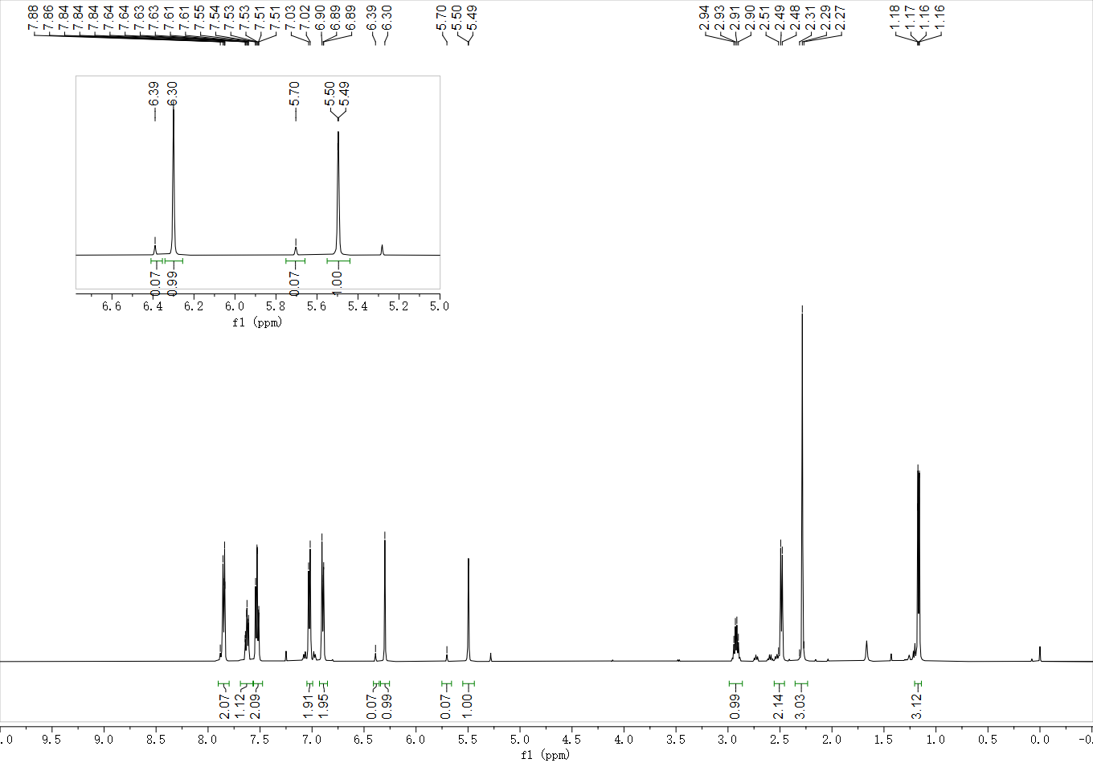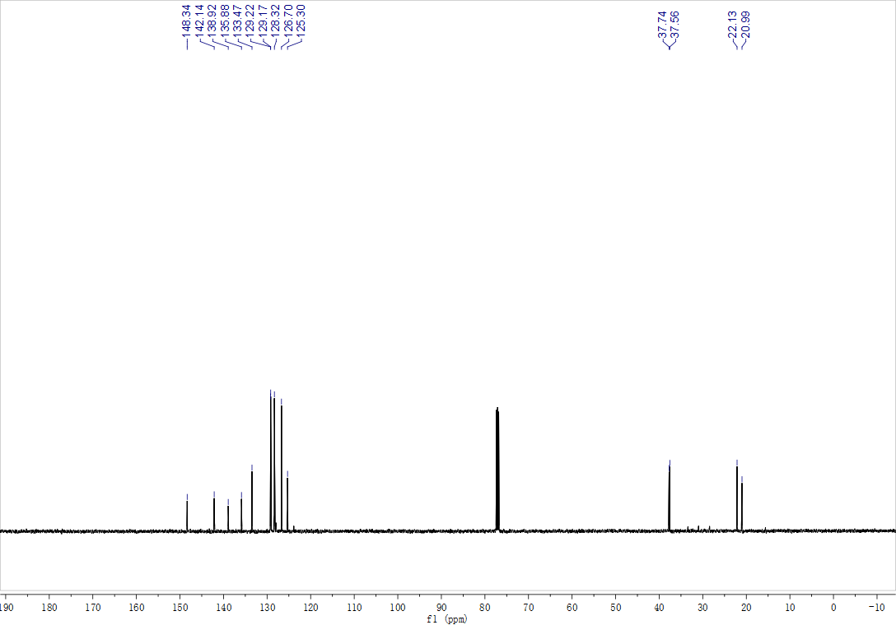
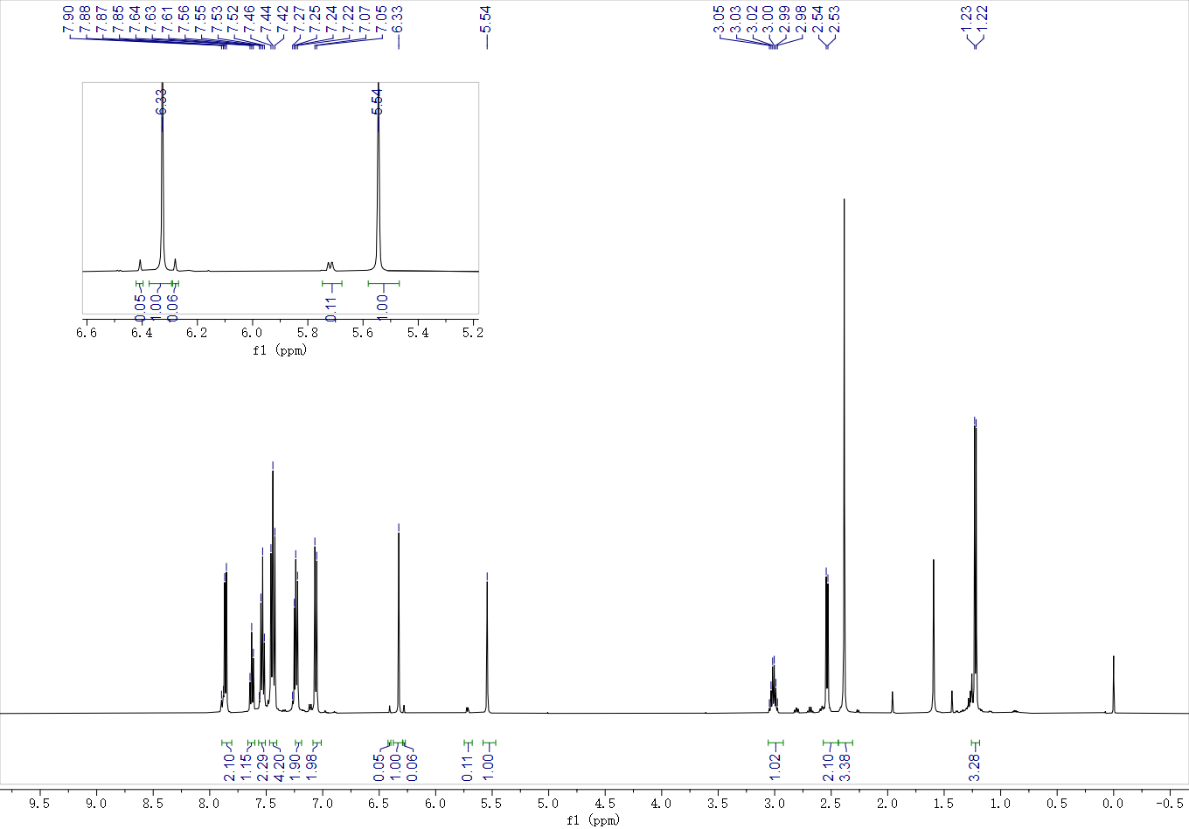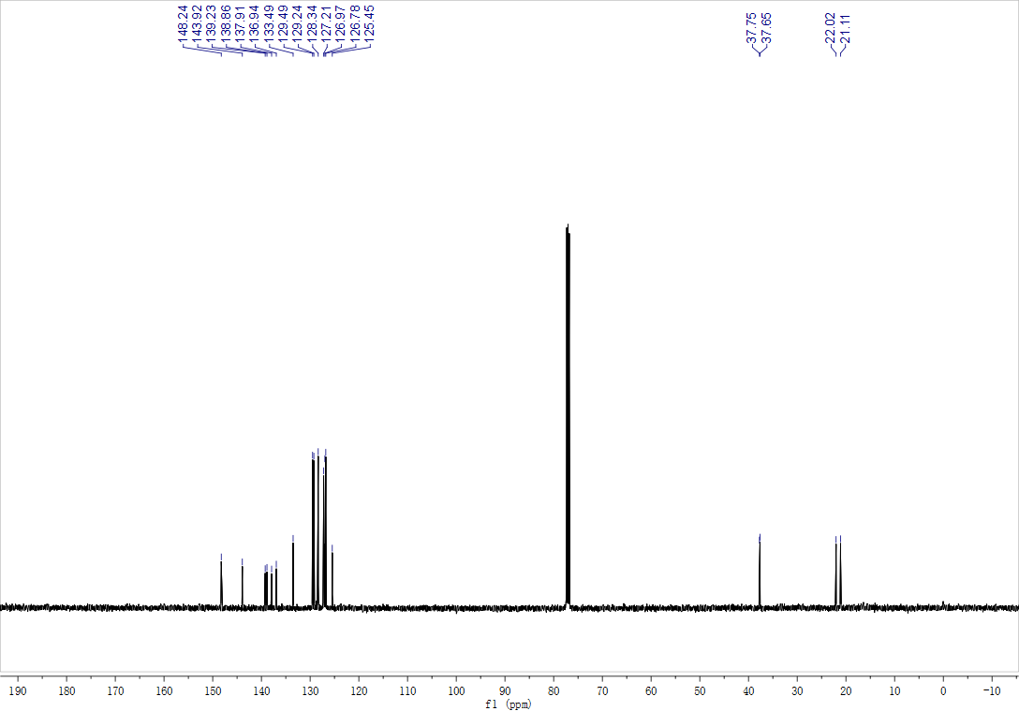
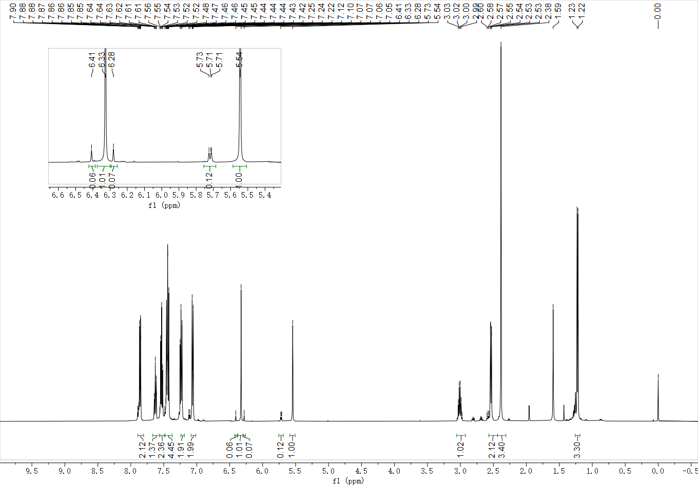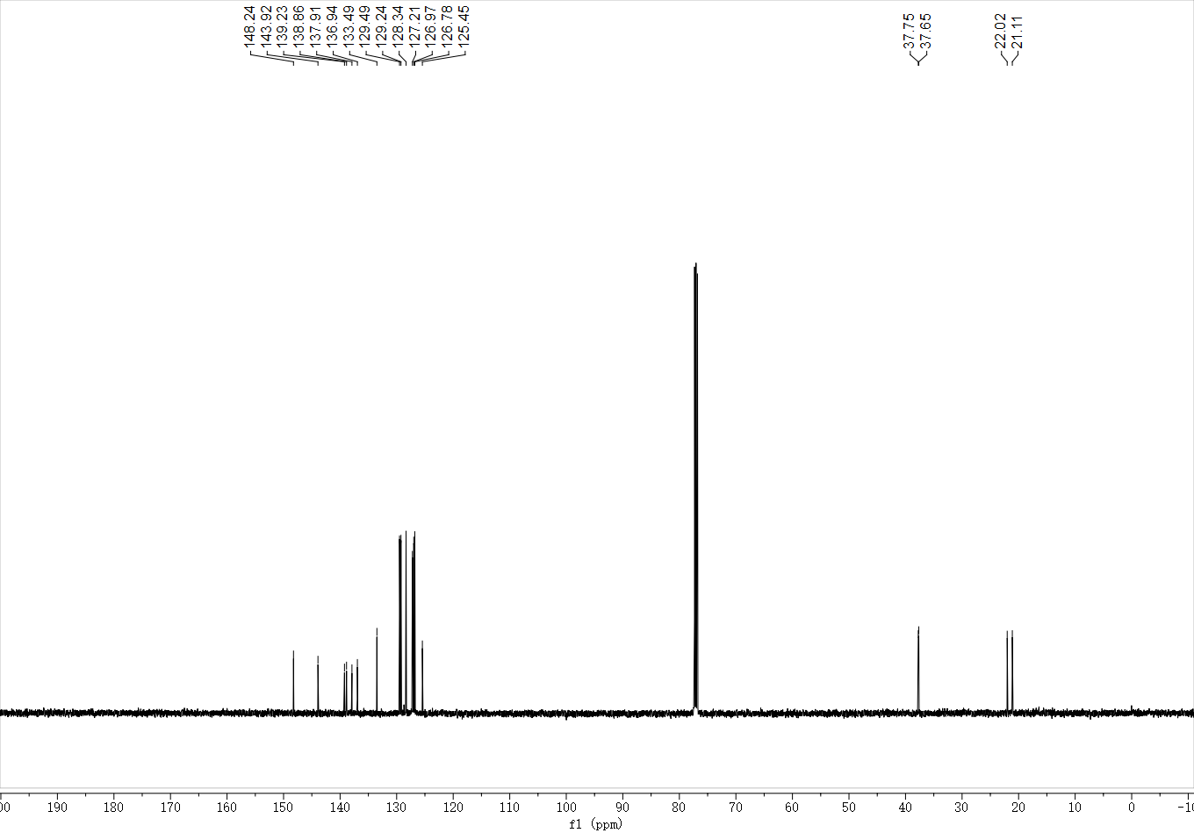
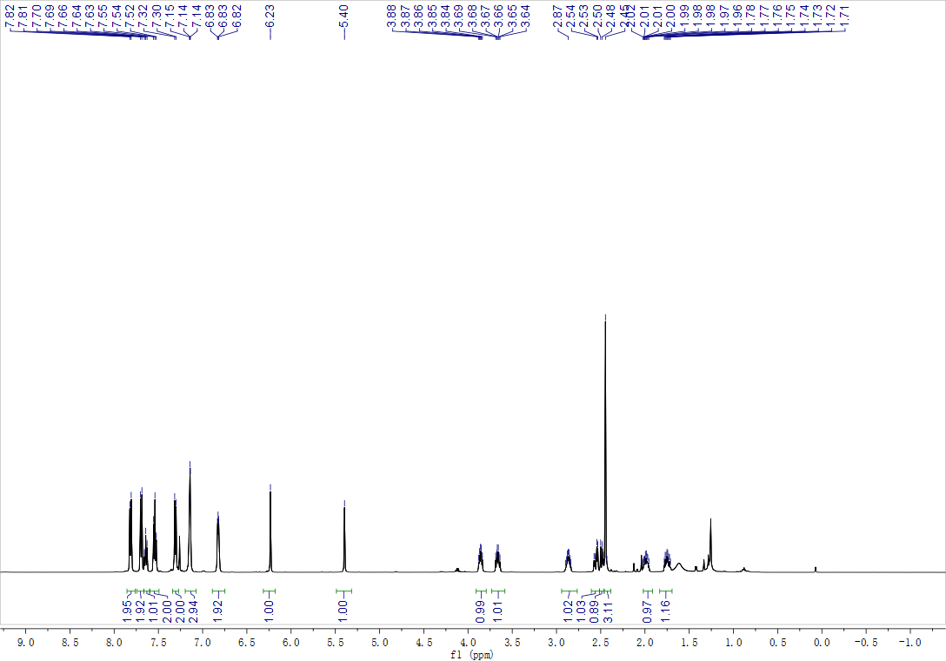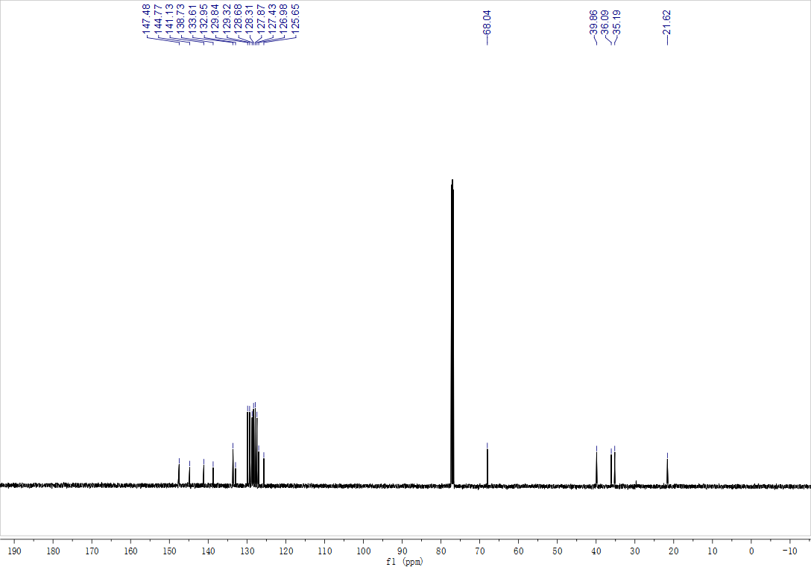
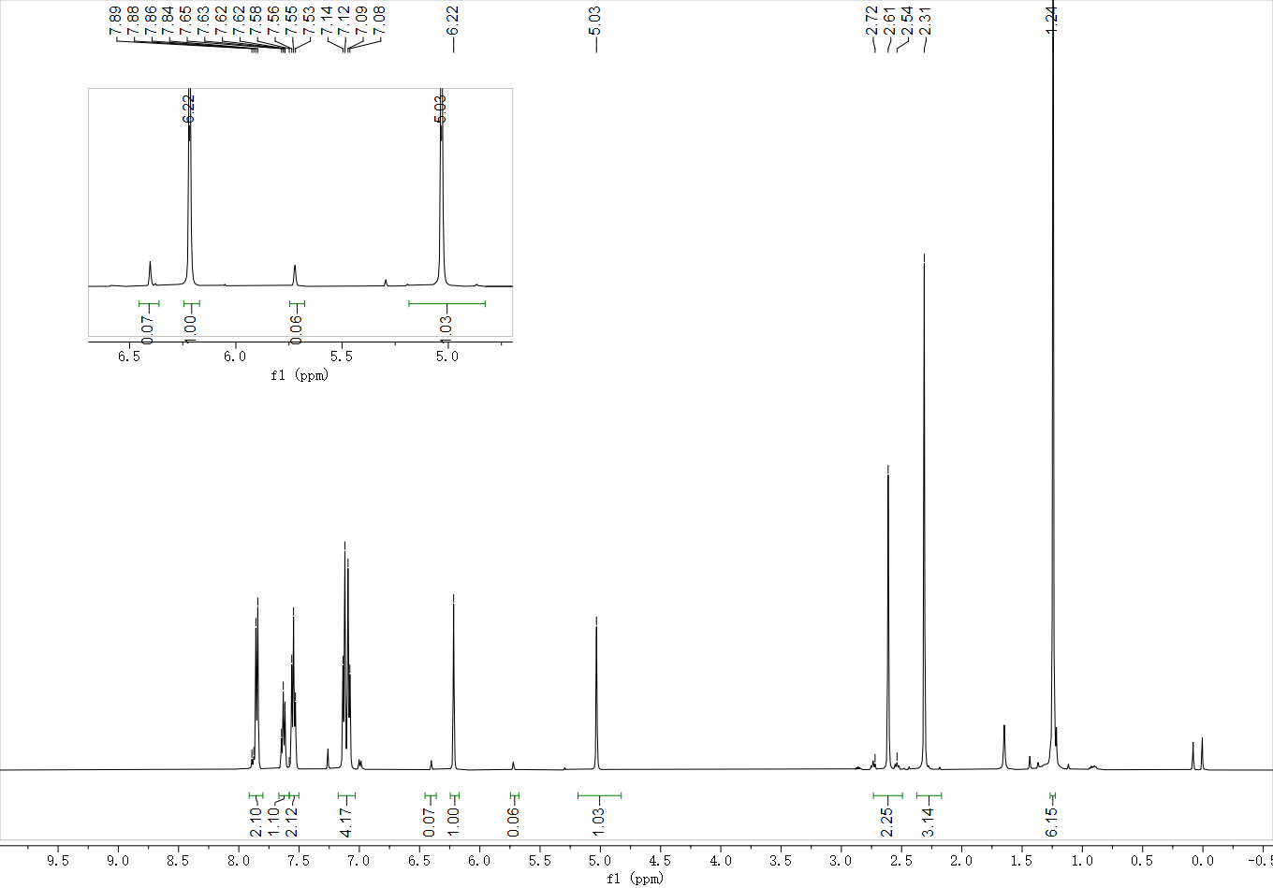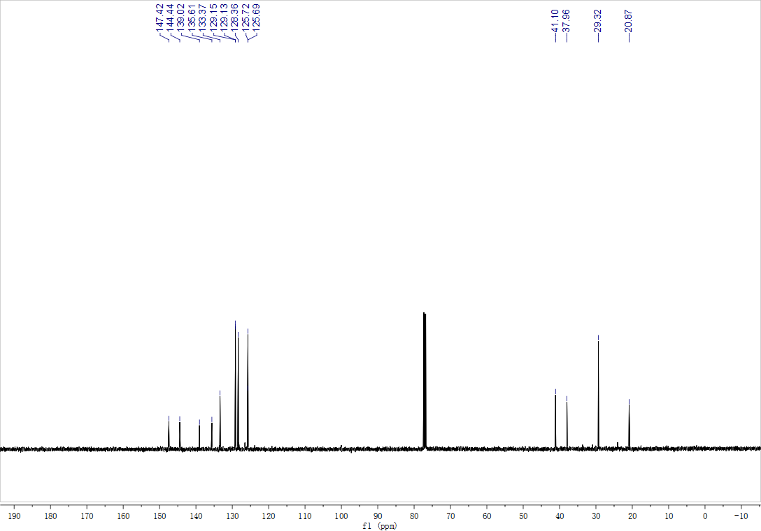
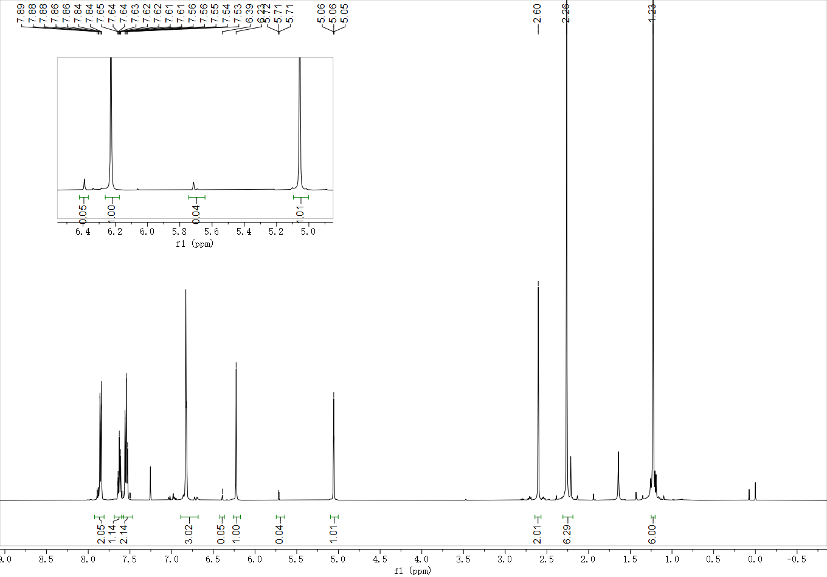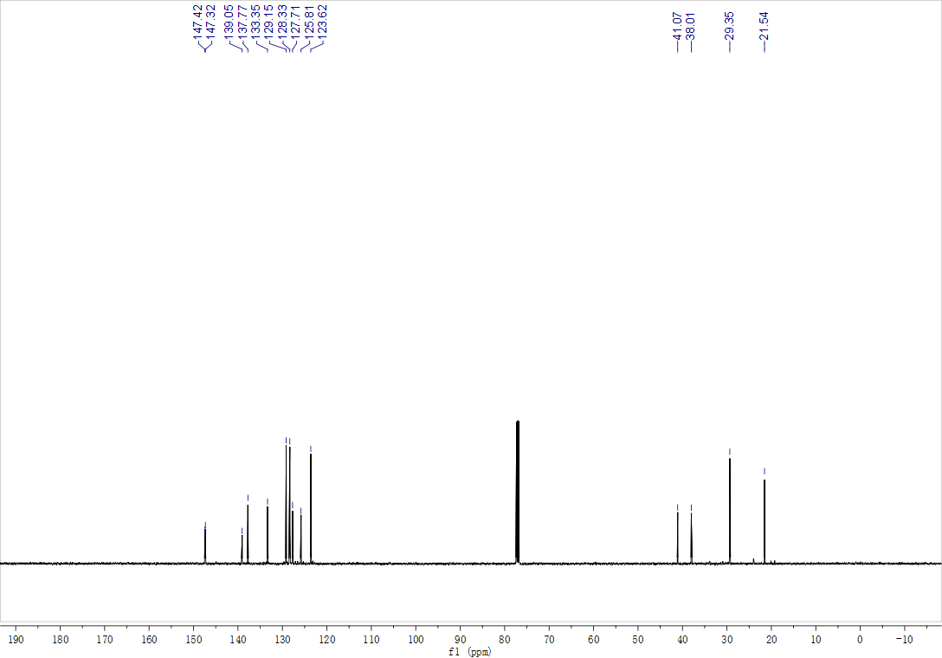
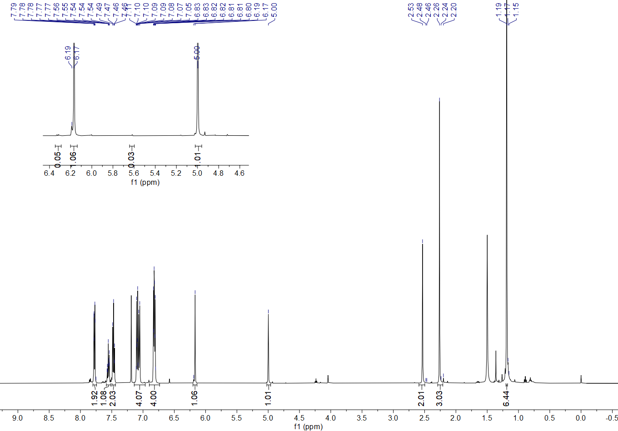
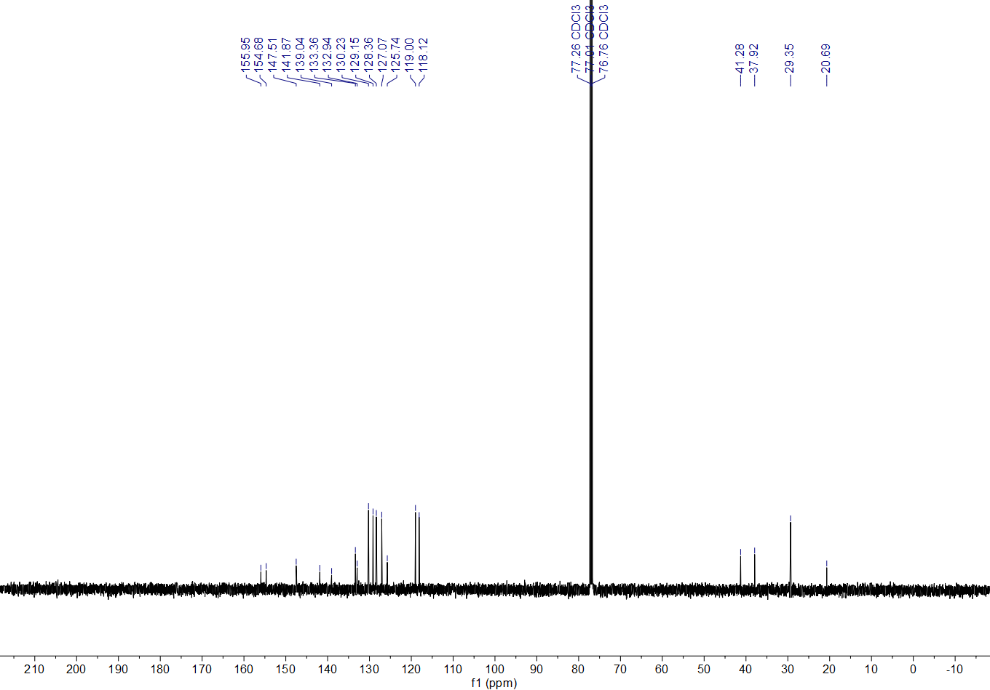
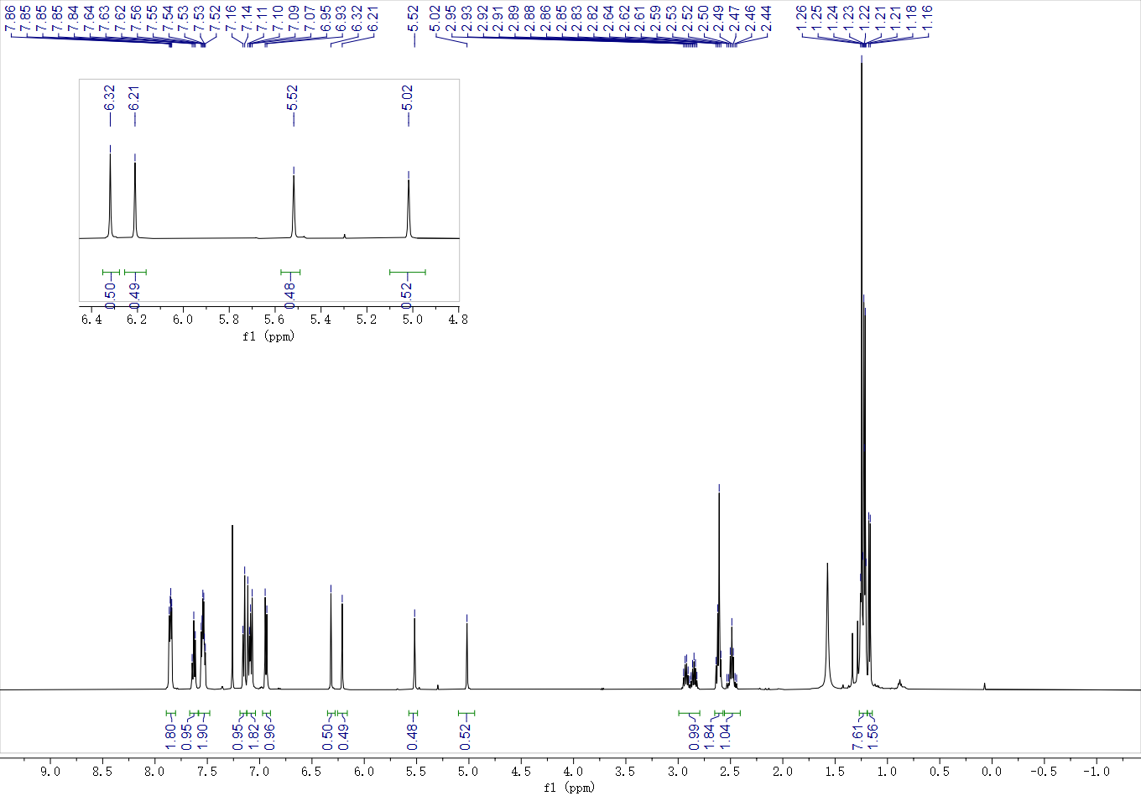
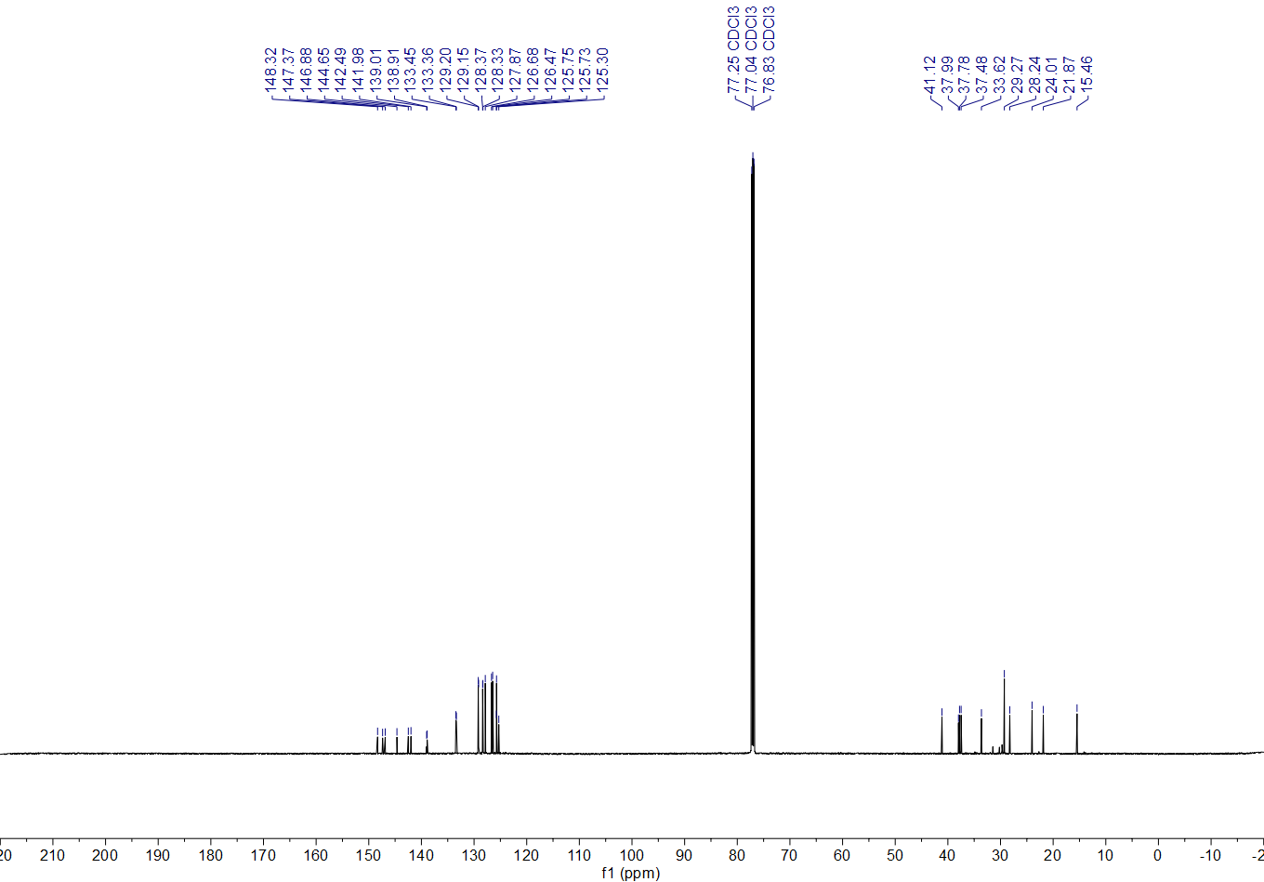
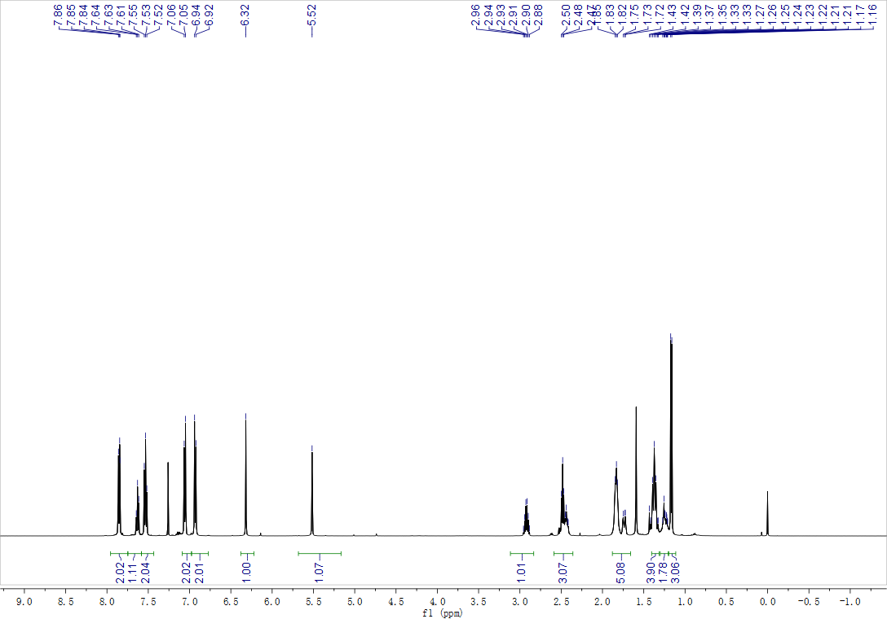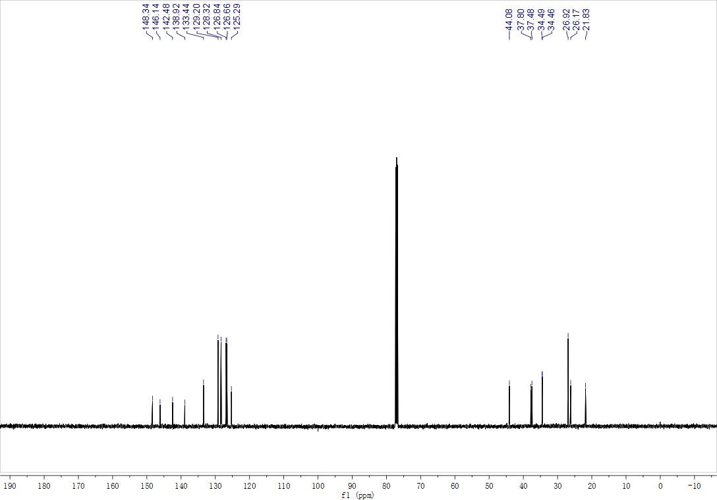

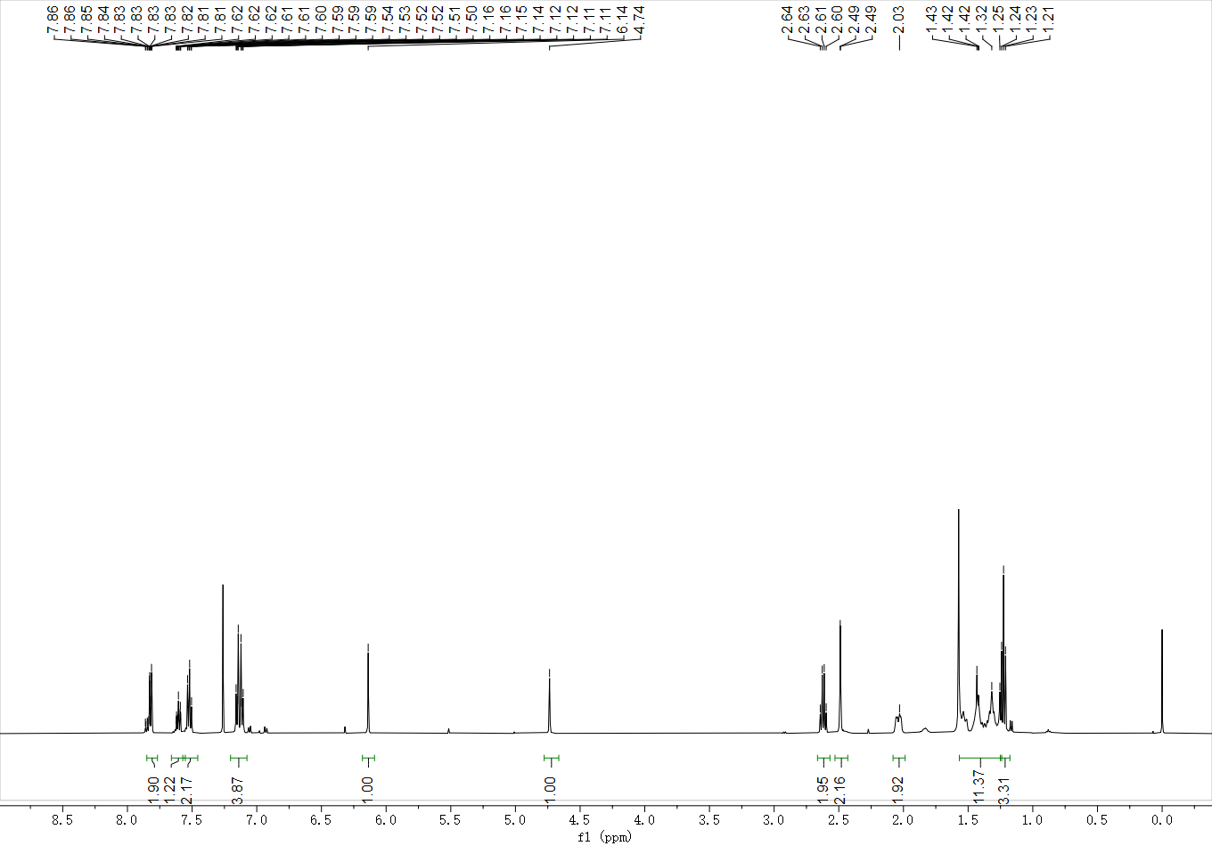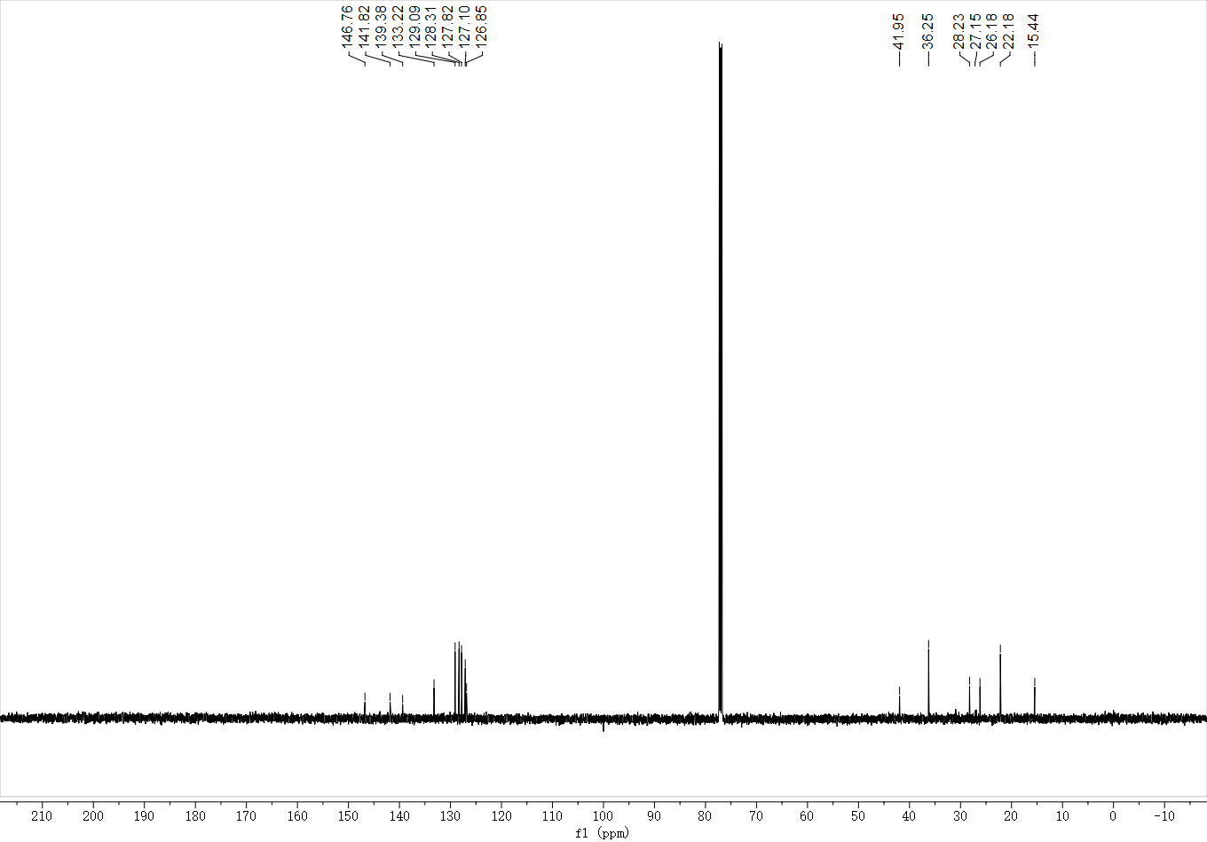
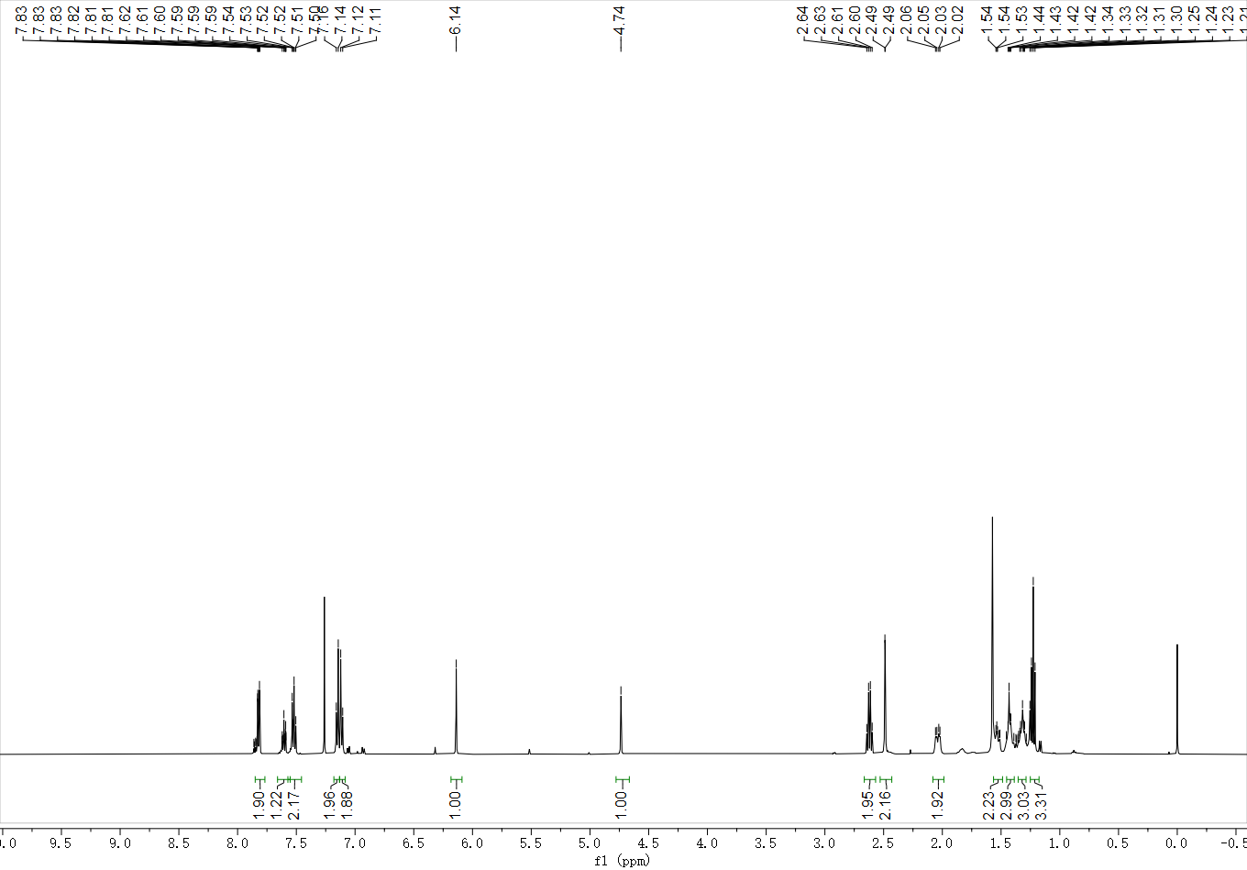
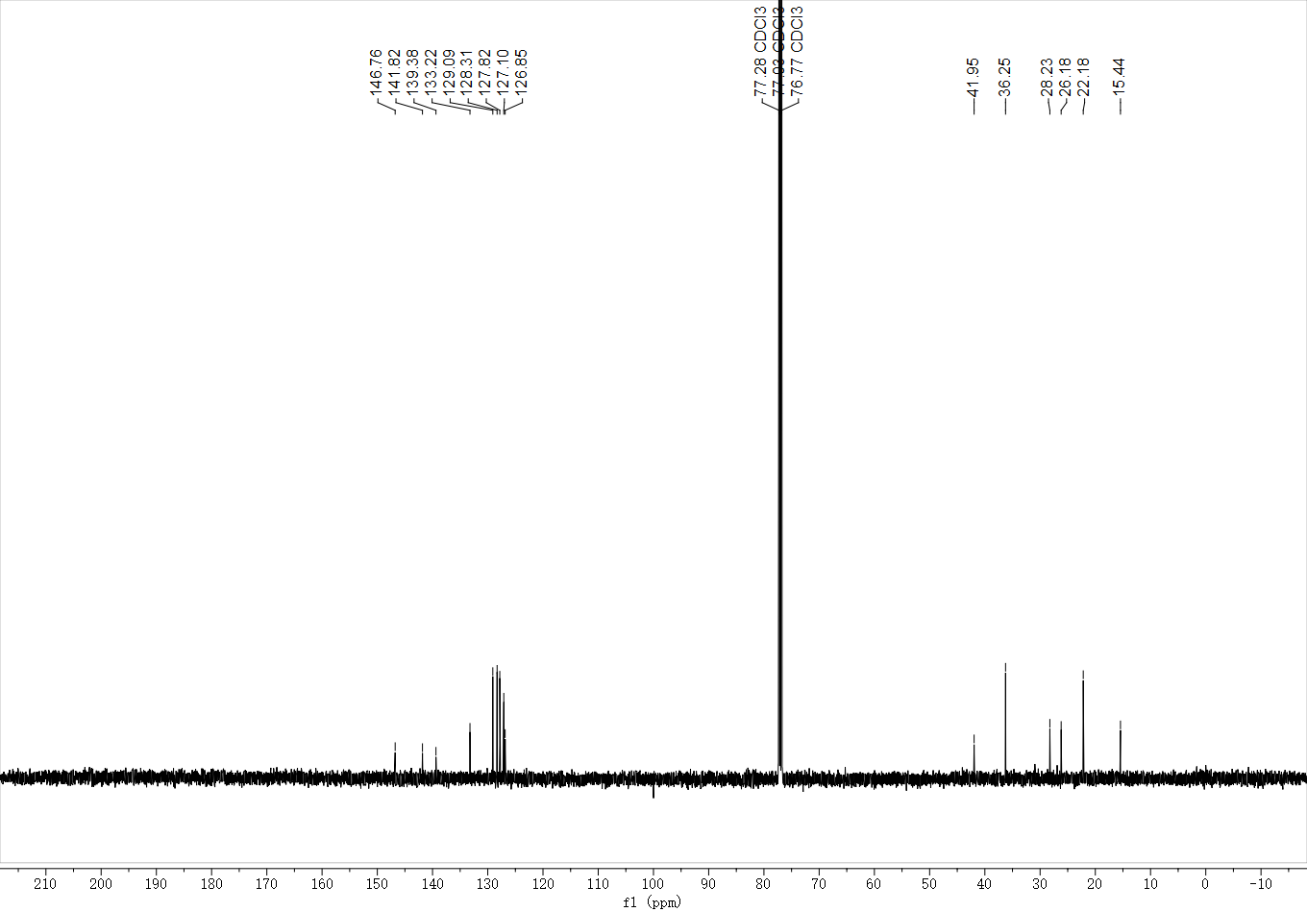
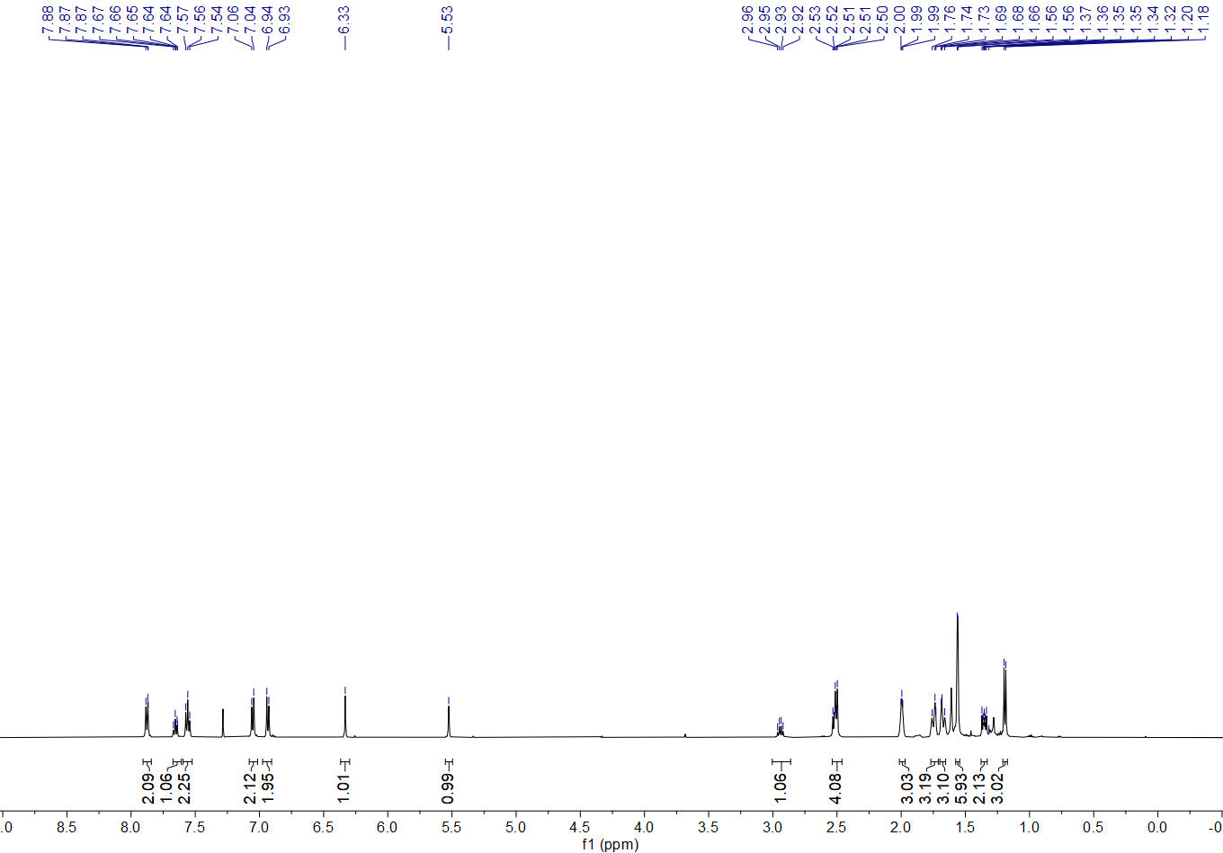
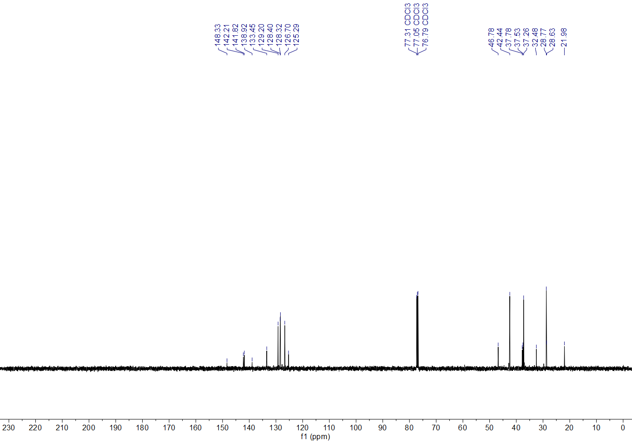
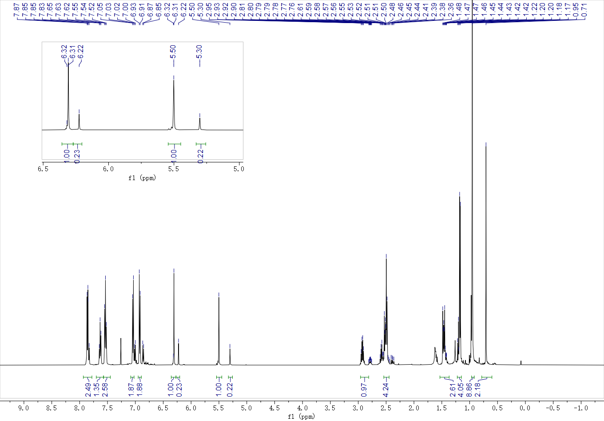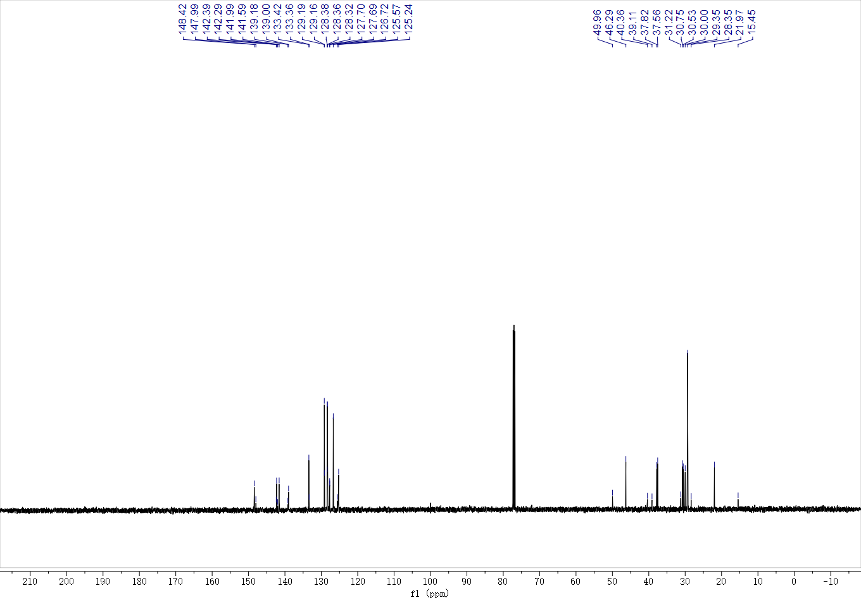
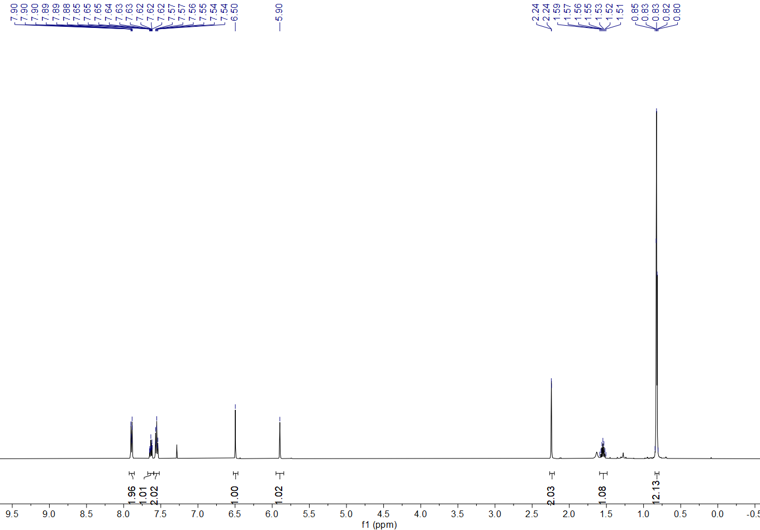
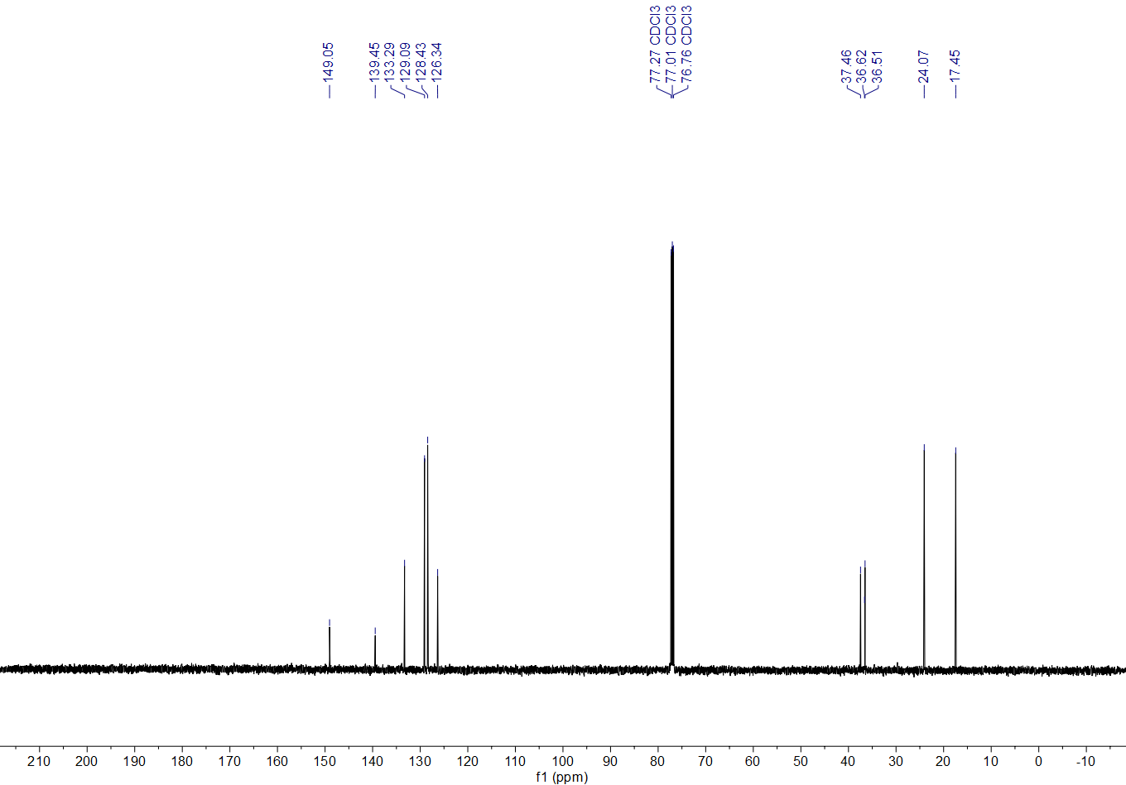
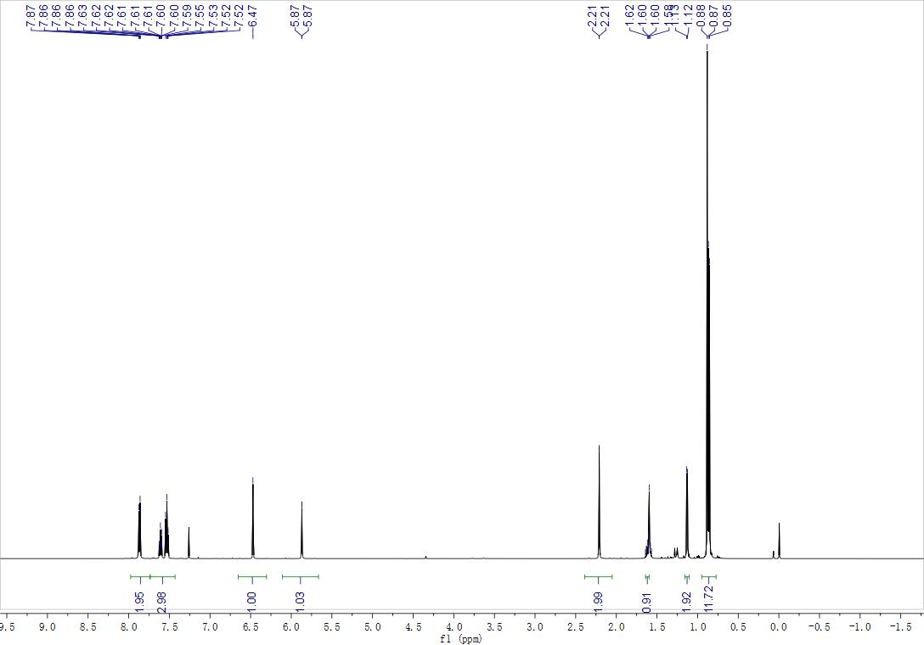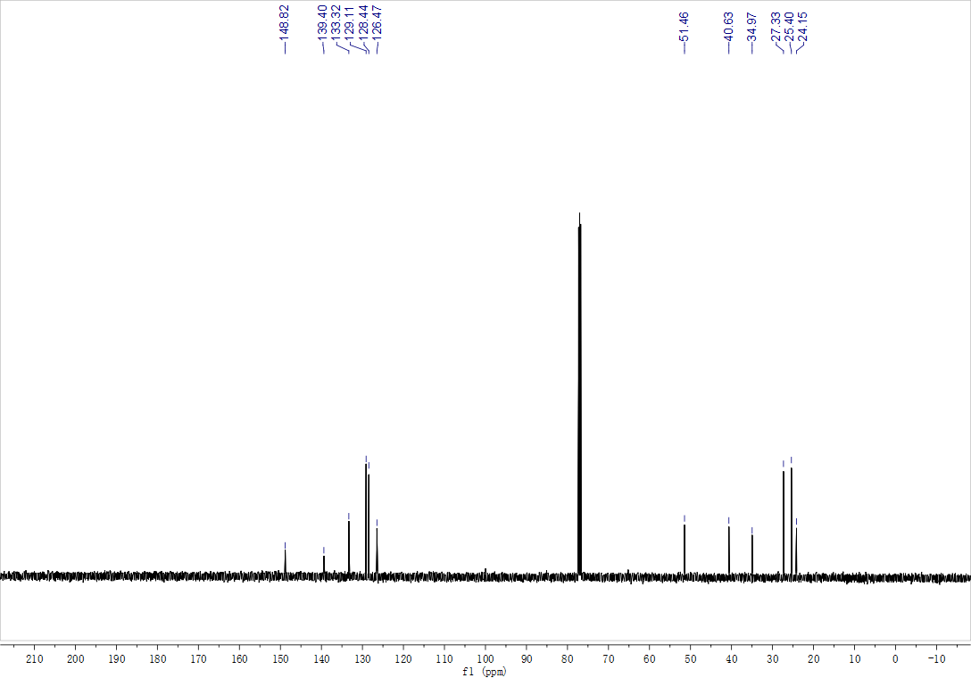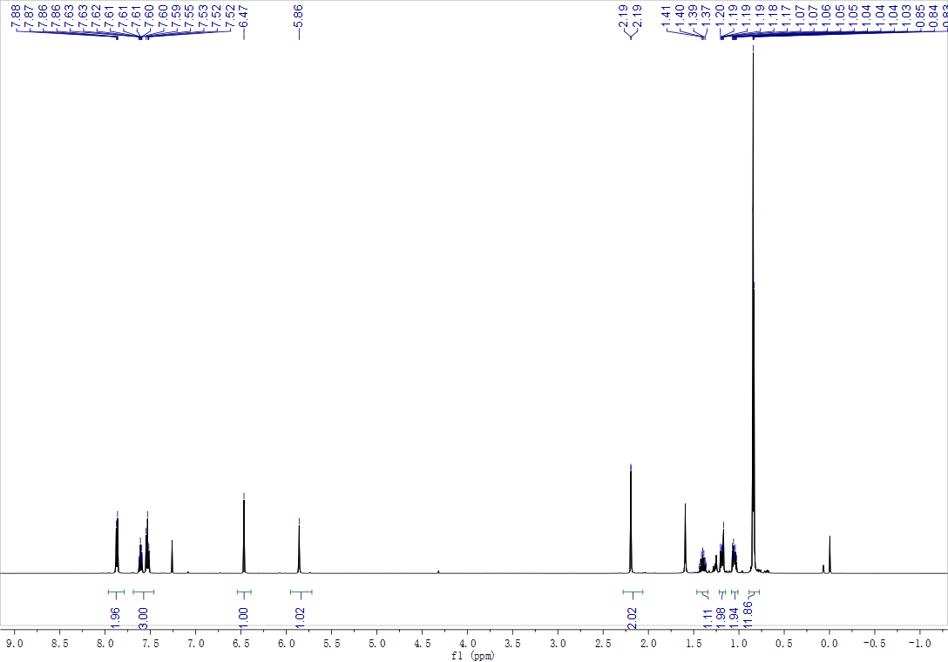
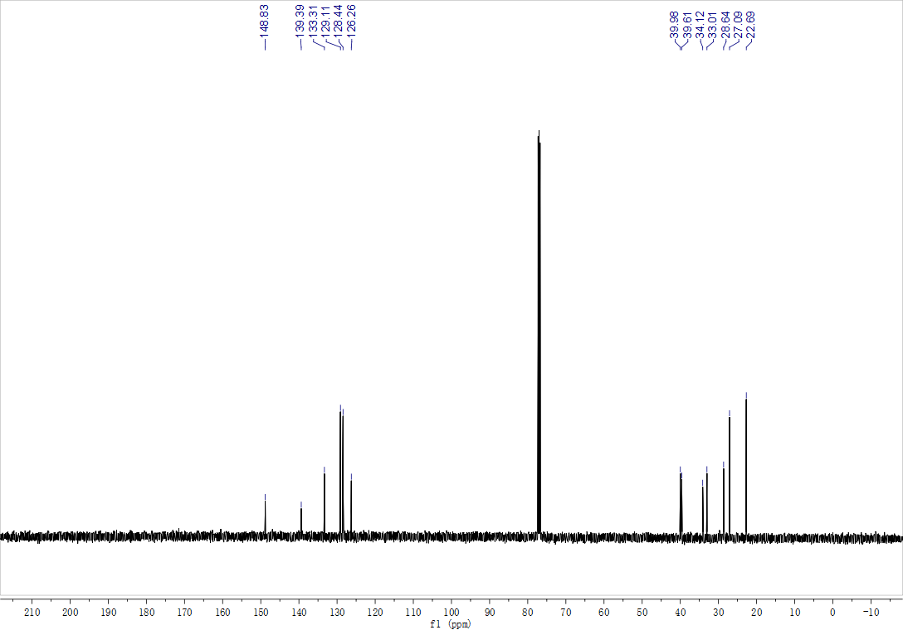
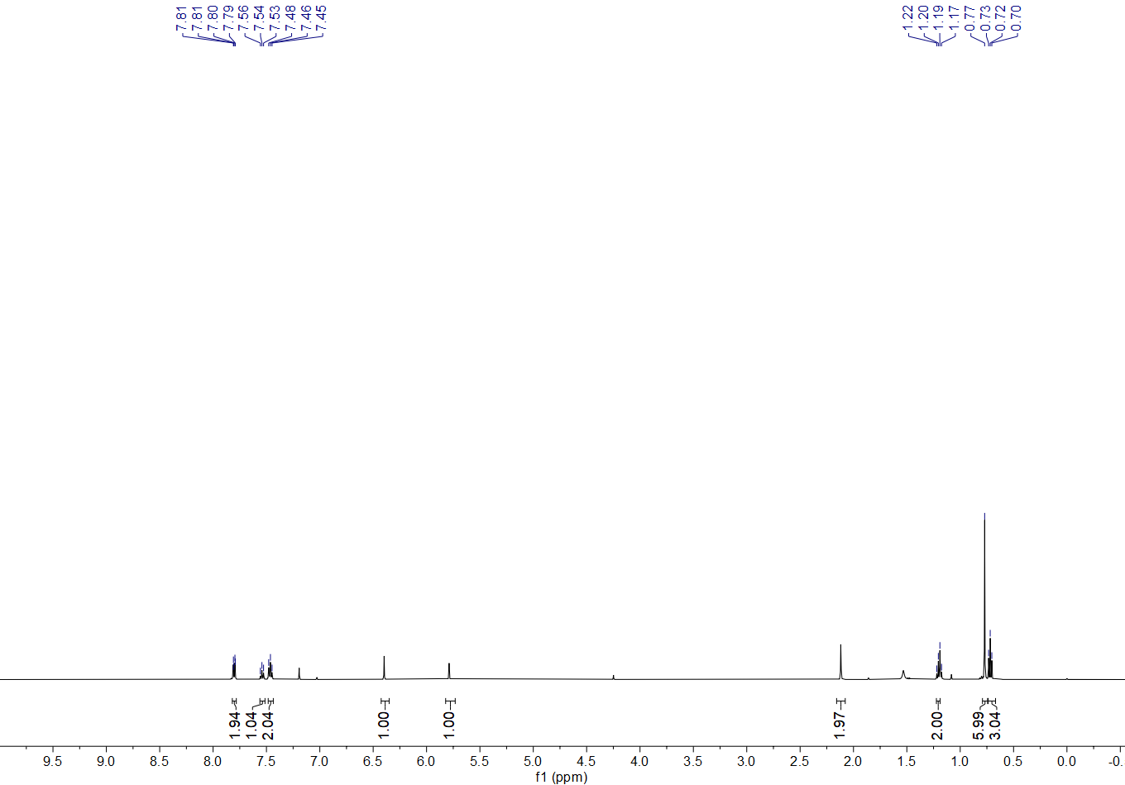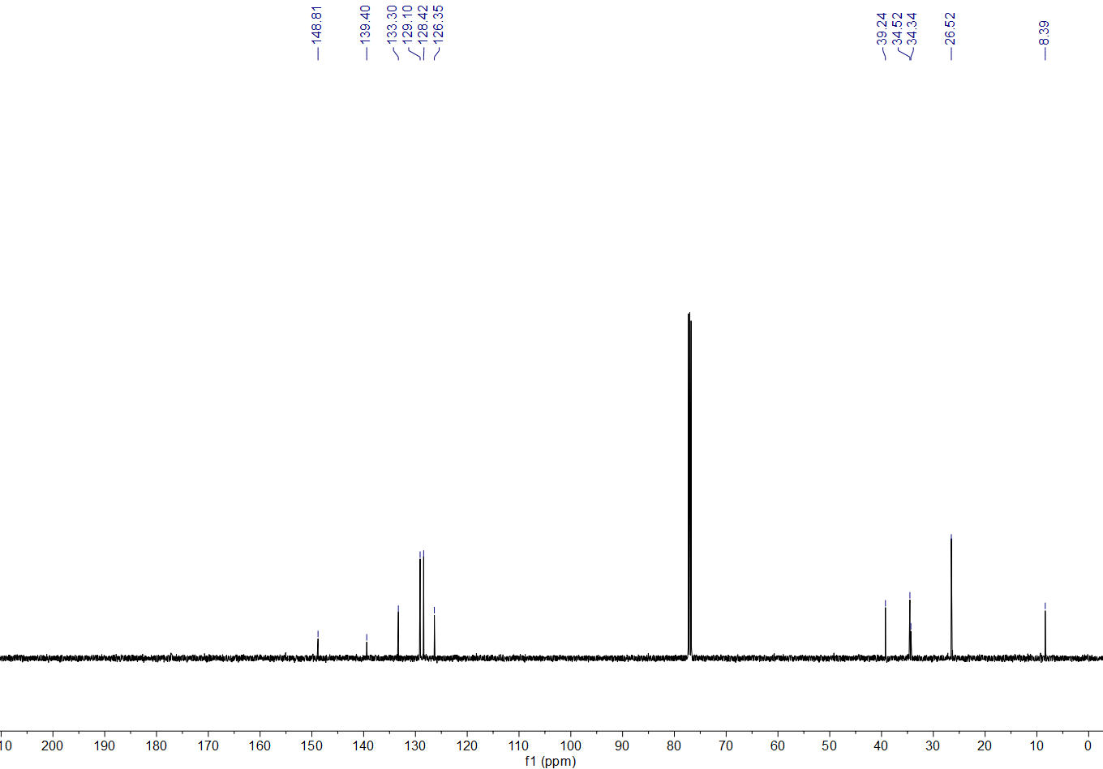
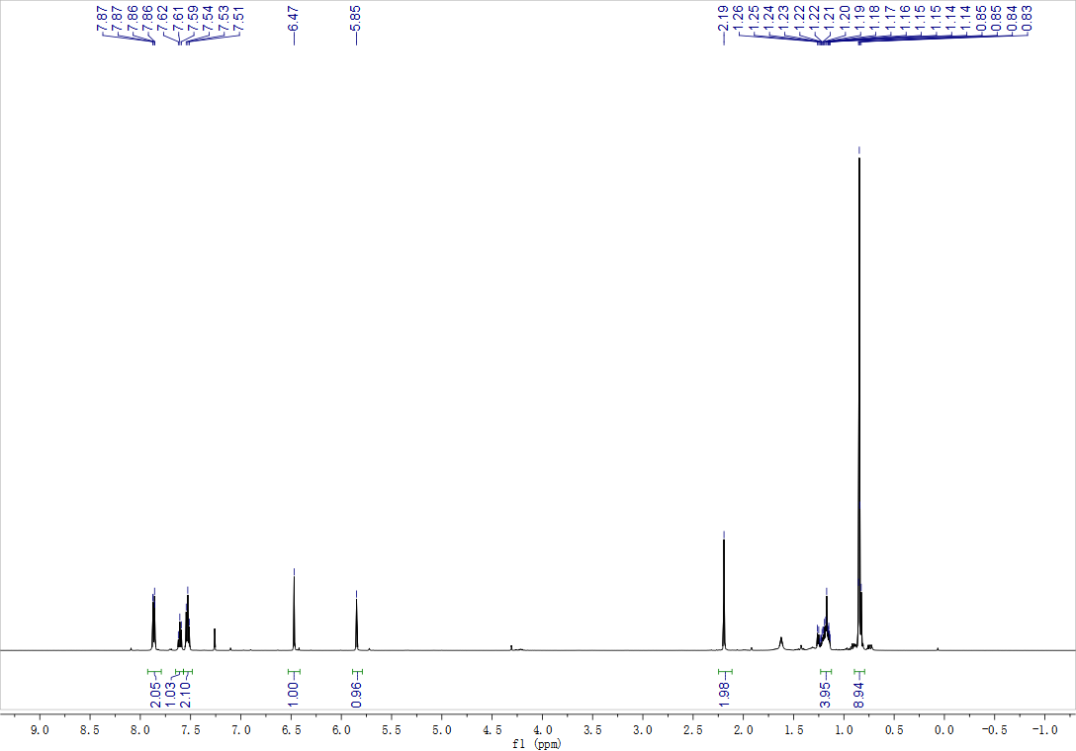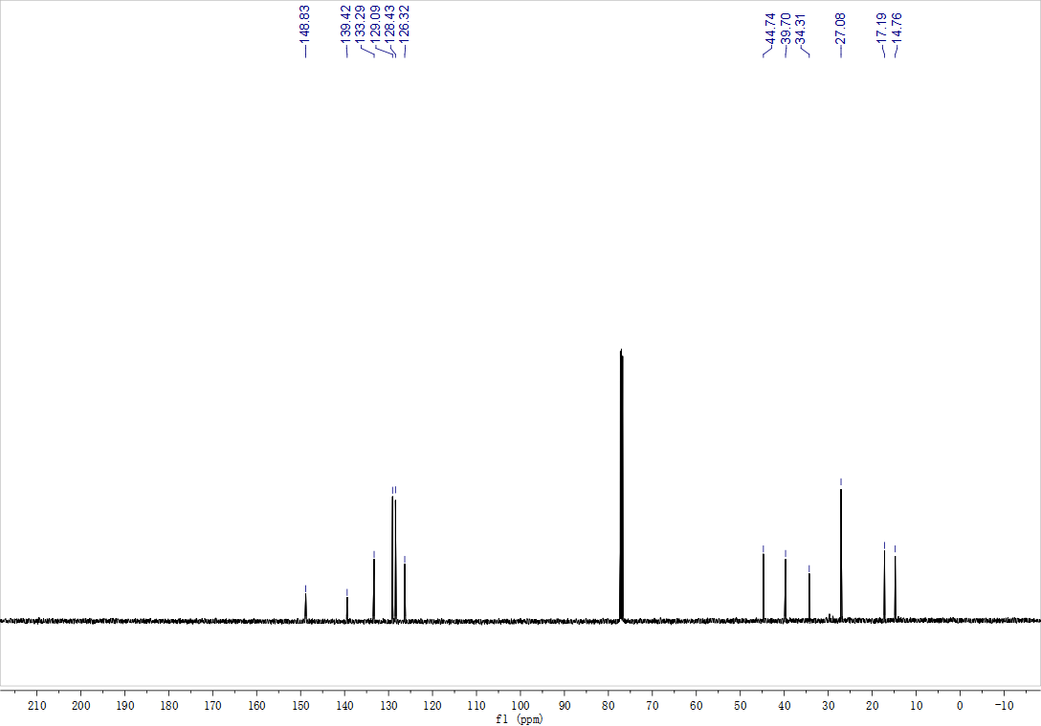
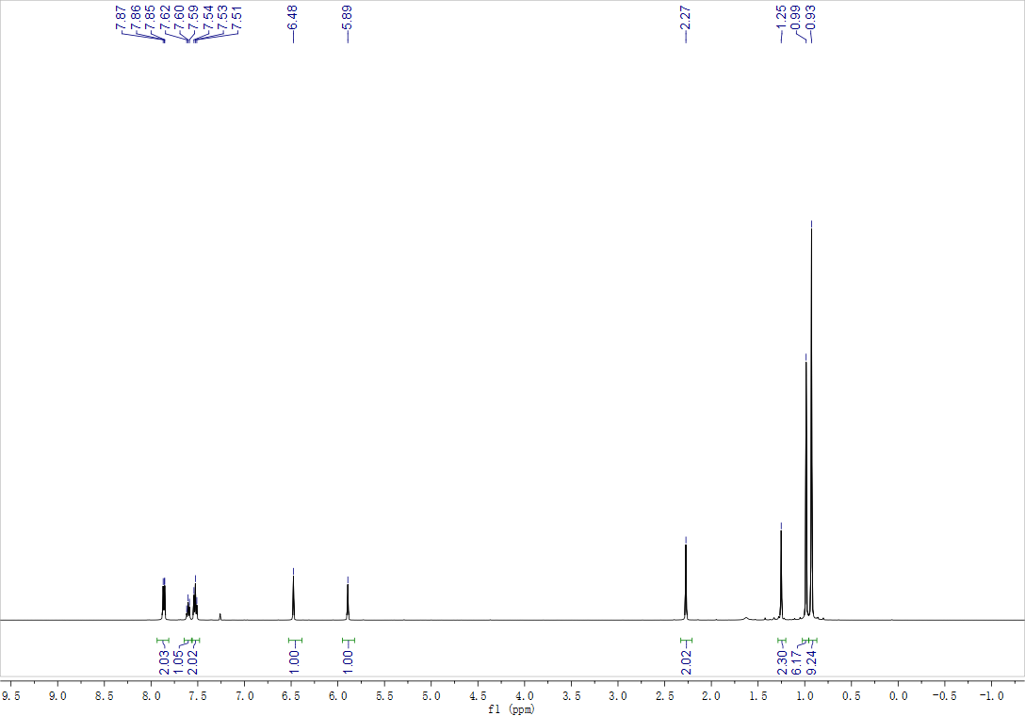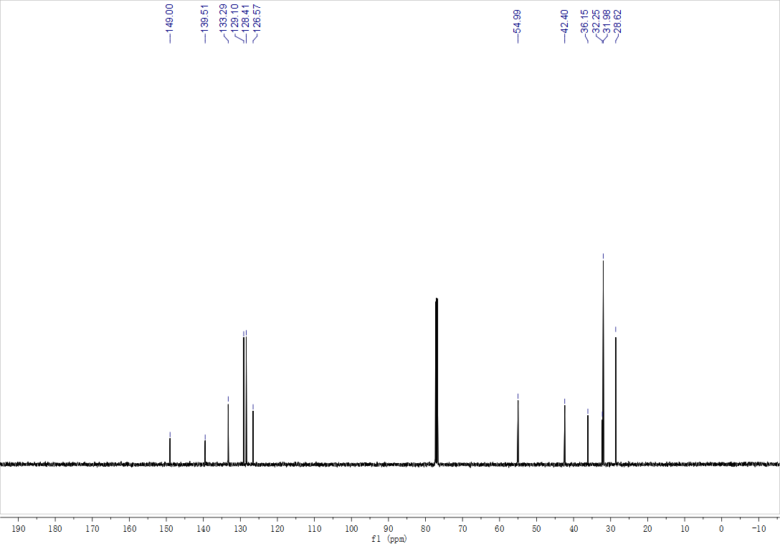
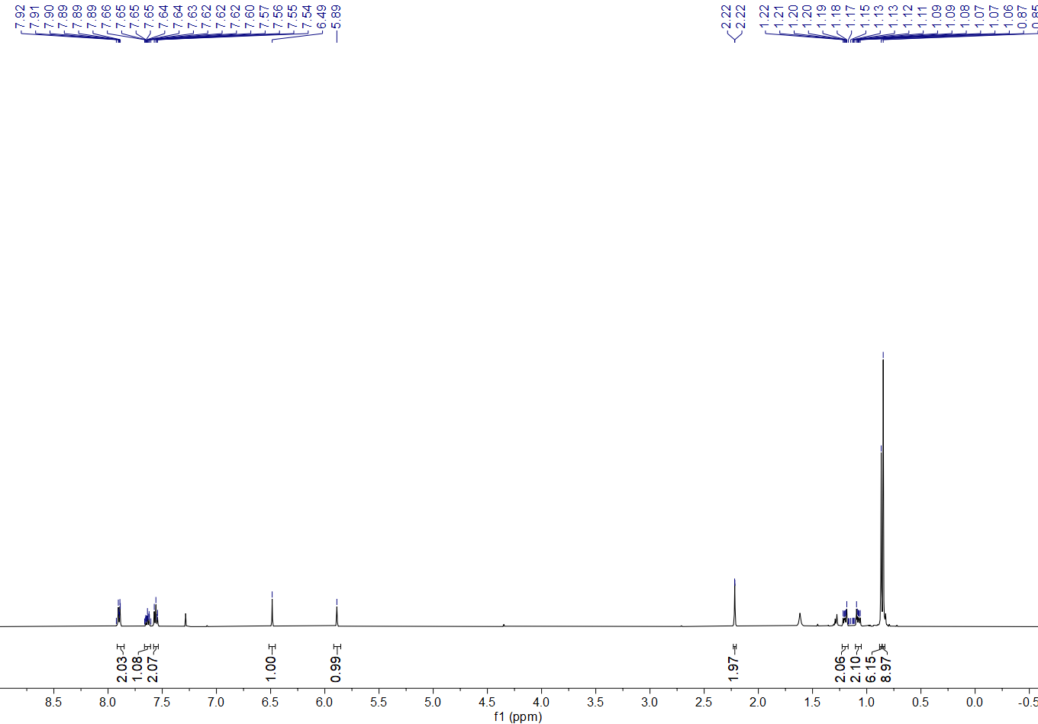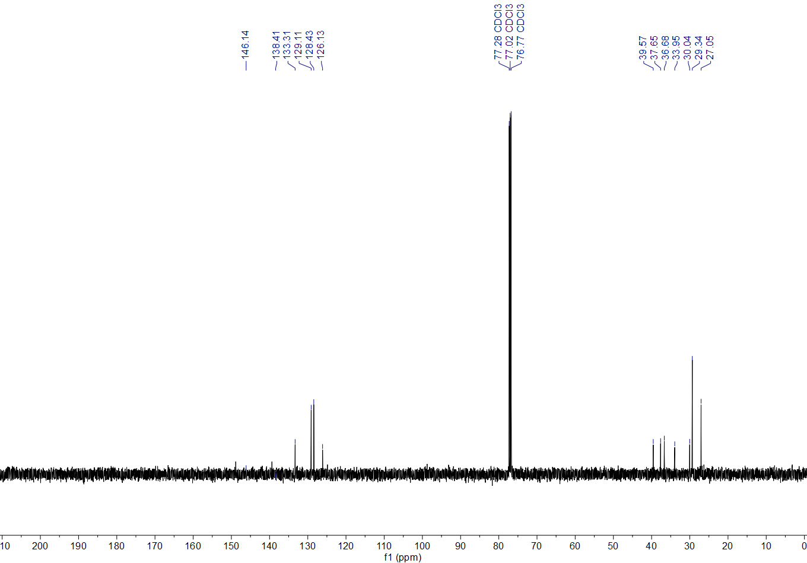
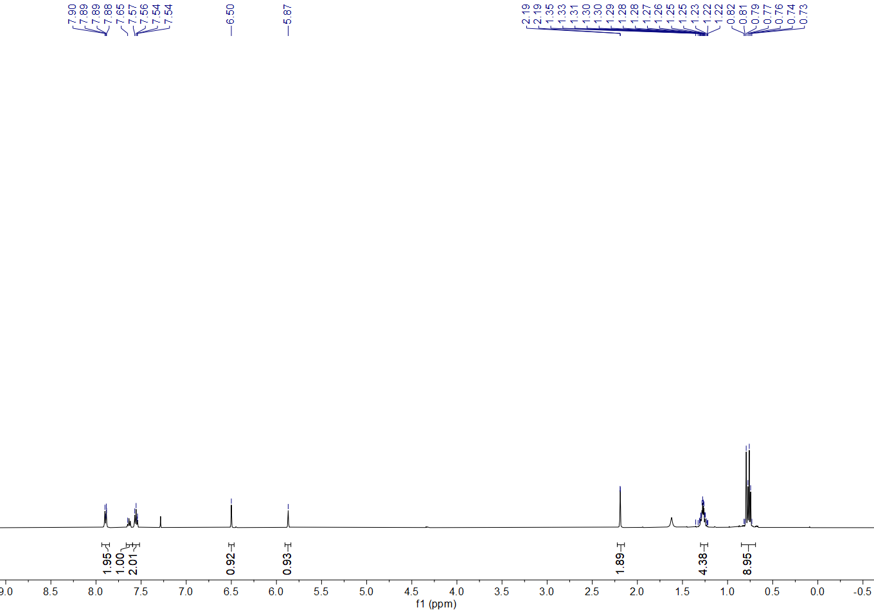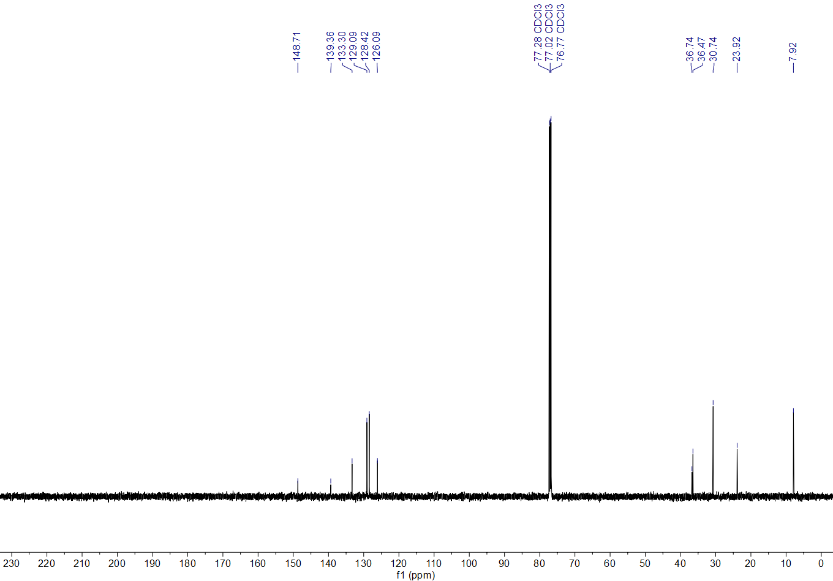
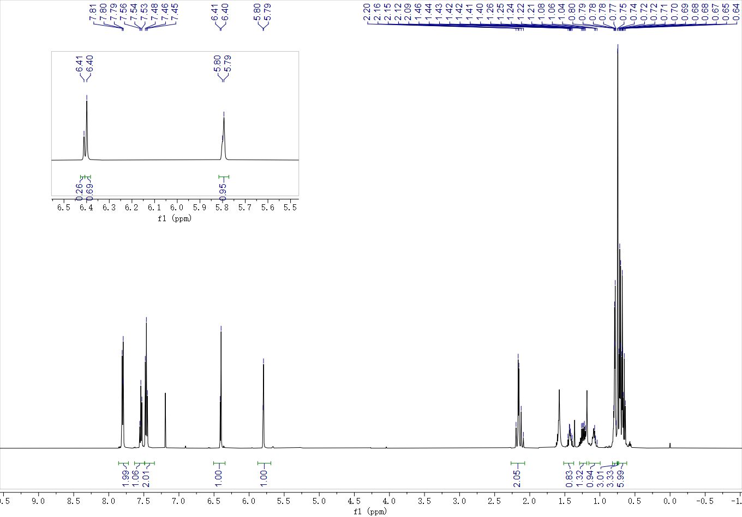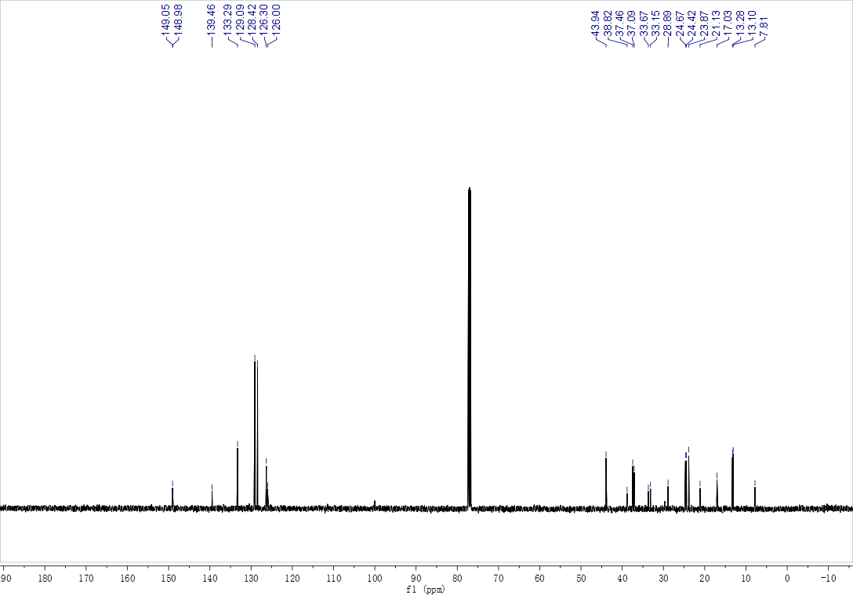
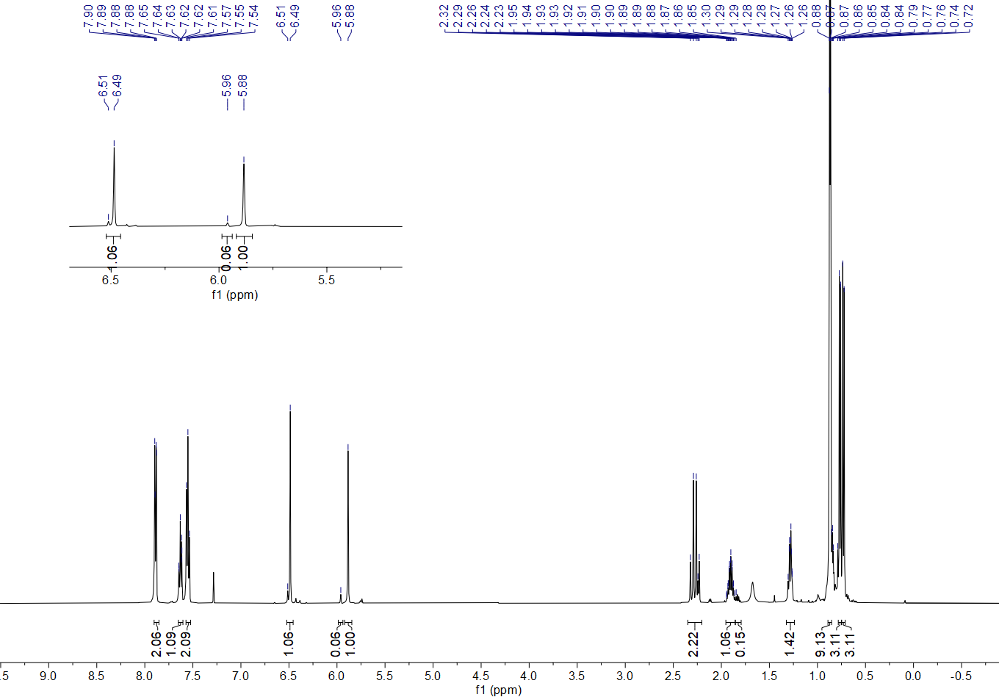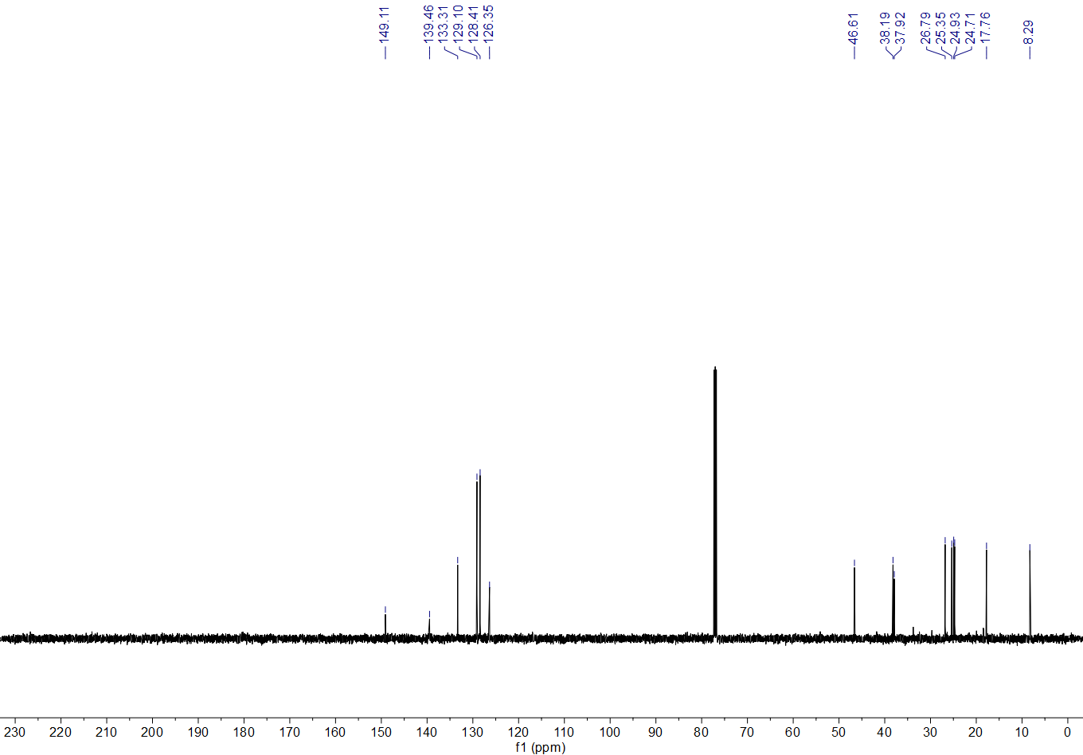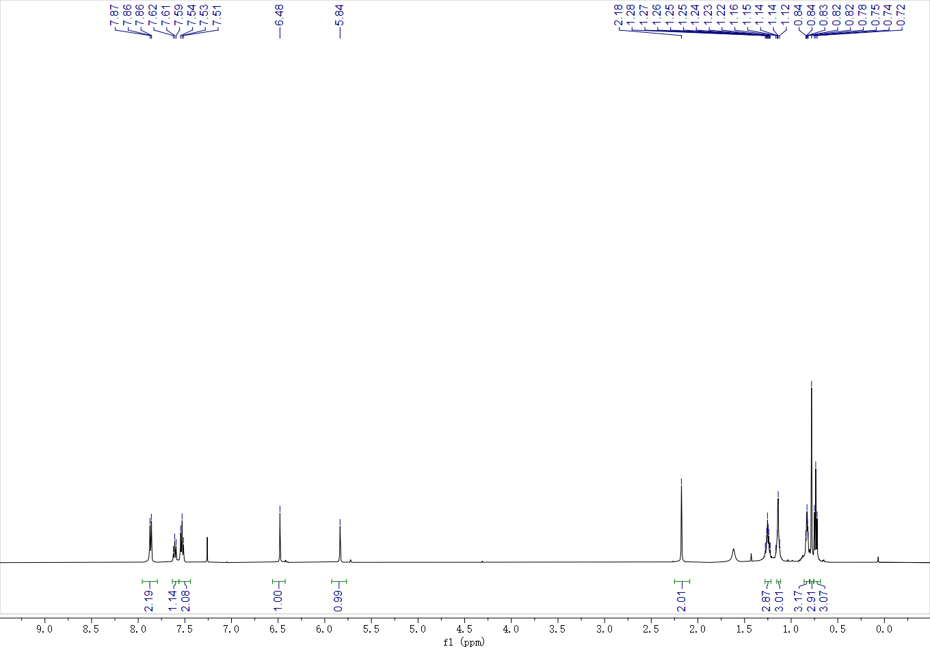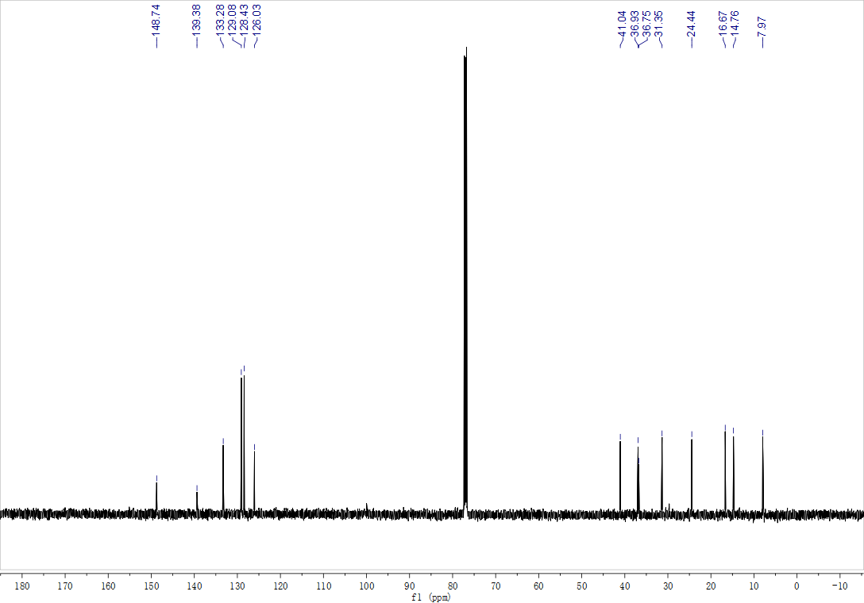
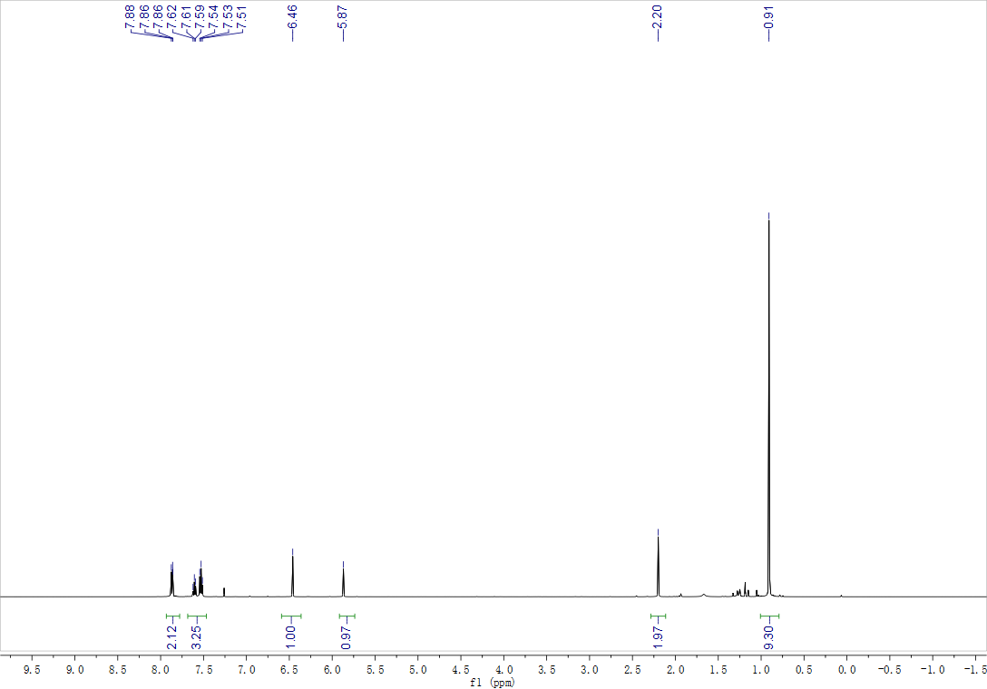
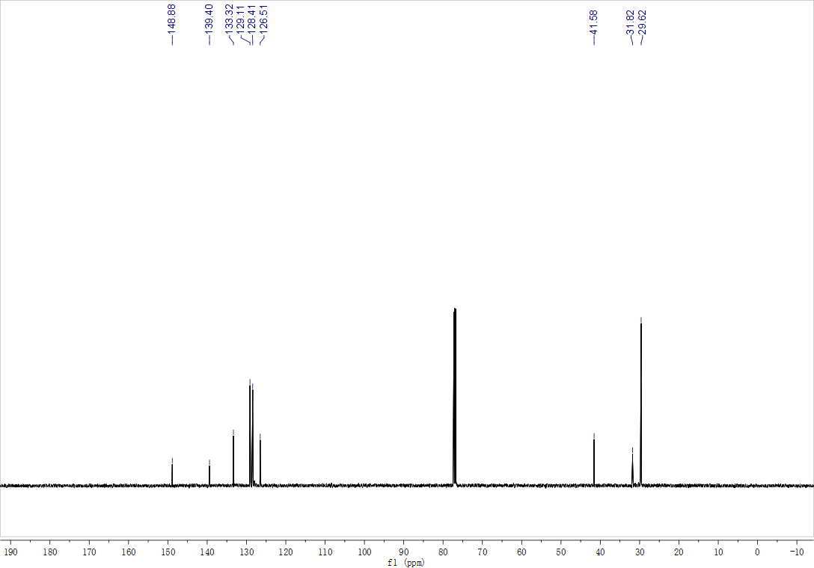
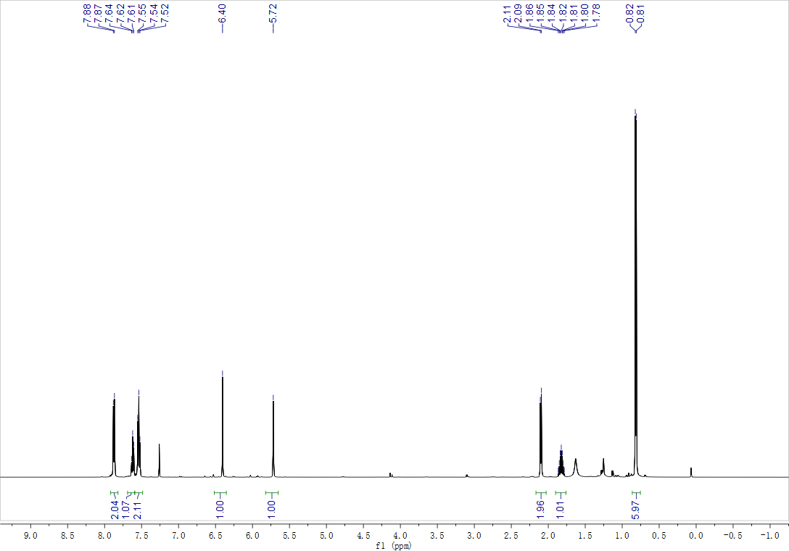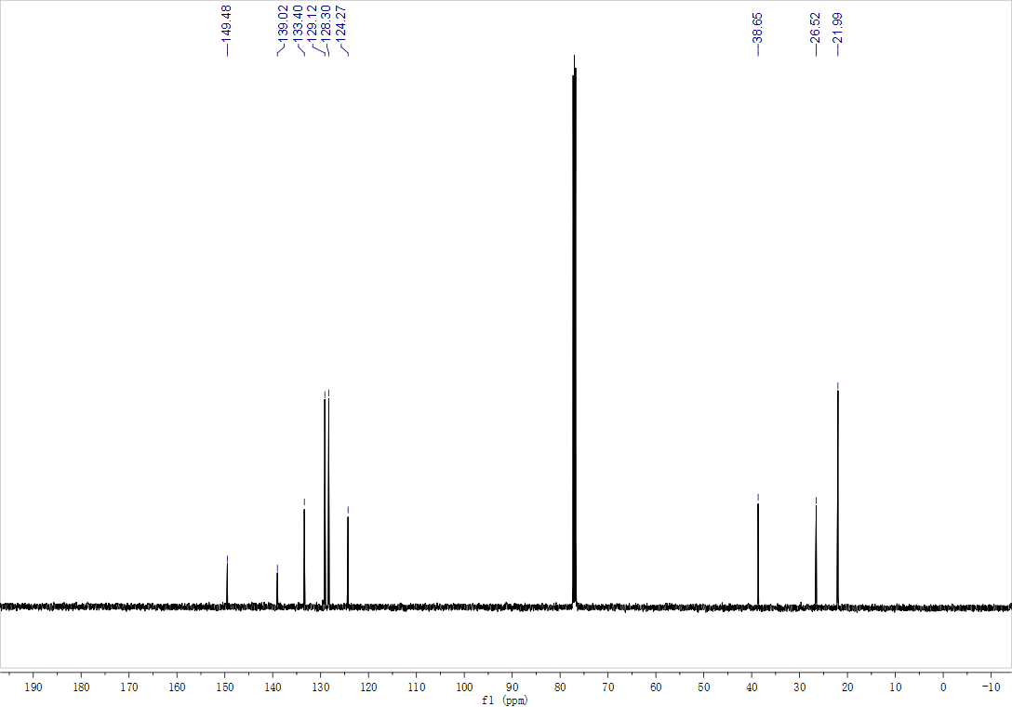
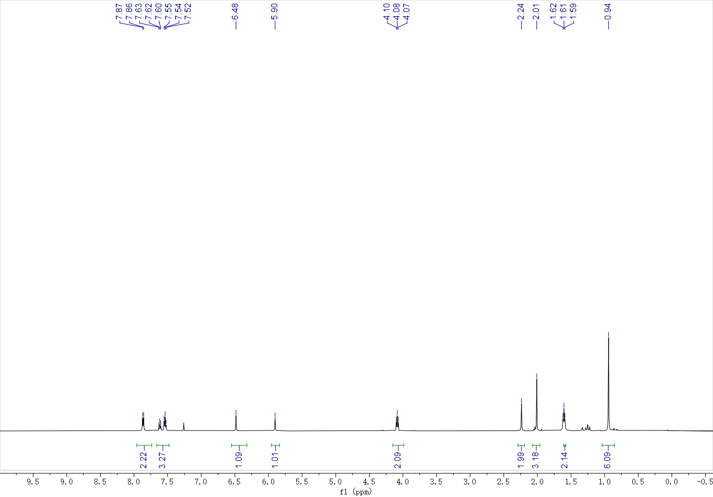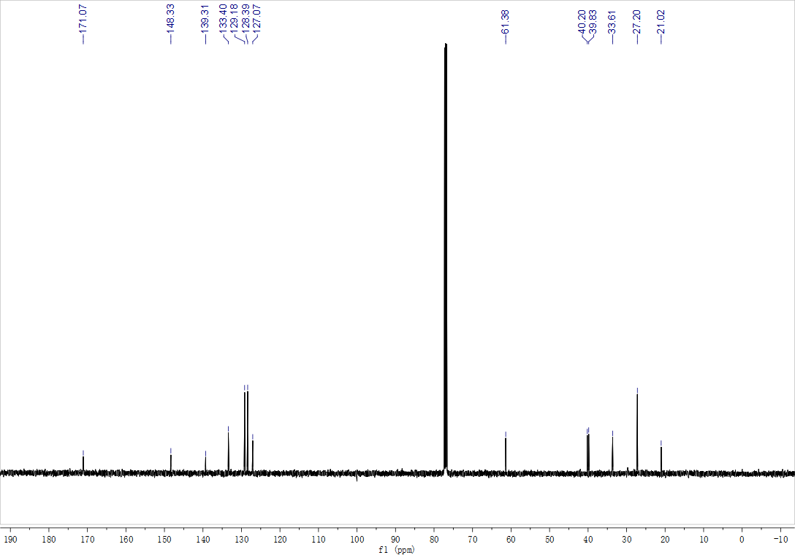
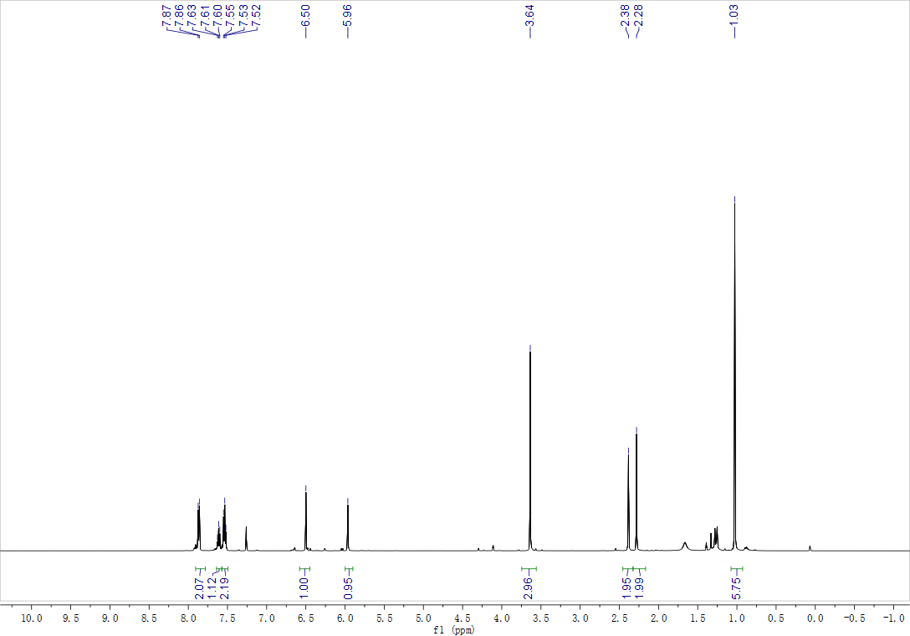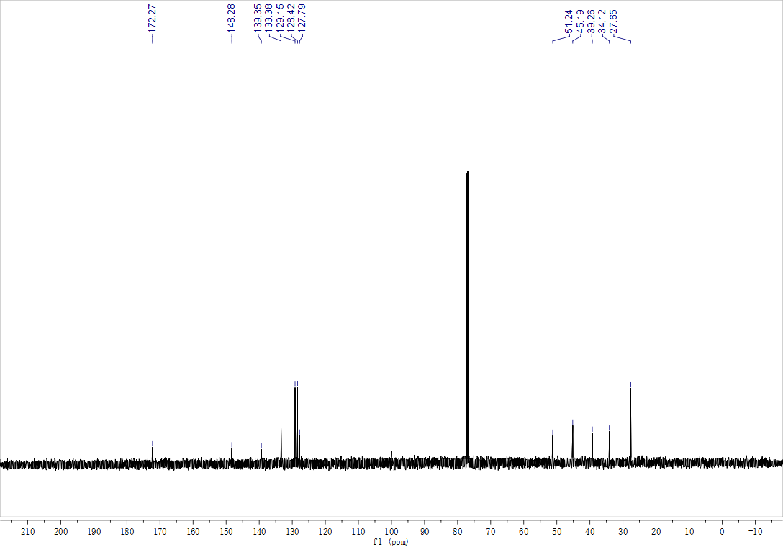
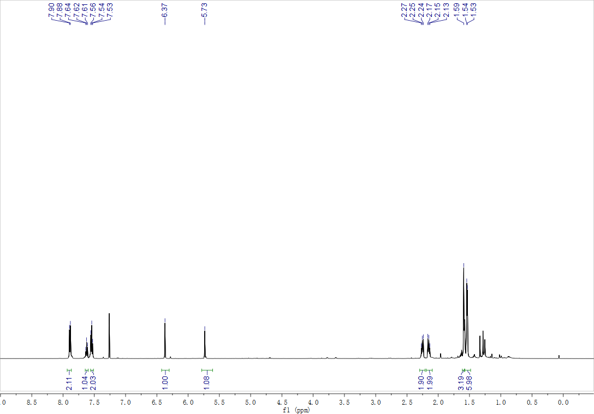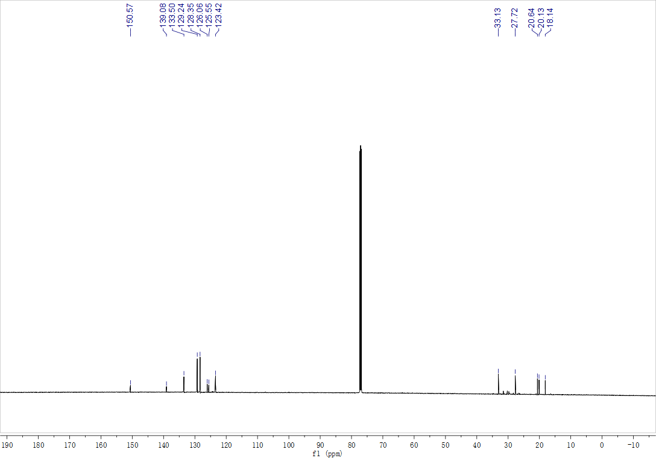
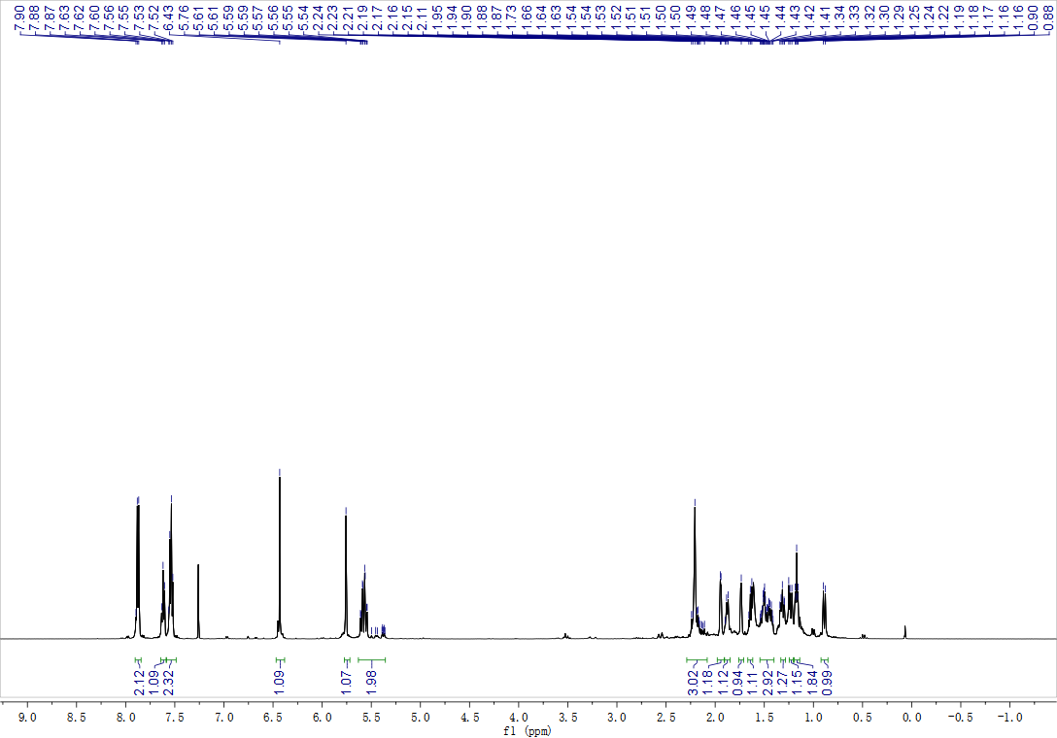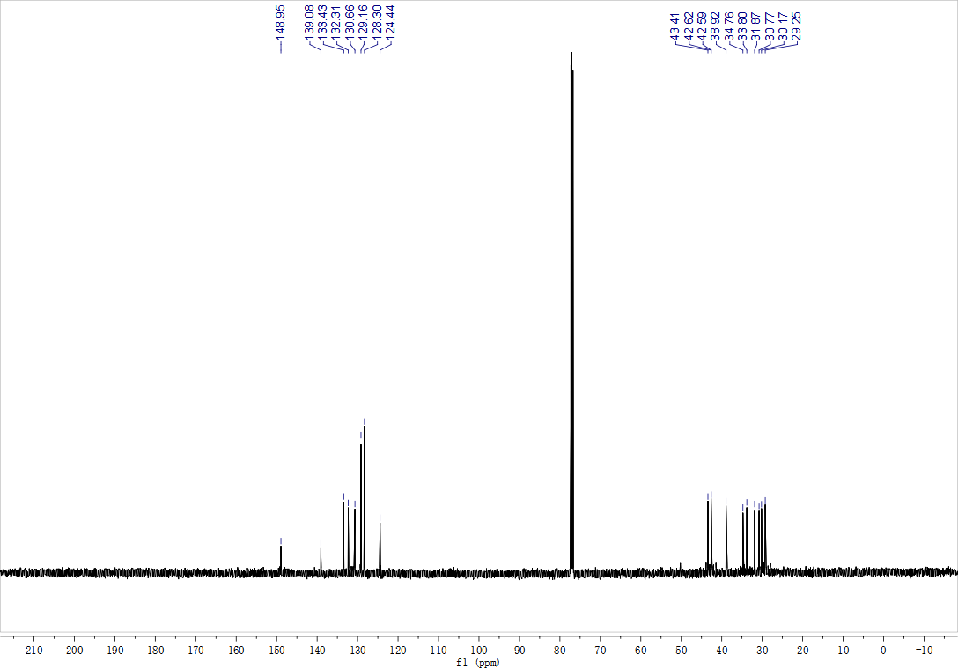
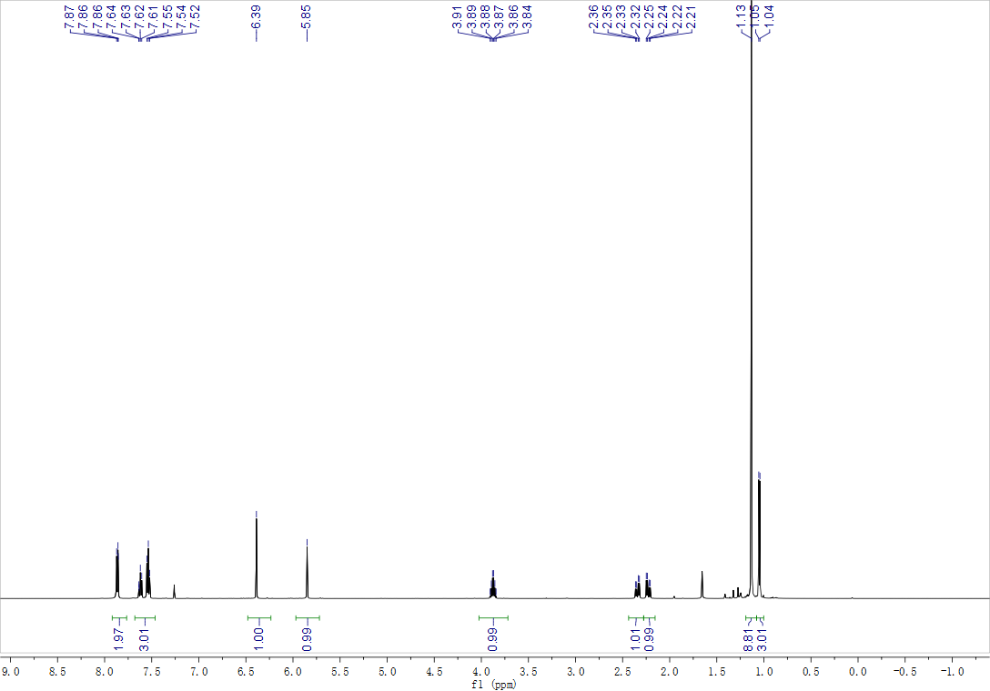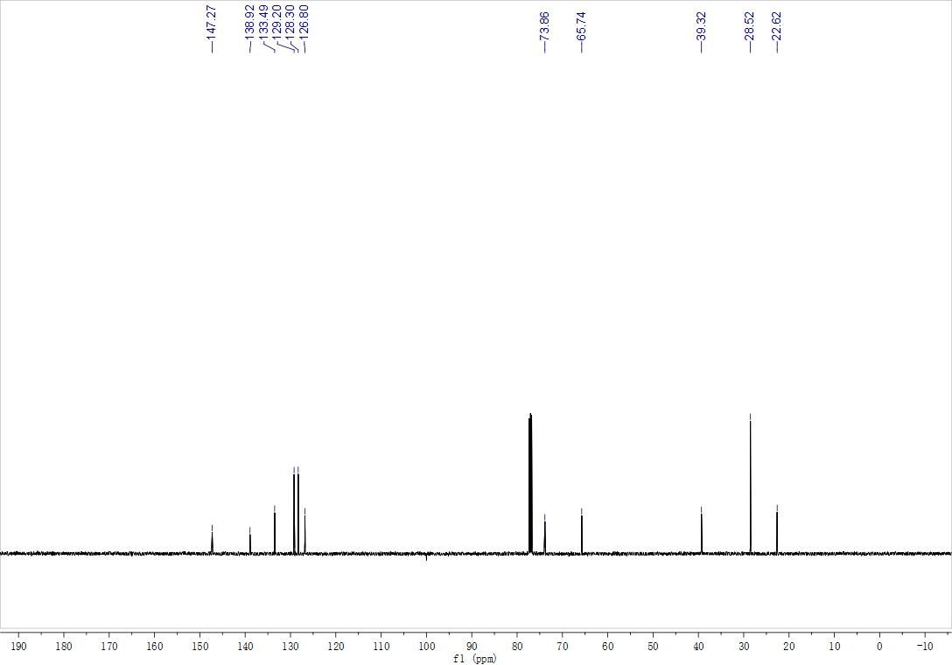
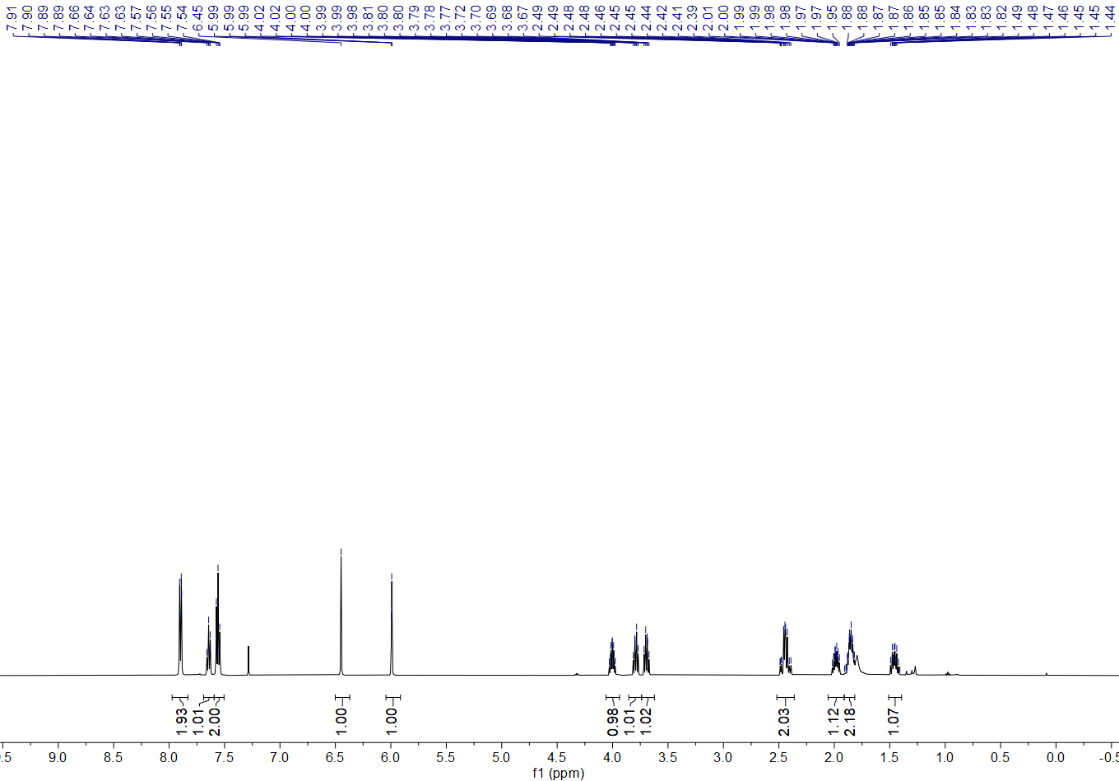
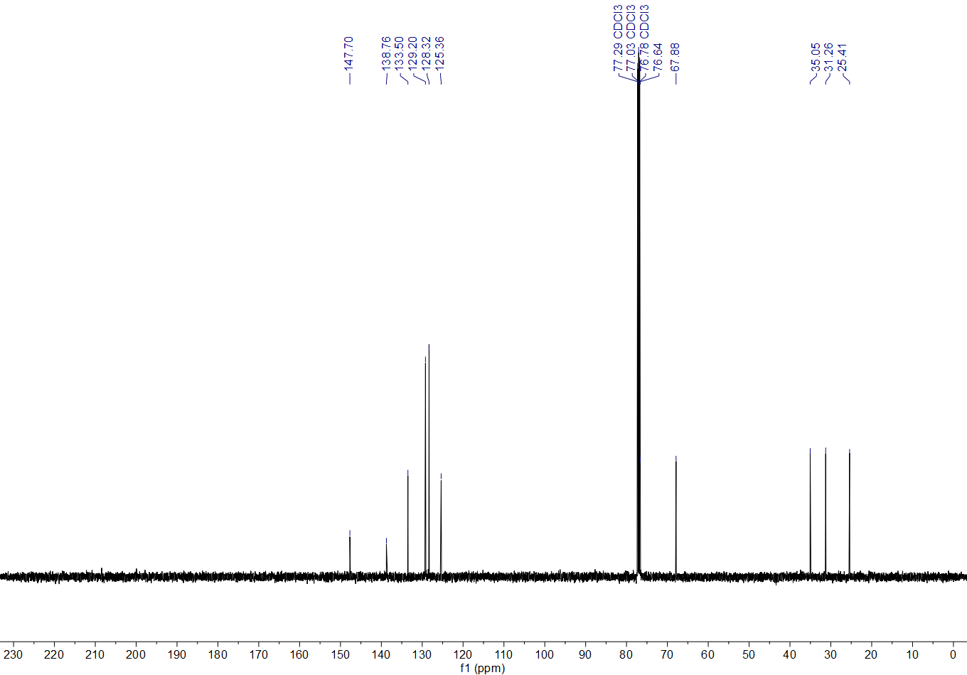
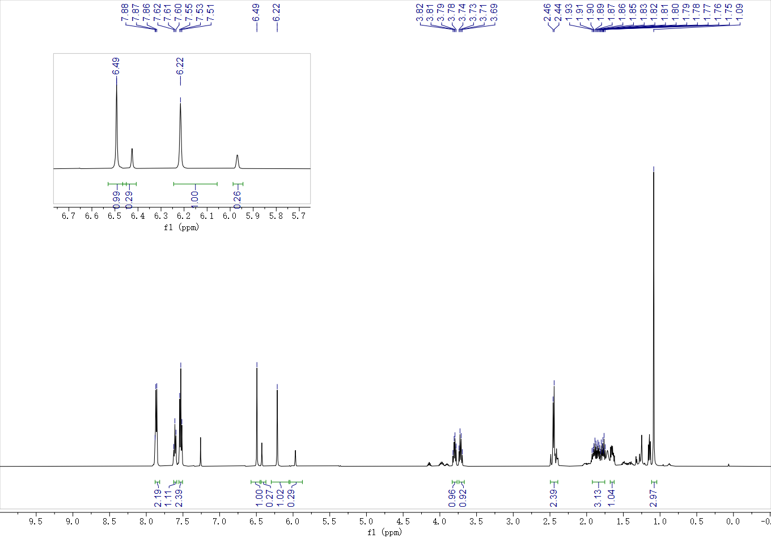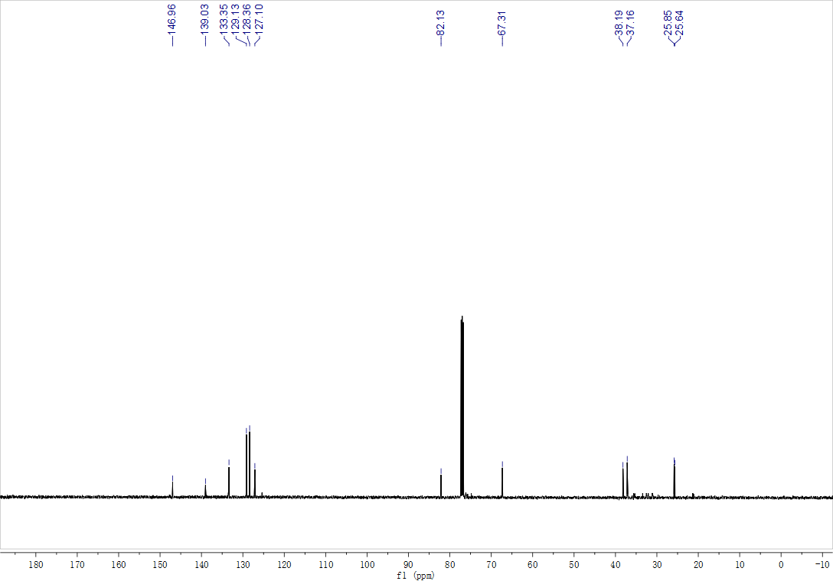
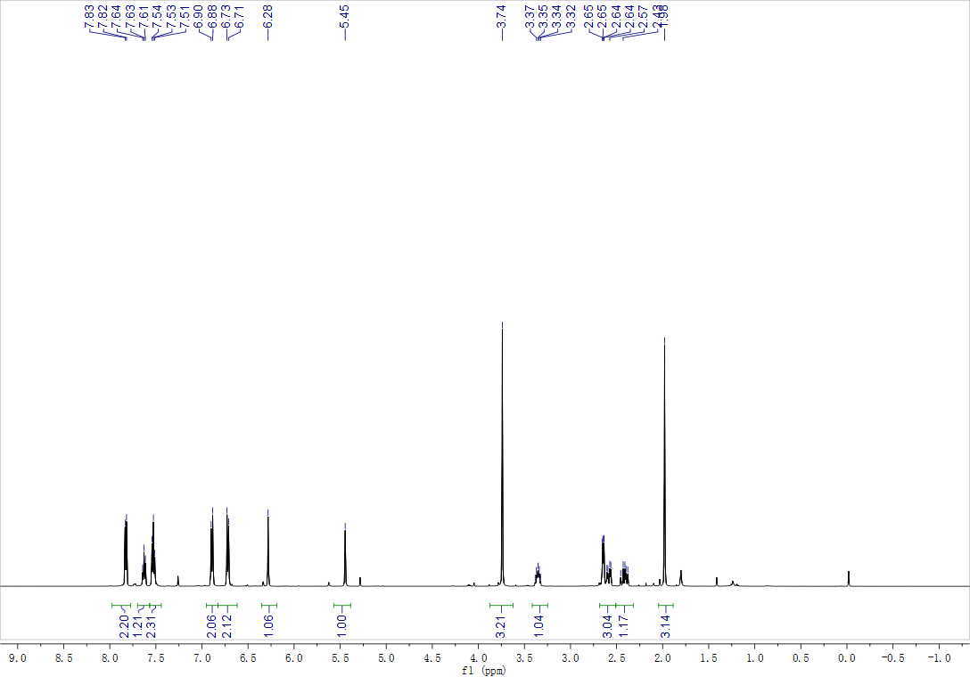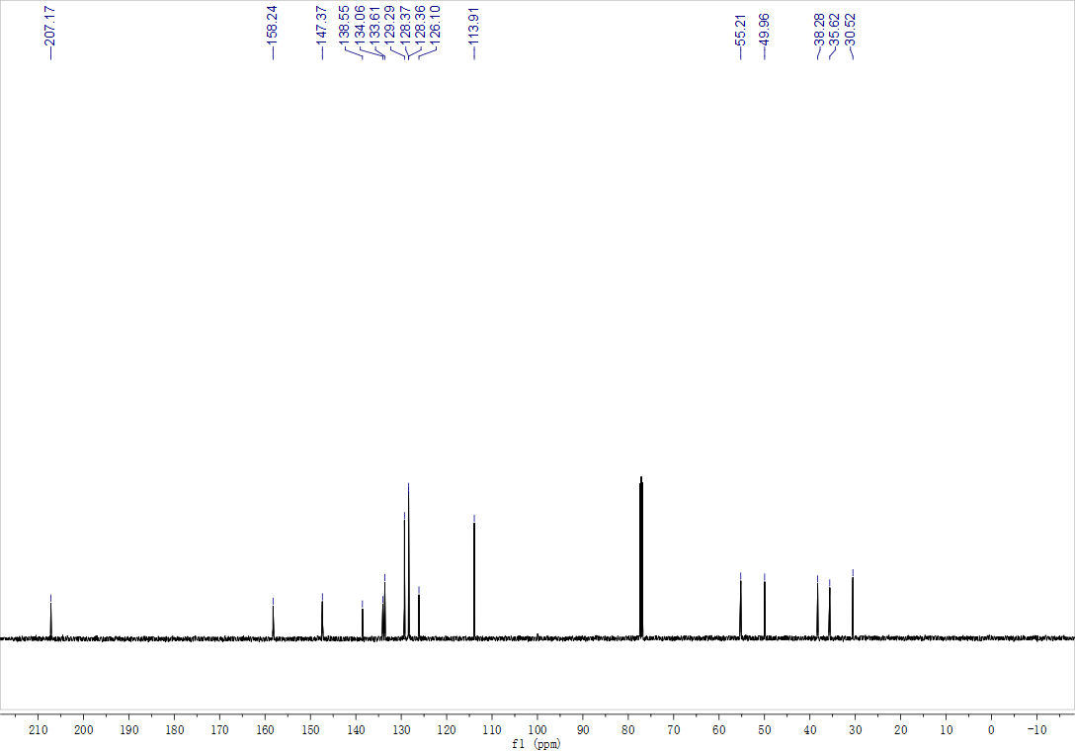
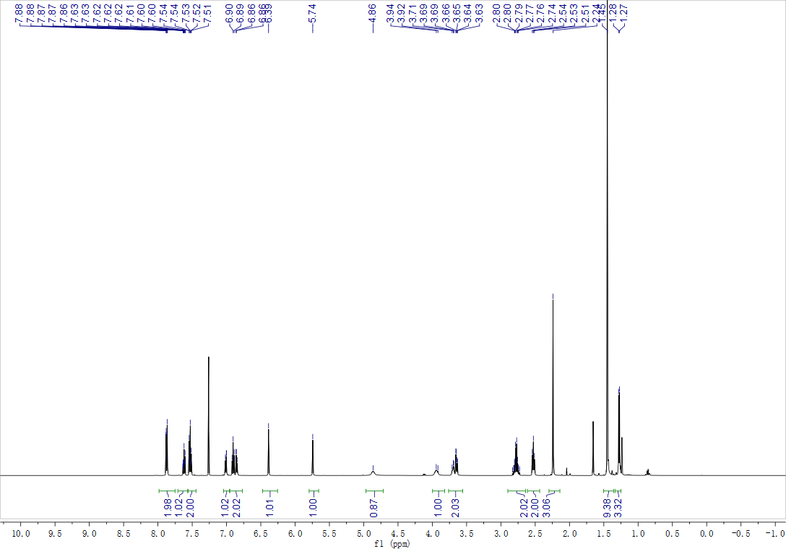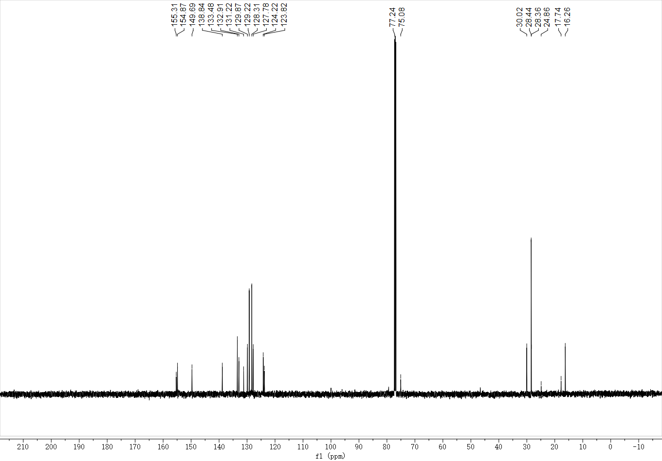
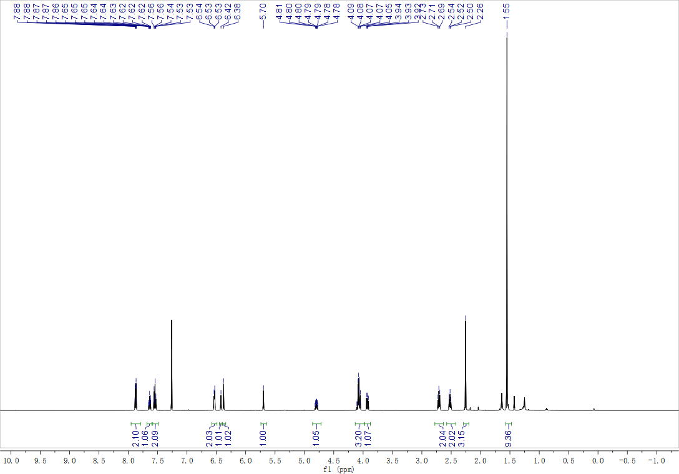
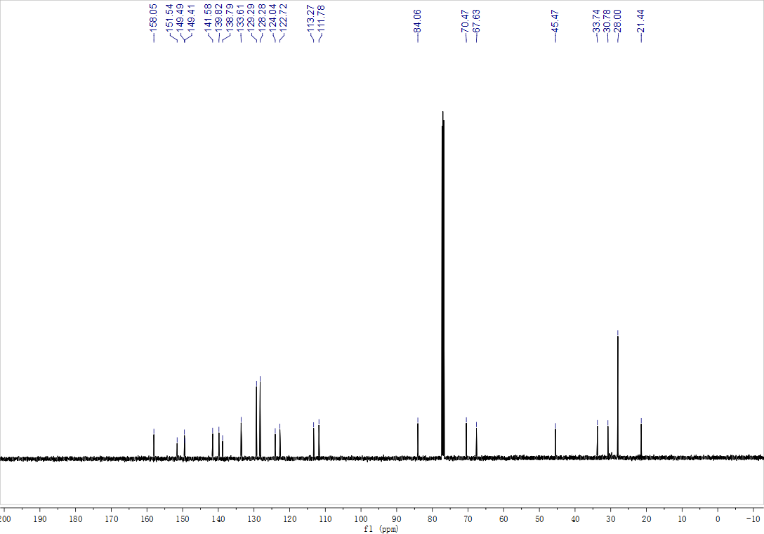
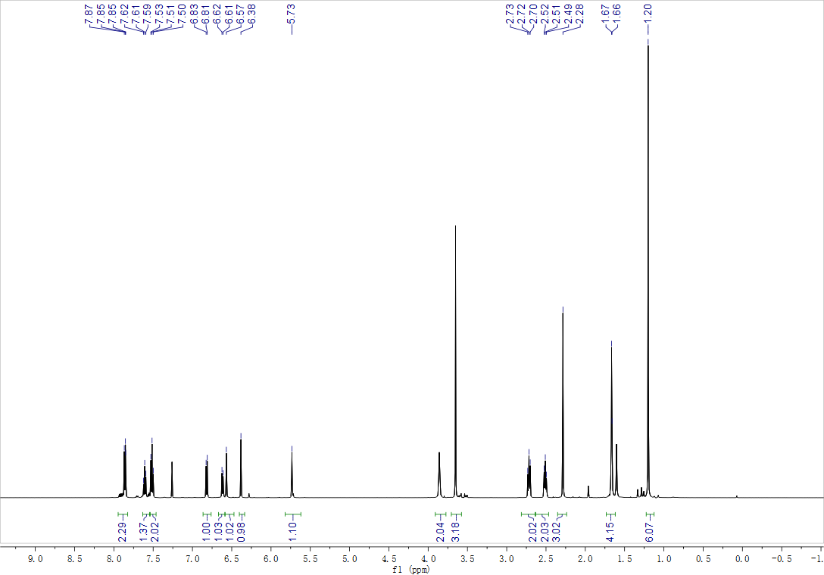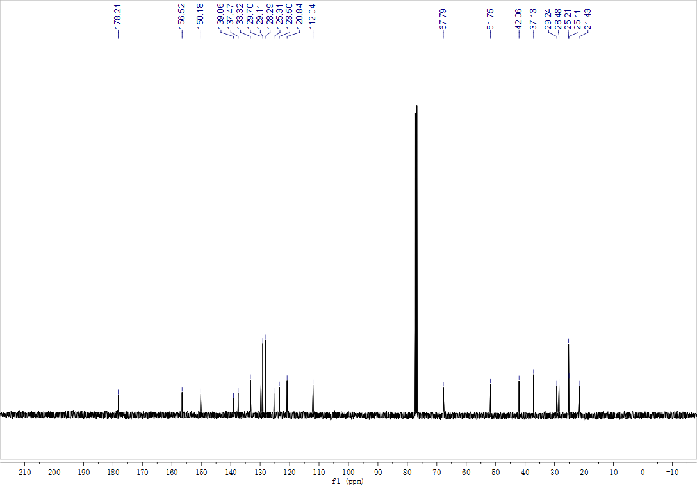
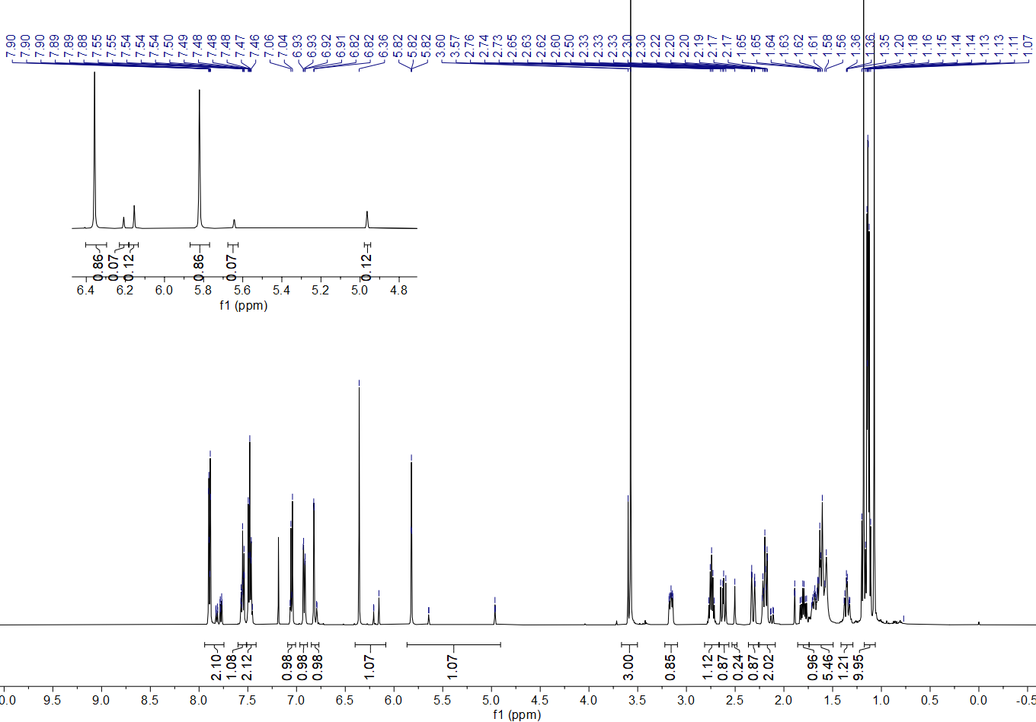
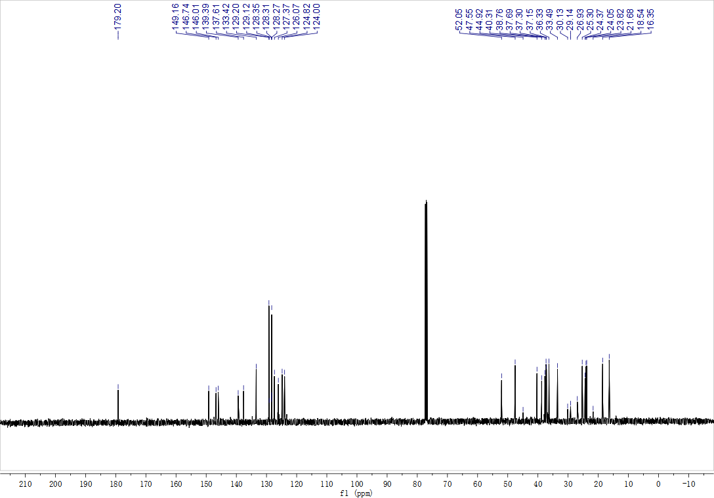
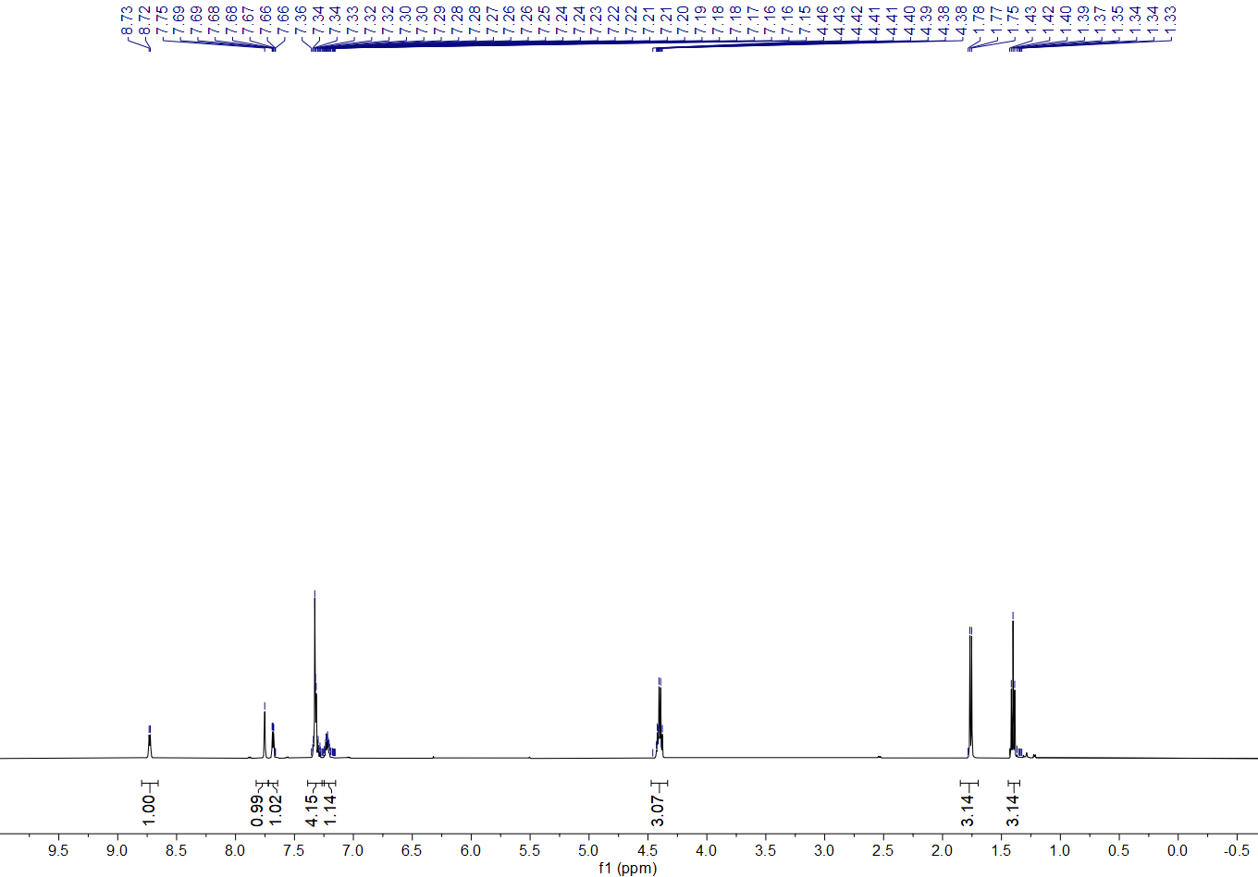
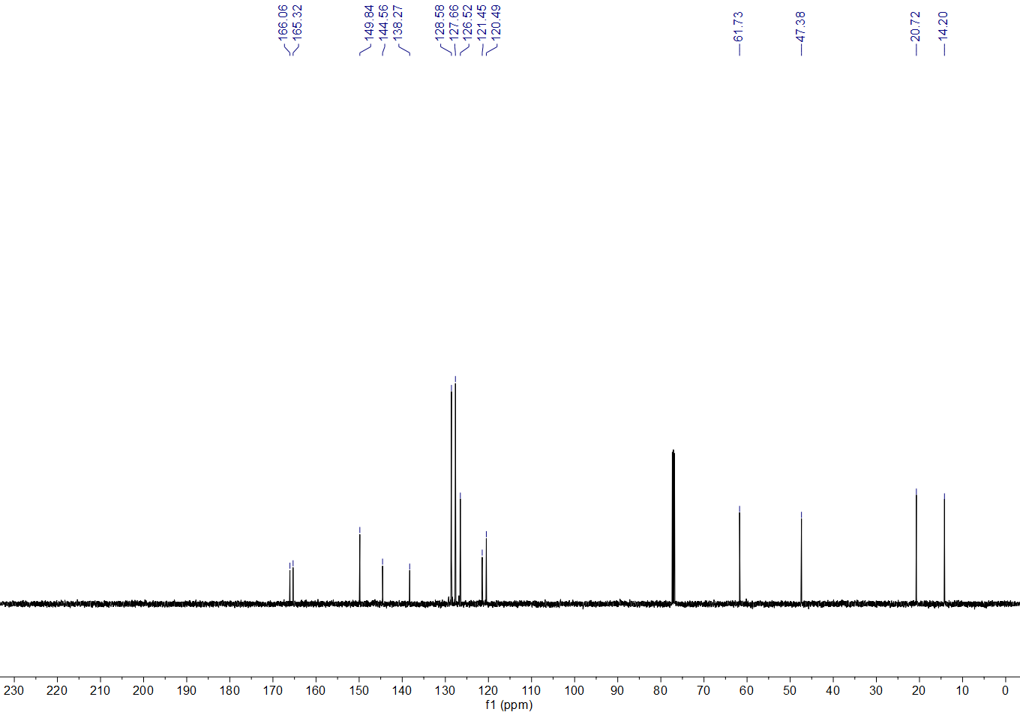
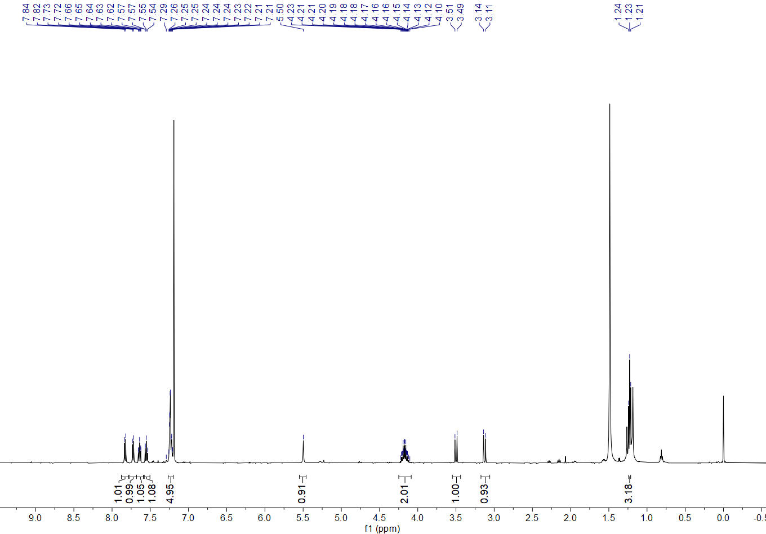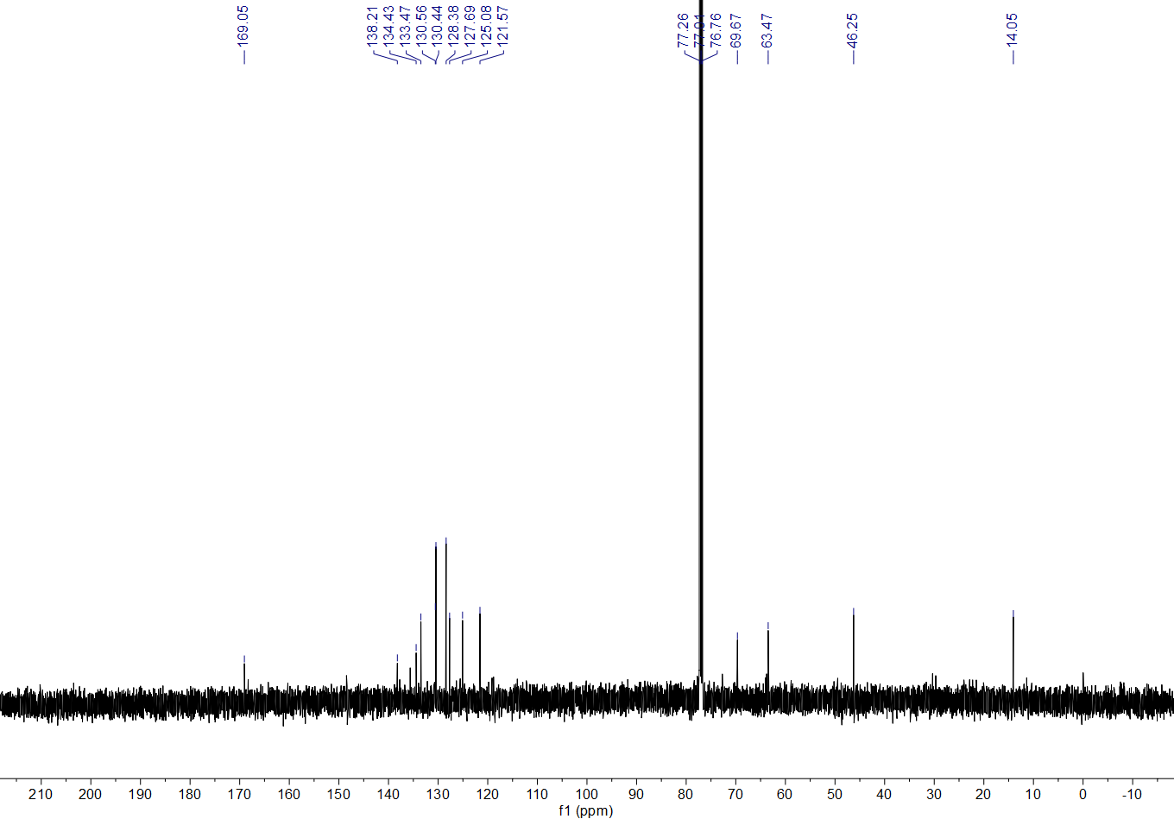
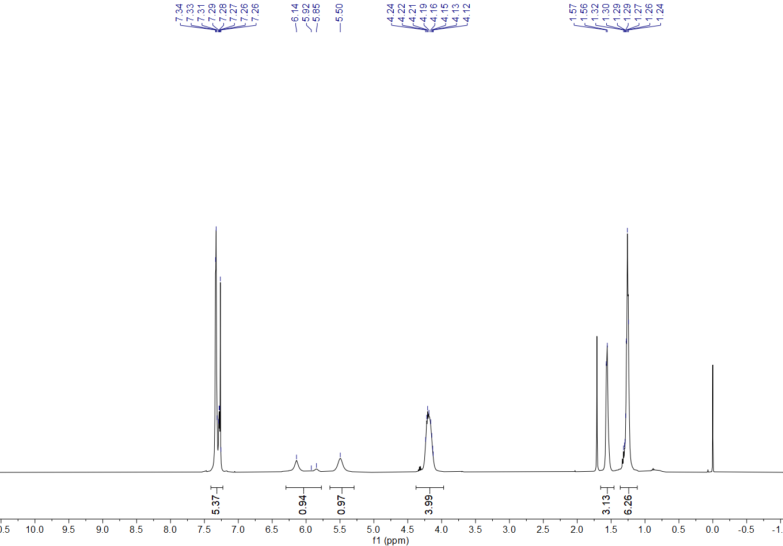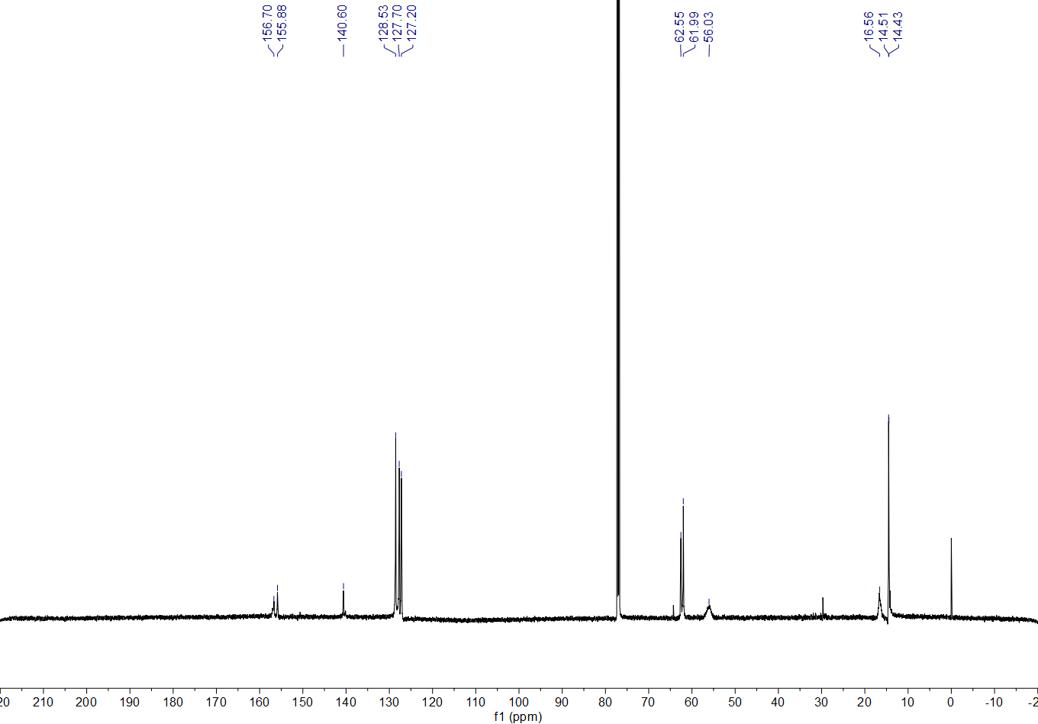
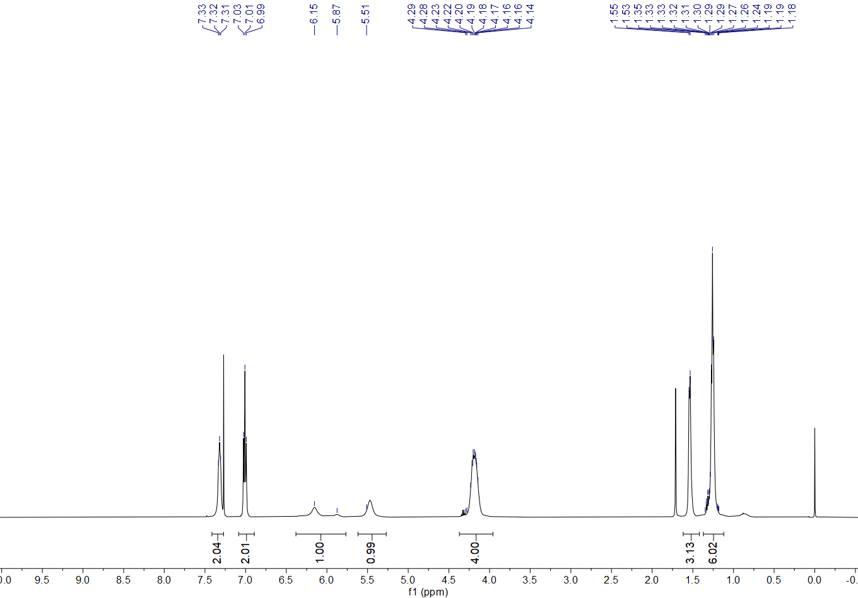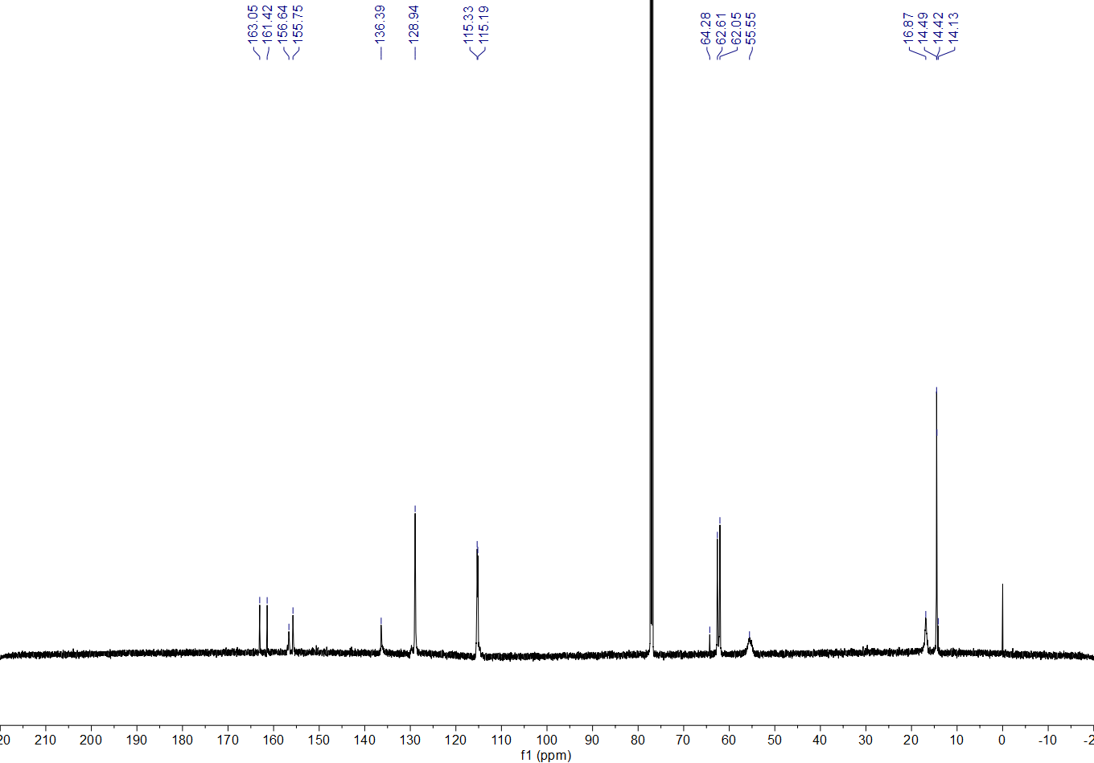
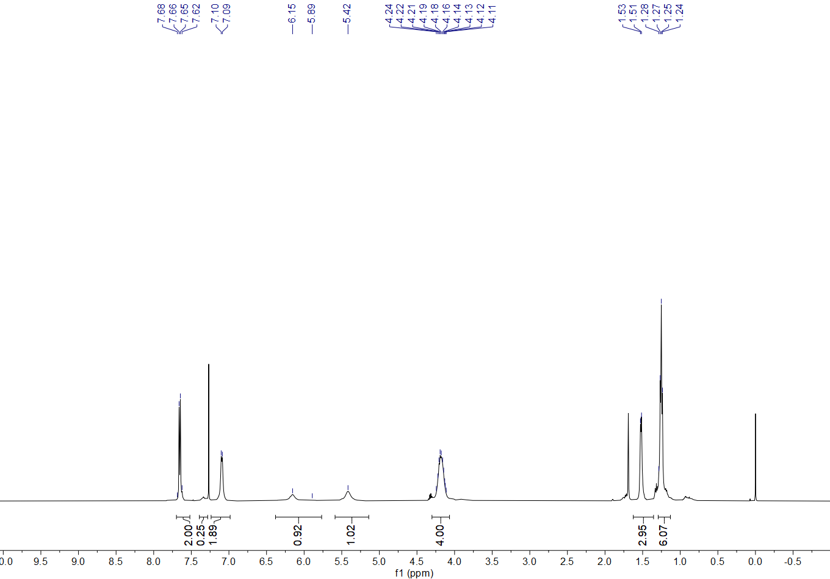
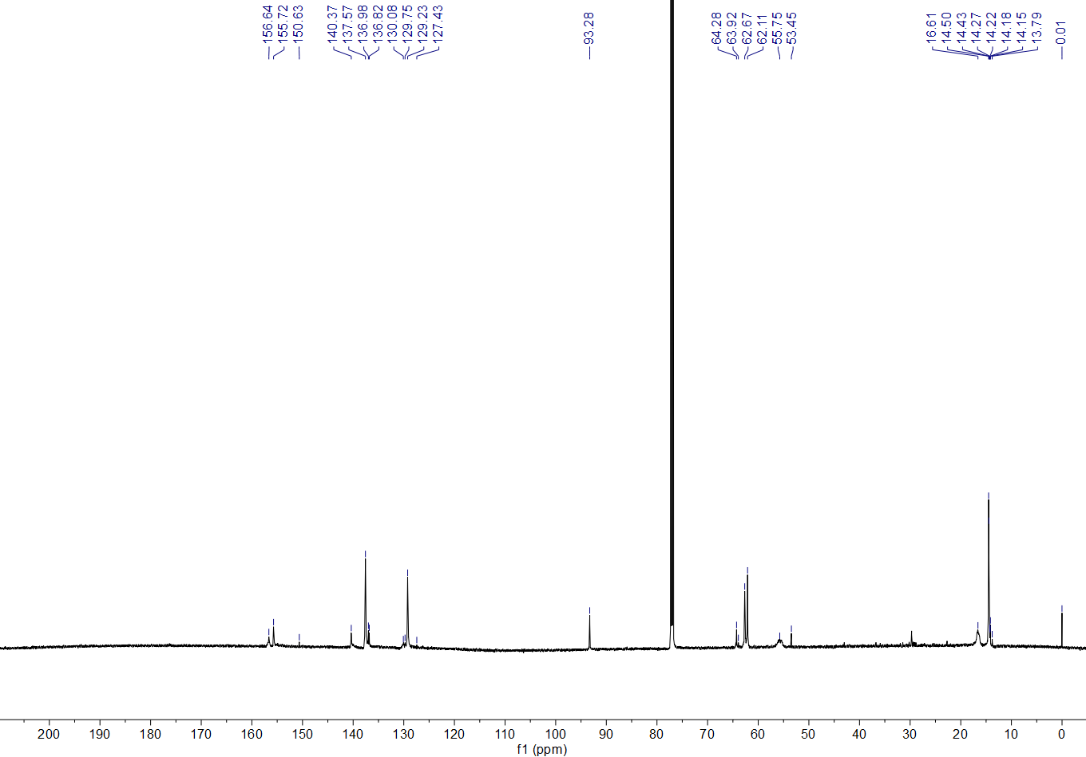
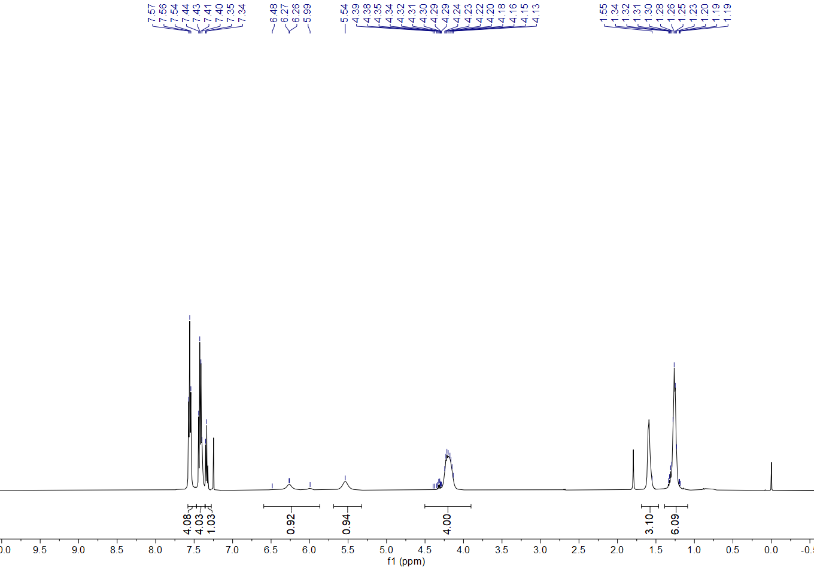
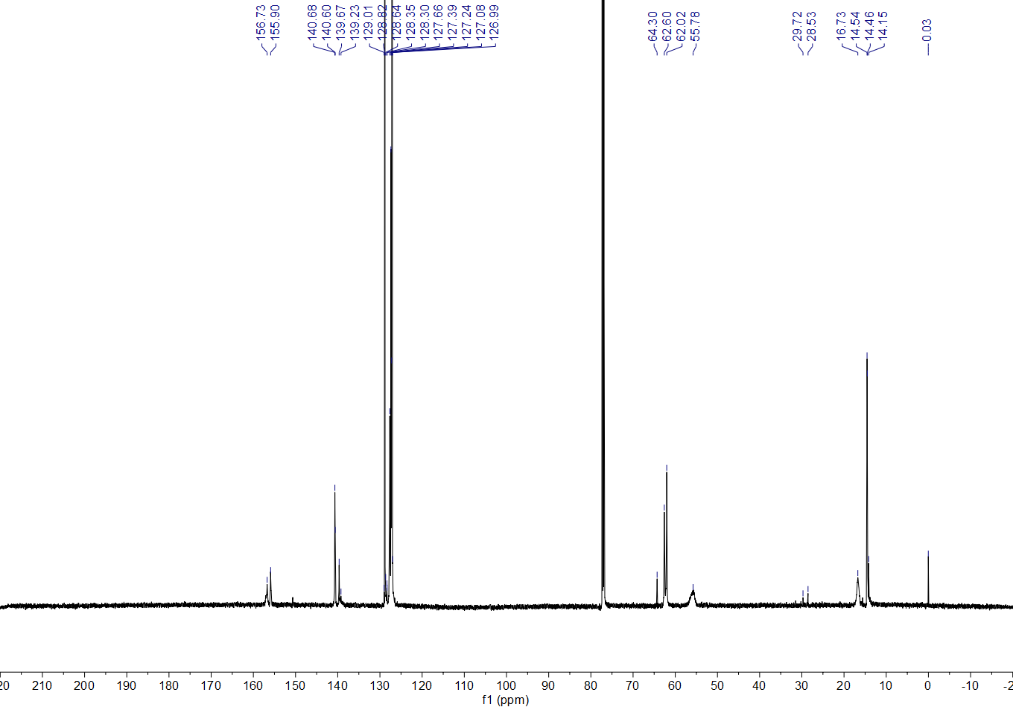
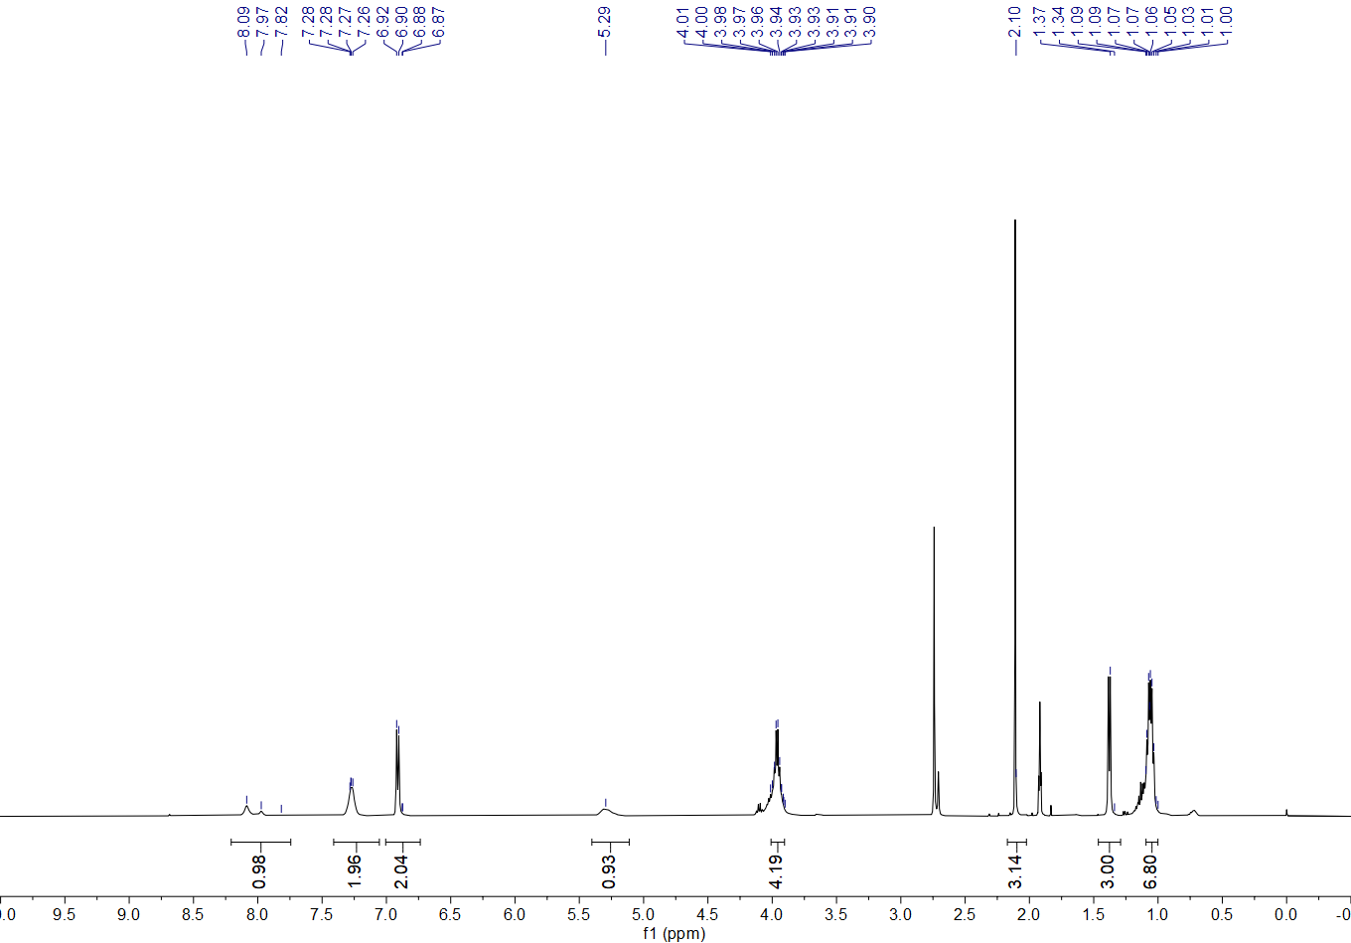
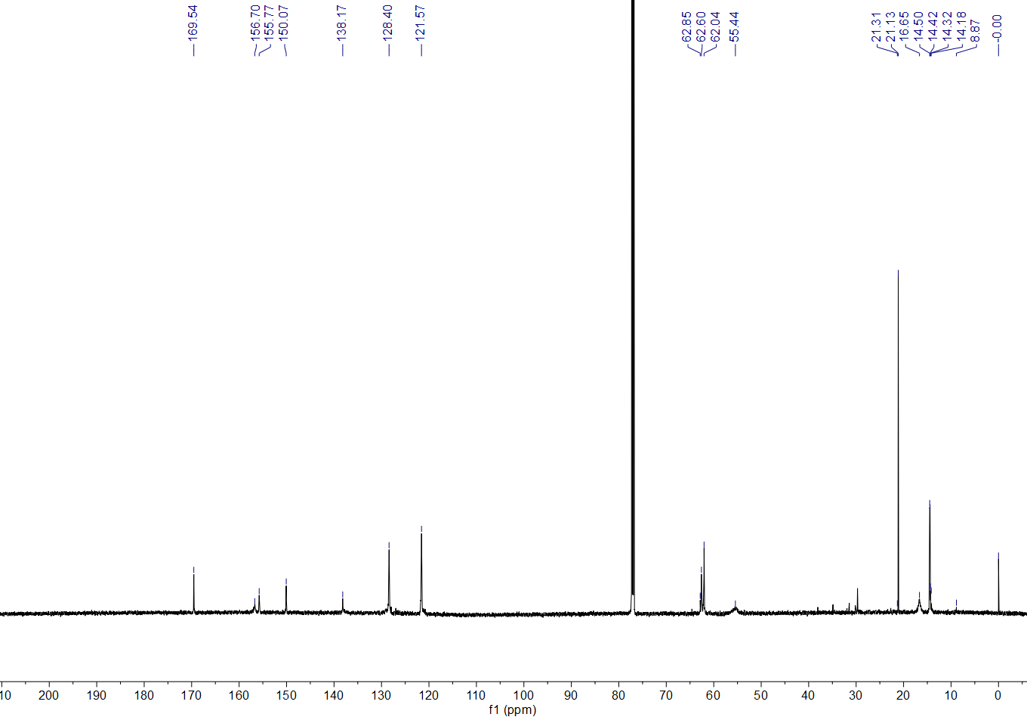
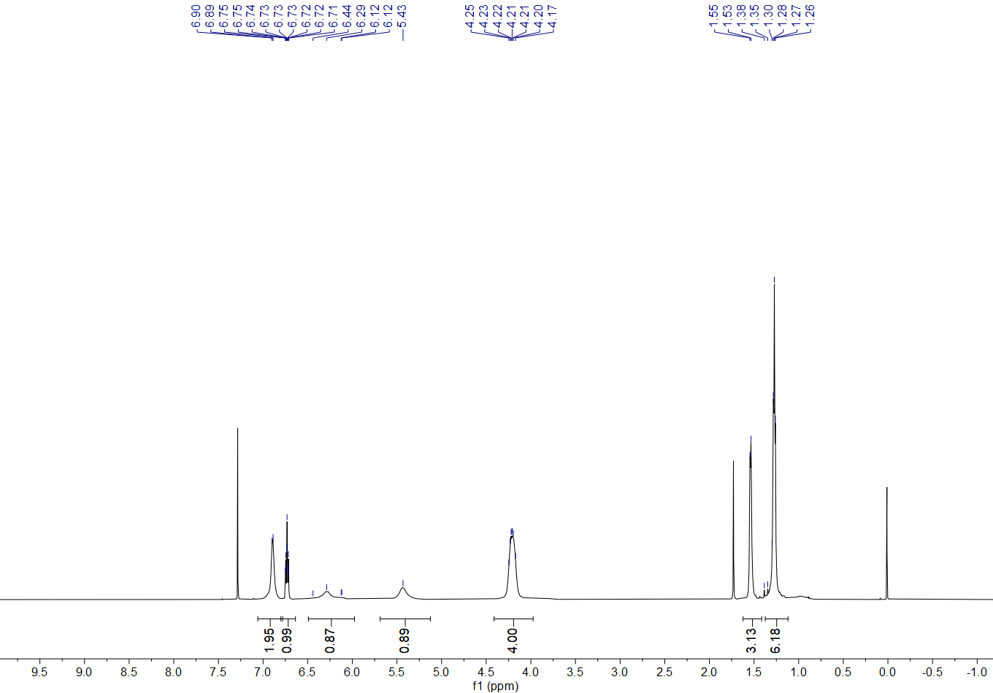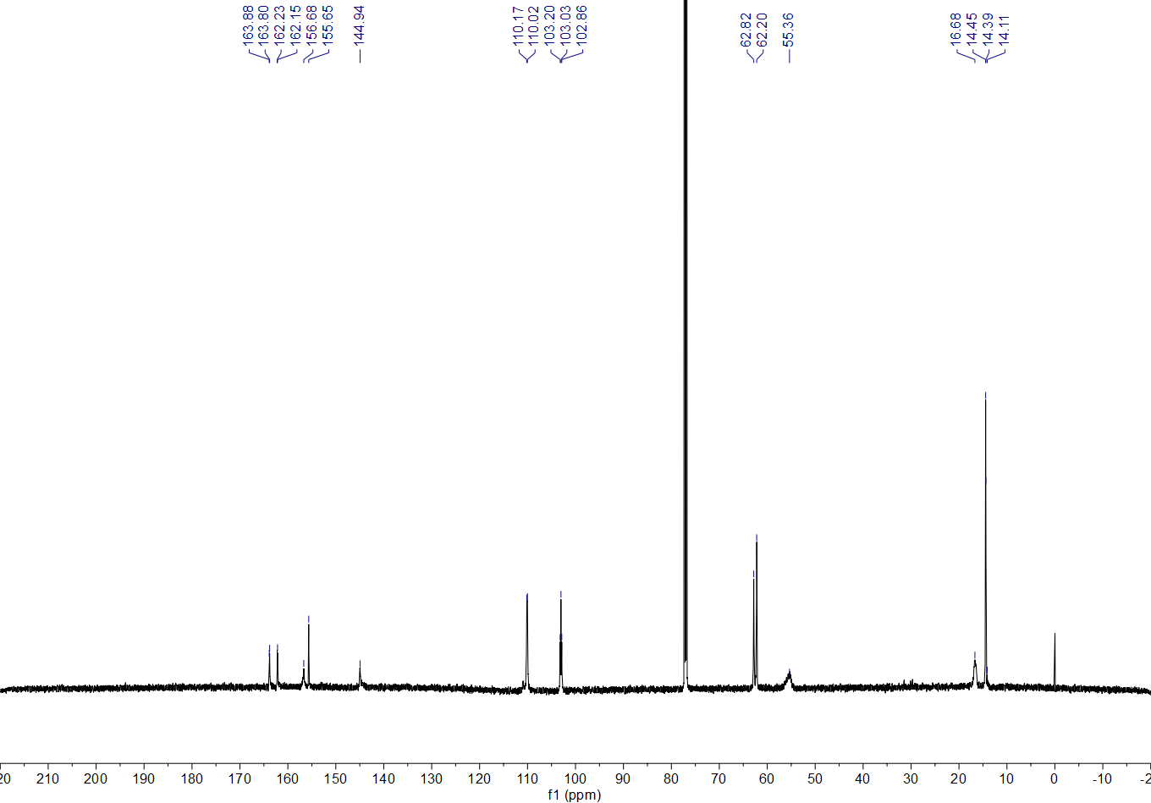
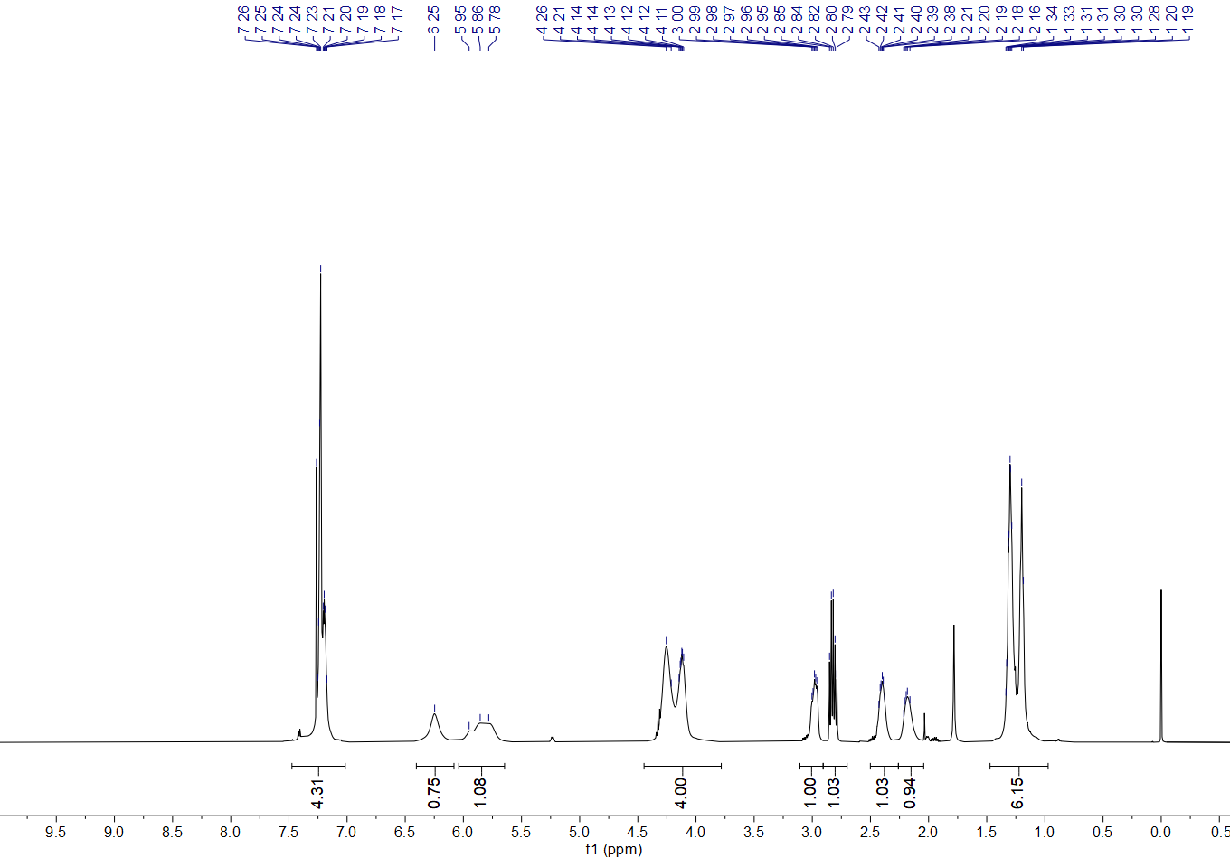
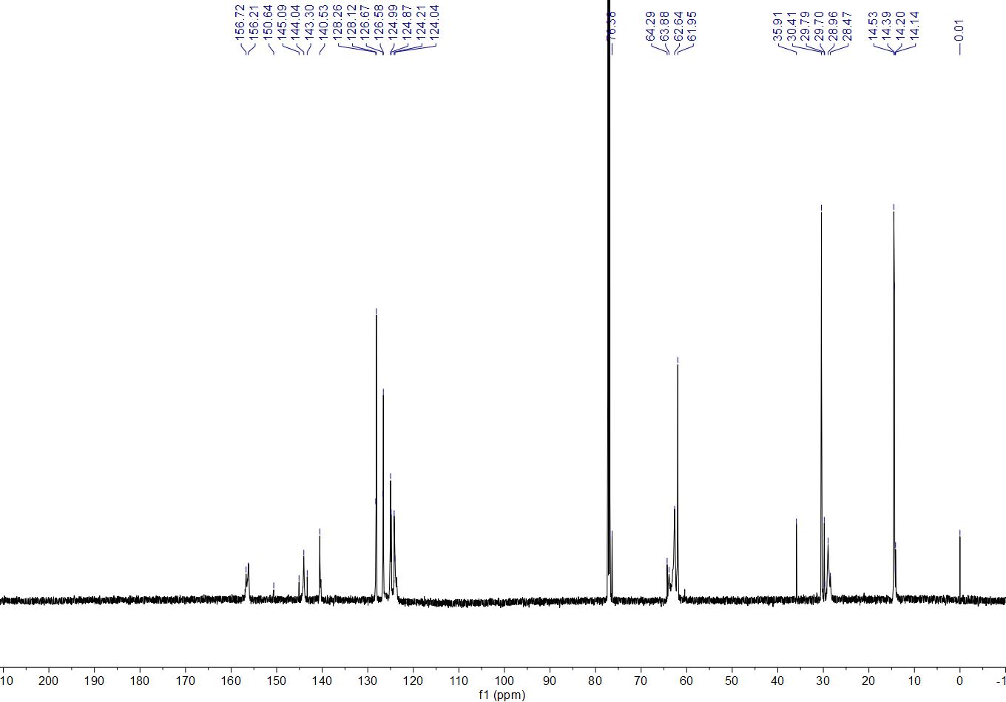
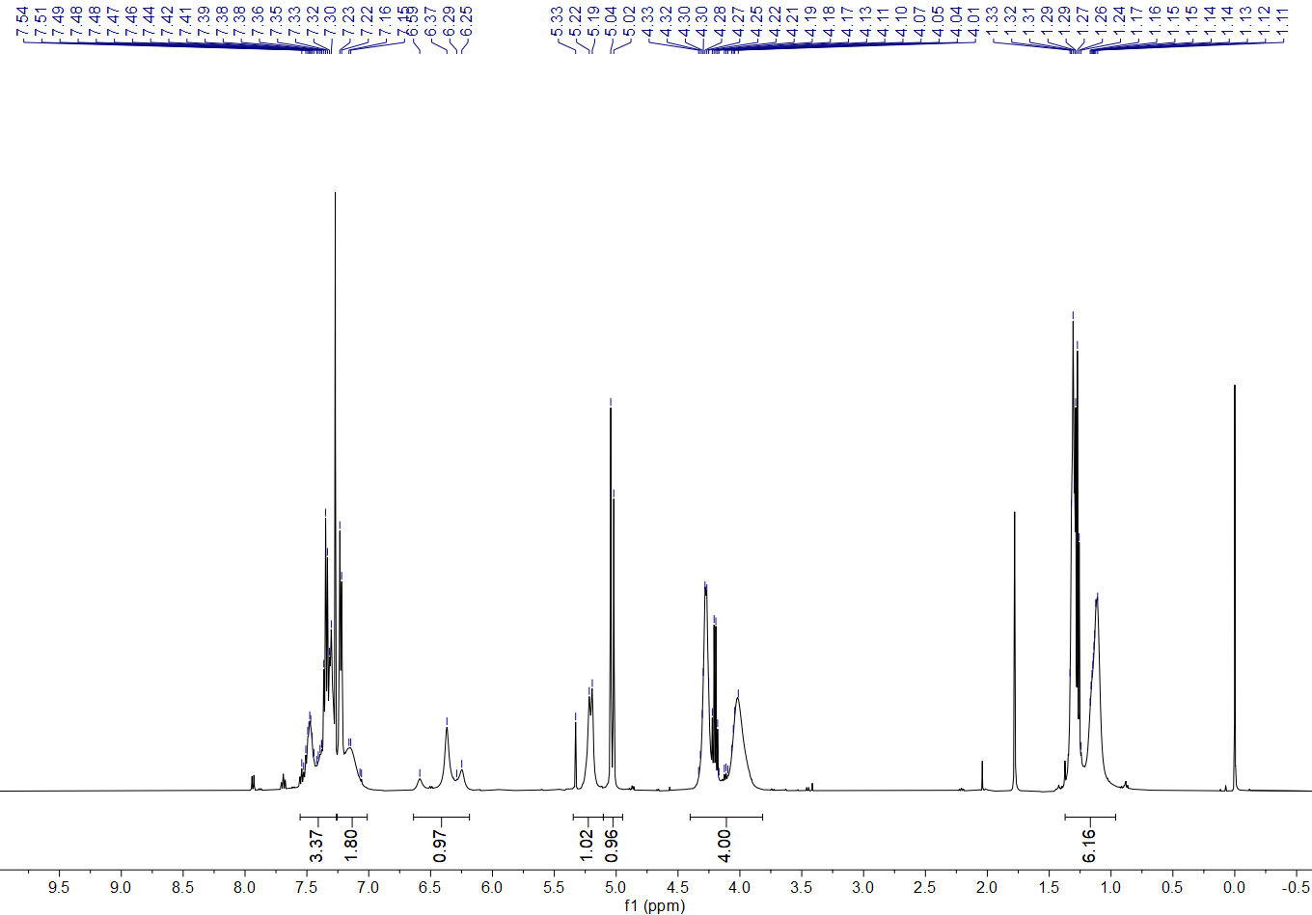
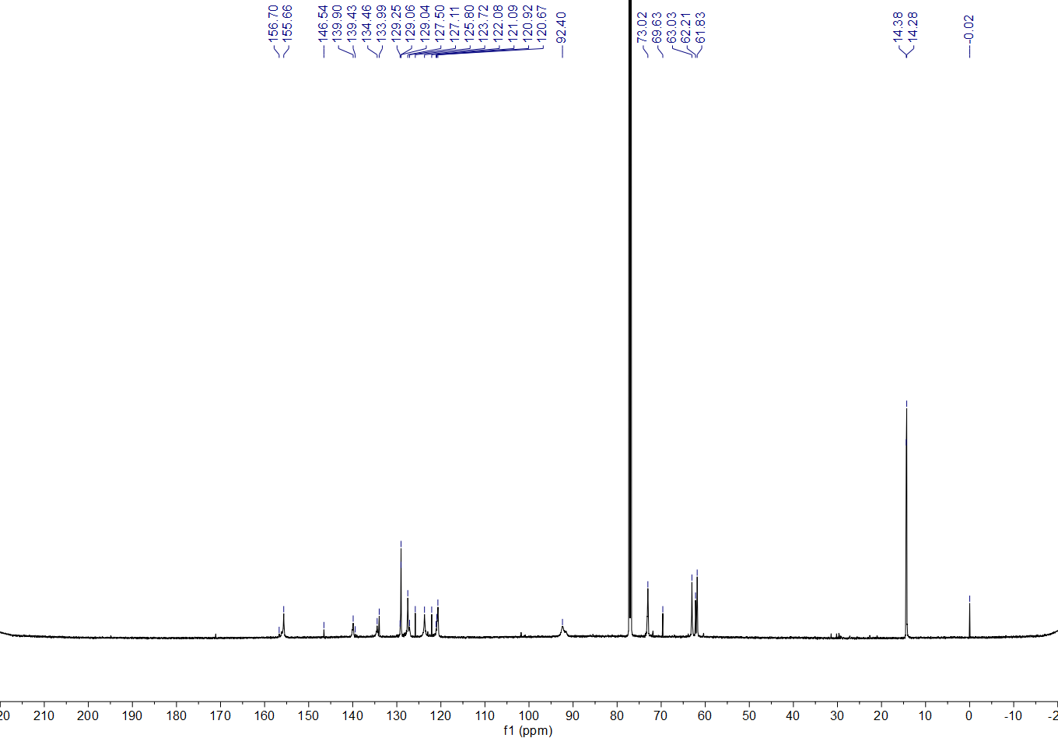
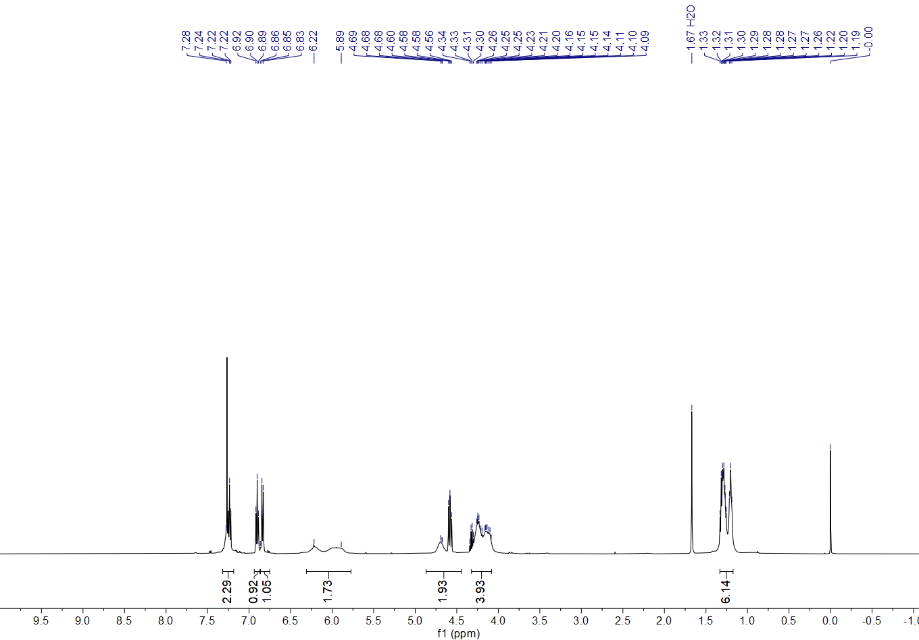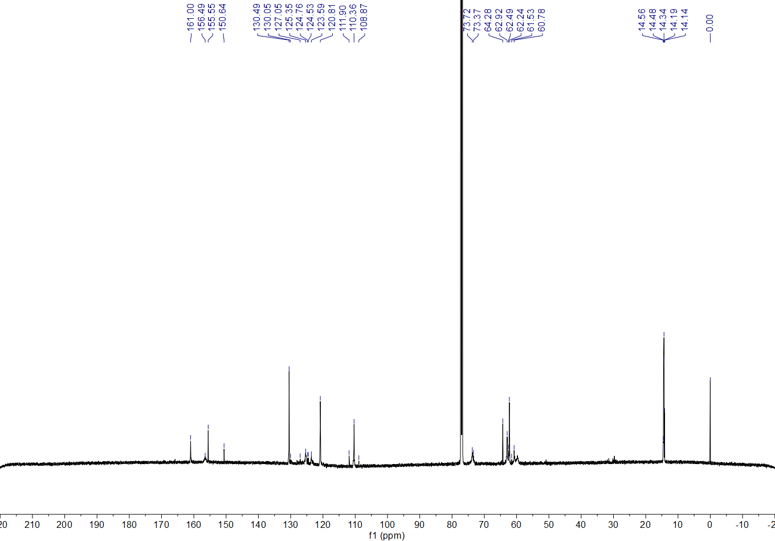
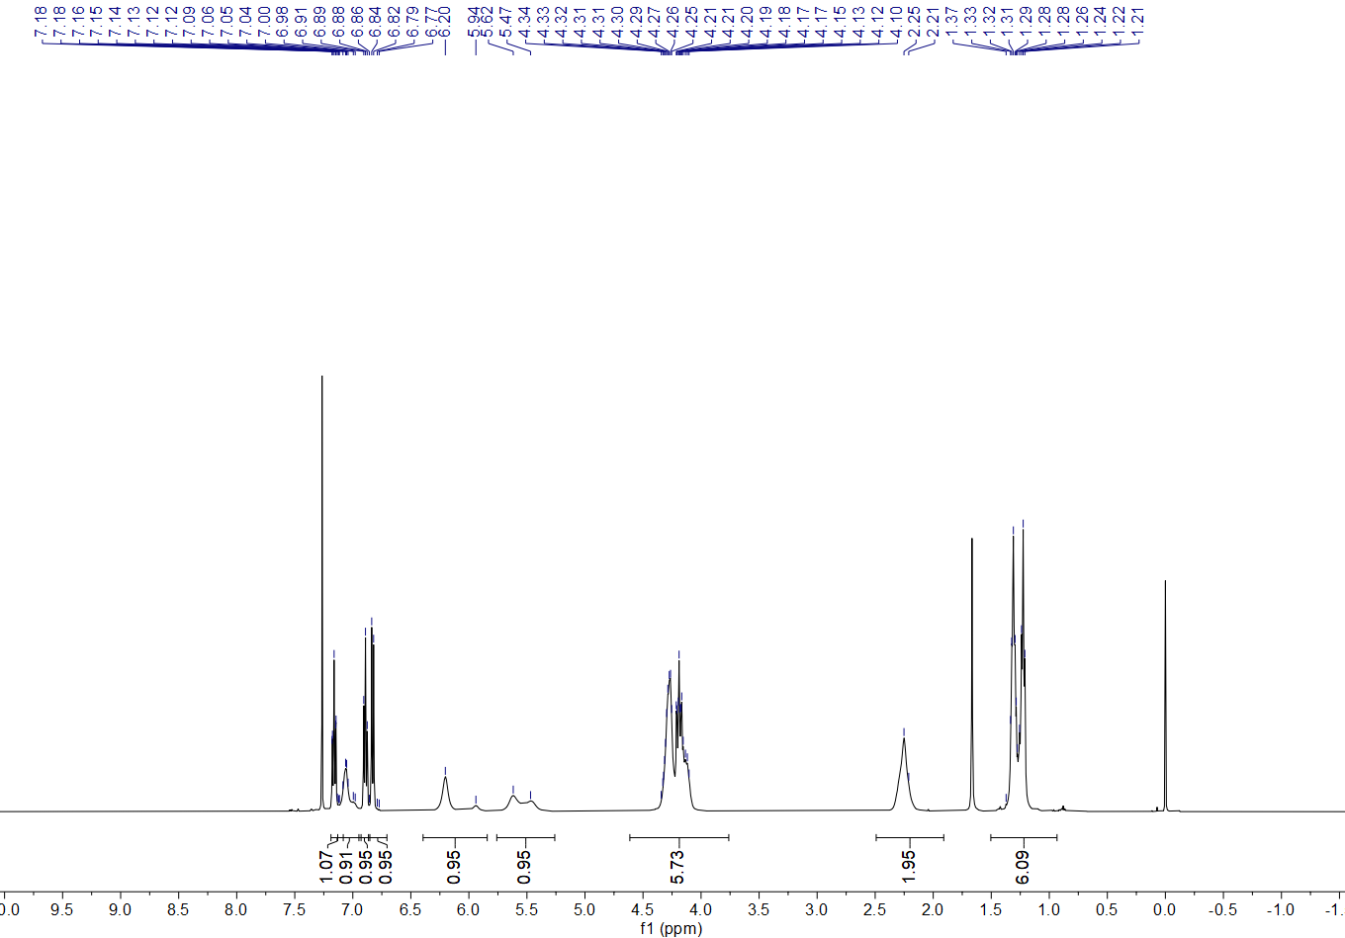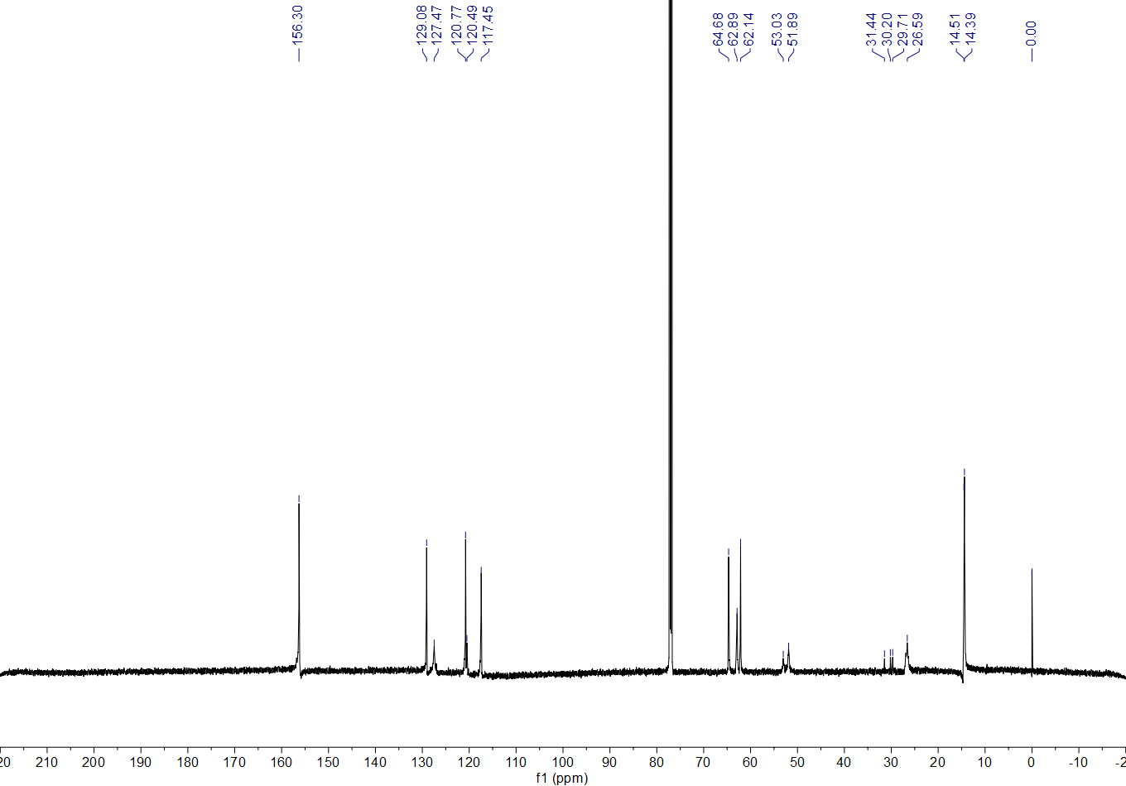
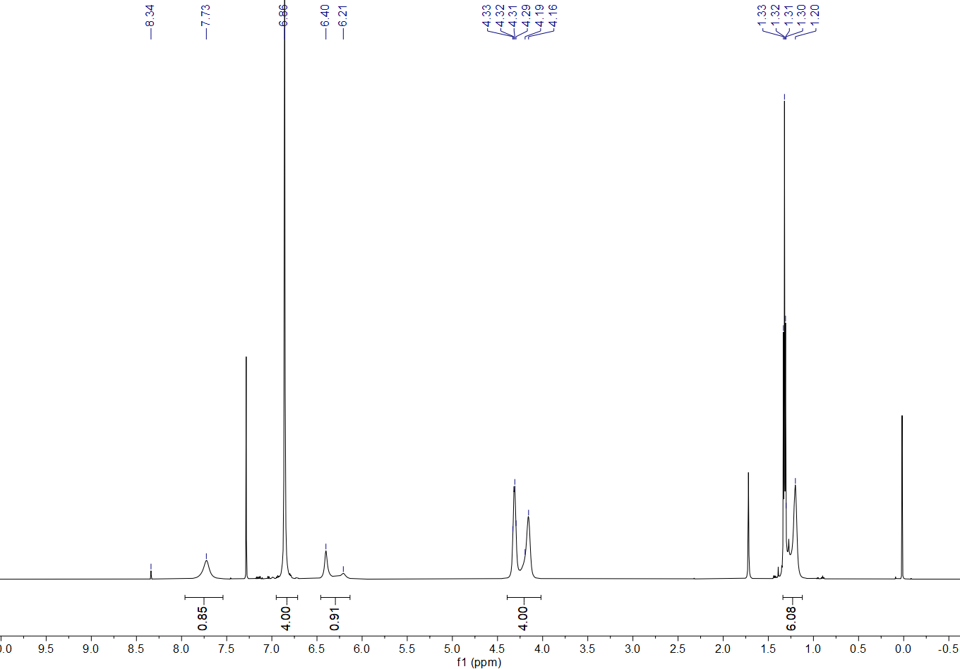
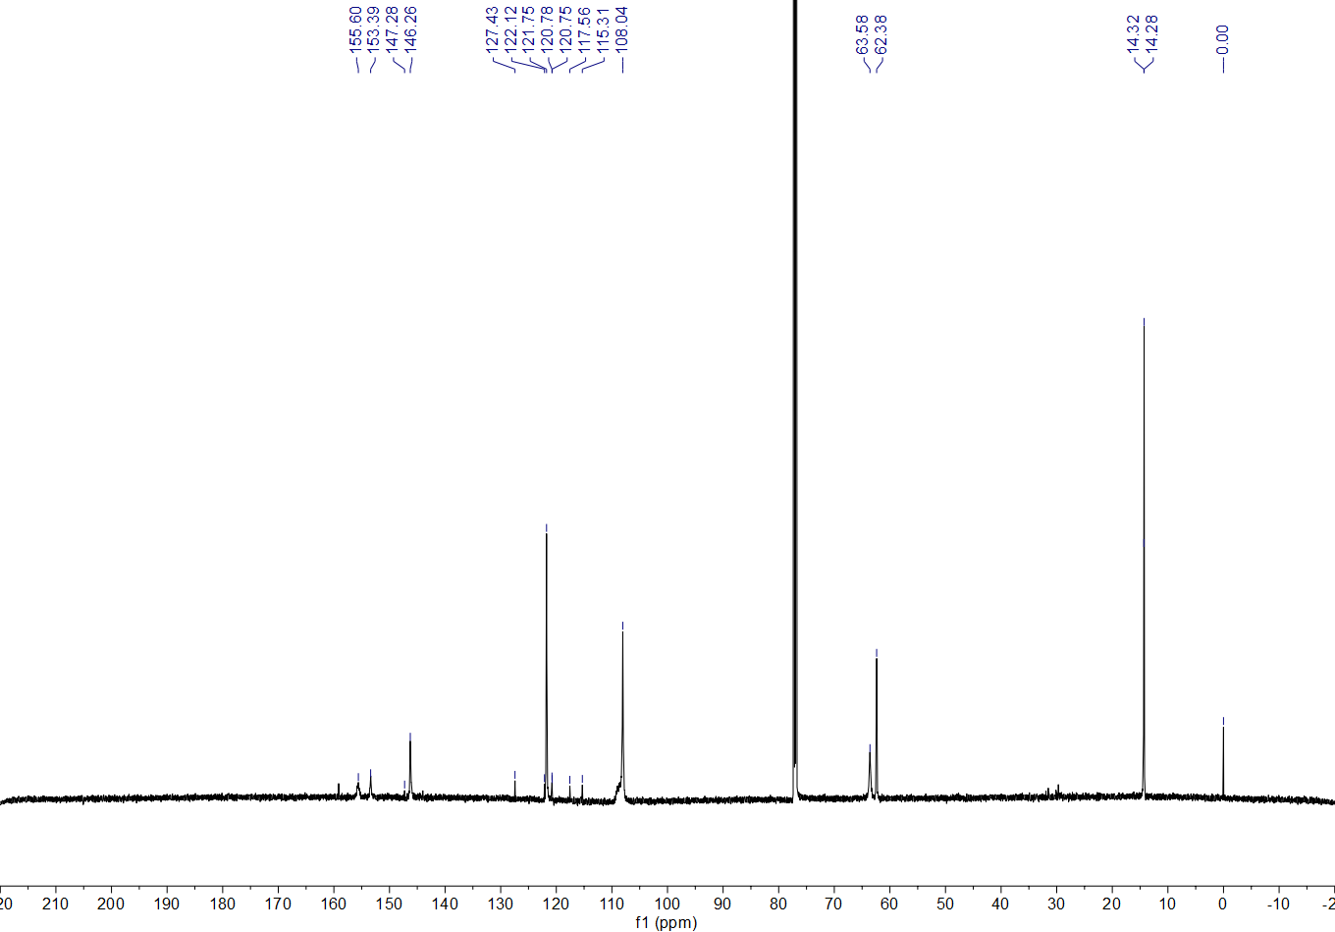
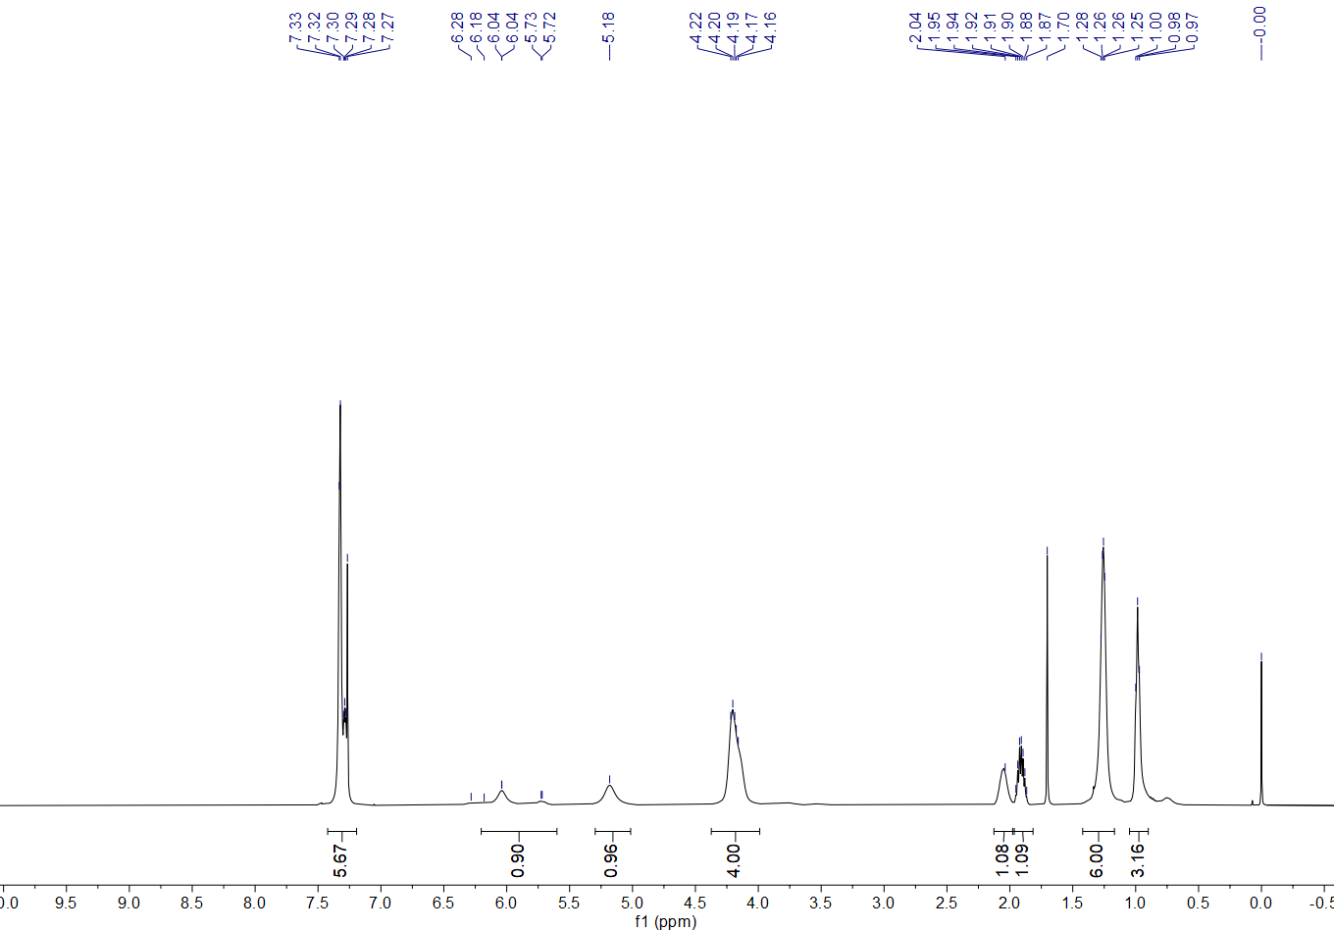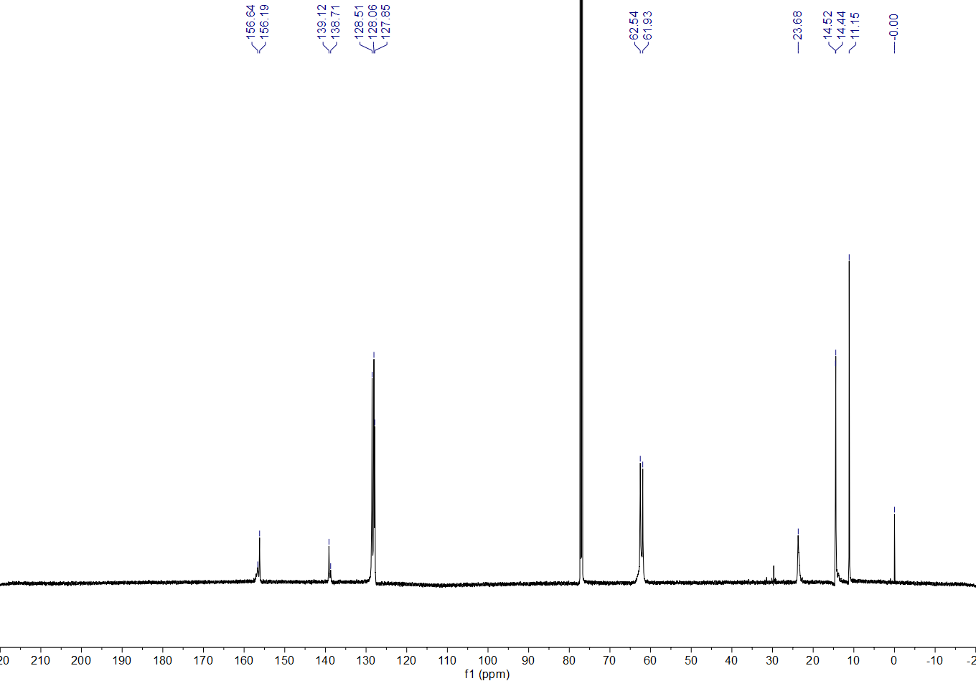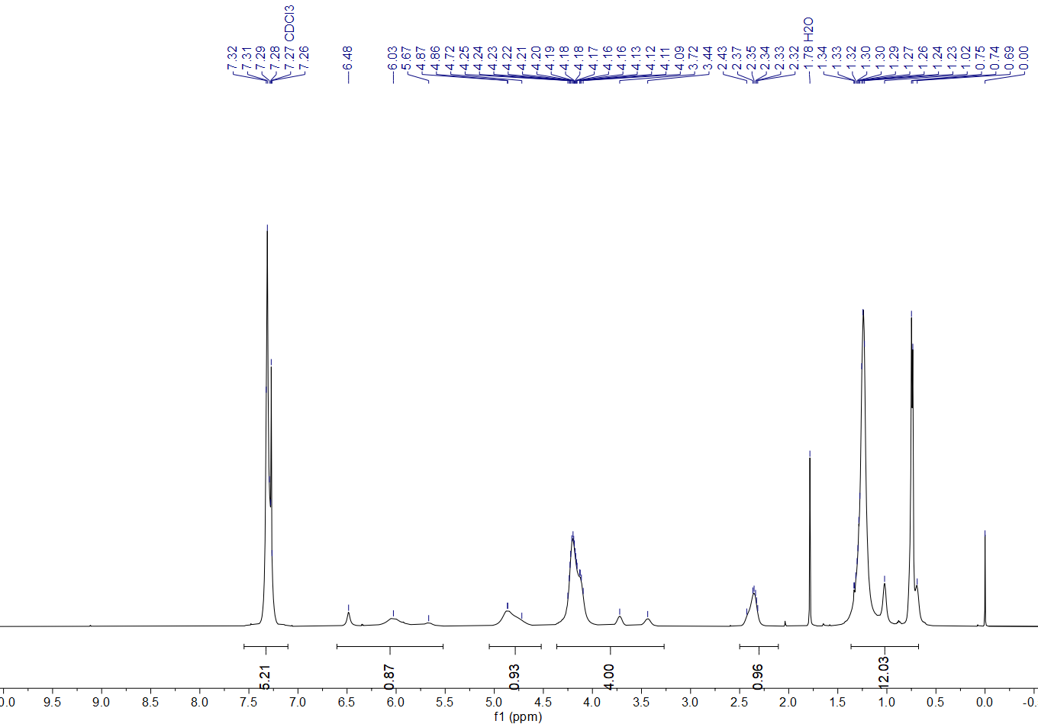
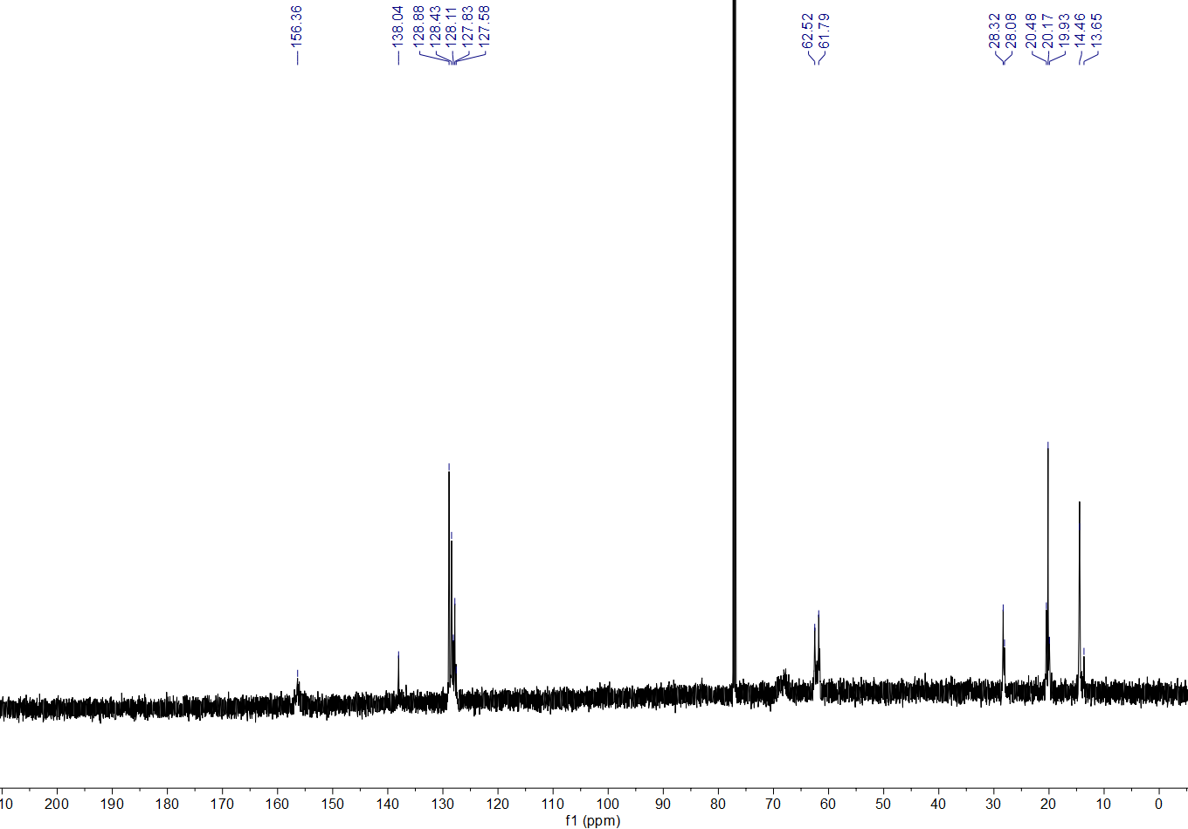
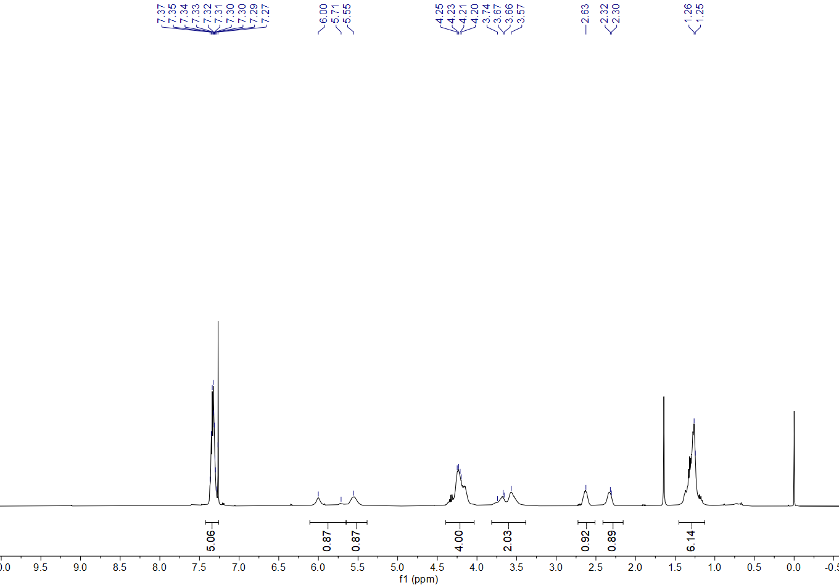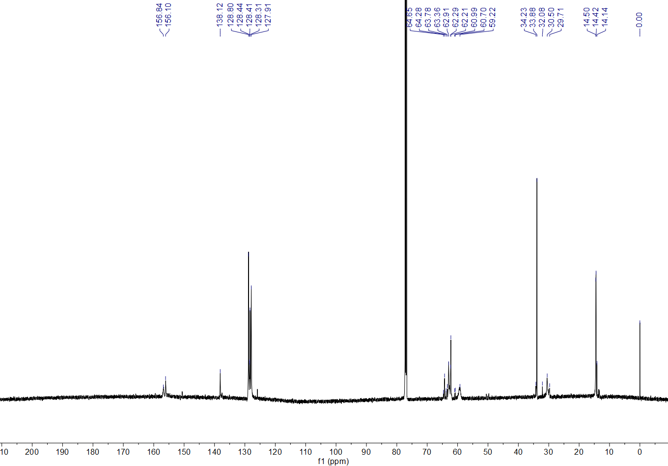

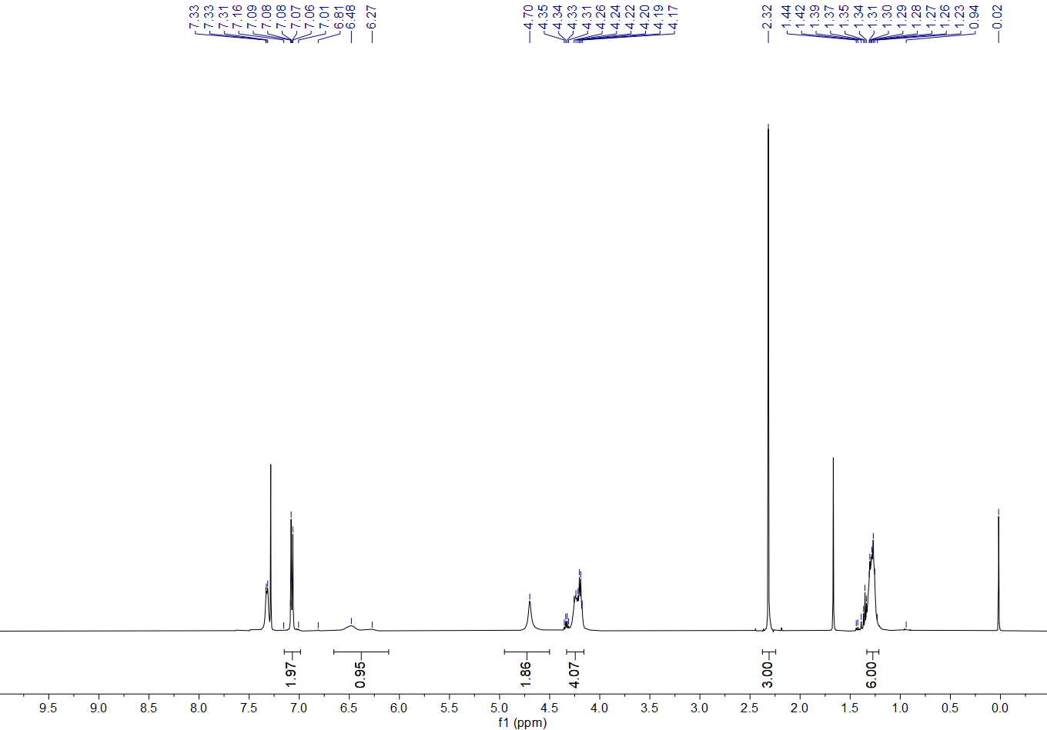
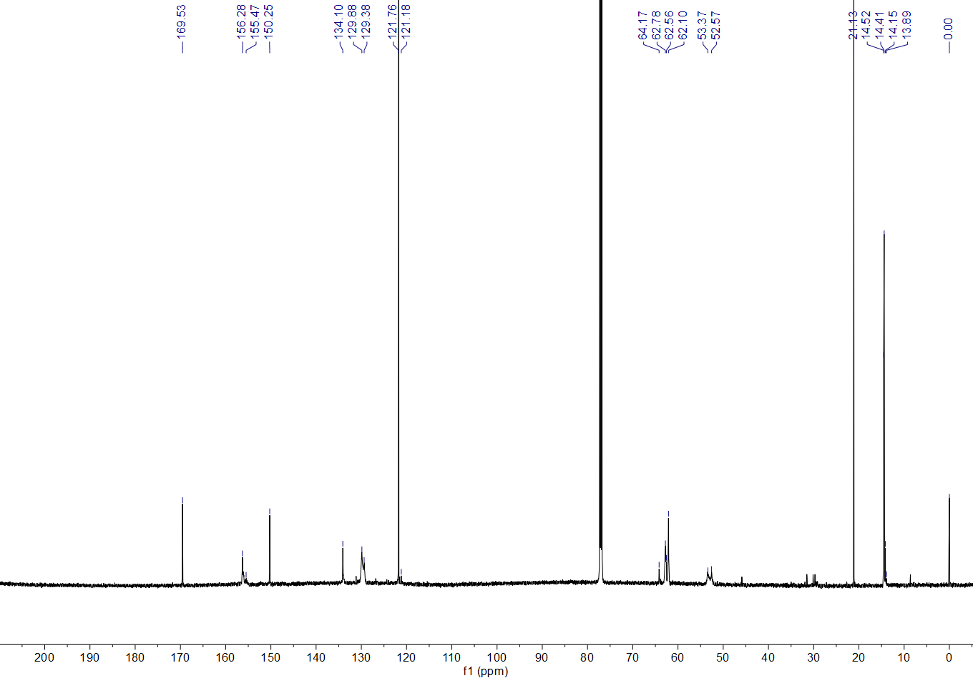
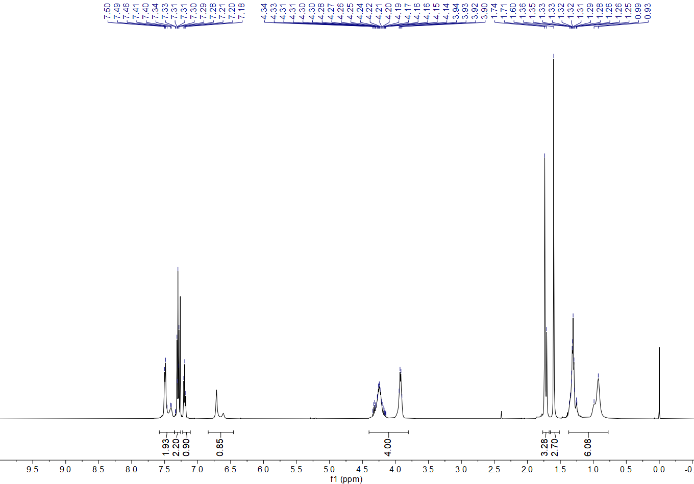
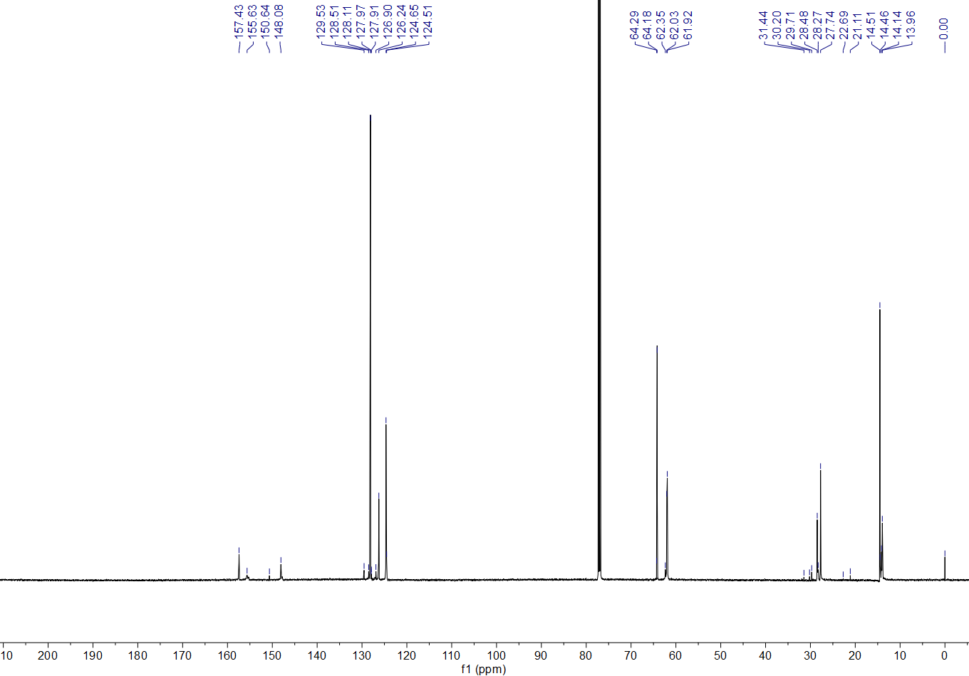
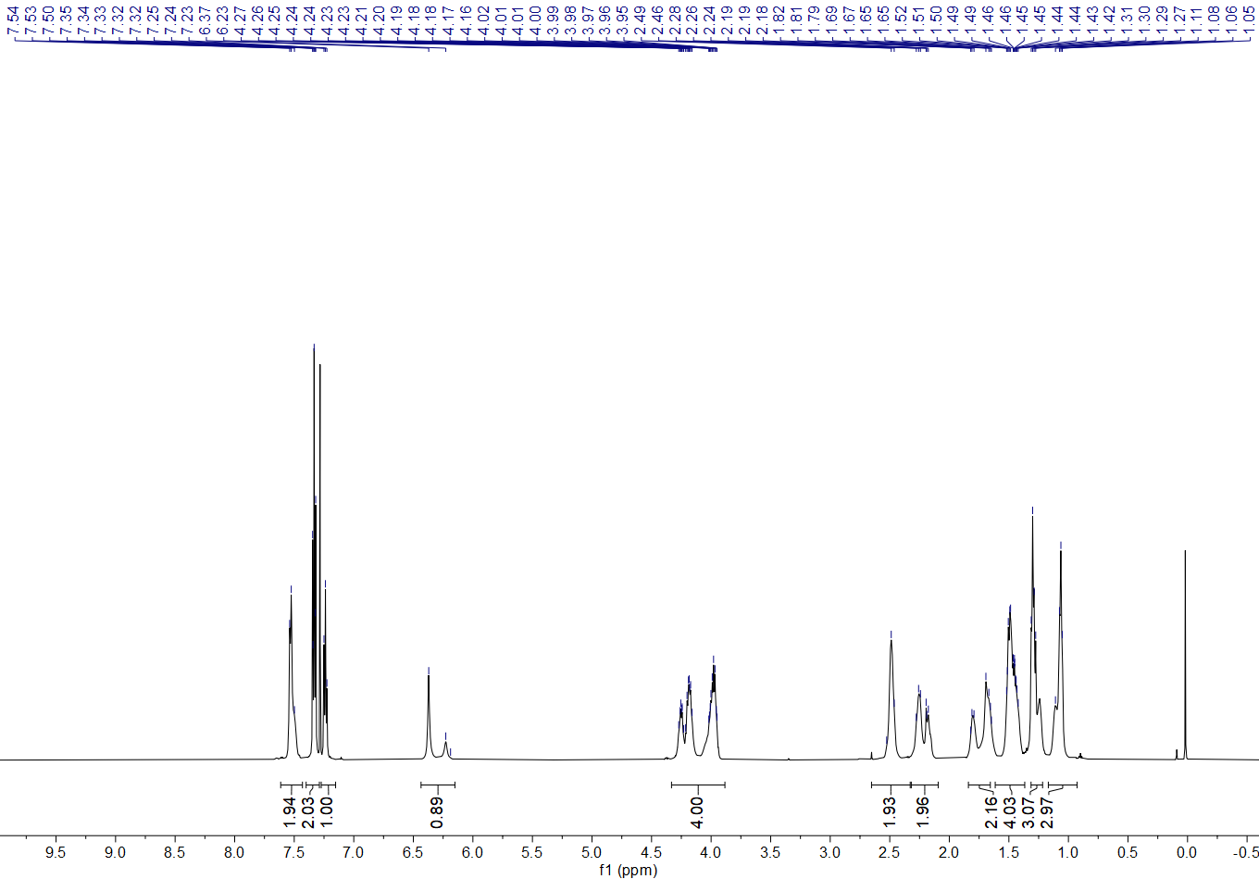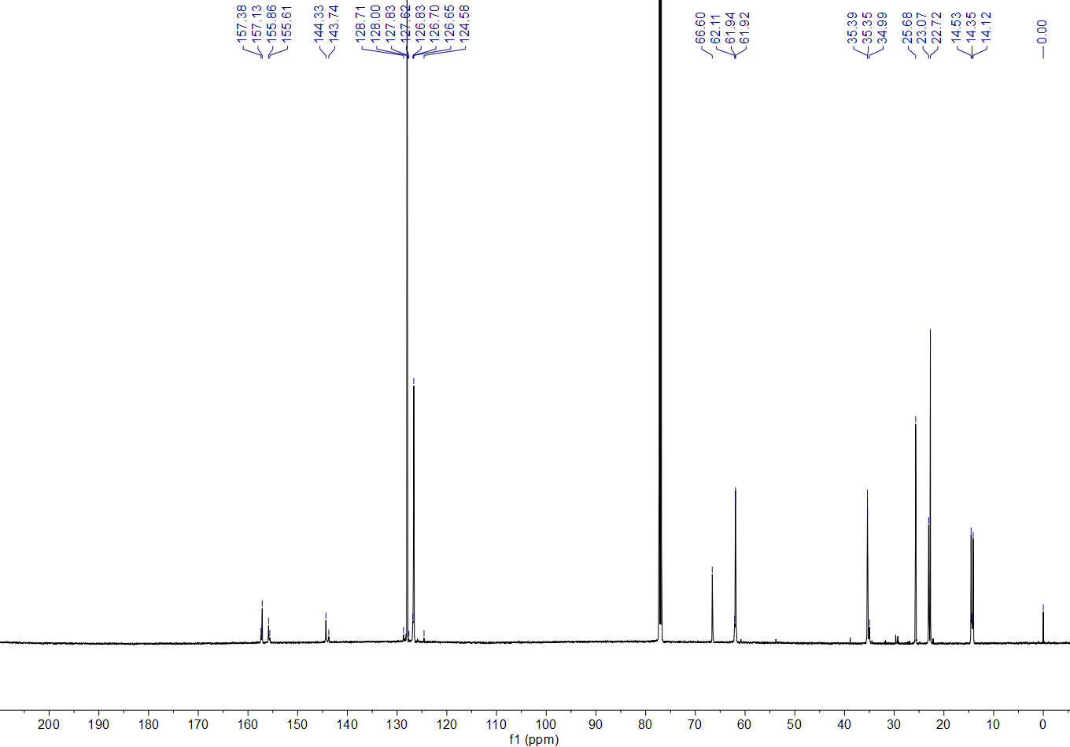
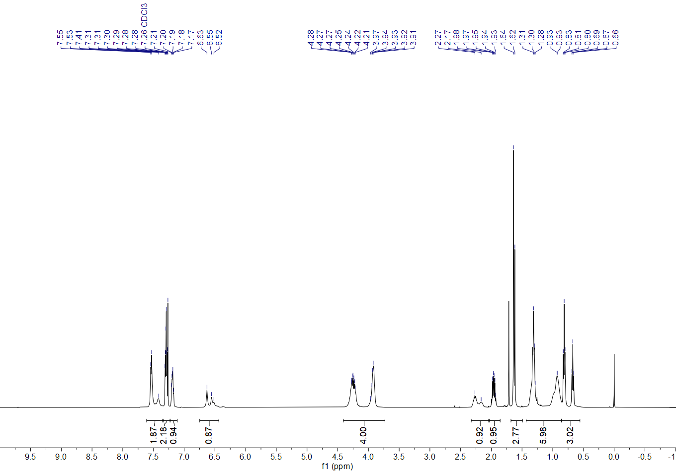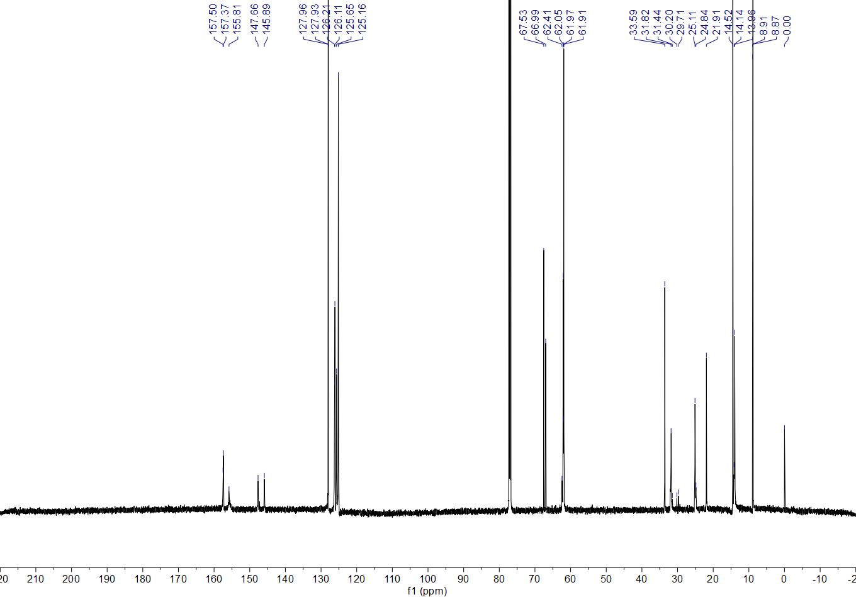
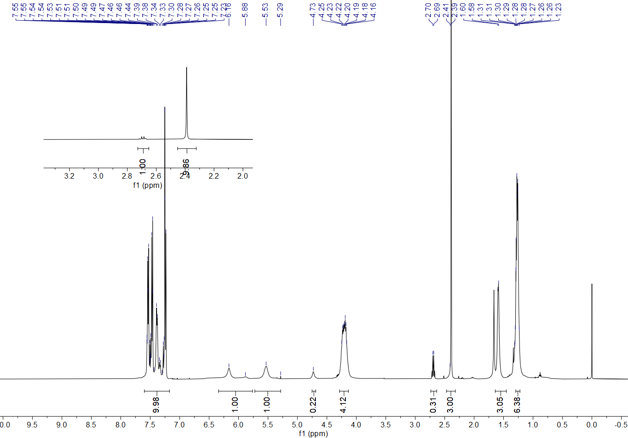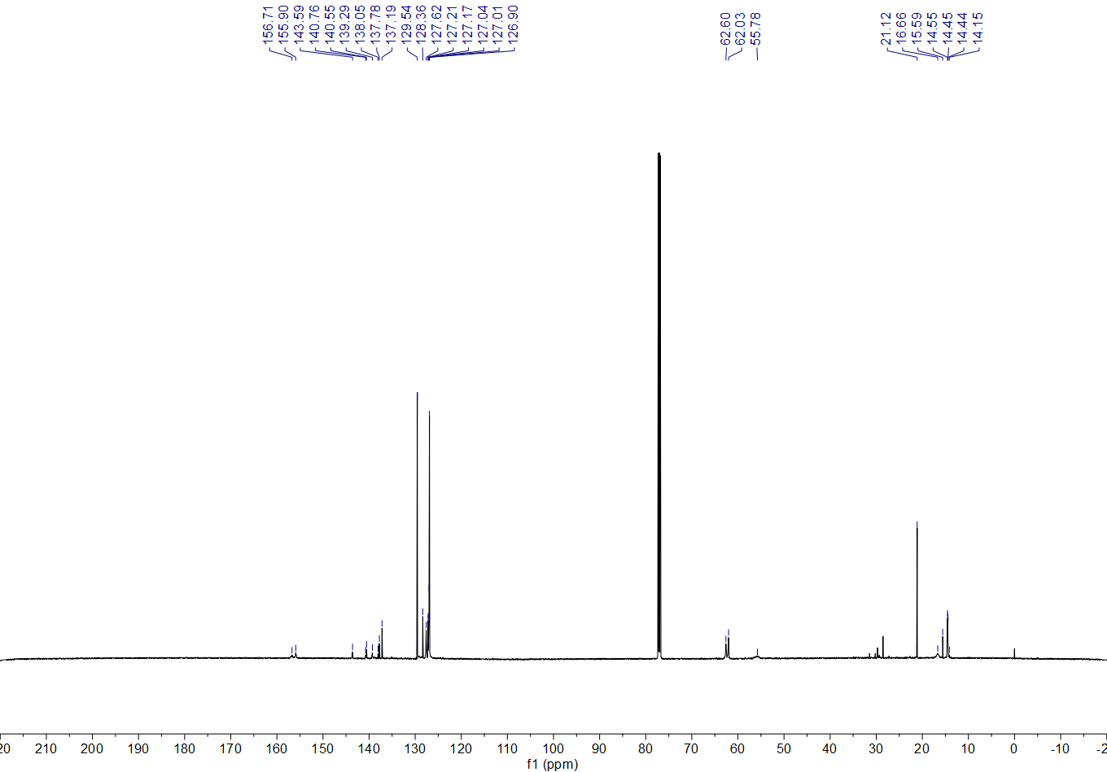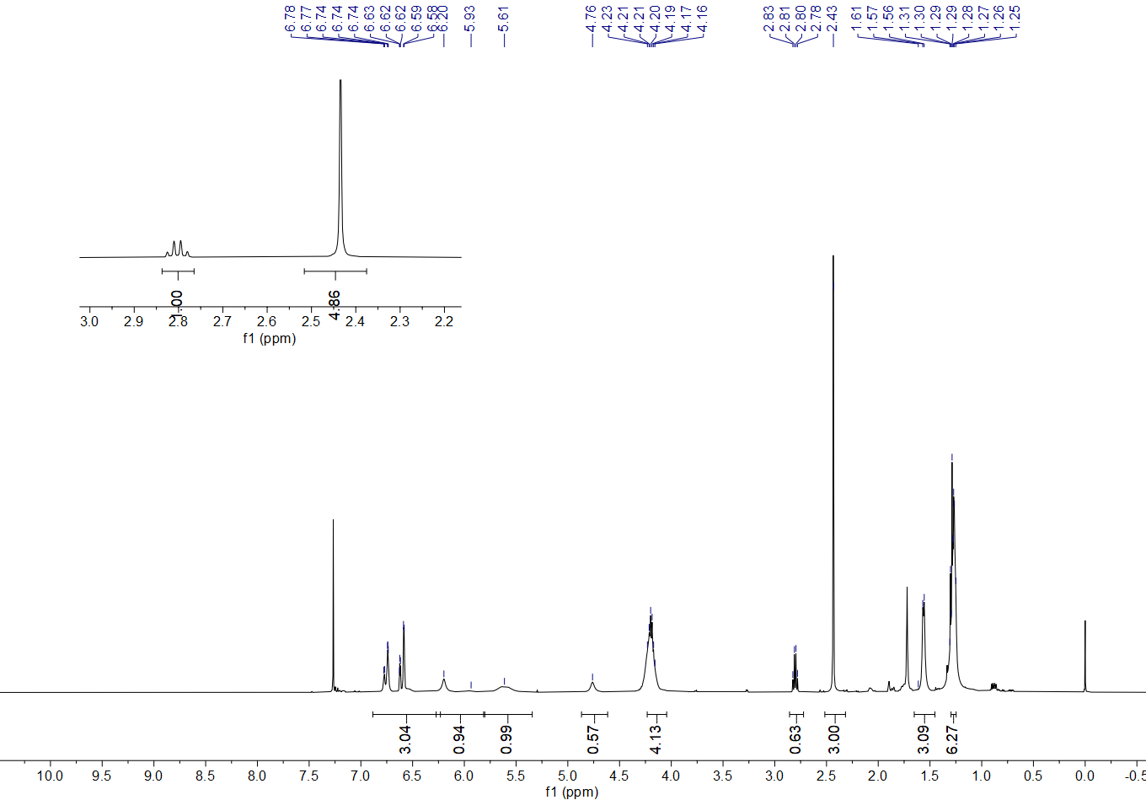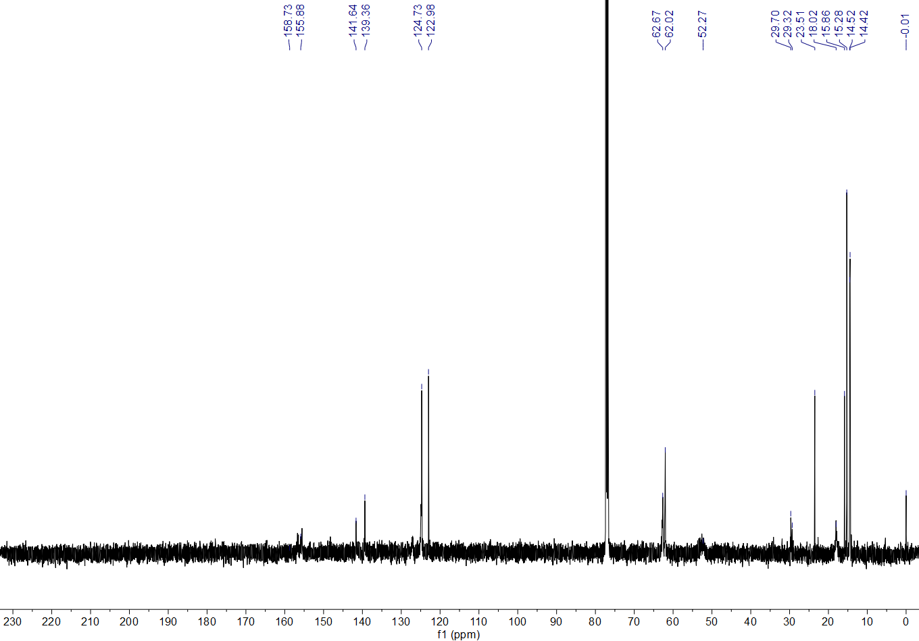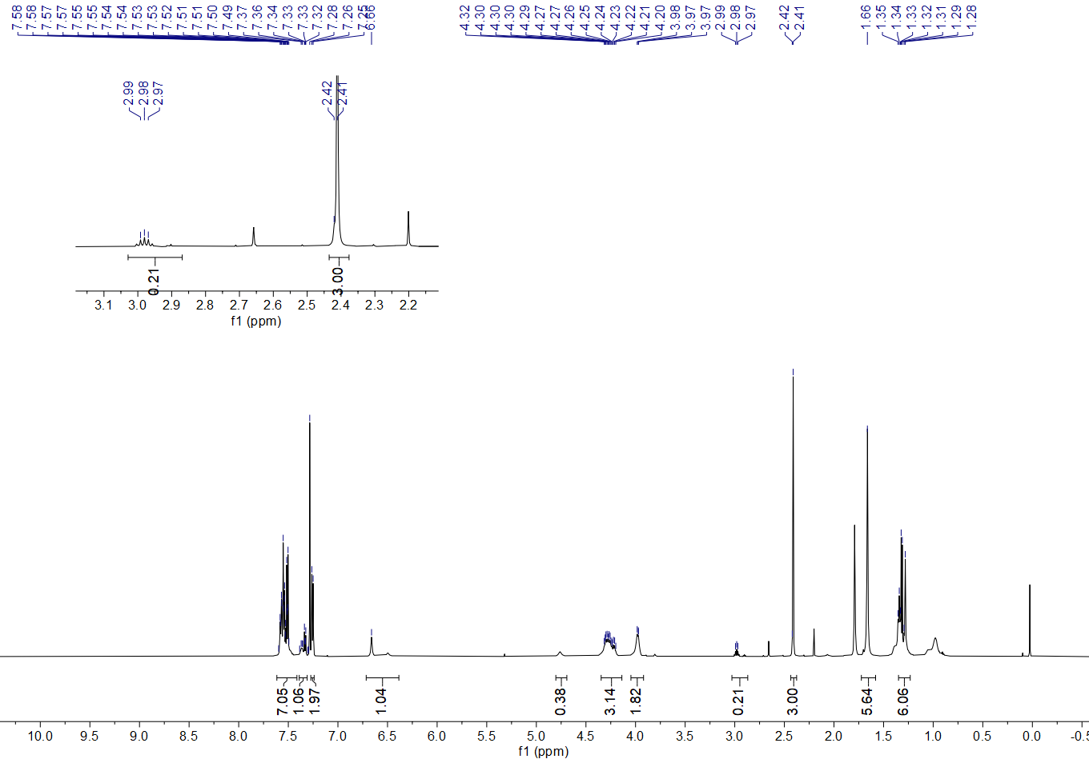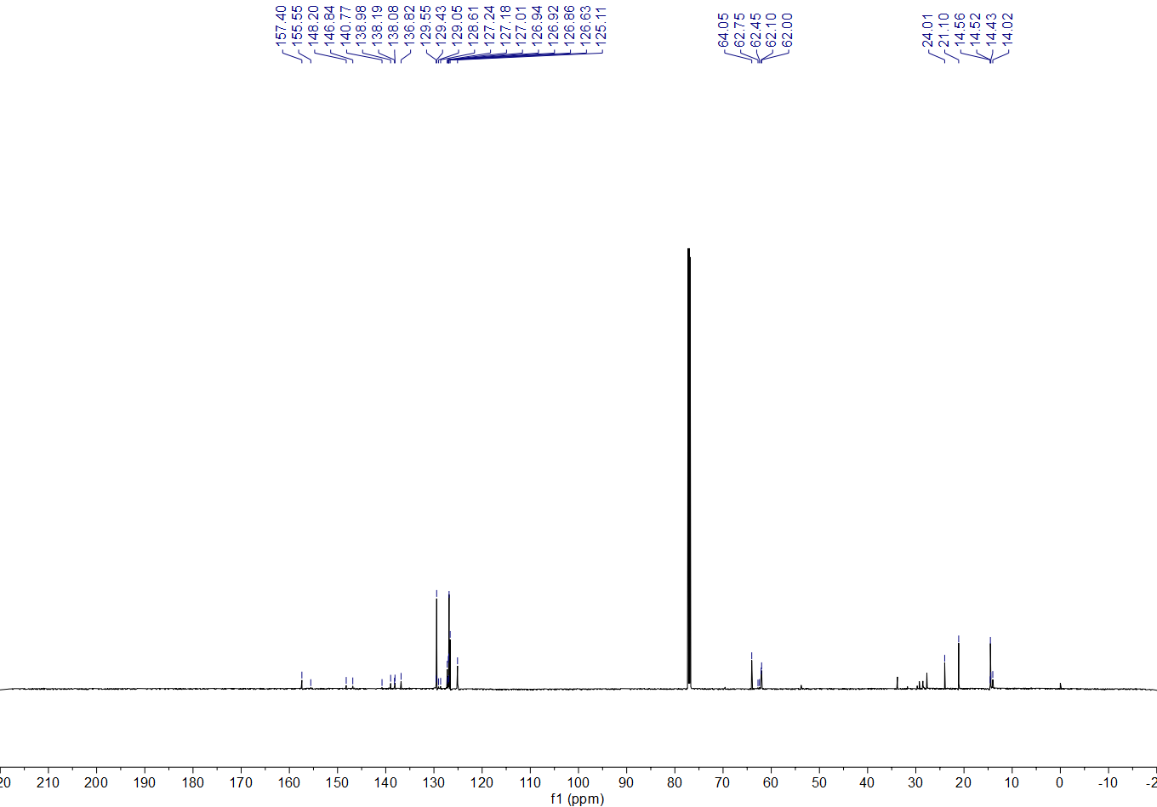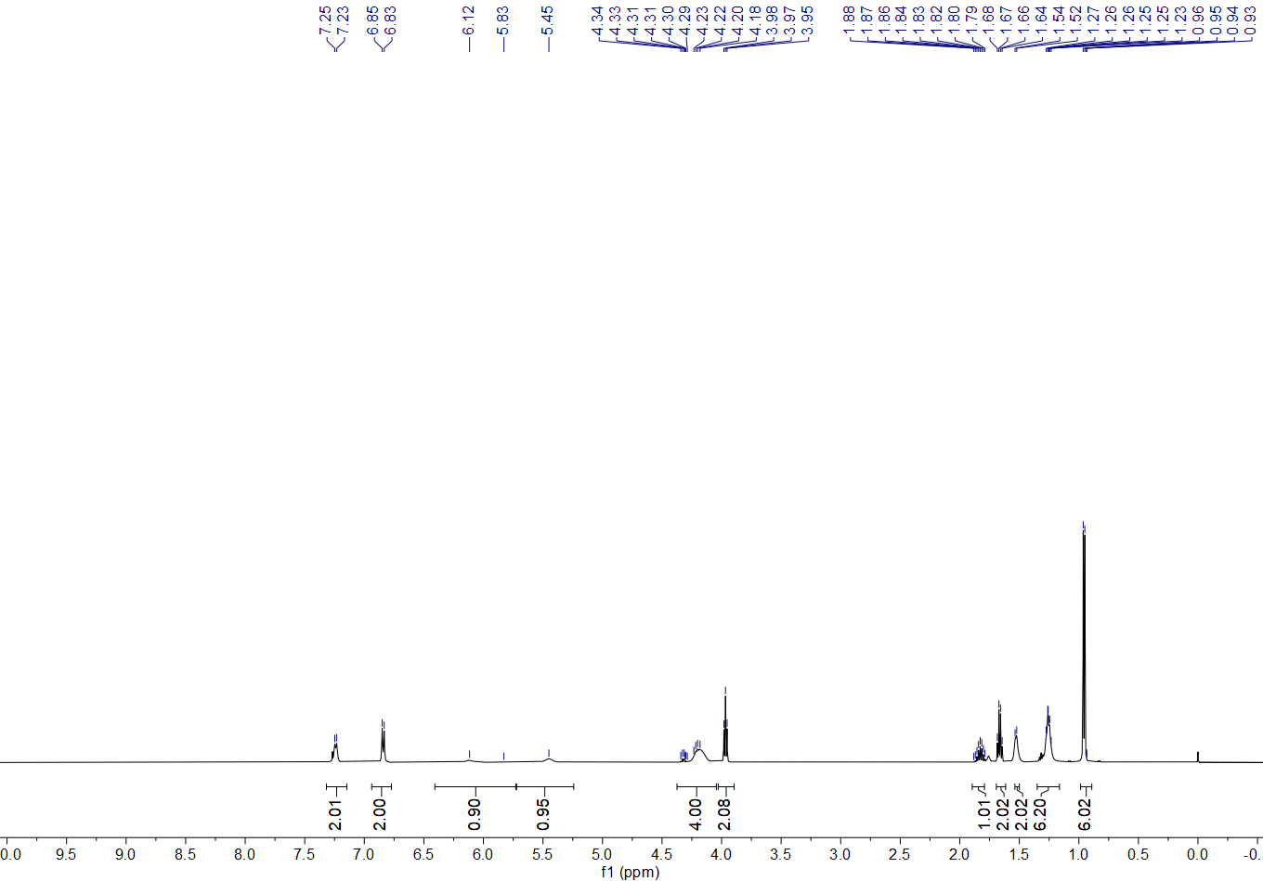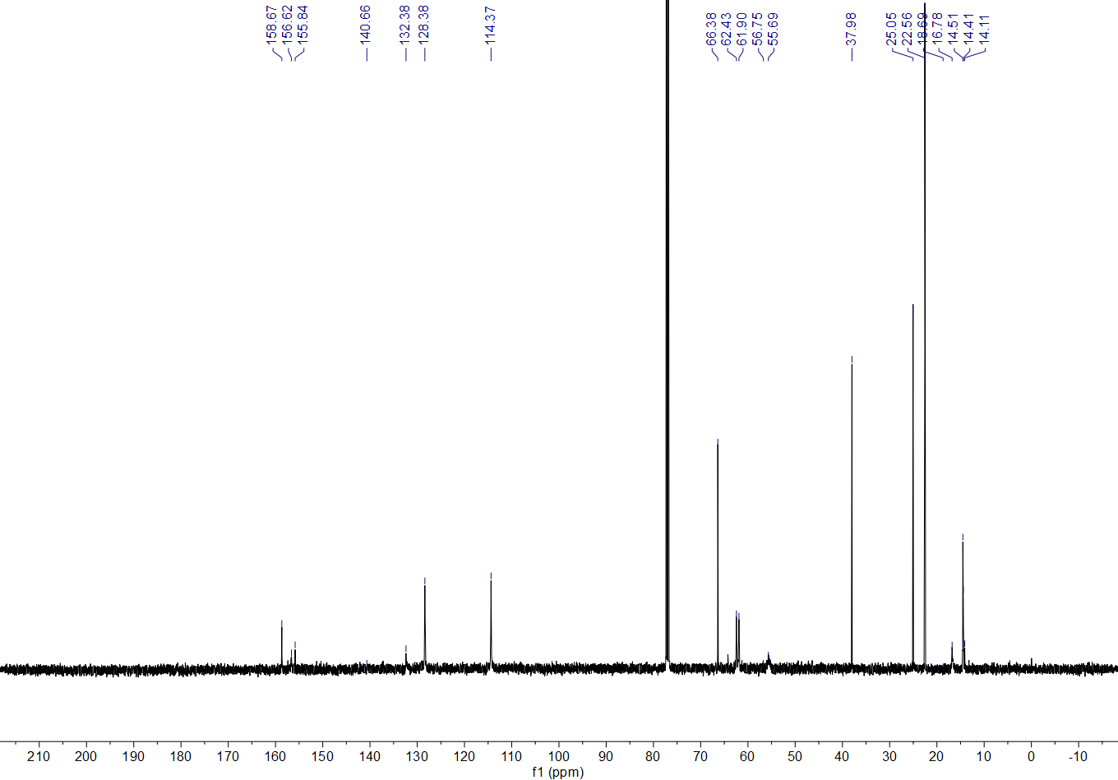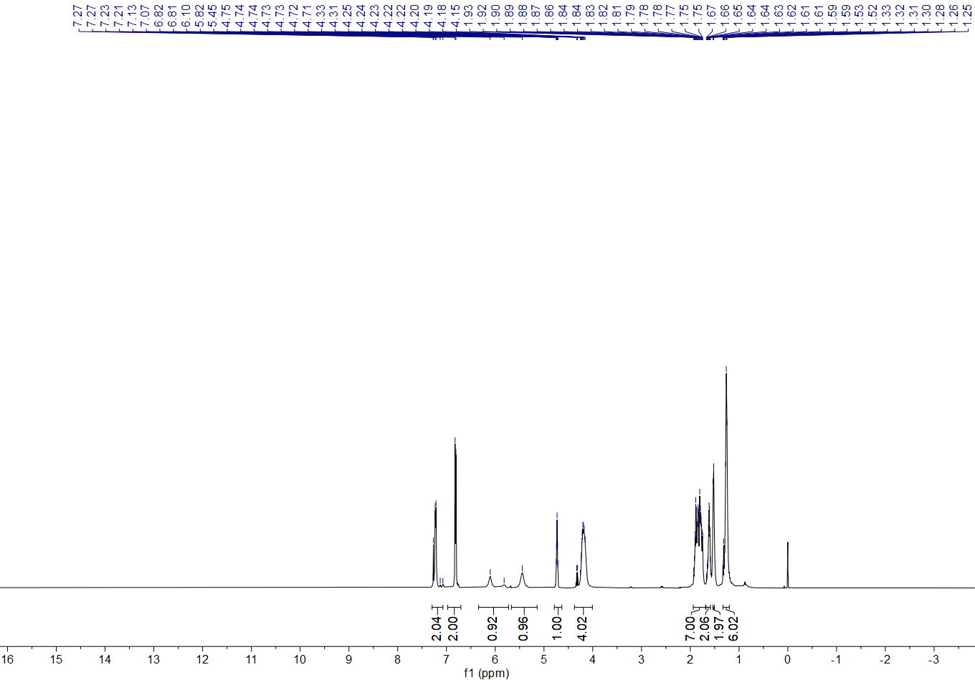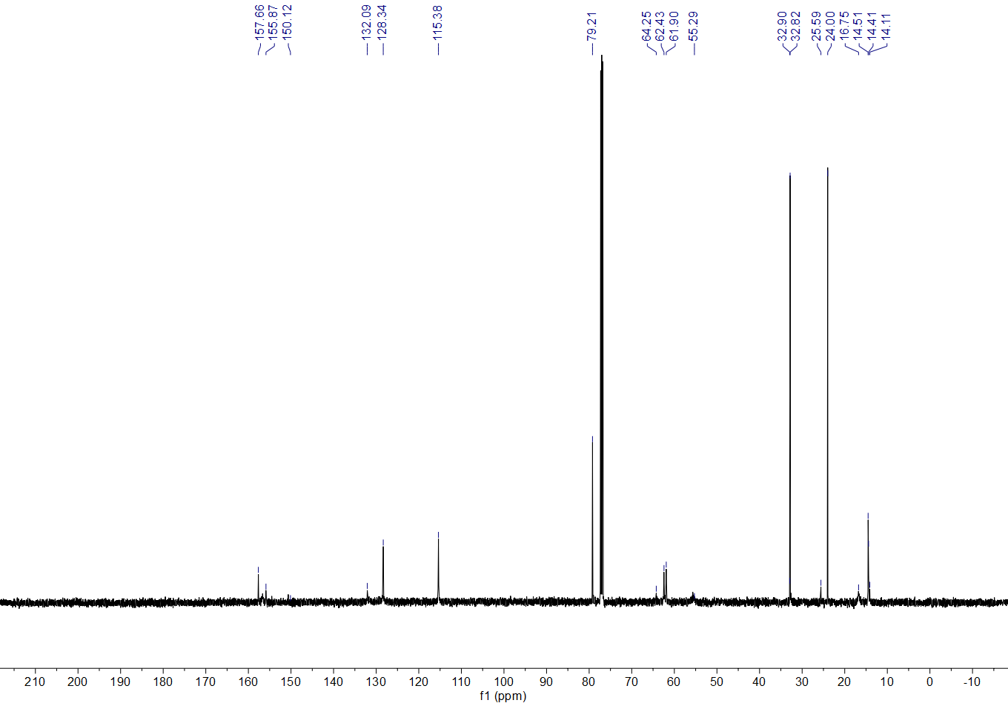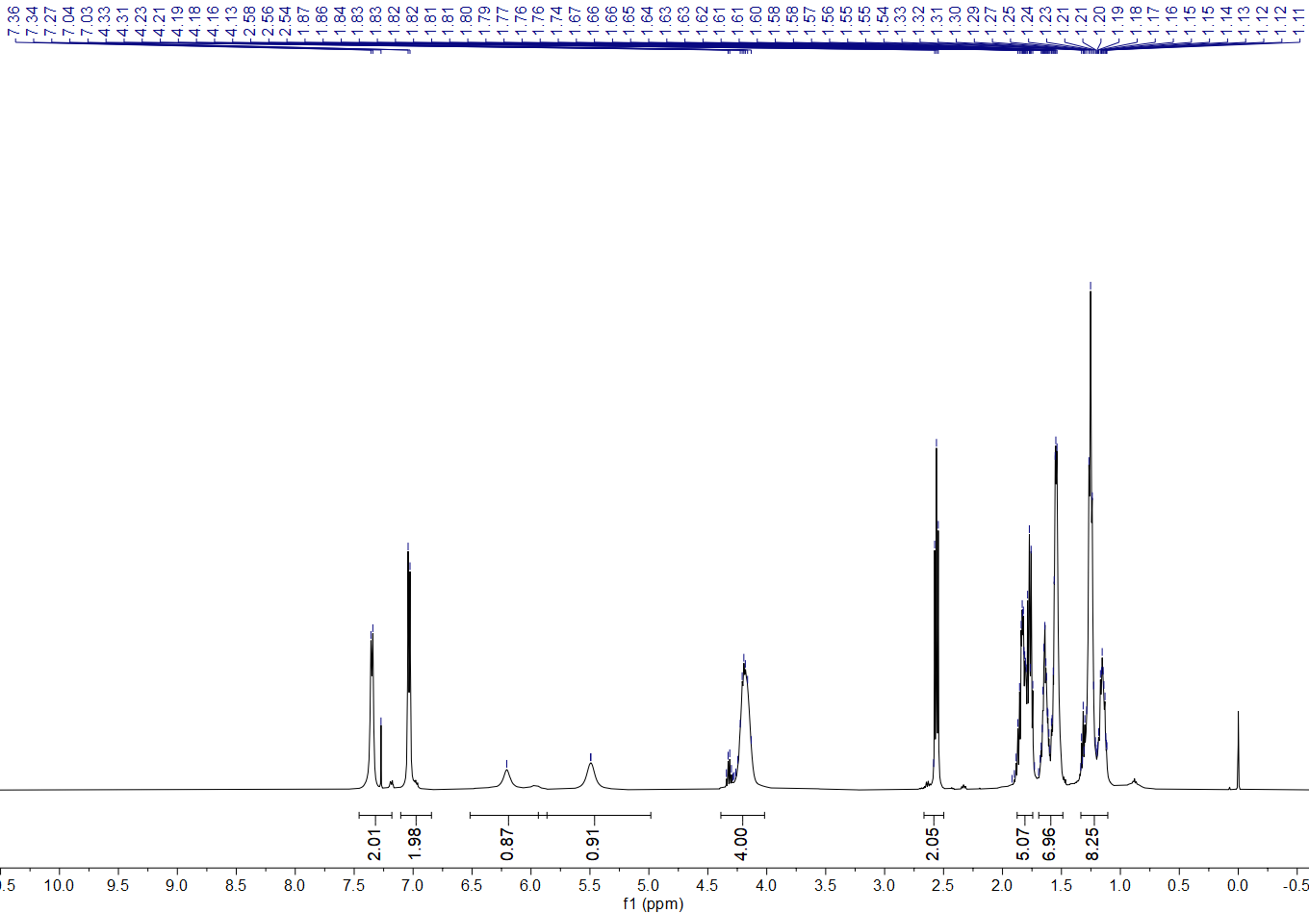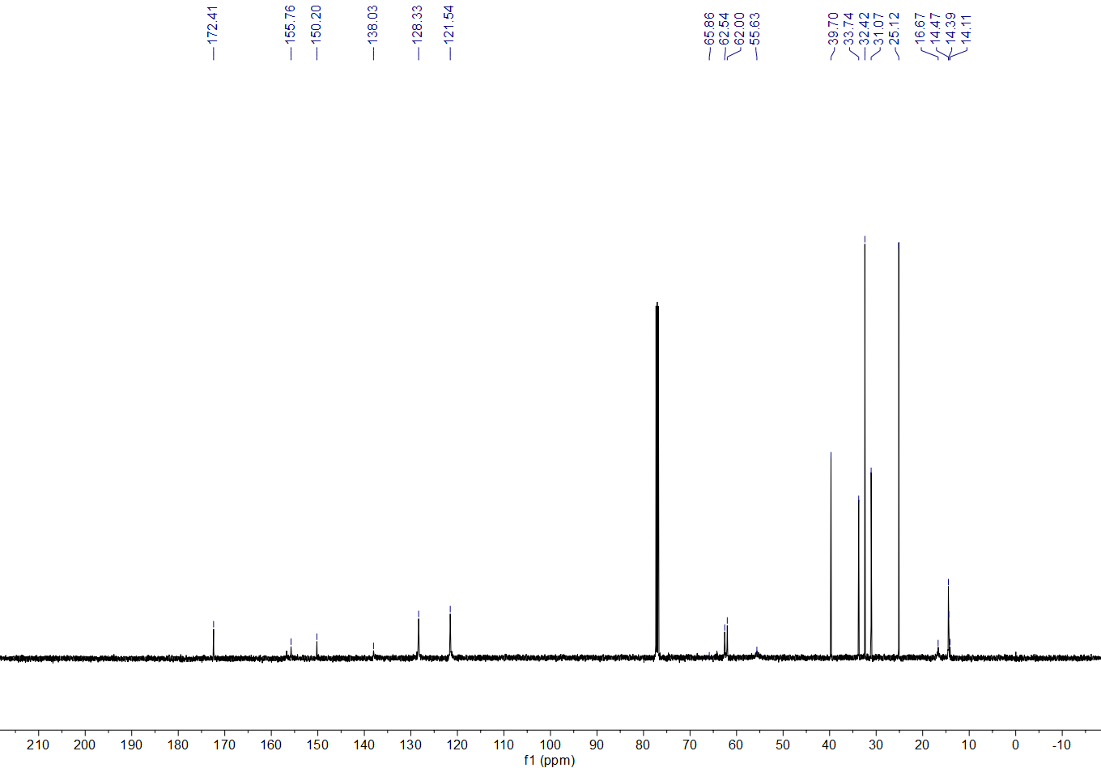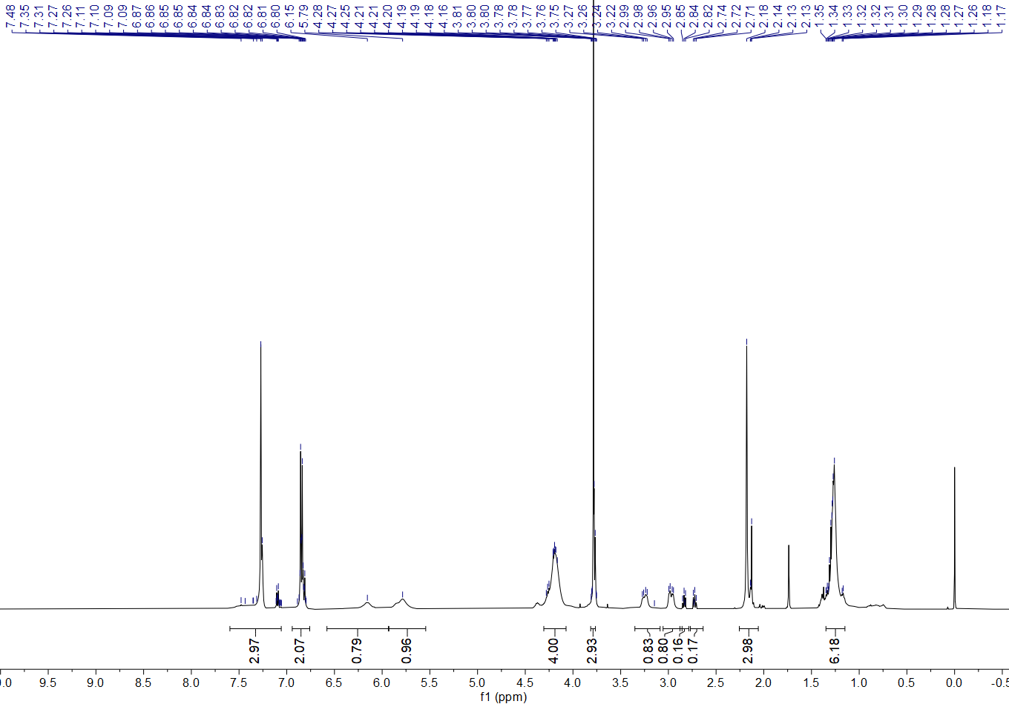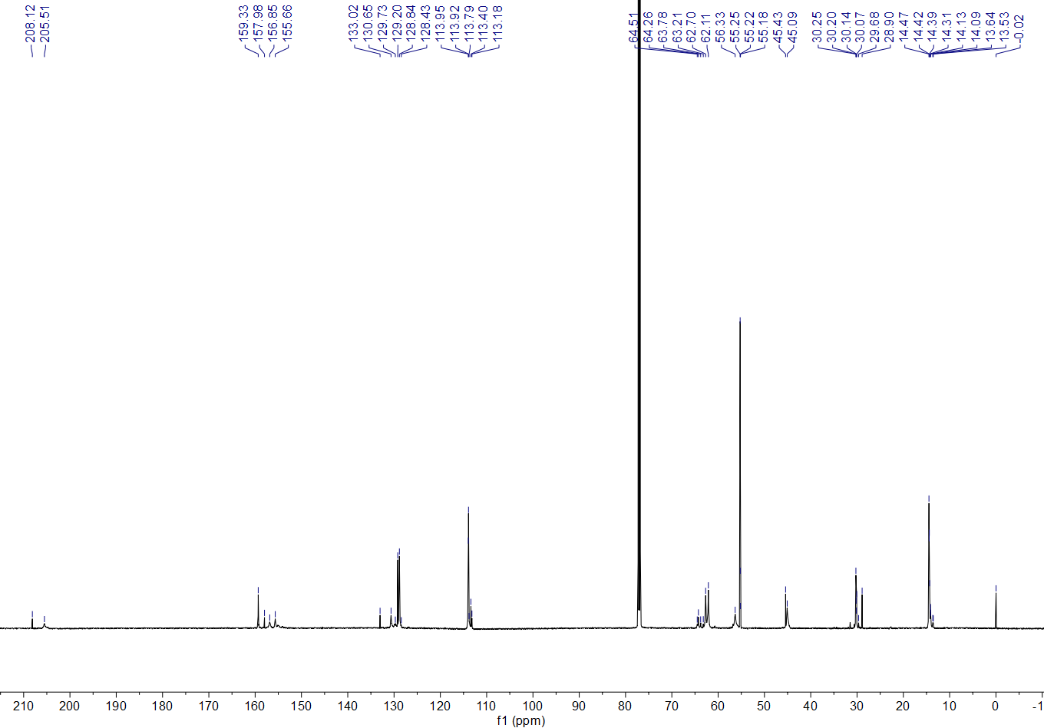
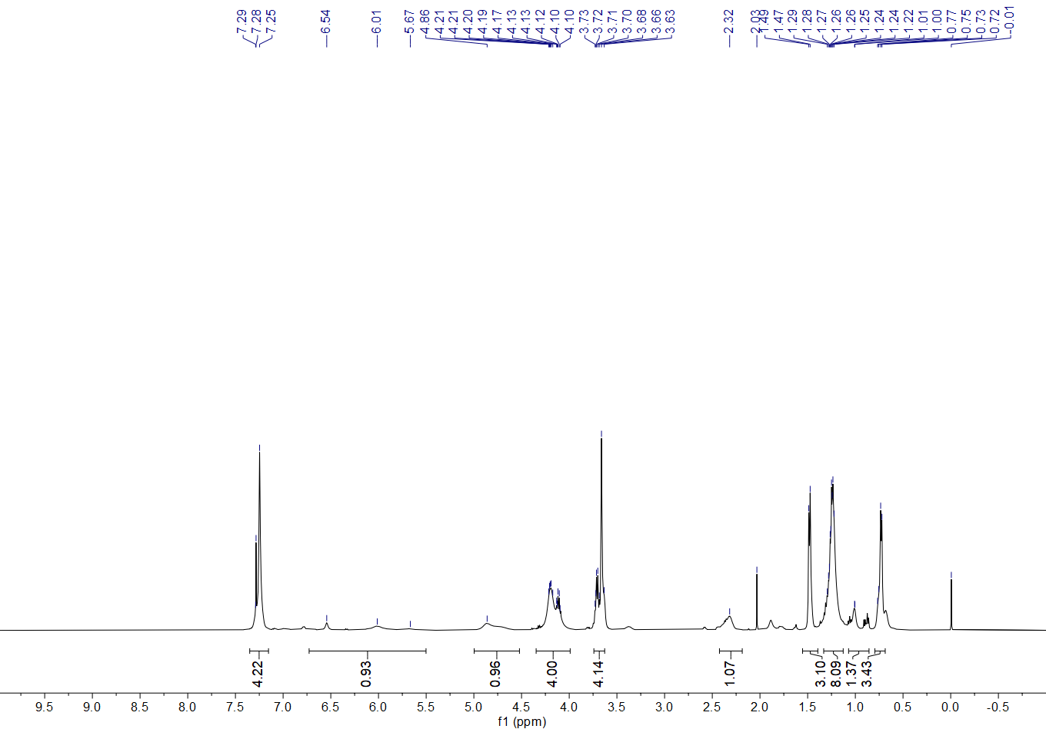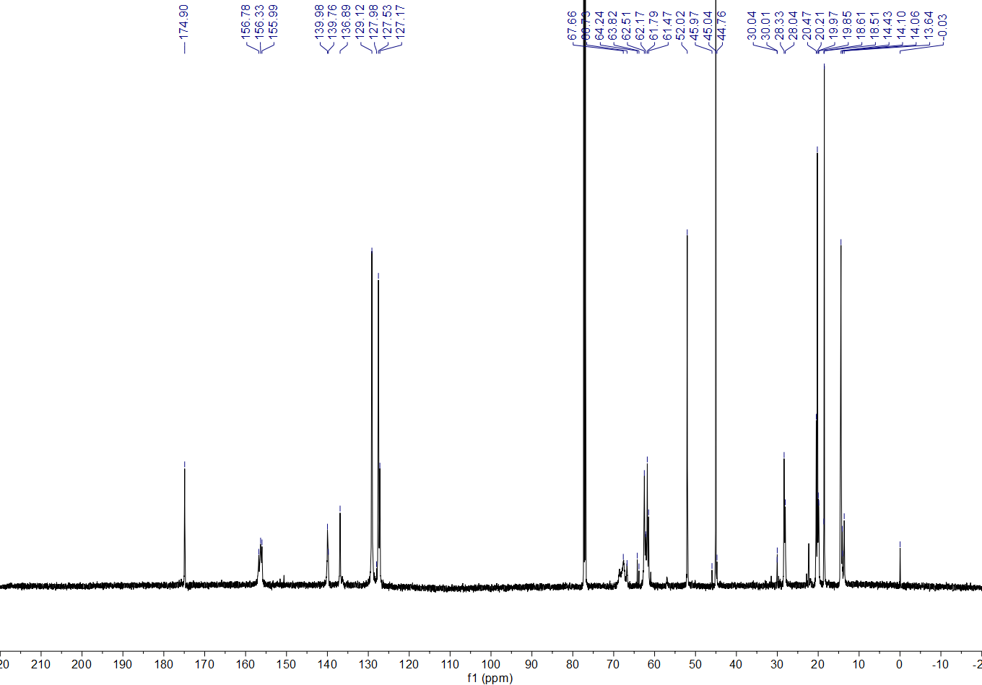
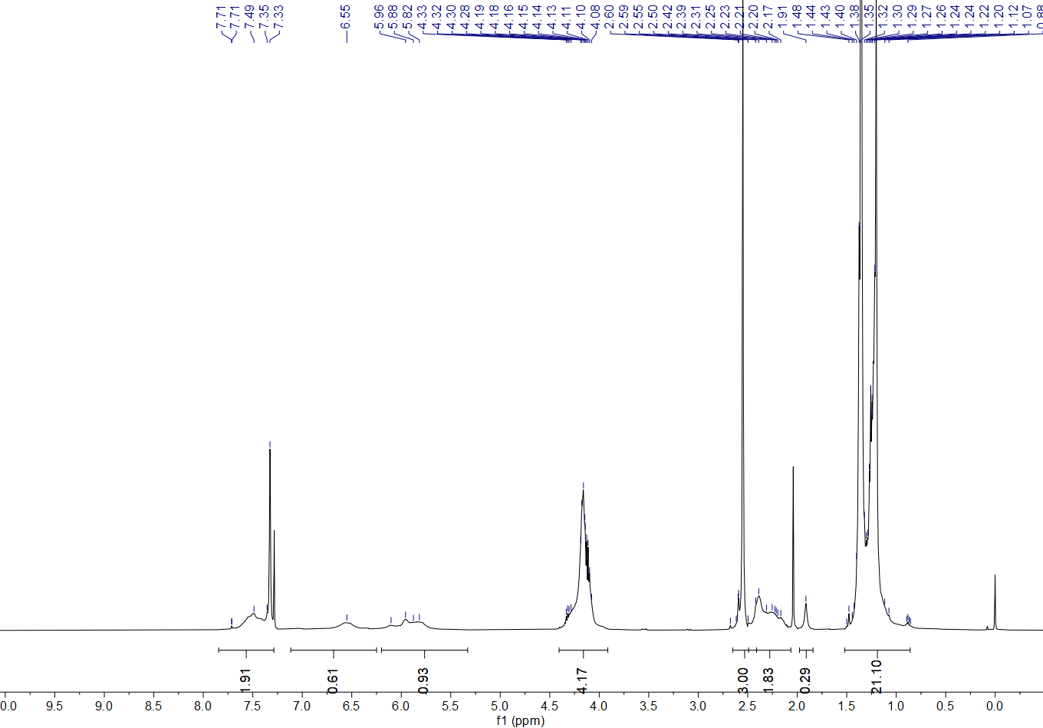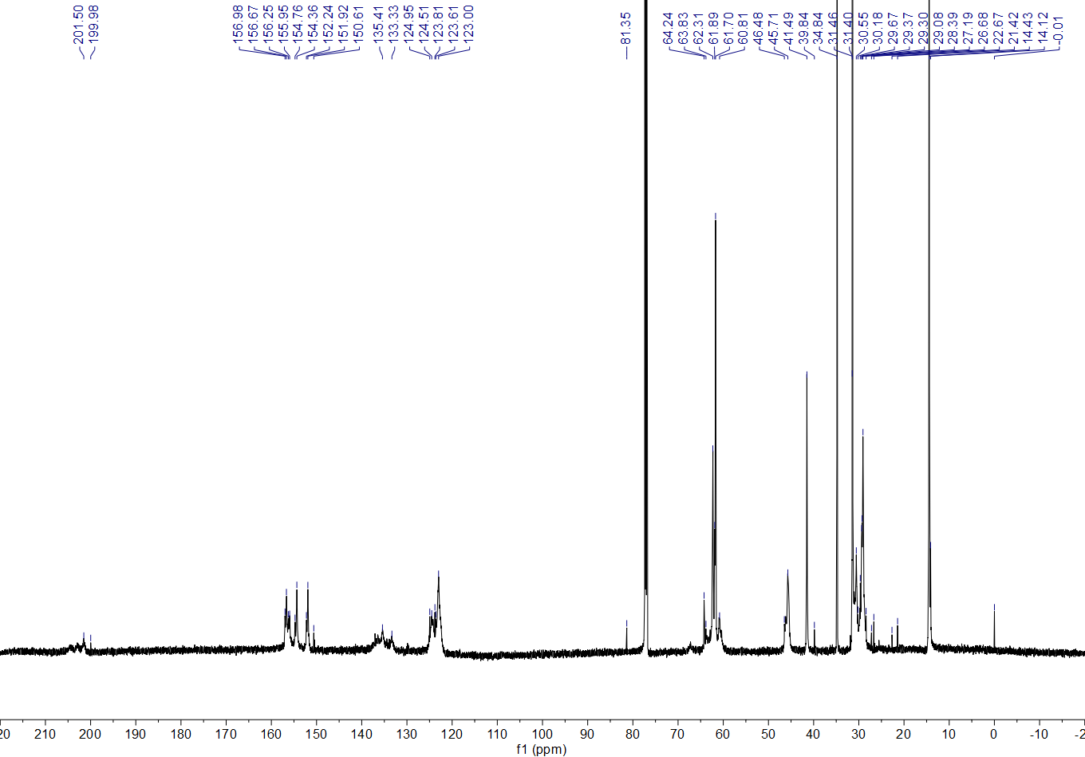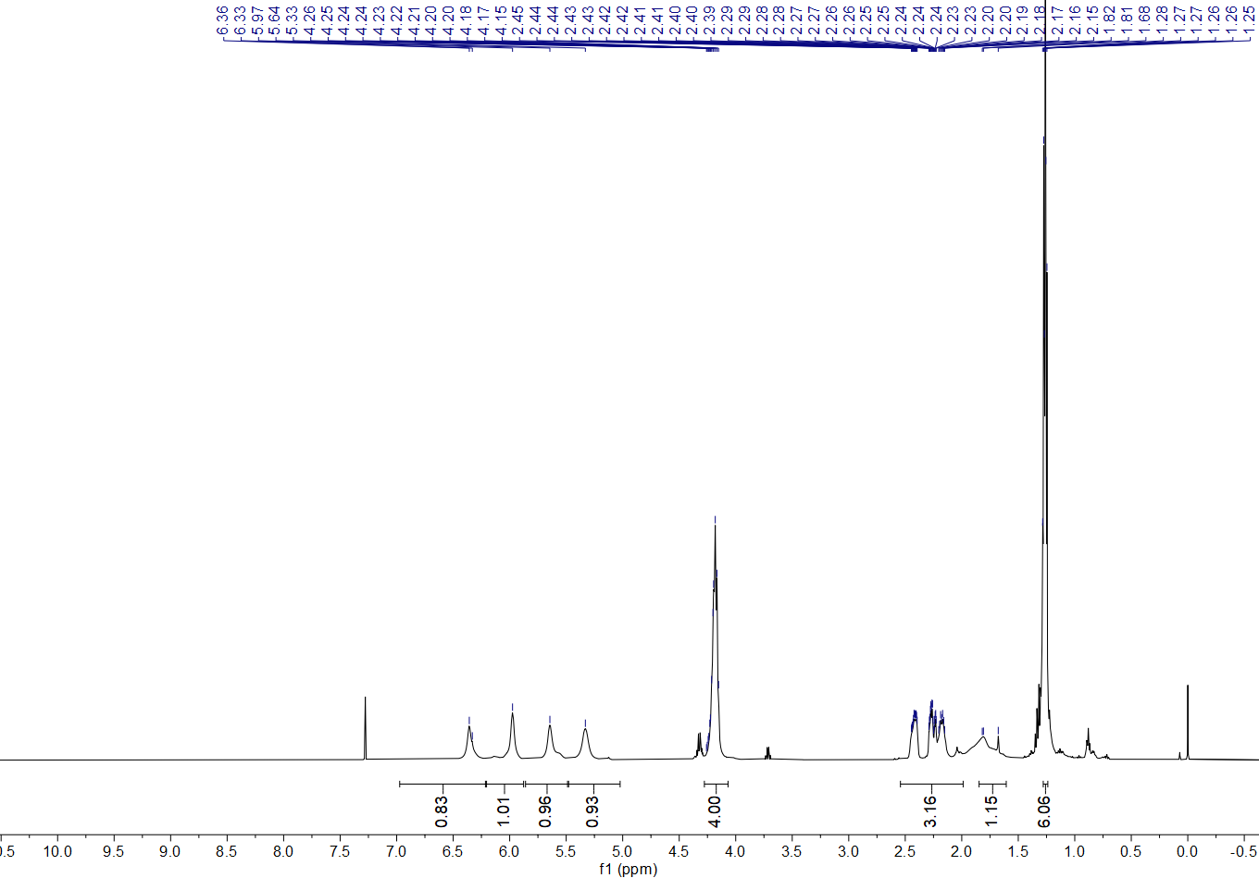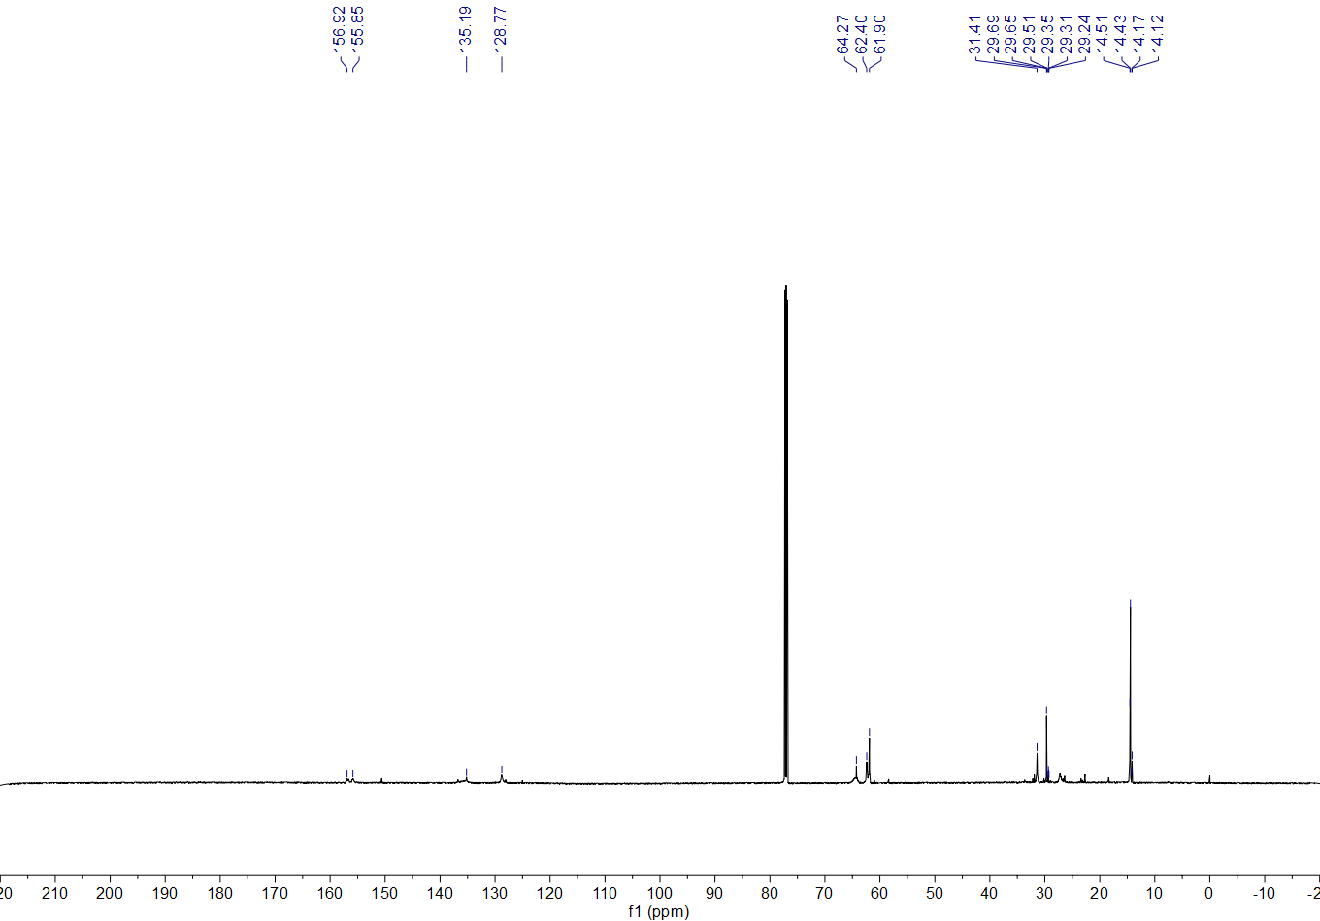
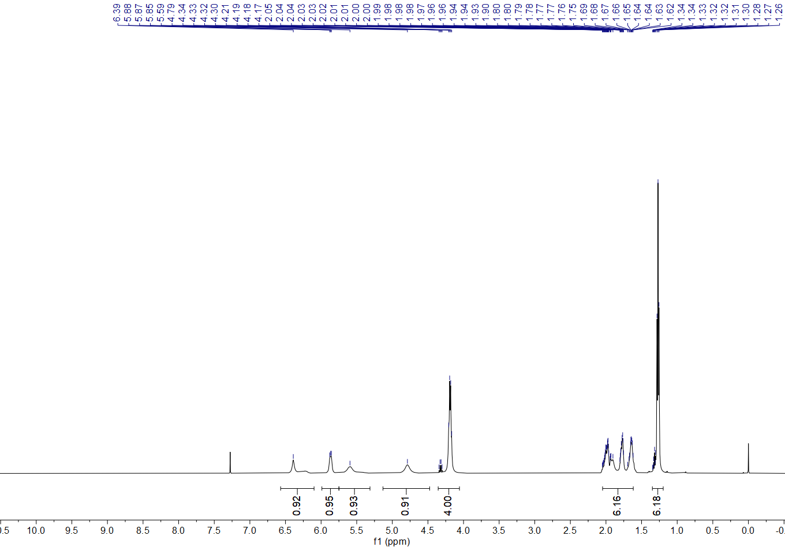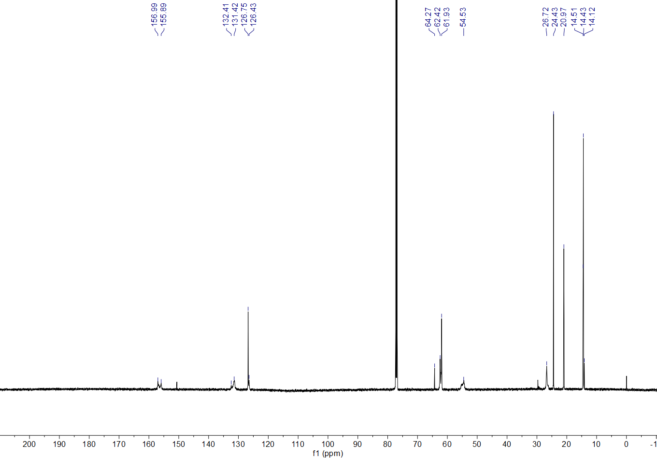
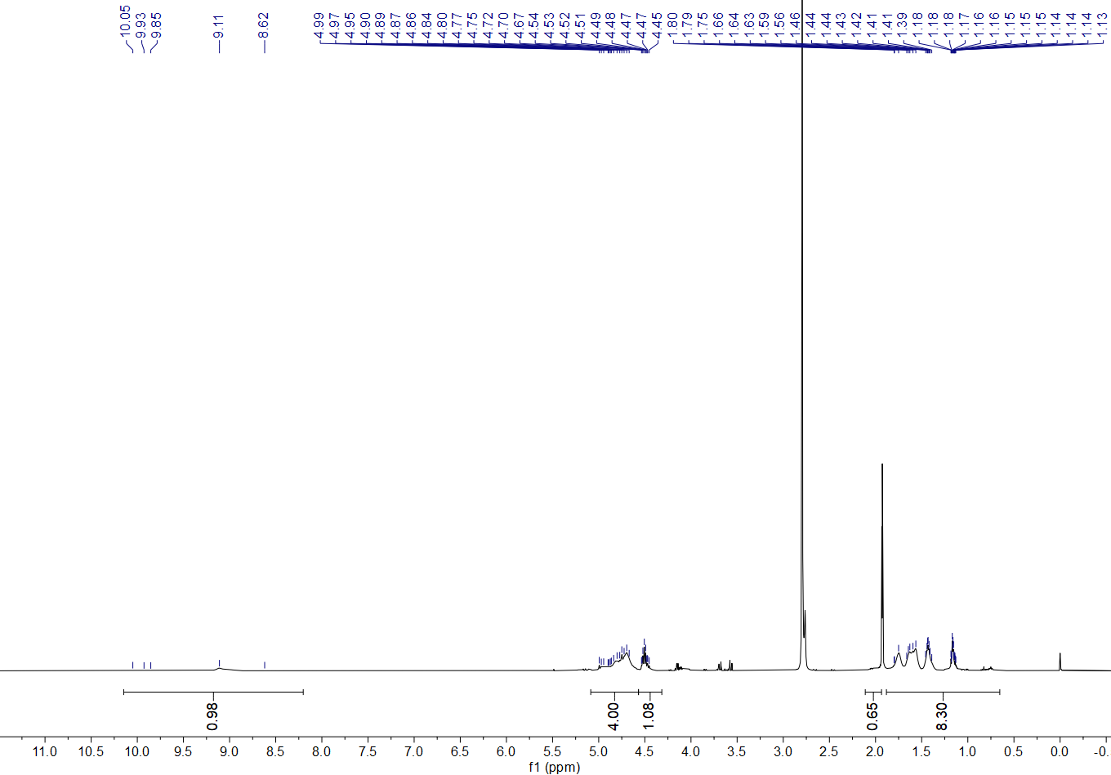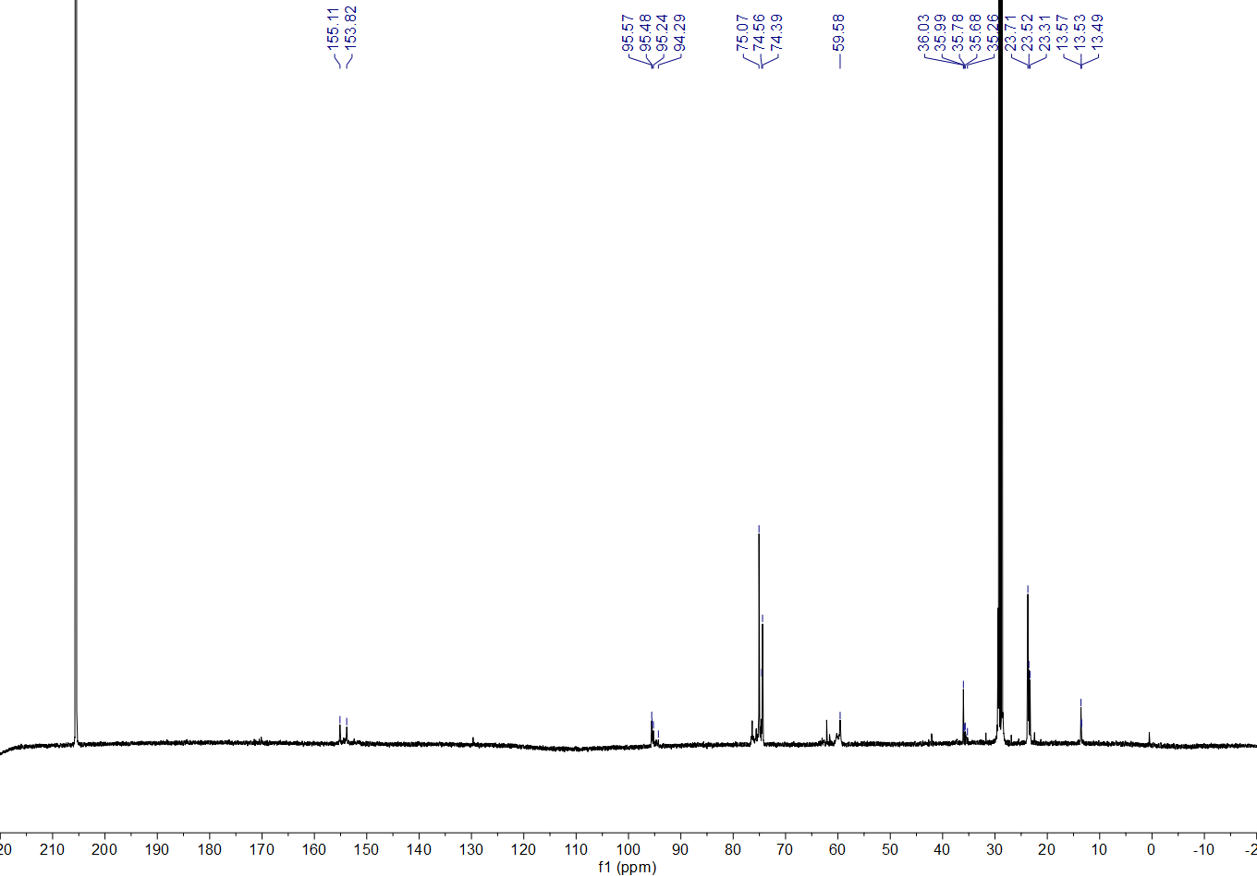
Multiple singles are probably derived from the rotameric amide
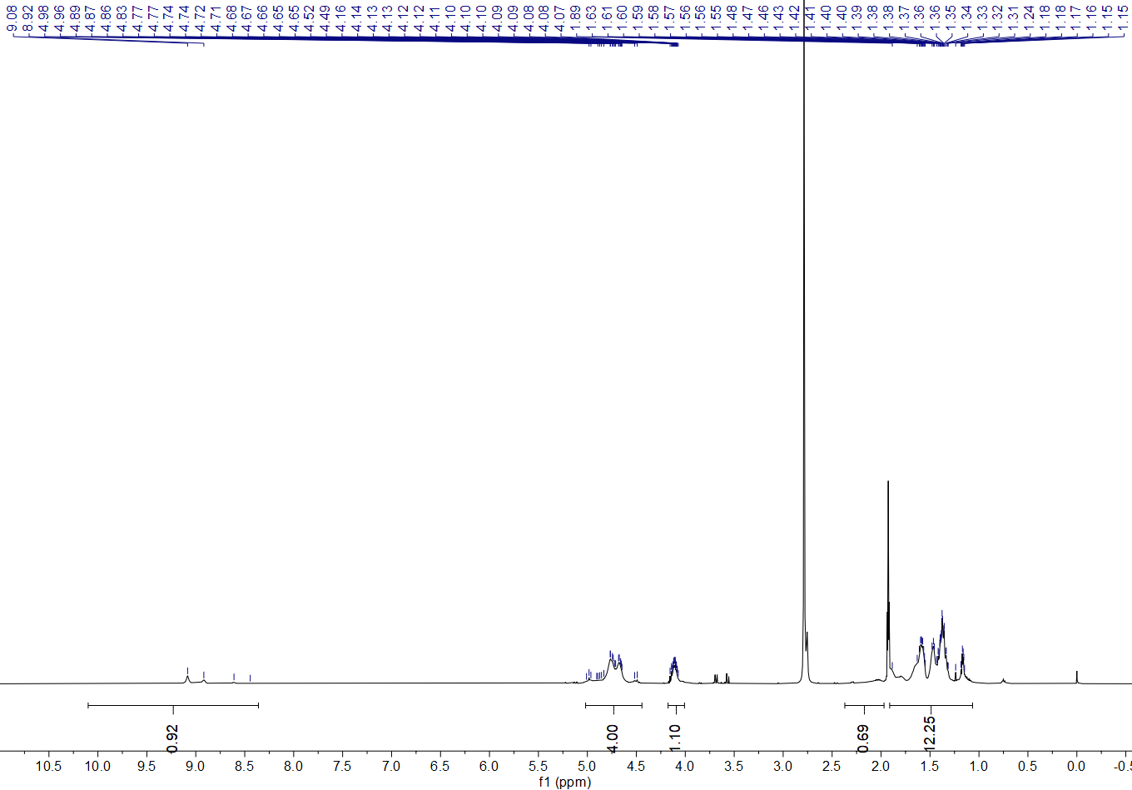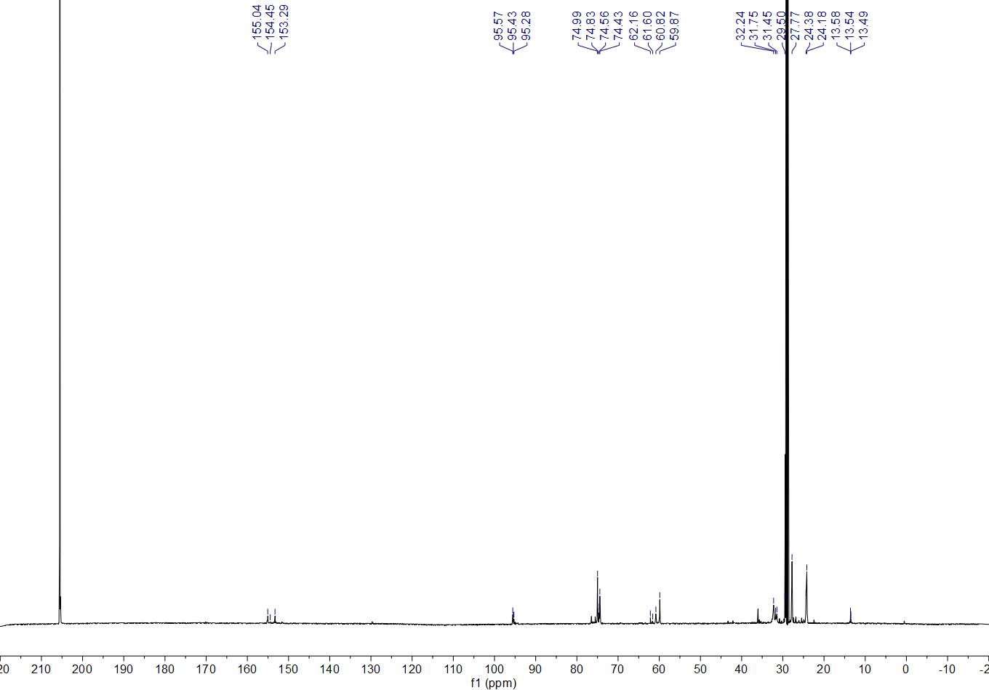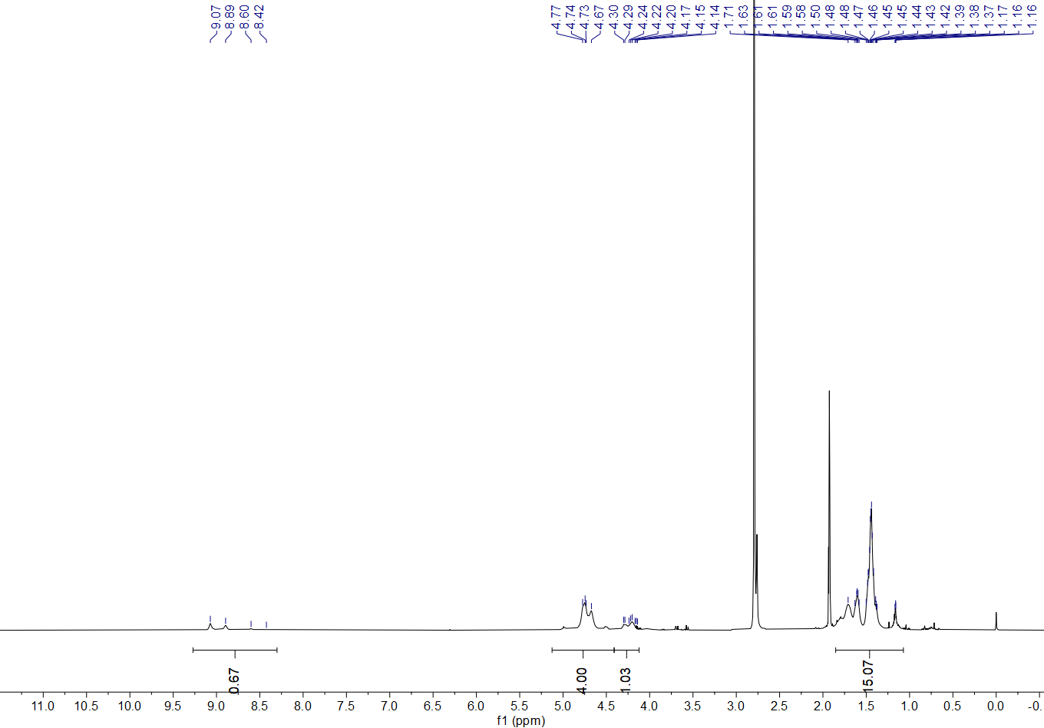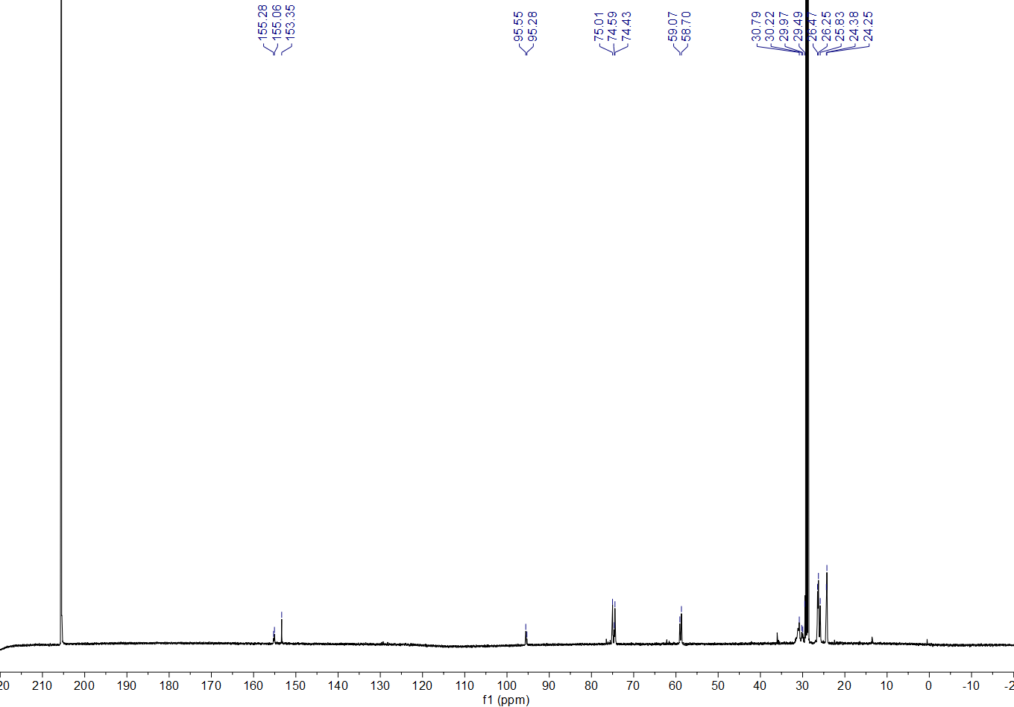
Multiple singles are probably derived from the rotameric amide
Multiple singles are probably derived from the rotameric amide
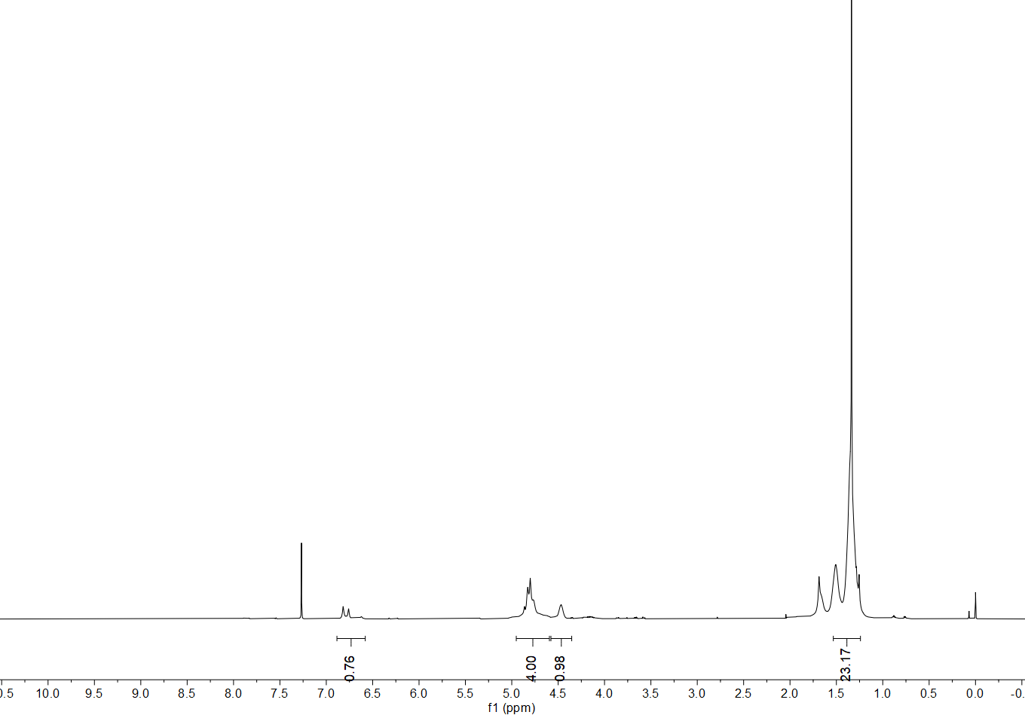
Multiple singles are probably derived from the rotameric amide
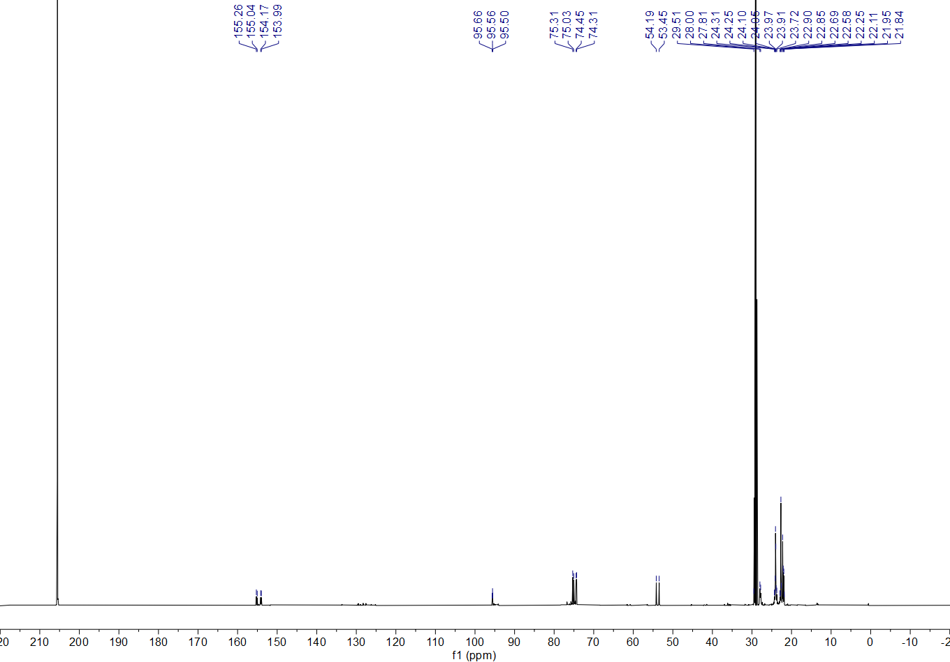
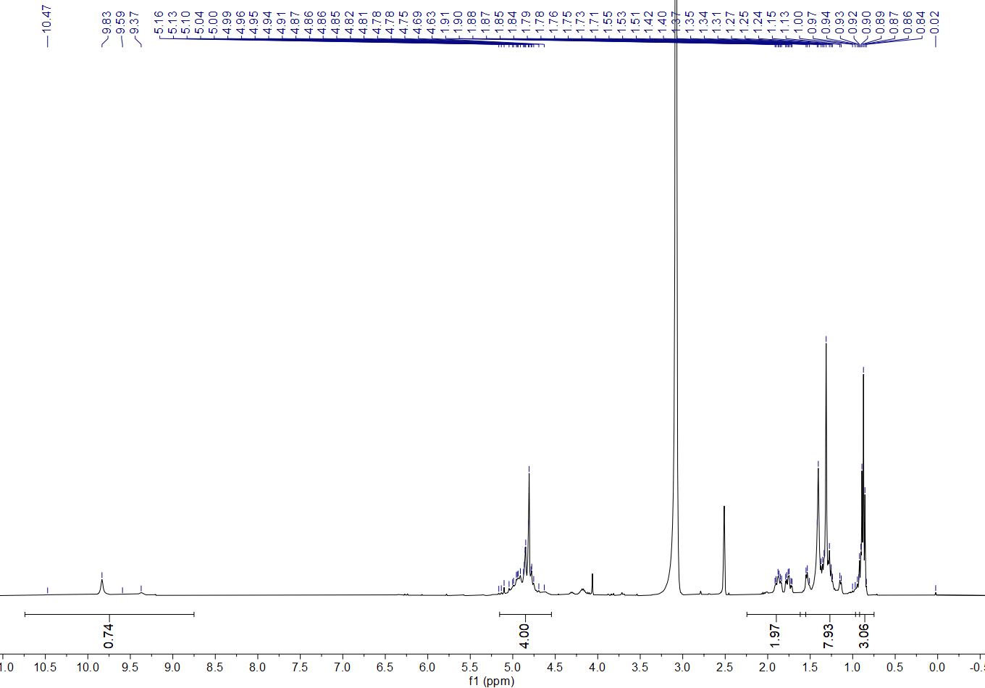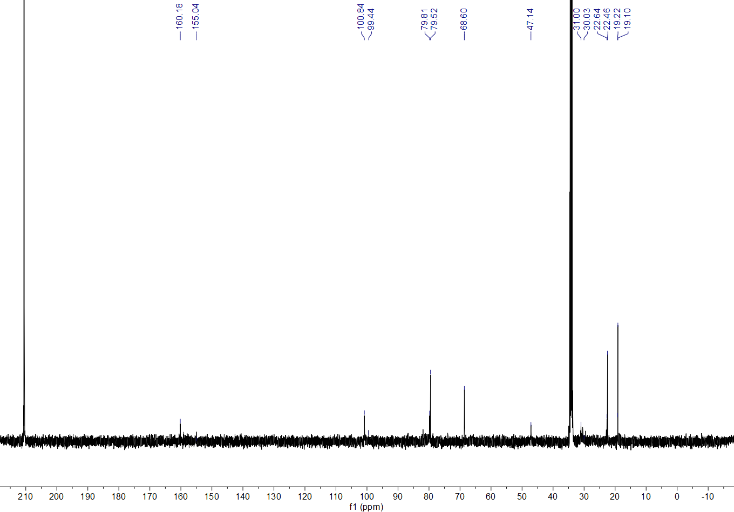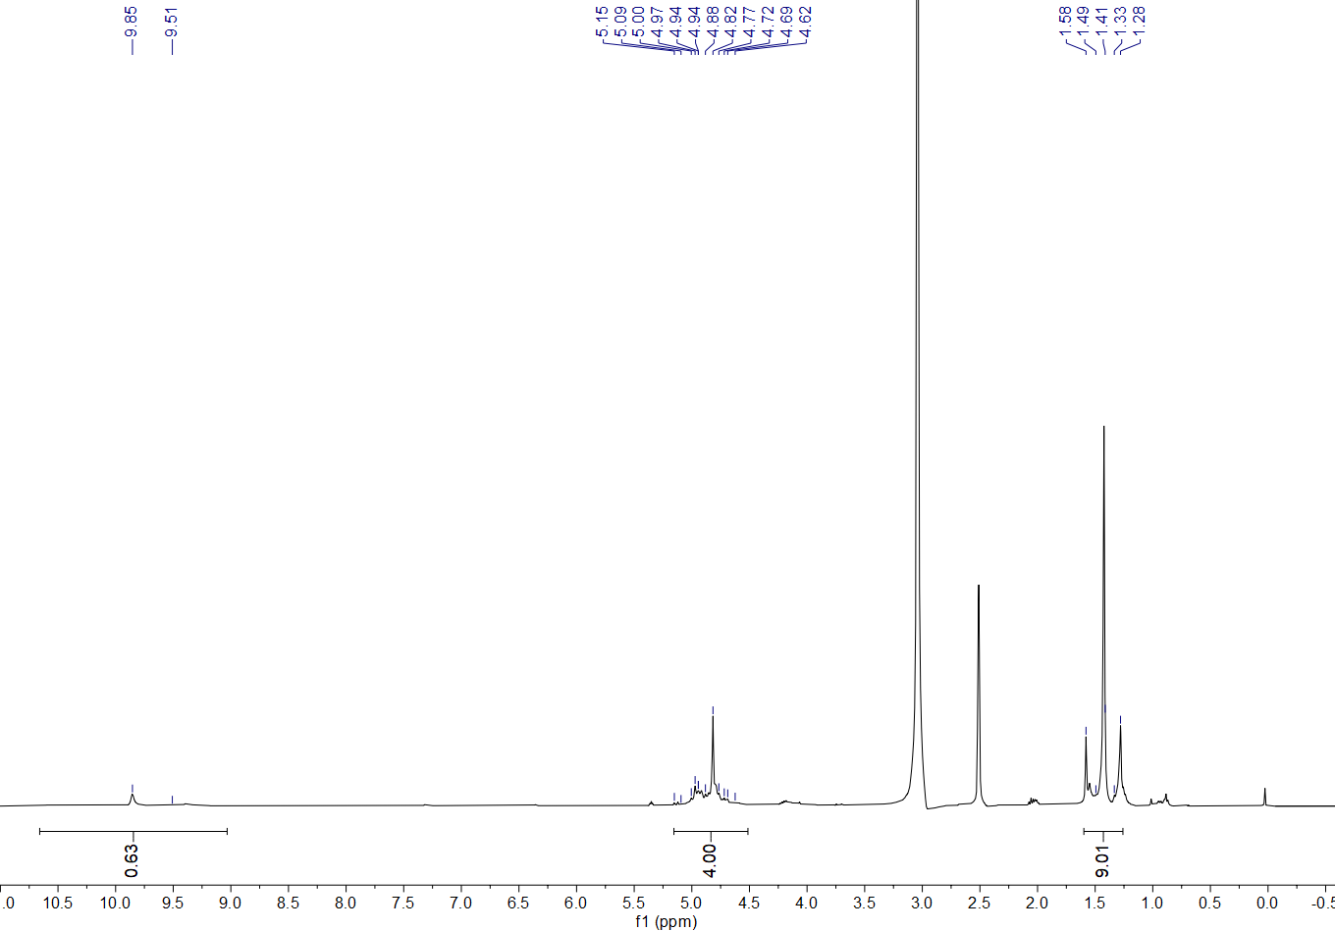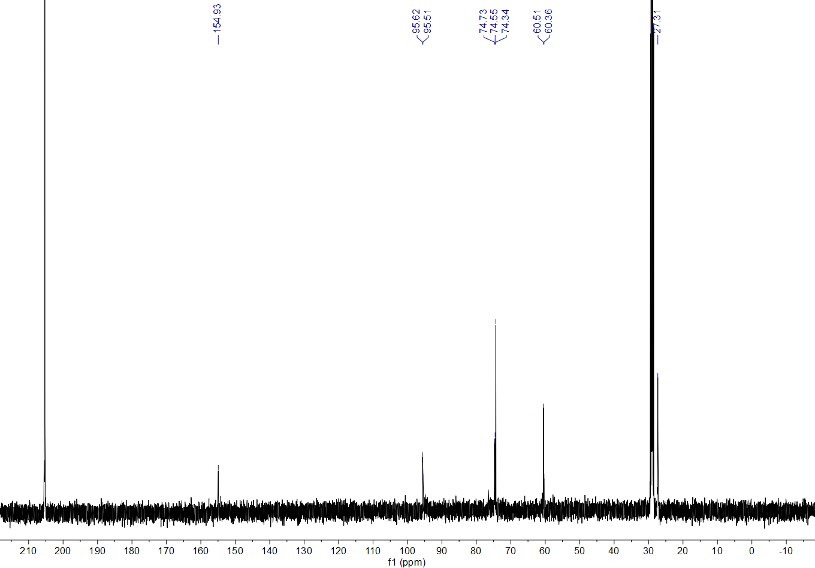
Multiple singles are probably derived from the rotameric amide
Multiple singles are probably derived from the rotameric amide
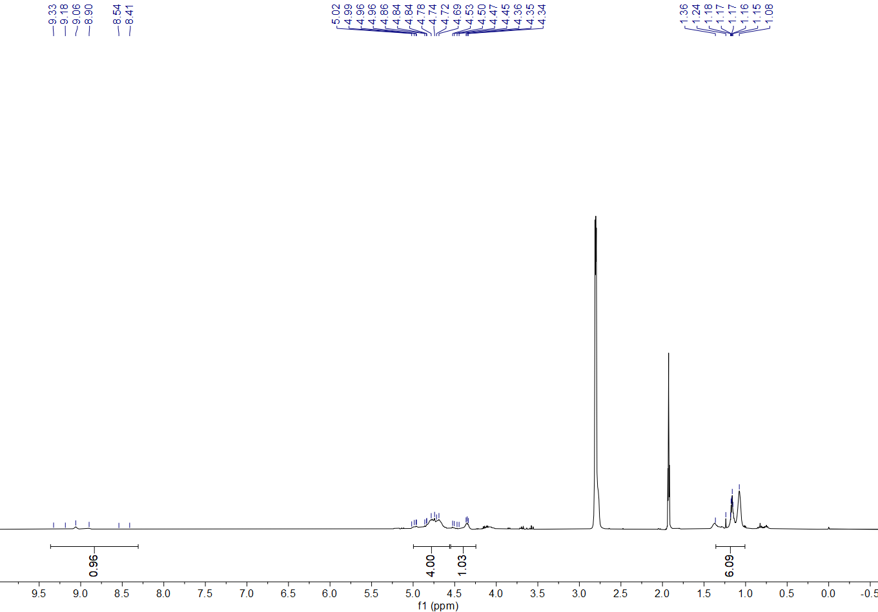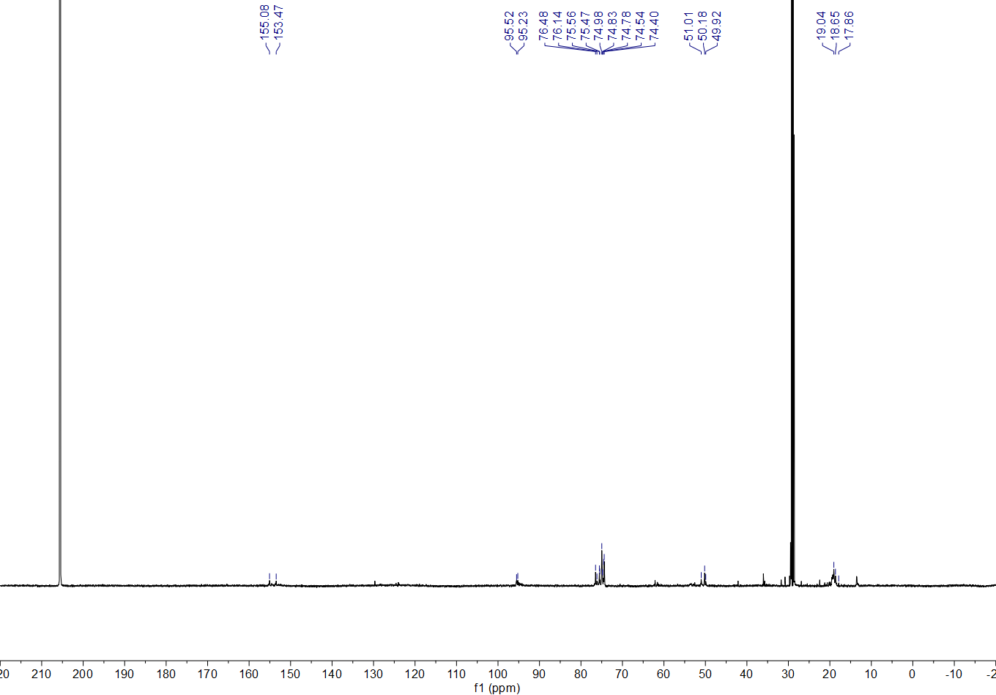
Multiple singles probably derived from the rotameric amide
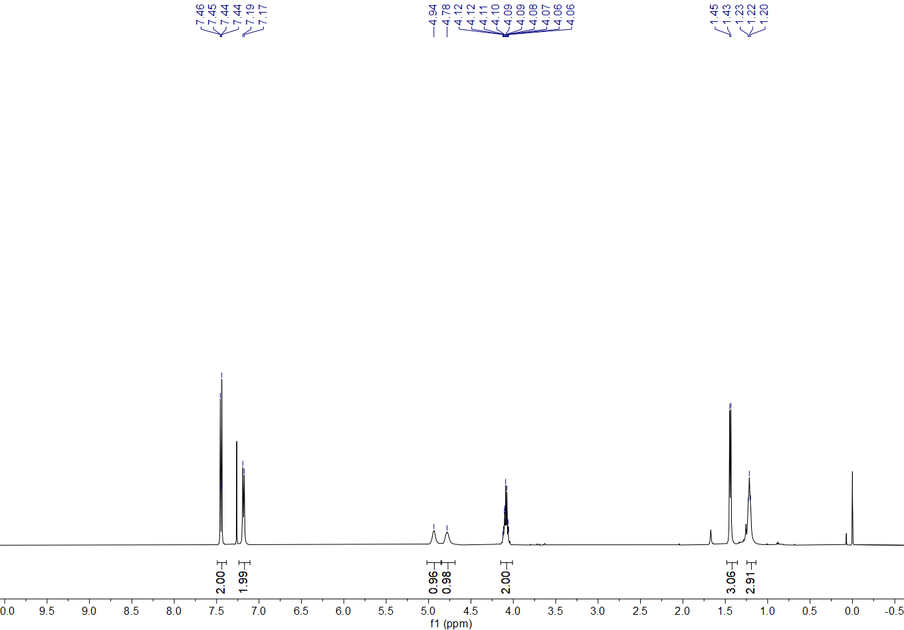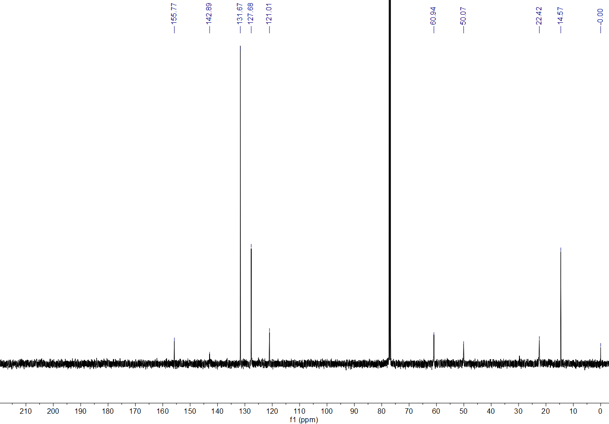
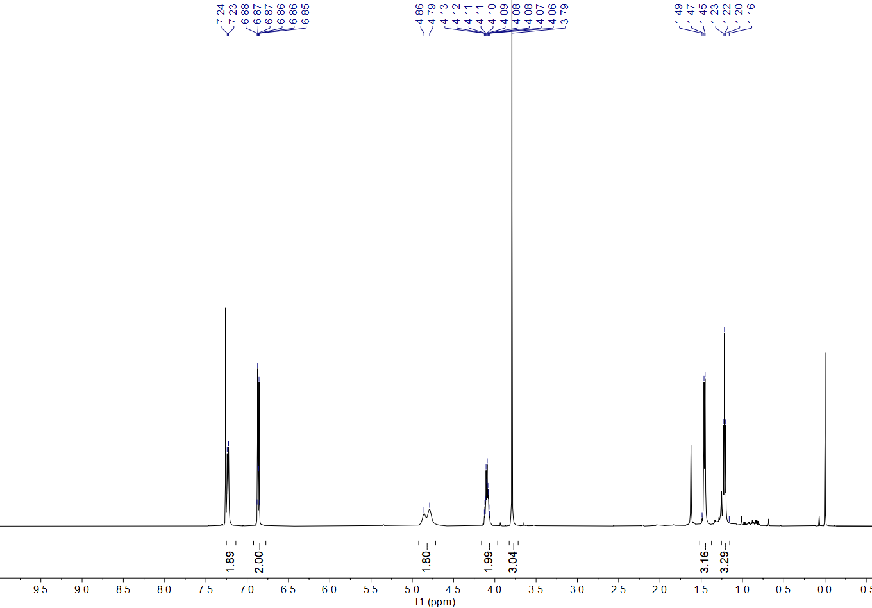
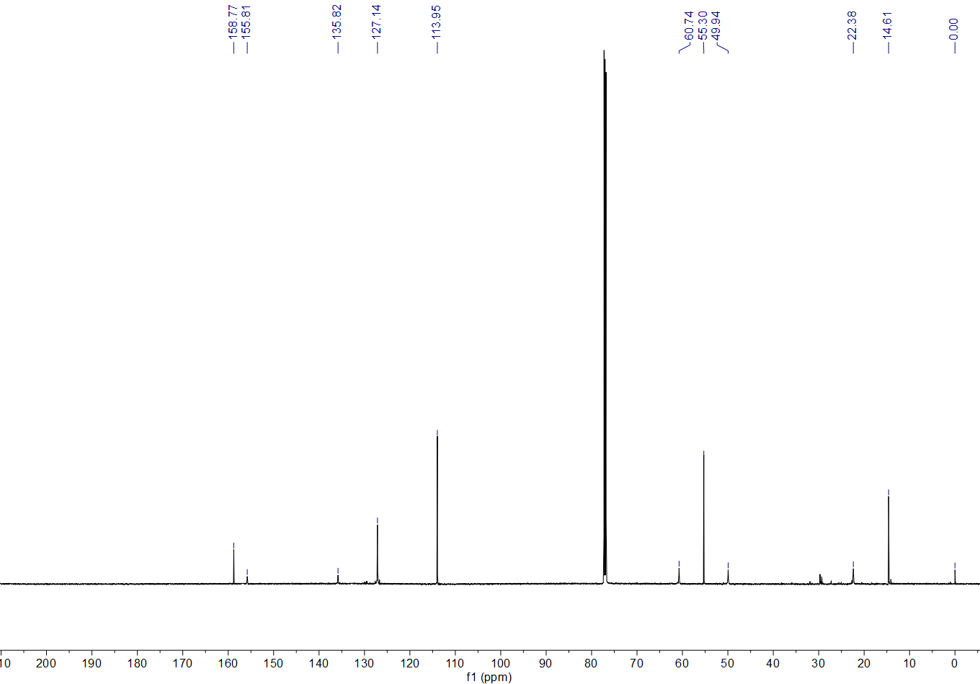
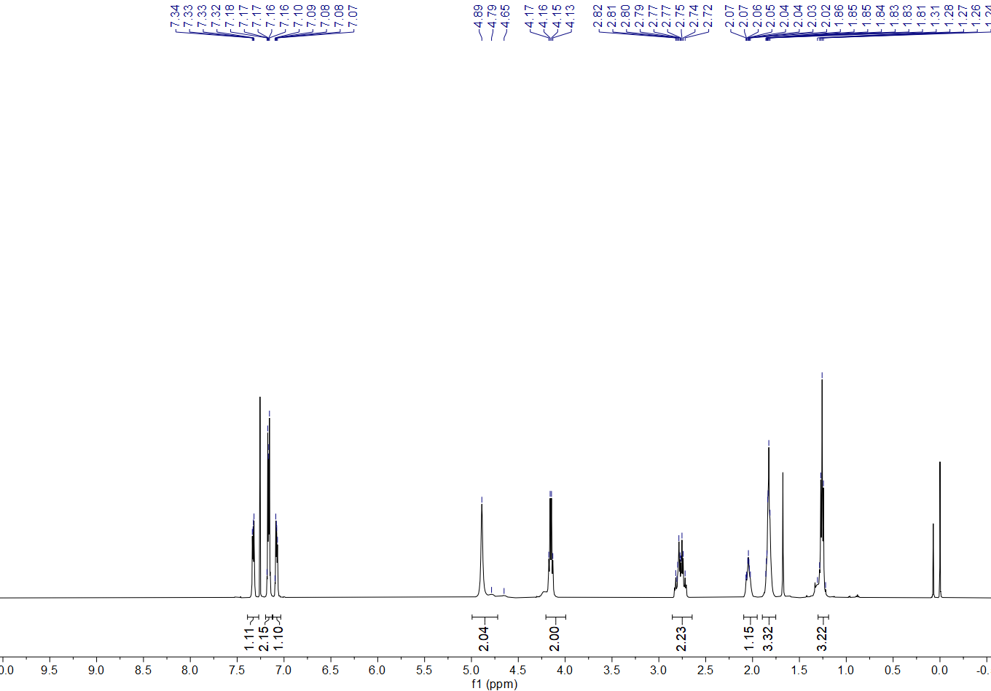
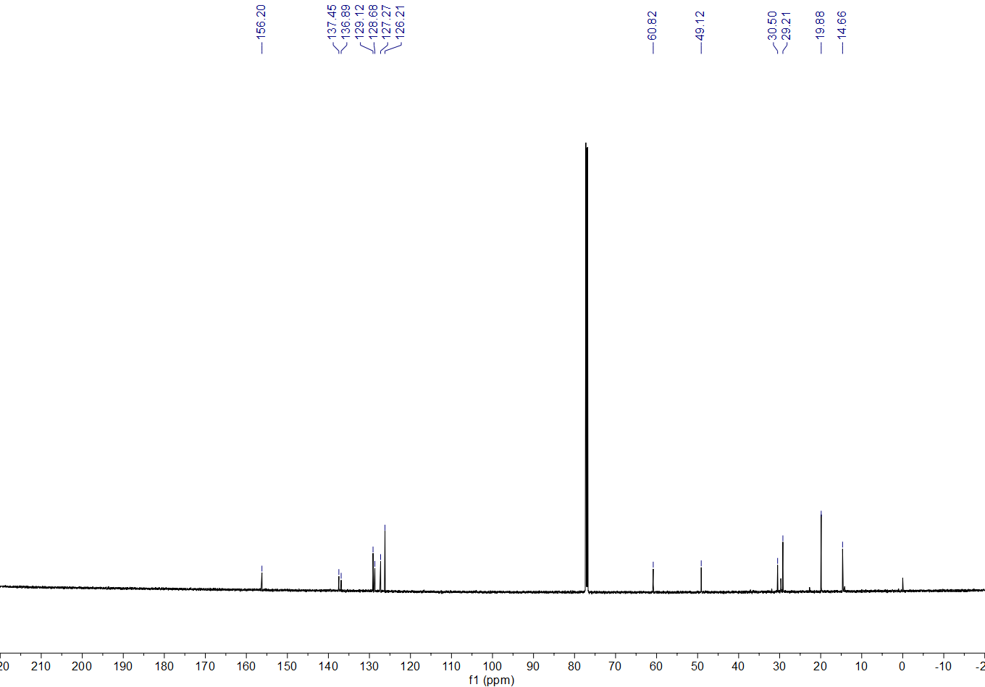
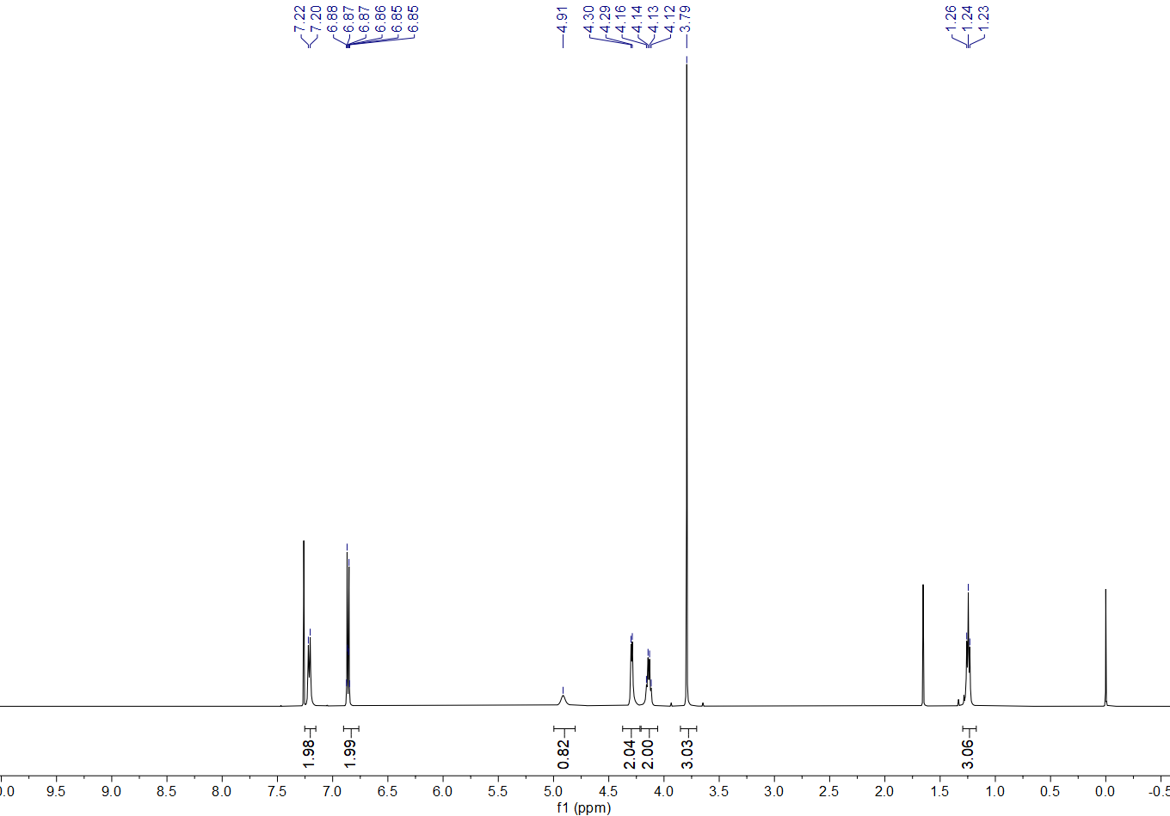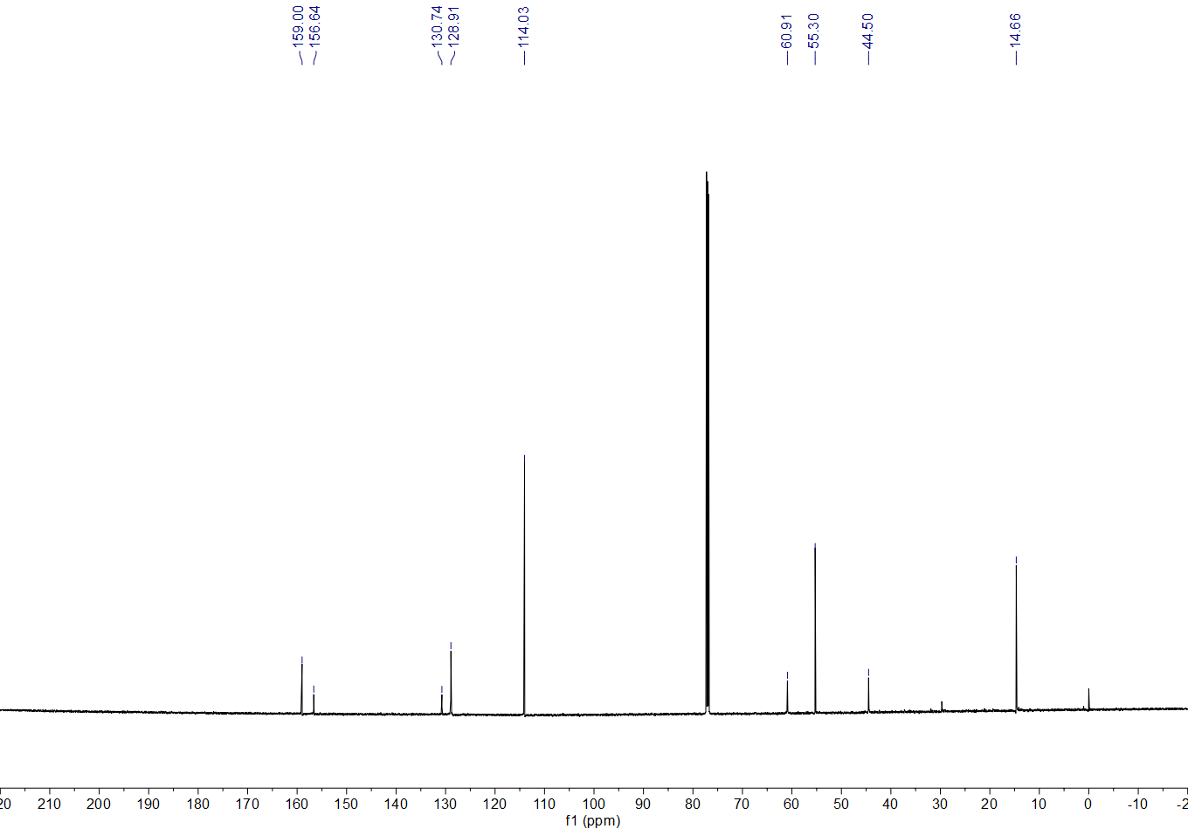
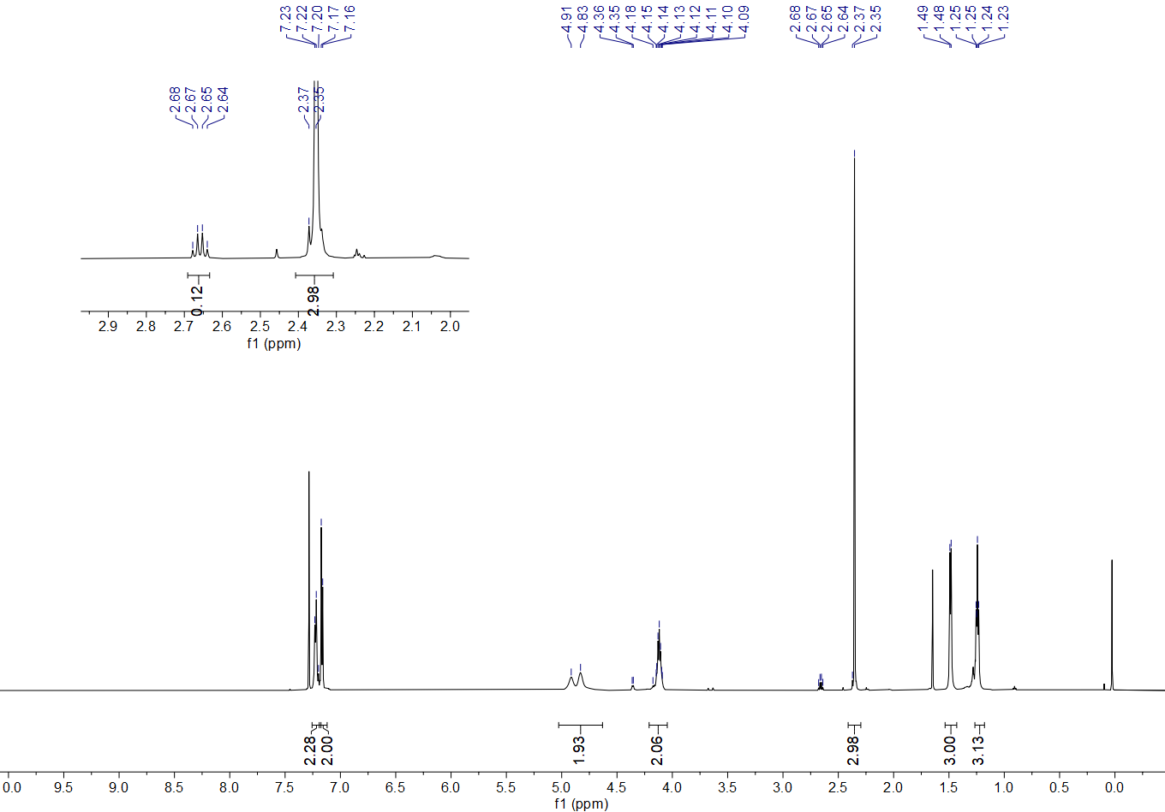
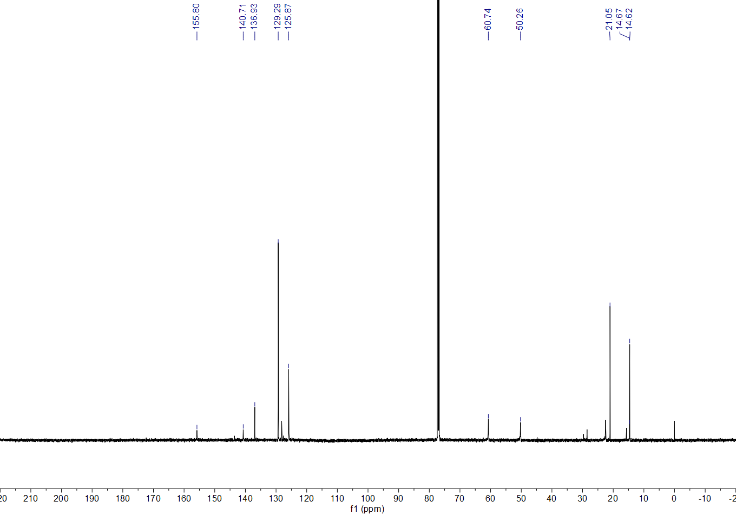
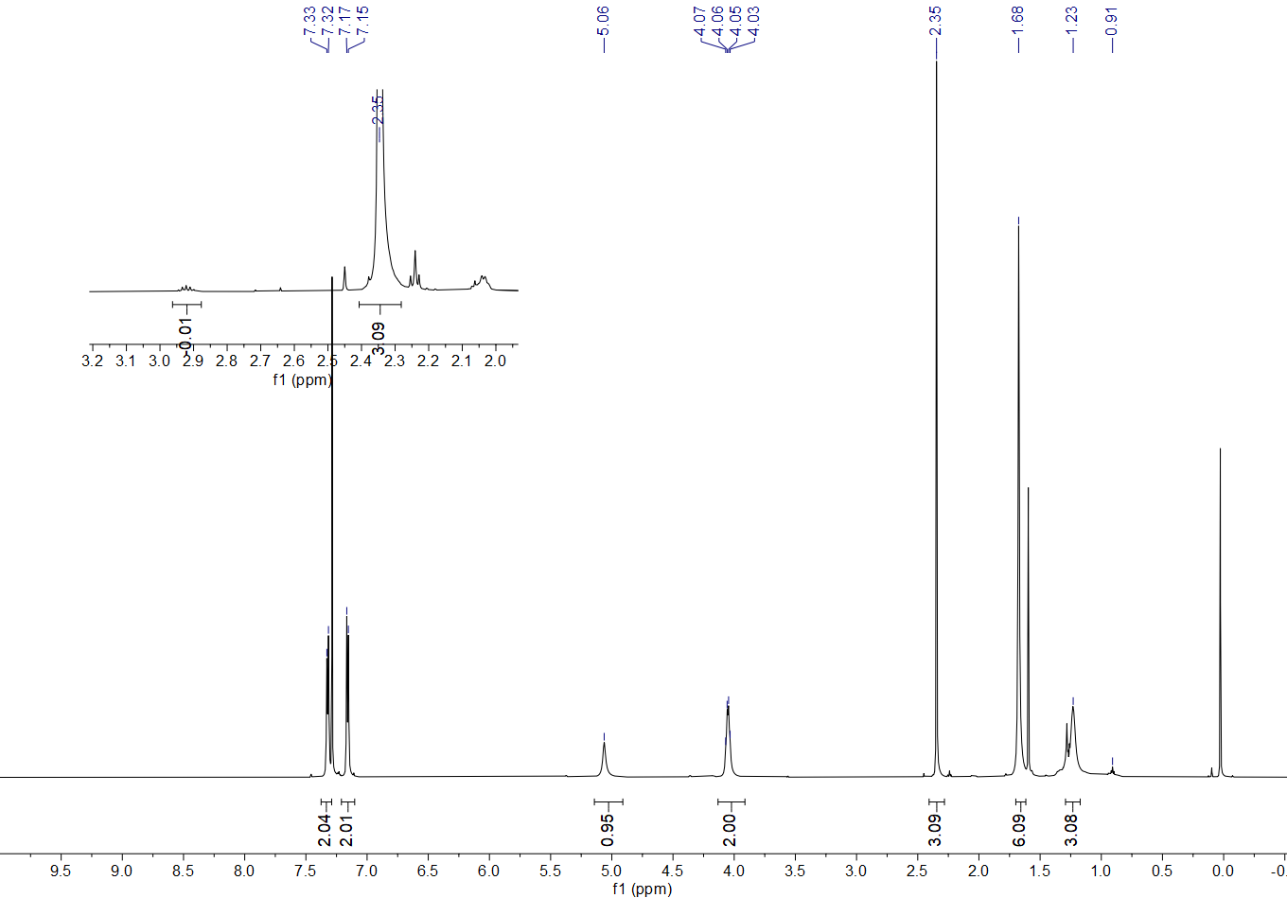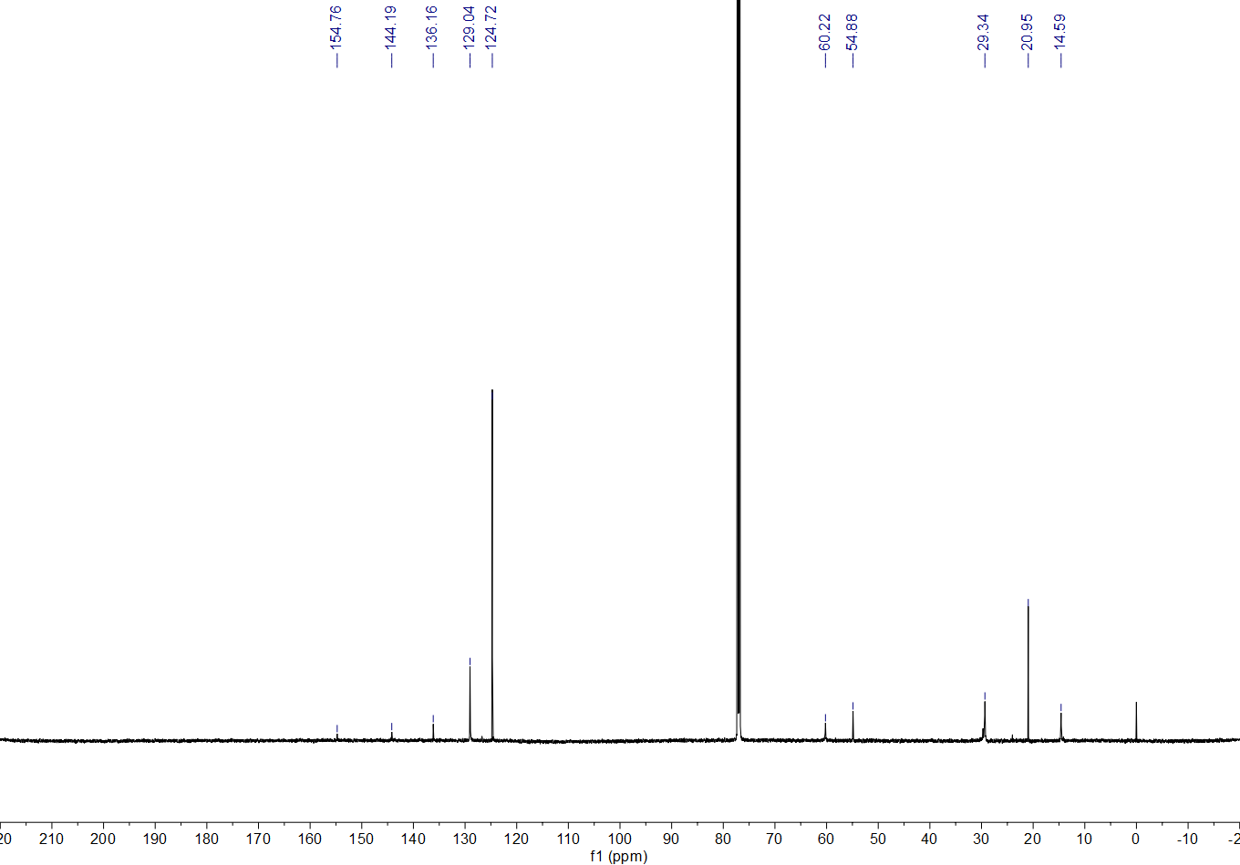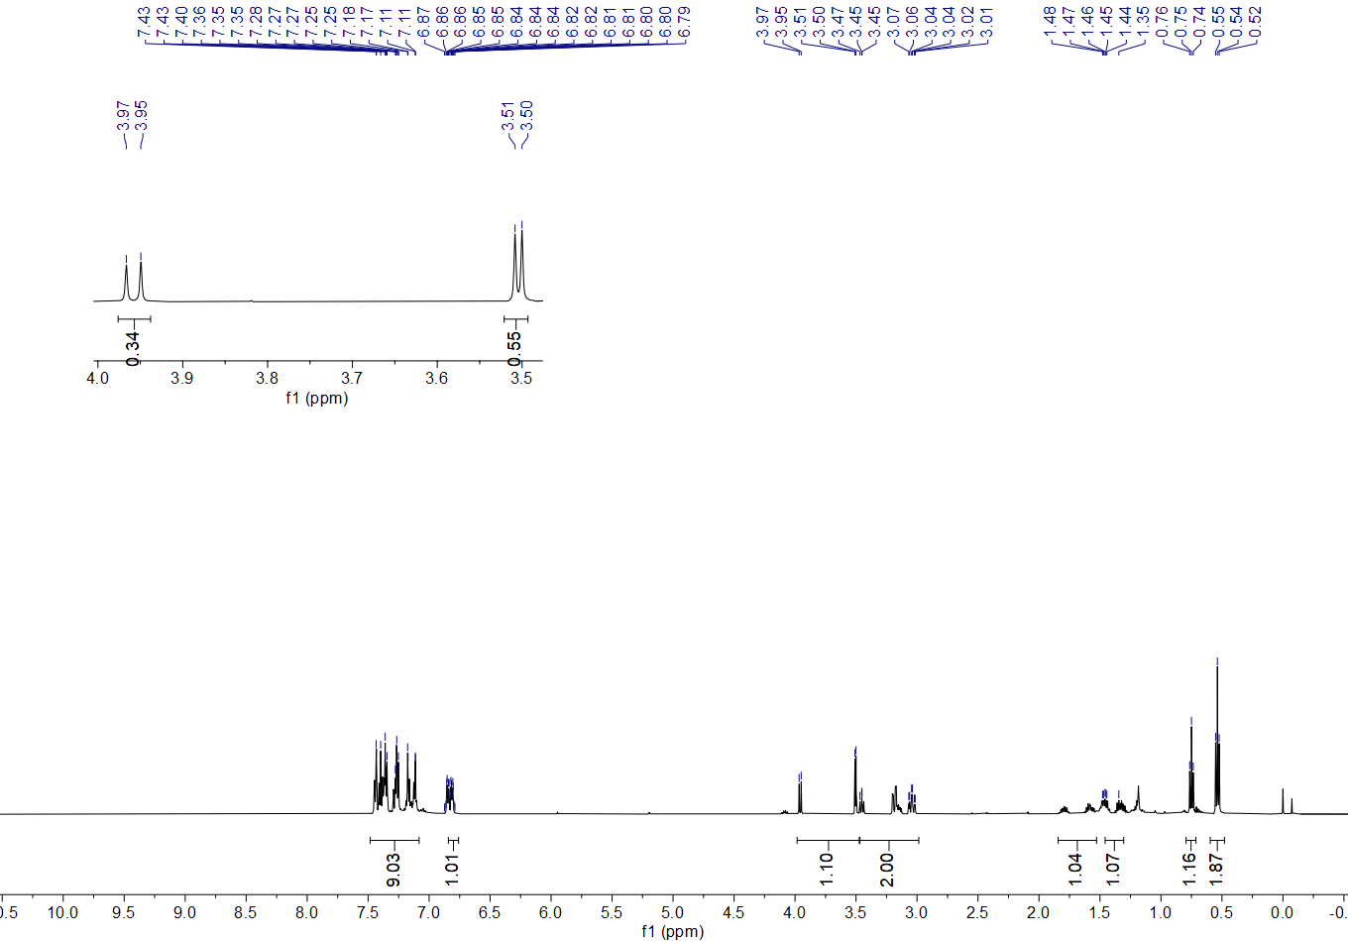
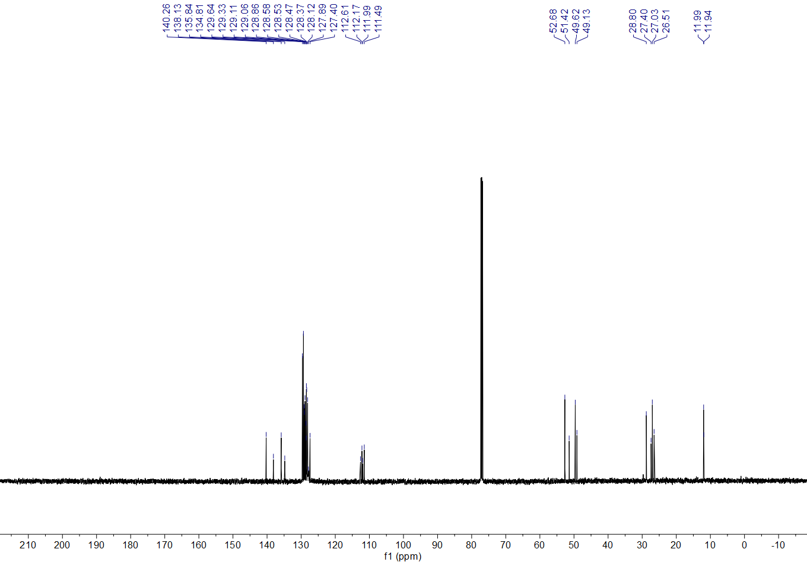
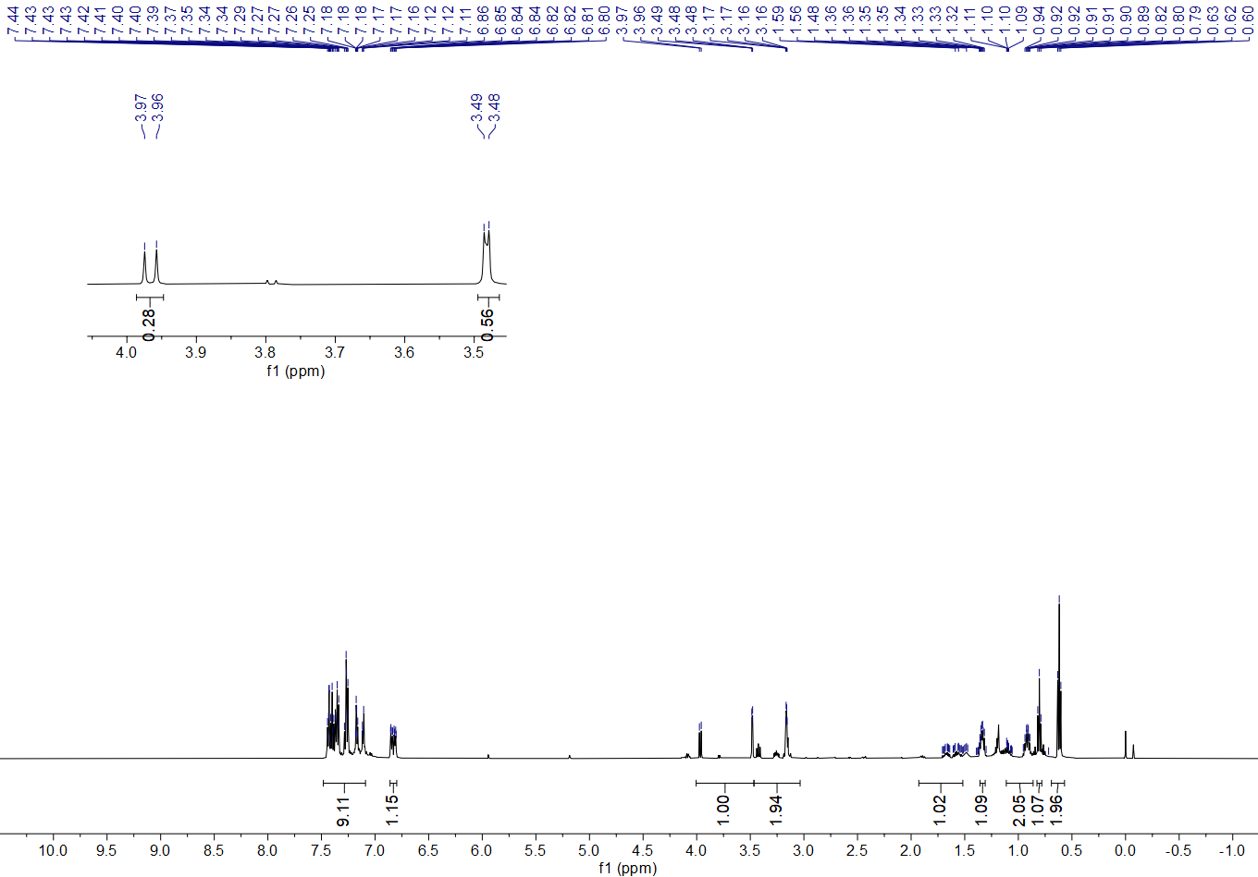
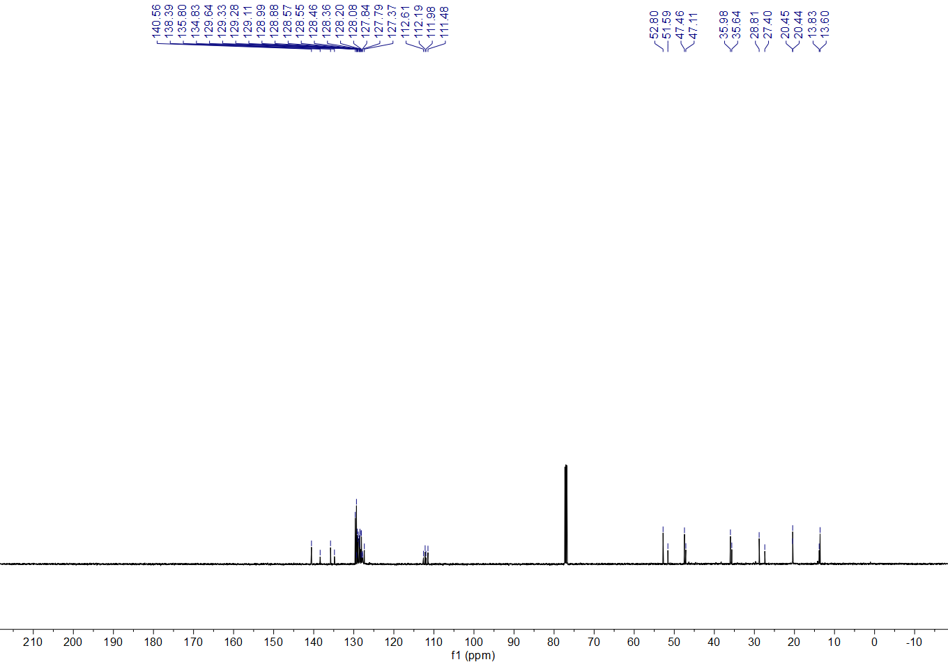
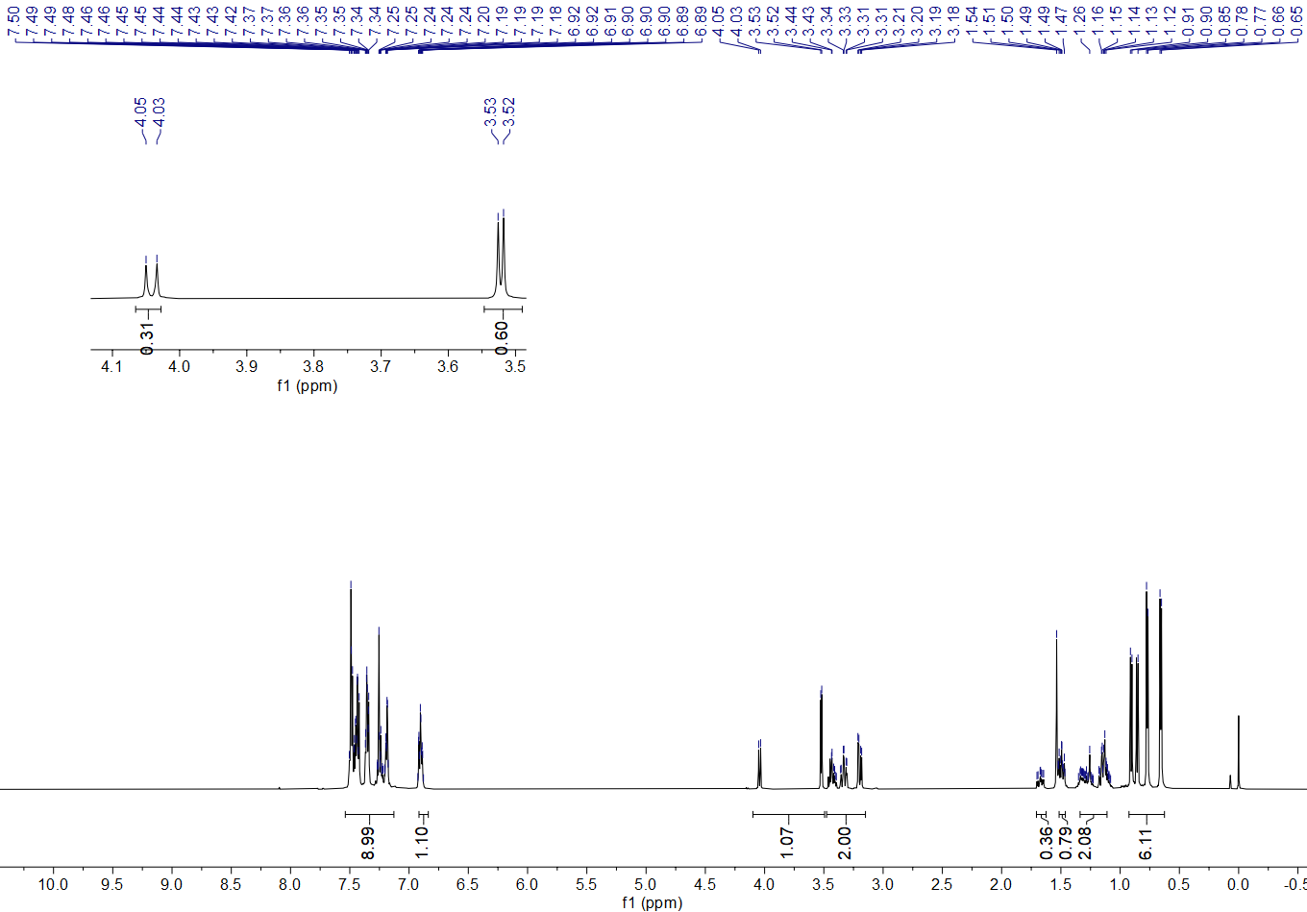
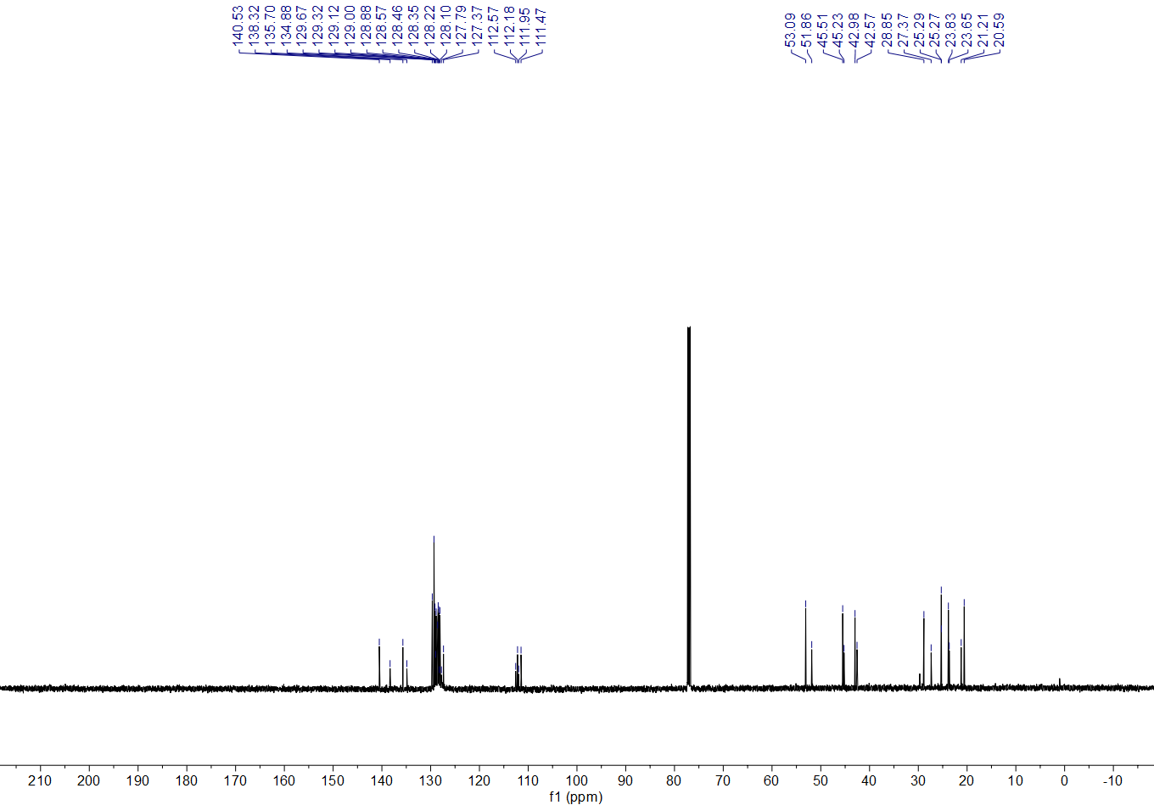
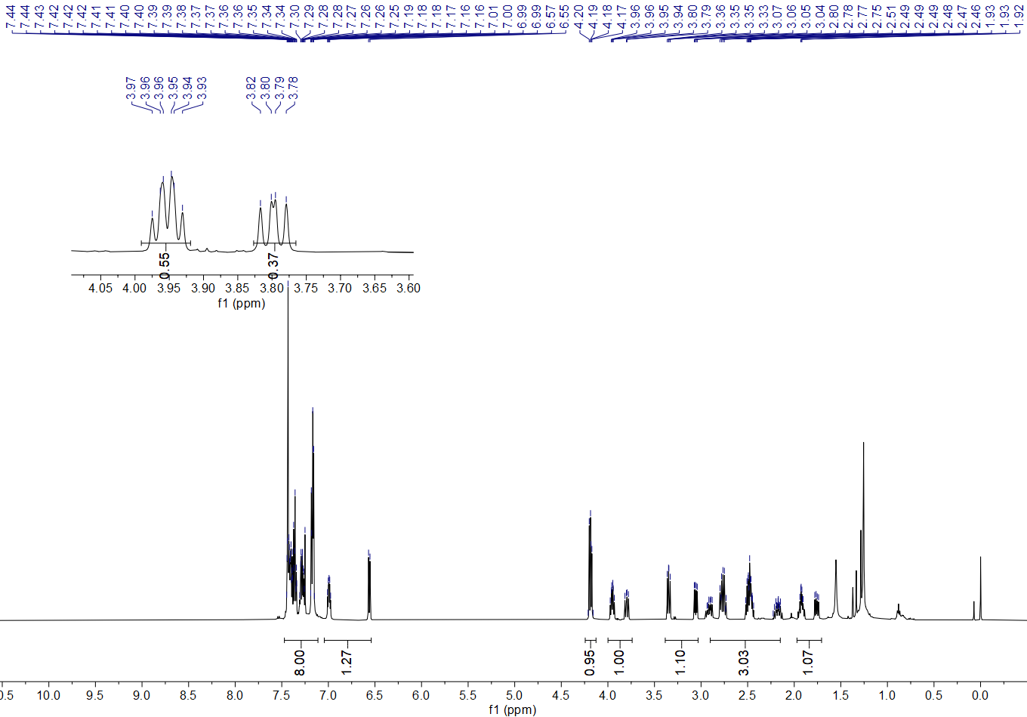
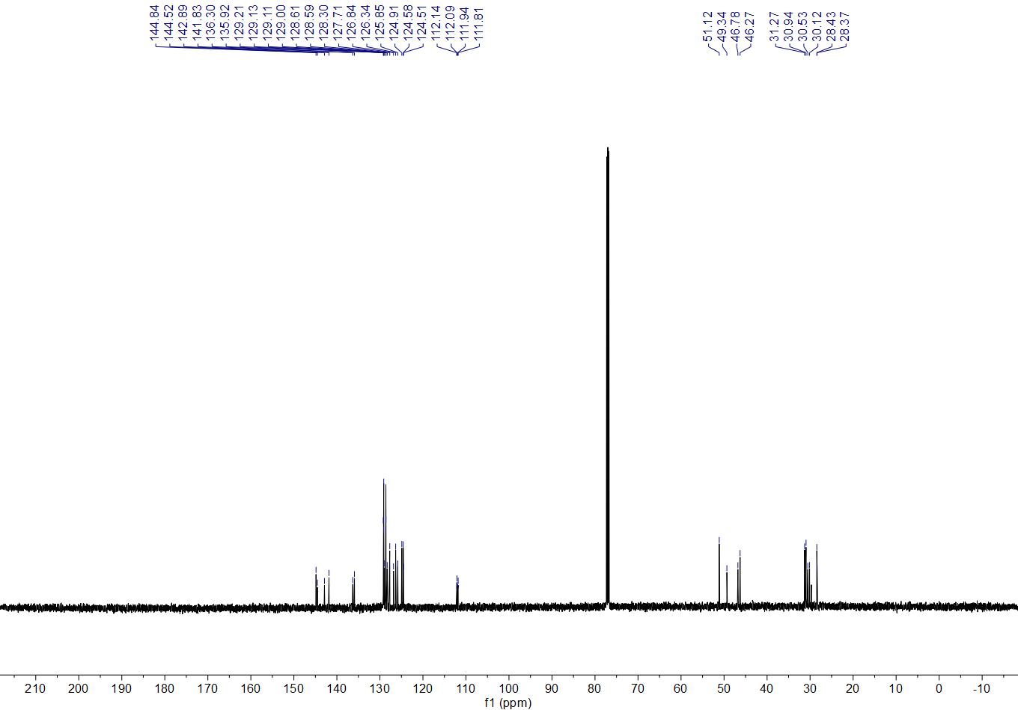
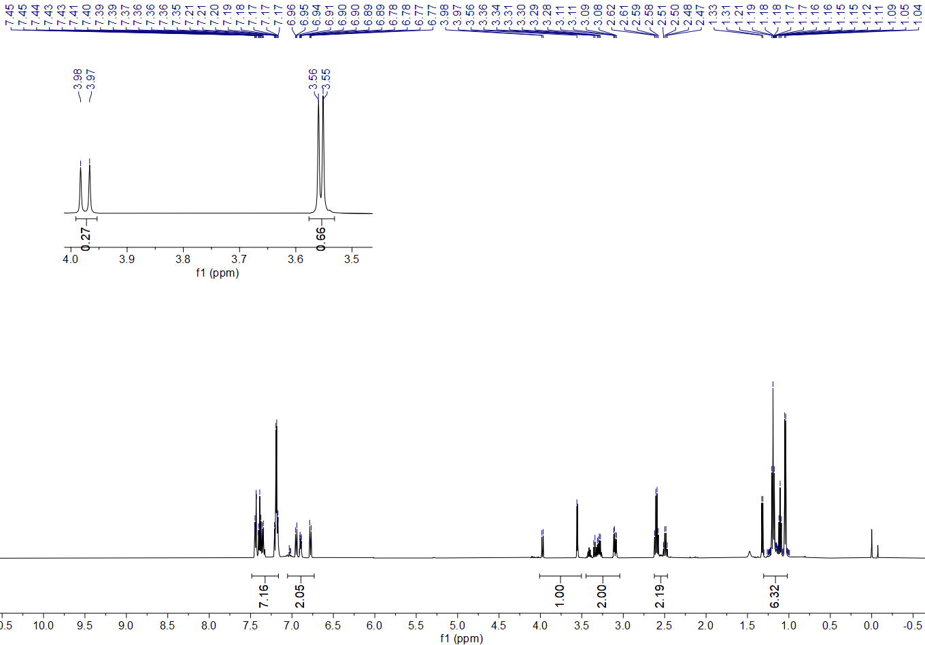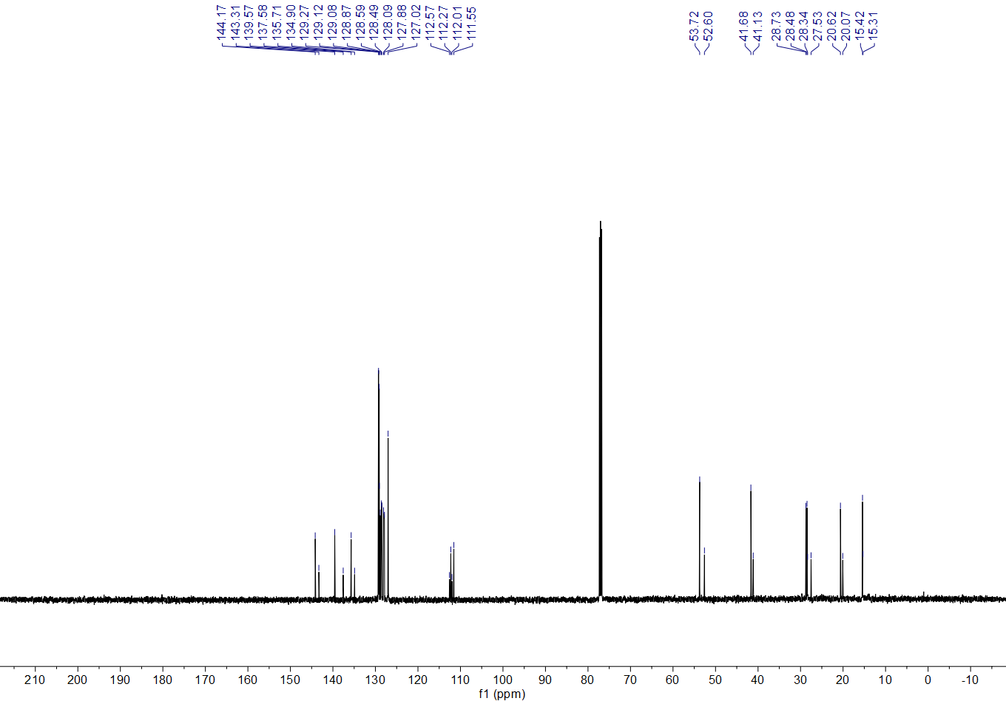
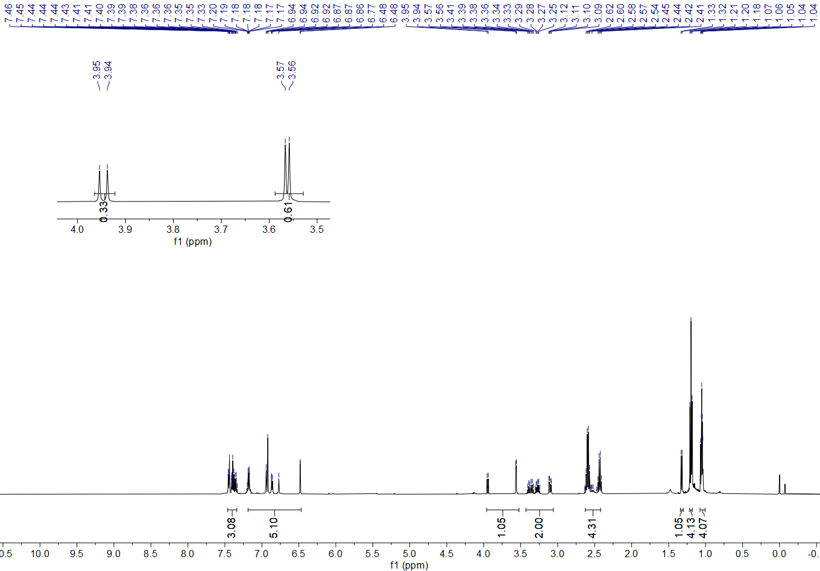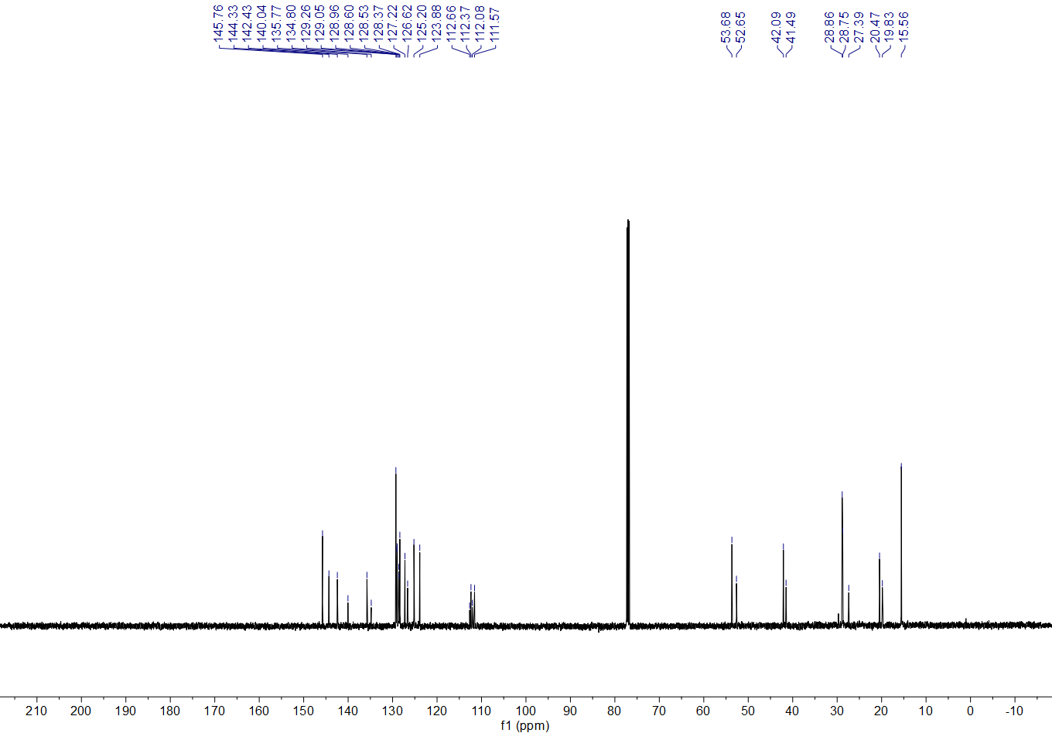
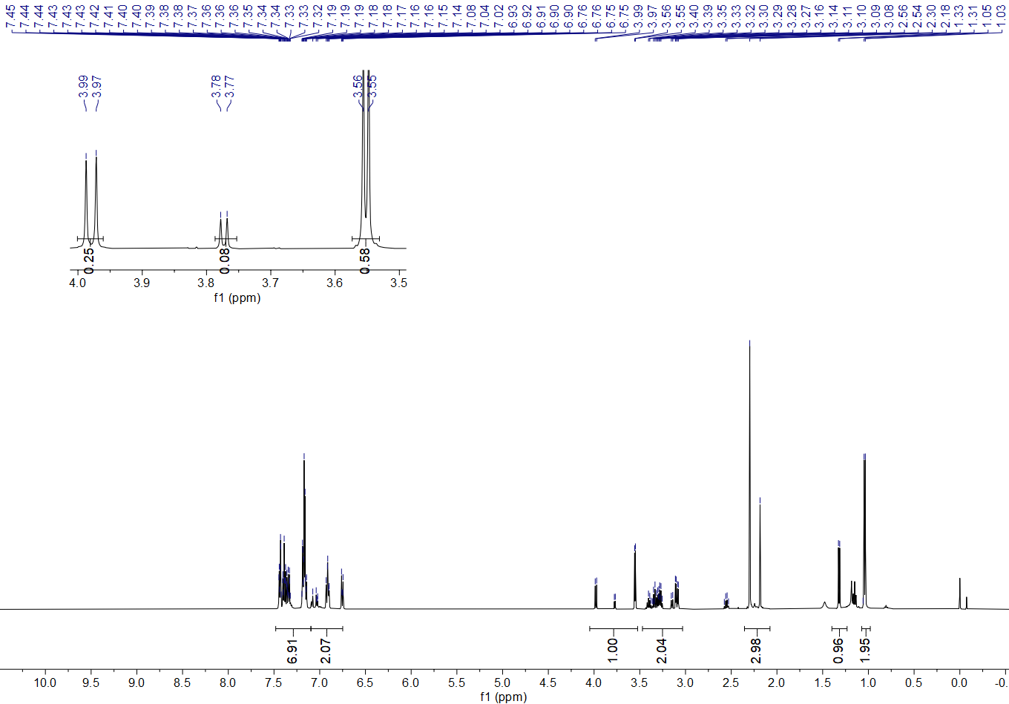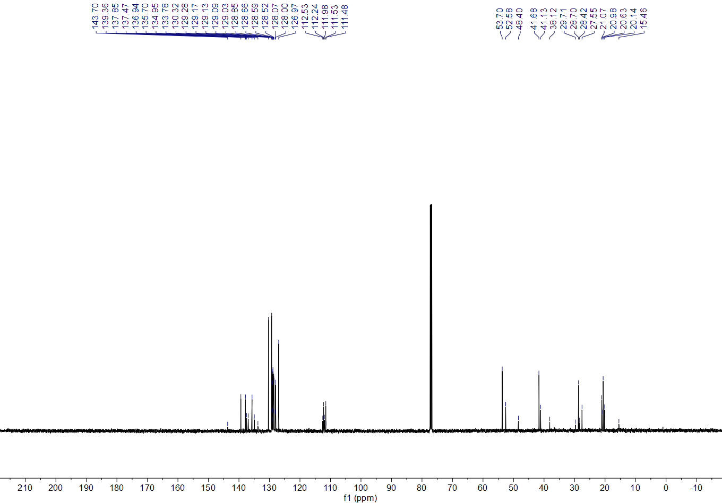
9. References.
- H. Liu, L. Ge, D.-X. Wang, N. Chen, C. Feng, photoredox-coupled F-nucleophilic addition: Allylation of gem-difluoroalkenes. Angew. Chem. Int. Ed. 58, 3918–3922 (2019).
- Y. Yang, I. Cho, X. Qi, P. Liu, F. H. Arnold, An enzymatic platform for the asymmetric amination of primary, secondary and tertiary C(sp³)–H Bonds. Nat. Chem. 11, 987–993 (2019).
- R. Liu, J. Han, B. Li, X. Liu, Z. Wei, J. Wang, Q. Wang, R. Jiang, H. Nie, S. Zhang, Enantioselective synthesis of tetrahydroisoquinolines via catalytic intramolecular asymmetric reductive amination. Org. Chem. Front. 8, 1930–1934 (2021).
- B. Karimi, P. F. Akhavan, Main-chain NHC-palladium polymer as a recyclable self-supported catalyst in the Suzuki–Miyaura coupling of aryl chlorides in water. Chem. Commun. 2009, 3750–3752 (2009).
- Y. Li, Y. Luo, L. Peng, Y. Li, B. Zhao, W. Wang, H. Pang, Y. Deng, R. Bai, Y. Lan, G. Yin, Reaction scope and mechanistic insights of nickel-catalyzed migratory Suzuki–Miyaura cross-coupling. Nat Commun. 11, 417–429 (2020).
- T. Kato, K. Maruoka, Design of bowl-shaped N-Hydroxyimide derivatives as new organoradical catalysts for site-selective C(sp³)-H bond functionalization reactions. Angew. Chem. Int. Ed. 59, 14261–14264 (2020).
- L. Wu, Q. Shao, G. Yang, W. Zhang, Cobalt-catalyzed asymmetric allylation of cyclic ketimines. Chem. Eur. J. 24, 1241–1245 (2018).
- C. Le, T. Q. Chen, T. Liang, P. Zhang, D. W. C MacMillan, A radical approach to the copper oxidative addition problem: Trifluoromethylation of bromoarenes. Science 360, 1010-1014 (2018).
- J.-B. Han, A. Guo, X.-Y. Tang, Alkylation of allyl/alkenyl sulfones by deoxygenation of alkoxyl radicals. Chem. Eur. J. 25, 2989–2994 (2019).
- M. Ueda, A. Maeda, K. Hamaoka, M. Sasano, T. Fukuyama, I. Ryu, Bromine-radical-mediated site-selective allylation of C(sp³)–H bonds. Synthesis 51, 1171-1177 (2019).
- L. Řehová, I. Císařová. U. Jahn, Divergent reactivity of alkyl aryl sulfones with bases: Selective functionalization of ortho-aryl and α-alkyl units enabled by a unique carbanion transmetalation. Eur. J. Org. Chem. 2014, 1461–1476 (2014).
- S. Kamijo, K. Kamijo, K. Maruoka, T. Murafuji, Aryl ketone catalyzed radical allylation of C(sp³)–H bonds under photoirradiation. Org. Lett. 18, 6516–6519 (2016).
- T. Kippo, K. Hamaoka, M. Ueda, T. Fukuyama, I. Ryu, Radical bromoallylation of alkynes leading to 1-bromo-1,4-dienes. Tetrahedron 72, 7866–7874 (2016).
- Y. Li, M. Lei, L. Gong, Photocatalytic regio- and stereoselective C(sp³)-H functionalization of benzylic and allylic hydrocarbons as well as unactivated alkanes. Nat. Catal. 2, 1016–1026 (2019).
- M. J. Frisch, G. W. Trucks, H. B. Schlegel, G. E. Scuseria, M. A. Robb, J. R. Cheeseman, G. Scalmani, V.Barone, B. Mennucci, G. A. Petersson, H. Nakatsuji, M. Caricato, X. Li, H. P. Hratchian, A. F. Izmaylov, J. Bloino, G. Zheng, J. L. Sonnenberg, M. Hada, M. Ehara, K. Toyota, R. Fukuda, J. Hasegawa, M. Ishida, T. Nakajima, Y. Honda, O. Kitao, H. Nakai, T. Vreven, J. A. Montgomery, Jr., J. E. Peralta, F. Ogliaro, M. Bearpark, J. J. Heyd, E. Brothers, K. N. Kudin, V. N. Staroverov, T. Keith, R. Kobayashi, J. Normand, K. Raghavachari, A. Rendell, J. C. Burant, S. S. Iyengar, J. Tomasi, M. Cossi, N. Rega, J. M. Millam, M. Klene, J. E. Knox, J. B. Cross, V.Bakken, C.A damo, J. Jaramillo, R. Gomperts, R. E. Stratmann, O. Yazyev, A. J. Austin, R. Cammi, C. Pomelli, J. W. Ochterski, R. L. Martin, K. Morokuma, V. G. Zakrzewski, G. A. Voth, P. Salvador, J. J. Dannenberg, S. Dapprich, A. D. Daniels, O. Farkas, J. B. Foresman, J. V. Ortiz, J. Cioslowski, D. J. Fox, Gaussian 09, Revision E.01 (Gaussian, Inc., Wallingford CT) (2013).
- Y. Zhao, D. G. Trunhlar, The M06 suite of density functionals for main group thermochemistry, thermochemical kinetics, noncovalent interactions, excited states, and transition elements: Two new functionals and systematic testing of four M06-class functionals and 12 other functionals. Theor. Chem. Account. 120, 215–241 (2008).
- F. Weigend, R. Ahlrichs, Balanced basis sets of split valence, triple zeta valence and quadruple zeta valence quality for H to Rn: Design and assessment of accuracy. Phys. Chem. Chem. Phys. 7, 3297–3305 (2005).
- A. V. Marenich, C. J. Cramer, D. G. Truhlar, Universal solvation model based on solute electron density and on a continuum model of the solvent defined by the bulk dielectric constant and atomic surface tensions. J. Phys. Chem. B. 113, 6378−6396 (2009).
- S. Grimme, J. Antony, S. Ehrlich, H. Krieg, A consistent and accurate ab initio parametrization of density functional dispersioncorrection (DFT-D) for the 94 elements H-Pu. J. Chem. Phys. 132, 154104 (2010).
- K. Fukui, A formulation of the reaction coordinate. J. Phys. Chem. 74, 4161−4163 (1970).
- C. Y. Legault, CYLview, 1.0b. Université de Sherbrooke. (http://www.cylview.org) (2009).
- W. Humphrey, A. Dalke, K. Schulten, VMD: Visual molecular dynamics. J. Mol. Graphics. 14, 33–38 (1996).
- T. Lu., F. Chen. Multiwfn: A multifunctional wavefunction analyzer. J. Comput. Chem. 33, 580–592 (2012).

