Supporting Information for:
Obesity-upregulated YAP/IL33 signaling axis promotes an immunosuppressive tumor microenvironment in breast cancer
Jia-Zih Dai^{1,2}, Ching-Chieh Yang^{3,4}, Pei-Wei Shueng^{5,6}, Yen-Ju Wang^{1,2}, Chen-Shiuan Huang², Yi-Chun Chao^{1,2}, Cheng-Wei Lin^{1,2,7,8#}
¹Graduate Institute of Medical Sciences, College of Medicine, Taipei Medical University, Taipei, Taiwan.
²Department of Biochemistry and Molecular Cell Biology, School of Medicine, College of Medicine, Taipei Medical University, Taipei, Taiwan.
³Department of Radiation Oncology, Chi Mei Medical Center, Tainan, Taiwan.
⁴Department of Pharmacy, Chia-Nan University of Pharmacy and Science, Tainan, Taiwan.
⁵Division of Radiation Oncology, Far Eastern Memorial Hospital, New Taipei City, Taiwan
⁶Faculty of Medicine, School of Medicine, National Yang Ming Chiao Tung University, Taipei, Taiwan
⁷Drug Development and Value Creation Research Center, Kaohsiung Medical University, Kaohsiung, Taiwan.
⁸Cell Physiology and Molecular Image Research Center, Wan Fang Hospital, Taipei Medical University, Taipei, Taiwan.

#Corresponding author: Cheng-Wei Lin; Department of Biochemistry and Molecular Biology, School of Medicine, College of Medicine, Taipei Medical University, 250 Wu-Xing Street, Taipei 11031, Taiwan. Email: cwlin@tmu.edu.tw; Phone: 886-2-27361661 ext. 3160; Fax: 886-2-27356689.

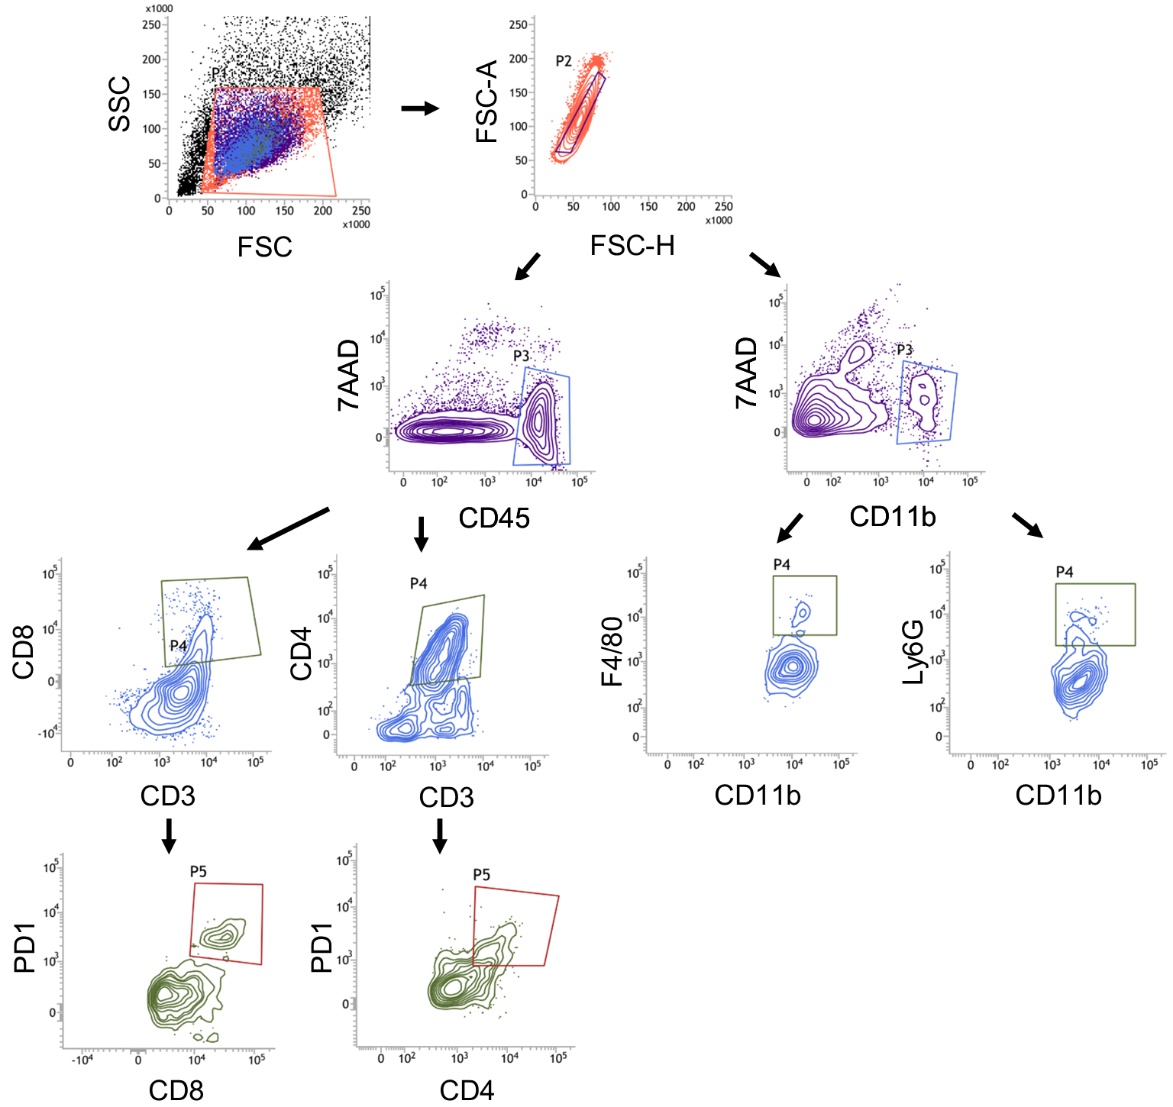
Supplementary Fig.1 Gating Strategy for tumor-infiltrating lymphocytes.

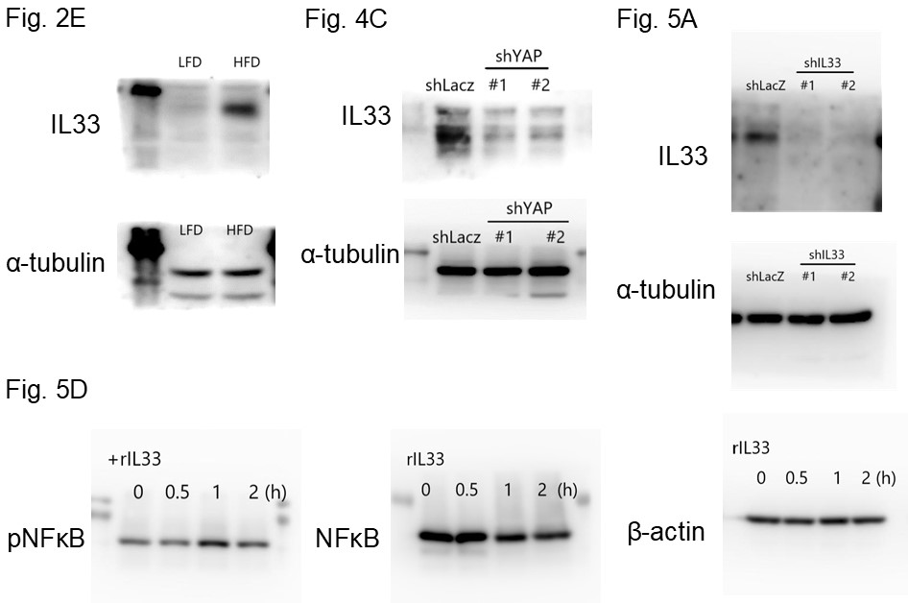
Supplementary Fig.2 Unprocessed images of Western blots.

