Suppplementary materials

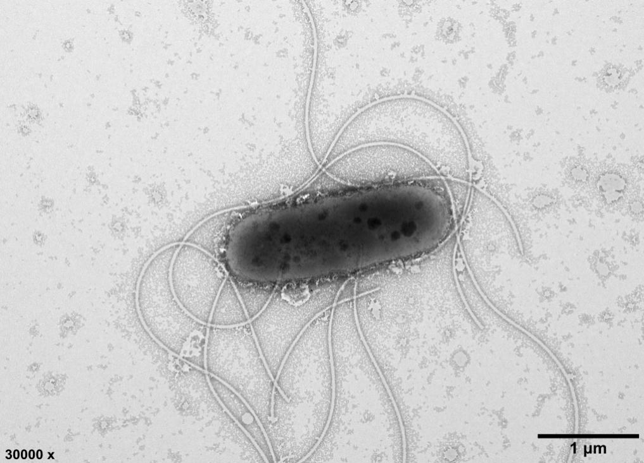
Supplementary Fig. S1. Transmission electron microscope image showing the cellular morphology of strain QX-1^{T} grown on MA for 18 h. Bar, 1 μm.

Supplementary Fig. S2. Polar lipids of strain QX-1^{T}. DPG, diphosphatidylglycerol; PG, phosphatidylglycerol; PE, phosphatidylethanolamine; PL, unidentified phospholipid; APL, unidentified aminophospholipid; L, unidentified lipids.
1, first dimension of TLC; 2, second dimension of TLC. All data were obtained from this study.
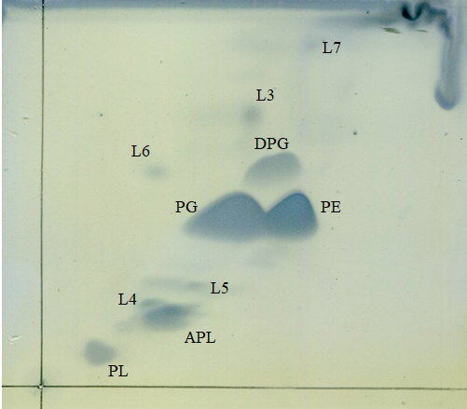
1
2

Supplementary Fig. S3. Neighbour-joining phylogenetic tree based on rpoD gene sequences of strain QX-1^{T} and related species (which belongs to the family Halomonadaceae). Distance estimations were obtained by the Kimura two-parameter model. Bootstrap values (>50%) based on 1000 replication are shown at branch. Filled circles, open circles, or rhombus at nodes indicate generic branches that were also recovered with the Maximum-Likelihood and Minimum-Evolution algorithms, just the Minimum-Evolution algorithm, or with only the Maximum-Likelihood algorithm, respectively. Bar, 0.02 substitutions per nucleotide position.
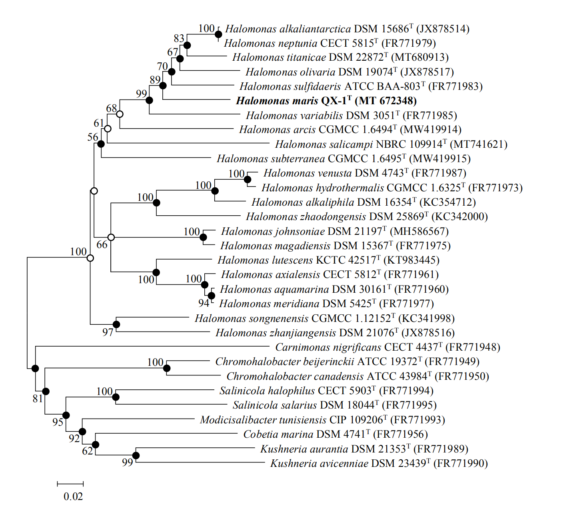
Supplementary Fig. S4. Neighbour-joining phylogenetic tree based on gyrB gene sequences of strain QX-1^{T} and related species (which belongs to the family Halomonadaceae). Distance estimations were obtained by the Kimura two-parameter model. Bootstrap values (>50%) based on 1000 replication are shown at branch. Filled circles, open circles, or rhombus at nodes indicate generic branches that were also recovered with the Maximum-Likelihood and Minimum-Evolution algorithms, just the Minimum-Evolution algorithm, or with only the Maximum-Likelihood algorithm, respectively. Bar, 0.02 substitutions per nucleotide position.
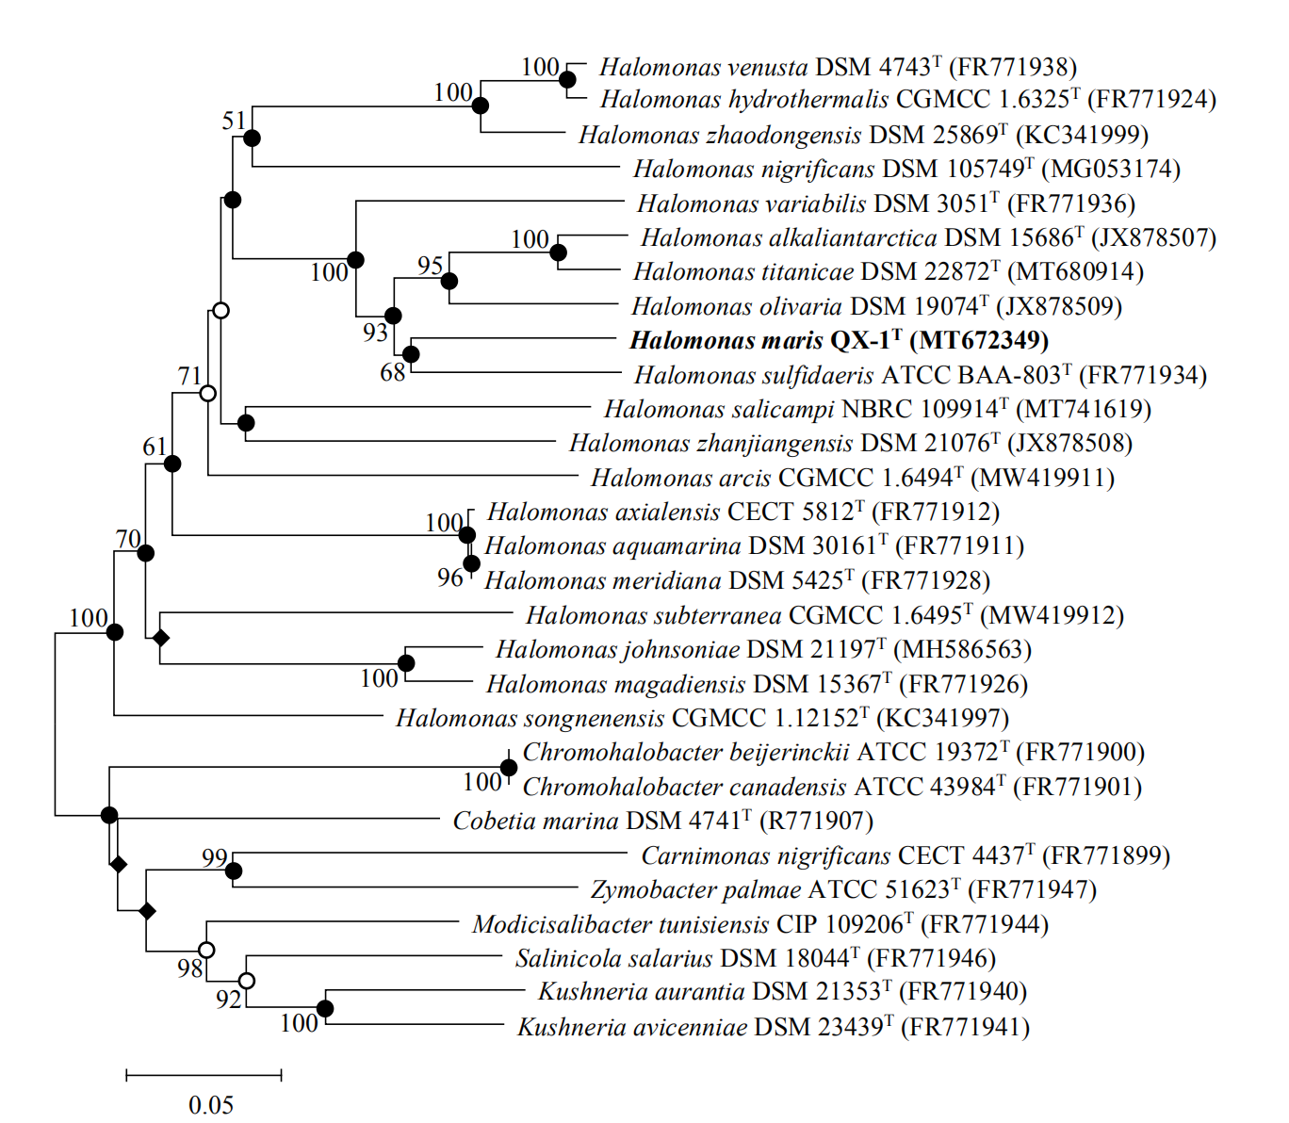
Supplementary Table 1. Cellular fatty acid composition (%) of strain QX-1^{T} and related type strains of the genus Halomonas.
Strains: 1, QX-1^{T}; 2, H. sulfidaeris ATCC BAA-803^{T}; 3, H. zhaodongensis DSM 25869^{T}; 4, H. songnenensis CGMCC 1.12152^{T}; 5, H. hydrothermalis CGMCC 1.6325^{T}; 6, H. subterranea CGMCC 1.6495^{T}; 7, H. salicampi NBRC 109914^{T}; 8, H. arcis CGMCC 1.6494^{T}. All strains were grown on MA at 37 ℃ for 48 h. All data were obtained from this study. Values are percentages of total fatty acids; -, not detected; TR, trace (<0.5%).
Fatty acid | 1 | 2 | 3 | 4 | 5 | 6 | 7 | 8
Saturated
C_{10:0} | 1.49 | 1.43 | 1.88 | 2.60 | 1.27 | 1.52 | 1.44 | 1.32
C_{12:0} | 2.05 | 1.90 | 1.04 | TR | TR | TR | 1.09 | TR
C_{14:0} | 0.77 | 2.32 | 3.34 | 2.23 | 3.91 | 2.37 | - | -
C_{16:0} | 25.50 | 14.25 | 20.01 | 13.21 | 12.36 | 21.82 | 16.65 | 19.85
C_{17:0} | 0.85 | - | - | - | - | - | - | -
C_{18:0} | 0.52 | 6.21 | 1.92 | - | TR | 11.57 | - | 13.08
anteiso-C_{11:0} | 0.89 | - | 0.58 | 1.97 | - | TR | - | TR
Hydroxy
C_{10:0}-3OH | - | 2.07 | 0.83 | - | 1.78 | 2.27 | 6.41 | 2.45
C_{12:0}-3OH | 8.00 | 14.02 | 4.87 | 6.91 | 6.71 | 3.28 | 5.77 | 4.31
C_{16:0}-2OH | - | - | 0.15 | 1.97 | - | - | 1.80 | -
Cyclopropane
C_{17:0} cyclo | 14.02 | 2.54 | - | - | - | 3.26 | 11.08 | 5.79
C_{19:0} cyclo ω8c | 18.72 | 2.84 | - | TR | - | 15.68 | 30.38 | 11.24
Unsaturated
C_{18:1} ω9c | - | 2.22 | 0.83 | TR | 2.68 | TR | - | TR
iso-C_{16:1} G | 1.72 | - | - | - | - | - | - | -
Summed Feature 2 | 1.10 | 1.75 | - | 12.35 | 0.52 | 0.89 | 4.11 | 1.11
Summed Feature 3 | - | 18.98 | 10.44 | 15.14 | 10.31 | 2.87 | 6.88 | 8.77
Summed Feature 5 | 5.66 | - | - | - | - | - | - | -
Summed Feature 8 | 18.08 | 25.94 | 50.55 | 41.22 | 56.61 | 31.75 | 13.96 | 28.62
* Summed features are groups of two or three fatty acids that cannot be separated by GLC with the MIDI system. Summed feature 2 contained iso-C_{16:1} I and/or C_{14:0}-3OH; Summed feature 3 contained C_{16:1} ω7c and/or C_{16:1} ω6c; Summed feature 5 contained C_{18:2} ω6,9c and/or ante-C_{18:0}; Summed feature 8 contained C_{18:1} ω7c and/or C_{18:1} ω6c.

Supplementary Table 2. DNA-DNA hybridization (DDH) between strain QX-1^{T} and related type strains of the genus Halomonas.
Strains: 1, QX-1^{T}; 2, H. sulfidaeris ATCC BAA-803^{T}; 3, H. zhaodongensis DSM 25869^{T}; 4, H. songnenensis CGMCC 1.12152^{T}; 5, H. hydrothermalis CGMCC 1.6325^{T}; 6, H. subterranea CGMCC 1.6495^{T}; 7, H. salicampi NBRC 109914^{T}; 8, H. arcis CGMCC 1.6494^{T}.
Strain |  |  | DNA-DNA hybridization with: (%)
 |  | 1 | 2 | 3 | 4 | 5 | 6 | 7 | 8
1 |  | 100
2 |  | 26.50 | 100
3 |  | 19.40 | 19.40 | 100
4 |  | 19.80 | 19.70 | 19.10 | 100
5 |  | 20.90 | 20.40 | 25.60 | 19.10 | 100
6 |  | 20.60 | 19.90 | 19.40 | 20.00 | 20.00 | 100
7 |  | 20.00 | 20.60 | 19.40 | 19.40 | 20.30 | 20.60 | 100
8 |  | 20.20 | 20.40 | 19.50 | 19.40 | 20.10 | 23.50 | 25.10 | 100

Supplementary Table 3. The average nucleotide identity (ANI, %) values between strain QX-1^{T} and related type strains of the genus Halomonas.
Strains: 1, QX-1^{T}; 2, H. sulfidaeris ATCC BAA-803^{T}; 3, H. zhaodongensis DSM 25869^{T}; 4, H. songnenensis CGMCC 1.12152^{T}; 5, H. hydrothermalis CGMCC 1.6325^{T}; 6, H. subterranea CGMCC 1.6495^{T}; 7, H. salicampi NBRC 109914^{T}; 8, H. arcis CGMCC 1.6494^{T}.
Strain | 1 | 2 | 3 | 4 | 5 | 6 | 7 | 8
1 | 100
2 | 83.54 | 100
3 | 75.54 | 75.43 | 100
4 | 76.32 | 79.94 | 75.07 | 100
5 | 76.47 | 75.70 | 82.92 | 75.19 | 100
6 | 76.68 | 75.99 | 75.14 | 76.47 | 75.32 | 100
7 | 74.94 | 75.05 | 73.86 | 74.74 | 74.38 | 75.70 | 100
8 | 76.40 | 76.54 | 75.08 | 75.34 | 75.25 | 81.08 | 77.53 | 100

