Supplementary material
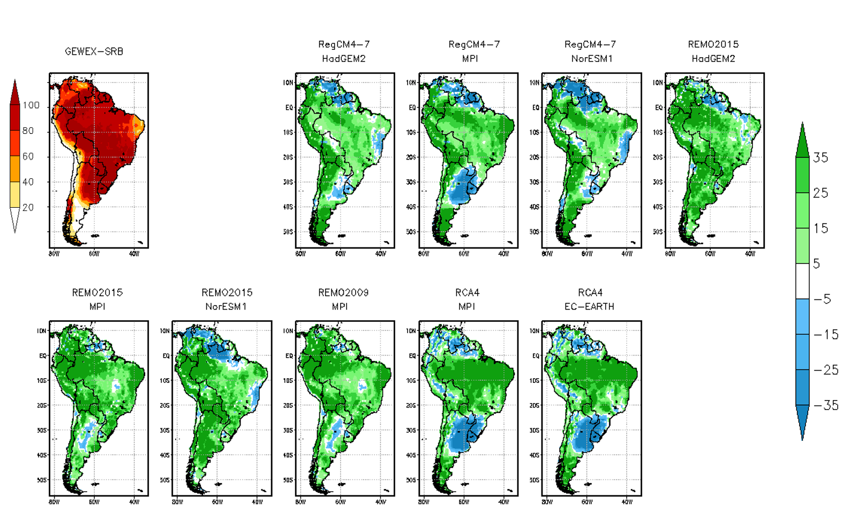
Figure S1 Observed mean latent heat flux (panel 1) and latent heat flux bias for the period 1979-2005 for DJF. Units are W/m².
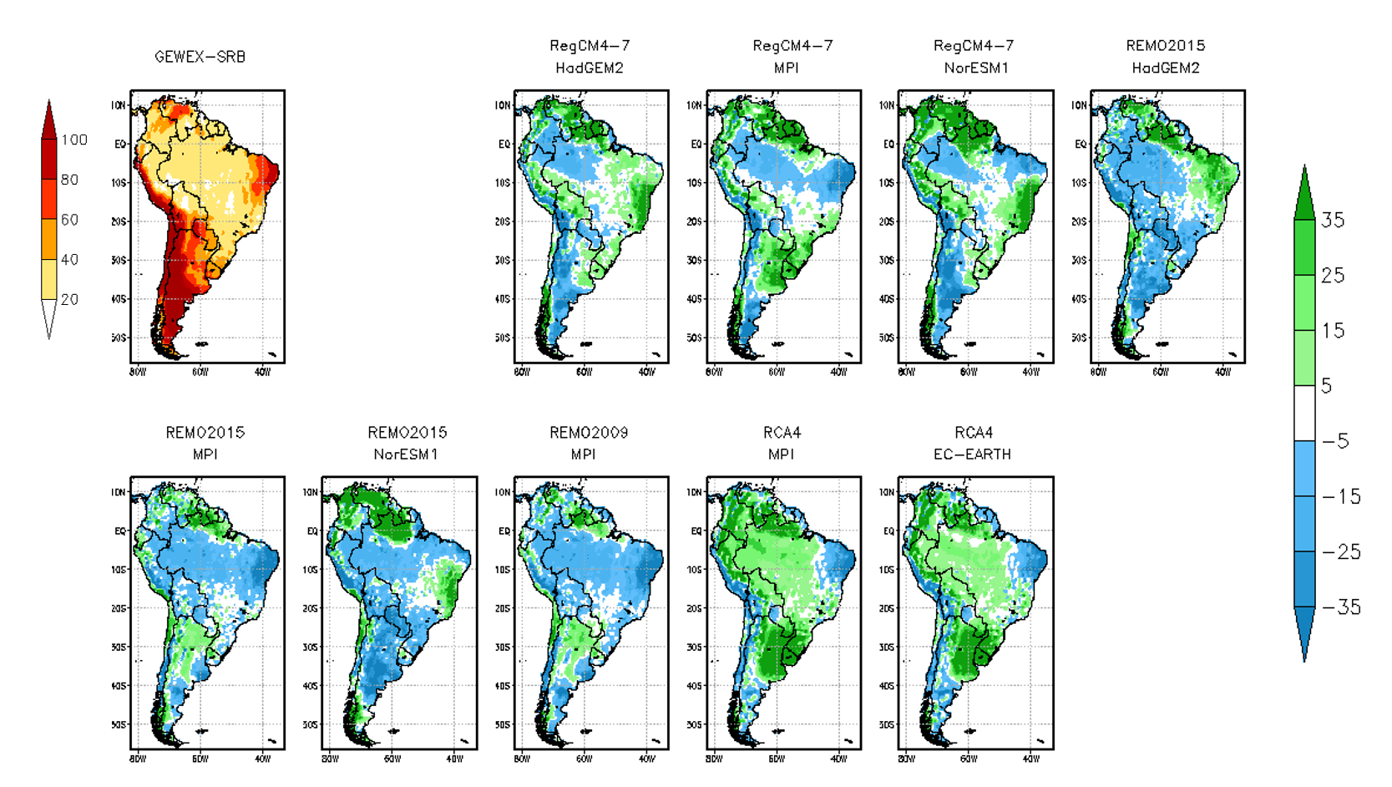
Figure S2 Same as Figure S1 but for sensible heat flux. Units are W/m².

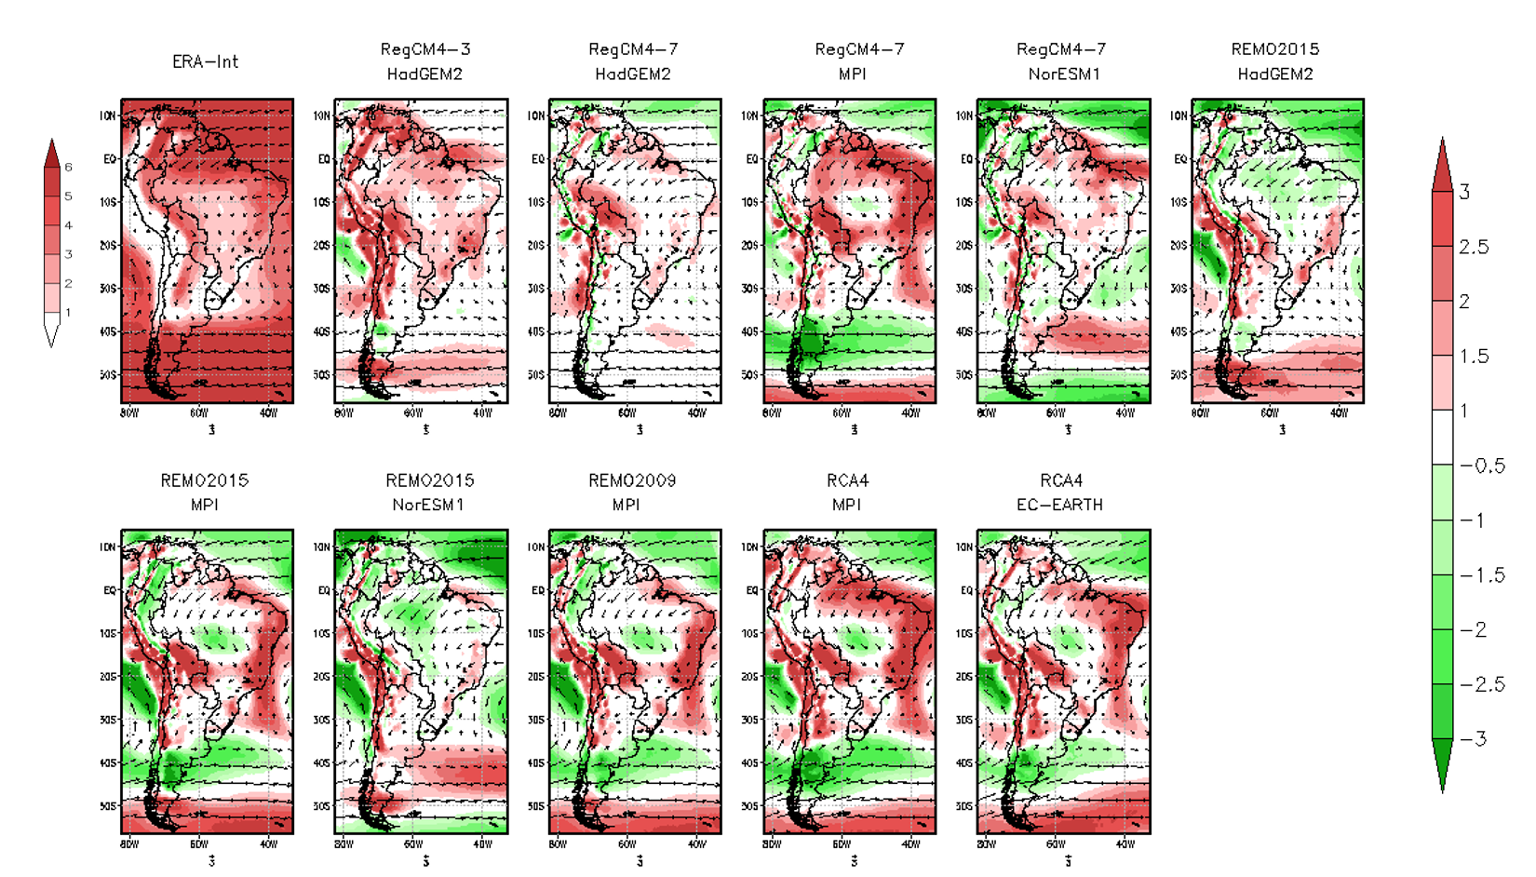
Figure S3 Observed and simulated 850 hPa wind direction (arrows), 850 hPa observed wind intensity (panel 1) and 850 hPa wind intensity bias (shaded) for the period 1979-2005 for DJF. Units are m/seg.
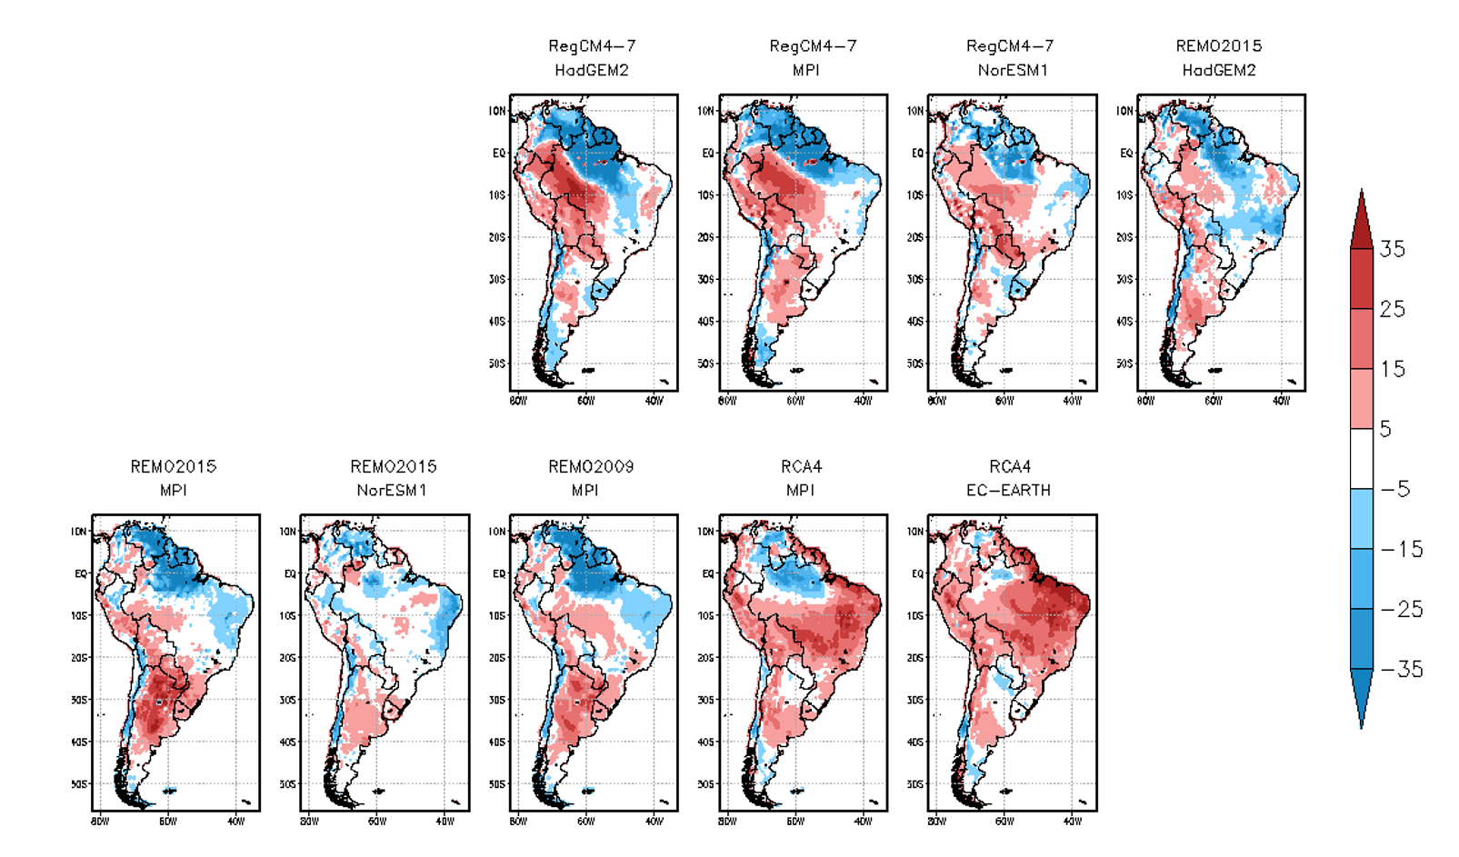
Figure S4 Mean latent heat change between future climate (2071-2100) and present climate (1979-2005) for DJF. Units are W/m².

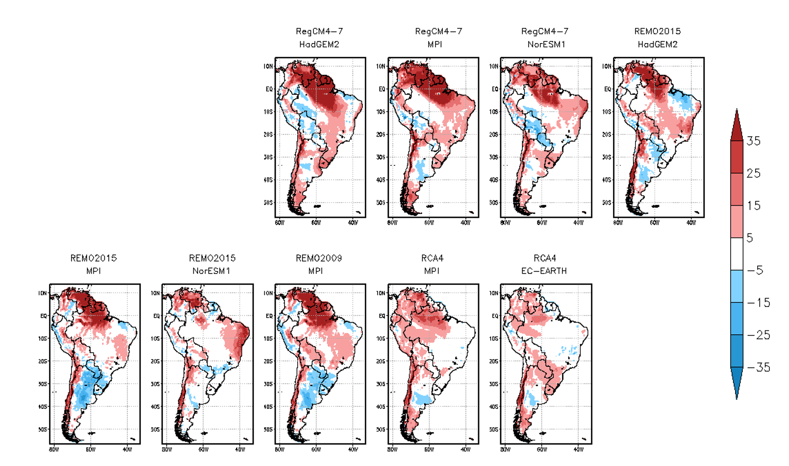
Figure S5 Same as Figure S4, but for sensible heat flux. Units are W/m².

