Characteristics |  | Total |  | Train |  | Validation |  | p-Value
 |  | n | % | n | % | n | % | p-Value
Age (years) | ≤65 | 478 | 93.18 | 244 | 94.94 | 234 | 91.41 | 0.1129
 | >65 | 35 | 6.82 | 13 | 5.06 | 22 | 8.59
Gender | Male | 285 | 55.56 | 147 | 57.20 | 138 | 53.91 | 0.454
 | Female | 228 | 44.44 | 110 | 42.80 | 118 | 46.09
Grade | II | 248 | 48.34 | 130 | 50.58 | 138 | 53.91 | 0.3099
 | III | 265 | 51.66 | 127 | 49.42 | 118 | 46.09
MGMT | Methylated | 424 | 82.65 | 220 | 85.60 | 204 | 79.69 | 0.0772
 | Un-methylated | 89 | 17.35 | 37 | 14.40 | 52 | 20.31
1p19q_codeletion | Non-codel | 345 | 67.25 | 173 | 67.32 | 172 | 67.19 | 0.9755
 | Codel | 168 | 32.75 | 84 | 32.68 | 84 | 32.81
IDH_mutation | Mutant | 417 | 81.29 | 217 | 84.44 | 200 | 78.13 | 0.0325
 | Wildtype | 93 | 18.13 | 37 | 14.40 | 56 | 21.88
 | unknow | 3 | 0.58 | 3 | 1.17 | 0 | 0.00

Table S1 Clinicopathological characteristics of patients with LGG

Table S2 The 47 RNA methylation regulators included in current study.
RNA methylation regulator | RNA methylation types | RNA methylation regulator | RNA methylation types | RNA methylation regulator | RNA methylation types
YTHDC1 | m1A | NSUN7 | m5C | FTO | m6A
YTHDF1 | m1A | DNMT1 | m5C | ALKBH5 | m6A
YTHDF2 | m1A | TRDMT1 | m5C | YTHDC1 | m6A
YTHDF3 | m1A | DNMT3A | m5C | YTHDC2 | m6A
TRMT6 | m1A | DNMT3B | m5C | YTHDF1 | m6A
TRMT61A | m1A | TET2 | m5C | YTHDF2 | m6A
TRMT61B | m1A | YBX1 | m5C | YTHDF3 | m6A
TRMT10C | m1A | ALYREF | m5C | IGF2BP2 | m6A
BMT2 | m1A | METTL3 | m6A | IGF2BP3 | m6A
ALKBH1 | m1A | METTL14 | m6A | HNRNPA2B1 | m6A
ALKBH3 | m1A | METTL16 | m6A | HNRNPC | m6A
RRP8 | m1A | WTAP | m6A | RBMX | m6A
METTL1 | m7G | KIAA1429 | m6A | LRPPRC | m6A
WDR4 | m7G | VIRMA | m6A | FMR1 | m6A
NOP2 | m5C | RBM15 | m6A | IGF2BP1 | m6A
NSUN2 | m5C | RBM15B | m6A | YTHDF1 | m6A
NSUN3 | m5C | ZC3H13 | m6A | YTHDF2 | m6A
NSUN4 | m5C | YTHDC1 | m6A | YTHDF3 | m6A
NSUN5 | m5C

Table S3 The univariate cox regression analytic data of 47 RNA methylation regulators in LGG.
gene | HR | z | pvalue | lower | upper
IGF2BP3 | 2.997 | 9.626 | 0.000 | 2.397 | 3.748
IGF2BP2 | 1.829 | 9.259 | 0.000 | 1.610 | 2.078
NSUN7 | 3.063 | 8.859 | 0.000 | 2.391 | 3.924
METTL1 | 1.576 | 7.058 | 0.000 | 1.389 | 1.788
DNMT3A | 3.799 | 5.332 | 0.000 | 2.326 | 6.206
DNMT1 | 2.241 | 5.126 | 0.000 | 1.646 | 3.051
YTHDF2 | 3.196 | 5.099 | 0.000 | 2.045 | 4.995
RBM15 | 4.001 | 5.058 | 0.000 | 2.338 | 6.847
DNMT3B | 4.451 | 5.008 | 0.000 | 2.481 | 7.984
NSUN4 | 4.609 | 4.751 | 0.000 | 2.454 | 8.658
HNRNPA2B1 | 2.560 | 4.200 | 0.000 | 1.651 | 3.969
TRMT6 | 2.676 | 3.930 | 0.000 | 1.638 | 4.372
WDR4 | 2.446 | 3.907 | 0.000 | 1.562 | 3.832
IGF2BP1 | 119899.434 | 3.855 | 0.000 | 313.986 | 45785136.250
NOP2 | 1.686 | 3.502 | 0.000 | 1.259 | 2.258
YTHDF1 | 2.620 | 3.277 | 0.001 | 1.473 | 4.661
NSUN5 | 1.556 | 3.208 | 0.001 | 1.188 | 2.039
WTAP | 2.036 | 3.007 | 0.003 | 1.281 | 3.237
FTO | 0.532 | -2.986 | 0.003 | 0.352 | 0.805
ALYREF | 1.507 | 2.712 | 0.007 | 1.120 | 2.027
YTHDC1 | 0.462 | -2.538 | 0.011 | 0.254 | 0.839
LRPPRC | 0.604 | -2.272 | 0.023 | 0.391 | 0.933
YTHDC2 | 1.855 | 2.270 | 0.023 | 1.088 | 3.161
ALKBH5 | 2.276 | 2.183 | 0.029 | 1.087 | 4.762
YBX1 | 1.305 | 2.094 | 0.036 | 1.017 | 1.675
NSUN2 | 1.654 | 2.061 | 0.039 | 1.025 | 2.669
METTL3 | 0.719 | -1.593 | 0.111 | 0.479 | 1.079
YTHDF3 | 1.555 | 1.551 | 0.121 | 0.890 | 2.715
ALKBH3 | 0.656 | -1.428 | 0.153 | 0.368 | 1.170
TET2 | 0.737 | -1.426 | 0.154 | 0.484 | 1.121
TRMT10C | 0.659 | -1.367 | 0.172 | 0.362 | 1.198
TRMT61A | 1.341 | 1.307 | 0.191 | 0.864 | 2.082
ALKBH1 | 0.704 | -1.229 | 0.219 | 0.402 | 1.232
TRDMT1 | 1.591 | 1.089 | 0.276 | 0.690 | 3.668
HNRNPC | 0.744 | -1.055 | 0.291 | 0.430 | 1.288
BMT2 | 0.793 | -1.044 | 0.297 | 0.513 | 1.226
TRMT61B | 1.226 | 0.812 | 0.417 | 0.750 | 2.004
RBMX | 0.837 | -0.800 | 0.424 | 0.540 | 1.295
METTL14 | 1.300 | 0.739 | 0.460 | 0.648 | 2.609
RRP8 | 1.246 | 0.736 | 0.462 | 0.693 | 2.241
RBM15B | 1.170 | 0.642 | 0.521 | 0.725 | 1.888
ZC3H13 | 0.916 | -0.416 | 0.677 | 0.607 | 1.383
METTL16 | 0.909 | -0.366 | 0.715 | 0.544 | 1.517
KIAA1429 | 1.084 | 0.305 | 0.760 | 0.647 | 1.816
VIRMA | 1.084 | 0.305 | 0.760 | 0.647 | 1.816
NSUN3 | 1.078 | 0.163 | 0.870 | 0.436 | 2.669
FMR1 | 1.015 | 0.055 | 0.956 | 0.598 | 1.724

Table S4 The coefficients for each alternative splicing included in our prognosis model.
group | coefficients
UGP2|53744|AP | -3.017100976
FAM72A|9575|AP | -1.691855255
SET|87776|AP | -1.387812105
ZNF33A|11309|AT | -0.163187478
FAM72A|9576|AP | 1.26247E-13
ZNF33A|11308|AT | 0.84476434
PCBP2|22052|ES | 1.589980243
SDR39U1|27009|AA | 2.647971227

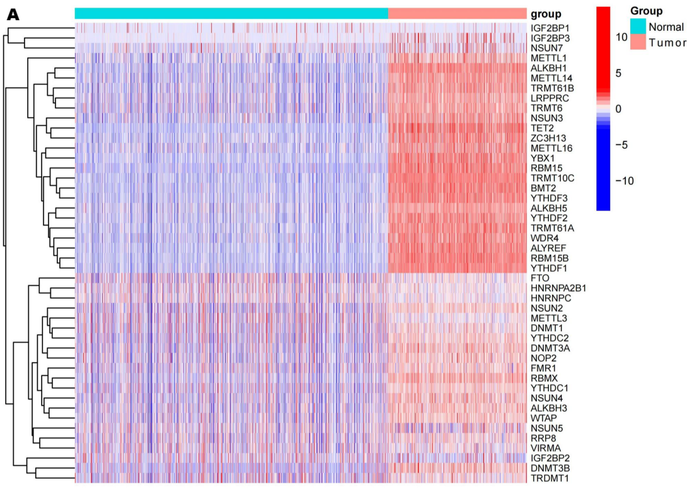
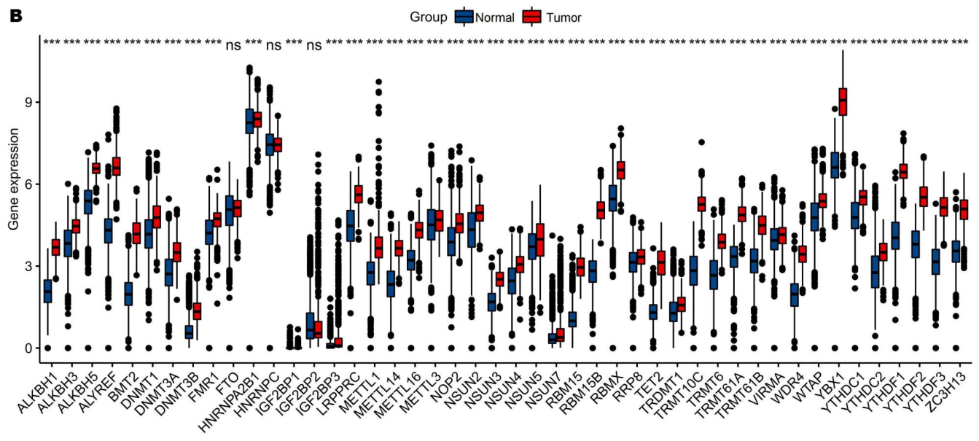

Figure S1 (A, B) Expression of 47 RNA methylation regulators in LGG and normal brain tissues.

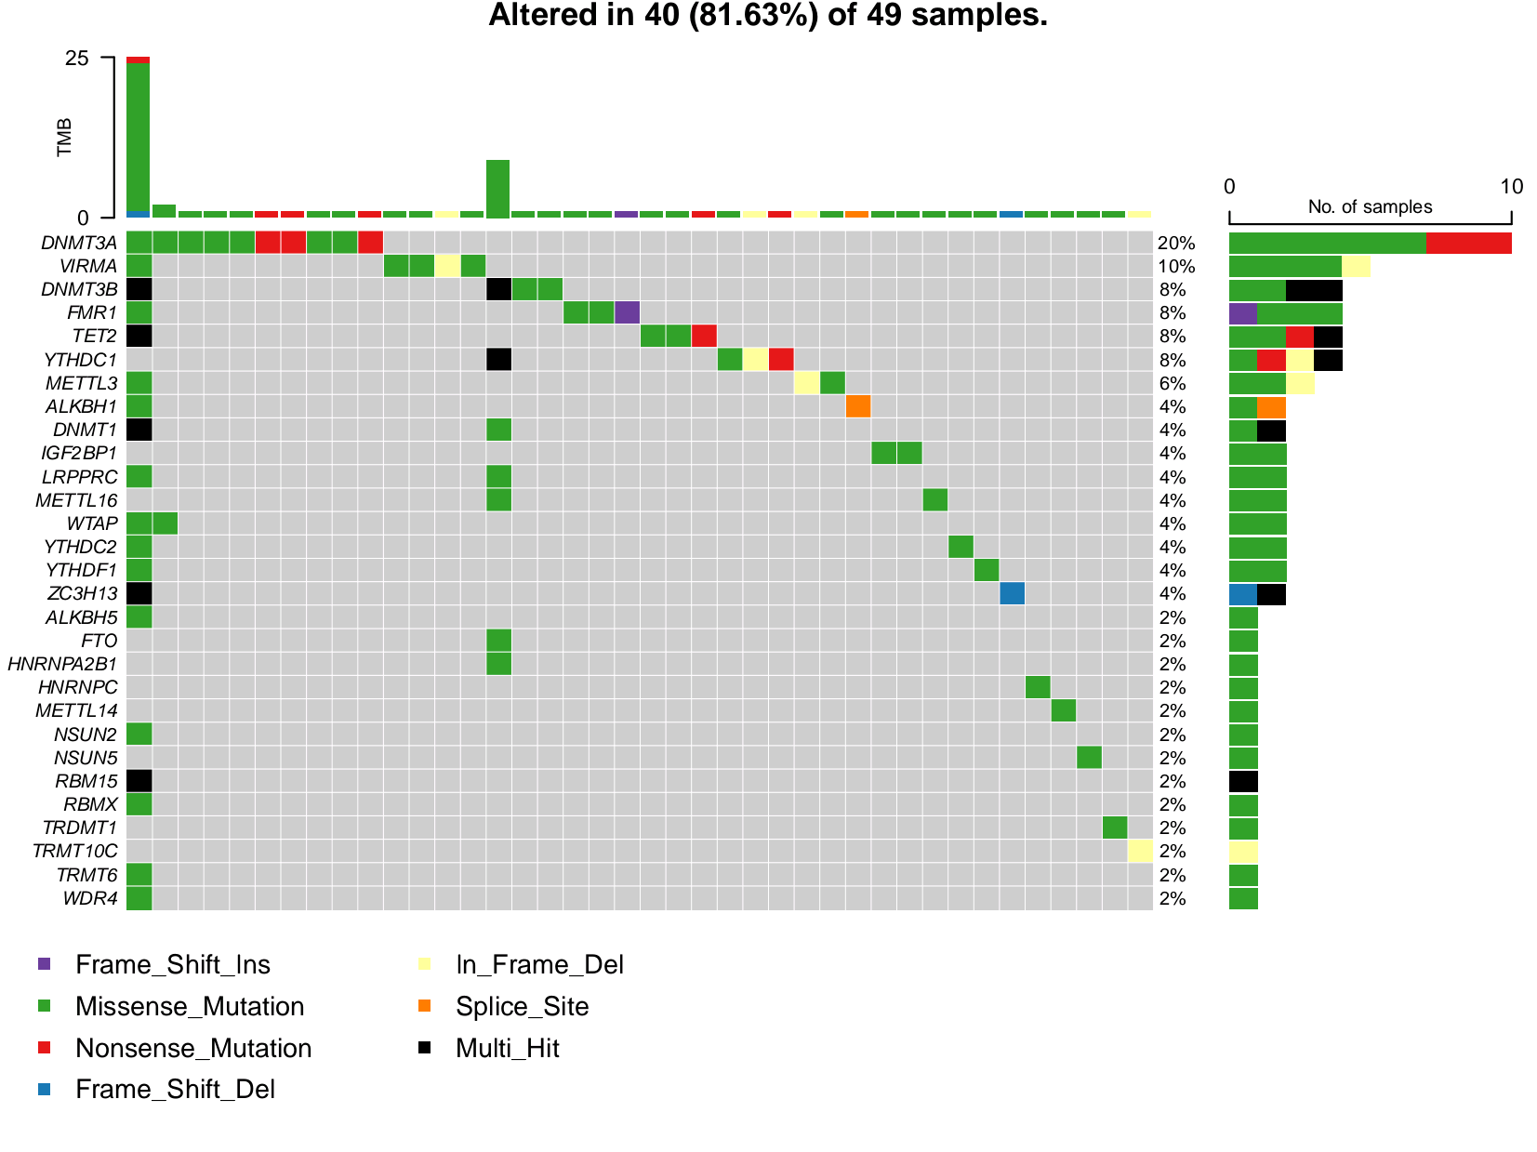

Figure S2 The somatic mutation frequencies of RNA modification regulators in LGG.
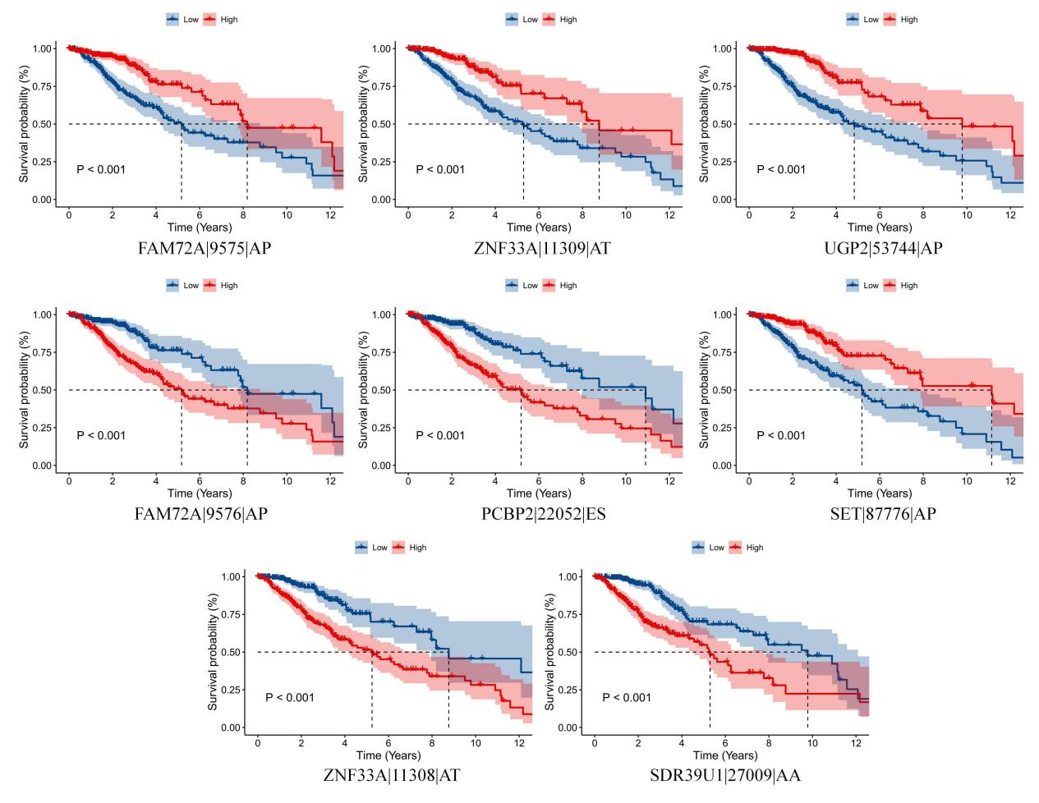
Figure S3 The survival analysis results of 8 Alternative Splicing events included in our prognosis model.

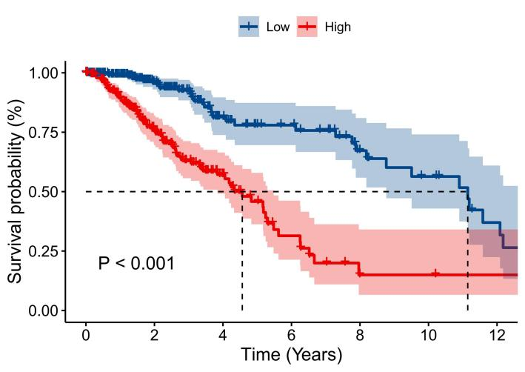
Figure S4 The survival analysis results of tumor mutation burden.

