Table S1 Summary of DEGs involved in glutathione metabolism and photosynthesis under NK and LK
Treatment | Sample | Clean reads | Clean bases | GC Content (%) | Q30 (%) | Mapped Reads (%) | Unique Mapped Reads (%) | Multiple Map Reads (%) | Reads Map to '+' (%) | Reads Map to '-' (%)
NK | Youyan57_1 | 20137910 | 5988220758 | 0.4673 | 0.9425 | 89.82 | 85.26 | 4.56 | 44.14 | 44.28
NK | Youyan57_2 | 21727248 | 6470593282 | 0.4702 | 0.9428 | 88.52 | 83.64 | 4.87 | 43.3 | 43.54
NK | Youyan57_3 | 22233526 | 6630241950 | 0.4736 | 0.9413 | 90.13 | 85.66 | 4.47 | 44.33 | 44.45
NK | Chuanyou36_1 | 20254201 | 6028685102 | 0.4781 | 0.9437 | 89.35 | 84.8 | 4.55 | 43.94 | 44.1
NK | Chuanyou36_2 | 21010810 | 6289946962 | 0.4742 | 0.9422 | 89.03 | 84.89 | 4.14 | 43.88 | 43.98
NK | Chuanyou36_3 | 20044671 | 5951182910 | 0.4749 | 0.9414 | 89.2 | 84.56 | 4.64 | 43.8 | 43.95
LK | Youyan57_1 | 21188822 | 6330995180 | 0.4755 | 0.9381 | 90.13 | 85.89 | 4.24 | 44.39 | 44.47
LK | Youyan57_2 | 20417390 | 6086322934 | 0.4759 | 0.9389 | 90.29 | 85.8 | 4.49 | 44.42 | 44.51
LK | Youyan57_3 | 21440833 | 6415038268 | 0.4638 | 0.9369 | 89.26 | 84.94 | 4.33 | 43.9 | 44.02
LK | Chuanyou36_1 | 21160857 | 6328591690 | 0.4682 | 0.9359 | 88.36 | 84.09 | 4.27 | 43.45 | 43.62
LK | Chuanyou36_2 | 21075091 | 6296414968 | 0.4664 | 0.938 | 87.88 | 83.77 | 4.11 | 43.28 | 43.39
LK | Chuanyou36_3 | 21494970 | 6415245080 | 0.4777 | 0.9405 | 89.39 | 85.02 | 4.37 | 44 | 44.1
Note: NK and LK represent 1 mM and 0.01 mM K₂SO₄ supplied with 7% PEG6000, respectively.

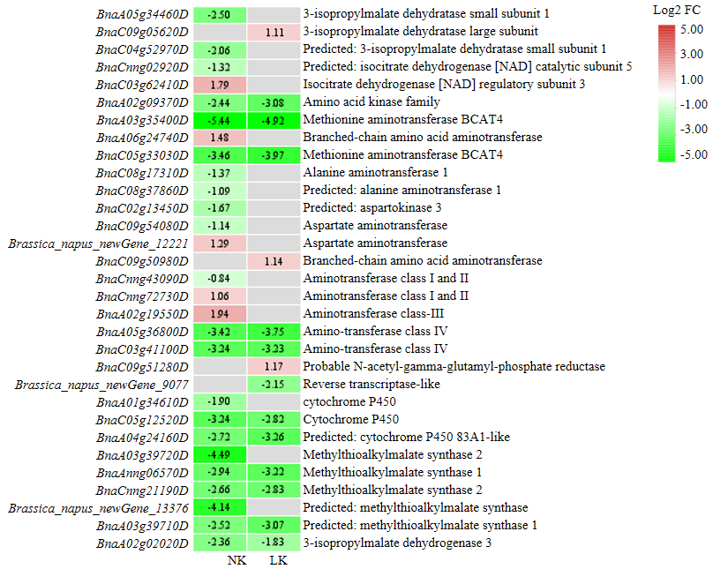
Fig. S1 Heatmap of DEGs involved in 2-oxocarboxylic acid metabolism. Gradient colors indicate log2 fold change of gene expression between Youyan57 and Chuanyou36, and color of grey represents no significant difference between the two cultivars.

