  - Supplement to
I’am hiQ – A Novel Accuracy Index for Imputed Genotypes
Albert Rosenberger¹, Viola Tozzi¹, Rayjean J Hung², David C Christiani³, Neil E Caporaso⁴, Geoffrey Liu^{5,6}, Stig E Bojesen^{7,8,9}, Loic Le Marchand¹⁰, Demetrios Albanes⁴, Melinda C Aldrich¹¹, Adonina Tardon¹², Guillermo Fernández-Tardón¹², Gad Rennert¹³, John K Field¹⁴, Mike Davies¹⁴, Triantafillos Liloglou¹⁴, Lambertus A Kiemeney¹⁵, Philip Lazarus¹⁶, Aage Haugen¹⁷, Shanbeh Zienolddiny¹⁷, Stephen Lam¹⁸, Matthew B Schabath¹⁹, Angeline S Andrew²⁰, Eric J Duell²¹, Susanne M Arnold²², Hans Brunnsstöm²³, Olle Melander^{23,24}, Gary E Goodman²⁵, Chu Chen²⁶, Jennifer A Doherty²⁷, Marion Dawn Teare²⁸, Angela Cox²⁹, Penella J Woll³⁰, Angela Risch³¹, Thomas R Muley^{32,33}, Mikael Johansson³⁴, Paul Brennan³⁵, Maria Teresa Landi⁴, Sanjay S Shete³⁶, Christopher I Amos³⁷, Heike Bickeböller¹ on behalf of the INTEGRAL-ILCCO consortium
- Department of Genetic Epidemiology, University Medical Center, Georg-August-University Göttingen, Göttingen, Germany.
- Lunenfeld-Tanenbaum Research Institute, Sinai Health System, University of Toronto, Toronto, Ontario, Canada.
- Department of Environmental Health, Harvard T.H. Chan School of Public Health and Massachusetts General Hospital/Harvard Medical School, Boston, Massachusetts, USA.
- Division of Cancer Epidemiology and Genetics, National Cancer Institute, US National Institutes of Health, Bethesda, Maryland, USA.
- Medical Oncology and Medical Biophysics, Princess Margaret Cancer Centre, Toronto, Ontario, Canada.
- Medicine and Epidemiology, Dalla Lana School of Public Health, University of Toronto, Toronto, Ontario, Canada.
- Department of Clinical Biochemistry, Herlev and Gentofte Hospital, Copenhagen University Hospital, Copenhagen, Denmark.
- Faculty of Health and Medical Sciences, University of Copenhagen, Copenhagen, Denmark.
- Copenhagen General Population Study, Herlev and Gentofte Hospital, Copenhagen, Denmark.
- Epidemiology Program, University of Hawaii Cancer Center, Honolulu, Hawaii, USA.
- Department of Thoracic Surgery, Division of Epidemiology, Vanderbilt University Medical Center, Nashville, Tennessee, USA.
- University of Oviedo, ISPA and CIBERESP, Faculty of Medicine, Oviedo, Spain.
- Clalit National Cancer Control Center at Carmel Medical Center and Technion Faculty of Medicine, Haifa, Israel.
- Roy Castle Lung Cancer Research Programme, The University of Liverpool, Department of Molecular and Clinical Cancer Medicine, Liverpool, UK.
- Departments of Health Evidence and Urology, Radboud University Medical Center, Nijmegen, the Netherlands.
- Department of Pharmaceutical Sciences, College of Pharmacy, Washington State University, Spokane, Washington, USA.
- National Institute of Occupational Health, Oslo, Norway.
- British Columbia Cancer Agency, Vancouver, British Columbia, Canada.
- Department of Cancer Epidemiology, H. Lee Moffitt Cancer Center and Research Institute, Tampa, Florida, USA.
- Department of Epidemiology, Geisel School of Medicine, Hanover, New Hampshire, USA.
- Unit of Biomarkers and Susceptibility, Oncology Data Analytics Program, Catalan Institute of Oncology (ICO), Bellvitge Biomedical Research Institute (IDIBELL), Barcelona, Spain.
- Markey Cancer Center, University of Kentucky, Lexington, Kentucky, USA.
- Lund University, Department of Clinical Sciences, Laboratory Medicine Region Skåne, Pathology, Lund, Sweden
- Lund University, Department of Clinical Sciences, Skåne University Hospital, Internal Medicine, Malmö, Sweden
- Swedish Medical Group, Seattle, Washington, USA
- Program in Epidemiology, Fred Hutchinson Cancer Research Center, Seattle, Washington, USA.
- Huntsman Cancer Institute, Department of Population Health Sciences, University of Utah, Salt Lake City, Utha, USA
- Institute of Health and Society, Newcastle University, Newcastle upon Tyne, UK
- Department of Oncology and Metabolism, School of Health and Related Research, University of Sheffield, Sheffield, UK.
- Academic Unit of Clinical Oncology, University of Sheffield, Weston Park Hospital, Sheffield, UK
- University of Salzburg and Cancer Cluster Salzburg, Salzburg, Austria.
- Translational Lung Research Center (TLRC) Heidelberg, Member of the German Center for Lung Research (DZL), Heidelberg, Germany.
- Translational Lung Research Center Heidelberg, Heidelberg, Germany.
- Department of Radiation Sciences, Umeå University, Umeå, Sweden.
- International Agency for Research on Cancer, World Health Organization, Lyon, France.
- Department of Biostatistics, Division of Basic Sciences, The University of Texas MD Anderson Cancer Center, Houston, Texas, USA
- Dan L Duncan Comprehensive Cancer Center, Baylor College of Medicine, Houston, Texas, USA.

Corresponding author: Albert Rosenberger, PhD
Universitätsmedizin Göttingen
Institut für Genetische Epidemiologie
Humboldtallee 32, 37073 Göttingen, Germany
Tel: +49 551 3914044;
Fax: +49 551 3914094;
Email: arosenb@gwdg.de
ORCID: 0000-0001-7848-1332

Running title: I’am hiQ

Usability
We investigated the usability of the proposed indices in contrast to info by simulation. Usability was considered in terms of discrimination between sufficient and insufficient imputation, rather than in terms of validity of imputation because validity is a characteristic of the imputation routine (e.g. IMPUTE2).

Method
We defined eight (two times four) scenarios by haplotype-blocks from two common genotyped tagSNPs (alleles T and A) flanking one intermediate marker for imputation (imSNP: alleles G and C). The scenarios differ with regard to the number of haplotypes, minor allele frequencies (MAFs) and linkage disequilibrium (LD), displayed in Table 1, Table 2 and Figure 1. All markers were simulated in Hardy-Weinberg equilibrium. All eight scenarios are kept in linkage equilibrium to each other and are therefore independent. Each of the four pairs of scenarios (scenes) consists of one scenario that is sufficient/better and one scenario that is insufficient/worse for imputing. The difference between the paired scenarios was set to generate visible ROC curves.
We first simulated an artificial reference population of 100,000 individuals for all 3x8=14 genotypes and built a random reference sample of 1000 individuals. We than drew k=100 random samples of size n=500 individuals comprising the genotypes of 2x8=16 tagSNPs each. This genotype data set is then phased using SHAPEIT and missing genotypes were imputed with IMPUTE2. For all 8x100 imputed markers we calculated ${I'am}_{HWE}$, ${I'am}_{chance}$ and $hiQ$, and extracted info from the IMPUTE2 output files. Finally, we plotted comparative receiver operation curves (ROC) for each scene (pair of scenarios) to visualize the ability to discriminate between sufficient and insufficient imputation for all indices. We quantified the ability to discriminate between sufficient and insufficient imputation by the area under the curve (AUC) of the ROCs.
Table 1: Definition of scenes and scenarios
Scenes 1 and 2: common tagSNPs (MAF: 0.45 – 0.50) – common imSNP (MAF: 0.45 – 0.50)
Scene 1: 4 haplotypes (2 predominant haplotypes) – tagSNPs in strong LD to each other;
Scenario 1.1 (worse): weaker LD between both tagSNPs and imSNP*
Scenario 1.2 (better): stronger LD between both tagSNPs and imSNP*
Scene 2: 8 haplotypes (no predominant haplotype) – tagSNPs in weak or no LD to each other;
Scenario 2.1 (worse): weaker LD between of one tagSNP and imSNP*
Scenario 2.2 (better): stronger LD between both tagSNPs and imSNP*
Scenes 3 and 4: common tagSNPs (MAF: 0.45 – 0.50) – less frequent imSNP (MAF: 0.02 – 0.04)
Scene 3: 4 haplotypes (2 predominant haplotypes) – tagSNPs in strong LD to each other;
Scenario 3.1 (worse): weaker LD between both tagSNPs and imSNP*
Scenario 3.2 (better): stronger LD between one tagSNPs and imSNP*
Scene 4: 8 haplotypes (no predominant haplotype) – tagSNPs in no or weak LD to each other;
Scenario 4.1 (worse): weaker LD between of only tagSNP and imSNP*
Scenario 4.2 (better): stronger LD between both tagSNPs and imSNP*
* imSNP: marker for imputation

Table 2: Definition of scenes and scenarios
 | scene 1 |  |  | scene 2 |  | scene 3 |  |  | scene 4
 | 1.1. worse | 1.2. better | 2.1. worse |  | 2.2. better | 3.1. worse | 3.2. better | 4.1. worse |  | 4.2 better
Haplotypes with simulated frequency
ACA | 45.0% | 47.5% | 15.0% | 13.6% | 1.5% | 2.0% | <1% | <1%
ACT | -- | -- | 15.0% | 13.6% | -- | 2.0% | <1% | 2.9%
AGA | 5.0% | 2.5% | 10.0% | 9.1% | 48.5% | 40.8% | 24.5% | <1%
AGT | -- | -- | 10.0% | 13.6% | -- | 6.1% | 24.5% | 38.5%
TCA | -- | -- | 10.0% | 13.6% | -- | -- | <1% | <1%
TCT | 5.0% | 2.5% | 10.0% | 9.1% | 1.5% | -- | <1% | <1%
TGA | -- | -- | 15.0% | 13.6% | -- | 8.2% | 24.5% | 38.5%
TGT | 45.0% | 47.5% | 15.0% | 13.6% | 48.5% | 40.8% | 24.5% | 19.3%
Minor allele frequency in reference panel
tagSNP | 0.495 | 0.483 | 0.496 | 0.493 | 0.498 | 0.498 | 0.466 | 0.428
imSNP* | 0.498 | 0.487 | 0.470 | 0.491 | 0.037 | 0.038 | 0.022 | 0.036
tagSNP | 0.495 | 0.483 | 0.489 | 0.497 | 0.498 | 0.494 | 0.457 | 0.372
* imSNP: marker for imputation

Figure 1: LD-Pattern in reference panel
scene 1 |  | scene 2 |  | scene 3 |  | scene 4
1.1. worse | 1.2. better | 2.1. worse | 2.2. better | 3.1. worse | 3.2. better | 4.1. worse | 4.2 better
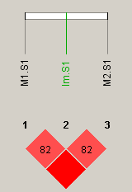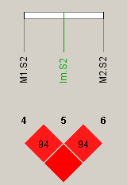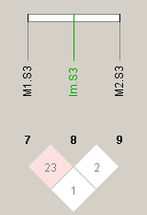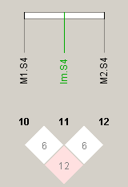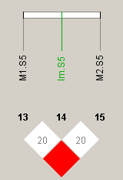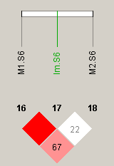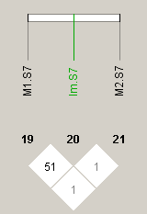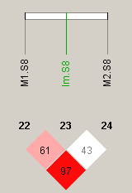
LD is presented as D’

Result
Info correlates in this artificial data set, across all four scenes, strongest to ${I'am}_{HWE}$ (r=0.97), followed by $hiQ$ (r=0.90) and ${I'am}_{chance}$ (r=0.80). This is similar to the real data example presented in the main text. The correlation of ${I'am}_{HWE}$ to $hiQ$ and to ${I'am}_{chance}$ was in-between (0.92 and 0.82 respectively).
In all four scenes the ROC curves of ${I'am}_{HWE}$ and ${I'am}_{chance}$ are identical, hereinafter referred together as $I'am$. Scene >1< can be regarded as proof of general functionality for common SNPs, since all but one indices truly indicate almost perfect discrimination between sufficient and insufficient imputation (all AUC=1, see Figure 2 and Table 3) in the presence of predominant haplotypes. Solely hiQ shows a lower discriminability relative to the other accuracy scores (AUC=0.896). In scene >2< $I'am$ and info are almost equally sufficient (AUC~0.82), while hiQ shows again a lower discriminability relative to the other accuracy scores (AUC=0.748).
In contrast, hiQ shows a uniformly higher level of discriminability than info and I’am in scene >3<, where the MAF of the SNP to be imputed is low but two haplotypes predominate. Info and I'am remain comparable, given the pair of scenarios was set very close. In the more complex scene >4<, info and hiQ seems to be comparable but consistently show a slightly higher degree of distinctness than I'am.
Figure 2: ROC to visualize discrimination between sufficient and insufficient imputation
scene 1 | scene 2 | scene 3 | scene 4
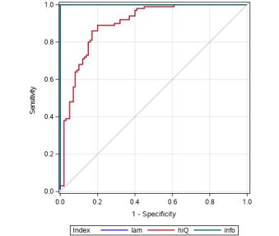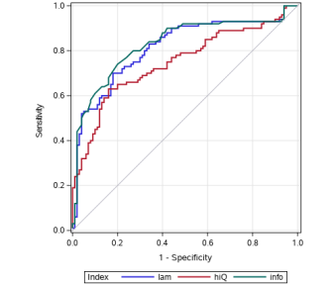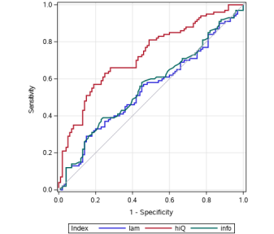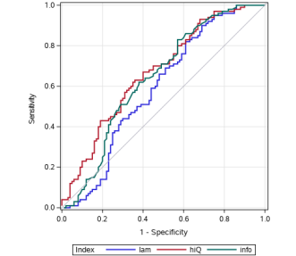

Table 3: AUC-ROC to quantify discrimination between sufficient and insufficient imputation
Scene | Score | AUC-ROC | Standard  Error | 95% Wald  Confidence Limits
1 | $${I'am}_{HWE}$$ | 1 | -- | -- | --
 | $${I'am}_{chance}$$ | 1 | -- | -- | --
 | $$hiQ$$ | 0.8960 | 0.0226 | 0.8516 | 0.9404
 | info | 1 | -- | -- | --
2 | $${I'am}_{HWE}$$ | 0.8139 | 0.0313 | 0.7526 | 0.8752
 | $${I'am}_{chance}$$ | 0.8139 | 0.0313 | 0.7526 | 0.8752
 | $$hiQ$$ | 0.7478 | 0.0351 | 0.6789 | 0.8167
 | info | 0.8293 | 0.0304 | 0.7698 | 0.8888
3 | $${I'am}_{HWE}$$ | 0.5418 | 0.0411 | 0.4613 | 0.6223
 | $${I'am}_{chance}$$ | 0.5418 | 0.0411 | 0.4613 | 0.6223
 | $$hiQ$$ | 0.7250 | 0.0357 | 0.6549 | 0.7951
 | info | 0.5565 | 0.0409 | 0.4763 | 0.6367
4 | $${I'am}_{HWE}$$ | 0.5901 | 0.0410 | 0.5097 | 0.6705
 | $${I'am}_{chance}$$ | 0.5901 | 0.0410 | 0.5097 | 0.6705
 | $$hiQ$$ | 0.6699 | 0.0380 | 0.5954 | 0.7444
 | info | 0.6397 | 0.0397 | 0.5619 | 0.7174
Bold numbers display the largest AUC-ROC (area under the receiver operating characteristic curve) within a scene.

Conclusion
Info and I’am appear to be comparable in terms of the distinction between sufficient and insufficient imputation for common SNPs. However, hiQ seems to be superior if the minor allele frequency (MAF) of the imputed marker is low.
Nevertheless, please note: Simulation studies are computer experiments with data generated from known probability distributions by means of pseudo-random samples. The performance of statistical methods is only examined in specific predefined scenarios. Therefore, the results of simulations are limited to the scenarios selected for data generation. Simulations give different results when based on different random numbers generating processes, and conclusions from them are therefore always limited and subject to uncertainty (1).

Reference
1. Morris TP, White IR, Crowther MJ. Using simulation studies to evaluate statistical methods. Statistics in Medicine. 2019;38(11):2074–102.

SAS-MACRO
The following macro for SAS® 9.4 calculates the measures I’am_{HWE}, I’am_{chance} and hiQ for autosomal markers based on the dosage-file as output of IMPUTE2. To run the macro one needs to specify:
dose_path: the physical path of the dosage-file
dose_file: the physical name of the dosage-file
out_file: the physical name of the output-file, that is stored in the dose_path

%macro IamHIQ(dose_path,dose_file,out_file);
****** determine number of individuals in dosage file *********;
****************************************************************; option;
proc printto log=sinnlos; run;
data _null_;
length lines 8 cmd $300;
cmd = catx(' ','head -n 1 ',"&dose_path.&dose_file..imputed",' | wc -w');
infile cmd pipe filevar=cmd truncover;
input lines @;
if _N_=1 then do;
anz_iid=(lines-5)/3;
call symputx('anz_iid',anz_iid);
call symputx('firstvar',6);
call symputx('lastvar',5+3*anz_iid);
end;
run;
proc printto log=log; run;
%put anz_iid: &anz_iid. &firstvar. - &lastvar.;

****** read dosage file --> calculate Iam hiQ ***********;
****** export as xx.IamHiQ and as SAS-file ************;
***************************************************************; option;
libname dosage "&dose_path.";
options;
data dosage.&out_file._IamHiQ(keep=snp_id rs_id position a0 a1 MAF Iam_chance Iam_HWE hiQ);
%let _EFIERR_ = 0; /* set the ERROR detection macro variable */
infile "&dose_path.&dose_file..imputed"
delimiter = ' ' MISSOVER DSD lrecl=32767 firstobs=1 ;/*obs=100*/;
informat snp_id $3. rs_id $45. position best32. a0 a1 $1. MAF Q Q_HWE Hsum Iam_chance Iam_HWE hiQ 8.6 VAR&firstvar.-VAR&lastvar. best32. ;
format snp_id $3. rs_id $5. position best. a0 a1 $1. VAR&firstvar.-VAR&lastvar. 6.4 ;
input snp_id $ rs_id $ position a0 $ a1 $ VAR&firstvar.-VAR&lastvar. ;

array dd {&anz_iid.,3} VAR&firstvar.-VAR&lastvar. ;
array bd {3] bd1-bd3 (0 0 0);
array ad {3] ad1-ad3 (0 0 0);
*array A_count [3] A_count1-A_count3;
MAF=0;
do i=1 to &anz_iid.;
MAF=sum(MAF,0*dd[i,1],1*dd[i,2],2*dd[i,3]);
end;
MAF=MAF/2/&anz_iid.;
If MAF=0 then MAF=0.5/2/&anz_iid.; *** correction for monomorphic markers ****;
If MAF=1 then MAF=1-0.5/2/&anz_iid.; *** correction for monomorphic markers ****;

Q=0;
do i=1 to &anz_iid.;
*** calculate best guess dosage ***;
b1=0; b2=0; b3=0;
if dd[i,1]=max(dd[i,1],dd[i,2],dd[i,3]) then b1=1;
if dd[i,2]=max(dd[i,1],dd[i,2],dd[i,3]) then b2=1;
if dd[i,3]=max(dd[i,1],dd[i,2],dd[i,3]) then b3=1;
b_sum=sum(b1,b2,b3);
b1=b1/b_sum;
b2=b2/b_sum;
b3=b3/b_sum;

*** sum of best guess dosage ***;
bd[1]=sum(bd[1],b1);
bd[2]=sum(bd[2],b2);
bd[3]=sum(bd[3],b3);
*** sum of dosage ***;
ad[1]=sum(ad[1],dd[i,1]);
ad[2]=sum(ad[2],dd[i,2]);
ad[3]=sum(ad[3],dd[i,3]);

*** calculate Q ***;
Q=sum(Q,dd[i,1]*(1-dd[i,1]),
dd[i,2]*(1-dd[i,2]),
dd[i,3]*(1-dd[i,3]));
end;
**** calculate means from sums ****;
Q=Q/&anz_iid.;
bdsum=sum(of bd[*]); *** correction of round-off errors / denominator instead of &anz_iid. ****;
bd[1]=bd[1]/bdsum;
bd[2]=bd[2]/bdsum;
bd[3]=bd[3]/bdsum;

adsum=sum(of ad[*]); *** correction of round-off errors / denominator instead of &anz_iid. ****;
ad[1]=ad[1]/adsum;
ad[2]=ad[2]/adsum;
ad[3]=ad[3]/adsum;

Q_HWE=2*MAF*(1-MAF)*(3*MAF**2-3*MAF+2);
Iam_chance=1-Q/(2/3);
if Q_HWE>0 then Iam_HWE=1-Q/Q_HWE;

Hsum=min(1,sum(sqrt(ad[1]*bd[1]),sqrt(ad[2]*bd[2]),sqrt(ad[3]*bd[3])));
hiQ=1-sqrt(1-Hsum);

***** Export as txt-file*****;
file "&dose_path.&dose_file..IamhiQ";
if _N_=1 then put 'snp_id rs_id position a0 a1 MAF Iam_chance Iam_HWE hiQ';
put snp_id rs_id position a0 a1 MAF Iam_chance Iam_HWE hiQ;
run;

****** print calculate Iam hiQ *************;
****************************************************************; option;
proc print data=dosage.&out_file._IamHiQ noobs;
var snp_id rs_id position a0 a1 MAF Iam_chance Iam_HWE hiQ
run;
%mend IamHIQ;

Comparison of I’am and hiQ
Supplementary Table I I’am_{HWE} contrasted with hiQ
 | I’am_{HWE}
 | negative | 0.0-<0.1 | 0.1-<0.2 | 0.2-<0.25 | 0.25-<0.3 | 0.3-<0.4 | 0.4-<0.5 | 0.5-<0.6 | 0.6-<0.7 | 0.7-<0.75 | 0.75-<0.8 | 0.8-<0.85 | 0.85-<0.9 | 0.9-<0.95 | 0.95-<1 | 1* | All
hiQ | N  cum-%  %-info | N  cum-%  %-info | N  cum-%  %-info | N  cum-%  %-info | N  cum-%  %-info | N  cum-%  %-info | N  cum-%  %-info | N  cum-%  %-info | N  cum-%  %-info | N  cum-%  %-info | N  cum-%  %-info | N  cum-%  %-info | N  cum-%  %-info | N  cum-%  %-info | N  cum-%  %-info | N  cum-%  %-info | N
0.4-<0.5 |  | 784  <0.1%  0% |  |  |  |  |  |  |  |  |  |  |  |  |  |  | 784
0.5-<0.6 |  | 700  <0.1%  0% |  |  |  |  |  |  |  |  |  |  |  |  |  |  | 700
0.6-<0.7 |  | 1,000  <0.1%  0% | 19  <0.1%  0% |  |  |  |  |  |  |  |  |  |  |  |  |  | 1,019
0.7-<0.75 |  | 801  <0.1%  0% | 54  <0.1%  0% |  |  |  |  |  |  |  |  |  |  |  |  |  | 855
0.75-<0.8 |  | 861  <0.1%  0% | 94  <0.1%  0% | 3  <0.1%  0% |  |  |  |  |  |  |  |  |  |  |  |  | 958
0.8-<0.85 | 272  <0.1%  0% | 643  <0.1%  0% | 417  0.1%  0% | 45  0.1%  0% | 18  0.1%  0% | 4  0.1%  0% |  |  |  |  |  |  |  |  |  |  | 1,399
0.85-<0.9 | 903  <0.1%  0% | 866  0.1%  0% | 406  0.1%  0% | 653  0.1%  0% | 956  0.1%  0% | 994  0.1%  0% | 49  0.1%  0% | 2  0.1%  0% |  |  |  |  |  |  |  |  | 4,829
0.9-<0.95 | 1,972  <0.1%  0% | 2,118  0.1%  0% | 627  0.1%  0% | 300  0.1%  0% | 1,644  0.2%  0% | 10,332  0.3%  0% | 12,018  043%  0% | 3,171  0.4%  0% | 273  0.4%  0% | 16  0.4%  <0.1% | 7  0.4%  <0.1% |  |  |  |  |  | 32,478
0.95-<1.0 | 1,761  <0.1%  0% | 13,779  0.3%  0% | 33,698  0.6%  0% | 48,171  1.1%  0% | 92,235  2.0%  0% | 403,504  6.0%  0% | 679,310  12.6%  <0.1% | 727,860  19.6%  <0.1% | 704,259  26.3%  <0.1% | 334,333  29.6%  0.2% | 303,985  32.5%  1.3% | 249,988  34.9%  5.0% | 194,721  36,7%  10.0% | 191,258  38.6%  17.2% | 349,192  41.9%  43.7% | 130,112  43.2%  45.7% | 4,458,166
1.0* |  | 41  0.3%  0% | 2,681  0.6%  0% | 5,125  1.1%  0% | 10,575  2.2%  0% | 71,753  6.8%  0% | 209,348  15.5%  <0.1% | 304,154  25.4%  <0.1% | 328,620  35.3%  <0.1% | 189,950  40.3%  0.2% | 238,318  45.5%  1.3% | 323,744  51.0%  5.3% | 452,150  57.2%  10.7% | 724,635  66.0%  18.7% | 2,143,291  89.9%  48.6% | 922,026  100%  50.9% | 5,926,411
All | 4,908 | 21,593 | 37,996 | 54,297 | 105,428 | 486,587 | 900,725 | 1,035,187 | 1,033,152 | 524,299 | 542,310 | 573,732 | 646,871 | 915,893 | 2,492,483 | 1,052,138 | 10,427,599
cum-%: : cumulated proportion of all markers belonging to cells to the left und above the indicating cell;
%-info: proportion of marker belonging to the indicated cell with info≥0.8.; * >0.995

Markers and regions of low accuracy

Supplementary Table II I’am sections
 |  | cold |  |  | hot |  |  | very hot
chromosome | N  sections | N  sections | N markers |  | N  sections | N markers |  | N  sections | N markers
chromosome | N  sections | N  sections | min | max | N  sections | min | max | N  sections | min | max
All | 9,201 | 4,427 | 1 | 259,790 | 4,603 | 1 | 3,218 | 171 | 1 | 6,030
1 | 775 | 381 | 1 | 259,790 | 388 | 1 | 2,313 | 6 | 1 | 3,772
2 | 470 | 233 | 1 | 157,307 | 235 | 1 | 966 | 2 | 3 | 3,545
3 | 180 | 90 | 1 | 146,181 | 90 | 1 | 136
4 | 374 | 187 | 1 | 128,016 | 187 | 1 | 1,167
5 | 183 | 91 | 1 | 144,454 | 92 | 1 | 243
6 | 164 | 82 | 1 | 178,987 | 82 | 1 | 164
7 | 720 | 360 | 1 | 104,708 | 360 | 1 | 126
8 | 398 | 199 | 1 | 83,900 | 199 | 1 | 834
9 | 437 | 142 | 1 | 124,506 | 219 | 1 | 148 | 76 | 1 | 6,030
10 | 294 | 147 | 1 | 182,491 | 147 | 1 | 890
11 | 1,283 | 632 | 1 | 162,101 | 641 | 1 | 241 | 10 | 1 | 4
12 | 149 | 74 | 1 | 151,950 | 75 | 1 | 238
13 | 214 | 107 | 1 | 158,509 | 107 | 1 | 121
14 | 298 | 149 | 1 | 174,951 | 149 | 1 | 3,218
15 | 244 | 118 | 1 | 79,309 | 122 | 1 | 2,014 | 4 | 2 | 2,642
16 | 1,343 | 598 | 1 | 61,727 | 672 | 1 | 252 | 73 | 1 | 75
17 | 357 | 178 | 1 | 63,321 | 179 | 1 | 245
18 | 275 | 138 | 1 | 137,118 | 137 | 1 | 59
19 | 447 | 223 | 1 | 32,005 | 224 | 1 | 175
20 | 78 | 39 | 1 | 41,291 | 39 | 1 | 34
21 | 234 | 117 | 1 | 48,667 | 117 | 1 | 896
22 | 284 | 142 | 1 | 70,118 | 142 | 1 | 1,674
I’am_{HWE}: cold I’am_{HWE}(ewma)> 0.47 hot I’am_{HWE}(ewma)<= 0.47 very hot I’am_{HWE}(ewma)<= 0.23

Supplementary Table III hiQ sections
 |  | cold |  |  | hot |  |  | very hot
chromosome | N  sections | N  sections | N markers |  | N  sections | N markers |  | N  sections | N markers
chromosome | N  sections | N  sections | min | max | N  sections | min | max | N  sections | min | max
All | 5,801 | 2,902 | 1 | 493,993 | 2,899 | 1 | 6,181
1 | 815 | 407 | 1 | 215,969 | 408 | 1 | 4,376
2 | 364 | 182 | 1 | 354,867 | 182 | 1 | 3,557
3 | 111 | 56 | 1 | 416,639 | 55 | 1 | 105
4 | 324 | 162 | 1 | 493,993 | 162 | 1 | 390
5 | 96 | 48 | 1 | 289,128 | 48 | 1 | 50
6 | 174 | 87 | 1 | 178,990 | 87 | 1 | 75
7 | 273 | 137 | 1 | 143,501 | 136 | 1 | 76
8 | 256 | 128 | 1 | 268,957 | 128 | 1 | 212
9 | 113 | 56 | 1 | 251,107 | 57 | 1 | 6,181
10 | 418 | 209 | 1 | 252,751 | 209 | 1 | 96
11 | 397 | 199 | 1 | 304,344 | 198 | 1 | 189
12 | 116 | 58 | 1 | 316,860 | 58 | 1 | 74
13 | 170 | 85 | 1 | 315,765 | 85 | 1 | 38
14 | 484 | 242 | 1 | 260,266 | 242 | 1 | 353
15 | 241 | 120 | 1 | 129,380 | 121 | 1 | 2,644
16 | 326 | 163 | 1 | 84,886 | 163 | 1 | 165
17 | 156 | 78 | 1 | 82,837 | 78 | 1 | 99
18 | 51 | 26 | 1 | 211,630 | 25 | 1 | 27
19 | 219 | 109 | 1 | 78,534 | 110 | 1 | 31
20 | 51 | 26 | 1 | 80,031 | 25 | 1 | 11
21 | 293 | 147 | 1 | 126,529 | 146 | 1 | 153
22 | 353 | 177 | 1 | 87,799 | 176 | 1 | 455
hiQ: cold hiQ (ewma)> 0.97 hot hiQ (ewma)<= 0.97 very hot hiQ (ewma)<= 0.48

Supplementary Table IV Size of Sections with elevated I’am or hiQ
N markers | I’am sections |  |  |  |  |  | hiQ sections
N markers | cold |  | hot |  | very hot |  | cold |  | hot
N markers | N | % | N | % | N | % | N | % | N | %
1 | 1,184 | 26.7% | 1,626 | 35.3% | 47 | 27.4% | 799 | 27.5% | 968 | 33.3%
2 | 449 | 10.1% | 670 | 14.5% | 21 | 12.2%
3-5 | 715 | 16.1% | 878 | 19.0% | 45 | 26.3% | 367 | 12.6% | 395 | 13.6%
6-20 | 808 | 18.2% | 940 | 20.4% | 23 | 13.4% | 480 | 16.5% | 553 | 19.0%
>21 | 1,271 | 28.7% | 489 | 10.6% | 35 | 20.4% | 556 | 19.1% | 634 | 21.8%

Supplementary Table V Missingness of accuracy measures per chromosome
chromosome |  | I’am_{HWE} | % | hiQ | % | info | % | certainty | %
all | n | 10,427,599 | -- | 10,427,599 | -- | 8,556,447 |  | 10,367,376
 | missing | 0 |  | 0 |  | 1,871,152 | 17.90% | 60,223 | 0.60%
1 | n | 827,075 |  | 827,075 |  | 673,664 |  | 886,729
 | missing | 0 | -- | 0 | -- | 153,431 | 18.60% | 4,714 | 0.60%
2 | n | 886,729 |  | 886,729 |  | 725,693 |  | 881,752
 | missing | 0 | -- | 0 | -- | 161,036 | 18.20% | 4,977 | 0.60%
3 | n | 741,115 |  | 741,115 |  | 613,539 |  | 736,768
 | missing | 0 | -- | 0 | -- | 127,576 | 17.20% | 4,347 | 0.60%
4 | n | 744,039 |  | 744,039 |  | 615,826 |  | 739,435
 | missing | 0 | -- | 0 | -- | 128,213 | 17.20% | 4,604 | 0.60%
5 | n | 662,493 |  | 662,493 |  | 546,907 |  | 658,654
 | missing | 0 | -- | 0 | -- | 115,586 | 17.40% | 3,839 | 0.60%
6 | n | 680,135 |  | 680,135 |  | 562,867 |  | 675,715
 | missing | 0 | -- | 0 | -- | 117,268 | 17.20% | 4,420 | 0.60%
7 | n | 608,856 |  | 608,856 |  | 498,045 |  | 605,374
 | missing | 0 | -- | 0 | -- | 110,811 | 18.20% | 3,482 | 0.60%
8 | n | 572,378 |  | 572,378 |  | 471,242 |  | 569,105
 | missing | 0 | -- | 0 | -- | 101,136 | 17.70% | 3,273 | 0.60%
9 | n | 458,056 |  | 458,056 |  | 373,531 |  | 455,436
 | missing | 0 | -- | 0 | -- | 84,525 | 18.50% | 2,620 | 0.60%
10 | n | 524,418 |  | 524,418 |  | 431,775 |  | 521,238
 | missing | 0 | -- | 0 | -- | 92,643 | 17.70% | 3,180 | 0.60%
11 | n | 512,601 |  | 512,601 |  | 422,525 |  | 509,537
 | missing | 0 | -- | 0 | -- | 90,076 | 17.60% | 3,064 | 0.60%
12 | n | 498,183 | -- | 498,183 | -- | 409,701 | 17.80% | 495,064 | 0.60%
 | missing | 0 |  | 0 |  | 88,482 |  | 3,119
13 | n | 373,913 |  | 373,913 |  | 311,154 |  | 371,663
 | missing | 0 | -- | 0 | -- | 62,759 | 16.80% | 2,250 | 0.60%
14 | n | 342,312 |  | 342,312 |  | 282,327 |  | 340,241
 | missing | 0 | -- | 0 | -- | 59,985 | 17.50% | 2,071 | 0.60%
15 | n | 307,558 |  | 307,558 |  | 251,973 |  | 307,558
 | missing | 0 | -- | 0 | -- | 55,585 | 18.10% | 0 | --
16 | n | 338,758 |  | 338,758 |  | 270,652 |  | 336,666
 | missing | 0 | -- | 0 | -- | 68,106 | 20.10% | 2,092 | 0.60%
17 | n | 294,636 |  | 294,636 |  | 235,253 |  | 292,927
 | missing | 0 | -- | 0 | -- | 59,383 | 20.20% | 1,709 | 0.60%
18 | n | 292,314 |  | 292,314 |  | 241,881 |  | 290,595
 | missing | 0 | -- | 0 | -- | 50,433 | 17.30% | 1,719 | 0.60%
19 | n | 244,372 |  | 244,372 |  | 194,432 |  | 242,809
 | missing | 0 | -- | 0 | -- | 49,940 | 20.40% | 1,563 | 0.60%
20 | n | 230,100 |  | 230,100 |  | 189,574 |  | 228,803
 | missing | 0 | -- | 0 | -- | 40,526 | 17.60% | 1,297 | 0.60%
21 | n | 140,984 |  | 140,984 |  | 116,352 |  | 140,056
 | missing | 0 | -- | 0 | -- | 24,632 | 17.50% | 928 | 0.70%
22 | n | 146,574 |  | 146,574 |  | 117,554 |  | 145,646
 | missing | 0 | -- | 0 | -- | 29,020 | 19.80% | 928 | 0.60%

Supplementary Figure 1 Manhattan-like-plot: I’am hiQ by chromosomes
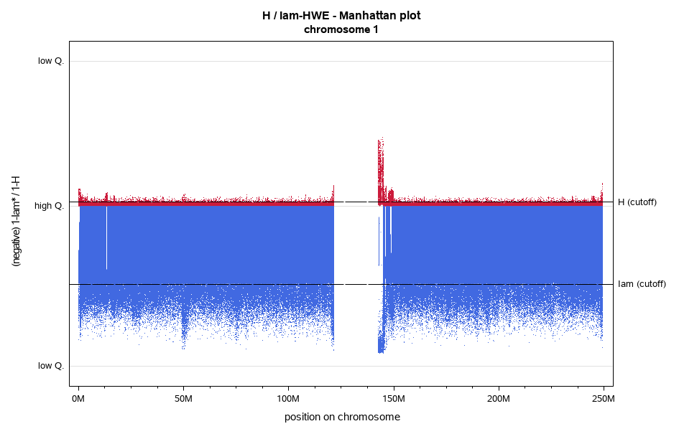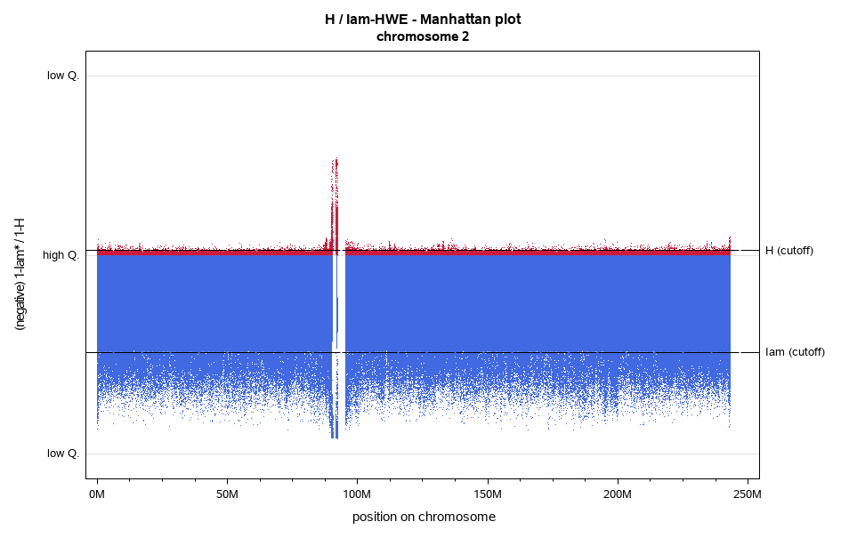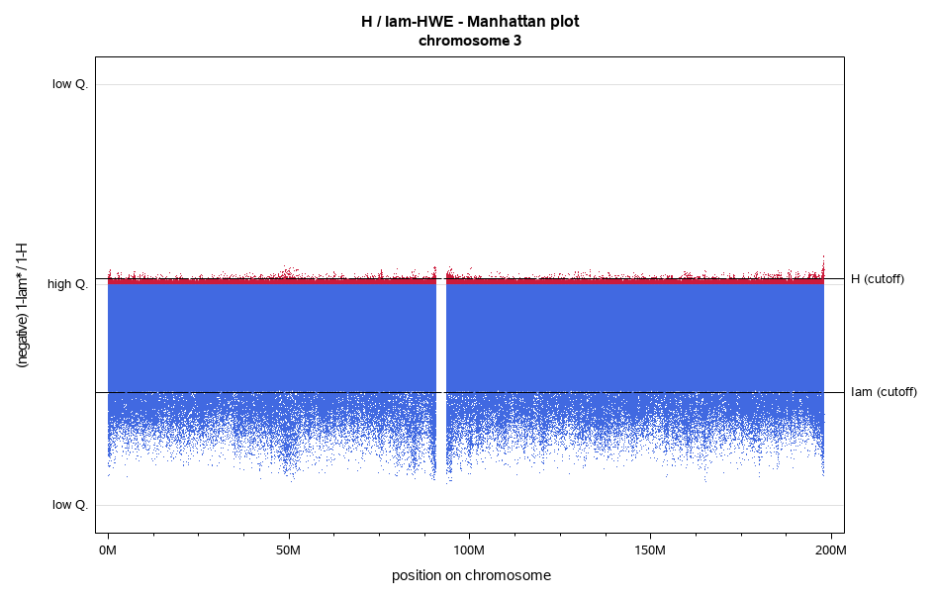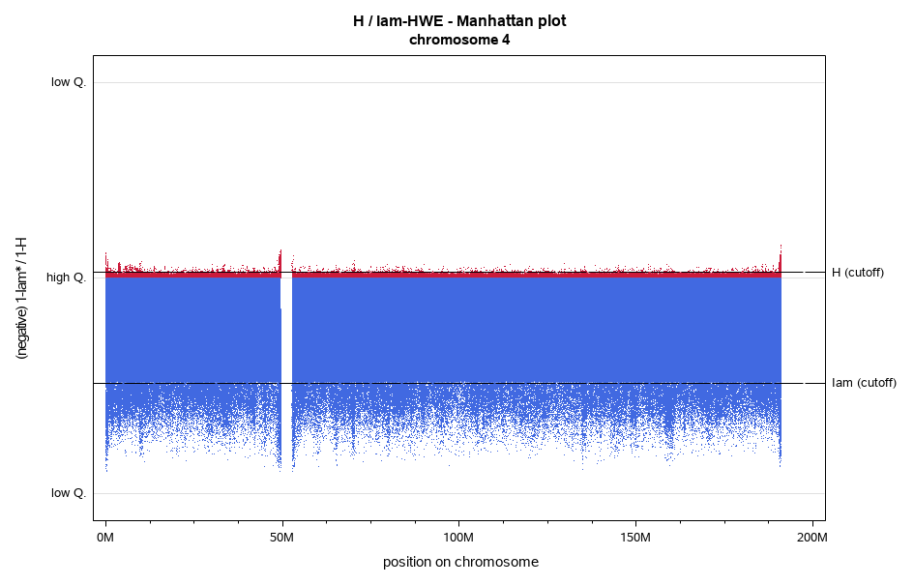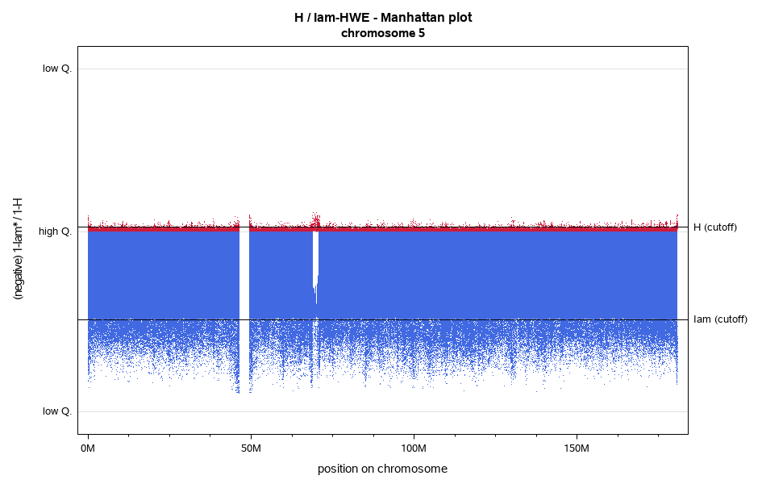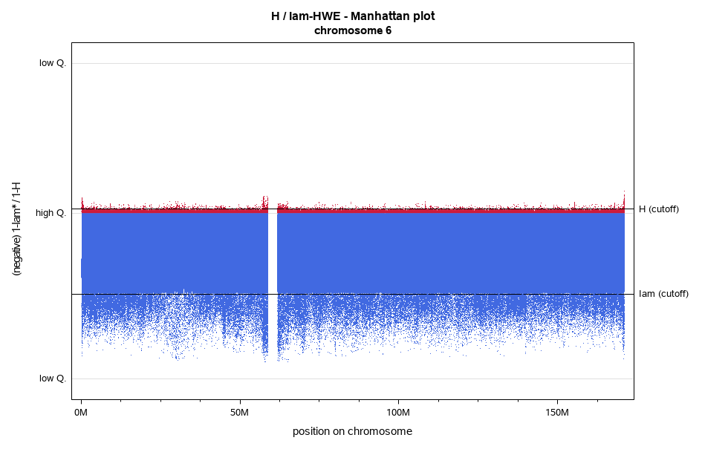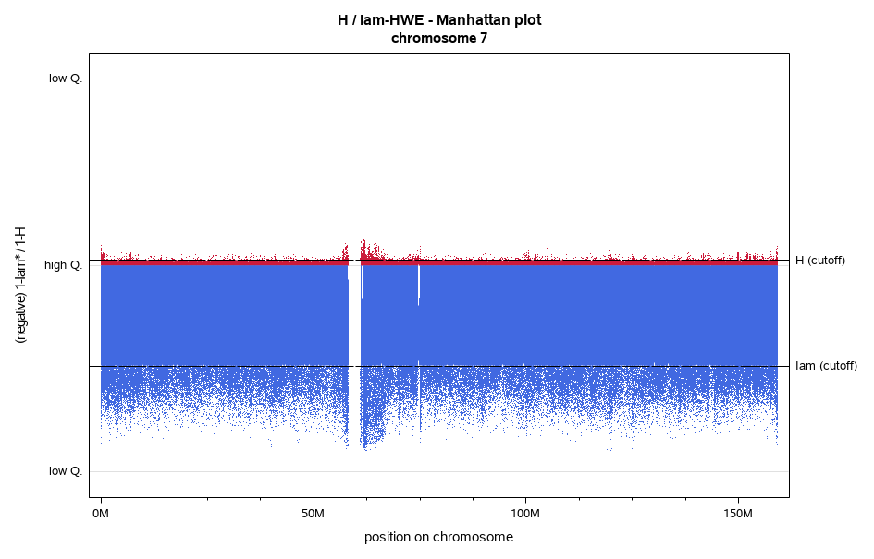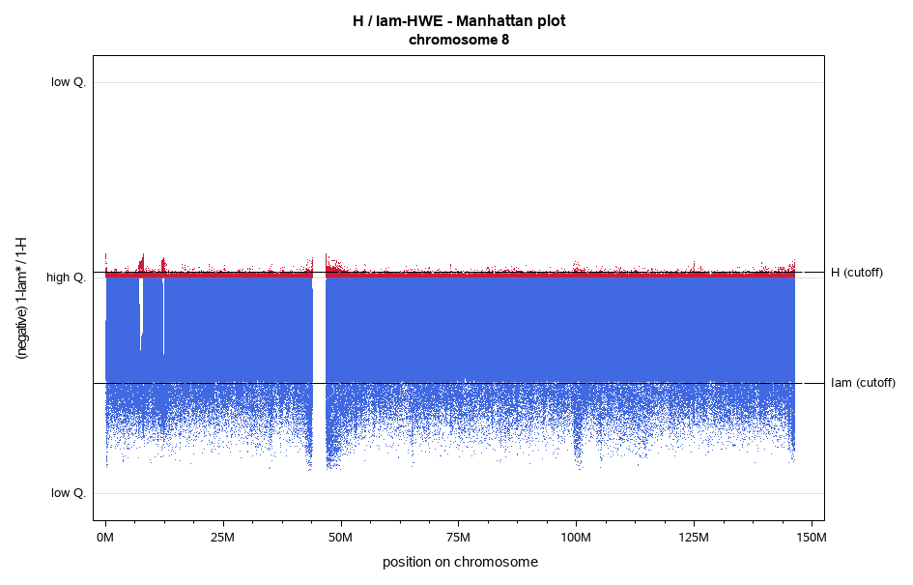
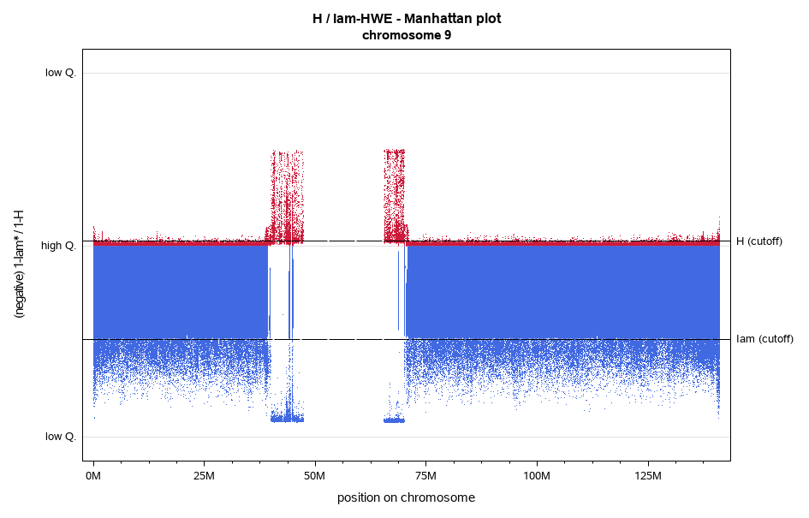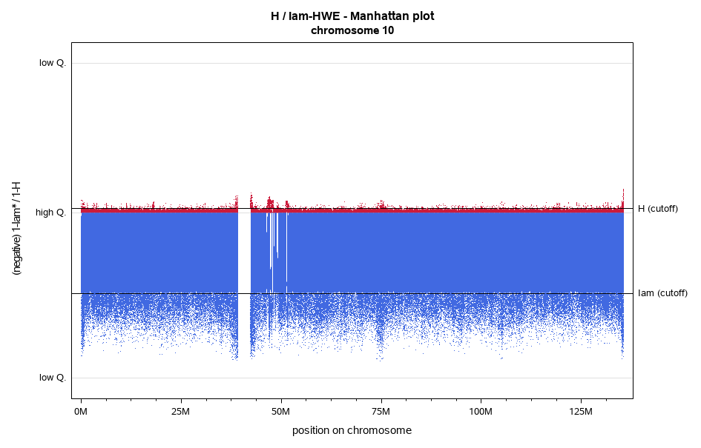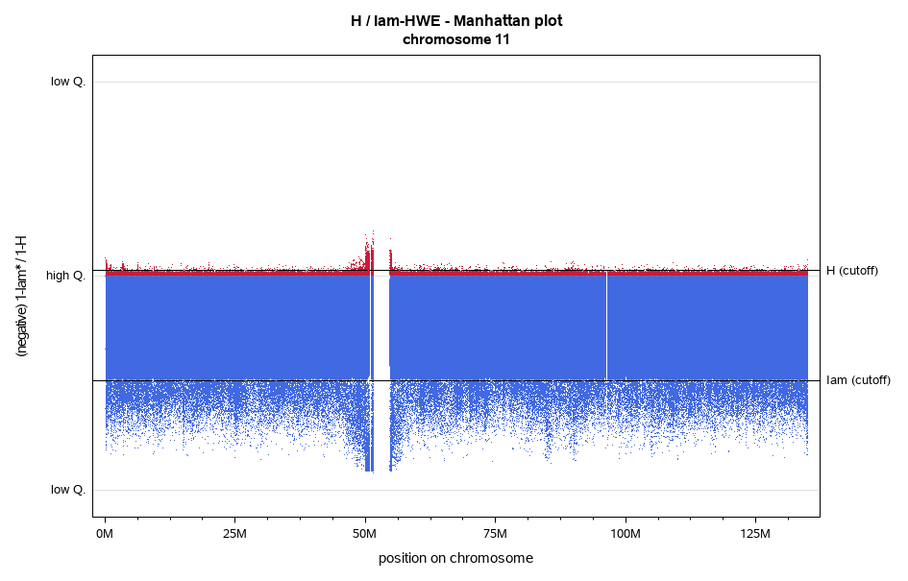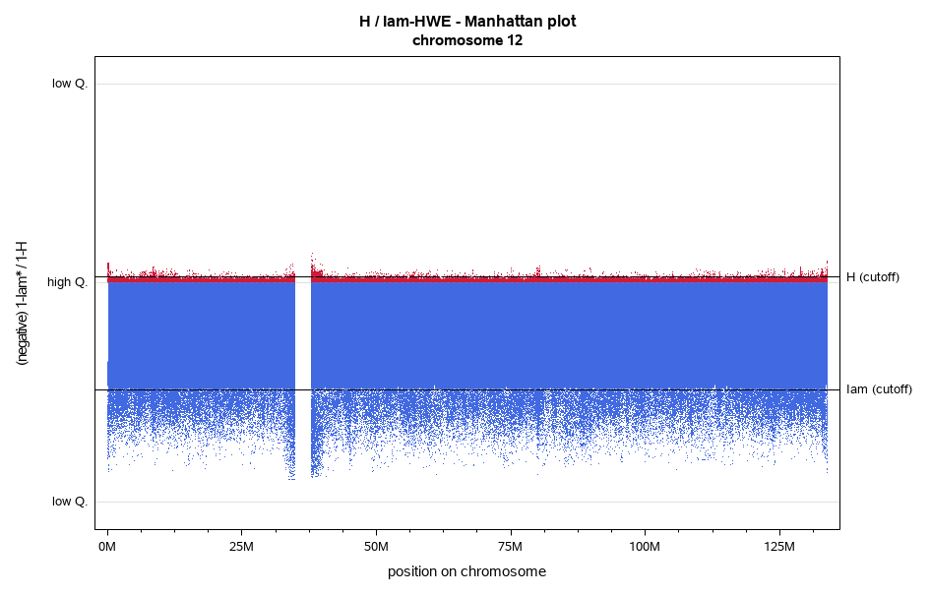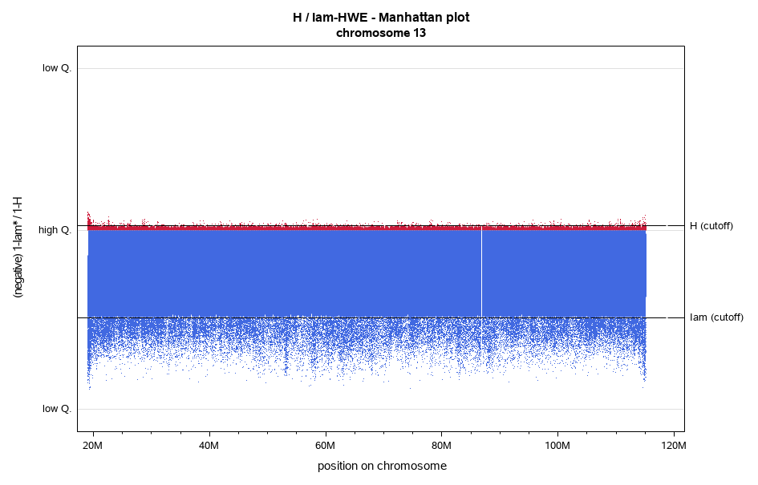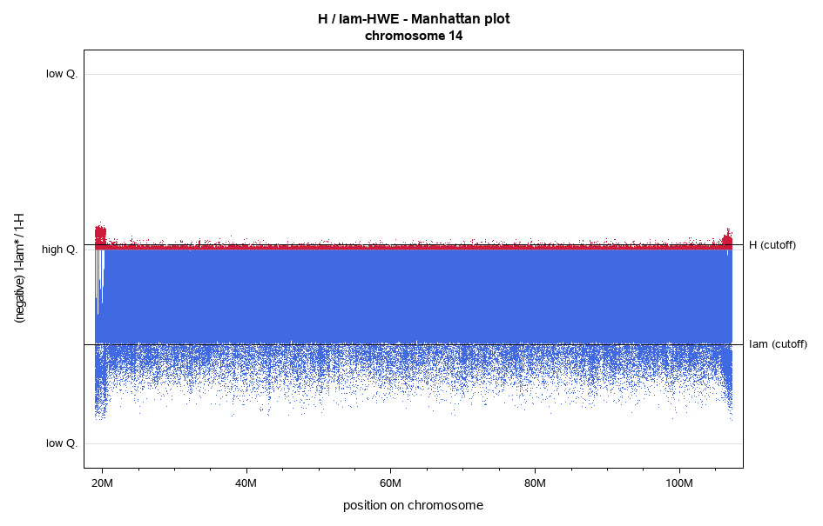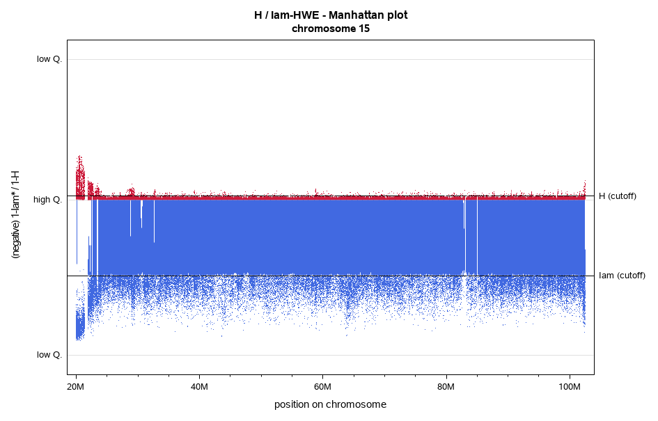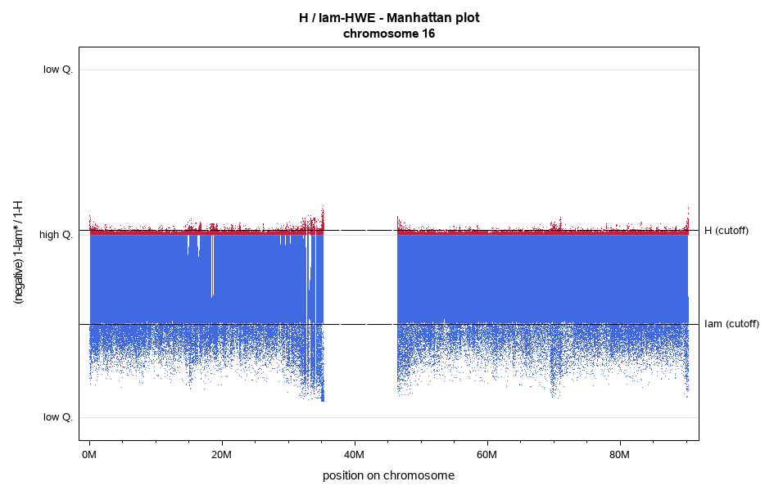
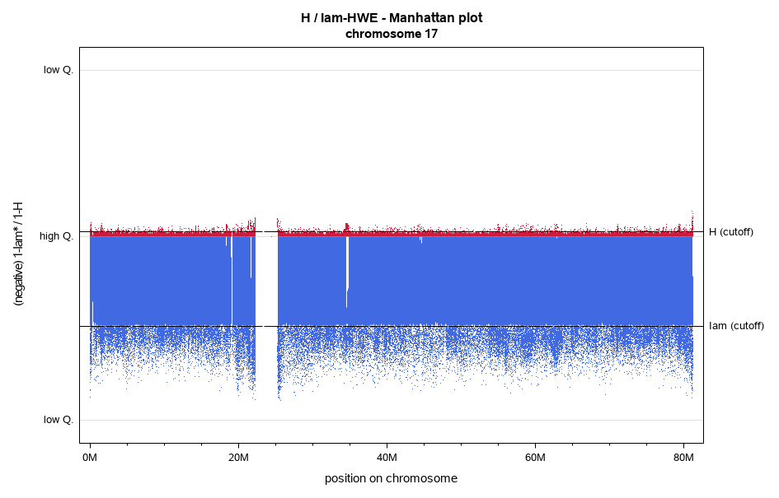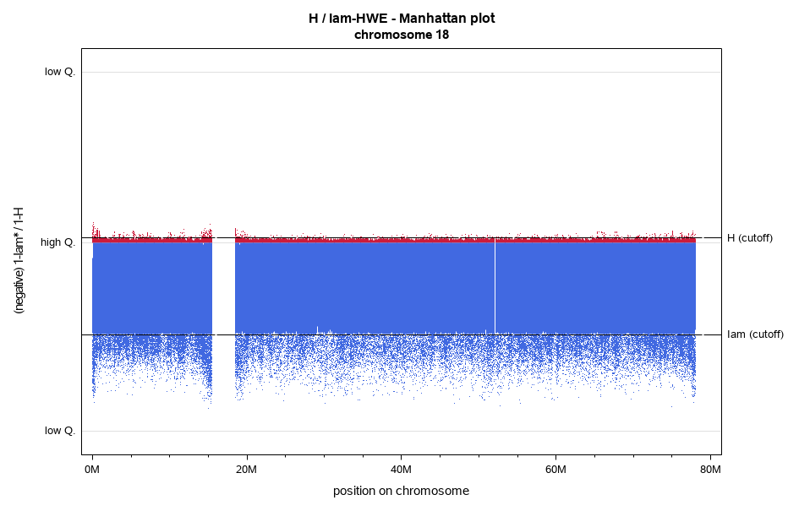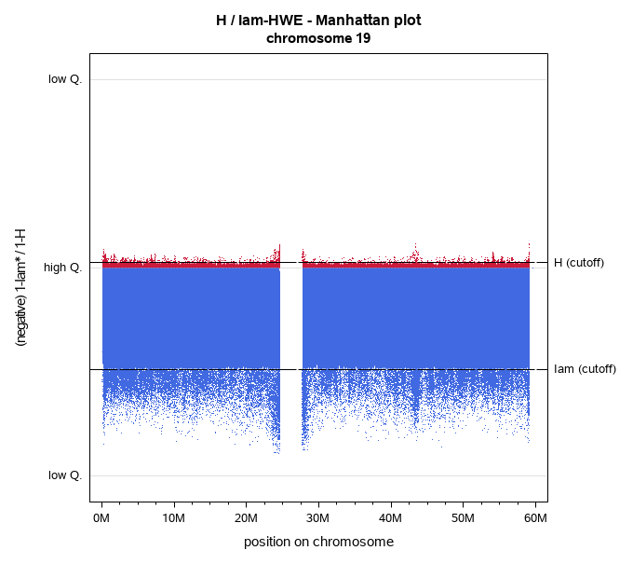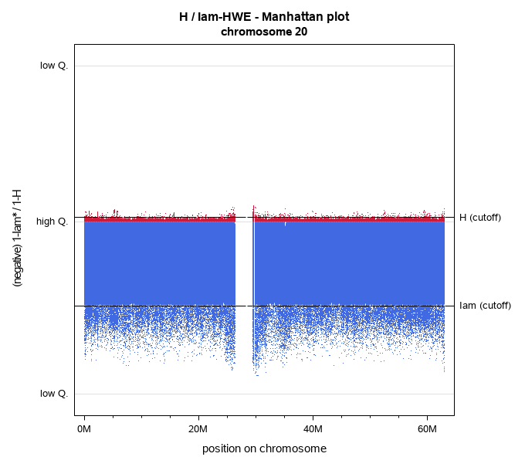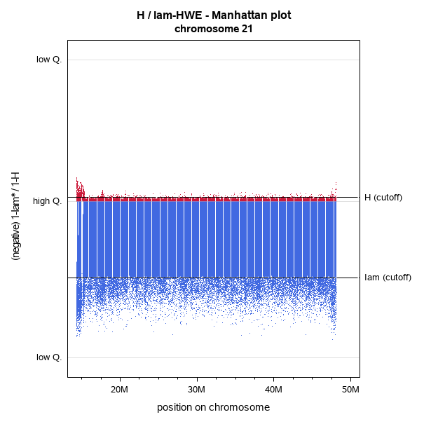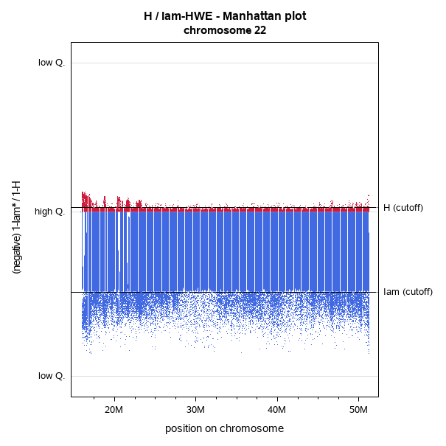

Comparing I’am with info
Supplementary Figure 2 Comparison: I’am with info (Impute2)
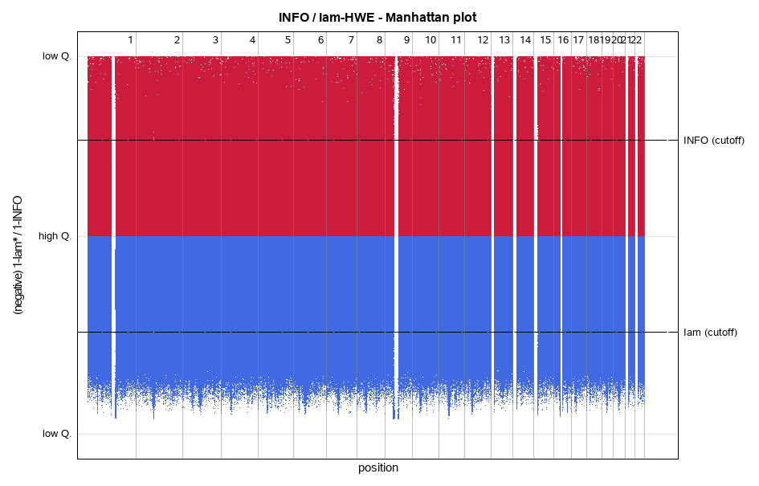
Upper panel: info (low Q.: info=0; high Q.: info=1; Thresholds info (cutoff=0.8); lower panel: ${I'am}_{HWE}$(low Q.: ${I'am}_{HWE}$=0; high Q.: ${I'am}_{HWE}$=1; Thresholds I’am cutoff=0.47): the threshold for ${I'am}_{HWE}$was defined according a robust 99.9999999% random interval (assuming a two-dimensional normal distribution)
Supplementary Figure 3 Comparison: I’am with info (Impute2): chromosome 1
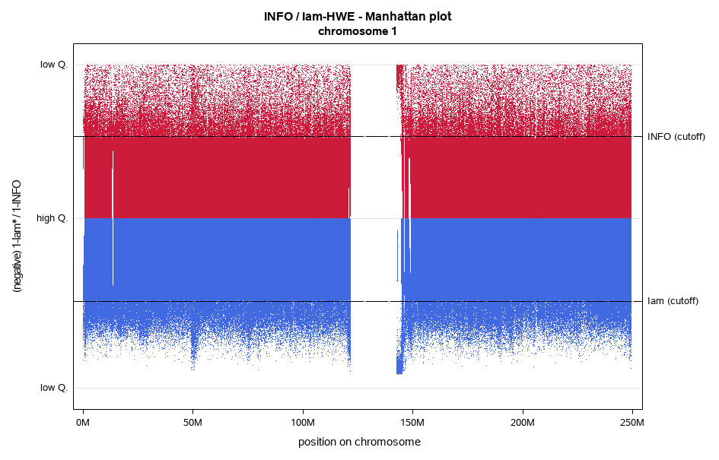
Upper panel: info (low Q.: info=0; high Q.: info=1; Thresholds info (cutoff=0.8); lower panel: ${I'am}_{HWE}$(low Q.: ${I'am}_{HWE}$=0; high Q.: ${I'am}_{HWE}$=1; Thresholds I’am cutoff=0.47): the threshold for ${I'am}_{HWE}$was defined according a robust 99.9999999% random interval (assuming a two-dimensional normal distribution)

