Online Supplemental Material
Title: Impact of diurnal temperature range on cardiovascular diseases mortality in residents in northern China
According to the sensitivity analyses, our estimates without controlling for the meteorological factor variable did not generally change much (See S.Fig.1). We changed the degrees of freedom of Time for 7, 8, and 9 per year (See S.Fig.2), the results changed a little. When changing the degrees of freedom of RH, SSD, and AW for 4, 5, and 6 (See S.Fig.3), and altering the maximum lag periods of DTR for 14, 27, and 31(See S.Fig.4), that gave similar results. Overall, our study results were stable.
List of Contents
S.Fig. 1 Cumulative exposure-response relationship over a lag of 21 days with reduced model taken Time trend, day of the week, public holiday and DTR into consideration only.
S.Fig. 2 Cumulative exposure-response relationship over a lag of 21 days, using (B) 7, (C) 8 and (D) 9 df per year for Time, respectively.
S.Fig. 3 Cumulative exposure-response relationship over a lag of 21 days, using (E) 4, (F) 5 and (G) 6 df for relative humidity, sunshine duration, and the average value of wind speed, respectively.
S.Fig. 4 Cumulative exposure-response relationship for different lag days, using (H) 14, (I) 27 and (J) 31 for max lag days, respectively.
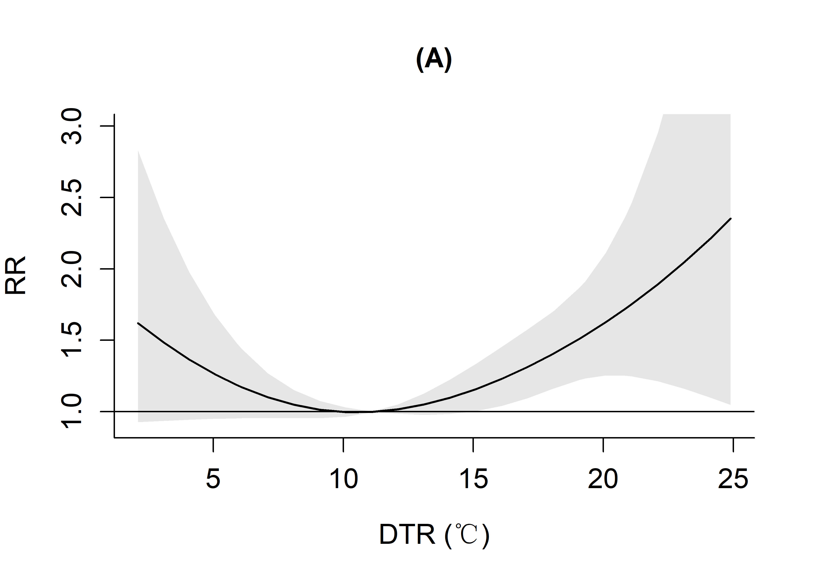
S.Fig. 1 Cumulative exposure-response relationship over a lag of 21 days with reduced model which taken Time trend, day of the week, public holiday and DTR into consideration only.
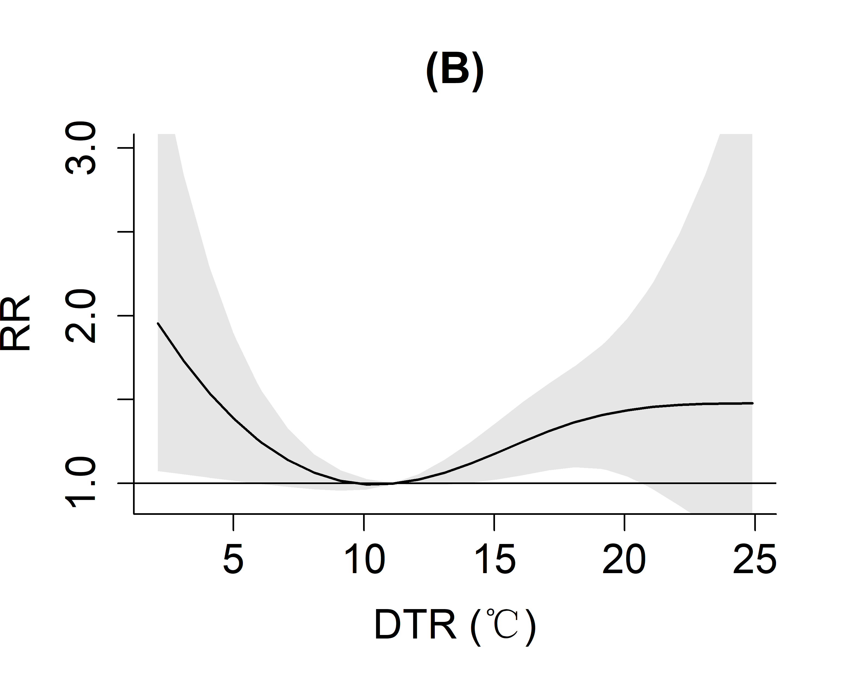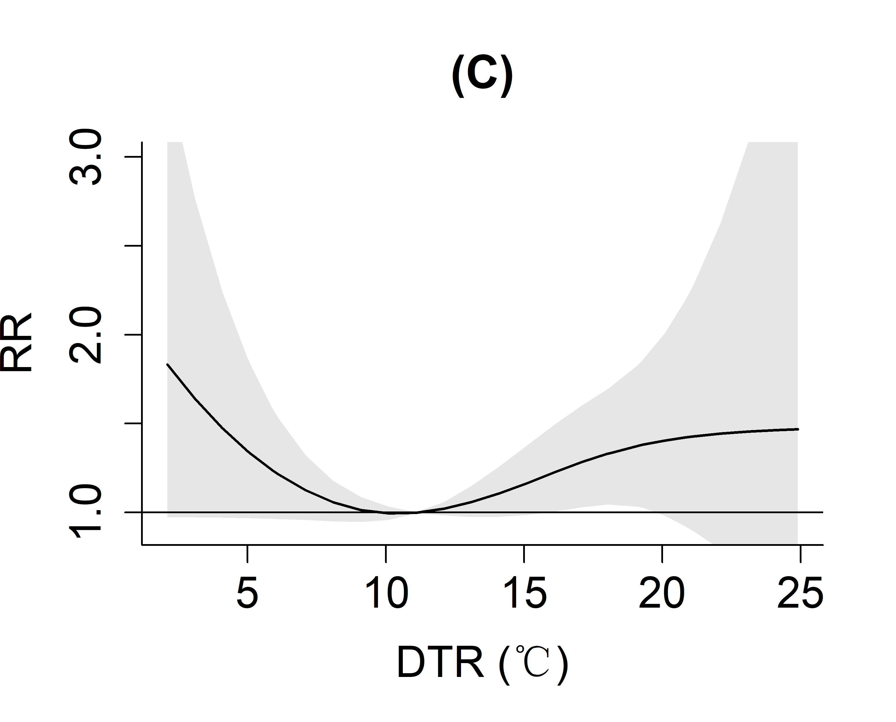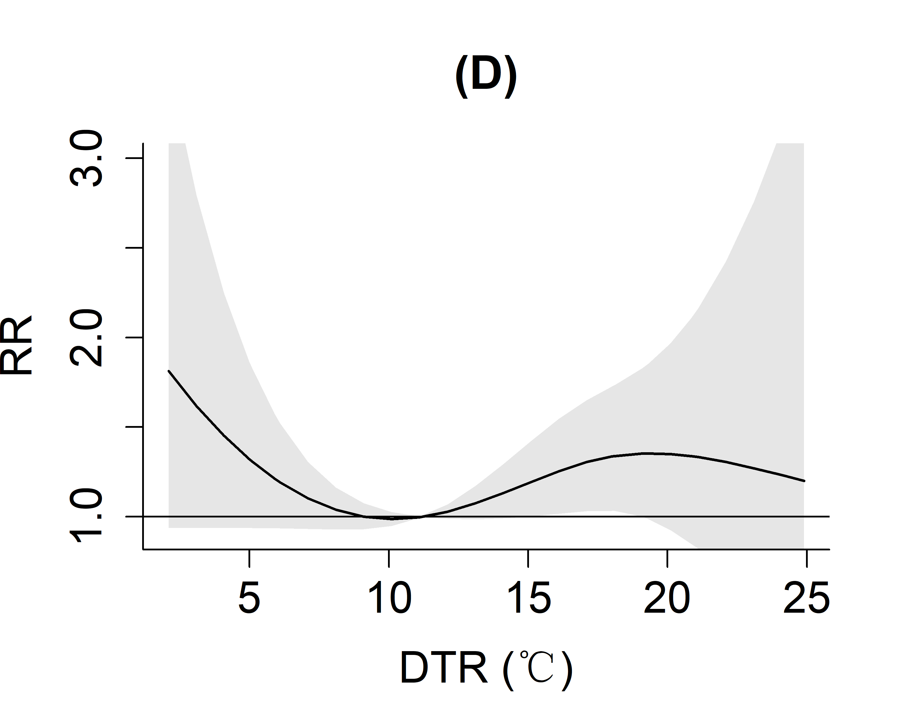
S.Fig. 2 Cumulative exposure-response relationship over a lag of 21 days, using (B) 7, (C) 8 and (D) 9 df per year for Time, respectively.
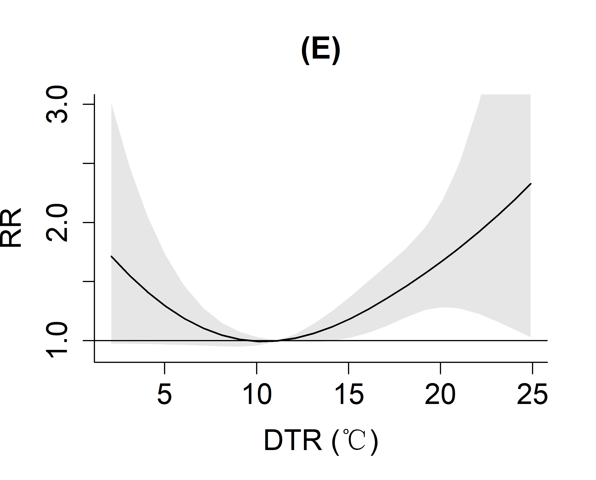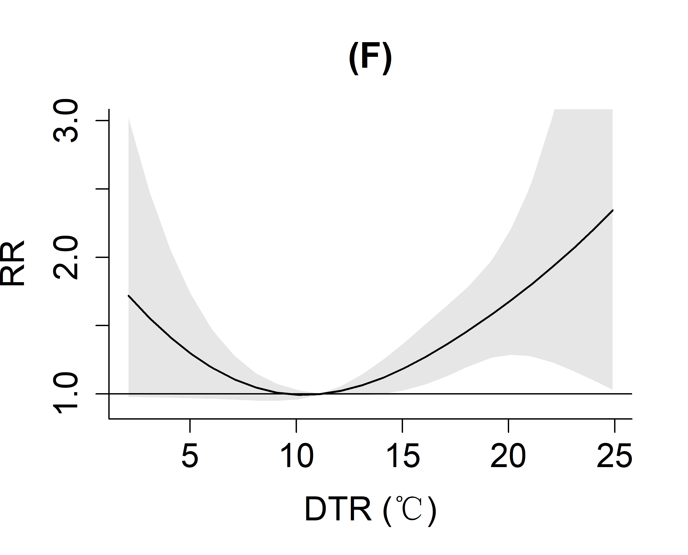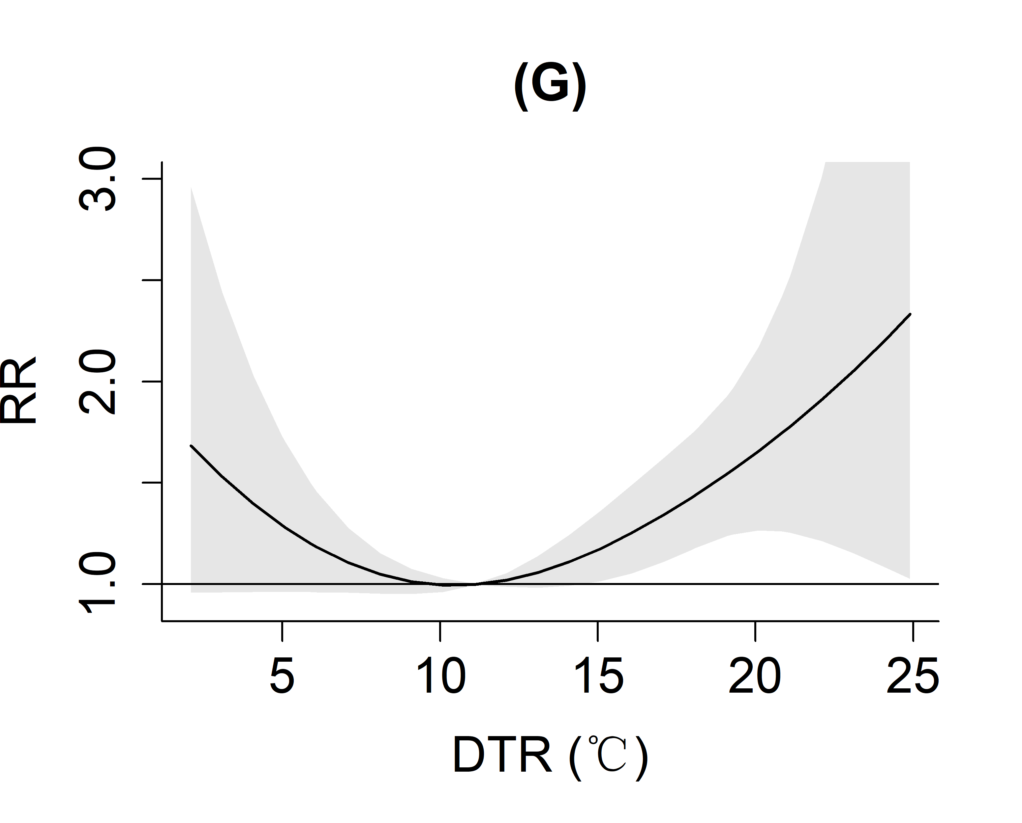
S.Fig. 3 Cumulative exposure-response relationship over a lag of 21 days, using (E) 4, (F) 5 and (G) 6 df for relative humidity, sunshine duration, and the average value of wind speed, respectively.
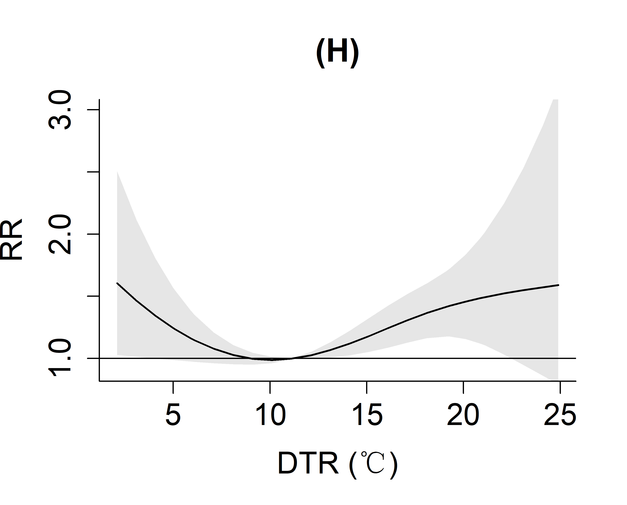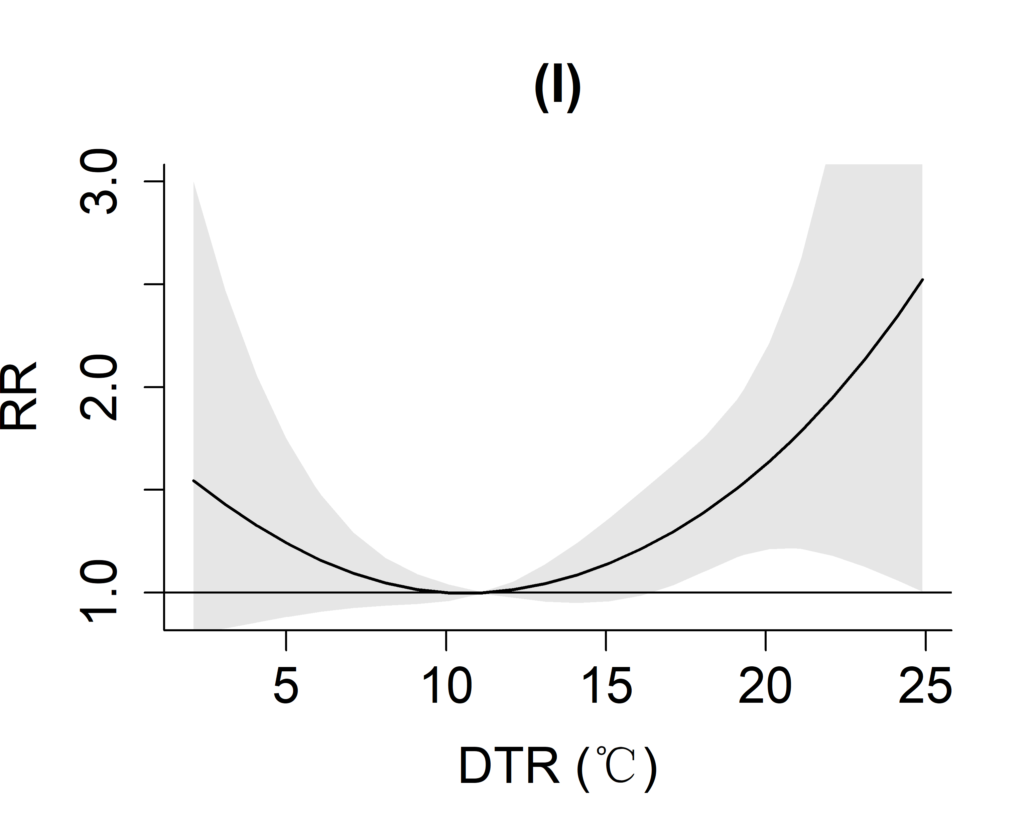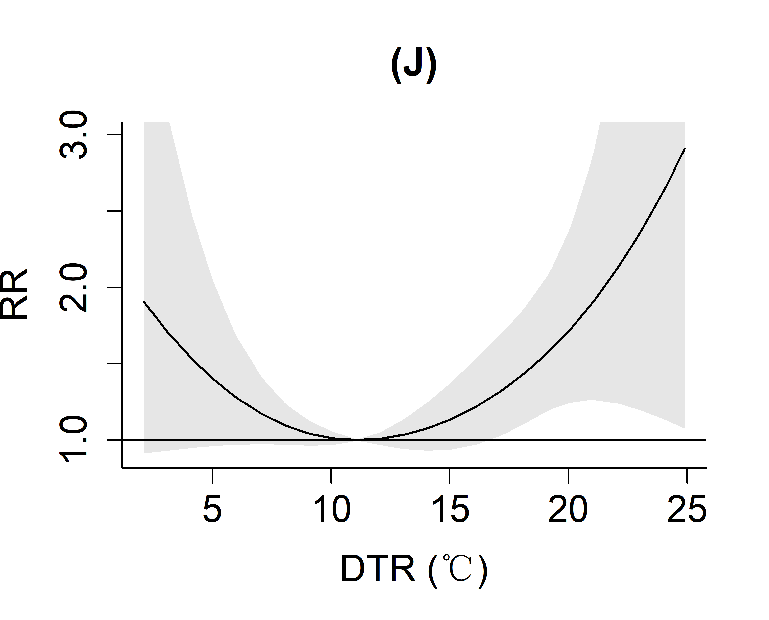
S.Fig. 4 Cumulative exposure-response relationship for different lag days, using (H) 14, (I) 27 and (J) 31 for max lag days, respectively.

