Berberine reverses nitroglycerin tolerance through suppressing PKCα activity in vascular smooth muscle cells
Huina Zhangª*, Jinghui Dong^{b}*, Chi-Wai Lau^{c}, Yongxiang Wei^{d}, Yu Huang^{c#}

ªBeijing An Zhen Hospital, Capital Medical University; Key Laboratory of Upper Airway Dysfunction-related Cardiovascular Diseases, Beijing Institute of Heart Lung and Blood Vessel Disease, Beijing, China;
^{b}Department of Physiology, Hebei Medical University, Hebei, China;
^{c}Shenzhen Research Institute, Heart and Vascular Institute, and Li Ka Shing Institute of Health Sciences, Chinese University of Hong Kong, Hong Kong, China
^{d}Department of Otolaryngology-Head and Neck Surgery, Beijing An Zhen Hospital, Capital Medical University, Beijing, China

Correspondence:
Yu Huang (yu-huang@cuhk.edu.hk) and Huina Zhang (whinnerzhn@126.com)

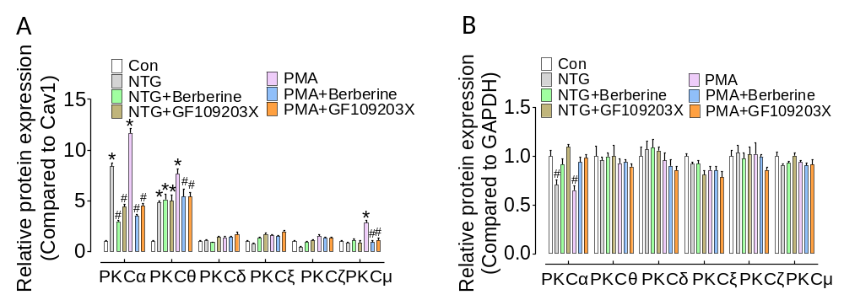
Supplemental Fig. 1. Berberine inhibits membrane location of PKCα−induced by NTG in primary vascular smooth muscle cells. (A-B) Statistical analysis of PKC isoforms (including PKCα, PKCθ, PKCδ, PKCξ, PKCζ, PKCμ) expression on membrane (A) or in cytosol (B) of VSMCs treated with NTG or PMA concomintantly with berberine or GF109203X or not. GAPDH was used as cytosol internal control; Cavolin 1 was used as membrane internal control. Results are mean ± SD (n=5). *P < 0.05 vs. Con. #P < 0.05 vs. NTG or PMA.

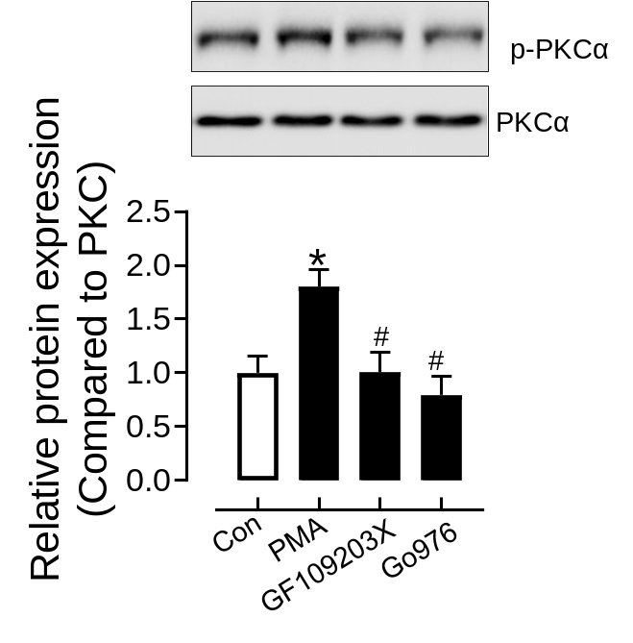
Supplemental Fig. 2. The inhibiors of PKC or PKCα reduce PKCα phosphorylation. 1-min treatment of GF109203X (2μM) or Go6976 (2μM) inhibited the phosphorylation level of PKCα induced by PMA (100 nM, 1 min) in VSMCs. Results are mean ± SD (n=4). *P< 0.05 vs. Con. #P< 0.05 vs. PMA.

