Grassland cover declined in Southern Africa but increased in other African subcontinents in early 21st century
Taofeek O. Muraina^{a,h*}, Beatrice Asenso Barnieh^{c,h*}, Saheed O. Jimoh^{b,h}, Ibraheem O. Olasupo^{d,h}, Suleiman K. Bello^{e,f}, Samaila Usman^{g,h}, Clarice P. Mudzengi^{i}, Nusseiba NourEldeen^{j}, Ammar Abdul Aziz^{k}, and Quadri A. Anibaba^{l}
ªDepartment of Animal Health and Production, Oyo State College of Agriculture and Technology, P.M.B. 10, Igbo-Ora, Oyo State, Nigeria
^{b}Leadvert Limited, Abeokuta 110124, Ogun State, Nigeria
^{c}University of Energy and Natural Resources, Earth Observation Research and Innovation Centre (EORIC), P. O. Box 214, Sunyani, Ghana
^{d}Sule Lamido University, PMB 048, Kafin Hausa, Jigawa State, Nigeria
^{e}Department of Arid Land Agriculture, Faculty of Meteorology, Environment and Arid Land Agriculture, King Abdulaziz University, Jeddah-80200, Kingdom of Saudi Arabia
^{f}Department of Soil Science, Faculty of Agriculture/Institute for Agricultural Research, Ahmadu Bello University, Zaria, P.M.B. 1044, Kaduna State, Nigeria
^{g}College of Grassland, Agriculture Science and Technology, Lanzhou University, Lanzhou, 730020, China
^{h}Agriculture Research Group, Organization of African Academic Doctors, Off Kamiti Road, P.O Box 25305-00100, Nairobi, Kenya
^{i}Department of Livestock, Wildlife and Fisheries, Gary Magadzire School of Agriculture, Great Zimbabwe University, Zimbabwe
^{j}Faculty of Geographical and Environmental Science, University of Khartoum, Khartoum 11111, Sudan
^{k}School of Agriculture and Food Sciences, University of Queensland, Australia.
^{l}Department of Ecology, Institute of Dendrology, Polish Academy of Sciences, Kórnik, Poland
*Correspondence: too.muraina@gmail.com; kod222@yahoo.com

Table S1. Lists of countries in Africa and their respective acronyms and subcontinents
Country acronym | Country name | Subcontinent | Country acronym | Country name | Subcontinent
AGO | Angola | Central Africa | LSO | Lesotho | Southern Africa
BDI | Burundi | East Africa | MAR | Morocco | North Africa
BEN | Benin | West Africa | MDG | Madagascar | Southern Africa
BFA | Burkina Faso | West Africa | MLI | Mali | West Africa
BWA | Botswana | Southern Africa | MOZ | Mozambique | East Africa
CAF | Central African Republic | Central Africa | MRT | Mauritania | West Africa
CIV | Cote d’Ivoire | West Africa | MWI | Malawi | East Africa
CMR | Cameroon | Central Africa | NAM | Namibia | Southern Africa
COD | Democratic Republic of the Congo | Central Africa | NER | Niger | West Africa
COG | Republic of Congo | Central Africa | NGA | Nigeria | West Africa
CPV | Cape Verde | West Africa | RWA | Rwanda | East Africa
DJI | Djibouti | East Africa | SDN | Sudan | North Africa
DZA | Algeria | North Africa | SEN | Senegal | West Africa
EGY | Egypt | North Africa | SLE | Sierra Leone | West Africa
ERI | Eritrea | East Africa | SOM | Somalia | East Africa
ESH | Western Sahara | North Africa | SSD | South Sudan | East Africa
ETH | Ethiopia | East Africa | SWZ | Swaziland | Southern Africa
GAB | Gabon | Central Africa | TCD | Chad | Central Africa
GHA | Ghana | West Africa | TGO | Togo | West Africa
GIN | Guinea | West Africa | TUN | Tunisia | North Africa
GMB | Gambia | West Africa | TZA | Tanzania | East Africa
GNB | Guinea-Bissau | West Africa | UGA | Uganda | East Africa
GNQ | Equatorial Guinea | Central Africa | ZAF | South Africa | Southern Africa
KEN | Kenya | East Africa | ZMB | Zambia | East Africa
LBR | Liberia | West Africa | ZWE | Zimbabwe | East Africa
LBY | Libya | North Africa

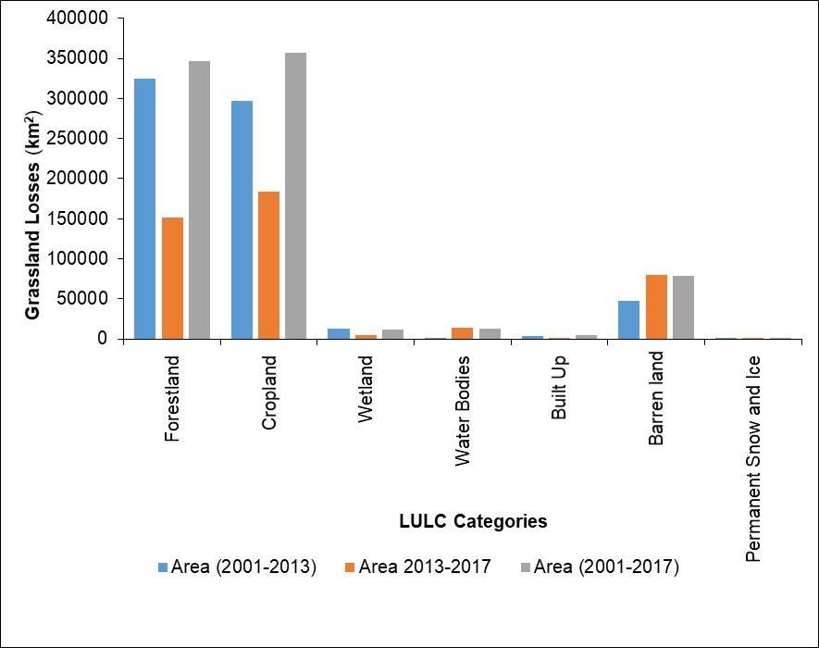
Figure S1. The extent of grassland cover losses to other LULC categories across Africa in 2001–2013, 2013–2017, and 2001–2017.

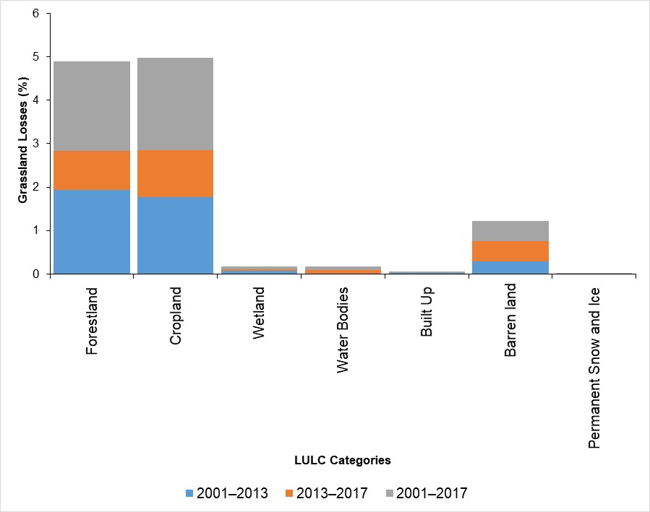
Figure S2. The percentage of grassland cover losses to other LULC categories across Africa in 2001–2013, 2013–2017, and 2001–2017.

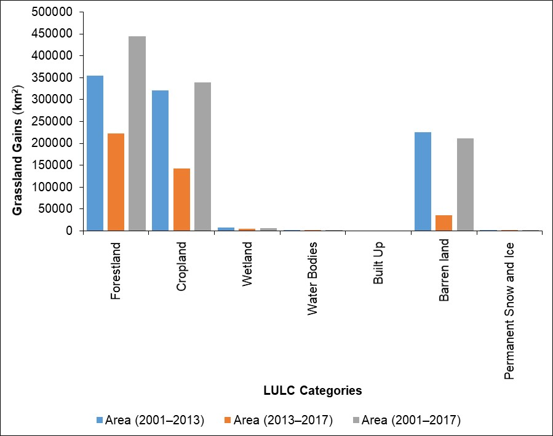
Figure S3. The extent of grassland cover gains from other LULC categories across Africa in 2001–2013, 2013–2017, and 2001–2017.

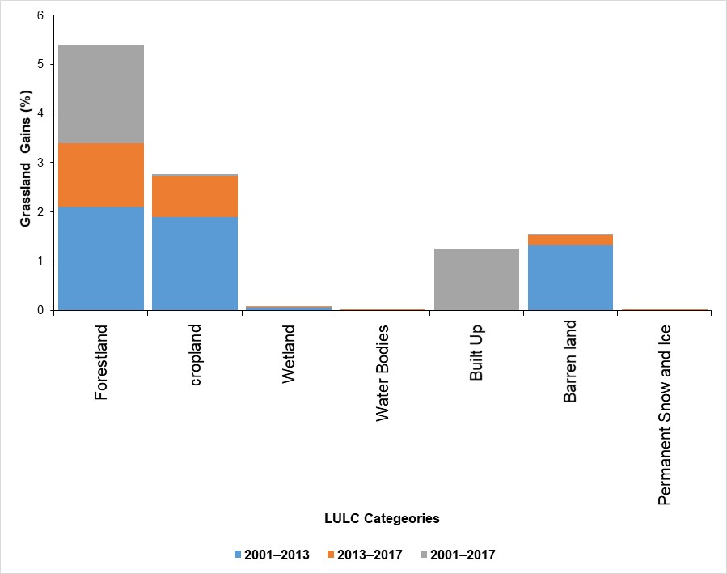
Figure S4. The percentage of grassland cover gains from other LULC categories across Africa in 2001–2013, 2013–2017, and 2001–2017.

