9 plots for the complete output of SHAP modeling.

Figure 1
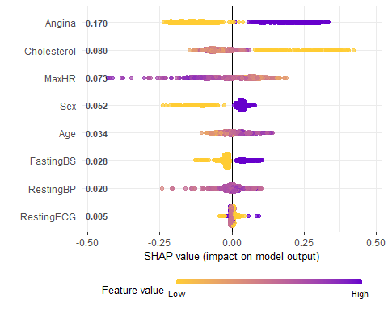
Legend: Purple values represent higher values for each covariate, the SHAP value represents change in Log-Odds for heart disease. Abbreviations: Maximum Heart Rate (MaxHR), Fasting Blood Sugar (FastingBS), Resting Blood Pressure (RestingBP), Resting Electrocardiogram (RestingECG)

Figure 2
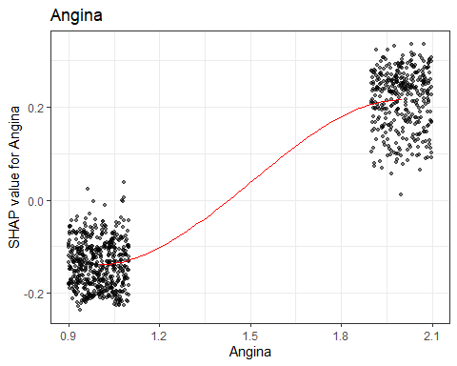
Legend: The dot represents each observation; the red line represents a trend line. X-axis is the covariate of interest, Angina, with 1 representing no angina and 2 representing angina. The SHAP value represents the log-odds for heart disease.

Figure 3
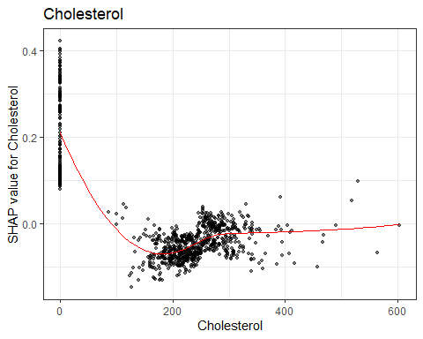
Legend: The dot represents each observation, the red line represents a trend line. X-axis is the covariate of interest, Cholesterol (mg/day). The SHAP value represents the log-odds for heart disease.

Figure 4
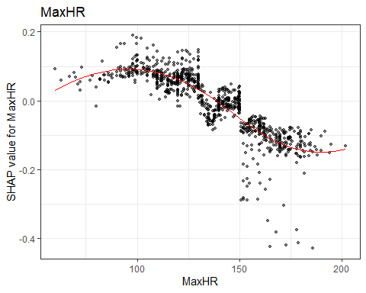
Legend: The dot represents each observation, the red line represents a trend line. X-axis is the covariate of interest, Maximum Heart Rate (beats/minute). The SHAP value represents the log-odds for heart disease.

Figure 5
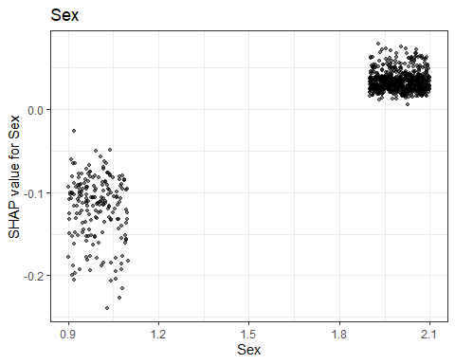
Legend: The dot represents each observation. X-axis is the covariate of interest, Sex (beats/minute). Sex = 1 represents female, Sex = 2 represents male. The SHAP value represents the log-odds for heart disease.

Figure 6
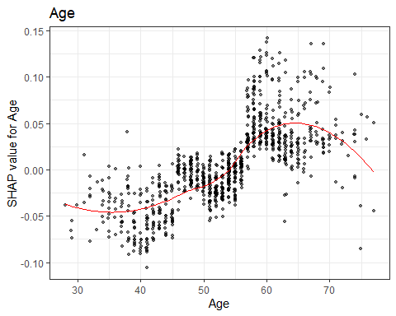
Legend: The dot represents each observation; the red line represents a trend line. X-axis is the covariate of interest, Age(years). The SHAP value represents the log-odds for heart disease.

Figure 7
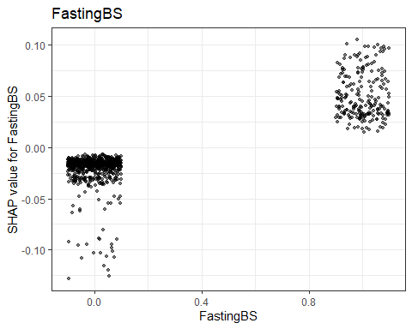
Legend: The dot represents each observation. X-axis is the covariate of interest, Fasting Blood Sugar. Non-elevated = 1, Elevated = 2. The SHAP value represents the log-odds for heart disease.

Figure 8
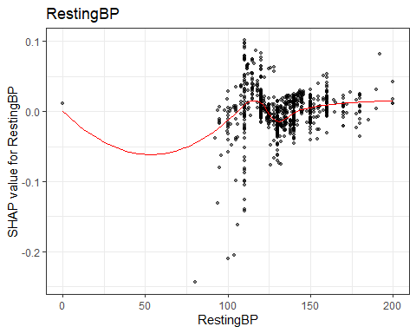
Legend: The dot represents each observation; the red line represents a trend line. X-axis is the covariate of interest, Resting Blood Pressure (mean arterial pressure). The SHAP value represents the log-odds for heart disease.

Figure 9

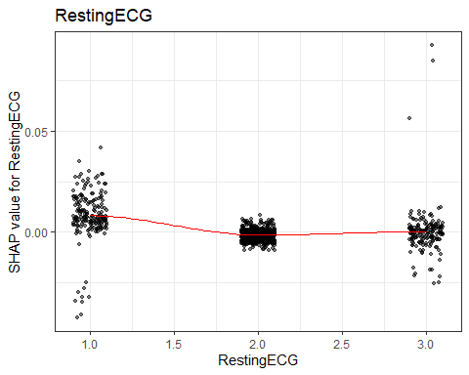
Legend: The dot represents each observation; the red line represents a trend line. X-axis is the covariate of interest, Resting Electrocardiogram. 1 represents an ST-elevation, 2 represents normal, and 3 represents left ventricular hypertrophy. The SHAP value represents the log-odds for heart disease.

