Table S1 Regression equations of multivariable models
Regression equation model based on person characteristics
-5.912+ 0.331065*Age+ 1.002198*Onset to Admission <2d+ 1.423189*WFNS grade >3+ 2.291073*Ultra-early Extubation

Table S2. Baseline characteristics before and after the propensity score-matched
 | Unmatched |  |  | Matched
 | Early | Ultra-early |  | Early | Ultra-early
 | 68 | 267 | p Value | 54 | 54 | p Value
Age,years | 58.3 ± 9.5 | 52.7 ± 10.3 | < 0.001 | 57.1 ± 9.3 | 54.7 ± 8.9 | 0.295*
Sex |  |  | 0.505 |  |  | 0.350†
Female | 41 (60.3) | 149 (55.8) |  | 30 (55.6) | 32 (59.3)
Male | 27 (39.7) | 118 (44.2) |  | 24 (44.4) | 22 (40.7)
Comorbidities
Smoking | 12 (17.6) | 47 (17.6) | 0.993 | 10 (18.5) | 11 (20.4) | 1.000†
Drinking | 7 (10.3) | 24 (9.0) | 0.740 | 5 (9.3) | 5 (9.3) | 1.000†
Hypertension | 37 (54.5) | 119 (44.6) | 0.146 | 31 (57.4) | 29 (53.7) | 0.845†
Diabetes | 6 (8.8) | 18 (6.7) | 0.552 | 5 (9.3) | 8 (14.8) | 0.549†
Hyperlipemia | 2 (2.9) | 7 (2.6) | 0.884 | 1 (1.9) | 3 (5.6) | 0.625†
Respiratory disease | 1 (1.5) | 3 (1.1) | 0.814 | 1 (1.9) | 1 (1.9) | 1.000†
Coronary disease | 3 (4.4) | 7 (2.6) | 0.439 | 2 (3.7) | 2 (3.7) | 1.000†
Prior infarction | 3 (4.4) | 19 (7.1) | 0.422 | 3 (5.6) | 8 (14.8) | 0.227†
Prior hemorrhage | 1 (1.5) | 1 (0.4) | 0.295 | 1 (1.9) | 0 (0) | 1.000†
Admission characteristics
Onset to admission (d) | 2 (1-4) | 2 (1-3) | 0.036 | 2 (1-5) | 2 (1-3) | 0.101§
Herniation | 8 (11.8) | 2 (0.7) | < 0.001 | 2 (3.7) | 2 (3.7) | 1.000†
H-H grade |  |  | 0.041 |  |  | 0.861‡
1 | 5 (7.4) | 35 (13.1) |  | 5 (9.3) | 3 (5.6)
2 | 33 (48.5) | 160 (59.9) |  | 26 (48.1) | 29 (53.7)
3 | 1 (1.5) | 4 (1.5) |  | 0 (0) | 2 (3.7)
4 | 29 (42.6) | 68 (25.5) |  | 23 (42.6) | 20 (37.0)
WFNS grade |  |  | < 0.001 |  |  | 0.423‡
1 | 14 (20.6) | 128 (47.9) |  | 14 (25.9) | 15 (27.8)
2 | 23 (33.8) | 112 (41.9) |  | 23 (42.6) | 24 (44.4)
3 | 4 (5.9) | 8 (3.0) |  | 4 (7.4) | 2 (3.7)
4 | 15 (22.1) | 17 (6.4) |  | 10 (18.5) | 12 (22.2)
5 | 12 (17.6) | 2 (0.7) |  | 3 (5.6) | 1 (1.9)
mFS |  |  | 0.001 |  |  | 0.269‡
1 | 8 (11.8) | 82 (30.7) |  | 7 (13.0) | 15 (27.8)
2 | 16 (23.5) | 67 (25.1) |  | 15 (27.8) | 9 (16.7)
3 | 7 (10.3) | 38 (14.2) |  | 6 (11.1) | 6 (11.1)
4 | 37 (54.4) | 80 (30.0) |  | 26 (48.1) | 24 (44.4)
mRS grade |  |  | < 0.001 |  |  | 0.275‡
1 | 32 (47.1) | 238 (89.1) |  | 32 (59.3) | 38 (70.4)
2 | 21 (30.9) | 20 (7.5) |  | 16 (29.6) | 7 (13.0)
3 | 6 (8.8) | 5 (1.9) |  | 1 (1.9) | 5 (9.3)
4 | 6 (8.8) | 3 (1.1) |  | 3 (5.6) | 3 (5.6)
5 | 3 (4.4) | 1 (0.4) |  | 2 (3.7) | 1 (1.9)
Data are given in mean ± SD or median (IQR) and counts (%).
* Wilcoxon test.
† McNemar test.
‡ Marginal homogeneity test.
§ Mann-Whitney U-test.

Figure S1. Predicted probability of EF after microsurgery in aSAH patients on the prediction score
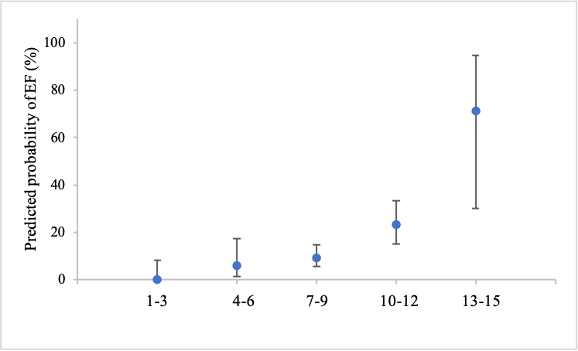

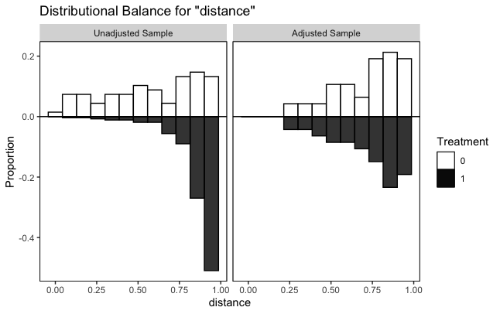
Figure S2. Standardized mean differences of included variables in the raw dataset and matched dataset
Standardized mean differences of included variables in the raw dataset and matched dataset were calculated and compared.

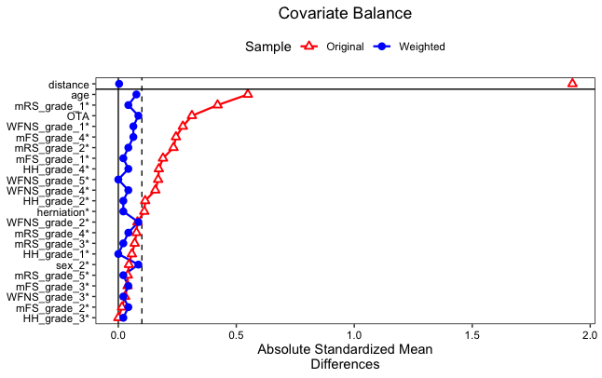
Figure S3. Absolute standardized mean differences of included variables in the raw dataset and matched dataset
All characteristics achieved the desirable cut-off of standardized mean differences <0.1 in the matched dataset.

