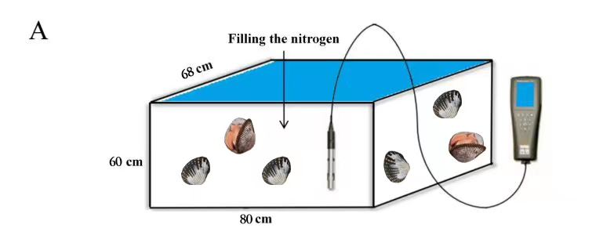
Fig. 1 Hypoxic experimental tank

Fig. 2 Amino acid sequence comparison of hypoxia inducible factor-1α between T.granosa and other species
Amino acid sequence Genebank number used for sequence alignment: T.granosa (Pec0025870.1); S. broughtonii (EVM0013350.1); C. virginica (AED87588.1); H. discus (MH135278.1); D. rerio (NP_001295488.1); M. musculus (AAH26139.1); H. sapiens (NP_001521.1) ;red: 100%, yellow: >75%, blue: >50%



Fig. 3 A Hypoxia inducible factor-1α domain of T.granosa

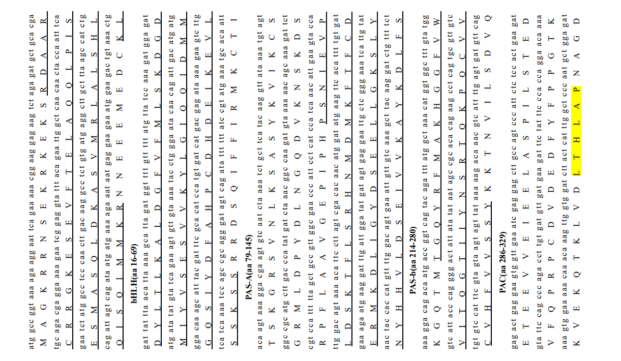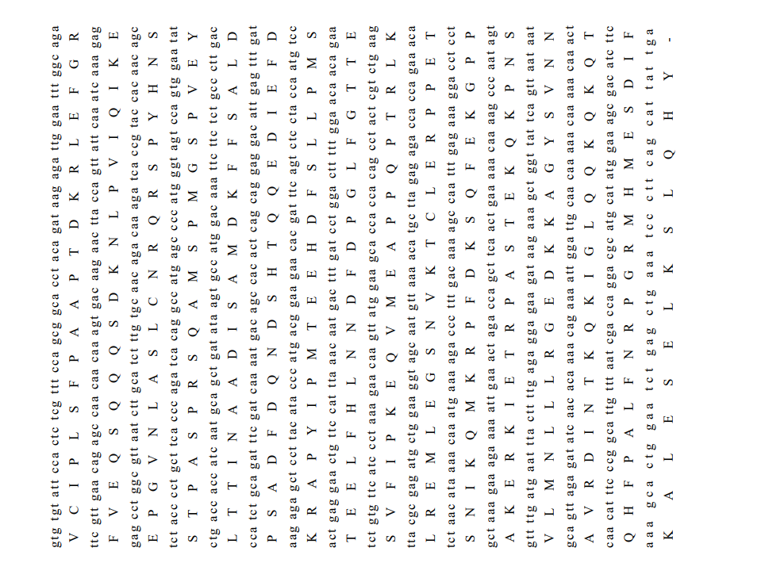

Fig 4. Sequence structure analysis of T.granosa HIF-1α

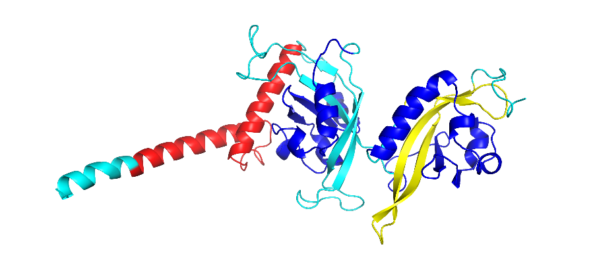
Fig. 5 Tertiary protein structure of hypoxia inducible factor-1α of T.granosa

