Fig.S1 SEM images of the cotton fabric
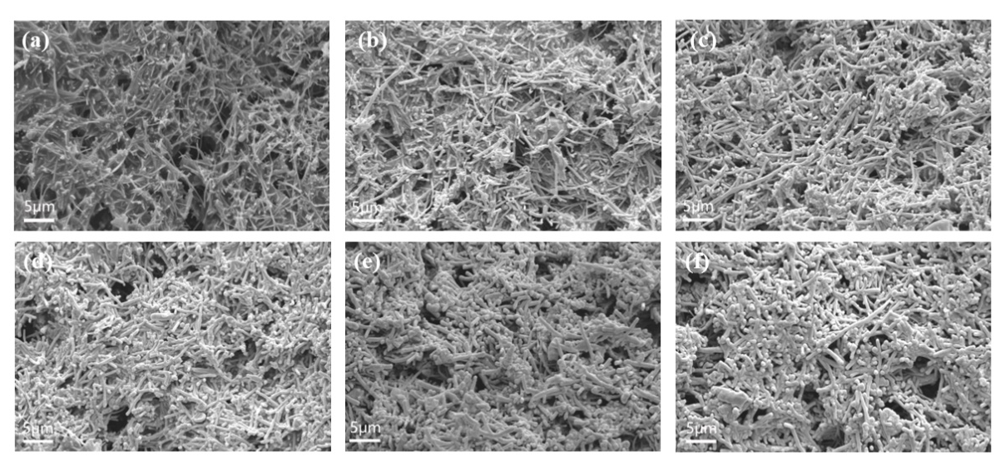
Fig.S2 surface SEM images with different deposition times of (a) the CCF, (b) the Bi₂Te₃/CCF-1, (c) the Bi₂Te₃/CCF-2, (d) the Bi₂Te₃/CCF-3, (e) the Bi₂Te₃/CCF-4 and (f) the Bi₂Te₃/CCF-5
Fig.S3 Physical photograph of (a) the Bi2Te3/CCF and (b) the SG-Bi₂Te₃/CCF
Fig.S4 (a)Physical photograph of water, coffee and milk on the P- Bi₂Te₃/CCF., (b) Self-cleaning test of contaminants on the surface of P- Bi₂Te₃/CCF.

