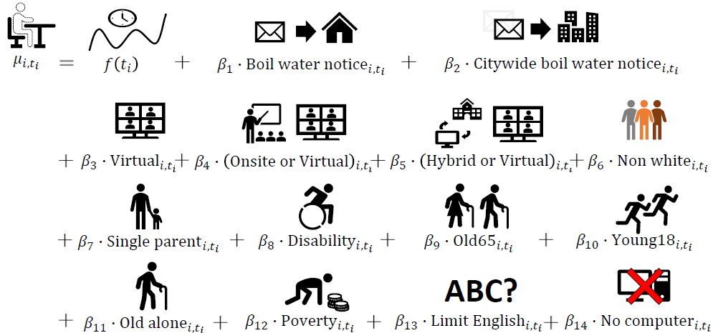
Extended Data Fig. 1 | An illustration of the generalized additive model used. The model contains a time-varying function, $f(t_{i })$, of school attendance at each time point $t_{i }$ for $i$th school, and parameters of boil water notice, city-wide boil water notice, a method of instructional delivery in school and vulnerabilities. In the model, we include a host of census block-level demographic characteristics as follows: boil water notice/advisory , city-wide boil water notice/advisory, virtual, online or virtual, hybrid or virtual, percentage of non-white, percentage of people with disability status, percentage of people older than 65, percentage of people younger than 18, percentage of people older than 65 and living alone, percentage of people with limited English, percentage of household with no computer access, percentage of people living in a household under poverty, percentage of a single-parent household. For a time-varying function $f(⋅)$, we considered the cubic regression spline basis function to approximate a nonparametric function³⁶; see Supplementary Information for the model specification, including the details on types of models and selection of roughness parameters and knot locations.
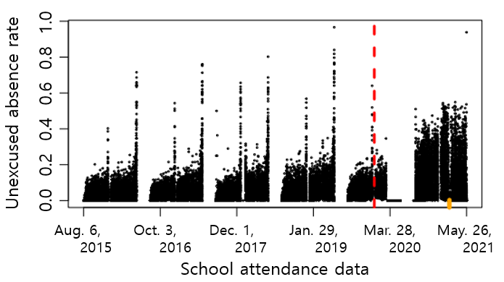
Extended Data Fig. 2 | The distribution of unexcused absence rates by school attendance date during our study period between 2015 and 2021. The red line indicates the end of period 1 and the beginning of period 2, corresponding to the COVID-19 transition. The observed gaps represent school holidays or breaks. The unexcused absence rate shows different nonlinear dynamic patterns during our study period. In particular, the unexcused absence rate has extreme peaks before holidays or breaks. The unexcused absence rate further increases after instructional delivery changed due to the COVID-19 global pandemic. These unexcused absence rate patterns demonstrate the importance of considering two time periods, one before COVID-19, and the other after COVID-19. The orange rug, displayed as a mark along the x-axis, indicates the school attendance date around February 20, 2021 with a huge drop in unexcused absence rate.

