Supplementary Information
Data Processing

We preprocessed the dataset of the BWA and all the vulnerability variables from household data for the analysis. Supplementary Information Fig. 1 indicates flowchart of school attendance and the BWA data process for unexcused absence rates, the BWA variable, and vulnerability variables. Original BWA data repeats for three types of schools, and we consider samples for 42 common schools in both BWA and school attendance data. From the BWA data with common schools, we take averages of values for each variable across the household. For each attendance date, we assign a value of one if the school attendance date is contained in a range generated based on the BWA dates and zero otherwise, as discussed in the main paper. On the other hand, for each attendance date and school, we keep the past and current BWA date and corresponding vulnerability variables from averaged vulnerability variables across the household in the BWA data. From this, all values of variables are aggregated as average for each school and its attendance date.

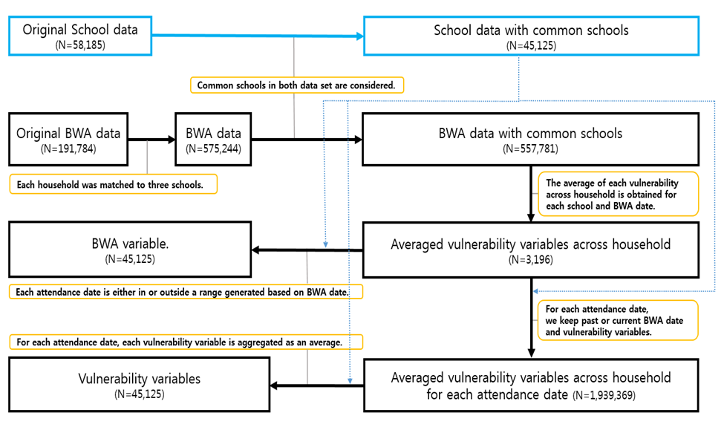
Supplementary Information Fig. 1 | Flowchart of school attendance and the BWA data process for unexcused absence rates, the BWA variable, and vulnerability variables. Solid arrow indicates the direction of the data process. The dashed arrow represents the ancillary information, which is used between particular data processes, from the dataset of the school attendance. Black and blue colored boxes and arrows are related to school attendance data and the BWA data, respectively. Yellow colored box indicates the process applied. The notation $N$ represents the number of samples.

Statistical Analysis

The Model Specification. For the ith school and the tith attendance school date, the conditional means for excused and unexcused absence rates, $μ_{i,t_{i}}$, given all the confounding variables and school attendance date, are modeled via the GAM as seen in Extended Data Fig. 1 of the main manuscript. The GAM model is fitted to three types of cases: (1) all the schools together; (2) each type of school (elementary, middle and high school); (3) each school. To be specific, regarding the ith school, the model for all the schools is fitted to data with all 42 common schools ($i=1,…, 42$) in both BWA and school attendance data, and the models for three types of schools are fitted to data with schools in each type of school ($i ∈ S_{j }$), respectively, where $S_{j }$ be a set containing the corresponding index for each type of school ($j = 1,2,3$). Lastly, the models for each school are fitted to data only with their index; for example, for the 1st school, the model is fitted to data for the school whose index is $i=1$. When fitting the model, the roughness parameter controls a tradeoff between the wiggliness of function and model fit, and it is chosen via generalized cross-validation (GCV) to decide the complexity of the function. For a function of attendance date, locations of knots are placed evenly through the attendance date, and we consider the number of knots from a grid of values (e.g., a sequence from 10 to 100 incremented by 5). The range of lags for the BWA for each model and the number of knots is chosen based on the Bayesian Information Criterion (BIC) for all types of models above.

Results
Time-varying Function of School Attendance Date. Supplemental Fig. 2 illustrates estimated time-varying functions of school attendance date and 95% approximated pointwise confidence intervals for unexcused and excused absence rates of all schools for each period. As given in Supplementary Information Fig. 2 and Table 2 of the main manuscript, for all the schools, general patterns of unexcused absences rates for Period1 fluctuate around their estimated fixed intercepts, 4.77%, and those of unexcused absences rates for Period 2 do around 12.59%. The rugs in Supplementary Information Fig. 2 indicate observed school attendance date, illustrated in Extended Data Fig. 2. Note that local peaks of the function of school attendance date for unexpected absence rates are repeatedly observed, especially before the end of each semester, because most schools have extremely large unexcused absence rates (e.g., more than 30%) around the end of the semester in Extended Data Fig. 2 in the main text. Interestingly, for the Period 2, Supplemental Fig. 2 depicts that the trend of unexcused absence rate goes up through the attendance dates, except for the date indicated by the rug colored in orange of Extended Data Fig. 2, as unexcused absence rates of most schools are comparatively smaller than before and after this period.
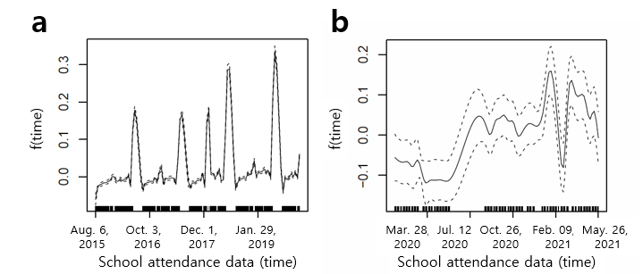
Supplementary Information Fig. 2 | Estimated univariate nonparametric functions of school attendance date for unexcused absence rates of all the schools. Each panel contains estimated function (solid line) and its approximated 95% pointwise confidence intervals (dashed line) for daily unexcused absence rates for Period 1 in panel a and Period 2 in panel b, respectively. Note that rugs, displayed as a mark along the x-axis in each plot, indicate the observed attendance date.

COVID-19 Instructional Delivery. As given by Table 2 of the main text, the variables related to the remote learning schedule for the JPSD are included only in the models for Period 2 as those are new study methods after the outbreak of COVID 19, which is not allowed for Period 1. The virtual decreases the averages of unexcused absence rates while either method of the hybrid or virtual raises the excused absence rate means although all of them are not significant. However, either method of the on-site or virtual was significant and negatively associated with the averages of unexcused absence rate (e.g., -5%).

Vulnerabilities. For all the schools, the impact of the “Single family” on an unexcused absence rate is significantly negative. The “Poverty” significantly increased the unexcused absence rate mean for Period 1. “Non_white” significantly increased the unexcused absence rate. For “Disabled”, estimates have a significantly positive and negative impact on the unexcused absence rate mean for Period 2 and Period 1, respectively. The “Old and living alone” for Period 1 and “Ederly” for Period 2 are negatively associated with unexpected absence rate means, respectively. For every one unit increase in “Limited English”, the averages of unexcused absence rate for Period 2 significantly decrease by 0.04%.

Sensitivity Analysis for Time Periods when Both Households and Schools Were under A Boil Water Advisory. During the 2015 - 2021 time period, there were 36 days when both households and schools received boil water advisory. To examine how much the confounding school BWA variable affects the estimates of the BWA, we report Supplementary Information Fig. 3, which represents the estimates of the BWA after adjusting for the other confounding variables, including the school BWA and the dynamic effect of school attendance date. Compared to Fig. 2 of the main text, estimates and 95% CIs of the BWA in Supplementary Information Fig. 4 for some schools, such as Cardozo in b, and Spann and Lester in a, are slightly different. However, most of them seem not sensitive to including the school BWA for most schools.

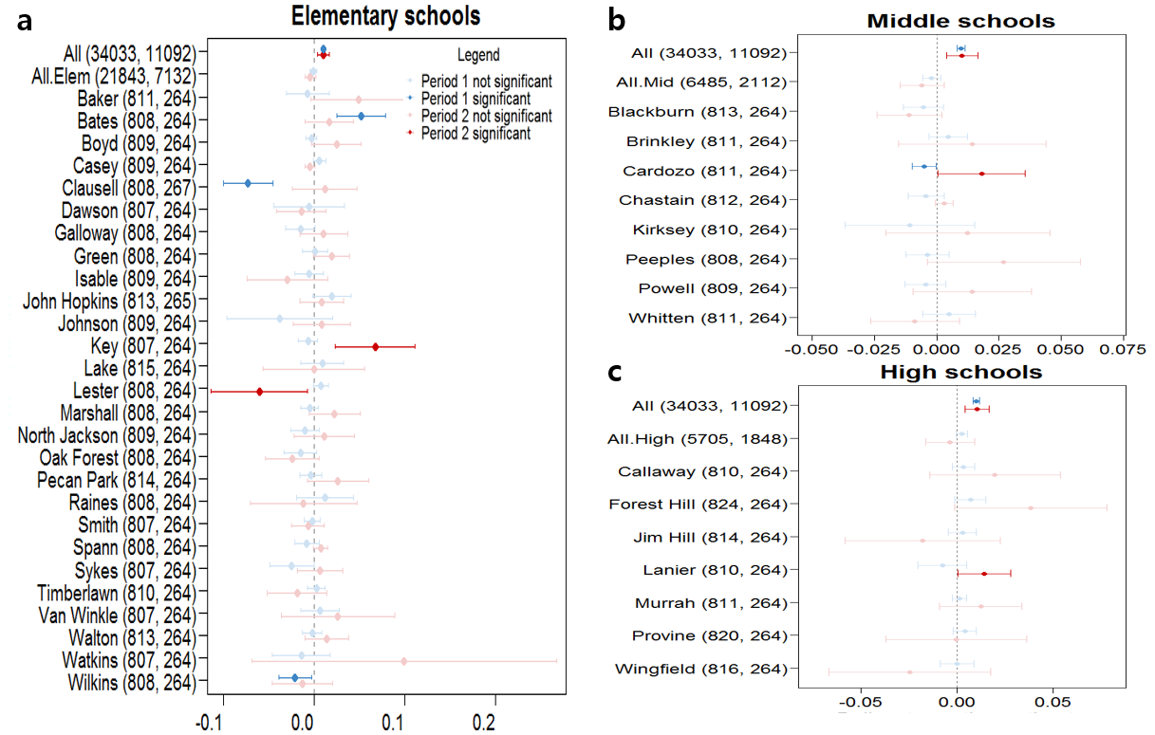
Supplementary Information Fig. 3 | Estimates and the 95% confidence intervals of the BWA covariates for the outcome unexcused absence rate, after including the school BWA variable in the models. Those based on the models for a. elementary schools, b. middle schools, and c. high schools for both Periods 1 (blue) and Period 2 (red) are reported. “All”, “All.Elem”, “All.Mid”, and “All.High” indicate all schools, all elementary schools, all middle schools, and all high schools, respectively. Each panel considers all the schools together. Darker lines correspond to coefficients that are significant (p-value $≤ 0.05$based on a two-tailed hypothesis test). Note that the y-axis label indicates “school name (sample size for Period 1, sample size for Period 2)” for each school, school types, and all schools.

