Appendix
Table A1: Cross-sectional summary statistics, by age group.*
 | Total sample | Age: < 40 years |  |  |  | Age: 40-60 years |  |  |  | Age: > 60 years
Overall Instrument Score | Range of submission dates | n | Mean | SD | Median | n | Mean | SD | Median | n | Mean | SD | Median | ANOVA P-value
Health related quality of life
EQ-5D-5L (VT) Index score | 07/2014-08/2019 | 19 | 0.643 | 0.294 | 0.728 | 18 | 0.708 | 0.220 | 0.760 | 11 | 0.570 | 0.302 | 0.649 | 0.411
EQ5D VAS score | 07/2014-08/2019 | 19 | 63.42 | 26.58 | 74.00 | 18 | 67.22 | 23.17 | 68.00 | 11 | 53.09 | 28.10 | 55.00 | 0.358
EQ5D-3L (CW) Index score | 07/2014-08/2019 | 19 | 0.558 | 0.326 | 0.664 | 18 | 0.604 | 0.241 | 0.663 | 11 | 0.465 | 0.345 | 0.567 | 0.490
SF-36- physical component score | 07/2014-08/2019 | 18 | 35.55 | 15.10 | 35.88 | 16 | 32.01 | 14.77 | 28.86 | 10 | 28.55 | 11.46 | 28.94 | 0.455
SF-36- mental component score | 07/2014-08/2019 | 18 | 47.77 | 9.94 | 49.28 | 16 | 46.23 | 11.74 | 46.64 | 10 | 52.91 | 8.39 | 54.26 | 0.273
Fatigue
FSS score | 09/2018-08/2019 | 7 | 28.57 | 11.30 | 25.00 | 10 | 34.60 | 17.16 | 32.50 | 6 | 34.83 | 12.12 | 33.50 | 0.651
FACIT-F score | 04/2015-08/2019 | 18 | 104.33 | 30.51 | 102.33 | 16 | 100.92 | 28.37 | 108.00 | 9 | 110.67 | 30.90 | 108.00 | 0.737
FACIT-F- physical well-being | 04/2015-08/2019 | 18 | 18.67 | 6.89 | 20.00 | 16 | 18.31 | 6.52 | 20.50 | 10 | 18.67 | 5.40 | 20.00 | 0.986
FACIT-F- social well-being | 04/2015-08/2019 | 18 | 21.22 | 4.81 | 23.00 | 16 | 19.10 | 5.07 | 19.50 | 10 | 21.78 | 5.83 | 22.17 | 0.346
FACIT-F- emotional well-being | 04/2015-08/2019 | 18 | 15.06 | 4.78 | 14.50 | 16 | 15.81 | 4.69 | 16.00 | 10 | 17.22 | 4.50 | 17.00 | 0.454
FACIT-F- functional well-being | 04/2015-08/2019 | 18 | 18.33 | 5.24 | 17.50 | 16 | 17.63 | 5.14 | 17.50 | 10 | 18.89 | 6.84 | 19.00 | 0.806
FACIT-F- fatigue subscale | 04/2015-08/2019 | 18 | 31.06 | 13.99 | 32.50 | 16 | 30.06 | 13.37 | 34.00 | 9 | 34.11 | 12.77 | 33.00 | 0.769
Pain
SF-MPQ-2 score | 07/2014-08/2019 | 19 | 1.89 | 1.55 | 1.91 | 16 | 2.01 | 1.72 | 1.50 | 11 | 1.89 | 1.25 | 1.86 | 0.968
Pain Detect score | 07-2014-08/2019 | 18 | 7.89 | 5.14 | 8.00 | 15 | 8.67 | 7.17 | 7.00 | 10 | 12.70 | 5.93 | 15.50 | 0.133
Sleep
ESS score | 09/2018-08/2019 | 7 | 5.00 | 3.00 | 5.00 | 10 | 5.40 | 3.17 | 6.00 | 6 | 7.67 | 5.05 | 7.00 | 0.389
PSQI score | 07/2014-06/2019 | 18 | 8.11 | 5.05 | 7.00 | 14 | 9.64 | 3.56 | 10.50 | 9 | 9.22 | 2.77 | 9.00 | 0.570
Mental wellbeing
HADS Anxiety score | 04/2015-06/2019 | 16 | 6.38 | 4.56 | 6.50 | 15 | 6.00 | 3.91 | 5.00 | 10 | 6.10 | 2.56 | 6.00 | 0.963
HADS Depression score | 04/2015-06/2019 | 16 | 4.31 | 3.52 | 4.50 | 15 | 4.73 | 3.13 | 4.00 | 10 | 5.30 | 4.19 | 4.50 | 0.789
*The sample is the first submitted instrument from each participant.
EQ-5D-5L (3L), EuroQol 5 dimensions – 5 levels (3 levels); VAS, Visual analogue scale; SF-36, Short-form 36; PCS, Physical Component Score; MCS, Mental Component Score; FSS, Fatigue Severity Scale; ESS, Epworth Sleepiness scale; PSQI, Pittsburgh sleep quality index; FACIT-F, Functional assessment of chronic illness therapy – fatigue; SF-MPQ-2, Short form McGill pain questionnaire version 2; HADS, Hospital anxiety and depression scale

Table A2: Cross-sectional summary statistics for SF-36 scales, by sex *
 | Total (n=44) |  |  | Female(n=35) |  |  | Male(n=9)
SF-36 Dimensions | Mean | SD | Median | Mean | SD | Median | Mean | SD | Median | T-test  P-value
Physical dimensions
Physical functioning | 44.89 | 29.99 | 45.00 | 42.43 | 26.77 | 45.00 | 54.44 | 40.73 | 50.00 | 0.421
Physical role limitations | 34.66 | 42.19 | 12.50 | 31.43 | 39.92 | 0.00 | 47.22 | 50.69 | 25.00 | 0.404
Pain | 53.41 | 32.17 | 50.00 | 51.43 | 29.04 | 50.00 | 61.11 | 43.50 | 75.00 | 0.541
General health | 44.20 | 23.72 | 40.00 | 41.23 | 22.15 | 40.00 | 55.78 | 27.39 | 67.00 | 0.169
Mental dimensions
Emotional well-being | 69.73 | 17.75 | 74.00 | 69.83 | 17.71 | 72.00 | 69.33 | 18.97 | 80.00 | 0.945
Emotional role limitations | 65.91 | 40.34 | 83.33 | 63.81 | 42.30 | 100.00 | 74.07 | 32.39 | 66.67 | 0.440
Energy/fatigue | 39.20 | 25.06 | 35.00 | 36.14 | 23.70 | 35.00 | 51.11 | 28.04 | 55.00 | 0.169
Social functioning | 62.22 | 30.91 | 75.00 | 64.29 | 28.14 | 75.00 | 54.17 | 40.98 | 62.50 | 0.500
*The sample is the first submitted instrument from each participant. The questionnaires were submitted
between 07/2014-08/2019.
SF-36, Short-form 36; PCS, Physical Component Score; MCS, Mental Component Score

Table A3: Cross-sectional summary statistics for SF-36 scales, by age.*
 | Total (n=44) |  |  | Age: < 40 years (n=18) |  |  | Age: 40-60 years (n=16) |  |  | Age: > 60 years (n=10)
SF-36 Dimensions | Mean | SD | Median | Mean | SD | Median | Mean | SD | Median | Mean | SD | Median | ANOVA  P-value
Physical dimensions
Physical functioning | 44.89 | 29.99 | 45.00 | 52.22 | 30.55 | 50.00 | 45.00 | 29.50 | 37.50 | 31.50 | 27.89 | 32.50 | 0.219
Physical role limitations | 34.66 | 42.19 | 12.50 | 41.67 | 45.37 | 25.00 | 31.25 | 40.31 | 12.50 | 27.50 | 41.58 | 0.00 | 0.652
Pain | 53.41 | 32.17 | 50.00 | 58.33 | 33.21 | 62.50 | 45.31 | 33.19 | 50.00 | 57.50 | 28.99 | 50.00 | 0.460
General health | 44.20 | 23.72 | 40.00 | 46.00 | 28.12 | 44.50 | 44.00 | 21.81 | 42.50 | 41.30 | 19.68 | 35.00 | 0.886
Mental dimensions
Emotional well-being | 69.73 | 17.75 | 74.00 | 67.11 | 20.14 | 70.00 | 68.75 | 17.66 | 66.00 | 76.00 | 12.65 | 78.00 | 0.440
Emotional role limitations | 65.91 | 40.34 | 83.33 | 72.22 | 36.60 | 100.00 | 54.17 | 41.94 | 66.67 | 73.33 | 43.89 | 100.00 | 0.352
Energy/fatigue | 39.20 | 25.06 | 35.00 | 37.22 | 27.07 | 27.50 | 36.88 | 25.36 | 32.50 | 46.50 | 21.61 | 47.50 | 0.588
Social functioning | 62.22 | 30.91 | 75.00 | 68.06 | 28.83 | 75.00 | 57.81 | 32.87 | 62.50 | 58.75 | 32.83 | 68.75 | 0.590
*The sample is the first submitted instrument from each participant. The questionnaires were submitted between 07/2014-08/2019.
SF-36, Short-form 36; PCS, Physical Component Score; MCS, Mental Component Score

Table A4: Cross-sectional summary statistics, by age and PROMs category
Instrument | Total |  | < 40 years |  | 40-60 years |  | > 60 years
Instrument | n | (%) | n | (%) | n | (%) | n | (%)
ESS Categories
Lower Normal Daytime Sleepiness | 12 | (52.17%) | 5 | (71.43%) | 5 | (50.00%) | 2 | (33.33%)
Higher Normal Daytime Sleepiness | 9 | (39.13%) | 1 | (14.29%) | 5 | (50.00%) | 3 | (50.00%)
Mild Excessive Daytime Sleepiness | 1 | (4.35%) | 1 | (14.29%) | 0 | (0.00%) | 0 | (0.00%)
Moderate Excessive Daytime Sleepiness | 0 | (0.00%) | 0 | (0.00%) | 0 | (0.00%) | 0 | (0.00%)
Severe Excessive Daytime Sleepiness | 1 | (4.35%) | 0 | (0.00%) | 0 | (0.00%) | 1 | (16.67%)
Pain Detect Categories
Negative | 28 | (65.12%) | 15 | (83.33%) | 10 | (66.67%) | 3 | (30.00%)
Unclear | 12 | (27.91%) | 3 | (16.67%) | 3 | (20.00%) | 6 | (60.00%)
Positive | 3 | (6.98%) | 0 | (0.00%) | 2 | (13.33%) | 1 | (10.00%)
HADS Categories
Anxiety
Normal | 26 | (63.41%) | 9 | (56.25%) | 9 | (60.00%) | 8 | (80.00%)
Mild | 10 | (24.39%) | 4 | (25.00%) | 4 | (26.67%) | 2 | (20.00%)
Moderate/severe | 5 | (12.20%) | 3 | (18.75%) | 2 | (13.33%) | 0 | (0.00%)
Depression
Normal | 35 | (85.37%) | 14 | (87.50%) | 13 | (86.67%) | 8 | (80.00%)
Mild | 2 | (4.88%) | 1 | (6.25%) | 1 | (6.67%) | 0 | (0.00%)
Moderate/severe | 4 | (9.76%) | 1 | (6.25%) | 1 | (6.67%) | 2 | (20.00%)
ESS, Epworth Sleepiness scale; HADS, Hospital anxiety and depression scale

Table A5: Cluster sensitivity analysis, mean instrument scores
Instrument | Cluster 1 (n=24)  “Higher-score” | Cluster 2 (n=9)  “Lower-score”
Instrument | (mean) | (mean)
EQ-5D-5L | 0.782 | 0.281
PSQI | 7.71 | 12.89
SF-36 - PCS | 38.35 | 18.38
SF-36 - MCS | 51.79 | 43.79
SF-MPQ-2 | 1.29 | 3.60
painDETECT | 6.79 | 15.89
Negative, n (%) | 20 (83.33) | 2 (22.22)
Unclear, n (%) | 4 (16.67) | 4 (44.44)
Positive, n (%) | 0 (0.00) | 3 (33.33)
EQ-5D-5L, EuroQol 5 dimensions – 5 levels; SF-36, Short-form 36; PCS, Physical Component Score; MCS, Mental Component Score; PSQI, Pittsburgh sleep quality index; SF-MPQ-2; Short form McGill pain questionnaire version 2

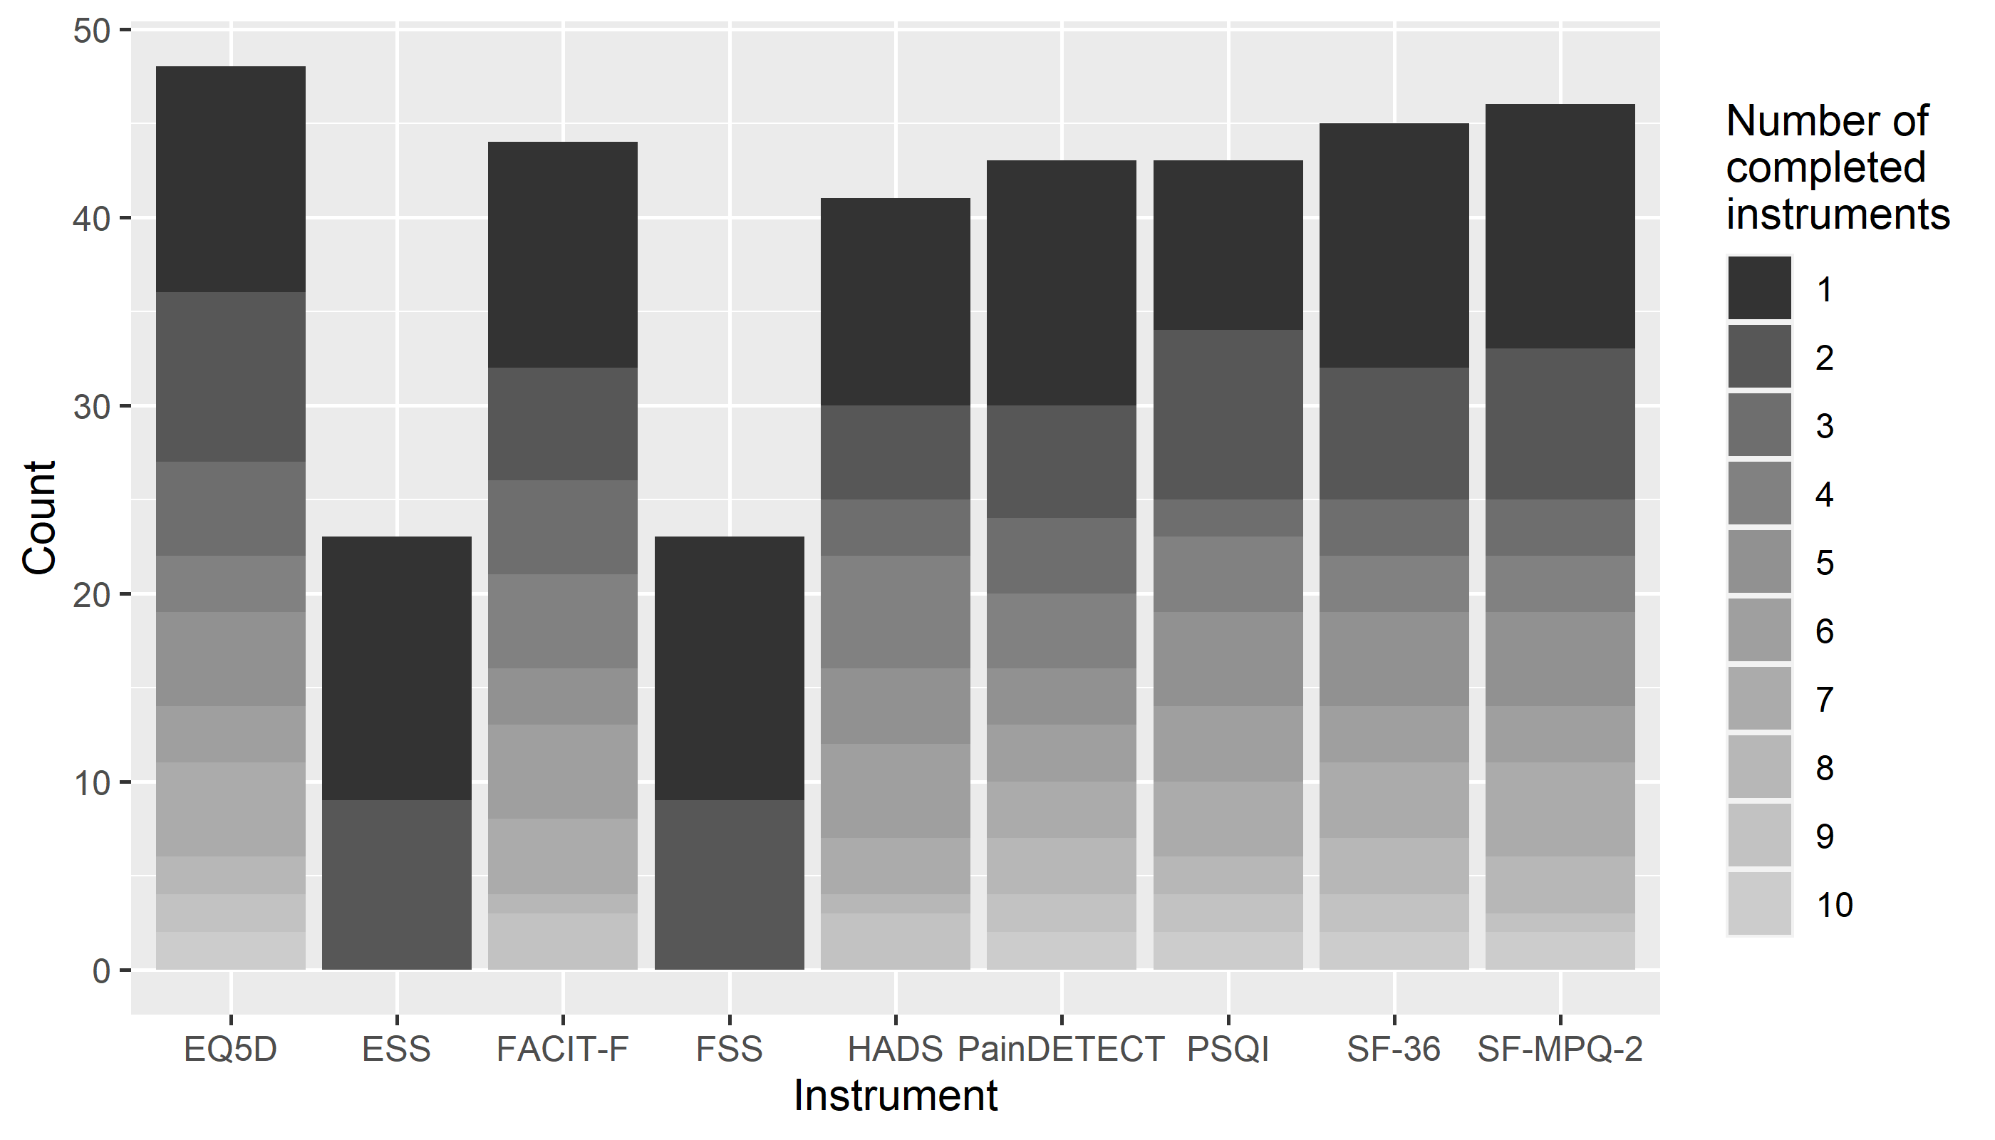
Figure A1: Stacked histogram of the number of instruments completed by the RUDY participants

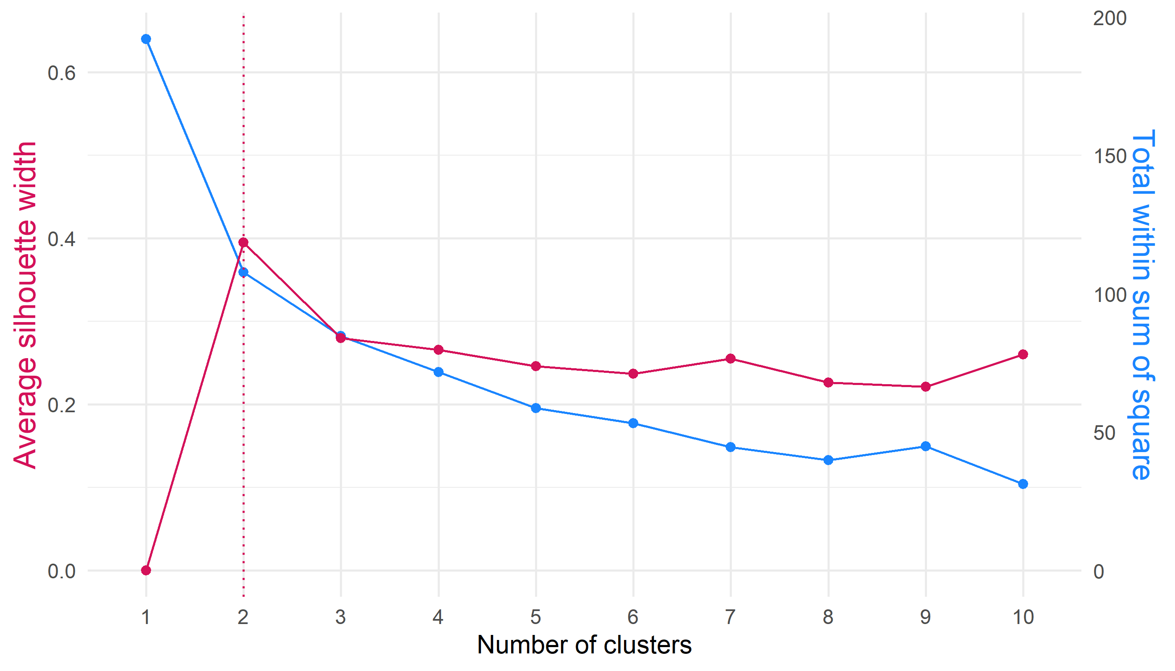
Figure A2: Cluster sensitivity analysis – Average silhouette and Elbow plot

