Supplementary Information

Integration of the landscape of fear concept in terrain management – an experimental study on deer in Bardia National Park, Nepal.

Authors
Shyam Kumar Thapa ^{a, b, 1, *}, Joost F. de Jong ^{a, 2}, Anouschka R. Hof ^{a, c, 3}, Naresh Subedi ^{b, 4}, Yorick Liefting ^{a,}, and Herbert H.T. Prins ^{d, 5}
ª Wildlife Ecology and Conservation Group, Wageningen University and Research, Droevendaalsesteeg 4, 6708 PB Wageningen, The Netherlands
^{b} National Trust for Nature Conservation, PO Box 3712, Khumaltar, Lalitpur 44700, Lalitpur, Nepal
^{c} Department of Wildlife, Fish and Environmental Studies, Swedish University of Agricultural Sciences (SLU), SE-90183 Umeå, Sweden
^{d} Animal Sciences Group, Wageningen University, De Elst 1, 6708 WD, Wageningen, The Netherlands
¹ https://orcid.org/0000-0003-4905-079X
² https://orcid.org/0000-0002-8042-6022
³ https://orcid.org/0000-0003-4517-4912
⁴ https://orcid.org/0000-0001-6743-0089
⁵ https://orcid.org/0000-0003-1131-5107

Corresponding author: * shyam.thapa@wur.nl / shamthapa@hotmail.com

Table S1: Results of the linear mixed effects model on the effects of mowing, fertilisation, species, and season on the level of use by the three deer species between the edge and the centre of the 3600 m² plots (point).
Treatments | Sum of Squares | Mean Squares | DF | F value | P value
Mowing | 0.904 | 0.904 | 1 | 112.3 | < 0.001 ***
Fertilisation | 0.249 | 0.125 | 2 | 15.48 | < 0.001 ***
Species | 24.571 | 12.285 | 2 | 1526.26 | < 0.001 ***
Season | 0.742 | 0.371 | 2 | 46.12 | < 0.001 ***
Point | 1.381 | 1.381 | 1 | 171.55 | < 0.001 ***
Mowing * Fertilisation | 0.002 | 0.001 | 2 | 0.15 | 0.857
Mowing * Species | 2.095 | 1.048 | 2 | 130.14 | < 0.001 ***
Fertilisation * Species | 0.262 | 0.066 | 4 | 8.14 | < 0.001 ***
Mowing * Species | 0.047 | 0.023 | 2 | 2.91 | 0.055
Fertilisation * Season | 0.026 | 0.007 | 4 | 0.82 | 0.513
Species * Season | 1.446 | 0.362 | 4 | 44.92 | < 0.001 ***
Mowing * Point | 0.142 | 0.142 | 1 | 17.67 | < 0.001 ***
Fertilisation * Point | 0.034 | 0.017 | 2 | 2.13 | 0.12
Species * Point | 1.59 | 0.795 | 2 | 98.79 | < 0.001 ***
Season * Point | 0.195 | 0.097 | 2 | 12.11 | < 0.001 ***
Mowing * Fertilisation * Species | 0.018 | 0.004 | 4 | 0.56 | 0.695
Mowing * Fertilisation * Season | 0.018 | 0.005 | 4 | 0.56 | 0.689
Mowing * Species * Season | 0.044 | 0.011 | 4 | 1.37 | 0.242
Fertilisation * Species * Season | 0.068 | 0.009 | 8 | 1.06 | 0.391
Mowing * Fertilisation * Point | 0.005 | 0.002 | 2 | 0.29 | 0.748
Mowing * Species * Point | 0.157 | 0.078 | 2 | 9.73 | < 0.001 ***
Fertilisation * Species * Point | 0.03 | 0.008 | 4 | 0.94 | 0.438
Mowing * Season * Point | 0.059 | 0.029 | 2 | 3.65 | 0.027 *
Fertilisation * Season * Point | 0.001 | 0 | 4 | 0.04 | 0.997
Species * Season * Point | 0.101 | 0.025 | 4 | 3.13 | 0.0146 *
Mowing * Fertilisation * Species * Season | 0.062 | 0.008 | 8 | 0.96 | 0.4672
Mowing * Fertilisation * Species * Point | 0.003 | 0.001 | 4 | 0.08 | 0.9877
Mowing * Fertilisation * Season * Point | 0.004 | 0.001 | 4 | 0.14 | 0.9678
Mowing * Species * Season * Point | 0.061 | 0.015 | 4 | 1.9 | 0.1095
Fertilisation * Species * Season * Point | 0.012 | 0.002 | 8 | 0.19 | 0.9922
Mowing * Fertilisation * Species * Season * Point | 0.023 | 0.003 | 8 | 0.35 | 0.9444

Significance codes: ∗ p < 0.05, ∗∗ p < 0.01, ∗∗∗ p < 0.001.

Fig. S1: Level of use (measured through pellet groups.m⁻²) of the three deer species in different-sized plots. Letters above each boxplot indicate a significant difference at alpha = 0.05, tested by estimated marginal means after the linear mixed effect model. Groups that share the same letter are not significantly different from each other.

Fig. S2: Level of use of the managed grasslands by the three deer species with respect to a: plot size, mowing, and species; b: plot sizes, fertilisation, and species; and c: mowing, season, and species. The level of use is measured through pellet density (groups.m⁻²) recorded in each experimental plot. Letters above each boxplot indicate a significant difference at alpha = 0.05, tested by estimated marginal means after the linear mixed effect model. Groups that share the same letter are not significantly different from each other.

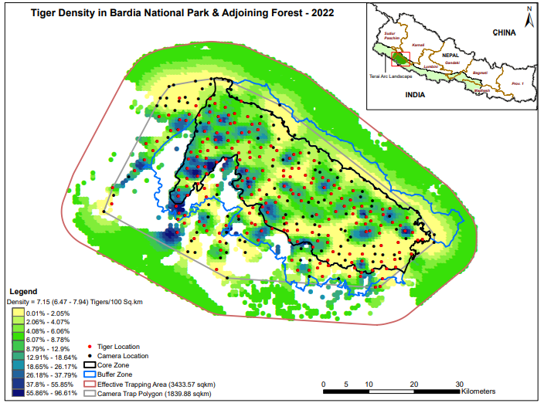
Fig. S3: Tiger density map of Bardia NP. (Source: DNPWC and DFSC 2022)

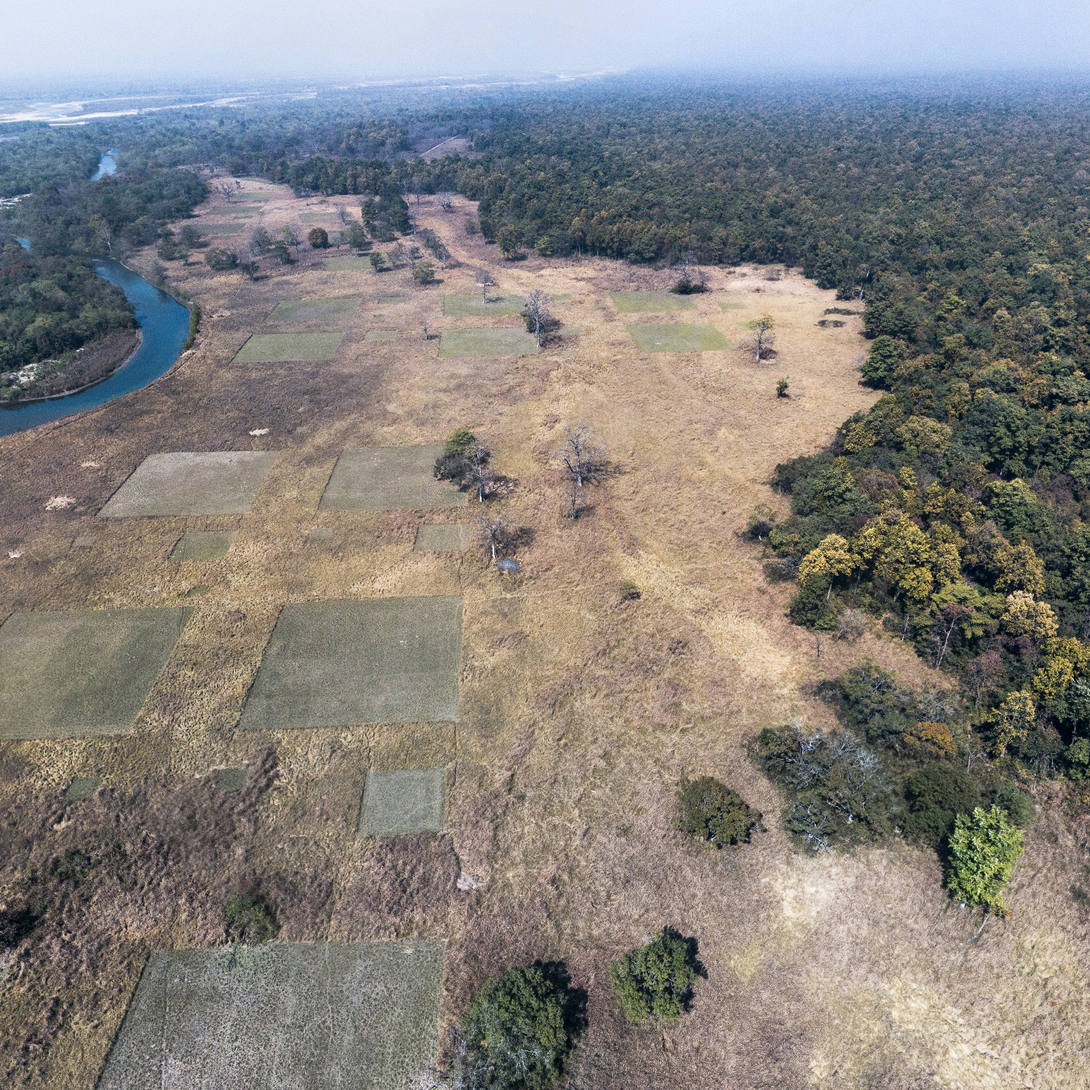
Fig. S4: Aerial view of the layout of the experimental plot in one of the open grassland phanta - Bagauraha phanta in Bardia NP. Tall grass swards were removed from the plots that were levelled to receive two or four times mowing treatment. Plots that received fertilisation treatment were fertilised with either nitrogen or phosphorus. Large-sized plots measured 3600 m², and the other two measured 400 m² and 49 m² respectively.

Edge
Edge
Centre
15 m
15 m
15 m
15 m
15 m
60 m
60 m
15 m
15 m
15 m
15 m

Fig. S5: Spatial layout of sampling points in 3600 m² plots. Each sampling point (indicated by small squares – measuring 2 m x 2m) is 15 m in distance from each other and also from the corner of the plot. The edge area of the plot is denoted by a grey shed and the central area is by white with grey dots.

