Supplementary Text and Figures for “Genome-Wide Association Studies and fine-mapping of genomic loci for n-3 and n-6 Polyunsaturated Fatty Acids in African American and Hispanic American Cohorts”

Chaojie Yang, Jenna Veenstra, Traci M. Bartz, Matthew C. Pahl, Brian Hallmark, Yii-Der Ida Chen, Jason Westra, Lyn Steffen, Christopher D. Brown, David Siscovick, Michael Y Tsai, Alexis C Wood, Stephen S Rich, Caren E Smith, Timothy D. O’Connor, Dariush Mozaffarian, Struan F.A. Grant, Floyd H Chilton, Nathan L. Tintle, Rozenn N. Lemaitre, Ani Manichaikul

Methods.

Study participants

MESA is a longitudinal cohort study of subclinical cardiovascular disease and risk factors that predict progression to clinically overt cardiovascular disease or progression of subclinical disease.¹ Between 2000 and 2002, MESA recruited 6,814 men and women 45 to 84 years of age from Forsyth County, North Carolina; New York City; Baltimore; St. Paul, Minnesota; Chicago; and Los Angeles. Participants at baseline were 38% White, 28% African American, 22% Hispanic and 12% Asian (primarily Chinese) ancestry.

CHS is a population-based cohort study of risk factors for coronary heart disease and stroke in adults ≥65 years conducted across four field centers.² The original predominantly European ancestry cohort of 5,201 persons was recruited in 1989-1990 from random samples of the Medicare eligibility lists; subsequently, an additional predominantly African-American cohort of 687 persons was enrolled in 1992-1993 for a total sample of 5,888. Analyses were limited to those with available DNA who consented to genetic studies.
FHS is a population-based longitudinal study of families living in Framingham, Massachusetts which originated in 1948 and consisted of individuals of predominantly European ancestry.³ In 1994, the Omni Cohort 1 enrolled 507 men and women of African-American, Hispanic, Asian, Indian, Pacific Islander and Native American origins, who at the time of enrollment were residents of Framingham and the surrounding towns.

Fatty Acid measurements

MESA: The fatty acids were measured in EDTA plasma, frozen at –70°C, using methods previously described by Cao.⁴ Lipids were extracted from the plasma using a chloroform/methanol extraction method and the cholesterol esters, triglyceride, phospholipids and free fatty acids are separated by thin layer chromatography. The fatty acid methyl esters were obtained from the phospholipids and were detected by gas chromatography flame ionization. Individual fatty acids were expressed as a percent of total fatty acids. A total of 28 fatty acids were identified.
CHS: Blood was drawn after a 12-hour fast and stored at –70°C. Total lipids were extracted from plasma using methods of Folch⁵, and phospholipids separated from neutral lipids by one-dimensional TLC. Fatty-acid-methyl-ester (FAME) samples were prepared by direct transesterification using methods of Lepage and Roy⁶, and separated using gas chromatography (Agilent5890 gas- chromatograph-FID-detector; Supelco fused-silica 100m capillary column SP-2560; initial 160°C 16 min, ramp 3.0°C/min to 240°C, hold 15 min).⁷ Identification, precision, and accuracy were continuously evaluated using model mixtures of known FAMEs and established in-house controls, with identification confirmed by GC-MS at USDA (Peoria, IL). A total of 42 fatty acids were identified. Fatty acid levels were expressed as percent of total fatty acids. CVs were <3% for most fatty acids.

FHS: Red blood cells (RBCs) were isolated from blood drawn after a 10–12 h fast and frozen at −80 °C immediately after collection. RBC fatty acid composition was analyzed by gas chromatography (GC) with flame ionization detection as previously described.⁸ Briefly, unwashed, packed RBCs were directly methylated with boron trifluoride and hexane at 100 °C for 10 min. The fatty acid methyl esters thus generated were analyzed using a GC2010 Gas Chromatograph (Shimadzu Corporation, Columbia, MD) equipped with an SP2560, fused silica capillary column (Supelco, Bellefonte, PA). Fatty acids were identified by comparison with a standard mixture of fatty acids characteristic of RBC (GLC 727, NuCheck Prep, Elysian, MN) which was also used to determine individual fatty acid response factors. The omega-3 index is defined as the sum of EPA and DHA expressed as a percent of total identified fatty acids. The coefficients of variation were 6.2% for EPA, 4.4% for DHA and 3.2% for the omega-3 index. All fatty acids present at >1% abundance had CVs of ≤7%.

Removing of outliers for race/ethnic groups

Self-reported race/ethnicity were cleaned by removing principal component analysis outliers for each of cohorts.

Genotyping and imputation

MESA: Participants in the MESA cohort who consented to genetic analyses and data sharing (dbGaP) were genotyped using the Affymetrix Human SNP Array 6.0 (GWAS array) as part of the NHLBI CARe (Candidate gene Association Resource) and SHARe (SNP Health Association Resource) projects. Genotype quality control for these data included filter on SNP level call rate < 95%, individual level call rate < 95%, heterozygosity > 53%, described previously7. The cleaned genotypic data was deposited with MESA phenotypic data into dbGaP (study accession phs000209.v13.p3); 8,224 consenting individuals (2,685 White, 2,588 non-Hispanic African-American, 2,174 Hispanic, 777 Chinese) were included, with 897,981 SNPs passing study specific quality control (QC). SNP coverage from the original GWAS SNP genotyping array was increased through imputation using the 1,000 Genomes Phase 3 integrated variant set completed using the Michigan Imputation Server (https://imputationserver.sph.umich.edu).

CHS: DNA was extracted from blood samples drawn on all participants at their baseline examination. In 2010, genotyping was performed at the General Clinical Research Center's Phenotyping/Genotyping Laboratory at Cedars-Sinai using the Illumina HumanOmni1-Quad_v1 BeadChip system on African-American CHS participants who consented to genetic testing, and had DNA available for genotyping. Genotyping was attempted in 844 participants, and was successful in 823. Participants were excluded if they had a call rate<=95% or if their genotype was discordant with known sex or prior genotyping (to identify possible sample swaps). Genotype quality control excluded SNPs with a call rate < 97%, HWE P < 10-5, > 1 duplicate error or Mendelian inconsistency (for reference CEPH trios), heterozygote frequency = 0, which resulted in a final set of 963,248 SNPs (940,567 autosomal). Imputation to the 1,000 Genomes Phase I integrated variant set was completed using IMPUTE version 2.2.2. Variants with insufficient effective minor alleles are filtered prior to analysis, with a threshold set at 5 effective alleles resulting in 14,191,388 variants for analysis.

FHS: Direct genotypes were obtained using the Affymetrix 500K and MIPS 50K chips, and were analyzed at the Affymetrix Core Laboratory. Genotype quality control for these data included filter on SNP level call rate < 95%, individual level call rate < 95%, HWE P < 10-5, and genotypes with Mendel errors were set to missing. The cleaned genotypic data consisted of N= 414 (211 Hispanic, 203 African-American) with 628,076 SNPs passing study specific quality control (QC). SNP coverage from the original GWAS SNP genotyping array was increased through imputation using the 1,000 Genomes Phase 3 integrated variant set completed using the Michigan Imputation Server (https://imputationserver.sph.umich.edu).

Reference.
1. Bild, D. E. et al. Multi-Ethnic Study of Atherosclerosis: objectives and design. Am. J. Epidemiol. 156, 871–881 (2002).
2. Fried, L. P. et al. The Cardiovascular Health Study: design and rationale. Ann Epidemiol 1, 263–276 (1991).
3. Mahmood, S. S., Levy, D., Vasan, R. S. & Wang, T. J. The Framingham Heart Study and the epidemiology of cardiovascular disease: a historical perspective. Lancet 383, 999–1008 (2014).
4. Cao, J., Schwichtenberg, K. A., Hanson, N. Q. & Tsai, M. Y. Incorporation and clearance of omega-3 fatty acids in erythrocyte membranes and plasma phospholipids. Clin. Chem. 52, 2265–2272 (2006).
5. Folch, J., Lees, M. & Sloane Stanley, G. H. A simple method for the isolation and purification of total lipides from animal tissues. J Biol Chem 226, 497–509 (1957).
6. Lepage, G. & Roy, C. C. Direct transesterification of all classes of lipids in a one-step reaction. J Lipid Res 27, 114–120 (1986).
7. Mozaffarian, D. et al. Circulating palmitoleic acid and risk of metabolic abnormalities and new-onset diabetes. Am J Clin Nutr 92, 1350–1358 (2010).
8. Harris, W. S., Pottala, J. V., Vasan, R. S., Larson, M. G. & Robins, S. J. Changes in erythrocyte membrane trans and marine fatty acids between 1999 and 2006 in older Americans. J Nutr 142, 1297–1303 (2012).

Figure S1. Manhattan plot of meta-analysis of GWAS for PUFAs in the Hispanic Americans.
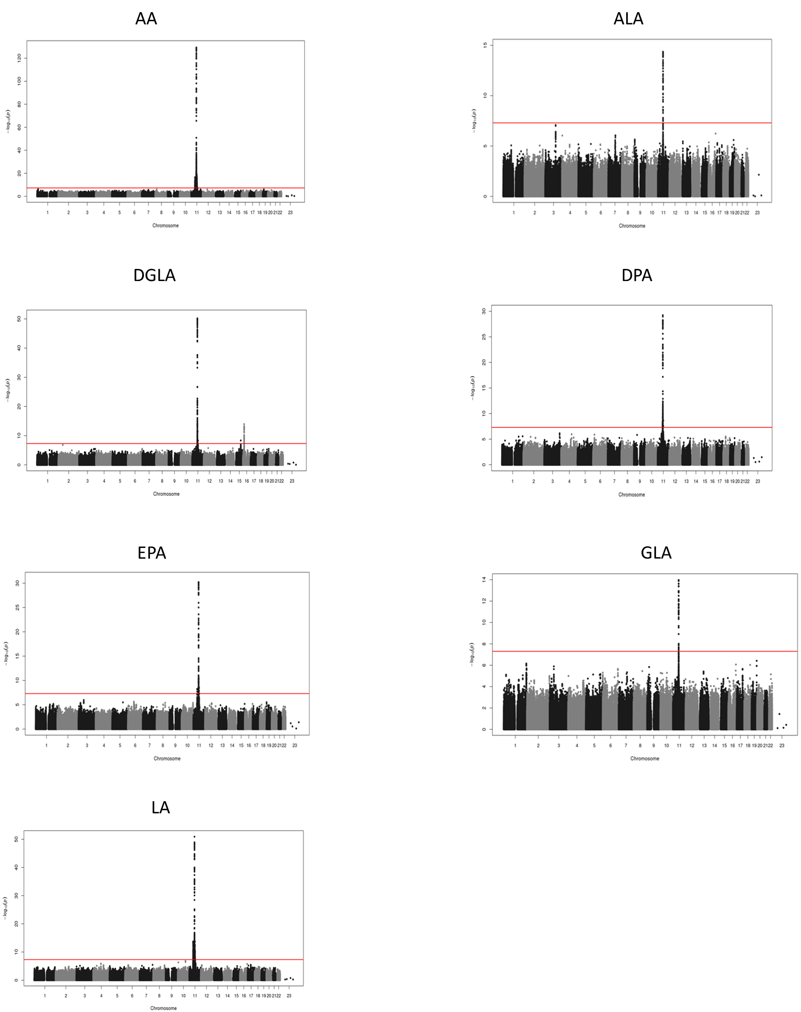
Figure S1 shows the Manhattan plot for PUFAs in the Hispanic Americans. Red line refers to the cut off (–log10(5 x 10-8)) of genome-wide significant variants.
Figure S2. Manhattan plot of meta-analysis of GWAS for PUFAs in the African American population.
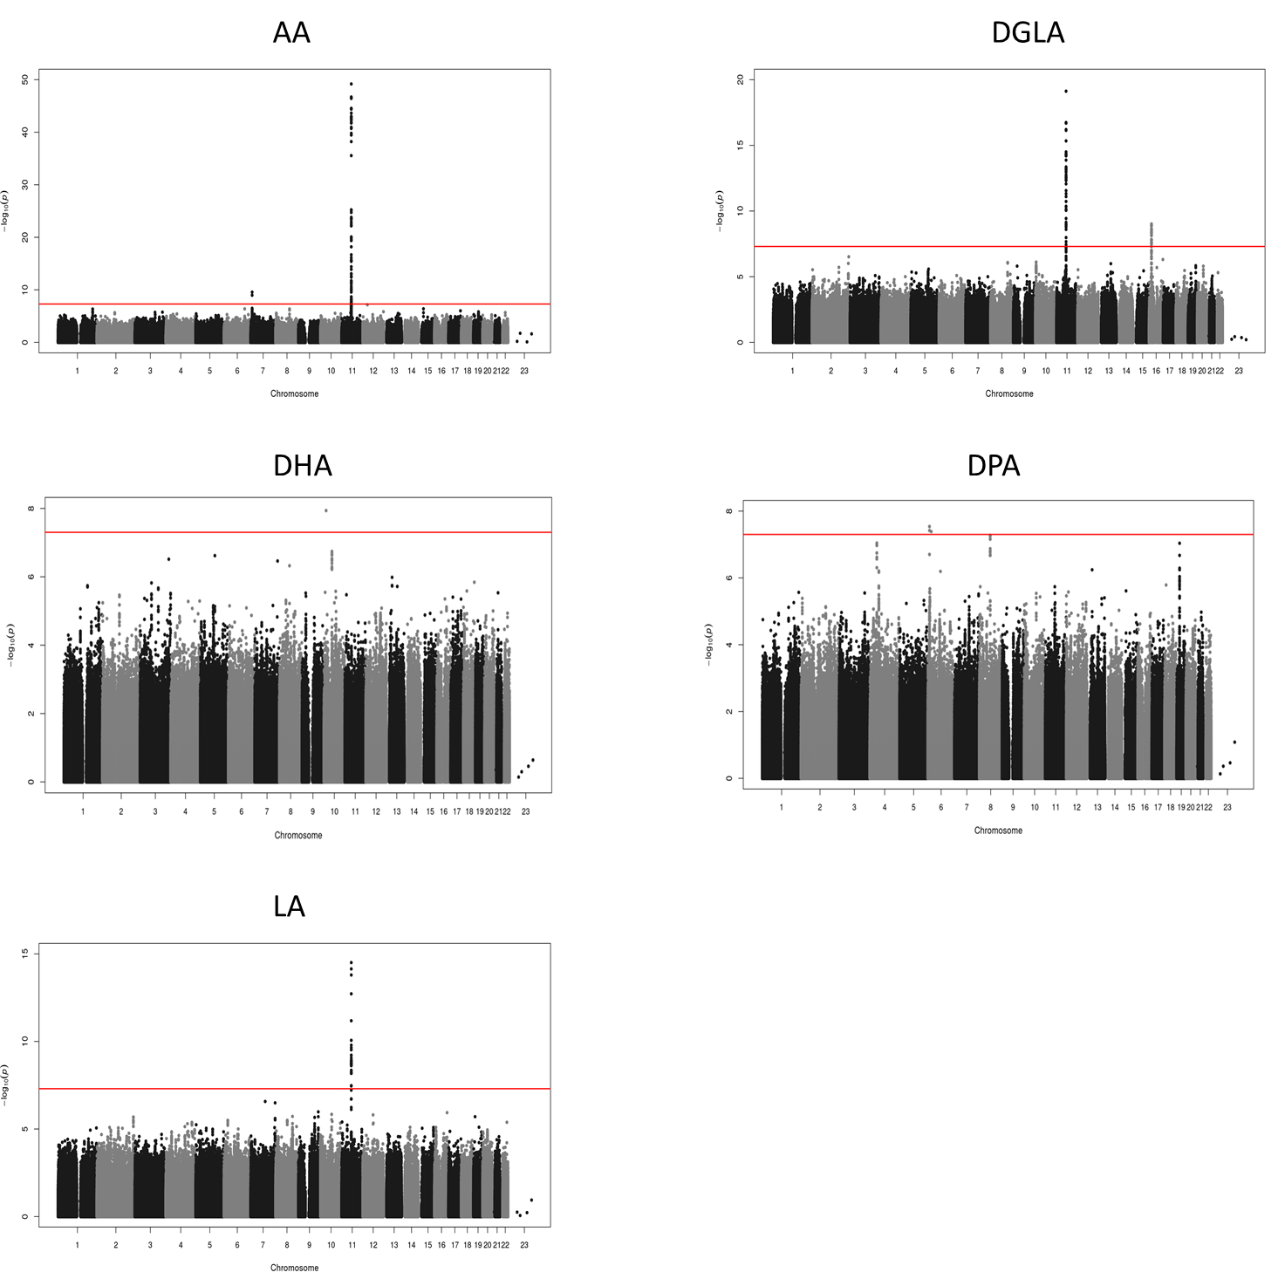Figure S2 shows the Manhattan plot for PUFAs in the African Americans. Red line refers to the cut off (–log10(5 x 10-8)) of genome-wide significant variants.

Figure S3. Local association plot of most significant for each PUFAs on each chromosome in the Hispanic Americans.
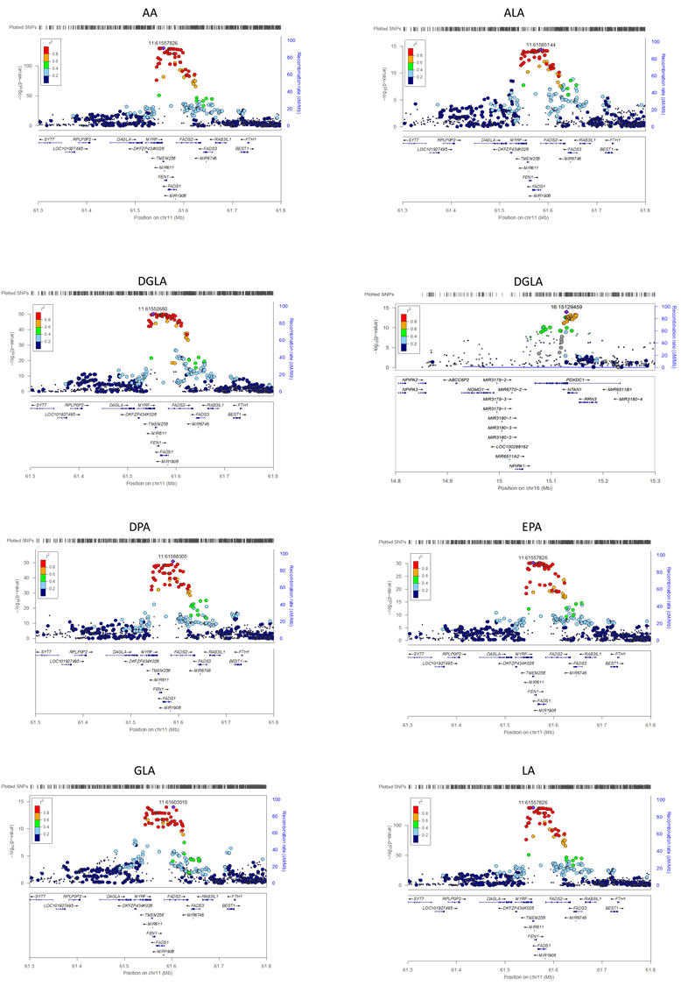
Figure S3 shows Local association plot of most significant for each PUFAs on each chromosome in the Hispanic Americans in the Hispanic Americans. Reference panel used to color LD is 1000 Genomes Americas (AMR) and the color scheme is red for strong linkage disequilibrium (LD; r2≥0.8) and blue color for lower LD.
Figure S4. Local association plot of most significant for each PUFAs on each chromosome in the African Americans.
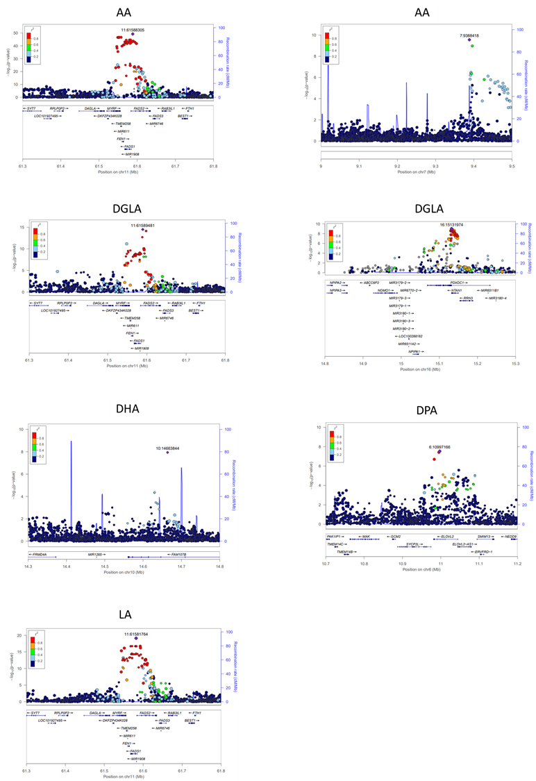
Figure S4 shows local association plot of most significant for each PUFAs on each chromosome in the African Americans. Reference panel used to color LD is 1000 Genomes Africa (AFA) and the color scheme is red for strong linkage disequilibrium (LD; r2≥0.8) and blue color for lower LD.

