A New Strategy of bi-Alkali Metal Doping to Design Boron Phosphide Nanocages of High Nonlinear Optical Response with Better Thermodynamic Stability
Rimsha Baloach¹, Khurshid Ayub², Tariq Mahmood², Anila Asif³, Sobia Tabassum³*, Mazhar Amjad Gilani¹*

¹Department of Chemistry, COMSATS University Islamabad, Lahore Campus, Lahore-54600, Pakistan
²Department of Chemistry, COMSATS University, Abbottabad Campus, Abbottabad-22060, Pakistan.
³Interdisciplinary Research Centre in Biomedical Materials (IRCBM), COMSATS University Islamabad, Lahore Campus, Lahore-54600, Pakistan

*Corresponding Authors
Mazhar Amjad Gilani
Email: mazhargilani@cuilahore.edu.pk
Sobia Tabassum
sobiatabassum@cuilahore.edu.pk

Supporting Information
Cartesian coordinates of B₁₂P₁₂
B 1.18782700 2.43305300 -0.00049500
B 0.00000000 1.18828800 -2.43288100
B -1.18782700 2.43305300 -0.00049500
B 0.00000000 1.18790500 2.43364800
B -2.43299300 0.00000000 -1.18798900
B -2.43290500 0.00000000 1.18794800
B -1.18782700 -2.43305300 -0.00049500
B 0.00000000 -1.18790500 2.43364800
B 0.00000000 -1.18828800 -2.43288100
B 1.18782700 -2.43305300 -0.00049500
B 2.43290500 0.00000000 1.18794800
B 2.43299300 0.00000000 -1.18798900
P -2.83481600 1.46638200 0.00016400
P -2.83481600 -1.46638200 0.00016400
P -1.46619500 0.00000000 -2.83481100
P 0.00000000 2.83573600 -1.46682100
P 0.00000000 2.83424800 1.46608600
P 1.46619500 0.00000000 -2.83481100
P 2.83481600 1.46638200 0.00016400
P 2.83481600 -1.46638200 0.00016400
P 1.46652100 0.00000000 2.83530600
P -1.46652100 0.00000000 2.83530600
P 0.00000000 -2.83424800 1.46608600
P 0.00000000 -2.83573600 -1.46682100
Cartesian Coordinates of Li₂@b₆₄
B -1.18623200 2.48707100 0.03364800
B 0.01200200 1.17442100 2.43143900
B 1.21192600 2.48264700 0.01452000
B -0.01056500 1.23408100 -2.34928700
B 2.31045900 -0.00011600 1.03198400
B 2.04384600 -0.00025800 -0.80261400
B 1.21146200 -2.48286300 0.01498200
B -0.01078900 -1.23448800 -2.34903800
B 0.01177600 -1.17396400 2.43165700
B -1.18668300 -2.48682200 0.03410000
B -2.18563100 0.00018700 -0.92490500
B -2.43787700 0.00037000 1.20940200
P 2.92297500 1.55536500 0.01757300
P 2.92268300 -1.55589900 0.01785800
P 1.49336600 0.00012100 2.79501500
P 0.01274000 2.83954600 1.49004600
P -0.00989100 2.91946500 -1.45283800
P -1.46339100 0.00040900 2.84728400
P -2.87155000 1.51309000 0.06479100
P -2.87180000 -1.51248900 0.06506900
P -1.47779000 -0.00011000 -2.70455600
P 1.44632700 -0.00037300 -2.67291700
P -0.01042900 -2.91972100 -1.45230200
P 0.01220300 -2.83926500 1.49057100
Li 3.87326500 -0.00052400 -1.88485900
Li -4.03997500 -0.00061300 -1.93626500
Cartesian Coordinates of Li₂@b₆₆
B 2.04127000 0.72869500 1.71902300
B 1.45972400 -2.07206200 0.81246500
B 2.64811700 0.33152000 -0.51700900
B 0.80007300 2.62363400 -0.21924200
B 0.79396200 -1.46502200 -2.02941400
B 0.45382400 0.76406700 -2.53791700
B -1.79597100 -0.57164800 -1.38282500
B -1.51927400 2.17210200 -0.78049900
B -0.86486500 -2.55641000 0.27340000
B -2.04813800 -0.26357500 0.26907700
B -0.78134100 1.59204200 2.02963000
B -0.43569800 -0.72350200 2.55420900
P 2.18728000 -0.10214100 -2.32572600
P -0.66990300 -0.72451300 -3.00055300
P 0.75815800 -2.94394400 -0.79492500
P 2.95081600 -0.84994000 1.03242200
P 2.53423900 2.01939300 0.38010900
P 0.02959800 -2.49948900 2.01351100
P 0.67285300 0.78841100 3.02867400
P -2.09519500 0.18868600 2.21838000
P -0.77810000 3.05096100 0.80201300
P -0.00682600 2.52018400 -1.96277500
P -3.00483200 0.95756200 -1.01899200
P -2.61402100 -2.09314600 -0.37660000
Li 3.05206500 -2.10258600 -1.14919500
Li -4.12519900 -0.39059600 0.85333000
Cartesian Coordinates of Li₂@r₆
B 0.70570400 1.51528100 2.11610800
B -0.70480300 -1.07563500 2.36987800
B 2.02360700 -0.33440300 1.67248500
B 2.02138000 1.61762000 -0.54625200
B 0.70789600 -2.58978900 0.25360600
B 2.02342100 -1.27983300 -1.12757400
B -0.70569500 -1.51515200 -2.11610600
B 0.70476900 1.07562600 -2.36983600
B -2.02140600 -1.61768300 0.54630000
B -2.02358500 0.33435500 -1.67248400
B -0.70785000 2.58989300 -0.25360300
B -2.02352200 1.27983300 1.12760100
P 2.49267200 -1.93429000 0.68040800
P 0.78797900 -2.65287900 -1.67826500
P -0.78463600 -2.78041800 1.45908100
P 0.78760700 -0.12608400 3.13667800
P 2.49051100 1.55911100 1.33525500
P -2.49046700 -0.37959200 2.01749800
P -0.78803200 2.65287300 1.67826200
P -2.49259600 1.93428100 -0.68038500
P 0.78467200 2.78043000 -1.45905300
P 2.49045700 0.37959200 -2.01746600
P -0.78765000 0.12613800 -3.13675900
P -2.49050600 -1.55919700 -1.33523600
Li 3.88772400 0.00249100 -0.00088000
Li -3.88763100 -0.00250300 0.00059300
Cartesian Coordinates of Li₂@B
B -1.51887500 2.17264000 -0.77967300
B -0.78218000 1.59069300 2.03037300
B 0.80015600 2.62379600 -0.21702600
B 0.45519500 0.76598600 -2.53677600
B 2.04054100 0.72761700 1.72032200
B 2.64892800 0.33159900 -0.51574700
B 1.45952600 -2.07259700 0.81177400
B 0.79529300 -1.46394800 -2.03006200
B -0.43722300 -0.72545300 2.55316100
B -0.86484800 -2.55638000 0.27083600
B -1.79556400 -0.57062100 -1.38380600
B -2.04863100 -0.26439600 0.26825300
P 2.53397900 2.01906300 0.38241200
P 2.95029100 -0.85050400 1.03324200
P 0.67148300 0.78608000 3.02938000
P -0.77847800 3.05038300 0.80392800
P -0.00608200 2.52170900 -1.96095100
P -2.09627100 0.18724400 2.21742200
P -3.00437900 0.95829500 -1.01968000
P -2.61399900 -2.09287000 -0.37919200
P -0.66838200 -0.72220400 -3.00081200
P 2.18850900 -0.10041500 -2.32512500
P 0.75867300 -2.94350800 -0.79672900
P 0.02859400 -2.50105300 2.01165300
Li -4.12567400 -0.39141800 0.85112100
Li 3.05211600 -2.10124400 -1.14824500
Cartesian Coordinates of Li₂@P
B -0.49611200 1.08159000 2.41564900
B -2.17654300 -1.02736900 1.16072100
B 0.49523200 -1.08167300 2.41580800
B 2.17615600 1.02735300 1.16159800
B -0.07230400 -2.73419200 -0.00004400
B 2.05981500 -1.77292600 0.00037200
B 0.49611000 -1.08160000 -2.41563800
B 2.17653400 1.02736000 -1.16070200
B -2.17615100 -1.02735500 -1.16158900
B -0.49523300 1.08166300 -2.41580200
B 0.07230600 2.73418700 0.00005200
B -2.05980500 1.77291300 -0.00036300
P 1.17113800 -2.62173600 1.48786800
P 1.17168800 -2.62168100 -1.48748900
P -2.00008900 -2.56338200 -0.00040800
P -1.33956700 -0.61404200 2.83000100
P 1.33852400 0.61395100 2.83053300
P -3.15770300 0.18738500 -0.00060500
P -1.17168600 2.62167000 1.48749800
P -1.17113700 2.62172900 -1.48786100
P 2.00009300 2.56337900 0.00041700
P 3.15770000 -0.18739400 0.00062100
P 1.33956500 0.61403100 -2.82998500
P -1.33852800 -0.61396300 -2.83053100
Li 5.56629800 -0.01707100 -0.00039900
Li -5.56629500 0.01742000 -0.00000100
Cartesian Coordinates of Na₂@b₆₆
B 1.77445400 -0.00058600 1.98368200
B 1.09026600 -2.47780900 0.47655100
B 2.40411300 -0.00066700 -0.00741000
B 1.09132200 2.47718800 0.47681600
B 0.93788900 -1.20125400 -2.20318800
B 0.93848200 1.20095800 -2.20300200
B -1.77614900 0.00049900 -1.99151000
B -1.08925000 2.47789400 -0.47680500
B -1.09033900 -2.47740700 -0.47705300
B -2.41132200 0.00055700 0.01116400
B -0.93769200 1.20134900 2.20341000
B -0.93822100 -1.20120900 2.20327900
P 2.44288000 -0.00055500 -1.94140800
P -0.24298000 0.00020600 -3.15099700
P 0.58945000 -2.88165300 -1.35561500
P 2.64492000 -1.53167900 1.16539600
P 2.64549800 1.53027200 1.16555900
P -0.59046900 -2.88111500 1.35482000
P 0.24409400 -0.00025000 3.14917300
P -2.44333400 0.00042700 1.94346100
P -0.58920300 2.88120100 1.35512600
P 0.59075700 2.88143600 -1.35530400
P -2.64263000 1.52960600 -1.16506100
P -2.64326700 -1.52833900 -1.16522000
Na 4.86275000 0.00047200 -0.20148200
Na -4.86761300 0.00035100 0.20342500
Cartesian Coordinates of Na₂@r₆
B 0.70791300 -2.61697700 -0.09173000
B -0.70934600 -1.22854800 -2.31264700
B 2.01664100 -1.11870800 -1.28786000
B 2.01608800 -0.55685100 1.61196000
B 0.71012100 1.38771400 -2.21976300
B 2.01727300 1.67384200 -0.32382200
B -0.70786400 2.61698400 0.09193000
B 0.70934600 1.22844000 2.31248200
B -2.01618500 0.55699300 -1.61210100
B -2.01661700 1.11869500 1.28788000
B -0.71006900 -1.38791700 2.21983900
B -2.01739500 -1.67372000 0.32383500
P 2.48702700 0.64401200 -1.92971600
P 0.78671000 2.95365200 -1.07754000
P -0.78476500 0.54408600 -3.09660600
P 0.78465700 -2.41023100 -2.01903600
P 2.48540500 -1.99466800 0.40675700
P -2.48657800 -1.34826000 -1.52384600
P -0.78684300 -2.95366200 1.07745500
P -2.48695200 -0.64404100 1.92977100
P 0.78476300 -0.54415400 3.09658100
P 2.48666800 1.34832500 1.52385100
P -0.78469700 2.41024700 2.01917200
P -2.48533000 1.99469800 -0.40676200
Na 4.46402600 -0.00096100 0.00039500
Na -4.46407100 0.00097800 -0.00050700
Cartesian Coordinates of Na₂@r₄
B 0.00310900 -1.19470100 2.40134900
B 2.36680300 -0.00101700 1.10635100
B 0.00340200 1.19357500 2.40141400
B -2.36486200 -0.00037900 1.11456800
B 1.17683700 2.49060200 -0.00155800
B -1.17631100 2.49085700 0.00166400
B -0.00312600 1.19377000 -2.40179500
B -2.36765900 -0.00017200 -1.10796000
B 2.36450200 -0.00083800 -1.11411300
B -0.00342100 -1.19423200 -2.40199900
B -1.17698800 -2.49126800 0.00137600
B 1.17657700 -2.49148400 -0.00186800
P 0.00233100 2.88404400 1.48962100
P -0.00177000 2.88390900 -1.48945100
P 2.85935900 1.51771200 -0.00439900
P 1.47625300 -0.00077400 2.79773200
P -1.46853800 -0.00042200 2.80256200
P 2.85967800 -1.51943100 -0.00461100
P 0.00175700 -2.88486000 1.48914600
P -0.00235500 -2.88430500 -1.48968600
P -2.85946500 -1.51843100 0.00373500
P -2.85879600 1.51811500 0.00403400
P -1.47631900 -0.00002700 -2.79866300
P 1.46859900 -0.00039900 -2.80272000
Na -5.15097800 0.00433300 0.00148200
Na 5.15049400 0.00470700 0.00337000
Cartesian Coordinates of Na₂@P
B -0.54237900 1.05748300 2.42289400
B -2.13749200 -1.11460600 1.16658500
B 0.53986300 -1.05701600 2.42346000
B 2.13634400 1.11513000 1.16887900
B 0.04838400 -2.72505200 0.00039700
B 2.13369900 -1.65320800 0.00149600
B 0.54229500 -1.05697200 -2.42209600
B 2.13740200 1.11509800 -1.16575100
B -2.13627600 -1.11458600 -1.16802400
B -0.53995600 1.05753000 -2.42264000
B -0.04845500 2.72555200 0.00037000
B -2.13388700 1.65382000 -0.00070600
P 1.28654000 -2.55379300 1.48349700
P 1.28807600 -2.55377100 -1.48143200
P -1.87833100 -2.63443200 -0.00060300
P -1.31280500 -0.67092400 2.83473800
P 1.30984200 0.67139600 2.83615000
P -3.17222700 0.03711400 -0.00123600
P -1.28812500 2.55424500 1.48218400
P -1.28665100 2.55434300 -1.48272200
P 1.87824100 2.63493600 0.00139100
P 3.17217300 -0.03658100 0.00209900
P 1.31271100 0.67144600 -2.83392900
P -1.30994500 -0.67089000 -2.83536900
Na 5.96588200 -0.00348800 -0.00446300
Na -5.96499100 -0.00216500 -0.00425100
Cartesian Coordinates of K₂@b₆₄
B 1.18153000 0.30648000 2.46651200
B 0.00062500 2.71709100 1.18096500
B -1.17898500 0.30655300 2.46778100
B 0.00058200 -2.09197400 1.20219000
B -2.41709900 1.44792600 0.00179500
B -2.24351800 -0.72704100 0.00108500
B -1.18142400 0.30805400 -2.46640900
B -0.00057900 -2.09130900 -1.20346300
B -0.00068200 2.71775900 -1.17946700
B 1.17909300 0.30808600 -2.46765400
B 2.24367600 -0.72717300 -0.00168800
B 2.41726800 1.44834000 -0.00096700
P -2.86499000 0.31194700 1.51481800
P -2.86630600 0.31289100 -1.51149400
P -1.47723900 3.12373300 0.00169500
P 0.00154800 1.78397100 2.85509200
P 0.00150800 -1.18370500 2.89647700
P 1.47717600 3.12387500 0.00006200
P 2.86628600 0.31199800 1.51141900
P 2.86499400 0.31298700 -1.51453000
P 1.47849100 -2.49123900 -0.00151100
P -1.47848200 -2.49127200 0.00000800
P -0.00140200 -1.18192500 -2.89714000
P -0.00141200 1.78573900 -2.85422900
K -4.82305400 -1.98406300 -0.00056300
K 4.82278900 -1.98430300 -0.00014200
Cartesian Coordinates of K₂@b₆₆
B 1.72544400 -0.00007500 -2.04665900
B 1.07324300 2.46618000 -0.49966500
B 2.47171700 -0.00006100 -0.01377300
B 1.07304000 -2.46618400 -0.49957300
B 0.99275400 1.19372800 2.18794100
B 0.99265800 -1.19360000 2.18798300
B -1.72556800 0.00018300 2.04616000
B -1.07336400 -2.46618100 0.49975000
B -1.07321300 2.46636400 0.49963700
B -2.47116200 0.00018100 0.01451900
B -0.99302000 -1.19369100 -2.18770600
B -0.99284700 1.19379100 -2.18779000
P 2.50242200 -0.00001500 1.91310500
P -0.16824000 0.00012300 3.17440800
P 0.62306000 2.87563700 1.34440400
P 2.60664400 1.51795600 -1.21372600
P 2.60653700 -1.51813000 -1.21366700
P -0.62289200 2.87574900 -1.34451400
P 0.16789600 -0.00004800 -3.17419700
P -2.50246400 0.00017700 -1.91247000
P -0.62314000 -2.87564800 -1.34439500
P 0.62286400 -2.87554500 1.34452200
P -2.60689300 -1.51811800 1.21392000
P -2.60684700 1.51849200 1.21387200
K 5.34033700 -0.00029900 0.07299800
K -5.33942100 -0.00036500 -0.07421100
Cartesian Coordinates of K₂@r₆
B 0.71371900 -2.25829400 1.31892100
B -0.71253300 -2.27177100 -1.29604800
B 2.02901800 -1.62973600 -0.49438100
B 2.02844500 0.38697900 1.65966600
B 0.71342100 -0.01284000 -2.61538500
B 2.02877100 1.24393100 -1.16409500
B -0.71369600 2.25803700 -1.31892100
B 0.71253800 2.27152400 1.29645300
B -2.02838900 -0.38688400 -1.65908800
B -2.02898800 1.62937800 0.49491500
B -0.71341700 0.01277000 2.61563100
B -2.02865400 -1.24431500 1.16441400
P 2.49183600 -0.47758700 -1.97451900
P 0.78662500 1.92089000 -2.47965500
P -0.78621700 -1.18755200 -2.90308700
P 0.78773000 -3.10818700 -0.42327600
P 2.49200800 -1.47062800 1.40169100
P -2.49109700 -1.94962400 -0.57349300
P -0.78636700 -1.92098200 2.47995300
P -2.49189700 0.47718800 1.97466200
P 0.78628900 1.18756200 2.90365800
P 2.49114300 1.94964200 0.57381400
P -0.78756900 3.10772500 0.42341200
P -2.49203100 1.47051700 -1.40126400
K 4.99238300 0.00070700 -0.00100500
K -4.99280100 0.00043100 -0.00104000
Fig.S1: Optimized geometries of bi-alkali metal doped Complexes.
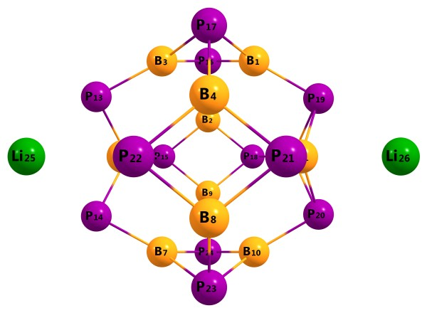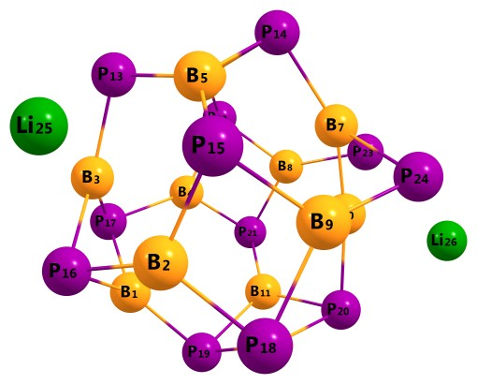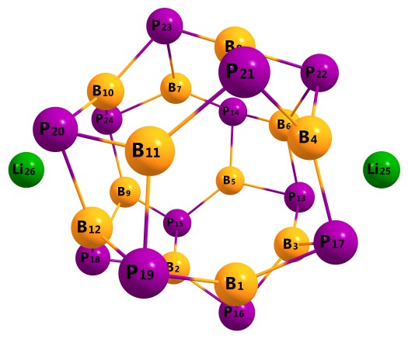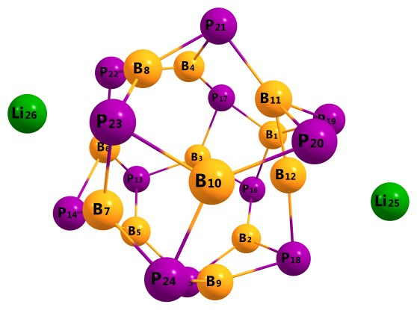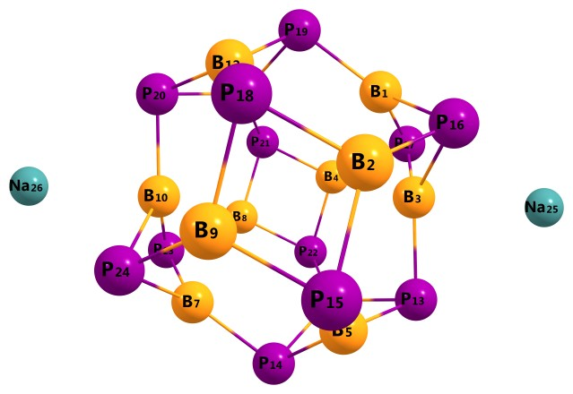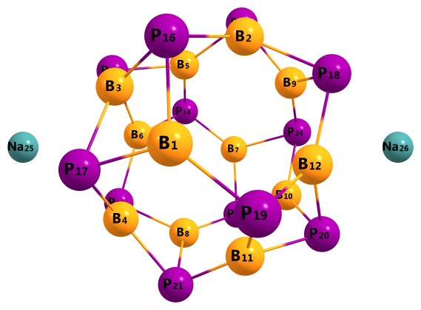
Li₂@b₆₄
Li₂@b₆₆

Li₂@r₆
Li₂@B
Na₂@b₆₆
Na₂@r₆
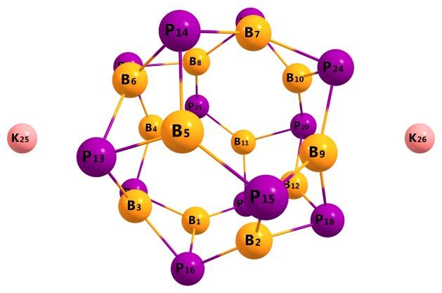
K₂@r₆

Fig.S2: HOMO and LUMO of bi-alkali metal doped nanocages. (Iso value=0.02)
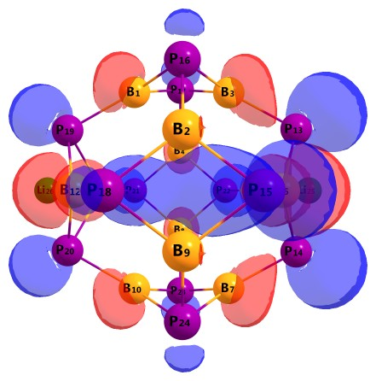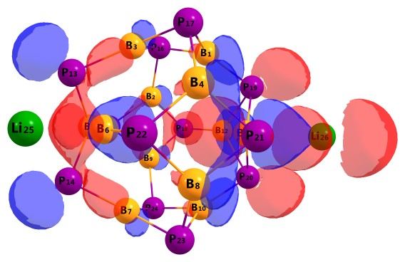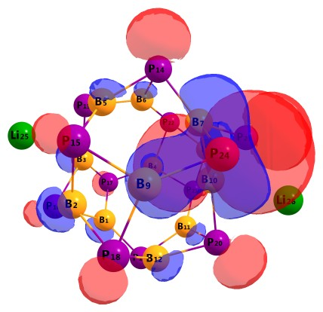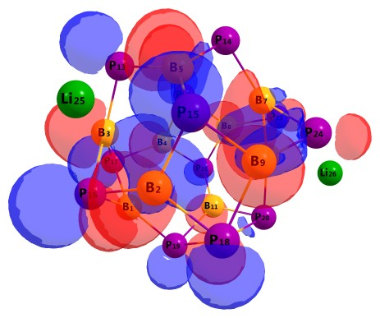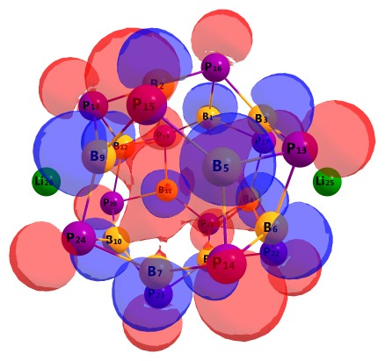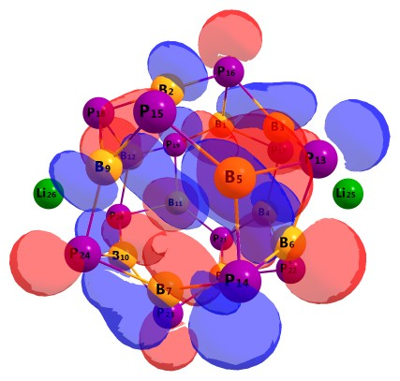
HOMO
LUMO
Li₂@b₆₄
Li₂@b₆₆
Li₂@r₆
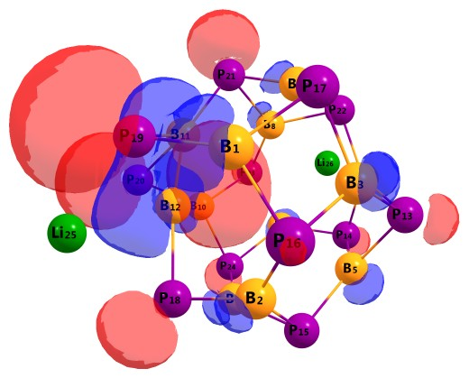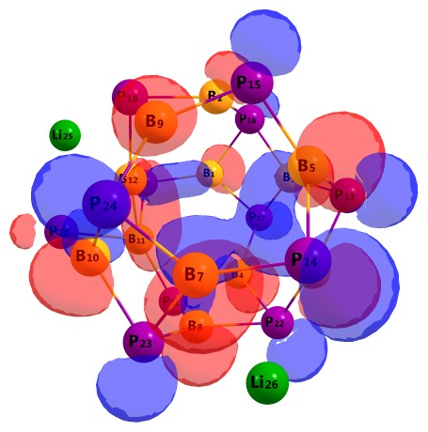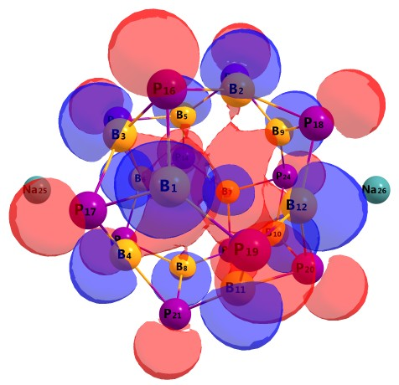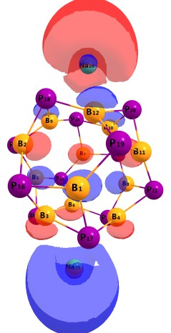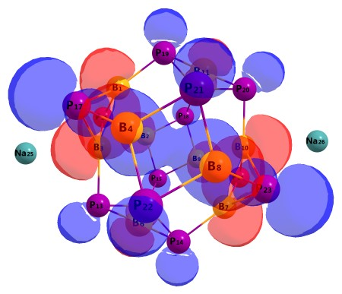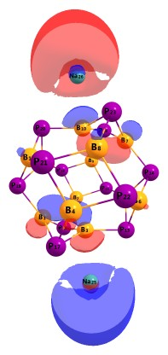
Li₂@B
Na₂@r₆
Na₂@b₆₆
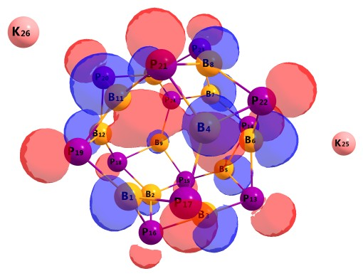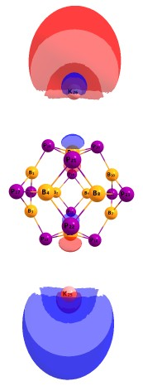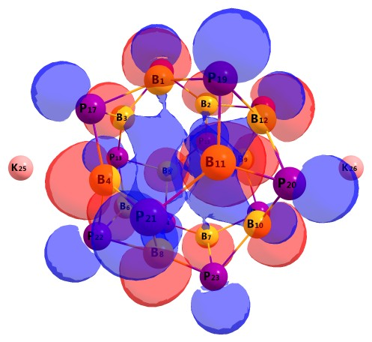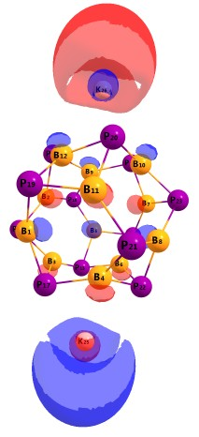
K₂@b₆₄
K₂@r₆

Fig.S3: TDOS of bi-metal doped boron phosphide complexes:

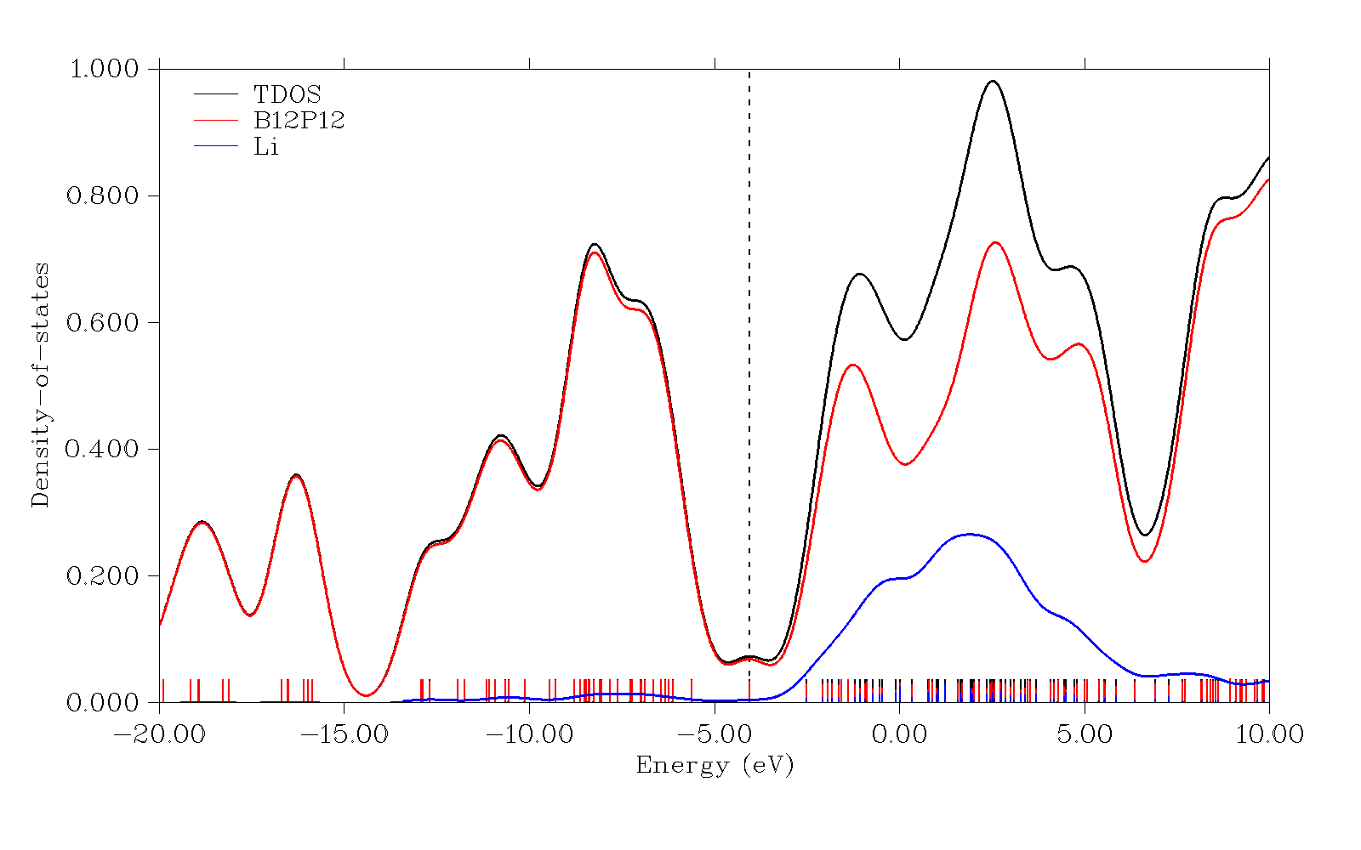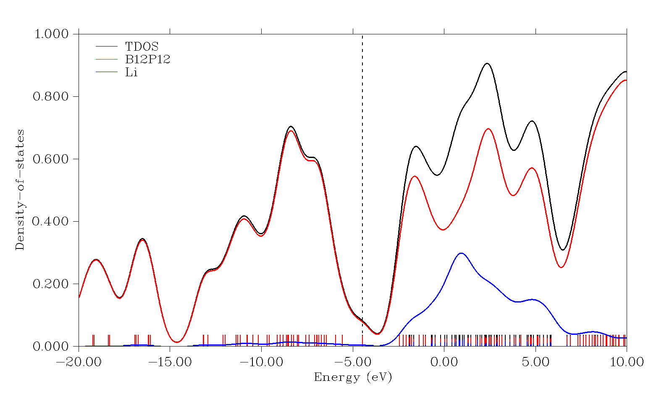
1.0
0.8
0.6
0.4
0.2
0.0
Density of States
-20.0 -15.0 -10.0 -5.0 0.0 5.0 10.0
Energy
TDOS
B₁₂P₁₂
Li
Li₂@b₆₄
1.0
0.8
0.6
0.4
0.2
0.0
Density of States
-20.0 -15.0 -10.0 -5.0 0.0 5.0 10.0
Energy
TDOS
B₁₂P₁₂
Li
Li₂@b₆₆
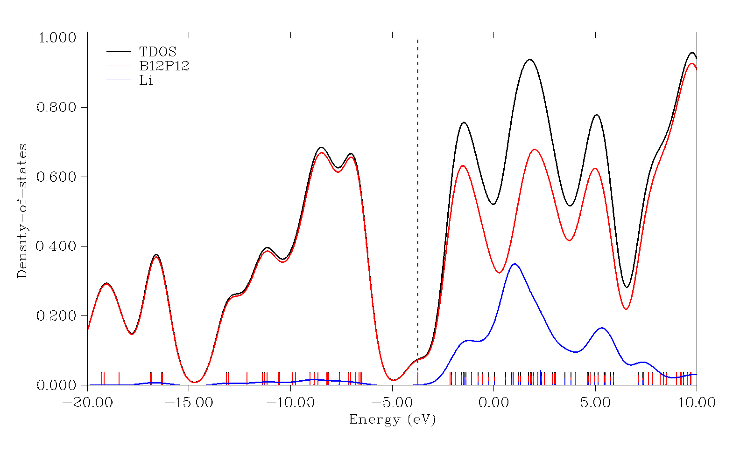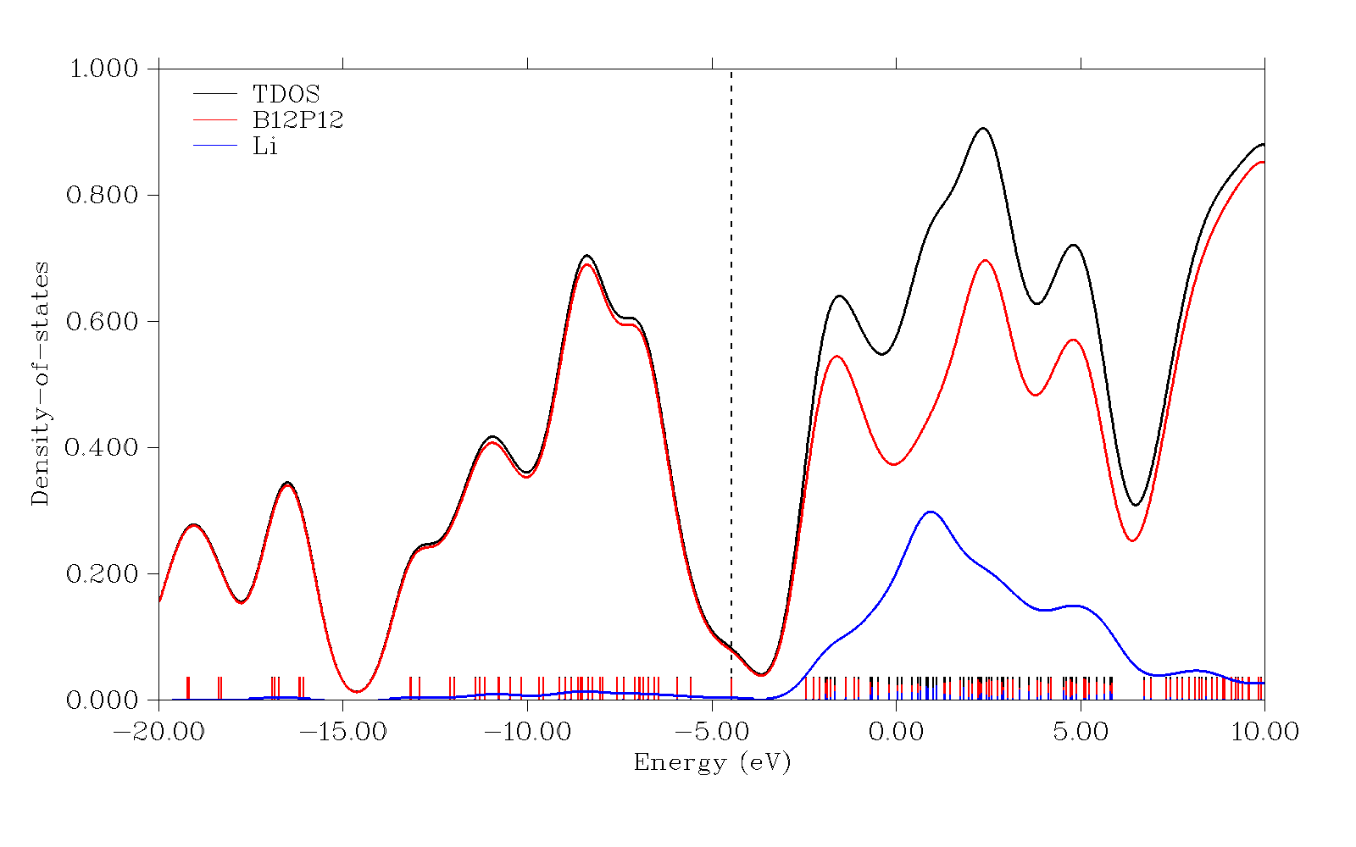
1.0
0.8
0.6
0.4
0.2
0.0
Density of States
-20.0 -15.0 -10.0 -5.0 0.0 5.0 10.0
Energy
TDOS
B₁₂P₁₂
Li
Li₂@r₆
1.0
0.8
0.6
0.4
0.2
0.0
Density of States
-20.0 -15.0 -10.0 -5.0 0.0 5.0 10.0
Energy
TDOS
B₁₂P₁₂
Li
Li₂@B

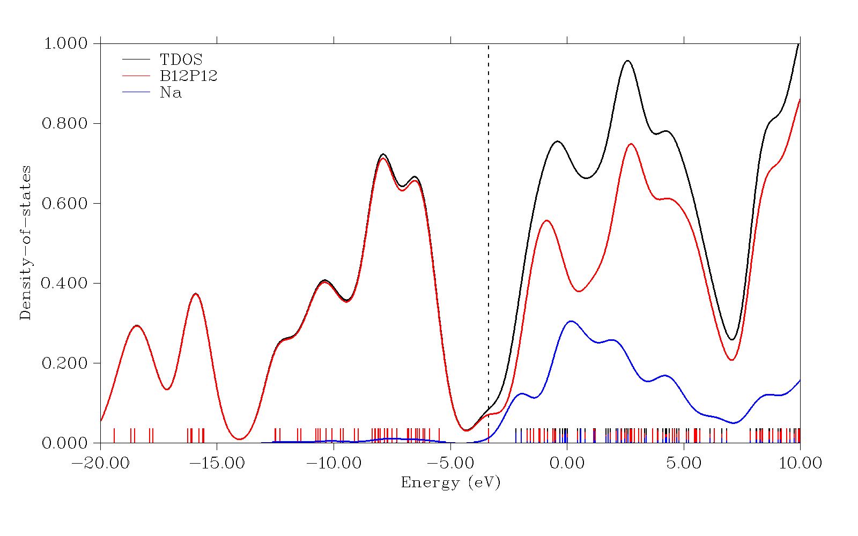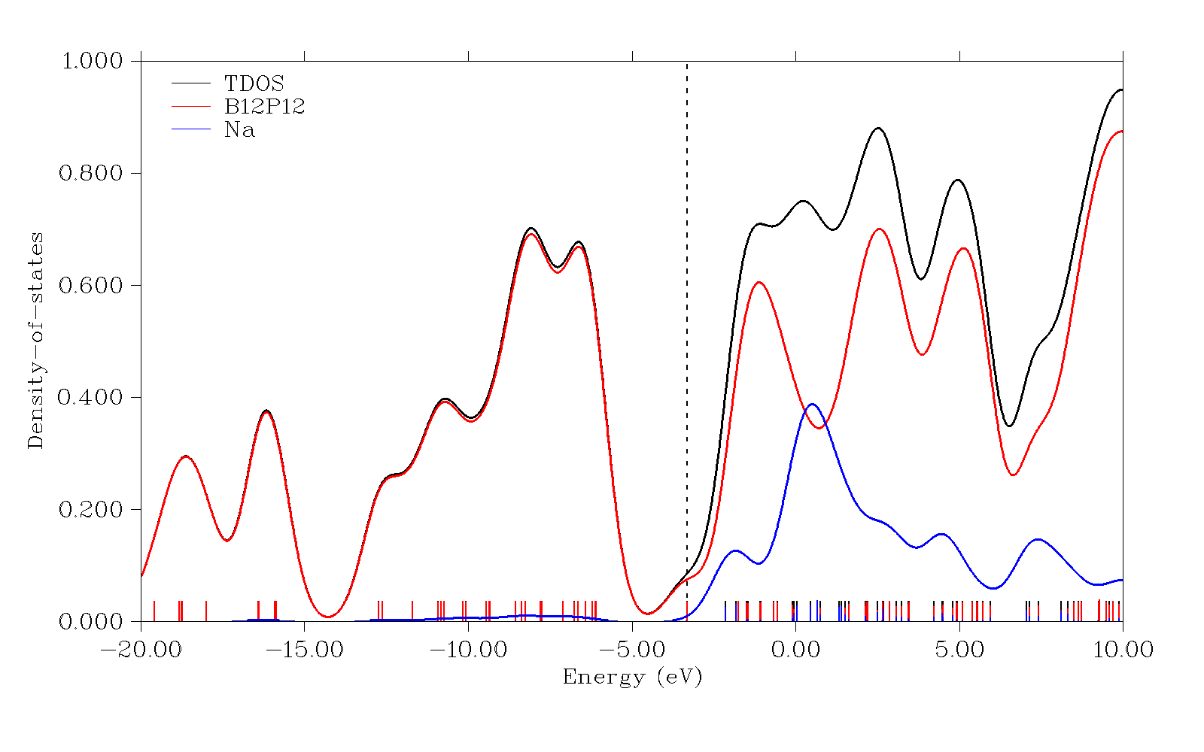
1.0
0.8
0.6
0.4
0.2
0.0
Density of States
-20.0 -15.0 -10.0 -5.0 0.0 5.0 10.0
Energy
TDOS
B₁₂P₁₂
Na
Na₂@b₆₆
1.0
0.8
0.6
0.6
0.4
0.2
0.0
Density of States
-20.0 -15.0 -10.0 -5.0 0.0 5.0 10.0
Energy
TDOS
B₁₂P₁₂
Na
Na₂@r₆

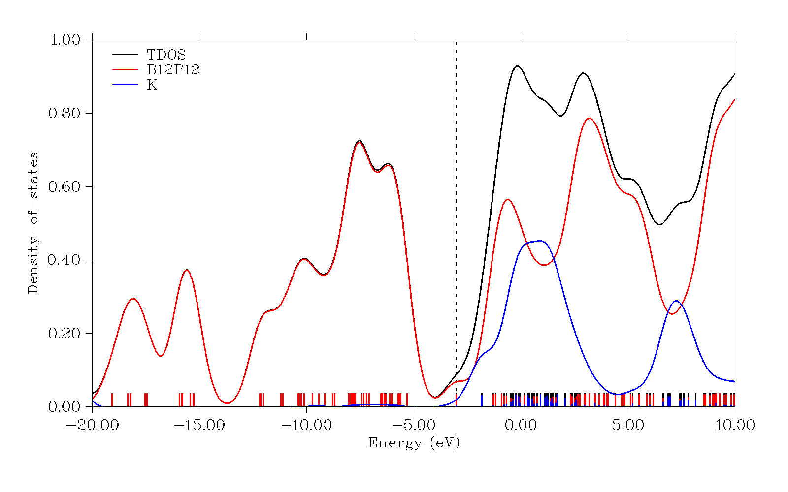
1.0
0.8
0.6
0.4
0.2
0.0
Density of States
-20.0 -15.0 -10.0 -5.0 0.0 5.0 10.0
Energy
TDOS
B₁₂P₁₂
Na
Na₂@r₄
1.0
0.8
0.6
0.4
0.2
0.0
Density of states
-20.0 -15.0 -10.0 -5.0 0.0 5.0 10.0
Energy
TDOS
B₁₂P₁₂
K
K₂@b₆₄

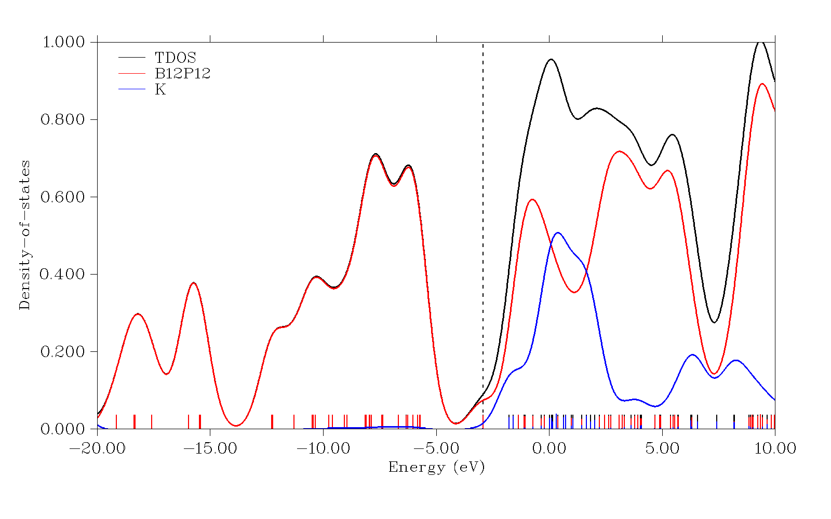
1.0
0.8
0.6
0.4
0.2
0.0
Density of States
-20.0 -15.0 -10.0 -5.0 0.0 5.0 10.0
Energy
TDOS
B₁₂P₁₂
K
K₂@r₆

Fig.S4: 3D NCI images and 2D NCI plots of bi-alkali metal doped B₁₂P₁₂ complexes:
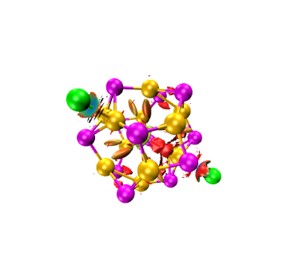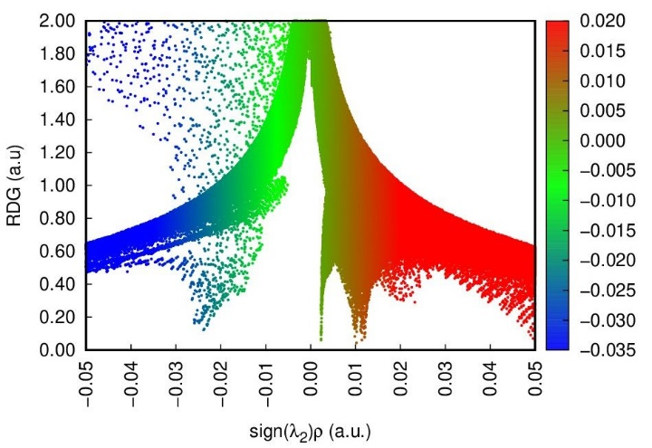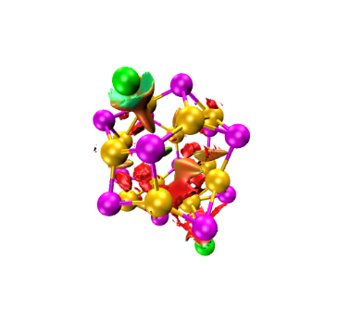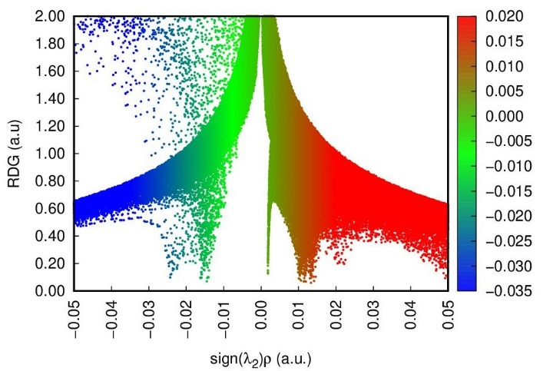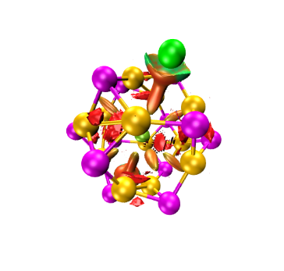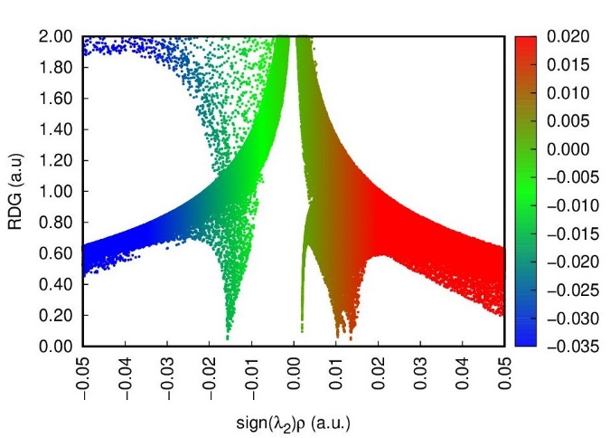
Li₂@b₆₄
Li₂@b₆₆
Li₂@r₆

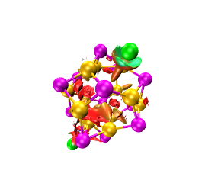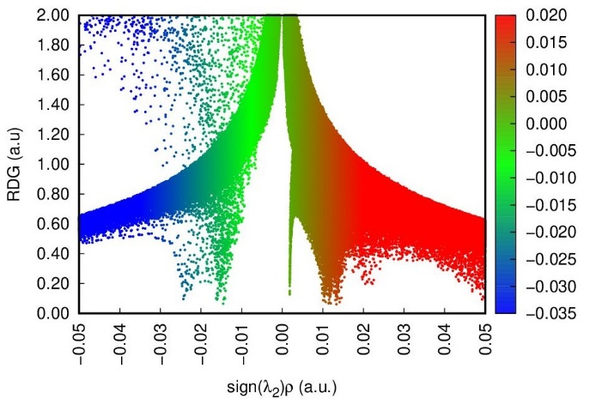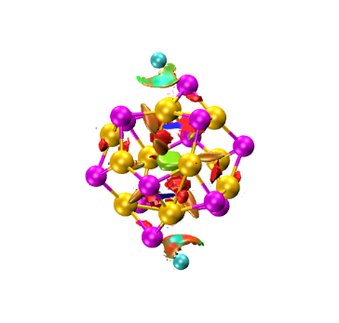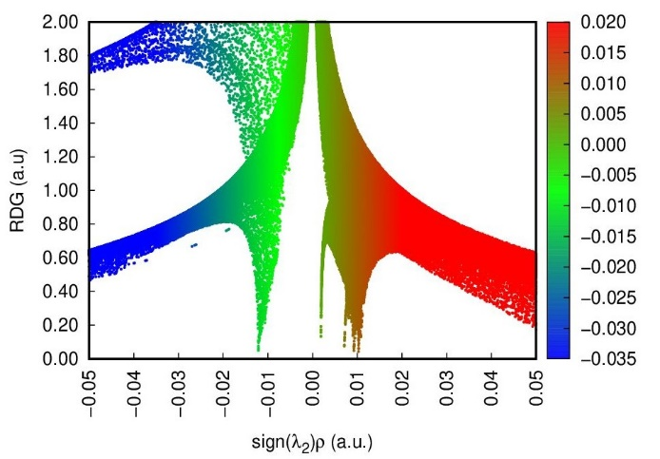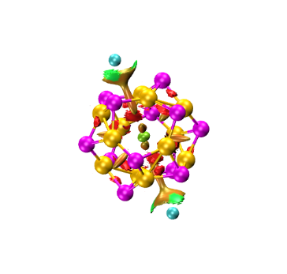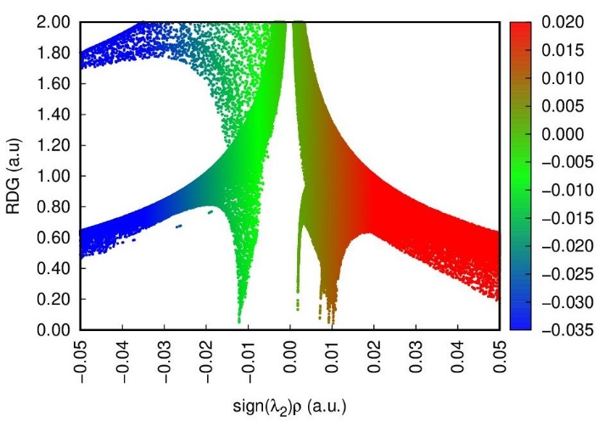
Li₂@B
Na₂@b₆₆
Na₂@r₆
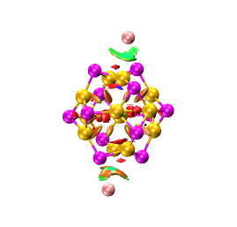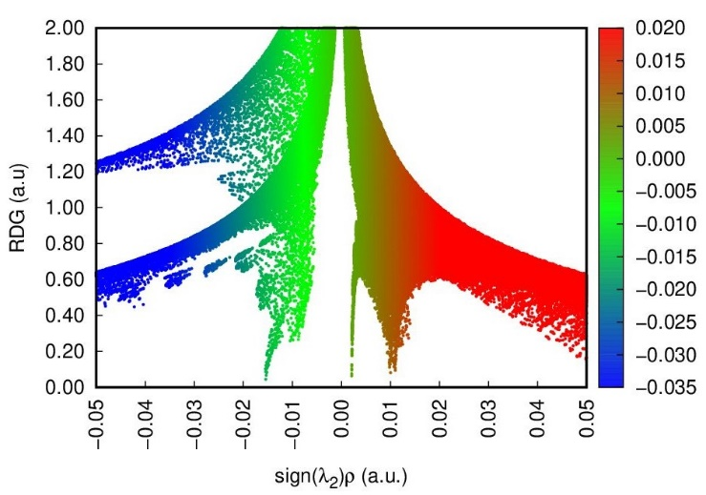
K₂@b₆₆

Fig.S5: QTAIM analysis of bi-metal decorated B₁₂P₁₂ complexes for non-covalent interactions.
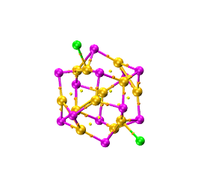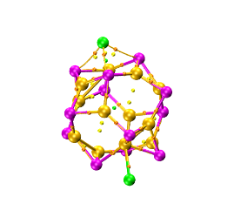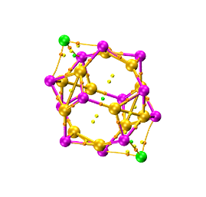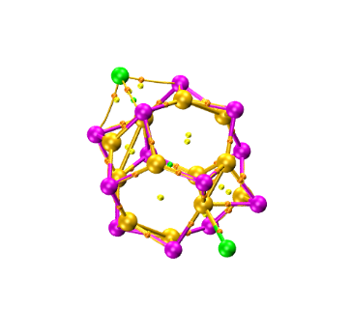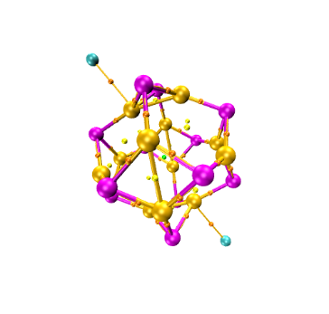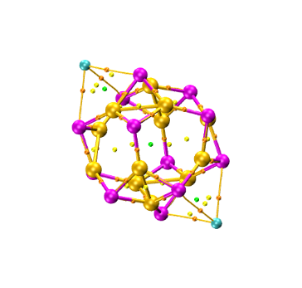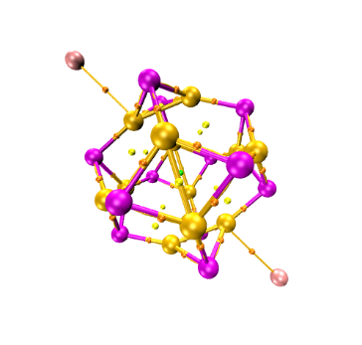
Li₂@b₆₄
Li₂@b₆₆
Li₂@r₆
Li₂@B
Na₂@b₆₆
Na₂@r₆
K₂@b₆₆

