ProfhEX: AI-based platform for small molecules liability profiling
Filippo Lunghini¹, Anna Fava¹, Vincenzo Pisapia², Francesco Sacco², Daniela Iaconis¹ and Andrea Rosario Beccari^{1,*}
¹EXSCALATE, Dompé Farmaceutici SpA, Via Tommaso de Amicis 95, Napoli 80123, Italy
²SAS Institute, Professional Service Department, Via Darwin 20/22, Milano 20143, Italy
KEYWORDS: virtual screening, liability profiling, polypharmacology, machine learning, webservice

SUPPORTING INFORMATION

Table S1. Detailed statistics on the selected 46 targets, listing their Uniprot ID, the number of unique molecules, the average pK value (range in brackets), pK standard deviation and for which liabilities the target is relevant for.
# | Protein family | Uniprot | Name | # mols | pK_{average} (min - max) | SD | Liabilities
1 | Electrochemical | P23975 | SLC6A2 | 7398 | 6.78 (1.8 - 10.2) | 1.24 | CV, CNS
2 | Electrochemical | Q01959 | SLC6A3 | 4658 | 6.47 (1.0 - 10.8) | 1.15 | CNS
3 | Electrochemical | P31645 | SLC6A4 | 11059 | 6.93 (1.2 - 14.4) | 1.33 | CV, CNS
4 | GPCR A (monoamine) | P35348 | ADRA1A | 2898 | 7.49 (2.4 - 11.0) | 1.31 | CV, CNS, GI
5 | GPCR A (monoamine) | P08913 | ADRA2A | 3513 | 6.86 (1.4 - 11.3) | 1.17 | CV, CNS
6 | GPCR A (monoamine) | P18089 | ADRA2B | 2168 | 6.83 (1.4 - 10.0) | 1.17 | CV, CNS
7 | GPCR A (monoamine) | P08588 | ADRB1 | 2240 | 6.61 (3.1 - 10.7) | 1.34 | CV, GI
8 | GPCR A (monoamine) | P07550 | ADRB2 | 4025 | 7.53 (1.0 - 12.1) | 1.51 | CV, PU
9 | GPCR A (monoamine) | P11229 | CHRM1 | 7576 | 6.28 (1.0 - 15.0) | 1.25 | CV, CNS, GI
10 | GPCR A (monoamine) | P20309 | CHRM3 | 6886 | 7.12 (1.0 - 15.0) | 1.91 | GI, PU
11 | GPCR A (monoamine) | P21728 | DRD1 | 2293 | 6.51 (3.0 - 10.3) | 1.07 | CV, CNS
12 | GPCR A (monoamine) | P14416 | DRD2 | 13497 | 6.77 (1.0 - 11.1) | 1.2 | CV, CNS, ED
13 | GPCR A (monoamine) | P35367 | HRH1 | 3347 | 6.44 (2.0 - 13.0) | 1.37 | CV, IM
14 | GPCR A (monoamine) | P25021 | HRH2 | 819 | 5.93 (3.0 - 13.0) | 1.19 | CV, GI
15 | GPCR A (monoamine) | P08908 | HTR1A | 9021 | 7.3 (1.0 - 13.7) | 1.32 | CNS, ED
16 | GPCR A (monoamine) | P28222 | HTR1B | 1540 | 7.12 (4.0 - 10.1) | 1.3 | CV, CNS
17 | GPCR A (monoamine) | P28223 | HTR2A | 11716 | 6.7 (1.3 - 12.5) | 1.62 | CV, CNS
18 | GPCR A (monoamine) | P41595 | HTR2B | 3283 | 6.18 (1.3 - 11.0) | 1.7 | CNS, ED, PU
19 | GPCR A (nucleotide-like) | P30542 | ADORA1 | 9009 | 6.64 (3.2 - 12.8) | 1.13 | CV, CNS
20 | GPCR A (nucleotide-like) | P29274 | ADORA2A | 15021 | 7.04 (1.9 - 13.0) | 1.36 | CV, CNS
21 | GPCR A (peptide) | P37288 | AVPR1A | 5878 | 7.76 (3.1 - 11.4) | 1.18 | CV, RE
22 | GPCR A (peptide) | P32238 | CCKAR | 941 | 7.23 (1.7 - 11.6) | 1.7 | GI
23 | GPCR A (peptide) | P21554 | CNR1 | 18896 | 6.69 (1.0 - 12.5) | 1.47 | CNS
24 | GPCR A (peptide) | P34972 | CNR2 | 18442 | 7.05 (1.8 - 12.1) | 1.36 | IM
25 | GPCR A (peptide) | P25101 | EDNRA | 4198 | 6.6 (1.8 - 12.5) | 1.92 | CNS, ED
26 | GPCR A (peptide) | P41143 | OPRD1 | 7993 | 7.39 (2.1 - 10.8) | 1.84 | CV, CNS
27 | GPCR A (peptide) | P41145 | OPRK1 | 9073 | 7.11 (2.0 - 12.3) | 1.55 | CV, CNS, GI
28 | GPCR A (peptide) | P35372 | OPRM1 | 13379 | 7.28 (1.7 - 13.4) | 1.69 | CV, CNS, GI
29 | Hydrolase | P22303 | ACHE | 4759 | 6.1 (1.2 - 14.3) | 1.63 | CV, GI, PU
30 | Kinase | P06239 | LCK | 3084 | 6.67 (3.3 - 11.0) | 1.43 | IM
31 | Ligand-gated | P46098 | HTR3A | 853 | 7.3 (1.5 - 10.4) | 1.55 | GI, ED
32 | Nuclear receptor | P10275 | AR | 6585 | 6.53 (1.4 - 12.1) | 1.23 | ED
33 | Nuclear receptor | P03372 | ESR1 | 6659 | 7.38 (1.7 - 14.1) | 1.78 | ED
34 | Nuclear receptor | P04150 | NR3C1 | 10030 | 7.07 (3.5 - 12.2) | 1.55 | ED, IM
35 | Nuclear receptor | Q07869 | PPARA | 6967 | 6.03 (1.6 - 13.3) | 1.27 | GI
36 | Nuclear receptor | Q03181 | PPARD | 4992 | 6.15 (2.7 - 12.0) | 1.32 | GI
37 | Nuclear receptor | P37231 | PPARG | 7567 | 6.17 (1.4 - 13.0) | 1.21 | GI
38 | Oxidoreductase | P21397 | MAOA | 3897 | 5.23 (1.4 - 12.3) | 1.11 | CV, CNS
39 | Oxidoreductase | P23219 | PTGS1 | 2995 | 5.26 (1.4 - 11.5) | 1.08 | GI, PU, RE
40 | Oxidoreductase | P35354 | PTGS2 | 6384 | 6.05 (2.2 - 11.7) | 1.22 | CV, IM
41 | P450 | P11511 | CYP19A1 | 3728 | 6.27 (1.6 - 11.4) | 1.44 | GI
42 | Phosphodiesterase | Q14432 | PDE3A | 976 | 6.5 (2.0 - 11.0) | 1.22 | CV
43 | Phosphodiesterase | Q08499 | PDE4D | 2710 | 5.87 (2.0 - 11.0) | 1.77 | CNS, IM
44 | Voltage-gated | P22460 | KCNA5 | 2135 | 5.97 (2.7 - 8.3) | 0.77 | CV
45 | Voltage-gated | Q12809 | KCNH2 | 11325 | 5.44 (1.0 - 9.9) | 0.95 | CV
46 | Voltage-gated | Q14524 | SCN5A | 2789 | 5.65 (1.1 - 9.6) | 1.31 | CV

Table S2. Detailed performance of developed models. The Pearson correlation coefficient (Rho), the R2 determination coefficient and the Root Mean Squared Error (RMSE), are reported for each type of validation: validation set (external), 5-fold cross validation (CV), bootstrap and y-scrambling.
# | Target | RHO |  |  |  | R2 |  |  |  | RMSE |  |  |  | EF |  |  | AUC
# | Target | Ext. | CV | Boot. | Y. | Ext. | CV | Boot. | Y. | Ext. | CV | Boot. | Y. | 1% | 5% | 10% | AUC
1 | ACHE | 0.84 | 0.85 | 0.81 | 0,00 | 0.64 | 0.65 | 0.59 | 0,00 | 0.82 | 0.84 | 0.96 | 1,65 | 40.5 | 13.7 | 8.4 | 0.97
2 | ADORA1 | 0.81 | 0.79 | 0.77 | 0,01 | 0.56 | 0.53 | 0.48 | 0,00 | 0.64 | 0.67 | 0.71 | 1,14 | 41.1 | 14.4 | 8.8 | 0.95
3 | ADORA2A | 0.86 | 0.85 | 0.82 | 0,00 | 0.67 | 0.66 | 0.6 | 0,00 | 0.65 | 0.67 | 0.76 | 1,30 | 16.6 | 8.0 | 6.0 | 0.91
4 | ADRA1A | 0.8 | 0.79 | 0.75 | 0,00 | 0.69 | 0.61 | 0.62 | 0,00 | 0.77 | 0.8 | 0.85 | 1,37 | 32.3 | 13.4 | 7.5 | 0.94
5 | ADRA2A | 0.82 | 0.81 | 0.78 | 0,00 | 0.61 | 0.6 | 0.59 | 0,00 | 0.64 | 0.66 | 0.72 | 1,18 | 28.4 | 16.1 | 8.6 | 0.92
6 | ADRA2B | 0.87 | 0.83 | 0.78 | 0,00 | 0.61 | 0.62 | 0.51 | 0,01 | 0.57 | 0.58 | 0.68 | 1,13 | 52.7 | 19.8 | 10.1 | 0.95
7 | ADRB1 | 0.83 | 0.84 | 0.78 | -0,01 | 0.69 | 0.69 | 0.69 | 0,00 | 0.72 | 0.7 | 0.77 | 1,37 | 35.9 | 17.4 | 8.9 | 0.90
8 | ADRB2 | 0.88 | 0.87 | 0.84 | -0,01 | 0.74 | 0.71 | 0.68 | 0,00 | 0.71 | 0.75 | 0.83 | 1,54 | 18.8 | 9.3 | 7.4 | 0.92
9 | AR | 0.87 | 0.86 | 0.82 | 0,00 | 0.69 | 0.69 | 0.65 | 0,00 | 0.6 | 0.61 | 0.66 | 1,24 | 37.9 | 12.7 | 7.0 | 0.92
10 | AVPR1A | 0.86 | 0.84 | 0.81 | -0,01 | 0.73 | 0.66 | 0.67 | 0,00 | 0.62 | 0.66 | 0.73 | 1,25 | 29.2 | 14.7 | 7.8 | 0.96
11 | CCKAR | 0.89 | 0.89 | 0.84 | 0,01 | 0.8 | 0.82 | 0.91 | 0,00 | 0.71 | 0.72 | 0.85 | 1,70 | 0.0 | 0.0 | 0.0 | 0.91
12 | CHRM1 | 0.85 | 0.83 | 0.8 | 0,01 | 0.73 | 0.72 | 0.68 | 0,01 | 0.6 | 0.64 | 0.69 | 1,21 | 35.2 | 16.4 | 8.6 | 0.90
13 | CHRM3 | 0.91 | 0.91 | 0.9 | 0,00 | 0.75 | 0.75 | 0.72 | 0,00 | 0.75 | 0.75 | 0.78 | 1,87 | 28.7 | 11.7 | 8.3 | 0.92
14 | CNR1 | 0.83 | 0.83 | 0.81 | 0,00 | 0.59 | 0.59 | 0.53 | 0,00 | 0.79 | 0.78 | 0.84 | 1,41 | 41.6 | 14.1 | 7.5 | 0.92
15 | CNR2 | 0.83 | 0.83 | 0.8 | 0,00 | 0.63 | 0.64 | 0.62 | 0,00 | 0.76 | 0.74 | 0.81 | 1,37 | 37.4 | 15.1 | 8.8 | 0.96
16 | CYP19A1 | 0.82 | 0.78 | 0.74 | 0,00 | 0.58 | 0.54 | 0.57 | 0,00 | 0.82 | 0.89 | 0.9 | 1,50 | 19.1 | 18.8 | 9.4 | 0.85
17 | DRD1 | 0.77 | 0.73 | 0.72 | 0,01 | 0.6 | 0.56 | 0.56 | 0,01 | 0.64 | 0.68 | 0.67 | 1,05 | 12.2 | 6.6 | 6.6 | 0.75
18 | DRD2 | 0.83 | 0.82 | 0.77 | 0,00 | 0.57 | 0.57 | 0.51 | 0,00 | 0.66 | 0.67 | 0.79 | 1,19 | 28.0 | 10.0 | 6.3 | 0.90
19 | EDNRA | 0.89 | 0.89 | 0.78 | 0,00 | 0.73 | 0.74 | 0.69 | -0,01 | 0.81 | 0.83 | 0.99 | 1,88 | 30.8 | 15.2 | 9.4 | 0.96
20 | ESR1 | 0.89 | 0.88 | 0.83 | 0,00 | 0.72 | 0.7 | 0.65 | 0,00 | 0.74 | 0.78 | 0.87 | 1,67 | 23.0 | 12.3 | 7.3 | 0.95
21 | HRH1 | 0.85 | 0.86 | 0.85 | 0,00 | 0.73 | 0.7 | 0.75 | 0,00 | 0.68 | 0.66 | 0.62 | 1,39 | 34.7 | 10.0 | 5.7 | 0.92
22 | HRH2 | 0.78 | 0.79 | 0.66 | 0,00 | 0.79 | 0.73 | 0.6 | 0,00 | 0.65 | 0.66 | 0.73 | 1,14 | 23.6 | 10.5 | 9.9 | 0.95
23 | HTR1A | 0.82 | 0.84 | 0.78 | 0,00 | 0.66 | 0.61 | 0.58 | 0,00 | 0.71 | 0.73 | 0.76 | 1,38 | 25.0 | 12.2 | 7.2 | 0.94
24 | HTR1B | 0.8 | 0.82 | 0.8 | 0,01 | 0.78 | 0.69 | 0.65 | 0,00 | 0.76 | 0.71 | 0.78 | 1,32 | 0.0 | 4.1 | 3.9 | 0.82
25 | HTR2A | 0.89 | 0.87 | 0.84 | 0,00 | 0.74 | 0.74 | 0.64 | -0,01 | 0.72 | 0.77 | 0.86 | 1,60 | 49.7 | 16.6 | 8.3 | 0.94
26 | HTR2B | 0.87 | 0.86 | 0.82 | -0,01 | 0.76 | 0.7 | 0.64 | 0,00 | 0.82 | 0.85 | 0.92 | 1,73 | 16.5 | 6.6 | 4.2 | 0.90
27 | HTR3A | 0.85 | 0.79 | 0.74 | 0,00 | 0.77 | 0.74 | 0.7 | 0,00 | 0.8 | 0.96 | 1.1 | 1,73 | 57.0 | 19.0 | 10.1 | 0.90
28 | KCNA5 | 0.79 | 0.8 | 0.78 | 0,00 | 0.66 | 0.65 | 0.56 | 0,00 | 0.47 | 0.45 | 0.5 | 0,80 | 29.3 | 12.2 | 9.0 | 0.92
29 | KCNH2 | 0.74 | 0.71 | 0.63 | 0,00 | 0.44 | 0.41 | 0.34 | -0,01 | 0.61 | 0.63 | 0.69 | 0,92 | 38.8 | 15.6 | 8.3 | 0.90
30 | LCK | 0.89 | 0.87 | 0.85 | -0,01 | 0.78 | 0.79 | 0.78 | 0,00 | 0.58 | 0.64 | 0.68 | 1,38 | 30.4 | 18.3 | 8.9 | 0.91
31 | MAOA | 0.78 | 0.73 | 0.66 | 0,00 | 0.55 | 0.47 | 0.43 | 0,00 | 0.66 | 0.73 | 0.78 | 1,12 | 24.9 | 16.2 | 9.3 | 0.88
32 | NR3C1 | 0.89 | 0.89 | 0.85 | 0,00 | 0.77 | 0.74 | 0.7 | -0,01 | 0.67 | 0.68 | 0.75 | 1,52 | 28.8 | 15.2 | 8.4 | 0.94
33 | OPRD1 | 0.91 | 0.9 | 0.86 | 0,00 | 0.81 | 0.78 | 0.79 | 0,00 | 0.74 | 0.77 | 0.87 | 1,89 | 9.4 | 3.7 | 3.1 | 0.90
34 | OPRK1 | 0.86 | 0.87 | 0.85 | 0,00 | 0.76 | 0.78 | 0.8 | 0,00 | 0.77 | 0.76 | 0.79 | 1,58 | 33.1 | 13.4 | 8.9 | 0.95
35 | OPRM1 | 0.89 | 0.89 | 0.89 | 0,00 | 0.75 | 0.73 | 0.7 | 0,01 | 0.74 | 0.75 | 0.81 | 1,70 | 25.0 | 15.2 | 9.1 | 0.95
36 | PDE3A | 0.91 | 0.89 | 0.85 | 0,02 | 0.74 | 0.81 | 0.76 | 0,00 | 0.53 | 0.57 | 0.59 | 1,33 | 48.3 | 19.3 | 10.2 | 0.99
37 | PDE4D | 0.95 | 0.94 | 0.91 | 0,00 | 0.88 | 0.81 | 0.77 | 0,02 | 0.58 | 0.64 | 0.73 | 1,18 | 19.2 | 20.0 | 10.0 | 0.98
38 | PPARA | 0.83 | 0.81 | 0.78 | 0,01 | 0.6 | 0.59 | 0.55 | 0,00 | 0.68 | 0.72 | 0.78 | 1,27 | 38.9 | 14.6 | 7.7 | 0.95
39 | PPARD | 0.85 | 0.85 | 0.81 | 0,01 | 0.76 | 0.73 | 0.66 | 0,00 | 0.67 | 0.67 | 0.7 | 1,34 | 22.7 | 17.7 | 9.4 | 0.96
40 | PPARG | 0.83 | 0.82 | 0.78 | 0,00 | 0.63 | 0.59 | 0.57 | 0,01 | 0.65 | 0.68 | 0.69 | 1,21 | 33.0 | 13.4 | 7.6 | 0.90
41 | PTGS1 | 0.66 | 0.63 | 0.6 | 0,00 | 0.39 | 0.39 | 0.38 | 0,00 | 0.76 | 0.78 | 0.79 | 1,04 | 25.9 | 8.4 | 5.0 | 0.77
42 | PTGS2 | 0.73 | 0.72 | 0.66 | 0,00 | 0.46 | 0.49 | 0.43 | 0,00 | 0.81 | 0.8 | 0.89 | 1,19 | 19.6 | 10.0 | 6.6 | 0.88
43 | SCN5A | 0.88 | 0.88 | 0.9 | 0,00 | 0.87 | 0.81 | 0.78 | 0,01 | 0.58 | 0.6 | 0.58 | 1,30 | 8.6 | 6.7 | 7.5 | 0.92
44 | SLC6A2 | 0.81 | 0.8 | 0.76 | 0,00 | 0.69 | 0.68 | 0.71 | 0,00 | 0.7 | 0.72 | 0.79 | 1,25 | 37.0 | 15.9 | 9.0 | 0.84
45 | SLC6A3 | 0.82 | 0.83 | 0.78 | 0,00 | 0.68 | 0.68 | 0.59 | 0,01 | 0.62 | 0.63 | 0.7 | 1,18 | 24.4 | 10.0 | 7.5 | 0.92
46 | SLC6A4 | 0.86 | 0.84 | 0.82 | 0,00 | 0.73 | 0.71 | 0.66 | -0,01 | 0.68 | 0.71 | 0.77 | 1,37 | 42.9 | 13.3 | 8.1 | 0.94
Ext. = external validation, CV = 5-fold cross validation, Boot. = bootstrapping, Y. = y-scrambling, EF = enrichment factor at 1, 5, and 10 % cutoff values, AUC = area under the curve referred to hit rate.

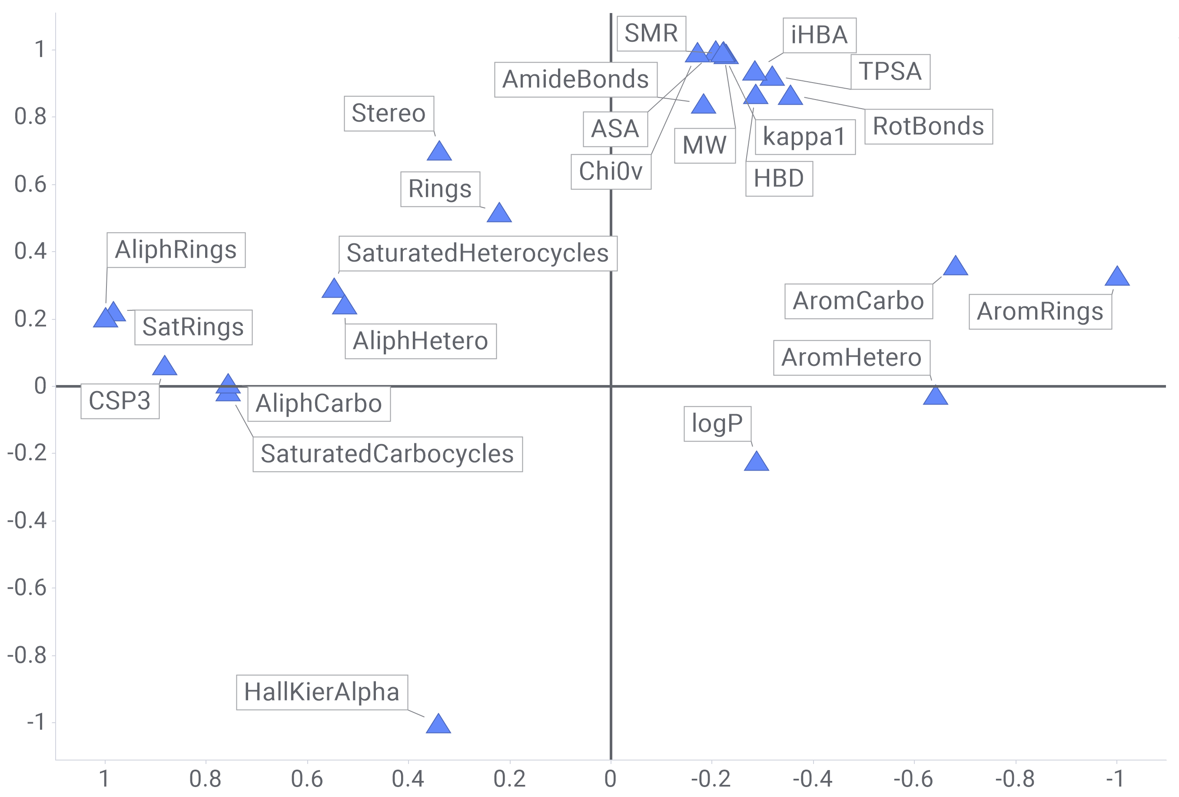
Figure S1. PCA loadings plot.

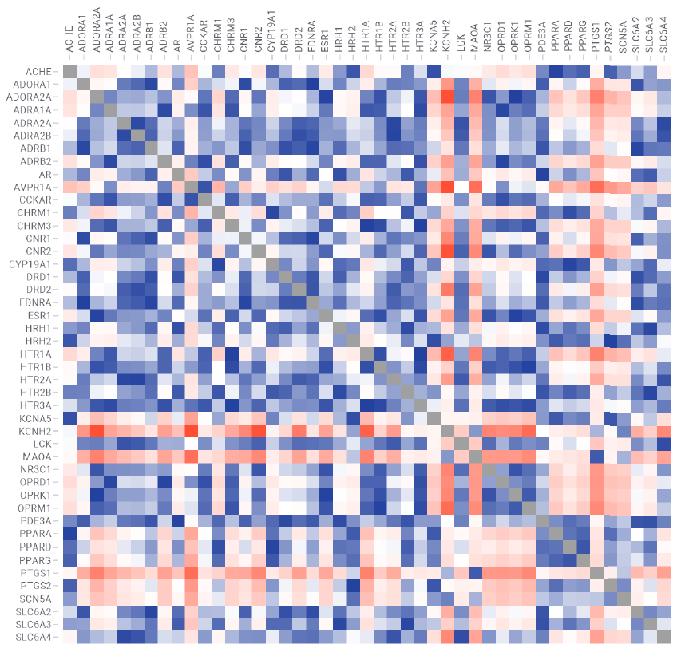
Figure S2. Extended version of Figure 4-a. Pairwise comparison of the 46 datasets pK distributions computed by Kolmogorov-Smirnov statistical test. The color scale has been normalized between 0 and 1: higher values (red) indicate that the given datasets pair show significantly different distributions, as opposite to values closer to 0 (blue).

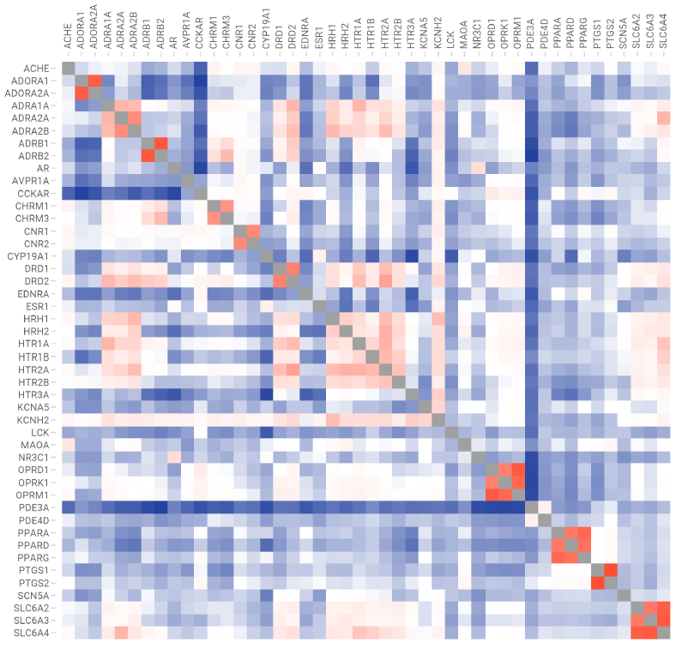
Figure S3. Extended version of Figure 4-b. Pairwise comparison of the 46 datasets pK distributions computed by average Tanimoto similarity coefficient. The color scale has been normalized between 0 and 1: higher values (red) indicate that the given datasets pair show higher chemical similarity, as opposite to values closer to 0 (blue).

